Relationships & Sex Education Survey 2022 – responses for Tendring

539 responses were received for Tendring
Gender:
- 41% female
- 54% male
- 2% non-binary
- Remainder did not disclose
Age:
- 73% Year 7-9
- 25% Year 10-11
- 1% age 17-25 [this equates to 6 responses and therefore have not been included in this report as sample is too small to be meaningful – raw data is available]
[Please note some questions were ‘select all that apply’ so percentages do not always add up to 100%. This may also be the case where percentages have been rounded.]
Year 7-9 [396 responses]
Where do you currently look for information on the following topics?
Topics | Top 3 places they’re most likely to look for information
Healthy and respectful relationships | - Friends/family (46%)  - School (29%)  - Online/social media (10%)  - 38% haven’t looked
Consent and the law | - School (32%)  - Friends/family (31%)  - Online/social media (13%)  - 41% haven’t looked
Staying safe online | - School (64%)  - Friends/family (42%)  - Online/social media (17%)  - 13% haven’t looked
Puberty | - Friends/family (46%)  - School (35%)  - Online/social media (6%)  - 28% haven’t looked
Periods | - Friends/family (40%)  - School (24%)  - Online/social media (6%)  - 41% haven’t looked
LGBTQ+ | - School (32%)  - Friends/family (21%)  - Online/social media (15%)  - 49% haven’t looked
In addition to RSE taught at school, which topics would you like to know more about?
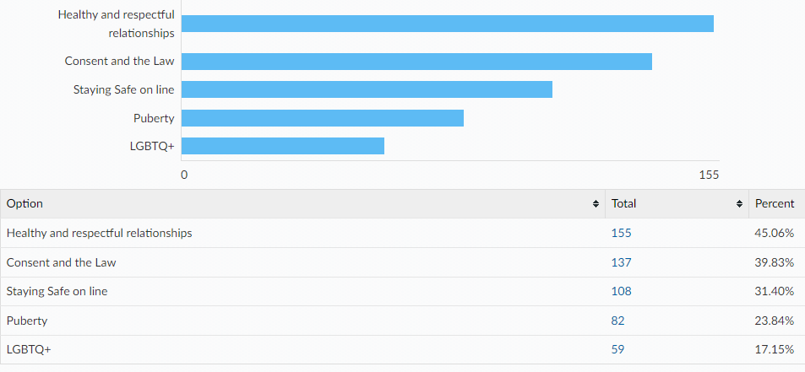
Other topics:
- how to adjust to jobs and how to act
- Sexual education
- not lgbtq
- sex education
- ethnicity
- money and finance
- how to make more healthy relationships
- PE

Links to the following sexual health information and services can all be found on the Essex Youth Service website. Which of the following are you already aware of?
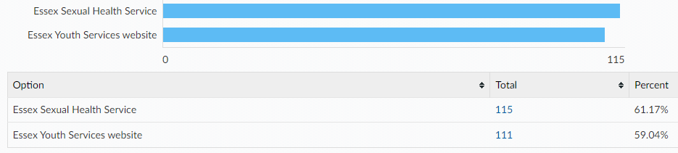

When being on the internet or social media have you ever felt...
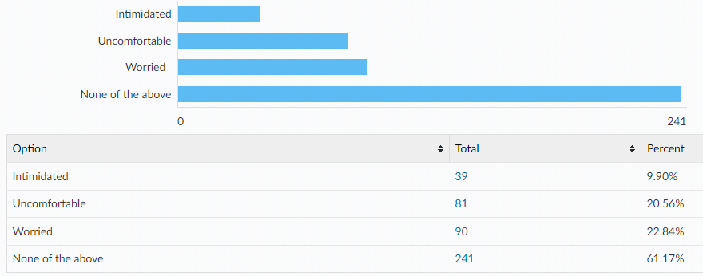
If you have felt intimidated, uncomfortable, worried…
Did you tell anyone?
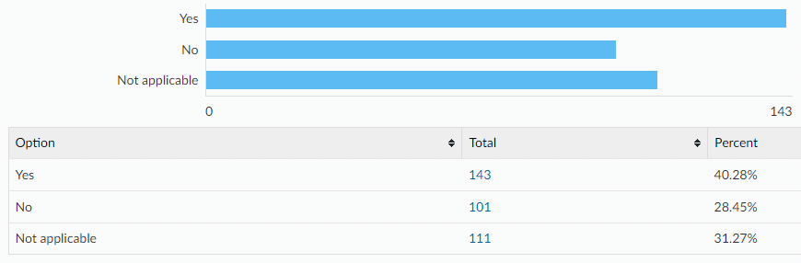
Did you know where to go for help?
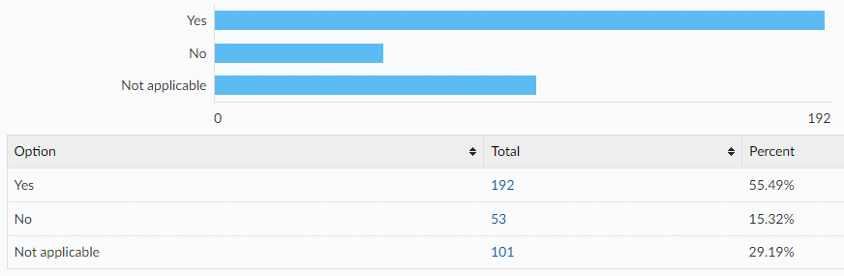

If you were to ever feel intimidated, uncomfortable or worried would you go to any of the following?
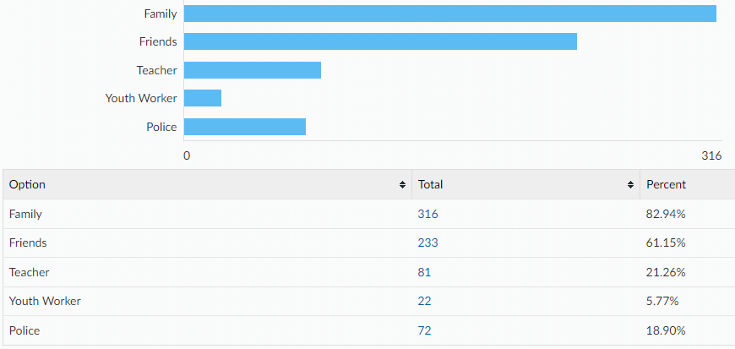
Would you tell an adult if you were asked to do something online that you were uncomfortable with? e.g. sending private pictures or joining an online private chat
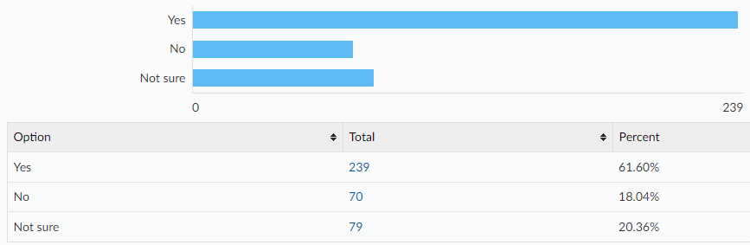
If no, what would be the reasons for not telling an adult?
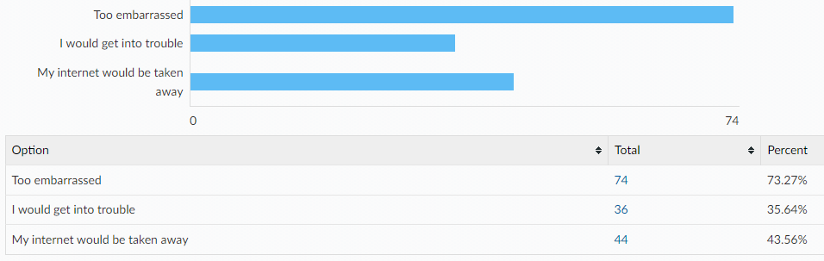

Something else:
- i would just turn off my phone
- anxiety and me imagining every way it could go wrong
- I would unless it would be a threat like if you don't join the group, you'd get kidnapped or...
- i cant be asked
- I don't feel comfortable
- i wouldnt send it
- none of their business
- i dont care and i wont do it
- i didn't want to
- because it is never that important and i dont do bad things anyways
- I know what to do.
- ignore it i wouldnt really care
- Don't really need to. I can just ignore them
- bc i dont listen to what people tell me to do
- I feel like they wouldnt help
- It can get uncomfortable
- because its got nothing to do with them
- it just depends on the situation
- because i can sort it myself
- I think it depends who it is
- I wouldnt care
Year 10-11 [137 responses]
Where do you currently look for information on the following topics?
Topics | Top 3 places they’re most likely to look for information
Healthy and respectful relationships | - Friends/family (40%)  - School (19%)  - Online/social media (11%)  - 29% haven’t looked
Consent and the law | - School (40%)  - Online/social media (14%)  - Friends/family (14%)  - 28% haven’t looked
Staying safe online | - School (38%)  - Friends/family (26%)  - Online/social media (8%)  - 27% haven’t looked
Pornography | - Online/social media (18%)  - Friends/family (14%)  - School (14%)  - 51% haven’t looked
Puberty | - School (37%)  - Friends/family (25%)  - Online/social media (9%)  - 23% haven’t looked
Masturbation | - School (13%)  - Online/social media (12%)  - Friends/family (9%)  - 57% haven’t looked
Menstruation | - School (25%)  - Friends/family (12%)  - Online (5%)  - 53% haven’t looked
LGBTQ+ | - School (33%)  - Online/social media (16%)  - Friends/family (9%)  - 38% haven’t looked
STIs | - School (44%)  - Online/social media (9%)  - Friends/family (8%)  - 32% haven’t looked
HIV | - School (40%)  - Friends/family (9%)  - Online/social media (7%)  - 35% haven’t looked
Methods of contraception | - School (37%)  - Friends/family (13%)  - Online/social media (10%)  - 33% haven’t looked
How to access contraception | - School (26%)  - Friends/family (16%)  - Online/social media (7%)  - 41% haven’t looked
Steps to take after unprotected sex | - School (29%)  - Online/social media (11%)  - Friends/family (11%)  - 41% haven’t looked
Choices around pregnancy | - School (25%)  - Friends/family (16%)  - Online/social media (8%)  - 43% haven’t looked

In addition to RSE taught at school, which topics would you like to know more about?
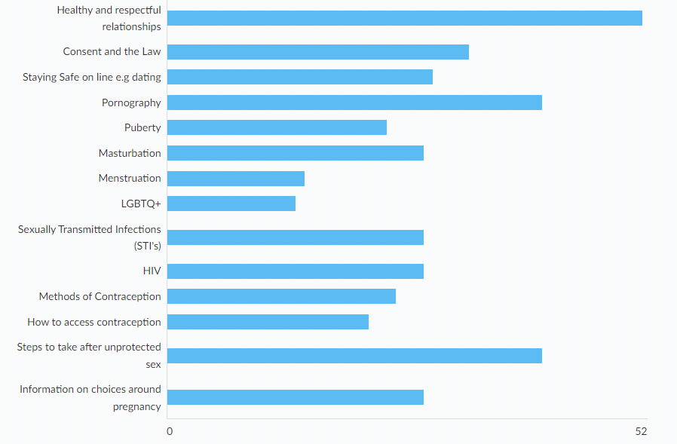

Links to the following sexual health information and services can all be found on the Essex Youth Service website. Which of the following are you already aware of?
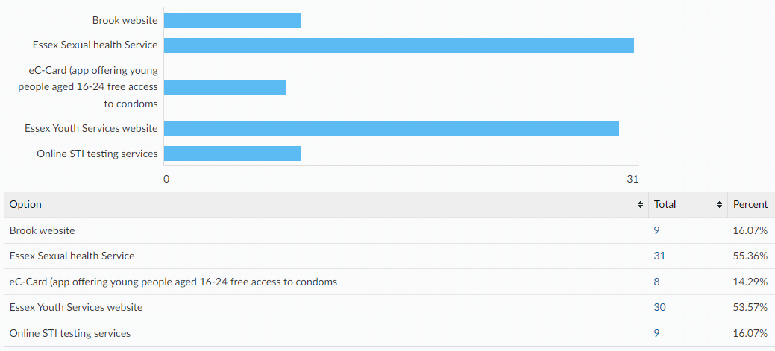
Condoms are the best way to prevent against sexually transmitted infections. There are a wide variety of other contraceptive methods designed to prevent pregnancy, some of which are listed below. All Young People have the right to information and support to allow informed choices on these methods. Please tick if you know how to access the following:

Please tell us where would you feel most comfortable going to access your chosen method of contraception?
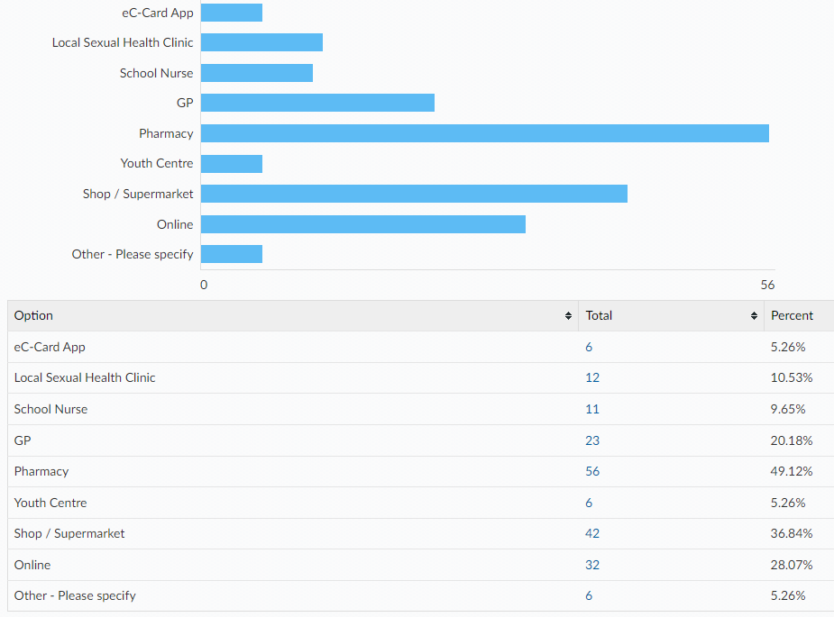
How confident do you feel that you would know how to access emergency contraception after unprotected sex (e.g. the 'morning after pill') for yourself or a partner?
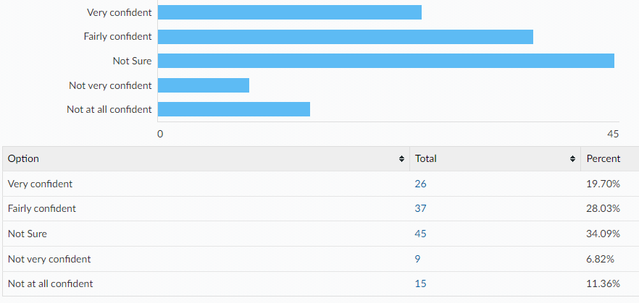

When being on the internet or social media have you ever felt...
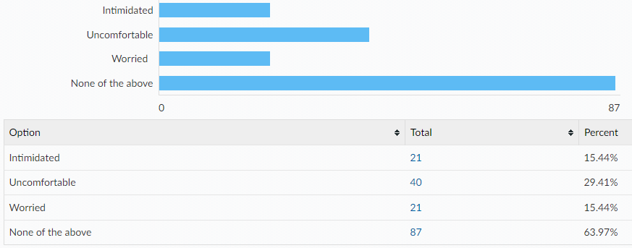
If you have felt intimidated, uncomfortable, worried…
Did you tell anyone?
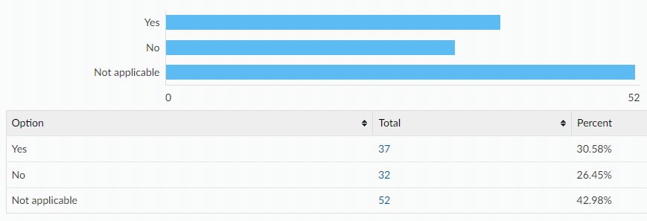
Did you know where to go for help?
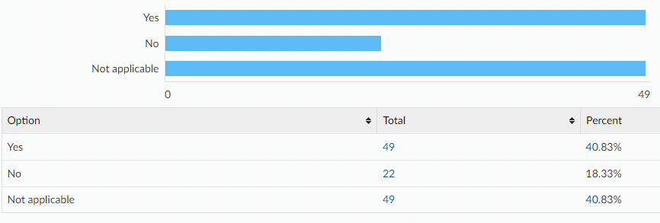

If you were to ever feel intimidated, uncomfortable or worried would you go to any of the following?
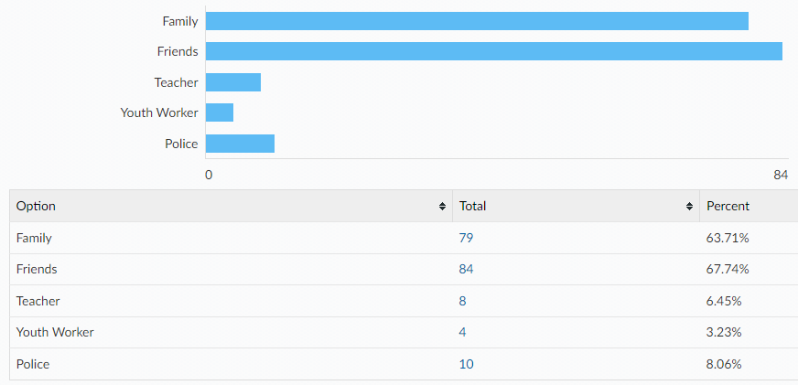
Would you tell an adult if you were asked to do something online that you were uncomfortable with? e.g. sending private pictures or joining an online private chat
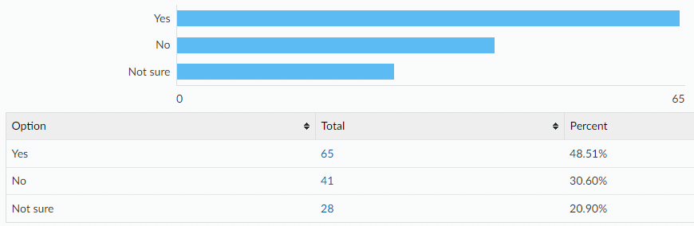
If no, what would be the reasons for not telling an adult? (please tick all that apply)
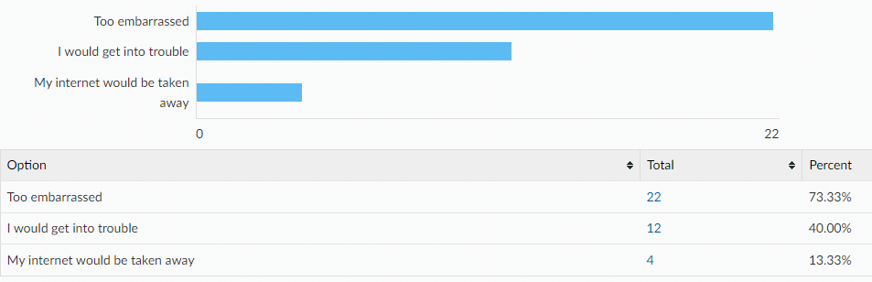

Other reasons:
- my problem
- i can handle it
- literally nothing i can handle it
- i can handle it
- not that deep
- i can fix it myself
- i wouldnt mind
- feel worries that i would get balmed
- i can look after myself perfectly well
- couldn't be bothered
- I just wouldn't because it doesn't worry me
- I would handle it myself
- i would deal with it alone
- I know how to be safe, the block button is my best friend
- just block them like a normal person
- beacause i know not to send stuff like that
- they would slap me
All ages:
[A note to help interpret this data: The total column shows percentages for ALL respondents, with age breakdowns shown along each row. E.g. 98.12% of all respondents have a mobile phone, of which 72.74% are in year 7-9 and 25.38% are year 10-11.]
Do you have any of the following?
A mobile phone with access to the internet
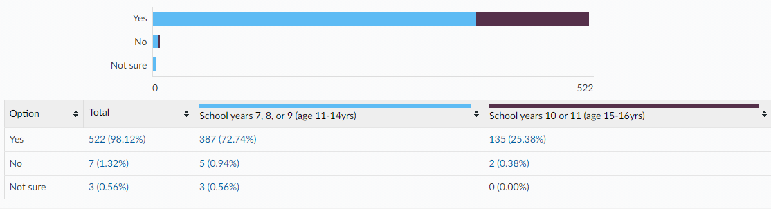
A Snapchat account
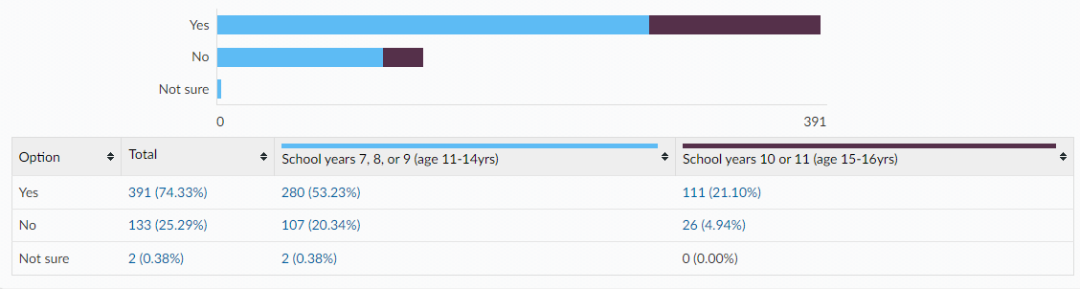
An Instagram account
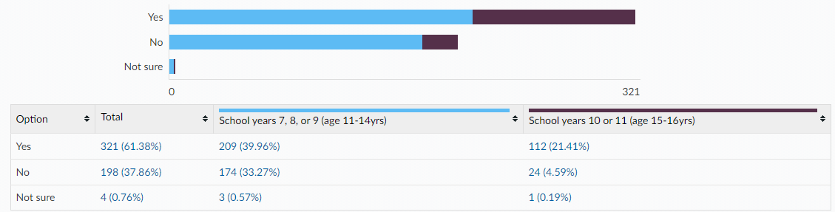
Tik Tok account
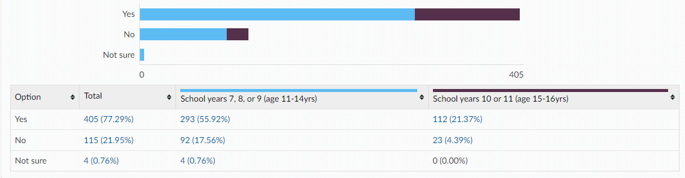
Twitch account
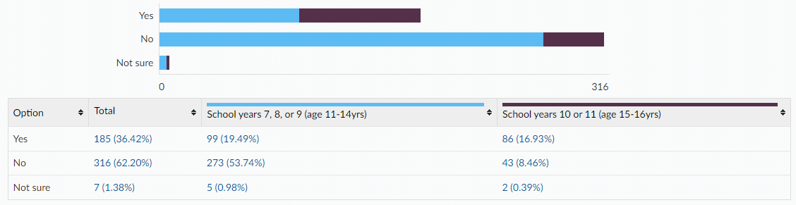
Engage in online gaming
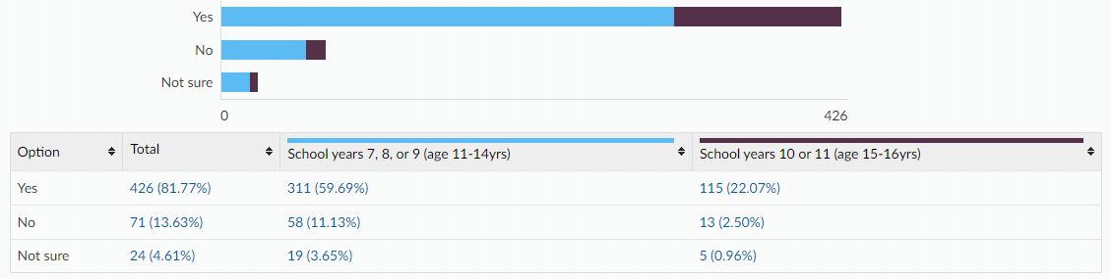

Is there anything else you would like to learn about or get support with around sex and relationships? (All ages)
- relationships
- I would like to know more about the contraception pill and how to access it.
- i would like to know the difference between toxic and healthy relationships
- How to talk to people that are difficult about a medical/mental condition I think I have.
- sex
- abusive relationships and how to help
- Everything please
- I would like to learn more about same sex relationships at school.
- what to do if you don't want to be serious with your partner but they do
- already know alot
- already understand alot
- what does a vagina look like
- How to put on and wear protection
- if you don't have your period can you get pregnant
- no not really but i would like to learn more about sex and realationship
- i dont really no much about sex education as missed it in primary from covid
- No we know enough in school, about relationships
- no because its awkward for some people
- no there isnt because i would fee uncomfortable by talking about my sex in front of people
- no because I learnt it in year 6 and I hated it
- how do you do it?
- Gay relationships and how it works in sex

This information is issued by:

Essex County Council
Research & Citizen Insight

Contact us:
research@essex.gov.uk
County Hall
Market Road
Chelmsford
CM1 1QH

Sign up to Keep Me Posted email updates:
Essex.gov.uk/keepmeposted
Twitter: Essex_CC
Facebook: Facebook.com/essexcountycouncil

Produced October 2022.

