Relationships & Sex Education Survey 2022 – responses for Harlow

231 responses were received for Harlow.
Gender:
- 59% female
- 34% male
- 4% non-binary
- Remainder did not disclose
Age:
- 57% Year 7-9
- 36% Year 10-11
- 6% age 17-25 [this equates to 15 responses and therefore have not been included in this report as sample is too small to be meaningful with many questions – raw data is available]
[Please note some questions were ‘select all that apply’ so percentages do not always add up to 100%. This may also be the case where percentages have been rounded.]
Year 7-9 [132 responses]
Where do you currently look for information on the following topics?
Topics | Top 3 places they’re most likely to look for information
Healthy and respectful relationships | - School (44%)  - Friends/family (41%)  - Online/social media (21%)  - 33% haven’t looked
Consent and the law | - School (45%)  - Friends/family (29%)  - Online/social media (18%)  - 30% haven’t looked
Staying safe online | - School (70%)  - Friends/family (42%)  - Online/social media (17%)  - 15% haven’t looked
Puberty | - School (56%)  - Friends/family (50%)  - Online/social media (15%)  - 15% haven’t looked
Periods | - Friends/family (57%)  - School (38%)  - Online/social media (11%)  - 19% haven’t looked
LGBTQ+ | - School (43%)  - Friends/family (38%)  - Online/social media (31%)  - 26% haven’t looked
In addition to RSE taught at school, which topics would you like to know more about?
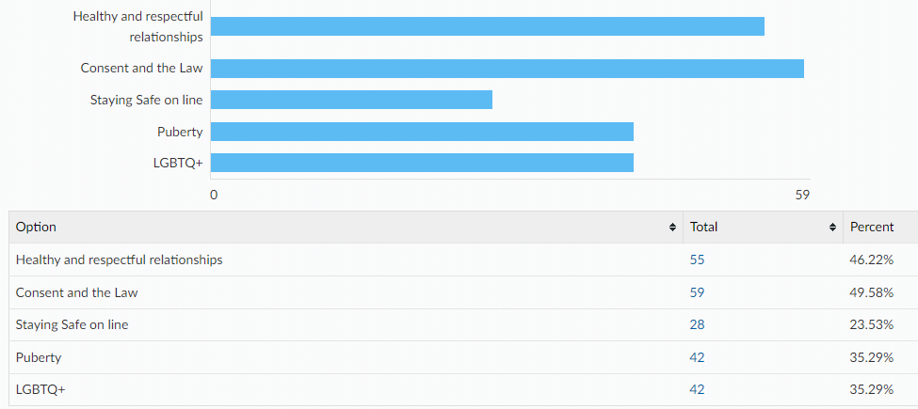
Other topics:
- Mental health
- Morgage, bills, loans and money
- Psychology and mental health issues
- Food
- Sex

Links to the following sexual health information and services can all be found on the Essex Youth Service website. Which of the following are you already aware of?
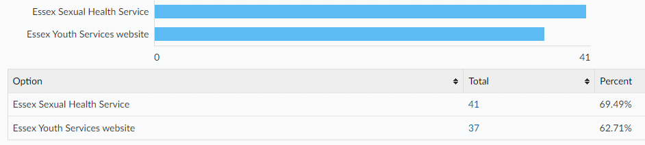

When being on the internet or social media have you ever felt...
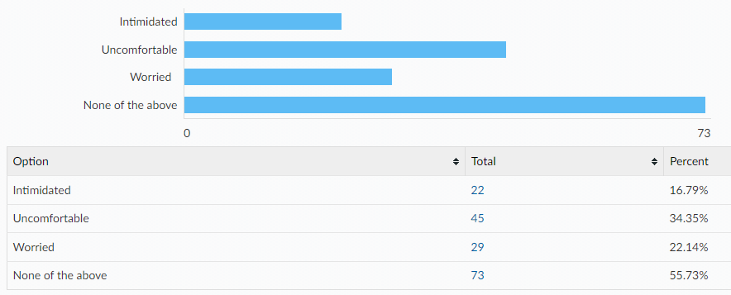
If you have felt intimidated, uncomfortable, worried…
Did you tell anyone?
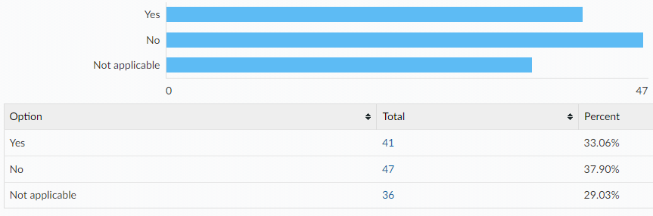
Did you know where to go for help?
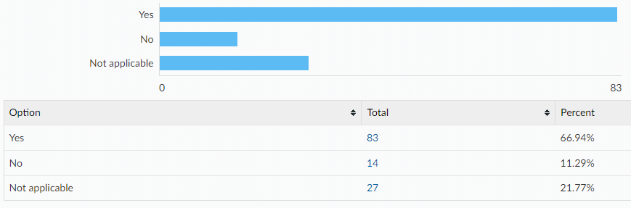

If you were to ever feel intimidated, uncomfortable or worried would you go to any of the following?
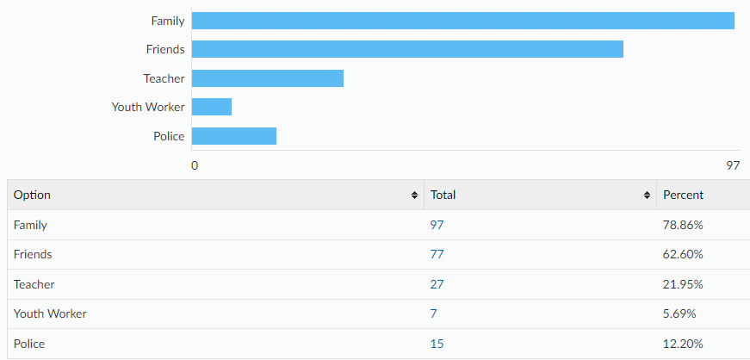
Would you tell an adult if you were asked to do something online that you were uncomfortable with? e.g. sending private pictures or joining an online private chat
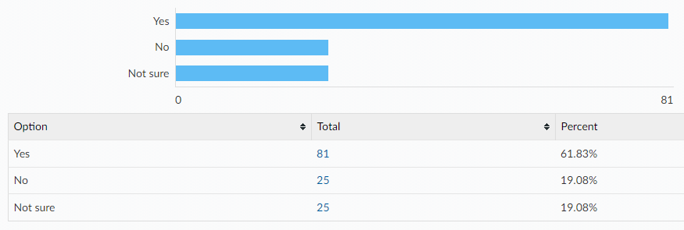
If no, what would be the reasons for not telling an adult?
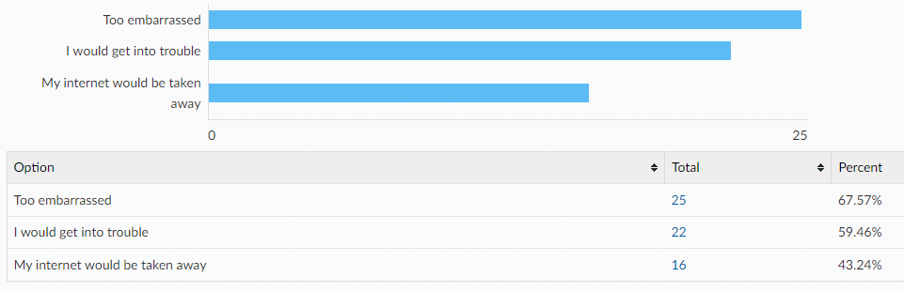

Something else:
- I wouldn't join
- Just would be a bit uncomfortable
- i’d be scared
- private matters that i am uncomfortable sharing with parents until they understand the situation
- I can deal with it myself
Year 10-11 [84 responses]
Where do you currently look for information on the following topics?
Topics | Top 3 places they’re most likely to look for information
Healthy and respectful relationships | - Friends/family (37%)  - Online/social media (19%)  - School (17%)  - 25% haven’t looked
Consent and the law | - School (52%)  - Online/social media (19%)  - Friends/family (7%)  - 19% haven’t looked
Staying safe online | - School (39%)  - Friends/family (23%)  - Online/social media (12%)  - 22% haven’t looked
Pornography | - School (17%)  - Online/social media (16%)  - Other (5%)  - 57% haven’t looked
Puberty | - School (38%)  - Friends/family (27%)  - Online/social media (8%)  - 23% haven’t looked
Masturbation | - Online/social media (12%)  - School (10%)  - Other (6%)  - 65% haven’t looked
Menstruation | - Friends/family (30%)  - School (29%)  - Online (5%)  - 33% haven’t looked
LGBTQ+ | - School (25%)  - Online/social media (25%)  - Friends/family (12%)  - 33% haven’t looked
STIs | - School (56%)  - Online/social media (10%)  - Friends/family and sexual health service (4%)  - 26% haven’t looked
HIV | - School (46%)  - Online/social media (8%)  - Friends/family (5%)  - 36% haven’t looked
Methods of contraception | - School (54%)  - Friends/family (11%)  - Online/social media (5%)  - 29% haven’t looked
How to access contraception | - School (35%)  - Friends/family (11%)  - Online/social media (7%)  - 42% haven’t looked
Steps to take after unprotected sex | - School (31%)  - Online/social media (8%)  - Friends/family (4%)  - 42% haven’t looked
Choices around pregnancy | - School (35%)  - Online/social media (13%)  - Friend/family (5%)  - 43% haven’t looked
In addition to RSE taught at school, which topics would you like to know more about?
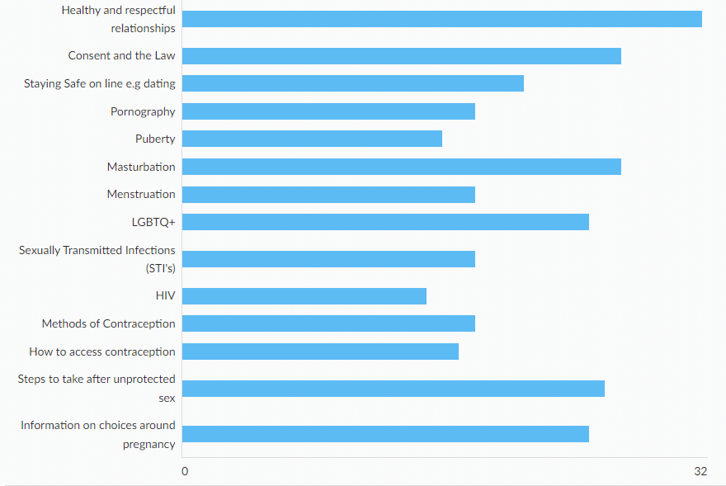
Other:
- Mental health
- How to talk to women
- I honestly don’t really care as I’m not going to do it this early on
Links to the following sexual health information and services can all be found on the Essex Youth Service website. Which of the following are you already aware of?
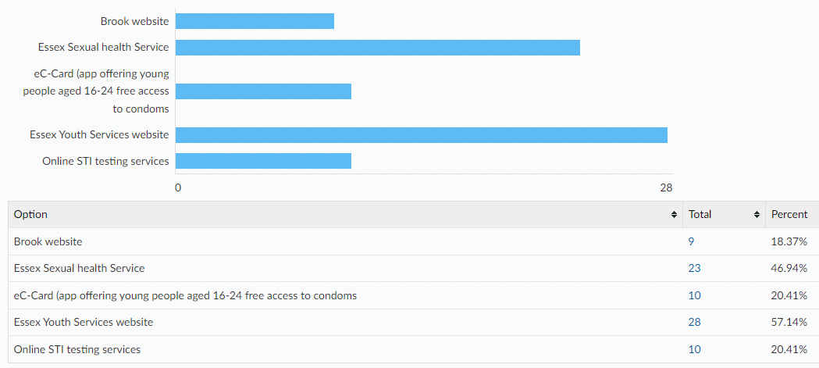

Condoms are the best way to prevent against sexually transmitted infections. There are a wide variety of other contraceptive methods designed to prevent pregnancy, some of which are listed below. All Young People have the right to information and support to allow informed choices on these methods. Please tick if you know how to access the following:

Please tell us where would you feel most comfortable going to access your chosen method of contraception?
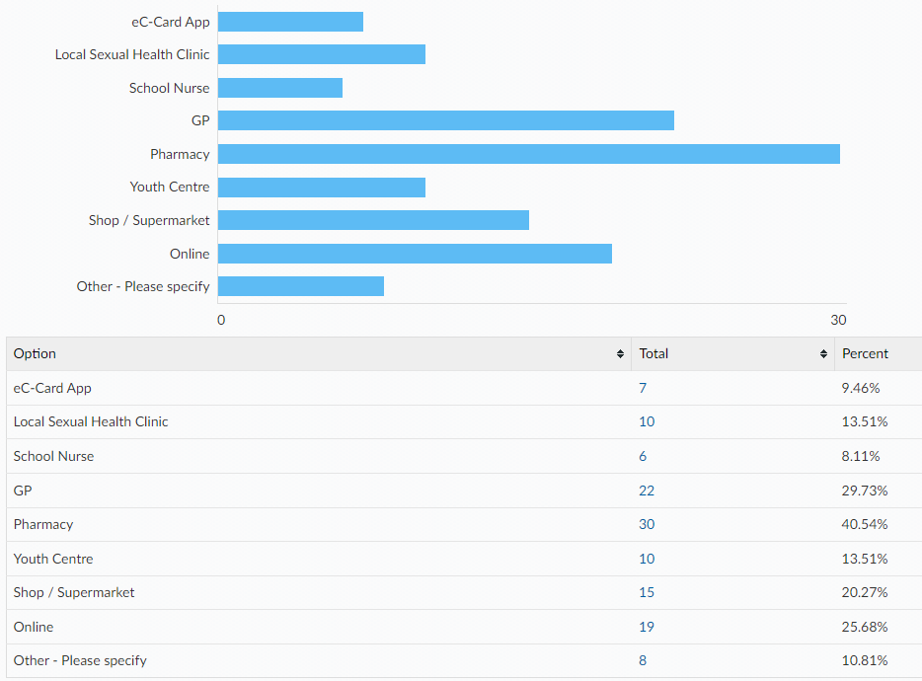
How confident do you feel that you would know how to access emergency contraception after unprotected sex (e.g. the 'morning after pill') for yourself or a partner?
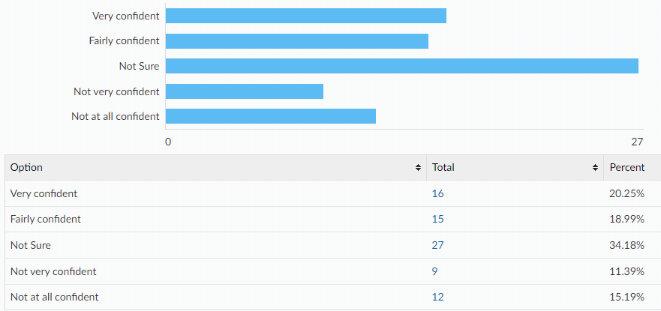

When being on the internet or social media have you ever felt...
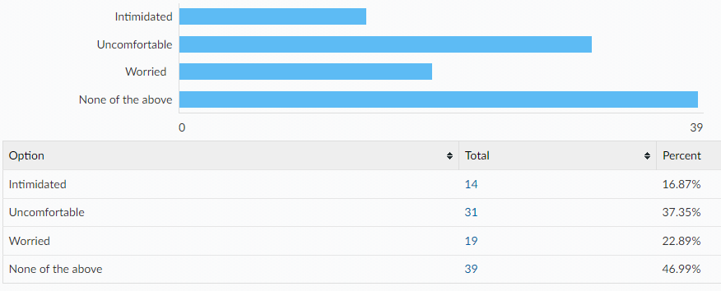
If you have felt intimidated, uncomfortable, worried…
Did you tell anyone?
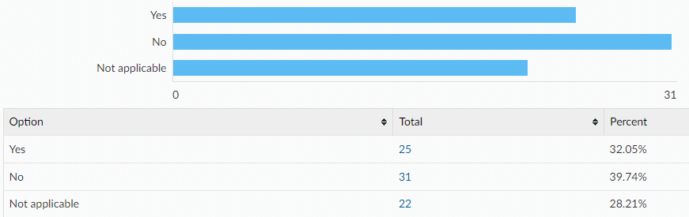
Did you know where to go for help?
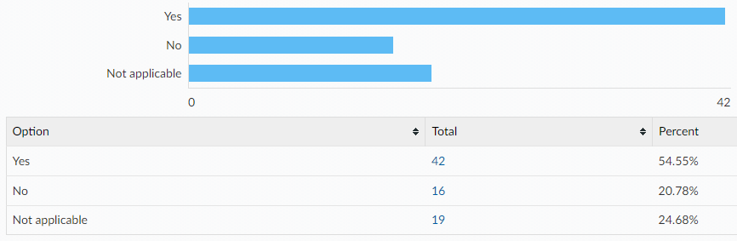
If you were to ever feel intimidated, uncomfortable or worried would you go to any of the following?
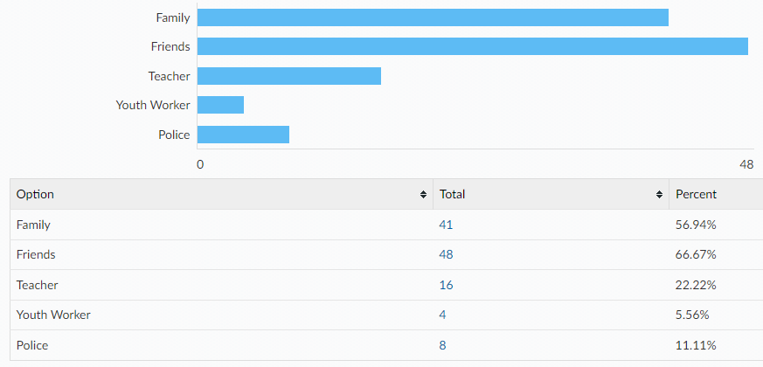

Would you tell an adult if you were asked to do something online that you were uncomfortable with? e.g. sending private pictures or joining an online private chat
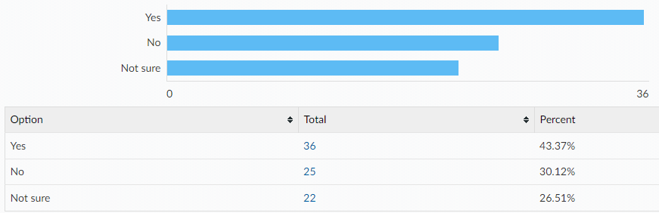

If no, what would be the reasons for not telling an adult? (please tick all that apply)
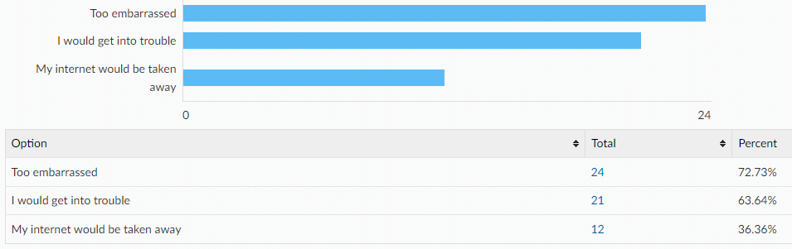
Other reasons:
- It’s not necessary to bring up in a conversation
- i don’t think adults need to be involved
- there is no need, I'll sort it out myself
- I just wouldnt listen to the person telling me to do that
- no need, i know what to do
- im responsible enough to deal with my own issues

All ages:
[A note to help interpret this data: The total column shows percentages for ALL respondents, with age breakdowns shown along each row. E.g. 98.70% of all respondents have a mobile phone, of which 56.09% are in year 7-9, 36.09% are year 10-11 and 6.52% are aged 17-25.]
Do you have any of the following?
A mobile phone with access to the internet
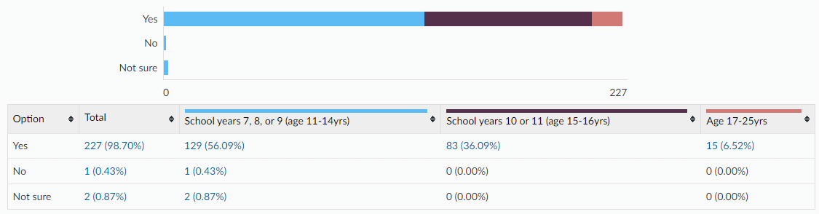
A Snapchat account
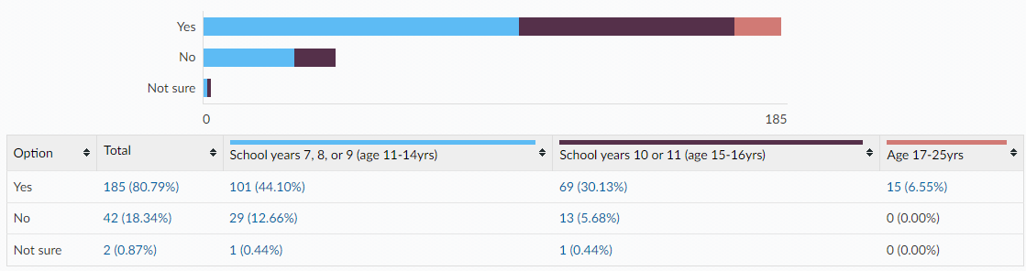
An Instagram account
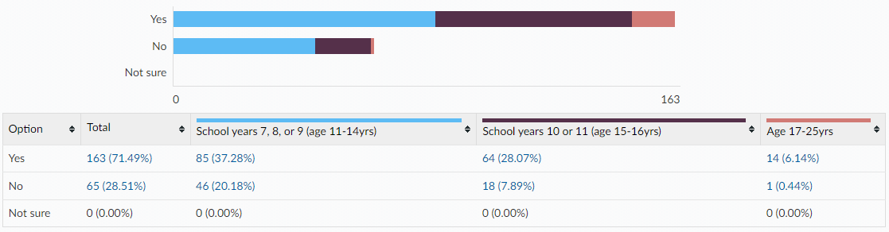
Tik Tok account
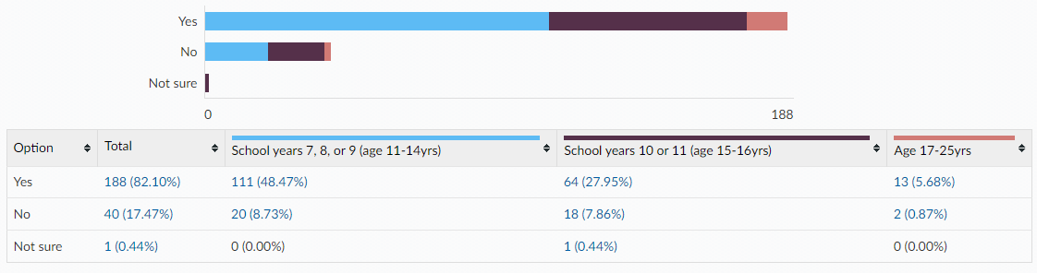
Twitch account
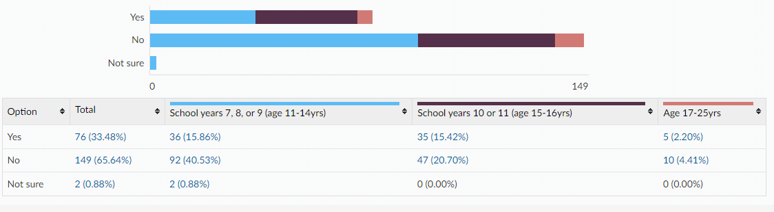
Engage in online gaming
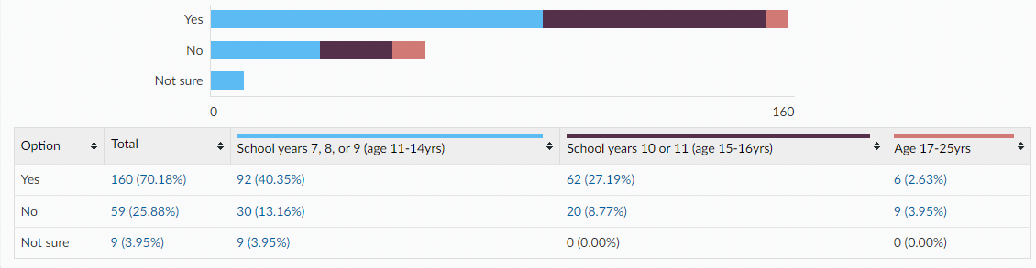

Is there anything else you would like to learn about or get support with around sex and relationships? (All ages)
- Why sex might not feel good for women (e.g., vaginismus etc.) or men.
- Sexual assault
- i just think all topics surrounding this should be looked at more within school cause then people won’t be as awkward to talk about it
- Learn more about sex and relationships(like bf and gf)
- stop teaching me LGBTQ
- How to actually have sex and talk to women
- About the consequences people have to live with when they do it too early or do it while drunk and so on, as it will then discourage a lot of people who are in my year from potentially doing so as soon as they get out of school.
- LGBTQ+ sex

This information is issued by:

Essex County Council
Research & Citizen Insight

Contact us:
research@essex.gov.uk
County Hall
Market Road
Chelmsford
CM1 1QH

Sign up to Keep Me Posted email updates:
Essex.gov.uk/keepmeposted
Twitter: Essex_CC
Facebook: Facebook.com/essexcountycouncil

Produced October 2022.

