Relationships & Sex Education Survey 2022 – responses for Basildon

278 responses were received for Basildon.
Gender:
- 55% female
- 41% male
- 1% non-binary/prefer to self-describe
- Remainder did not disclose
Age:
- 68% Year 7-9
- 28% Year 10-11
- 4% age 17-25 [this equates to 10 responses and therefore have not been included in this report as sample is too small to be meaningful – raw data is available]
[Please note some questions were ‘select all that apply’ so percentages do not always add up to 100%. This may also be the case where percentages have been rounded.]
Year 7-9 [189 responses]
Where do you currently look for information on the following topics?
Topics | Top 3 places they’re most likely to look for information
Healthy and respectful relationships | - Friends/family (54%)  - School (40%)  - Online/social media (13%)  - 26% haven’t looked
Consent and the law | - School (39%)  - Friends/family (34%)  - Online/social media (16%)  - 36% haven’t looked
Staying safe online | - School (74%)  - Friends/family (47%)  - Online/social media (17%)  - 9% haven’t looked
Puberty | - School (56%)  - Friends/family (54%)  - Online/social media (11%)  - 18% haven’t looked
Periods | - Friends/family (54%)  - School (43%)  - Online/social media (10%)  - 23% haven’t looked
LGBTQ+ | - School (40%)  - Friends/family (33%)  - Online/social media (19%)  - 36% haven’t looked
In addition to RSE taught at school, which topics would you like to know more about?
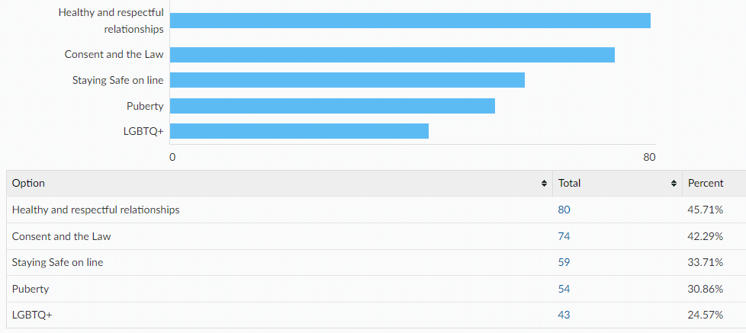
Links to the following sexual health information and services can all be found on the Essex Youth Service website. Which of the following are you already aware of?
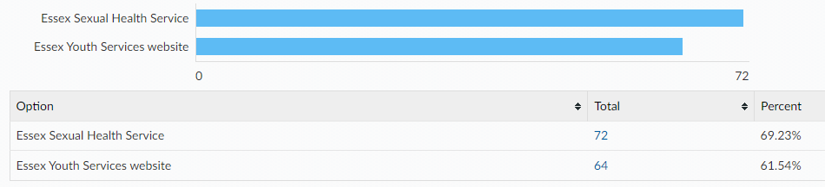
When being on the internet or social media have you ever felt...
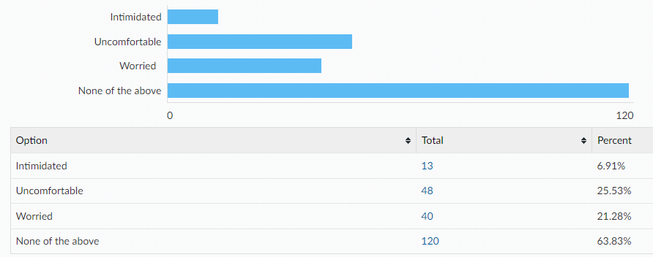
If you have felt intimidated, uncomfortable, worried…
Did you tell anyone?
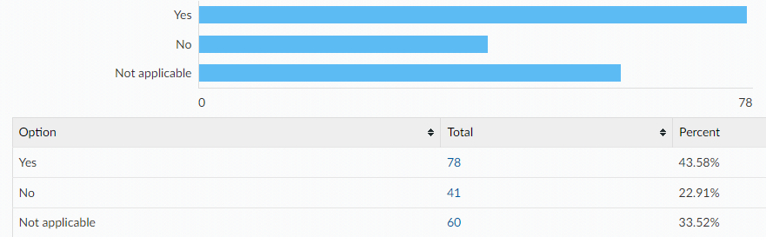
Did you know where to go for help?
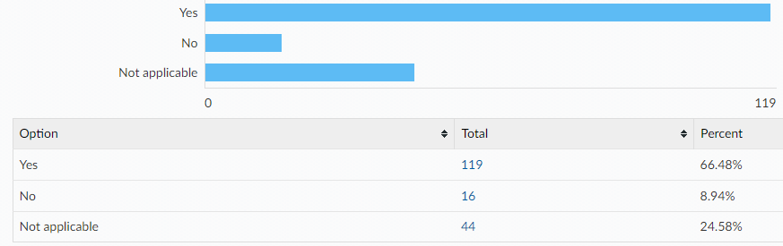
If you were to ever feel intimidated, uncomfortable or worried would you go to any of the following?
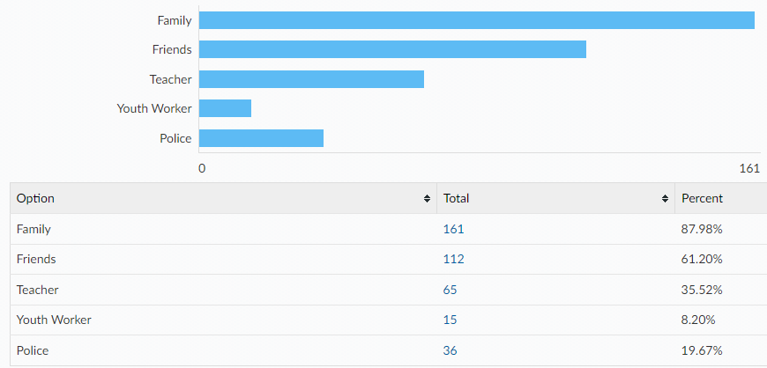

Would you tell an adult if you were asked to do something online that you were uncomfortable with? e.g. sending private pictures or joining an online private chat
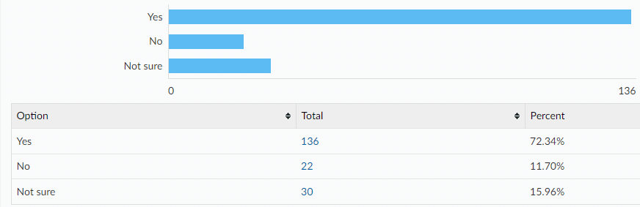
If no, what would be the reasons for not telling an adult?
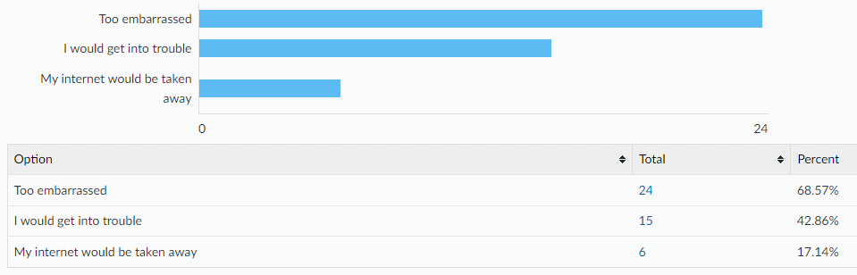
Something else:
- I would not join the group chat
- i don’t like them
- I would tell my friends instead
- Dont really bother me I would just ignore it
- I wouldn’t want to
- they wouldn't understand
- Don’t need to know
- Because i would just block them
- I would probably get called cringe by all my mates at school n by my parents
Year 10-11 [79 responses]
Where do you currently look for information on the following topics?
Topics | Top 3 places they’re most likely to look for information
Healthy and respectful relationships | - Friends/family (40%)  - School (18%)  - Online/social media (6%)  - 29% haven’t looked
Consent and the law | - School (41%)  - Online/social media (16%)  - Friends/family (16%)  - 18% haven’t looked
Staying safe online | - School (41%)  - Friends/family (21%)  - Online/social media (11%)  - 20% haven’t looked
Pornography | - Online/social media (17%)  - School (12%)  - Friends/family (8%)  - 55% haven’t looked
Puberty | - School (38%)  - Friends/family (29%)  - Online/social media (11%)  - 20% haven’t looked
Masturbation | - Online/social media (16%)  - Friends/family (12%)  - School (9%)  - 55% haven’t looked
Menstruation | - Friends/family (26%)  - School (21%)  - Online (5%)  - 41% haven’t looked
LGBTQ+ | - School (29%)  - Online/social media (17%)  - Friends/family (13%)  - 34% haven’t looked
STIs | - School (55%)  - Online/social media (7%)  - Friends/family, GP, youth workers (3%)  - 28% haven’t looked
HIV | - School (47%)  - Online/social media (8%)  - GP (5%)  - 33% haven’t looked
Methods of contraception | - School (49%)  - Friends/family (7%)  - Online/social media (5%)  - 28% haven’t looked
How to access contraception | - School (40%)  - Friends/family (8%)  - GP/other (5%)  - 35% haven’t looked
Steps to take after unprotected sex | - School (44%)  - Online/social media (9%)  - Other (4%)  - 34% haven’t looked
Choices around pregnancy | - School (36%)  - Friend/family (14%)  - Online/social media (6%)  - 34% haven’t looked
In addition to RSE taught at school, which topics would you like to know more about?
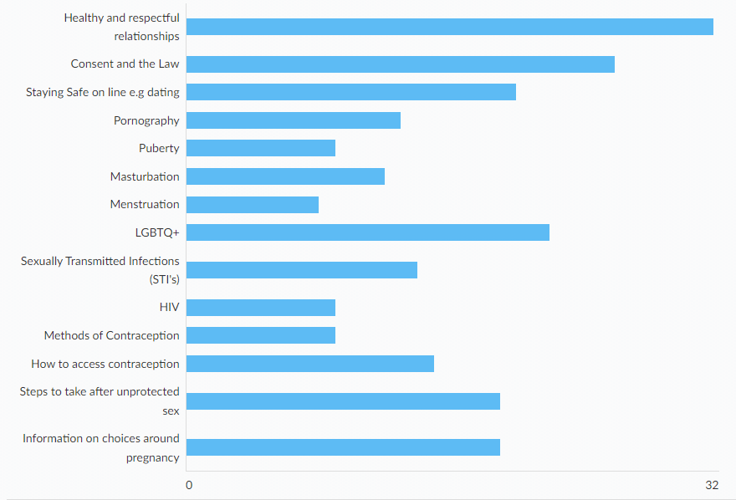
Other:
- Toxic masculinity and femininity when it comes to ‘virginity’
- Racism
Links to the following sexual health information and services can all be found on the Essex Youth Service website. Which of the following are you already aware of?
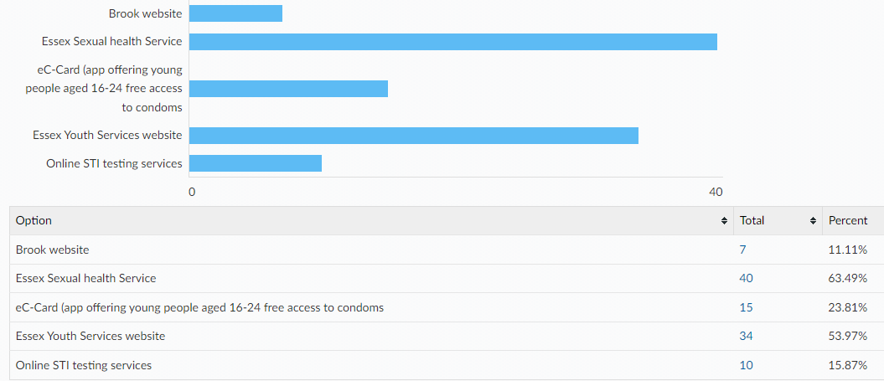

Condoms are the best way to prevent against sexually transmitted infections. There are a wide variety of other contraceptive methods designed to prevent pregnancy, some of which are listed below. All Young People have the right to information and support to allow informed choices on these methods. Please tick if you know how to access the following:

Comments:
- Many young people my age don’t feel comfortable or know if they are allowed to get/buy condoms and where to buy them, so they practise unprotected sex

Please tell us where would you feel most comfortable going to access your chosen method of contraception?
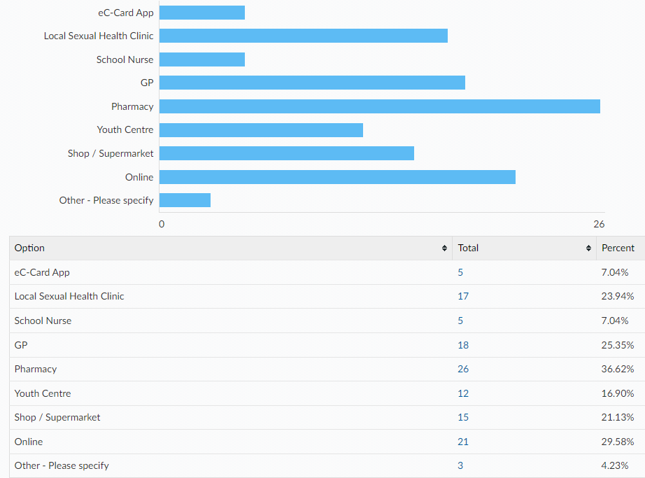
How confident do you feel that you would know how to access emergency contraception after unprotected sex (e.g. the 'morning after pill') for yourself or a partner?
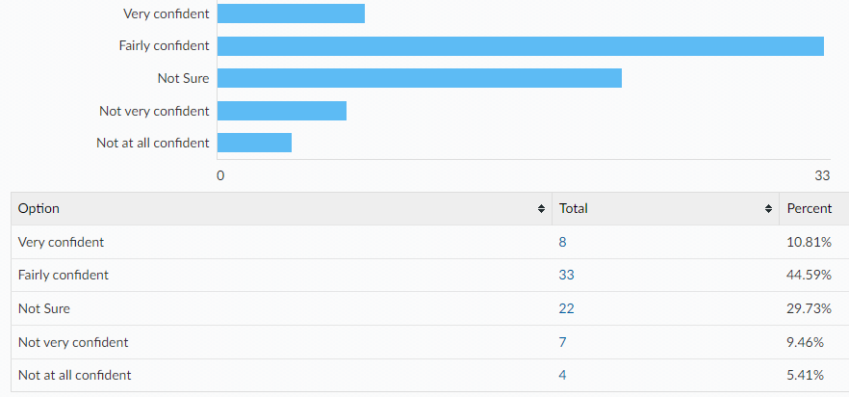
When being on the internet or social media have you ever felt...
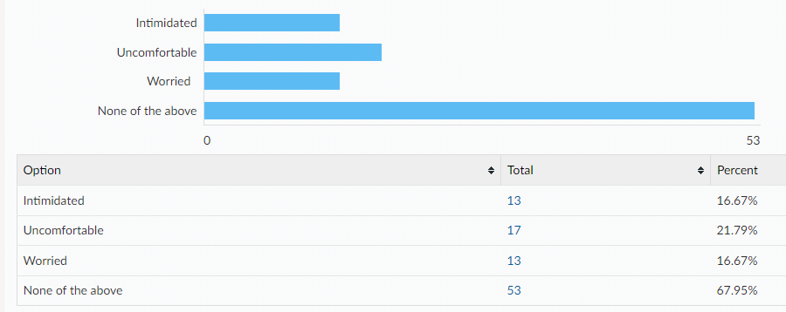
If you have felt intimidated, uncomfortable, worried…
Did you tell anyone?
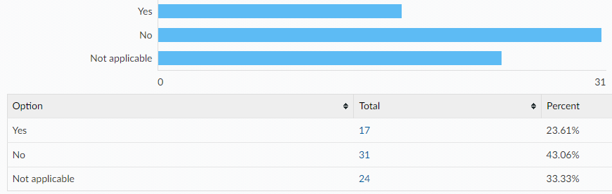
Did you know where to go for help?
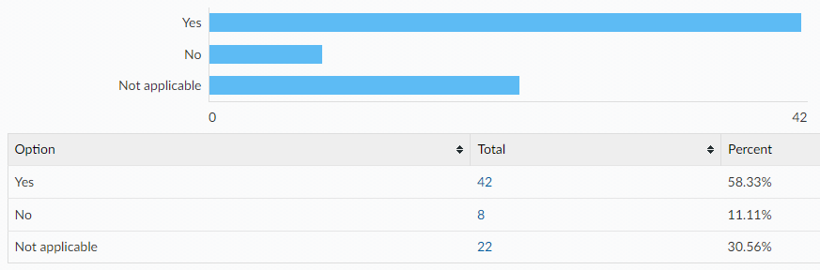

If you were to ever feel intimidated, uncomfortable or worried would you go to any of the following?
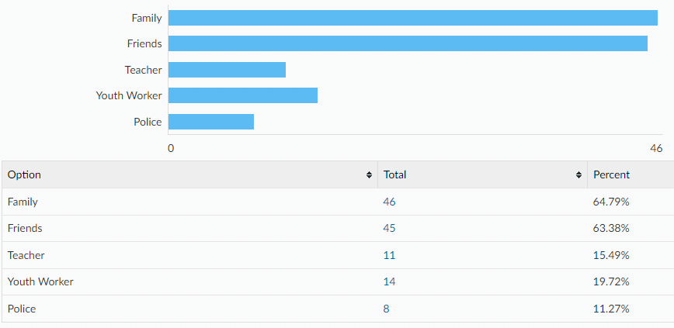
Would you tell an adult if you were asked to do something online that you were uncomfortable with? e.g. sending private pictures or joining an online private chat
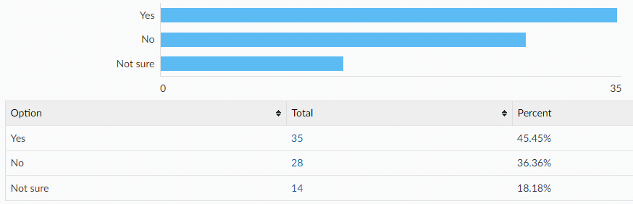
If no, what would be the reasons for not telling an adult? (please tick all that apply)
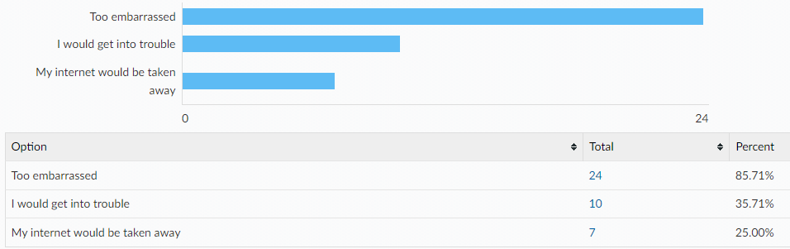

Other reasons:
- I don’t care
- My dad would tell me to block them
- I wouldn't be bothered
- They might blackmale me or they might know my address and kill me or hurt me If I tell someone and they find out about it
- It always happens so its not that deep anymore
- I would
- Pointless
- not that important as i would ignore it and move on.
All ages:
[A note to help interpret this data: The total column shows percentages for ALL respondents, with age breakdowns shown along each row. E.g. 98.13% of all respondents have a mobile phone, of which 70.52% are in year 7-9 and 27.61% are year 10-11.]
Do you have any of the following?
A mobile phone with access to the internet
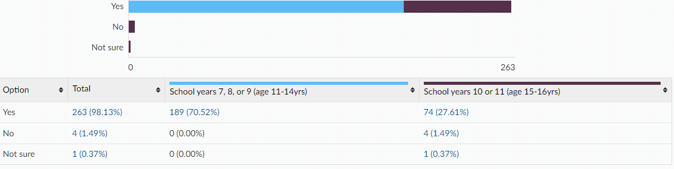
A Snapchat account
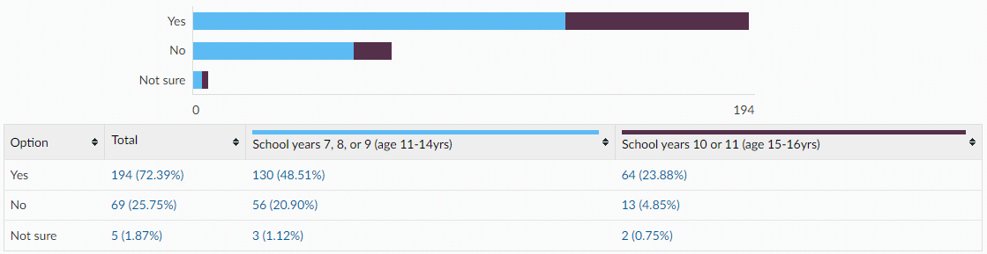
An Instagram account
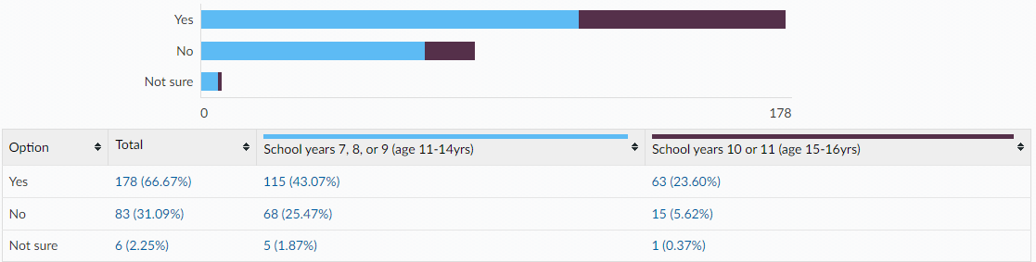
Tik Tok account
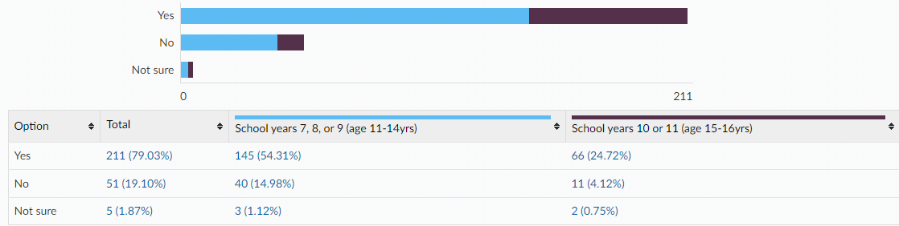
Twitch account
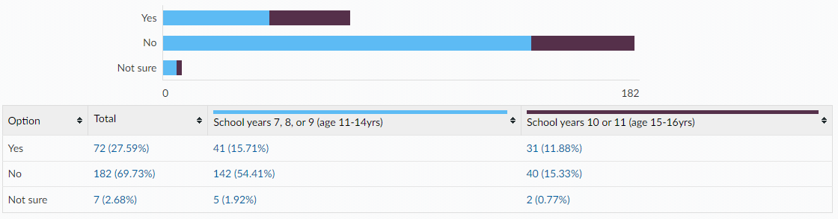
Engage in online gaming
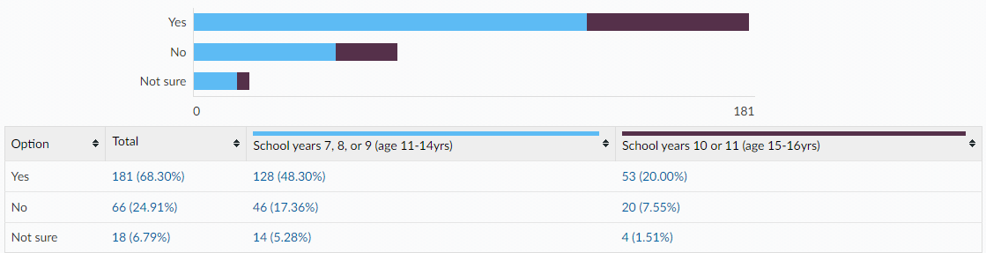
Is there anything else you would like to learn about or get support with around sex and relationships? (All ages)
- Lgbtq+ Sex
- Learn more about LGBTQ, access on websites and ins schools they need to be updated with more training for staff
- I would like to know which age you can have sex and what age is appropriate to have a healthy relationship
- How to make a healthy relationship.
- I think there needs to be more education around LGBTQ+ people and relationships because homophobia, transphobia, etc. is way too common in schools and teachers don't care

This information is issued by:

Essex County Council
Research & Citizen Insight

Contact us:
research@essex.gov.uk
County Hall
Market Road
Chelmsford
CM1 1QH

Sign up to Keep Me Posted email updates:
Essex.gov.uk/keepmeposted
Twitter: Essex_CC
Facebook: Facebook.com/essexcountycouncil

Produced October 2022.

