Local Cycling and Walking Infrastructure Plan Proposals for
Basildon, Braintree, Chelmsford & Colchester

March 2021

Contents
Introduction……………………………………… 3
Background……………………………………… 5
Developing the LCWIPS………………….……. 6
Stage 1: Determining the Scope………... 6
Stage 2: Gathering Information…………. 6
Stage 3: Network Planning for Cycling... 6
Stage 4: Network Planning for Walking., 6
Stage 5: Prioritisation Process…………. 19
Stage 6: Integration…………...………… 19
Next Steps……………………………………….. 20

Introduction
This document is a summary of key proposals to develop local cycling and walking networks in Basildon, Braintree, Chelmsford and Colchester for consultation. The networks are part of the Local Cycling and Walking Infrastructure Plans (LCWIPs).
- At this stage we are only asking your views on the shape and extent of walking and cycling network of routes, not on specific infrastructure enhancements to improve safety and make it easier to walk or cycle.
- There will be a further stage of consultation on specific schemes which will follow in early summer 2021. This stage of consultation is called Active Travel Fund (ATF) consultation.
- We are really keen to hear your views on these proposed networks. We want to know if you think they are broadly correct. Are there any gaps or routes which you consider should be extended?
Details of the proposed walking and cycling networks for Basildon, Braintree, Chelmsford and Colchester are included in this document Stage 3 Cycling and Stage 4 Walking.
This LCWIP consultation should be seen as the first stage of a process to implement LCWIPs by Essex County Council. They ensure that a long-term approach can be taken to develop local cycling and walking networks, ideally over the next 10-year period, and form a vital part of the Government’s strategy to increase the number of trips made on foot or by cycle.

What is an LCWIP?
One of the aims of the Essex County Council “Safer Greener Healthier” campaign is to encourage residents to rethink the way they travel, where possible and especially for shorter journeys. The Local Cycling and Walking Infrastructure Plans (LCWIPs) are a significant first step in achieving this. Implementing the plans will help relieve congestion, reduce vehicle emissions and improve both our physical and mental health.
The plans will see the introduction of new walking and cycling networks rolled out over the next ten years, initially in Basildon, Braintree, Chelmsford, and Colchester, making it easier and safer for people to walk or cycle on our streets.
Key outputs of the LCWIPs include:
- a network plan for walking and cycling which identifies preferred routes and core zones for further development.
- a prioritised programme of infrastructure improvements for future investment; and
- a report which sets out the underlying analysis carried out and provides a narrative which supports the identified improvements and network.

The development of each of the LCWIPs consisted of the following six key stages:
This document summarises each stage of the LCWIPs to date. We are currently at Stage 6 and will finalise the plan after public and stakeholder consultation closes in spring 2021.

Background
The Government has encouraged local authorities to develop Local Cycling and Walking Infrastructure Plans (LCWIPs) based on a methodology set out by the Department for Transport (DfT). LCWIPs are designed to create cycling and walking networks which will deliver streetscape enhancements. These enhancements will improve health and wellbeing as well as reduce congestion and improve air quality. Walking and cycling are both an important means of travel and have associated health benefits such as improved fitness, mental health and lower risk of obesity and heart diseases.

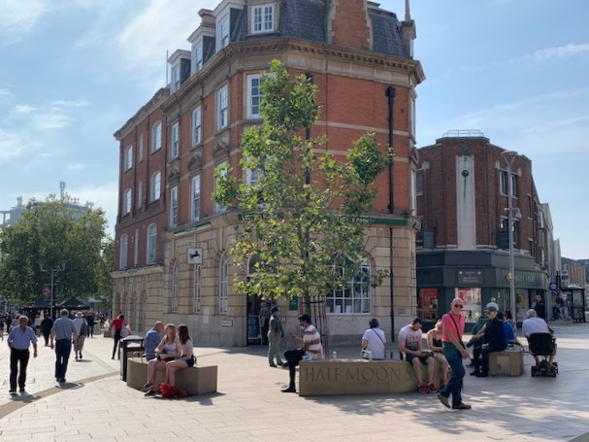

Essex’s vision
Essex County Council’s vision is for a transport system that supports sustainable economic growth as well as delivering the best quality of life for its residents.
Essex is growing and will need to accommodate new homes, the greatest projected increases are in Colchester, Basildon and Chelmsford. Approximately 180,000 additional homes are estimated to be needed across Greater Essex in the next 20 years.
Against this background of population increases and the associated need for more housing, it is essential that this growth is accommodated sustainably. Every effort must be made to ensure that safe and attractive walking and cycling routes are designed for existing communities as well as for new ones.

Developing the LCWIPS

Stage 1: Determining the Scope
The LCWIPs initially focus on the areas of Basildon, Braintree, Chelmsford and Colchester. These areas are experiencing significant growth pressures and therefore prioritising the development of good walking and cycling networks is an excellent way of ensuring new housing and commercial developments provide good walking and cycling infrastructure which enables trips into a wider active travel network.

Stage 2: Gathering Information
Data was gathered which included key destinations including schools and colleges, high streets, supermarkets, leisure centres, and doctors’ surgeries.
The emphasis was not only on end-to-end journeys, but also on identifying the stages of typical journeys to enable the shorter legs of multi-stage journeys to be undertaken sustainably. There are many opportunities to do this through improved walking environments to reach bus or rail interchanges as well as improving cycle networks to reach destinations within 2-5km.
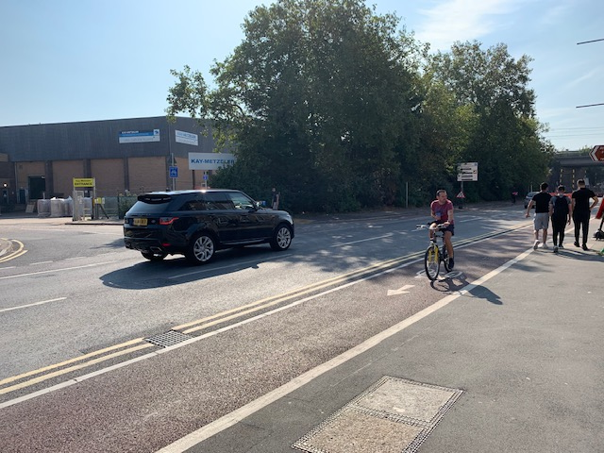

Stage 3: Network Planning for Cycling
In order to identify cycling routes, origin and destination points and cycle flows were analysed and converted into a network of cycle routes which showed the highest demand (both existing and potential). This allowed further consideration to be made to the type of cycle infrastructure which could be implemented. A number of tools were used including the Propensity to Cycle Tool (PCT) to help estimate future demand in line with Essex’ ambition to double the levels of cycle trips by 2025.
The LCWIP proposed routes for the Basildon, Braintree, Colchester and Chelmsford cycle networks are shown below:

Basildon Proposed LCWIP Cycle Network Map and Routes

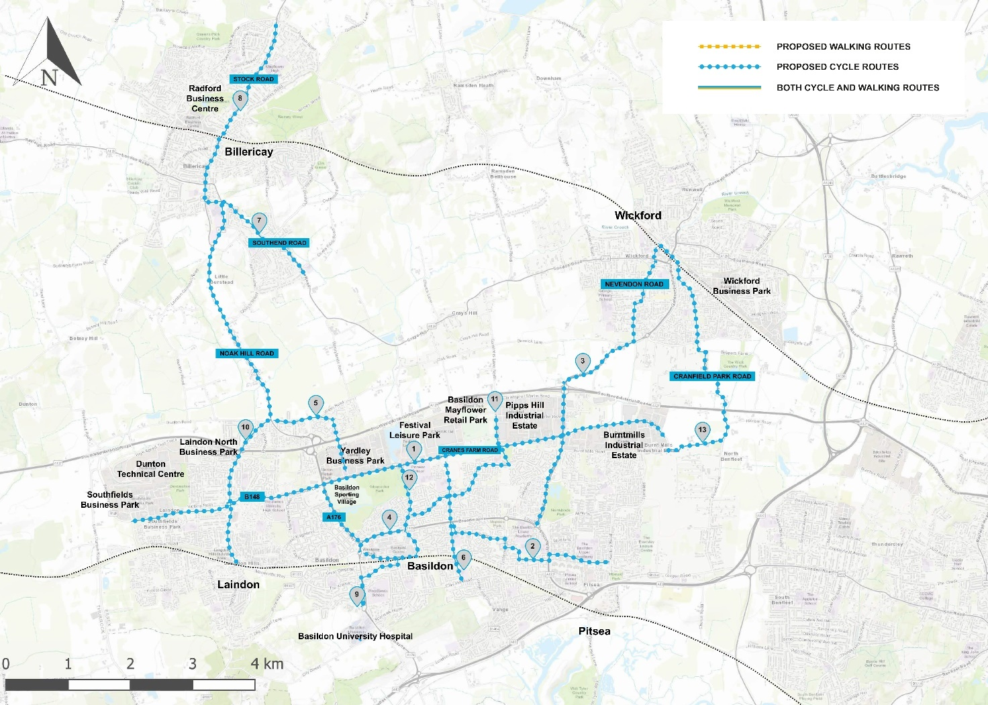
Basildon Proposed LCWIP Cycle Network Map
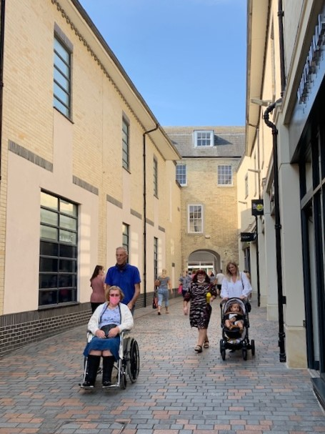
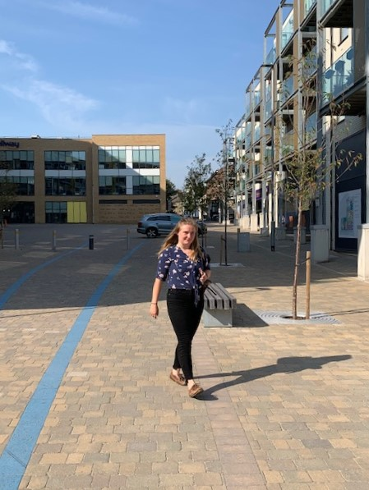
Scheme | Route | Route Description
Cycle Route 1 | Basildon East-West Link | Route 1 links West Mayne and Burnt Mills Industrial Estate along the A1235.
Cycle Route 2 | Basildon to Pitsea | Route 2 predominantly serves residential areas and education facilities including The Basildon Lower Academy and Basildon Upper Academy. The route would connect a new corridor on Church Road supporting further journeys to Festival Park.
Cycle Route 3 | Wickford to Basildon | Route 3 connects Wickford town centre and residential areas off Nevendon Road with Burnt Mills Estate and eastern areas of Basildon. The route intersects the key east-west connection through Basildon.
Cycle Route 4 | Central Basildon Ring | Route 4 consists of an orbital route around the town centre area.
Cycle Route 5 | Billericay to Basildon | Route 5 is a strategic corridor extending from Billericay to Basildon town centre, supporting commuter trips from Billericay to Pipps Hill Industrial Estate, as well as onward journeys into Central London from Basildon railway station, a cheaper option than from Billericay.
Cycle Route 6 | Basildon North-South | This route serves residential areas and schools on Church Road, connection to Cranes Farm Road in the North and Clay Hill Road in the South.
Cycle Route 7 | South East Billericay | Route 7 extends from Laindon Road at the northern extent along School Road to St Peter’s Catholic Primary School via Southend Road.
Cycle Route 8 | Billericay North-South | Route 8 is a key connection between Billericay town centre, the railway station and residential developments, existing and future in the north of the town. The route also serves education facilities including Mayflower High School.
Cycle Route 9 | Basildon Station to Basildon Hospital | Route 9 is a key connection from Southernhay to the University Hospital of Basildon. The route extends from Route 4 on Southernhay connecting to the hospital via Cherrydown Way and Nethermayne using an existing pedestrian bridge.
Cycle Route 10 | Laindon North-South | Route 10 provides a link between Laindon Railway station in the south, through residential areas off High Road. The route provides an onward connection to the proposed cycle route to Billericay.
Cycle Route 11 | Central Basildon to Gardiners Way | Route 11 extends from the outskirts of Basildon town centre to Pipps Hill Industrial estate, serving residential areas on Whitmore Way.
Cycle Route 12 | Central Basildon to Festival Park Leisure Centre | Cycle Route 12 runs on Ghyllgrove between Cranes Farm Road and Broadmayne, connecting to two additional cycle routes.
Cycle Route 13 | Wickford to Burnt Mills Industrial Estate | This is an alternative route between Wickford and Basildon, connecting residential areas in South Wickford to Wickford railway station in the north and Burnt Mills Industrial Estate in the south.
Basildon Proposed LCWIP Cycle Network Routes

Braintree Proposed LCWIP Cycle Network Map and Routes
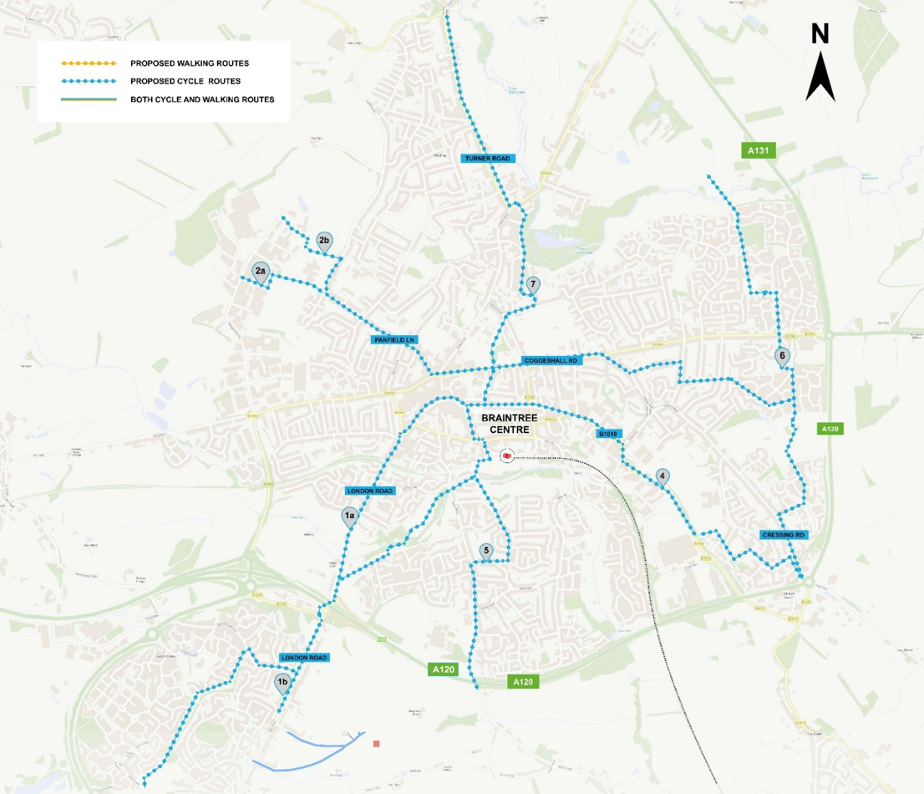
Braintree Proposed LCWIP Cycle Network Map

Scheme | Route | Route Description
Cycle Route 1a | Great Notley to Town Centre | Route 1a. Linking Great Notley to Braintree Town centre via London Road.
Cycle Route 1b | Great Notley to Town Centre | Route 1b. Linking Great Notley to Braintree Town centre and train station via Tortoiseshell Way.
Cycle Route 2a | East Braintree to Springwood Industrial Estate | This cycle route incorporates a link to the Springwood Industrial Area.
Cycle Route 2b | Galley’s Corner to Town Centre | This cycle route goes through Springwood Industrial Area.
Cycle Route 4 | Notley High School to Town Centre | This cycle route plans to link the industrial and housing areas, as well as Braintree Freeport.
Cycle Route 5 | Straights Mill to Galley’s Corner | Includes a transformational development to Notley Road.
Cycle Route 6 | Church Lane Bocking to Braintree Town Centre | An attractive river crossing could be built to unlock the path that continues to a new housing development at Straits Mill, as well as providing convenient links to the business area and Freeport.

Chelmsford Proposed LCWIP Cycle Network Map and Routes

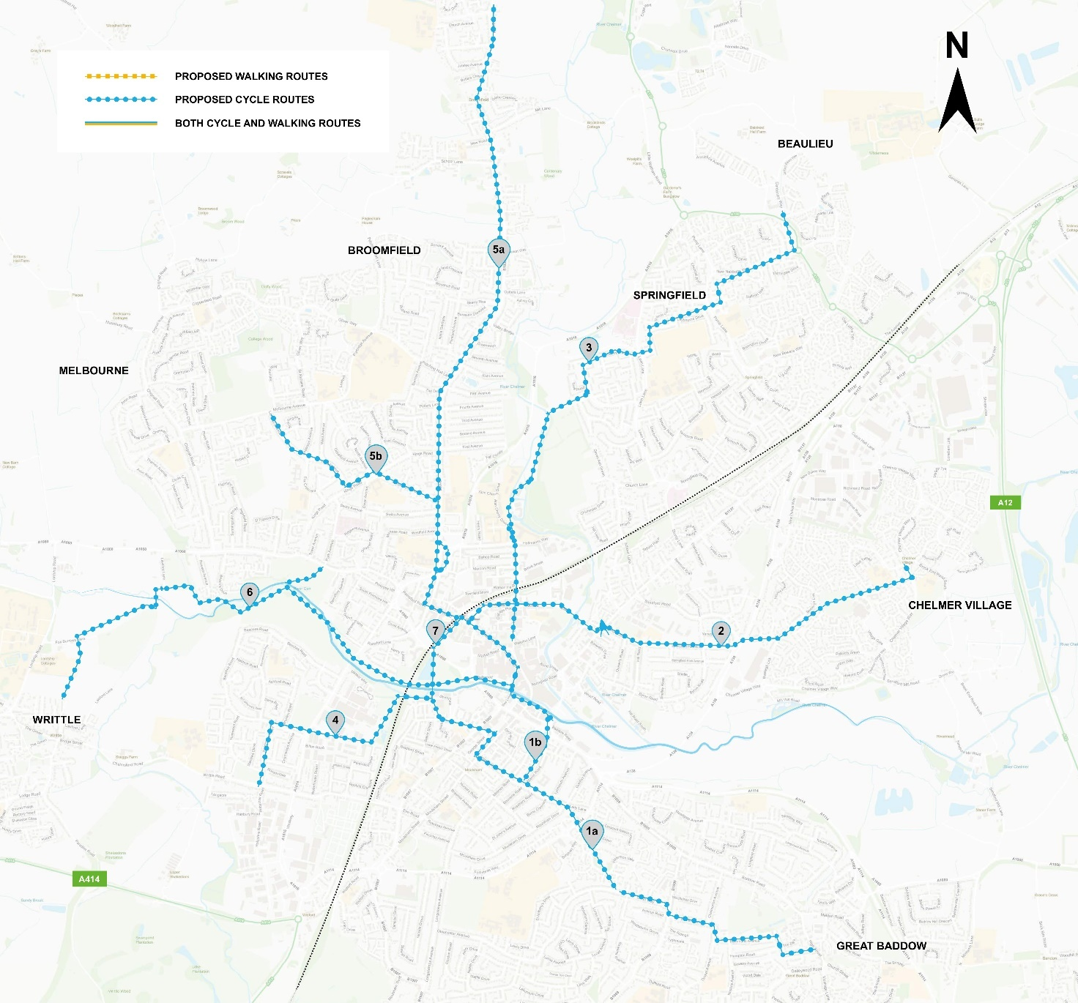
Chelmsford Proposed LCWIP Cycle Network Map

Scheme | Route | Route Description
Cycle Route 1a | Great Baddow to City Centre (Parkway) | Linking Great Baddow with the city centre, this route will create a sustainable transport corridor incorporating: Moulsham St shopping, Central Park and links to the train station.
Cycle Route 1b | Great Baddow to City Centre (Odeon Roundabout) | This route creates another sustainable transport corridor to the city centre, including improvements at the Odeon roundabout to complete this convenient route.
Cycle Route 2 | Chelmer Village to City Centre | Another sustainable transport corridor from Chelmer Village, with plans to reallocate road space on Victoria Road to New Street, creating a safer, more sustainable route to the city centre.
Cycle Route 3 | Beaulieu Park to City Centre via Springfield | With improved connectivity to Beaulieu Park and Park and Ride this route will also enhance routes from the University to the city centre.
Cycle Route 4 | Writtle Road to City Centre via Forest Drive and Central Park | This route provides an important link between Writtle Road and central park, the railway station and the city centre.
Cycle Route 5a | Broomfield Road to City Centre | Route 5a provides a strategic link along Broomfield Road linking a number of key trip attractors and generators including the city centre, schools and Broomfield hospital.
Cycle Route 5b | Melbourne to City Centre via Broomfield Road | This route will provide an important link between Melbourne and Route 5 which in turn links to the city centre via Broomfield Road.
Cycle Route 6 | Writtle to City Centre via Central Park | This existing route providing an off-road route connecting Writtle to Chelmsford City Centre via Admirals park will be improved.
Cycle Route 7 | City Centre Orbital | This route provides an opportunity to create a City Centre Orbital which will also create safe and attractive cycling and permeability across the city centre.
Chelmsford Proposed LCWIP Cycle Network Routes

Colchester Proposed LCWIP Cycle Network Map and Routes
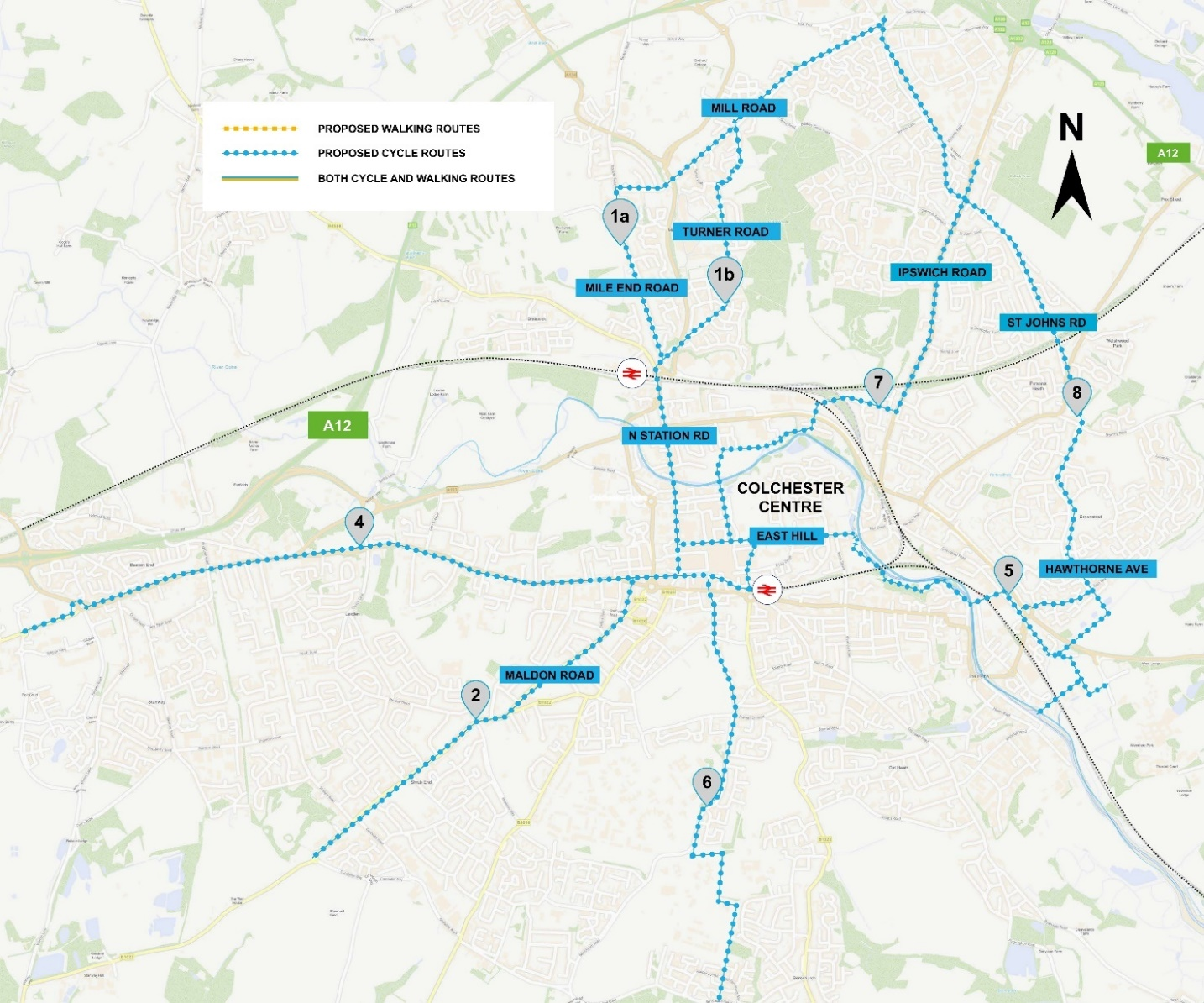
Colchester Proposed LCWIP Cycle Network Map
Scheme | Route | Route Description
Cycle Route 1a | Severalls Business Park to Town Centre via Mile End | This cycle route has links to Walking Route One and will reconfigure Albert Road Roundabout then develop North Station Roundabout to incorporate a healthy route.
Cycle Route 1b | Severalls Business Park to Town Centre via Hospital | This route is a key connection for people travelling between the town centre, business park and the Hospital.
Cycle Route 2 | Shrub End and Colchester Town centre | Cycle Route 2. With the following description: Cycle Route 2 provides connectivity between Shrub End and Colchester Town centre via Maldon Road.
Cycle Route 3 | Lexden Road | This route conveniently links a large residential area to the town centre within a cyclable journey
Cycle Route 4 | University of Essex to Town | Route 4 is an important link between the University, Knowledge centre, Hythe Station and the town.
Cycle Route 5 | The Garrison to Colchester Town Centre | Route 5 is an important North South route linking the Garrison and surrounding residential areas to the town centre including an improved crossing of Southway.
Cycle Route 6 | Severalls Business Park to Town Centre via Ipswich Road | Route 6 will provide connectivity between Ipswich Road and the surrounding residential areas with Castle Park and the town centre.
Cycle Route 7 | Severalls Business Park to University of Essex via Hythe Station | Route 7 will look to provide and key north south route linking Severalls Business Park with the University while at the same time providing a critical route through Greenstead.
Cycle Route 8 | Colchester Town Centre Orbital | Route 8 provides an opportunity to create a town Centre Orbital which will also create safe and attractive cycling and permeability across the town centre.
Colchester Proposed LCWIP Cycle Network Routes

Stage 4: Network Planning for Walking
Waking is often the most convenient way of accessing local neighbourhoods, town and city centres, local high streets and key destinations.
The LCWIP process presented an excellent opportunity to use the guidance and tools to develop a walking network which identified walking routes that linked key origins and destinations with greater coherence and directness.
Below are the LCWIP walking network proposed routes for Basildon, Braintree, Chelmsford and Colchester:

Basildon LCWIP Walking Network Map and Routes
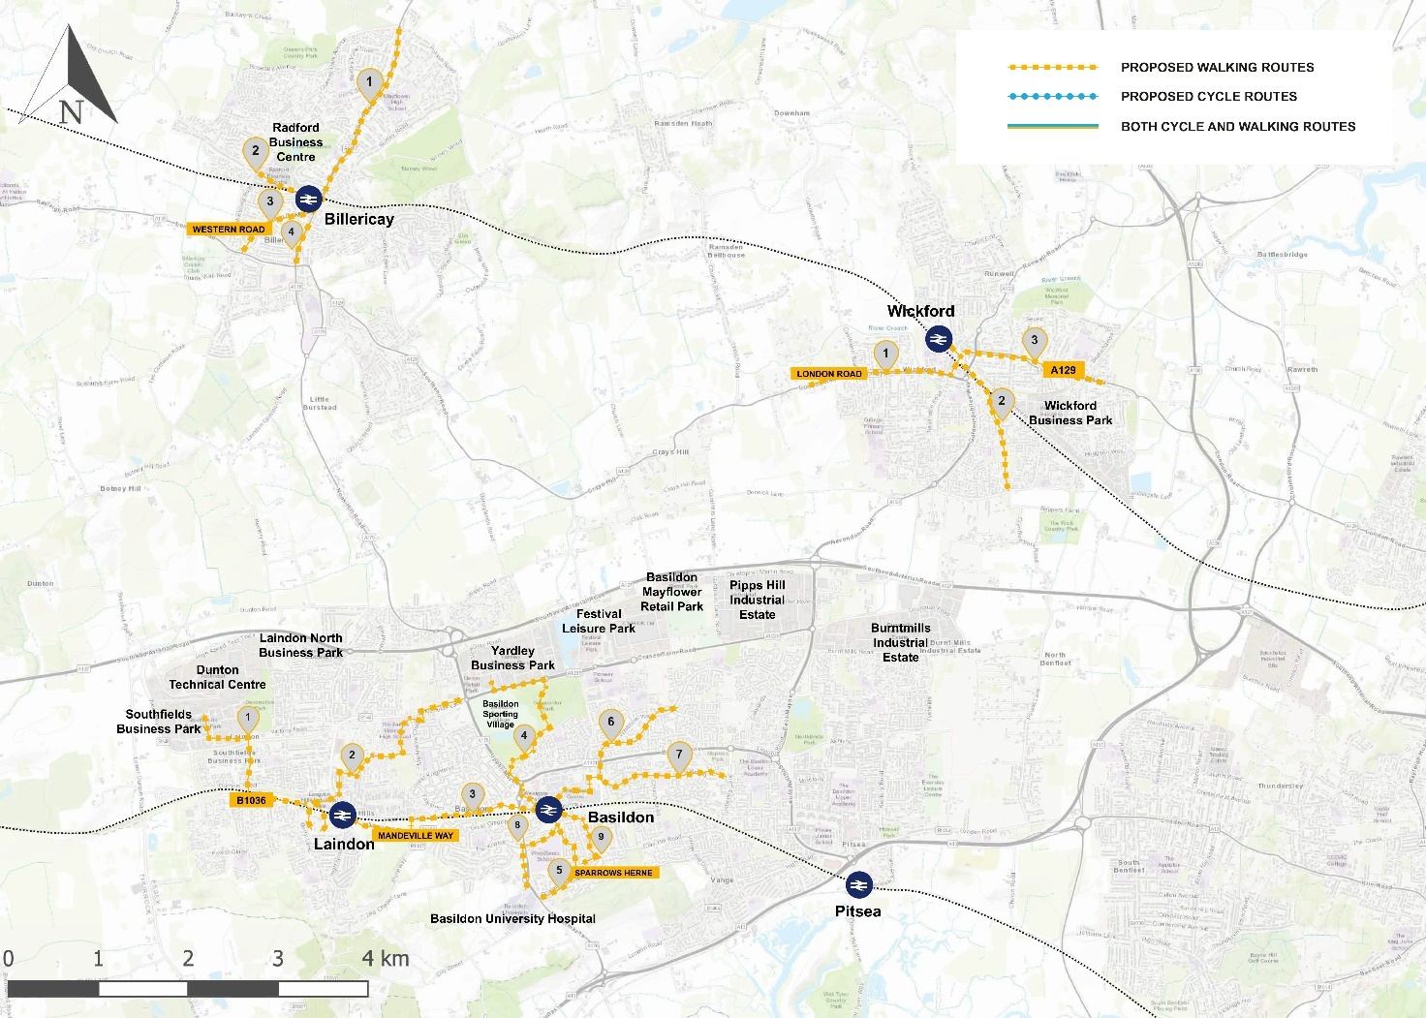Basildon LCWIP Walking Network Map
Scheme | Route | Route Description
Walking Route 1 | Laindon Station North-Eastern Link | This route from Laindon Railway Station provides links to employment areas towards Dunton Mills.
Walking Route 2 | Laindon Station North-Western Link | This route extends from Laindon Railway station towards employment and retail areas north of Basildon.
Walking Route 3 | Laindon Station to Basildon Station | This route connects Laindon Rail Station to Basildon Rail Station, running along the railway line.
Walking Route 4 | Basildon Station to Gloucester Park | Basildon Route 4 connects Basildon Railway Station to the employment and retail areas north of Gloucester Park.
Walking Route 5 | Basildon Station to Basildon Hospital Route | This route is a key connection between the railway station and the Hospital.
Walking Route 6 | Basildon Station North-Western Link | This route extends through Basildon town centre to residential areas in the north west of Basildon.
Walking Route 7 | Basildon Town Centre Eastern Link | Basildon Route 7 is an east west connection between Basildon Town Centre to Timberlog Lane, via Long Riding.
Walking Route 8 | Basildon Station to Basildon Hospital Route B | Route 8 provides an addition route between Basildon Railway station and the University Hospital.
Walking Route 9 | Basildon Station Southern Link | Basildon Route 9 serves walking trips between the railway station and residential areas in the south of the town centre, including two schools.
Basildon LCWIP Walking Network Key Routes

Braintree LCWIP Walking Network Map and Routes

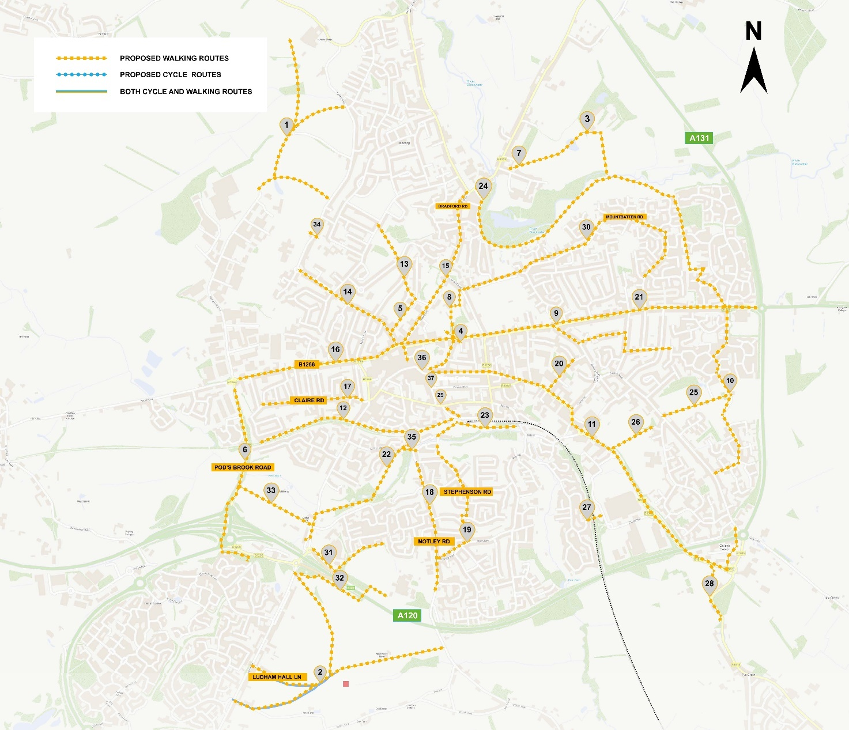
Braintree LCWIP Walking Network Map

Scheme | Route | Route Description
Walking Route 1 | North-West Braintree | Panfield Lane to Springwood Drive.
Walking Route 2 | Great Notley | Notley Road Growth Area to London Road.
Walking Route 3 | Straights Mill | Straights Mill Growth Area to Covent Lane.
Walking Route 4 | Weavers Park | Weavers Park to the Avenue.
Walking Route 5 | Panfield Lane | St Peters Walk to Panfield Lane.
Walking Route 6 | Springwood Drive | Great Notley to Springwood Drive.
Braintree LCWIP Walking Network Key Routes

Chelmsford LCWIP Walking Network Map and Routes
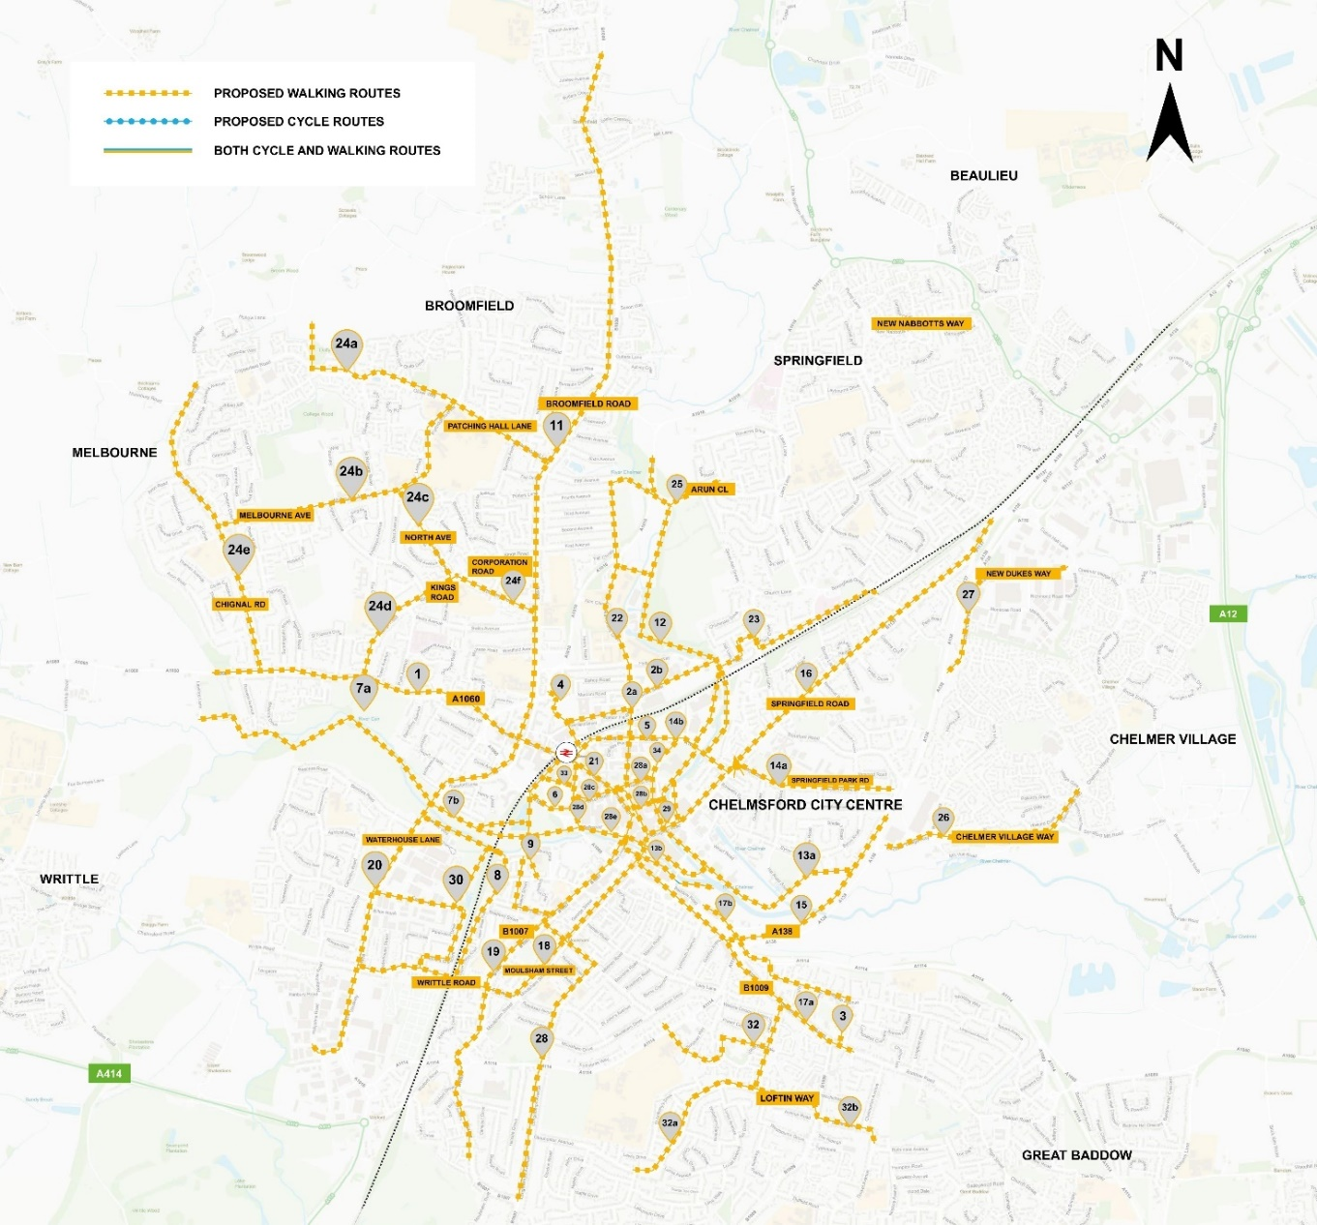Chelmsford LCWIP Walking Network Map
Scheme | Route | Route Description
Walking Route 1 | Chelmsford Railway Station - Rainsford Road | This route runs west from Chelmsford Railway station to Rainsford Road in west Chelmsford.
Walking Route 2a | Anglia Ruskin University to Tindal Square | Connecting Anglia Ruskin University to Tindal Square via New Street.
Walking Route 2b | Arbour Lane to Tindal Square | Linking Arbour Lane to Tindal Square via Brook Street.
Walking Route 3 | City Centre to Baddow Road | Connecting the Baddow road area to the city centre and Moulsham Street.
Walking Route 4 | Chelmsford Station (Broomfield Gyratory/Route 11 - Broomfield Road) | This route connects Chelmsford Station to Broomfield Road via Glebe Road to promote a more direct walking route to the city centre from the north.
Walking Route 5 | Springfield/Victoria Road to Station | This route connects the Springfield area to the station via Victoria Road.
Walking Route 6 | Parkway to City Centre | This route connects Parkway to the city centre.
Chelmsford LCWIP Walking Network Key Routes

Colchester LCWIP Walking Network Map and Routes
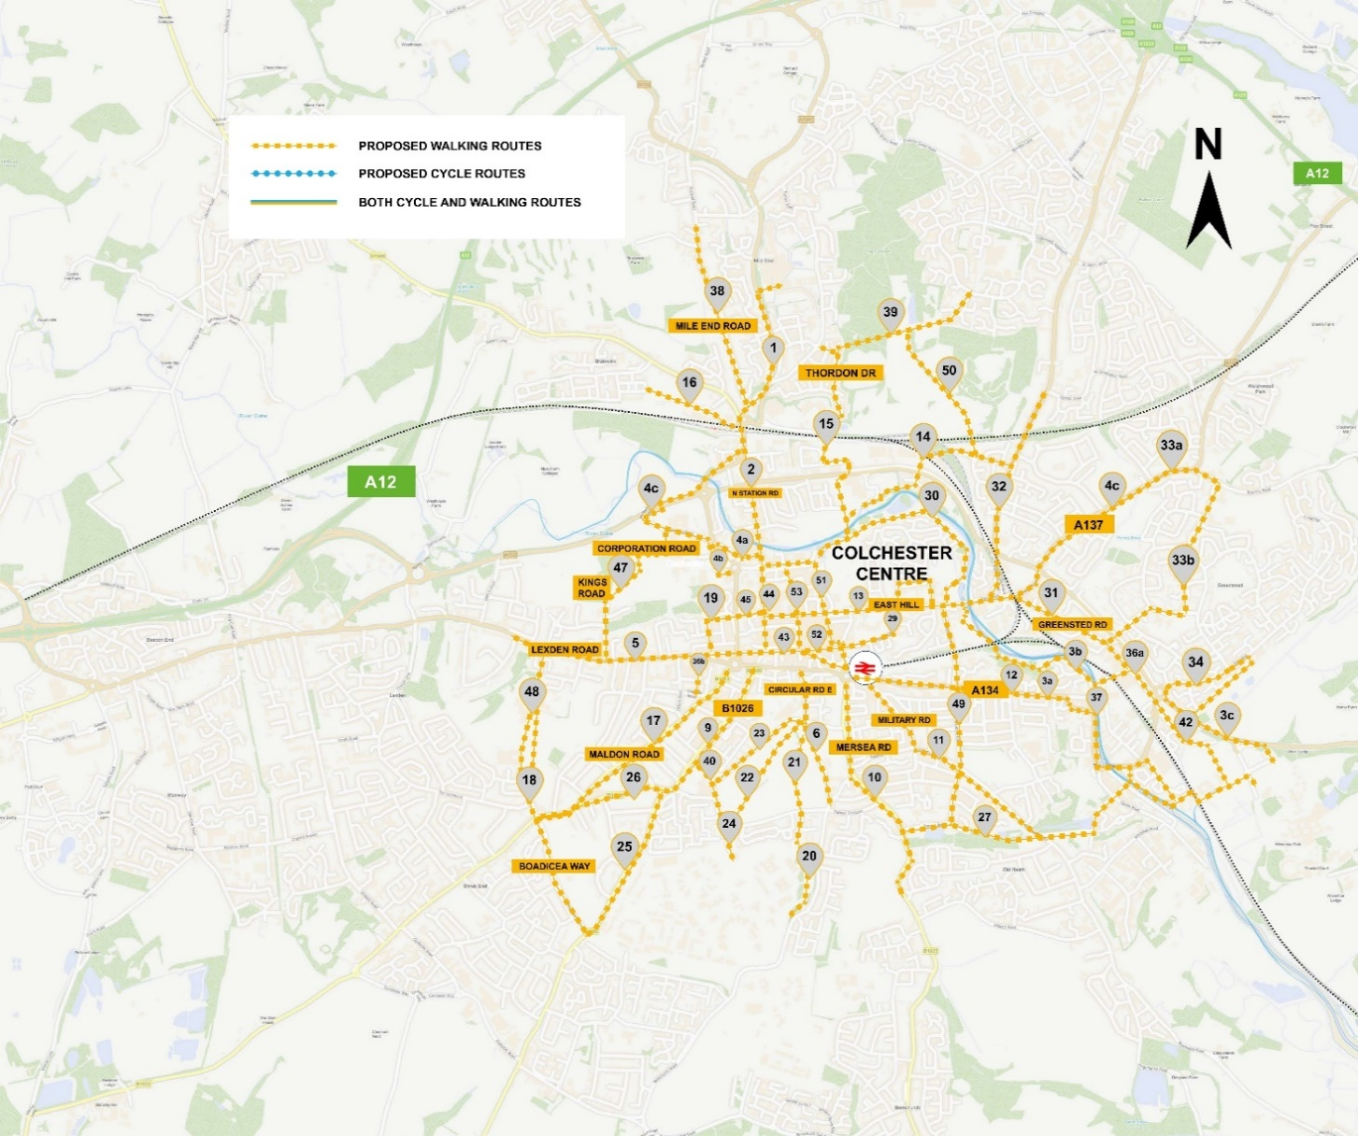Colchester LCWIP Walking Network Map

Scheme | Route | Route Description
Walking Route 1 | Colchester Station to Hospital | Connecting Colchester Station to the Hospital via Northern Approach Road.
Walking Route 2 | Colchester Station to Middleborough | This route is a key link from the station to the town centre via North Station Road.
Walking Route 3a | Town Centre to University of Essex | Connecting the Town Centre and the University via East Hill and Zig Zag Bridge.
Walking Route 3b | University to Hythe Station | Connecting Hythe Station and the University of Essex via Hawkins Road.
Walking Route 3c | University to Greenstead | Connecting the University of Essex with the Greenstead area.
Walking Route 4a (cluster) | Colchester Institute to Town Centre | Sheepen road to Middleborough via Sheepen Place.
Walking Route 4b | Colchester Institute to Town Centre | Sheepen Road to Balkern Hill.
Walking Route 4c | Colchester Institute to Colchester Station | Sheepen Road to Colchester Station.
Colchester LCWIP Walking Network Key Routes

Stage 5: Prioritisation Process
An initial prioritisation has been undertaken of the walking and cycling routes. In the short to medium term, a number of routes have been prioritised for further design work.
Short term priorities will deliver a level of quality for both networks which will enable more promotion of walking and cycling as a mode of travel. The selection of routes or corridors for enhancement in the short term is therefore driven by feasibility both in terms of what can be achieved around existing programmes and where delivery of improvements is less complex.

Stage 6: Integration
The LCWIPs are designed to be integrated into local planning and transport policies, strategies, and delivery plans. They are iterative and can be updated to reflect emerging policies and programme objectives, which will provide a longer-term framework to secure funding, for example, over a 10- year period, in three phases, which would be both transformative and efficient as it would allow economies of scale, better integration and alignment with other programmes, thus maximising the benefits of investment.
Next Steps
We are really keen to hear your views on the proposed networks as a first step in a series of consultations which aim to keep you informed about how the LCWIPs can act as a blueprint for active travel and help secure the recovery of our town centres and high streets. Identifying the routes are a key part of the process to then develop more detailed proposals which include proposed infrastructure such as better pavements, enhanced crossing points, segregated cycle routes and healthier streets.
Please complete the survey, or if you are an organisation, email your response to: SGH.Routes@essex.gov.uk.
Once views have been considered, the LCWIPs will be updated, finalised and will then be published. These plans will guide the decisions on how to implement improvements to our streets to develop coherent walking and cycling networks over time. As soon as the route networks are finalised, these will form the basis for bids for funding to implement improvements to our streets, to transform them so that they are fit for purpose for the future.
To kick start the LCWIPs, there are some initial scheme proposals that have been informed by the LCWIP for which the county council has secured funding from government, under the Active Travel Fund which are currently being developed in more detail. Initial proposals can be found at: https://www.essexhighways.org/getting-around/safer-greener-healthier.aspx
It is expected that consultation on these proposals (which will include better safety and enhanced infrastructure) will take place in early Summer 2021.

This information is issued by:
Essex County Council
Contact us:
xxx@essex.gov.uk
www.essex.gov.uk
00000 000 000

The information contained in this document can be translated, and/or made available in alternative formats, on request.
Published March 2021

