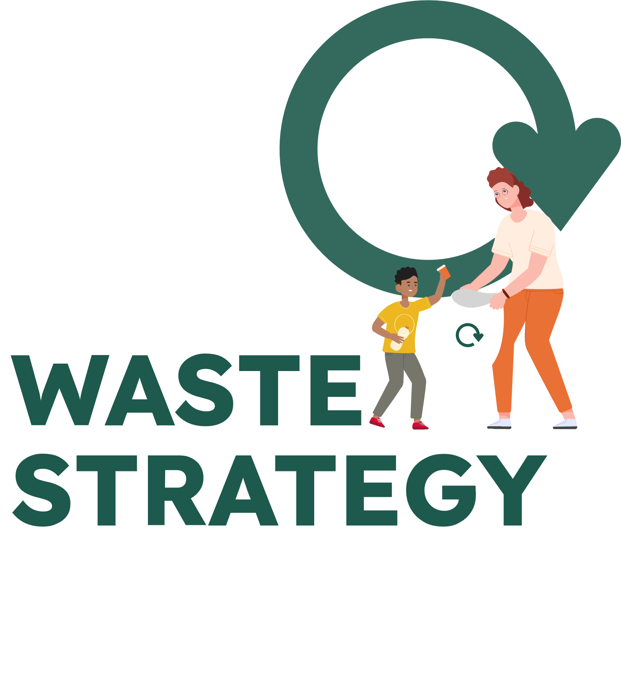

Frequently Asked Questions
Updated 27 September 2023
Contents
Introduction 2
Recycling and waste in Essex 3
The draft Waste Strategy for Essex 5
Waste and businesses 7
General terms 7

Introduction
Responses have been prepared to likely questions about the Waste Strategy for Essex and the consultation process.
This document may be updated during the consultation process.
Essex County Council (‘ECC’) as the Waste Disposal Authority (‘WDA’) for Essex and the 12 Borough, City and District councils as the constituent Waste Collection Authorities (‘WCAs’) of the county have a statutory duty to develop and maintain a Joint Waste Strategy. The Essex Waste Partnership (‘EWP’), which is formed of the WDA and the 12 WCAs, has developed a draft Waste Strategy for Essex (WSfE).
The EWP wishes to seek the views of Essex residents and others as part of the development of a final strategy for adoption. ECC will facilitate the consultation on behalf of the EWP, asking for views and feedback from Essex residents, communities, businesses and councils that use waste services or are affected by the proposals in this draft strategy. As facilitator, ECC’s cabinet took a decision to launch a consultation on 12 September 2023. The decision papers, including an Equality Comprehensive Impact Assessment on the consultation process, are published on the [ECC’s] county council website.
An independent organisation will be appointed to collate and analyse consultation responses and produce a report for publication. Feedback received via the consultation process will be considered, together with other relevant information, by the EWP and used to develop a final version of the Waste Strategy for Essex and Strategic Environmental Assessment.
The adoption of the WSfE by ECC will be subject to a separate decision, which will be supported with an updated Equalities Comprehensive Impact Assessment which assesses the impacts of the proposals. Each member council of the EWP will take individual decisions in line with their governance processes, on adoption of the final version of the strategy.

Recycling and waste in Essex

What happens to recycling collected in Essex? (Plastic, Tins, Card, Paper, Glass)
In Essex, your local council collects recycling and has contracts with companies to recycle it into new products and materials. Please check with your local council for more information on what happens to recycling.

What happens to food recycling collected in Essex?
In Essex, Food Waste collected from your kerbside is processed using Anaerobic Digestion (AD). AD is a process where food waste is broken down by micro-organisms to create biogas. Biogas is used to generate electricity and heat. The process also creates bio-fertiliser which can be used in agriculture.
To find out more about how to reduce your waste and recycle more, please visit the Love Essex website.

What happens to garden recycling collected in Essex?
In Essex, garden waste collected from your household and from recycling centres is processed using Open Windrow Composting (OWC). The garden waste is shredded, mixed, and placed into large, open-air rows. The rows of garden waste are turned regularly. After about 4 months, the process creates compost that can be used within gardens, horticulture, and agriculture.
To find out more about how to reduce your waste and recycle more, please visit the Love Essex website.

What currently happens to general rubbish in Essex?
In Essex, general rubbish (residual waste) is currently disposed of in landfill sites. A landfill site is an area of land that is used to contain rubbish either directly on the ground or filling an unwanted hole in the ground. Once a landfill is full, the site continues to be monitored and managed for the protection of the environment.
To find out how to reduce your waste and recycle more, please visit the Love Essex website.

Why does each council have different collections and containers?
Every council organises its waste collection system based on local priorities and local community needs. The government has consulted on introducing greater consistency of collections which may result in further standardisation of services in the future.
To find out what goes in your recycling and general rubbish bin at your home, as well as information on bulky waste and special collections, please visit your local council’s website or the recycling at home section of the Love Essex website

Why should I sort my rubbish?
We all have a part to play to reduce the amount of waste created and its environmental impact. The natural resources used to create products will not last forever. So, it is very important that we use them wisely, reuse as much as we can, and recycle items at the end of their life.
Successful recycling relies on good quality material. Your council has developed your recycling service to ensure that the materials that are collected can be recycled. You can help by sorting recycling ready for collection. To find out what goes in your recycling, please visit your local council’s website or the recycling at home section of the Love Essex website.
The government is also making producers and retailers responsible to reduce packaging that they create and increase the amount of recycled material used in packaging top ensure they play their part too.

How can I find out what is collected in my area?
To find out what goes in your recycling and general rubbish bin at home, as well as information on bulky waste and special collections, please visit the your local council’s website or visit the recycling at home section of the Love Essex website.

How can I find out more about how to reduce my waste / recycle more?
To find out more about how to reduce your waste and recycle more, please visit the Love Essex news and ideas page and sign up to our newsletter and social media channels.

What should I do if my local council does not collect a material in my area?
If you have sorted a material but it is not currently collected by your council, please visit the Love Essex website or Recycle Now to find out how you can recycle an item in your area.

How can I recycle if I live in a flat?
Some properties have different recycling and waste facilities because it can be difficult to sort, separate and collect recycling from buildings with multiple households. This may mean that you do not currently have recycling collected directly from your property.
Please check with your local council to find out what services are available and use recycling banks located in your local area or at your recycling centre. Details of local facilities can be found on the Love Essex website.

How do I find out about recycling centres?
Recycling Centres for Household Waste (“Recycling Centres”) in Essex are provided by Essex County Council. To find a recycling centre and how to make the most of your visit, please visit the Love Essex website.

How much is spent on waste management in Essex?
The current cost of collecting, treating, and disposing of the waste generated by Essex households is over £130 million per year.

The draft Waste Strategy for Essex

Which councils/ authorities/ companies are part of the Essex Waste Partnership?
- Basildon Borough Council
- Braintree District Council
- Brentwood District Council
- Castle Point Borough Council
- Chelmsford City Council
- Colchester City Council
- Epping Forest District Council
- Essex County Council
- Harlow District Council
- Maldon District Council
- Rochford District Council
- Tendring District Council
- Uttlesford District Council
To find out more about the Essex Waste Partnership, please refer to Appendix 12 - Essex Waste Partnership Terms of Reference.

Is the Waste Strategy for Essex affordable?
The waste generated by Essex residents currently costs the taxpayer more than £130m a year to collect treat and dispose of. This doesn’t include the cost to the environment. The number of households in Essex is set to increase in the next 20 years, so without changing how we operate it will cost even more in the future. This future money could be spent elsewhere.
The suggested approach outlined in the draft strategy has been developed to maximise limited resources while continuing to meet the needs of residents and businesses. The cost of not taking any action – both monetary and environmental – would be unaffordable.
Following adoption of a final version of this strategy, councils in Essex will develop detailed action plans. As part of action planning, we will assess value for money and affordability to ensure we take the right decisions.

Will you build an Energy from Waste facility in Essex?
Our priority is for Essex to be a zero-waste county. If we all take steps to reduce, reuse and recycle waste as much as possible, the need to recover and dispose of waste will be minimised.
Once we have reduced, reused, and recycled all we can, recovering energy is the proposed approach for managing the waste that is left over. Thanks to new technology, this can be done with less impact on the environment than sending the leftover waste to landfill. This consultation is an opportunity to have your say on the proposed future approaches to waste management and no decisions have been made.
The draft joint strategy does not identify any waste infrastructure need. Councils in Essex will seek further involvement from residents on any potential major waste infrastructure in the future.

What is happening at the MBT (Mechanical Biological Treatment) plant in Basildon?
The waste treatment contract for Tovi Eco Park, in Basildon, Essex was modified as part of a mutual agreement between Essex County Council (ECC) and UBB Waste (Essex) Limited (UBB).
Works have been underway since last summer to dismantle the Tovi Eco Park Mechanical and Biological Treatment (MBT) facility in Basildon, as plans for the future of household waste management in Essex progress.
Following the removal of equipment and machinery from the facility, the owner/operator of the facility, UBB Waste (Essex) Limited, removed the ventilation stack in June.
Significant parts of the site have already been broken down and levelled, and the remaining steel and concrete structure of the facility will be removed, section by section, and transported away for repurposing and recycling in the coming months.
Works are scheduled to be completed by summer 2024 with approximately 95% of the materials being reused, repurposed, and recycled.

If developments are fast-moving and dynamic, is a 5-year review of the strategy often enough?
As the design and delivery of waste management services are long-term activities, having a clear overarching framework for a 30-year period is important.
In the draft strategy, we propose to review the strategy as a minimum every five years. The five-yearly review is a guide based on Defra best practise for periods of review for a joint waste management strategy. However, we will actively respond to emerging trends and regulations and update more frequently if required.

Waste and businesses

How can businesses and retailers contribute to the targets in the strategy?
Many businesses in Essex have already made changes to reduce waste and increase recycling and we need to build on this to ensure we reach our targets. The draft strategy is aligned with Government legislation and policy which places requirements on businesses in respect of the environmental impact of their packaging and adopting a circular economy.

When the strategy is finalised, we will support businesses to transition to a more circular economy and contribute to achieving our targets, protecting the environment, and saving limited resources. We will also lobby the Government to accelerate the embedding of sustainable practices within businesses.

General terms
Please refer to the draft Waste Strategy for Essex for a full glossary of terms.

What does the Circular Economy mean?
A circular economy is an economic system designed with the intention that maximum use is extracted from resources and minimum waste is generated for disposal. In practice this means designing products that are durable, easy to maintain and repair. This encourages and enables individuals to reuse products many times. Finally, products should be designed to enable straightforward recycling when they can no longer be reused or repaired.

What does the Waste Hierarchy mean?
The waste hierarchy sets out the order in which options for waste management should be considered based on environmental impact. It is a legal framework that has become a cornerstone of sustainable waste management. In line with the waste hierarchy, products and materials should be kept in use, recycled when they are no longer useable and only sent for recovery or disposal as a last resort.

What is Energy from Waste (EfW)?
Energy from Waste is a recovery process that takes residual waste and turns it into electricity. Capturing and using the heat generated significantly increases the overall efficiency of the process and the environmental benefits.

What is Carbon capture, utilisation, and storage?
Carbon capture, utilisation and storage is a technology to prevent carbon emissions produced by industrial activity being released into the atmosphere. Carbon captured is either stored deep underground where it cannot enter the atmosphere or used in other industrial processes.

What is the difference between Energy from Waste (EfW) and incineration?
Energy from Waste (EfW) is a combustion technology that enables electricity to be generated and usable heat captured. The term incineration is generally used to mean the combustion of material without energy recovery.
EfW and incineration without energy recovery are viewed differently in the waste hierarchy. Although EfW and incineration both involve the combustion of waste, the former is a type of recovery whilst the latter is a form of disposal. The term Energy from Waste (EfW) has therefore been used within the draft strategy to differentiate this recovery approach, which ranks higher in the waste hierarchy, from the disposal technology of incineration without energy recovery which ranks as the least preferred option.

This information is issued by Essex County Council on behalf of Essex Waste Partnership
To have your say on the draft
Waste Strategy for Essex 2024-2054 and to see the full list of documents,
visit https://consultations.essex.gov.uk/rci/waste-strategy-for-essex-consultation/
visit essex.gov.uk/wastestrategy
For help filling out the survey,
call 0345 603 7625
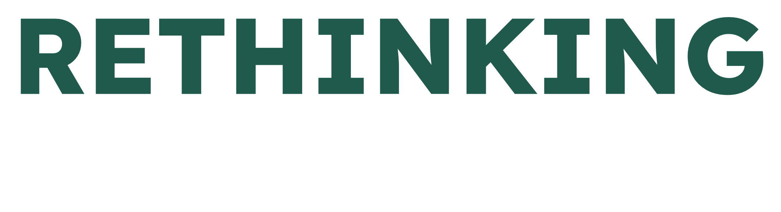
Updated 27 September 2023

