


Essex Part 2 Parking Guidance
Garden Communities and
Large Scale Developments

October 2023

Consultation Draft

Essex Part 2 Parking Guidance
Garden Communities and
Large Scale Developments

Version 2-0
Consultation Draft
October 2023

Produced by:



For:


Project Information Sheet
Client | Essex Planning Officers Association
Project Code | 3908
Project Name | Essex Garden Community Parking Guidance
Project Director | Geoff Burrage
Project Manager | Nicola Lodge (Siddall)
Quality Manager | Geoff Burrage
Additional Team Members | Georgia Taylor, Jenny Paxton, Blair Davidson, Phoebe Garside
Start Date | June 2022
File Location | 3908/Essex Parking Guidance/Reports
Document Control Sheet
Ver. | Project Folder | Description | Prep. | Rev. | App. | Date
V2-1 | 3908/Essex Parking Guidance/Reports | Consultation draft v2-1 | JP | NL | NL | 11/10/2023
V2-0 |  | Consultation draft | JP | NL | GB | 10/10/2023
V1-1 |  | EPOA Draft | JP, NS | NS | NS | 12/09/2023
V1-0 |  | Draft | JP, GT, BD, NS | NS | NS | 28/07/2023
V0-1 |  | Draft structure | TF | NS | NS | 27/01/2023
Notice
This report has been prepared for Essex Planning Officers Association in accordance with the terms and conditions of appointment. Integrated Transport Planning Ltd cannot accept any responsibility for any use of or reliance on the contents of this report by any third party.
Table of Contents
1. Introduction 1
Purpose of this Part 2 guidance 1
How to use the Part 2 guidance 2
When to apply it 4
2. The role of parking in GCs and LSDs 5
The current problem 5
The vision and outcomes 5
The parking hierarchy 8
3. Guidance on Supporting Measures 9
Density and land use planning 11
Active travel 13
Public transport 15
Car clubs and shared mobility 17
Demand management 19
Stewardship and enforcement 20
4. Accessibility-led Standards 23
Introduction 23
Applying to phases of development 24
Evidencing the approach 24
Step 1 – Determine parking based on Part 1 standards 27
Step 2 – Score against Accessibility Framework 28
Step 3 – Determine parking budget 34
Step 4 – On-/off-plot proportions 35
Step 5 - Other land uses 36
Step 6 – Reduce and repurpose 37
5. Outcomes by Design 39
Design principles 39
Applying the principles 41
Place-led design 41
Shared wherever possible 41
Accessible to all 42
Secure and appropriately located 43
Well-managed outcomes 44
Flexible and future-proofed 45
Typology matrix 46
Typology guidance 48
Cycle parking 49
Car parking 52

List of Tables
Table 4-1: Part 1 standards for C3 residential development in ‘low accessibility’ areas 27
Table 4-2: Accessibility framework 30
Table 5-1: Design typology matrix 47

List of Figures
Figure 2-1: Garden Community principles 6
Figure 2-2: GC and LSD parking outcomes 7
Figure 4-1: Decision tree for use of Accessibility Tool 26
Figure 5-1: Design principles 40

Appendices
Appendix A The context of Essex
Appendix B Walking, cycling and PTAL maps
Appendix C District Accessibility Level maps
Appendix D Vehicle parking reductions for non-residential land uses
Appendix E Accessibility Tool worked example

Acronyms
ECC | Essex County Council
EDG | Essex Design Guide
EPOA | Essex Planning Officers Association
EV | Electric vehicle
GC | Garden Community
LHA | Local highway authority
LPA | Local planning authority
LSOA | Lower Super Output Area (a Census geographic area)
LSD | Large scale development
NPPF | National Planning Policy Framework
PTAL | Public Transport Accessibility Level
PTW | Powered two wheeler
SuDS | Sustainable Drainage Systems

Introduction

Purpose of this Part 2 guidance
  - This parking guidance supports the Part 1 Essex Parking Standards produced by the Essex Planning Officers Association (EPOA) in collaboration with Essex County Council, the district councils and the unitary authorities. The Part 1 guidance applies to all new developments in Essex, whilst this Part 2 guidance is intended for application to Garden Communities (GCs) and large-scale developments (LSDs).
  - GCs and LSDs are defined as follows for the purposes of this guidance:
- Large scale developments are defined as residential-led developments comprising around 1,000+ homes - usually with other supporting land uses such as education, retail, commercial and community - but which are not recognised as GCs. LSDs are likely to be associated with existing settlements, rather than standalone developments. They do not refer to other significant developments such as business parks, logistics centres or energy / industrial / processing sites, and refer to a significantly greater scale of development than the ‘major development’ definition adopted in the planning system (referring to development of over 10 dwellings). If not defined within Local Plans, the decision over whether a development is to be classed as an LSD should be discussed with the local planning and local highway authorities (LPAs / LHAs) during pre-application.
- Garden Communities are defined as strategic, large-scale developments, acting as an extension to an existing town or forming a new settlement. GCs can range in scale from around 3,500 homes to 10,000+ homes (as part of mixed-use development). They represent a significant change in the traditional approach to delivery of strategic development, by virtue of their scale, underpinning principles, context, and Local Plan policy support. Many GCs are also recognised by the Government and have received funding to support their delivery, typically through a combination of the public and private sector, and existing local communities.
  - For simplicity, sometimes in this guidance the above types of development are collectively referred to as ‘strategic development’. Given the nature of these developments, this Part 2 guidance has a focus on residential parking, for all modes. It also covers parking associated with other land uses typically found within a large residential-led development, such as retail, commercial and community uses, given that parking availability at a destination can influence residential trips just as much as availability at the origin. Where a land use is not specifically mentioned in this guidance, the Part 1 guidance should be referred to.
  - This Part 2 guidance has been developed to guide the quantum and design of parking in new strategic developments reflecting objectives relating to reducing car use, enhancing sustainable mobility and enabling place quality and design. It is prepared on the basis that strategic developments in Essex will be developed as sustainable places. It therefore necessarily challenges conventional approaches to parking standards and design, and for this reason an Evidence Base Report has been prepared to support this guidance and underpin the recommendations made within it.

How to use the Part 2 guidance
  - As with the Part 1 guidance, this Part 2 guidance is aimed at:
- LPAs and LHAs who have adopted the guidance, in determining appropriate levels and design of parking within GCs and LSDs.
- Developers of GCs and LSDs, and their agents and consultants, when undertaking masterplanning and preparing planning applications.
  - The guidance can be applied to authorities in Greater Essex (including unitary authorities) but may also be of value to neighbouring authorities, where cross-boundary strategic developments are being delivered. For this reason, some mapping presented in this guidance shows areas outside of the EPOA area.
  - It is anticipated that this guidance will be applied at the planning and pre-planning stages of development, informing outline and reserved matters planning applications in tandem with Transport Assessments and masterplanning. The accessibility component in Chapter 4 may also be useful informing site allocations in Local Plans and infrastructure in Local Transport Plans, as well as potentially being useful for developments in town / city centres where there is good accessibility.
  - The Part 1 standards aim to reduce ambiguity around parking standards for smaller scale developments, to make planning decisions more straightforward. It is however expected that, given their complexities, GCs and LSDs will be subject to extensive baselining, scoping and masterplanning and there will be negotiation over many factors relating to transport and movement. Therefore, whilst this guidance provides more detail than previously in relation to large and complex sites in Essex, it still allows for some flexibility in how parking is designed into strategic developments. This flexibility will ensure that good outcomes are being achieved in the right places, recognising that the context and location of strategic developments will influence the quantum and design of parking within them.
  - Three components combine to form the process for using this guidance:
- Outcomes: sets out how parking relates to high-level sustainable mobility and design outcomes relevant to GCs and LSDs, and encourages an understanding of the ‘vision’ to be achieved by the development being assessed. The Outcomes component is described in Chapter 2.
- Accessibility: explores the potential for the outcomes to be achieved in spatial and infrastructure terms, both now and in the future. Based on accessibility mapping and scoring against criteria, the approach suggests a quantum of parking which will be appropriate to the development being assessed. GCs and LSDs which score highly will be able to introduce more progressive parking standards that reflect their high levels of connectivity by walking, cycling and public transport. The Accessibility component is described in Chapter 4.
- Design: guides the design of parking into the development being assessed, in terms of its location and typology. The Design component is described in Chapter 5.
  - The process for using this Part 2 guidance based on the three components is shown illustratively below.
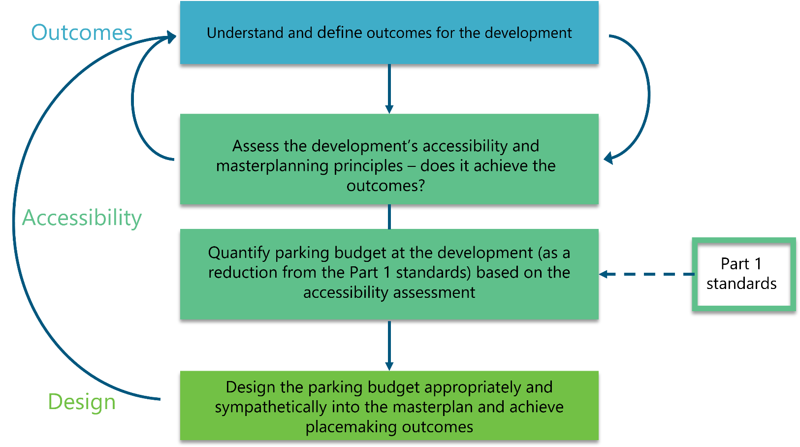

When to apply it
  - The Part 1 guidance covers detailed technical elements of parking provision for all modes, and these are not duplicated in this guidance. When considering the following, the Part 1 guidance should therefore be referred to:
- Vehicle and powered two-wheeler (PTW) parking bay dimensions and car park layouts (e.g. layout of spaces, aisle width).
- Cycle parking dimensions and layout (e.g. type of stand / rack, minimum spacing).
- Parking for mobility impaired vehicle dimensions and layout.
- Electric Vehicle charging infrastructure (charge point specifications, consumer capacity considerations).
- Flooding and drainage implications for different types of parking surface.
- Car Park Management Plans and parking enforcement.
  - This guidance also refers to the Part 1 standards for the level of cycle, electric vehicle and powered two wheeler (PTW) parking spaces. A progressive approach which enhances provision for these modes has been taken in the Part 1 guidance, and as this represents best practice, the standards are not altered in this Part 2 guidance. Further detail is contained in Chapter 4.

The role of parking in GCs and LSDs

The current problem
  - Places within Essex and across the UK which have been designed around the car have perpetuated car dependency, in turn worsening congestion, climate change and public health. The lack of alternative choices has been perceived as a part of the demand for parking spaces, and this has influenced the definition of parking standards.
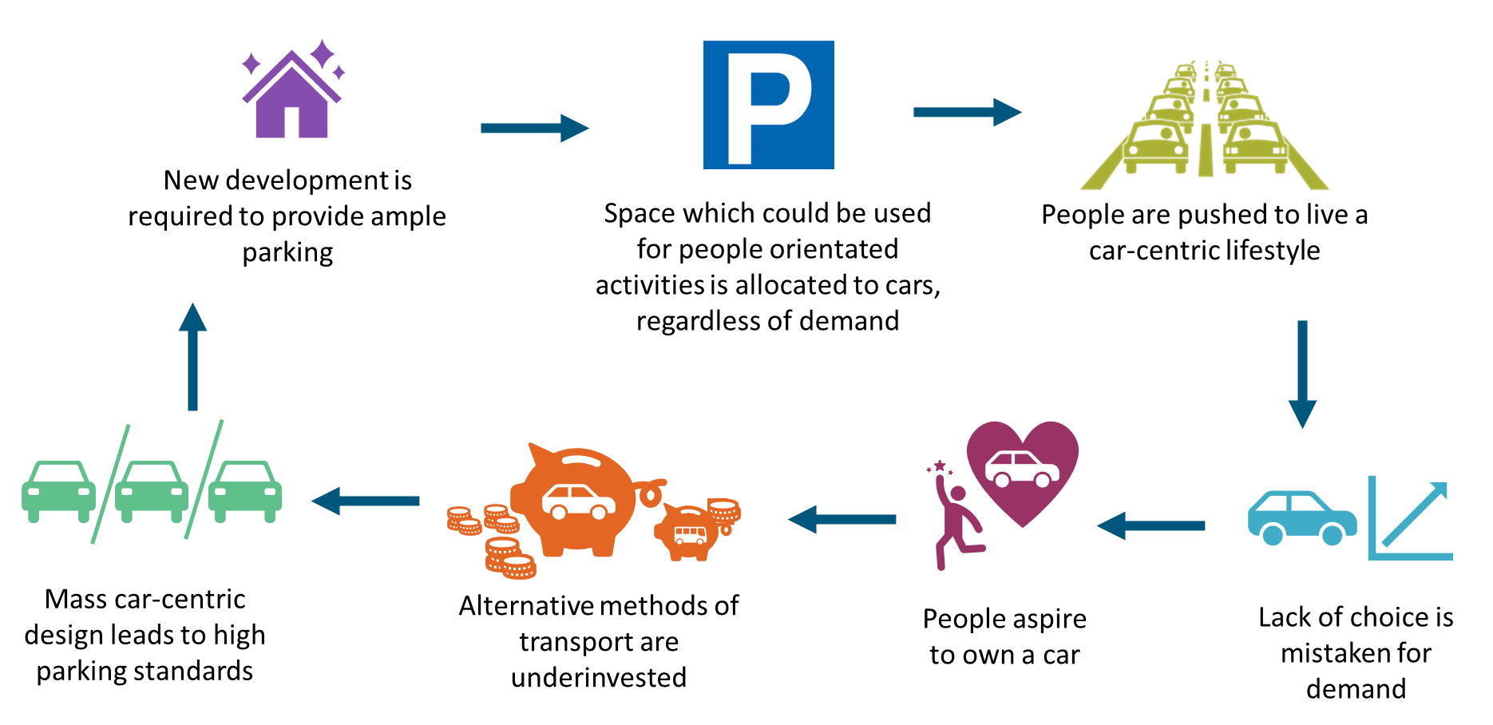
  - Appendix A presents information on car ownership and usage levels in Essex, setting out the existing situation and context for this Part 2 guidance. The Accessibility component of this guidance takes the above considerations and existing context into account.

The vision and outcomes
  - GCs and LSDs present opportunities to tackle these challenges, by promoting walkable, vibrant neighbourhoods, where as a result you do not need a car to move around. ECC’s GC principles and their relevance to parking are illustrated in Figure 2-1, demonstrating that the storage, ownership and use of cars is intrinsically linked to what makes a successful strategic development. Careful integration of parking is a means of facilitating density, elevating street design and creating safer streets. This in turn can drive up land value and marketability, by leaving space for more homes and facilities, and creating a place where people want to live.
Figure 2-1: Garden Community principles
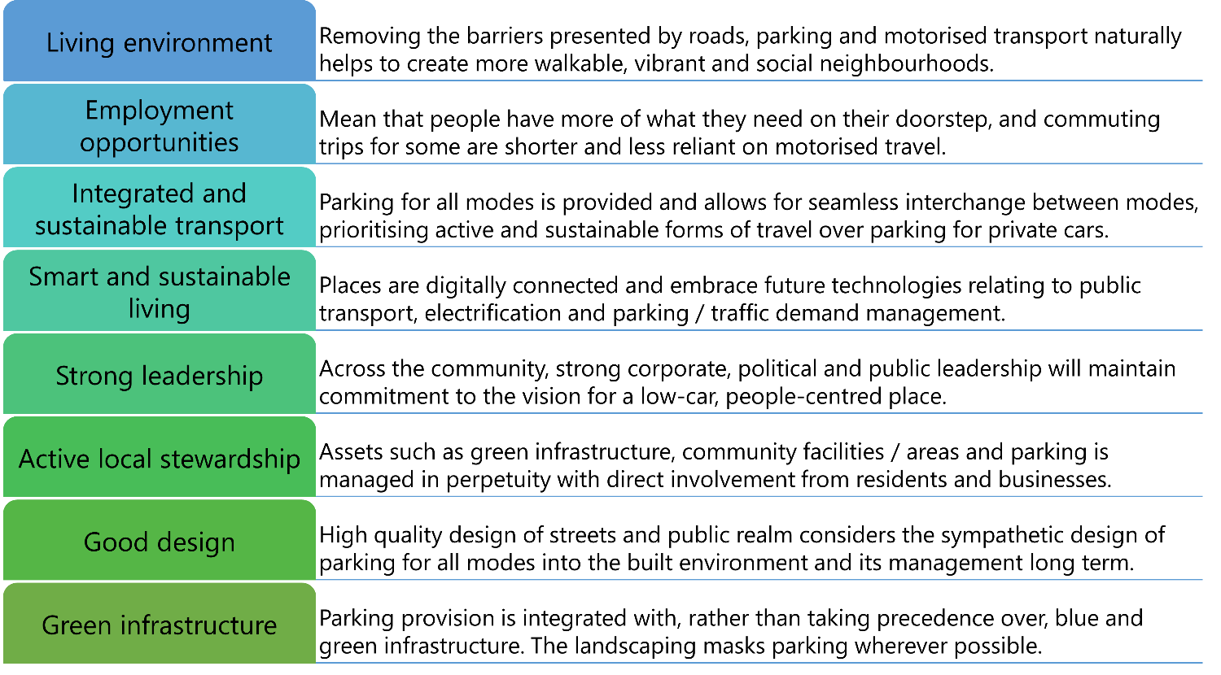
  - Influenced by the EDG GC principles, and other relevant local and national guidance documents, a succinct set of desirable outcomes related to parking at GCs and LSDs in Essex is set out in Figure 2-2. It represents the outcomes component of this Part 2 guidance, forming the basis of decisions related to parking and overall street design at new strategic developments in Essex.

Figure 2-2: GC and LSD parking outcomes
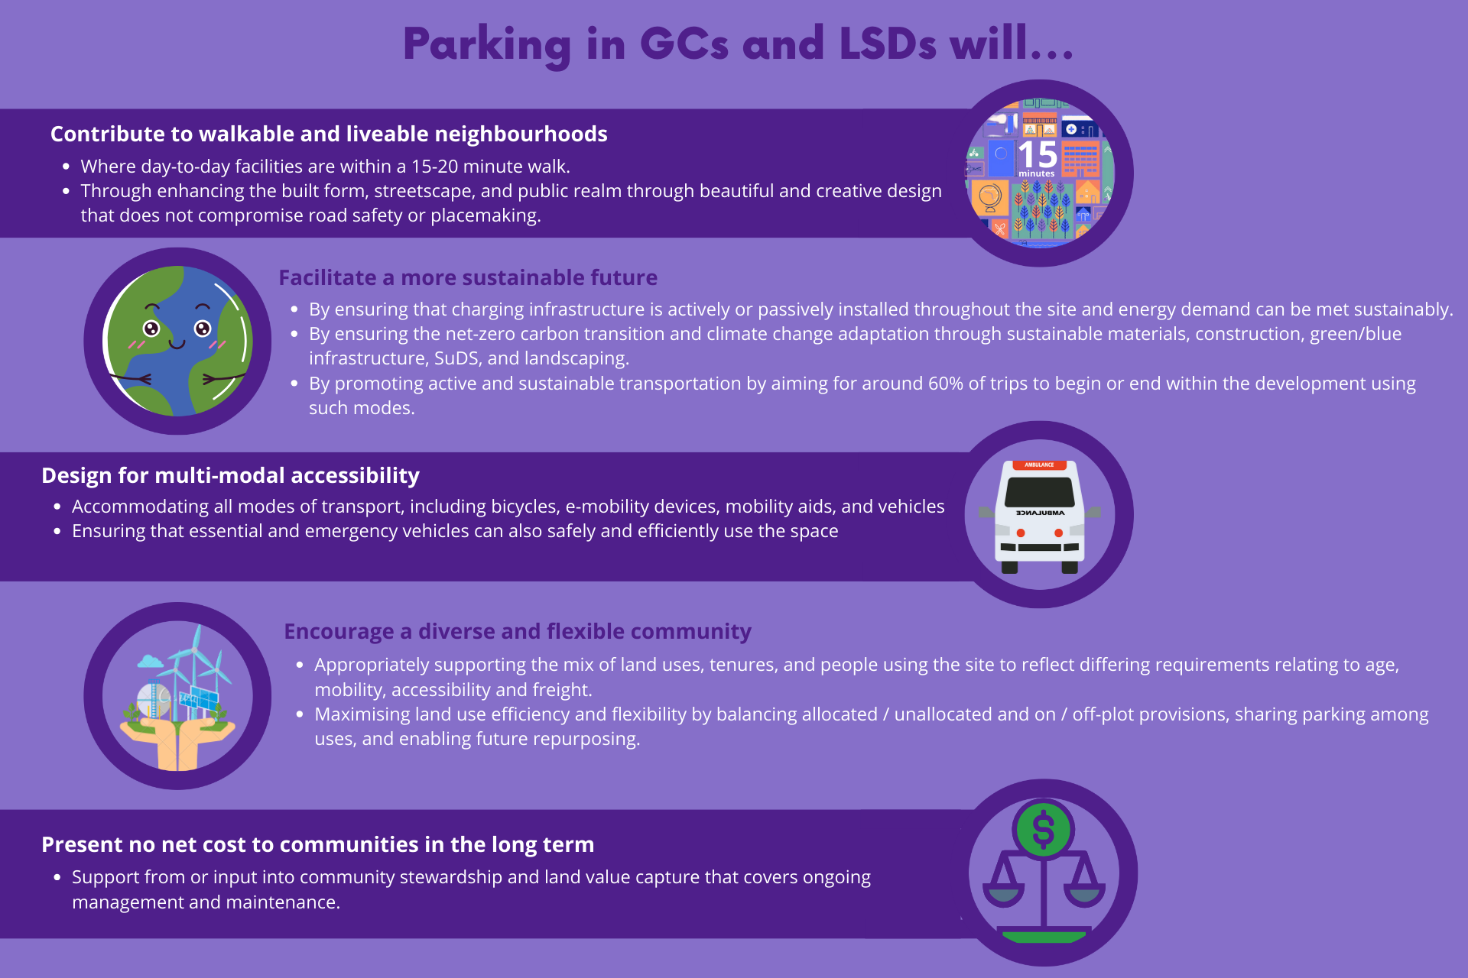

The parking hierarchy
  - The parking hierarchy below reflects the outcomes and is a simple and practical reference point when considering the quantum, design and provision of parking in new GCs and LSDs throughout the remainder of this guidance. It reflects an order of priority as follows:
- The storage of active and sustainable mobility and e-mobility modes should be considered first and made most convenient, attractive and prominent. These modes include (but are not limited to) bicycles, e-bikes and cargo bikes, scooters and e-scooters, and mobility scooters.
- Where vehicle parking is provided the space for car sharing should be most convenient and attractive (applicable to destination land uses such as employment). EV charging infrastructure should become more available and initially more convenient as the vehicle fleet switches from petrol and diesel vehicles. Dedicated space should be made available for PTWs.
- Parking for petrol and diesel private vehicles should be the least convenient and attractive type of parking, and should not be prominent within the streetscape or areas of parking.


Guidance on Supporting Measures
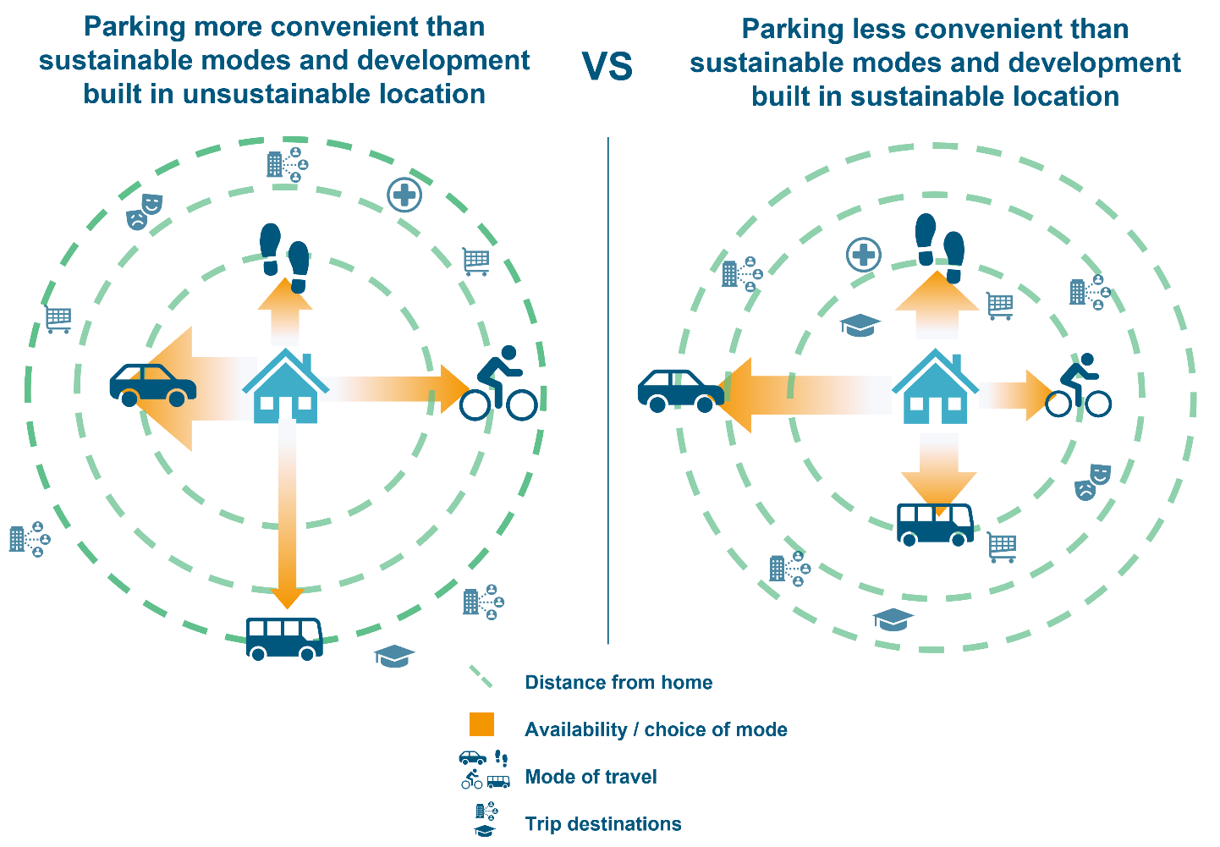
  - The Evidence Base demonstrates that restraining car parking provision in isolation (e.g. through maximum parking standards, or on-street parking controls) without other supporting measures can result in poor outcomes, which influence the attractiveness and quality of a place. Reducing car parking provision is just one mechanism out of many sustainable mobility interventions that need to work together to support an overall reduction in private vehicle usage.
  - The NPPF Paragraph 107 states:
“If setting local parking standards for residential and non-residential development, policies should take into account:
(a) the accessibility of the development;
(b) the type, mix and use of development;
(c) the availability of and opportunities for public transport;
(d) local car ownership levels; and
(e) the need to ensure an adequate provision of spaces for charging plug-in and other ultra-low emission vehicles.”
  - Quantifying the impact of transport and planning interventions on parking demand is challenging because the places in which they are delivered do not operate in a vacuum. Isolating the impacts of single interventions is seldom possible, but there is evidence that demonstrates that:
- Combining multiple measures that are known to contribute to sustainable travel patterns increases their effectiveness as a range of measures is more likely to meet more people’s needs, for a wider range of trips. This includes a range of land use measures.
- Positively influencing travel behaviours depends on human choice, so a range of measures that ‘push’ and ‘pull’ people towards desirable travel modes is required. For example, ensuring that sustainable travel options present safe and secure ways of travelling that are effective in taking people where they want to go, including supporting linked trips, is important.
- Early infrastructure investment is vitally important but works best when accompanied by new public transport services and behavioural measures to help people make more sustainable travel choices.
  - As such, to be effective and contribute towards achieving sustainable travel outcomes, an appropriate reduction in car parking provision in strategic developments in Essex can only be delivered alongside the supporting measures described in this chapter. These are discussed in brief in relation to car use and ownership, but this does not represent comprehensive guidance on designing for sustainable mobility outcomes, and should be viewed in the context of other strategies around good built form and landscape design. The supporting measures here feed directly into the accessibility-led standards detailed in Chapter 4.

Density and land use planning
  - The design of the urban environment can encourage active travel and contribute positively to public health and social wellbeing. A key part of this is limiting the access of vehicles, and where access is provided, managing the volume and speed of vehicles in ‘human scale’ spaces (including public squares and residential streets) through traffic management measures such as filtered permeability.
  - A varied mix of uses (residential, employment, leisure, retail and education) within new developments also encourages more sustainable travel patterns, by allowing more trips to be made internally, as does building at higher density. This creates a virtuous circle of more active streets, which encourages more walking and cycling.
  - Density has been shown to have a clear relationship with car kilometres driven per capita and delivering well planned higher density developments also enables public transport to be more viable and provide better connectivity to more dwellings.
  - This Walkable Neighbourhood philosophy is centred around creating places that are planned to reduce the need to travel longer distances. By integrating a mix of key land uses such as green spaces, retail, education, healthcare and community facilities within a 15-20-minute walk from people’s homes active and sustainable travel are promoted.
  - It should be noted that building at higher density need not entail high-rise buildings and compromised public spaces, with ‘gentle’ density radiating out from local centres in strategic developments proving to be successful in recent UK settings, such as Poundbury in Dorset. The case studies throughout this report are included to illustrate different approaches and do not necessarily reflect the answer, but provide built examples to illustrate the principles discussed.

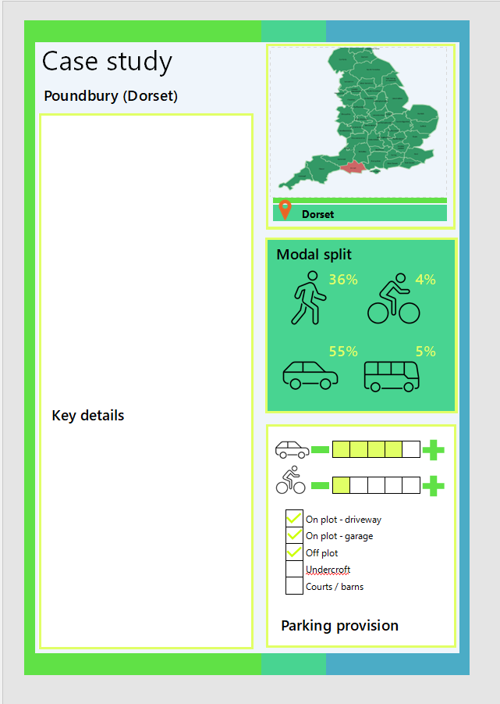
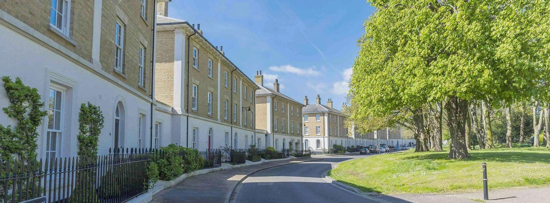
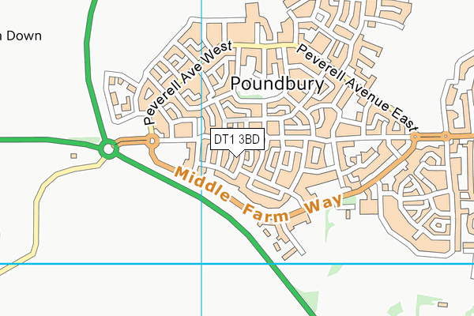
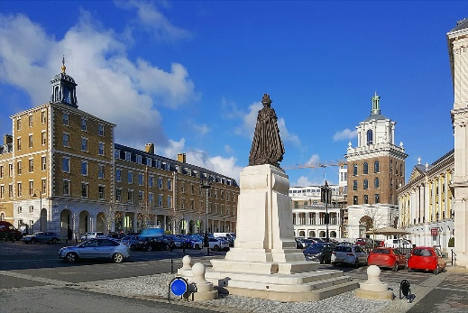
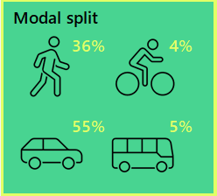
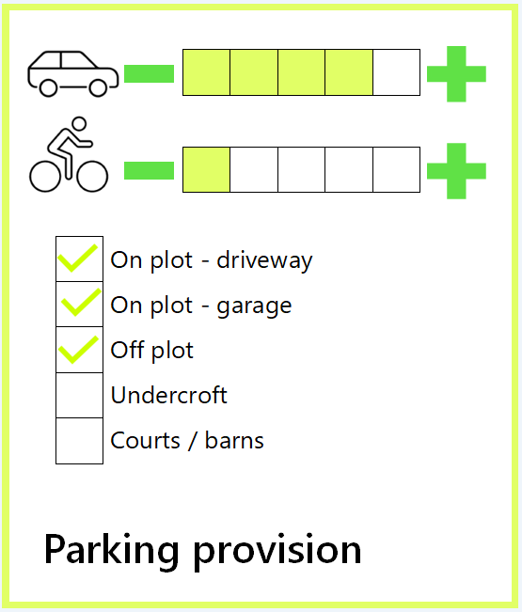
Poundbury, on the outskirts of Dorchester, England, is an experimental planned community due for completion in 2026 with an estimated population of over 6,000 residents (currently housing 3,800). The development is designed for the prioritisation of people rather than cars. The layout is characterised by high density areas, focusing on communities with accessible shops and businesses such that residents are less inclined to use a private vehicle. This is framed by high quality public realm. Despite this, Poundbury has not yet reduced car usage targets as originally intended, perhaps because the level of parking provision is high and there is good access to the strategic road network.


Active travel
  - Walking forms a key part of almost every journey. Nonetheless the design of the walking environment is often compromised in order to provide convenient car parking and roadspace, which encourages increased car ownership and use. People without access to a car are more likely to walk as a mode of transport, with the Evidence Base demonstrating that households without a car are as much as 20% more likely to undertake journeys on foot as households with one car.
  - Walking infrastructure should be safe, direct and convenient, overcoming severance and barriers and ideally segregated from cycling infrastructure. It should be well lit, accessible and adequate in width, integrated with the green infrastructure and street scene and with moments of interest to improve amenity and legibility, such as pocket / linear parks, ‘play on the way’ and open space.
  - As with walking, encouraging cycling necessitates a combination of infrastructure and behavioural measures. Segregated cycle lanes and secure cycle parking at the origin and the destination can both contribute to increasing cycling mode share. Cycle and e-bike hire also allows people to cycle for a single stage of a longer journey, and can encourage people to try cycling who otherwise might not.
  - The Walkable Neighbourhoods study provides guidance on creating places where walking is the natural first choice, because the streets and public realm are of exemplar quality and the facilities that people need to access on a day-to-day basis are within a short distance of every home. This is facilitated by higher densities and effective land use planning, as described below.

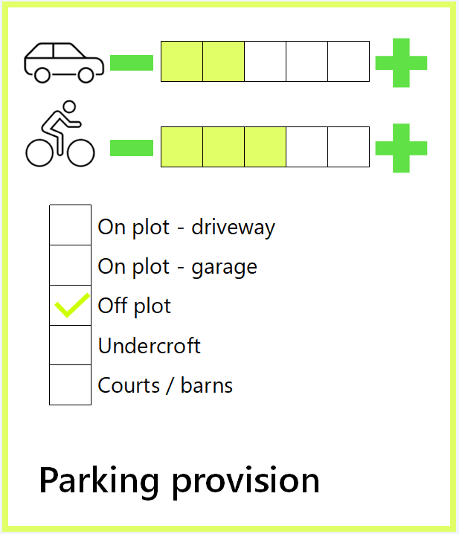
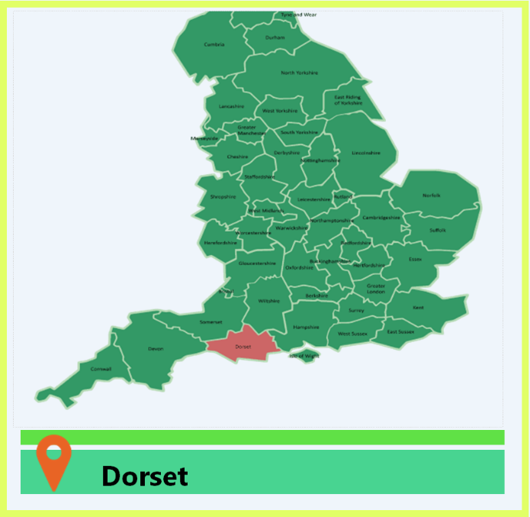

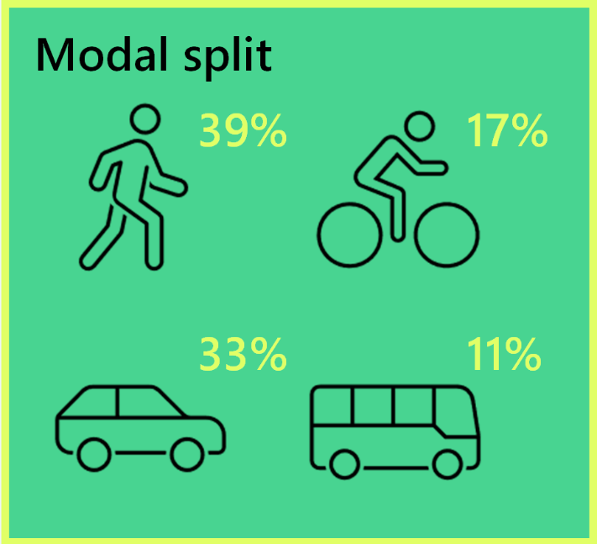
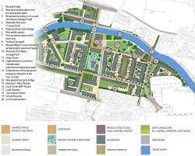
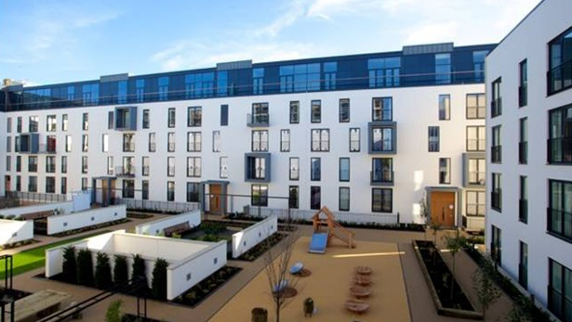
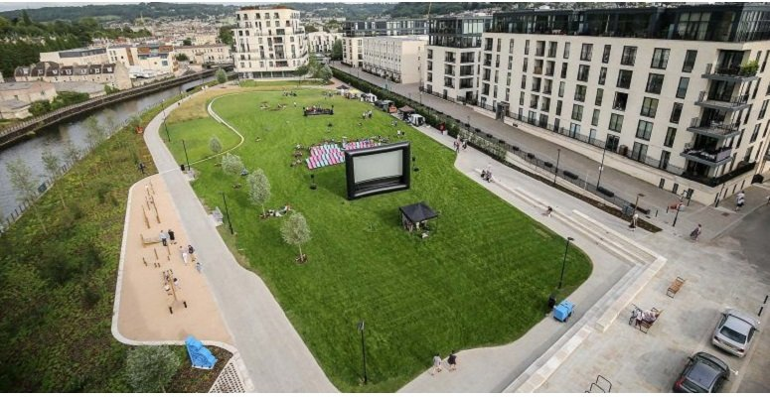
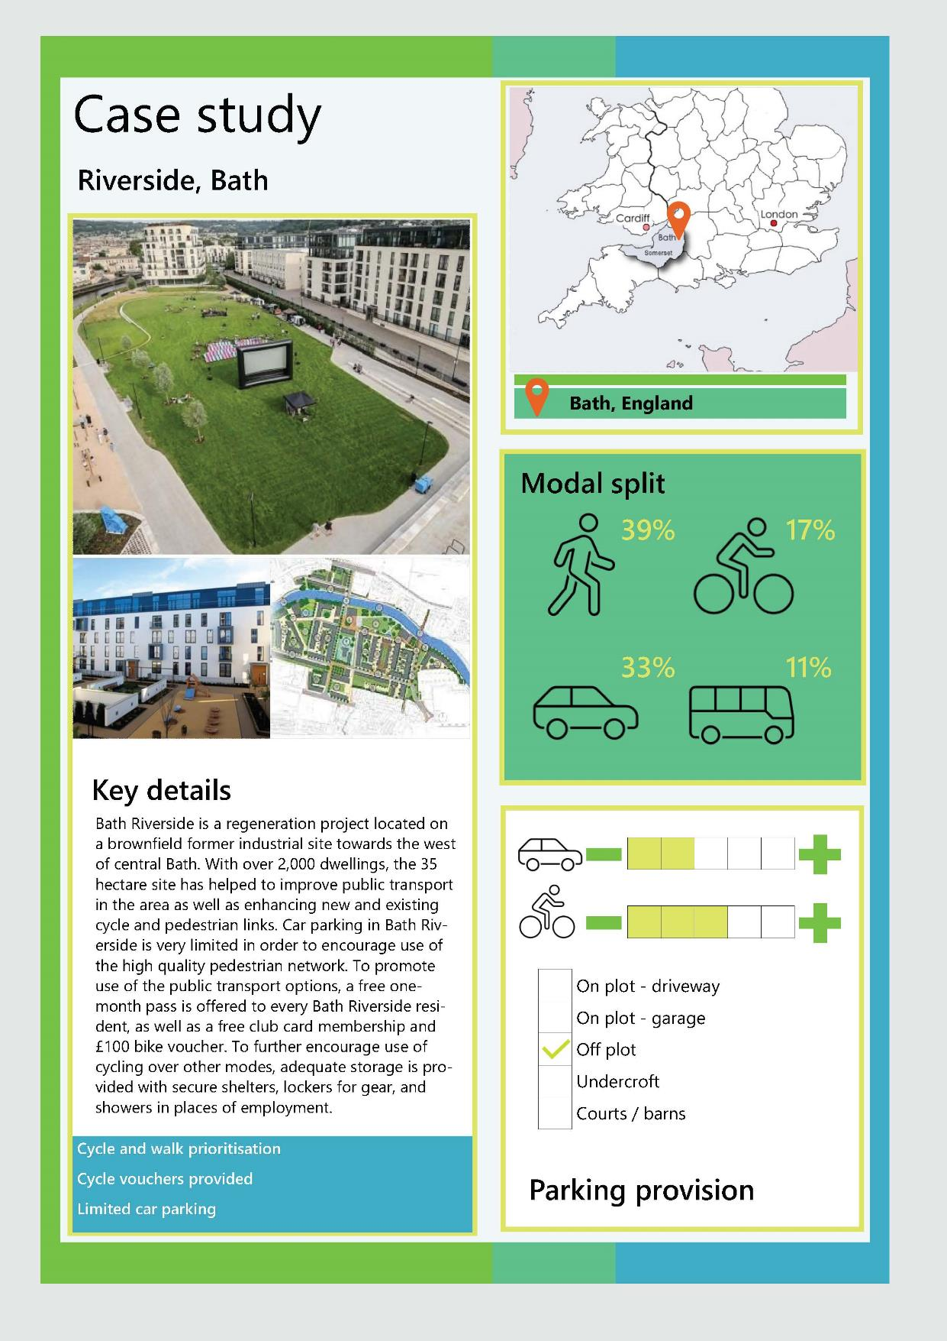
Bath Riverside is a regeneration project located on a brownfield former industrial site towards the west of central Bath. With over 2,000 dwellings, the 35 hectare site has helped to improve public transport in the area as well as enhancing new and existing cycle and pedestrian links. Car parking in Bath Riverside is very limited in order to encourage use of the high quality pedestrian network. To promote use of the public transport options, a free one-month pass is offered to every Bath Riverside resident, as well as a free club card membership and £100 bike voucher. To further encourage use of cycling over other modes, adequate storage is provided with secure shelters, lockers for gear, and showers in places of employment.

Public transport
  - Public transport provides a sustainable option for journeys that are further than a reasonable walk or cycle distance, as well as catering for those with impaired mobility where active modes are less of an option. They also provide safe and comfortable transport in bad weather, in the evening or when carrying shopping for example. Trains, buses, trams and forms of community transport (such as demand responsive) can all contribute to facilitating trips more sustainably than private vehicles.
  - Large towns and cities achieve the highest levels of public transport use and in turn support commercially viable services, often comprising of a multi-modal system such as bus. This suggests that high frequency (ideally every ten minutes or more), reliable multi-modal public transport with significant penetration across dense urban areas is important in encouraging high levels of public transport use and car use.
  - Bus journey times, compared to the comparable car trip, are also a factor in achieving a good mode share. Bus priority infrastructure such as traffic signal priority, bus lane and bus gates can offer advantages to public transport journey time through bypassing congestion and more direct routing. These contribute to making public transport services more attractive than using private cars.
  - The Evidence Base confirms that the proximity of bus stops to destinations (e.g. workplaces) is equally as important as their proximity to origins (i.e. homes), and that low cost public transport options are important if people are to view them as cheaper than driving, the costs of which are often perceived as lower (especially when parking at the destination is free). All bus stops should be high quality in their design, provide at least real-time information, shelters, seating and should be within 400m of every home / key destination. Safety and perceptions of safety both at bus stops and on vehicles are also important.
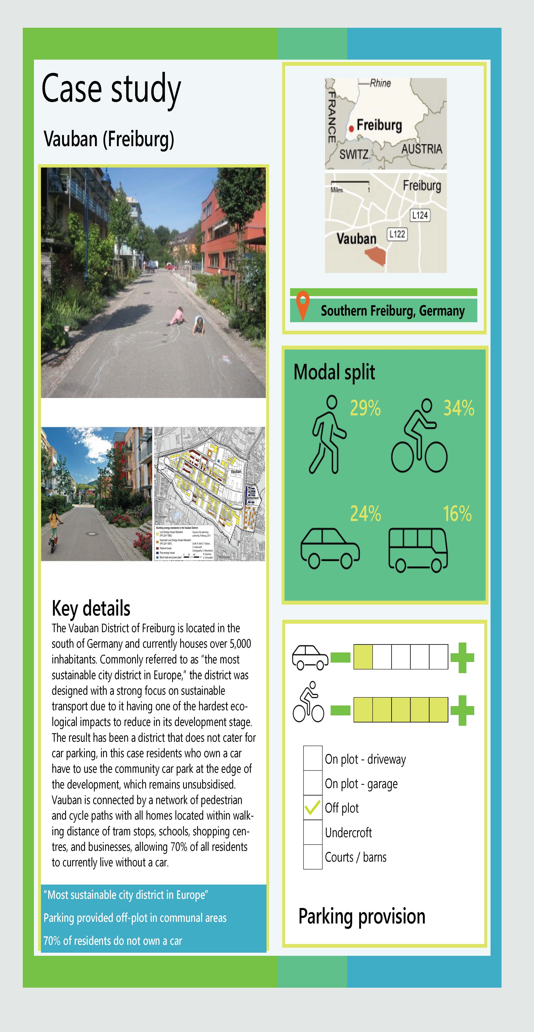
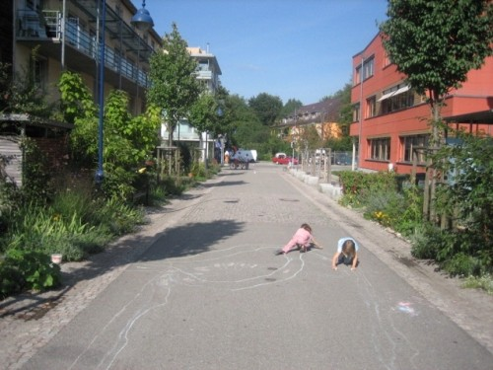
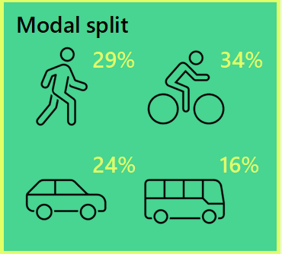
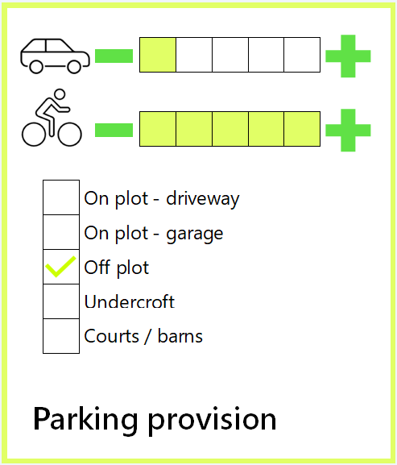
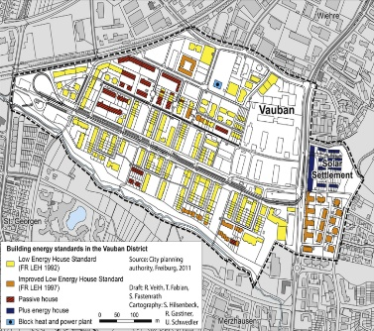
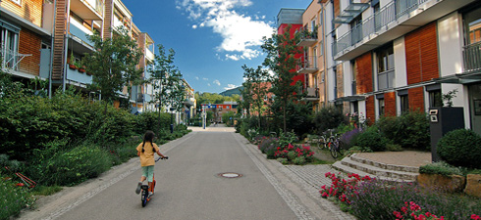
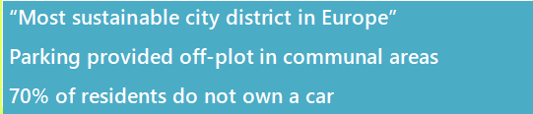
The Vauban District of Freiburg is located in the south of Germany and currently houses over 5,000 inhabitants. Commonly referred to as “the most sustainable city district in Europe,” the district was designed with a strong focus on sustainable transport due to it having one of the hardest ecological impacts to reduce in its development stage. The result has been a district that does not cater for car parking, in this case residents who own a car have to use the community car park at the edge of the development, which remains unsubsidised. Vauban is connected by a network of pedestrian and cycle paths with all homes located within walking distance of tram stops, schools, shopping centres, and businesses, allowing 70% of all residents to currently live without a car.

Car clubs and shared mobility
  - The Evidence Base highlights that car clubs and shared ownership of cars are still an emerging mechanism for reducing car use and car ownership, but that recent evidence suggest they can have a positive impact on car ownership if introduced in the right contexts. Research by CoMoUK suggests that each car club vehicle can on average replace 18 to 20 private cars.
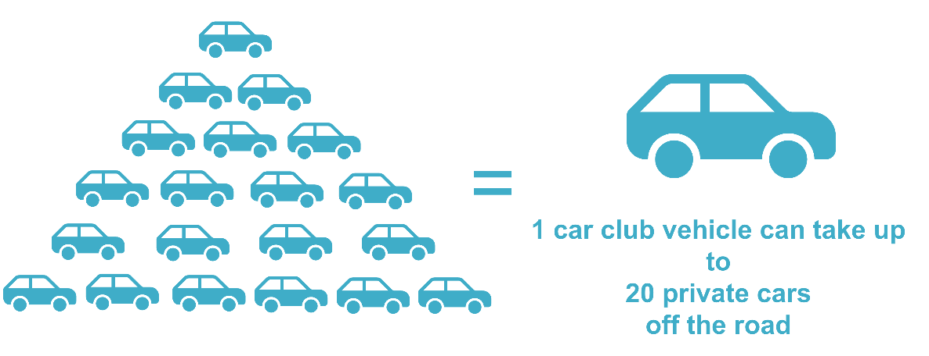
  - Car clubs can be effective in accommodating occasional longer distance journeys, or journeys which are more difficult to make by public transport, with everyday trips being made using sustainable and active modes. They are also becoming a valuable sales tool for developers, with many prospective residents seeking out the comfort of access to a second vehicle, without needing to own it (and cover the costs of vehicle ownership). The decision to give up a car is also one often made around significant life changes, for example moving house, which suggests building shared car ownership into new developments has the potential to engender the greatest uptakes.
  - Shared mobility could have the potential to reduce household car ownership and the proportion of lone-driver trips which are made in cars. There may be a role for car clubs to play in bridging the gap between one and two car households, if space is only provided for one vehicle to park per dwelling.
  - Car clubs can go hand in hand with mobility hubs, which should be provided within walking distance of every home and at minimum include a bus stop, seating, shelters and bicycle parking. Larger, ‘core’ mobility hubs offer the opportunity to co-locate car club and car hire spaces, retail, freight consolidation and parcel lockers, bike/e-bike and other micro-mobility hire, and community space.
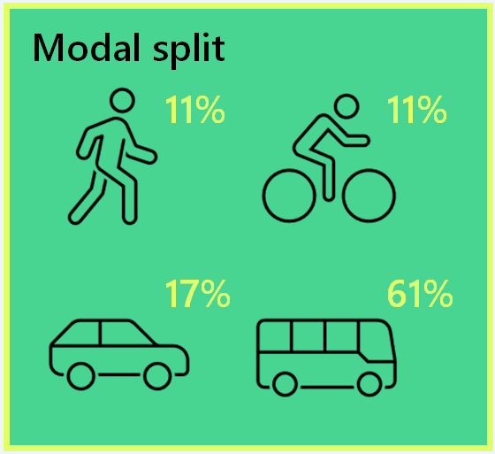
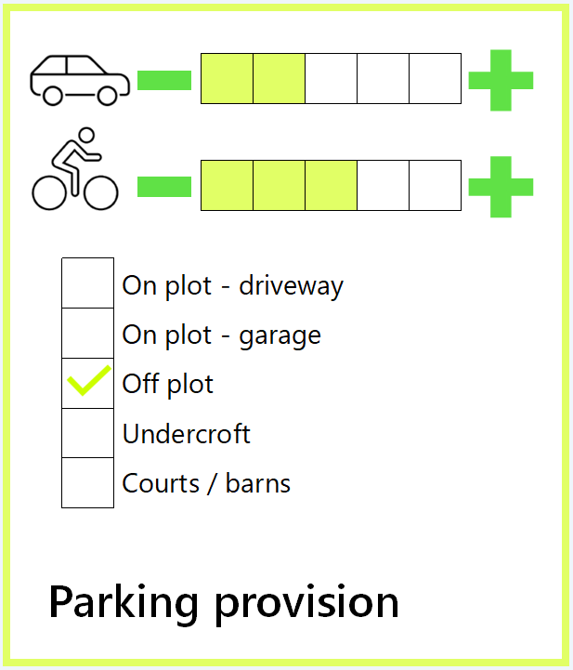

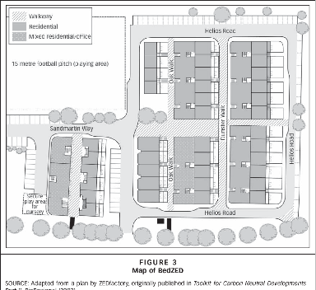
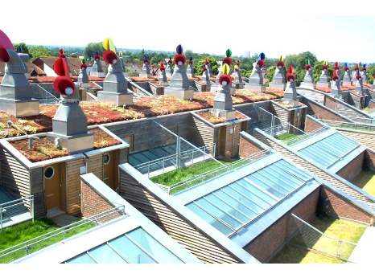
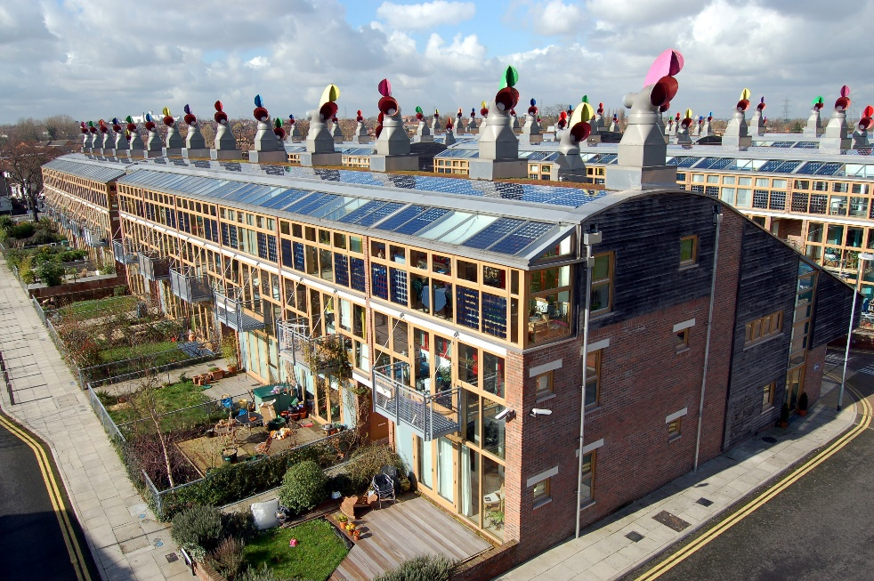
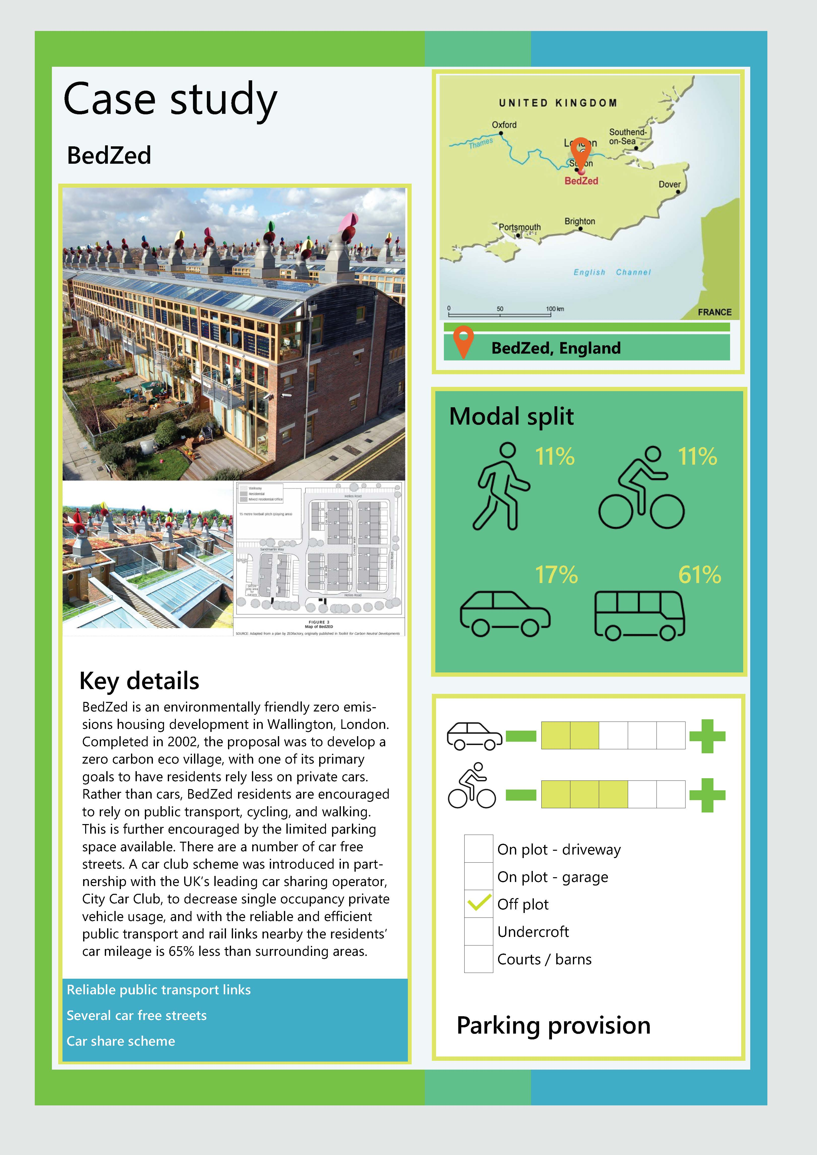
BedZed is a zero emissions housing development in Wallington, London. Completed in 2002, the proposal was to develop a zero carbon eco village, with one of its primary goals to have residents rely less on private cars. Rather than cars, BedZed residents are encouraged to rely on public transport, cycling, and walking. This is further encouraged by the limited parking space available. There are a number of car free streets. A car club scheme was introduced in partnership with the UK’s leading car sharing operator, City Car Club, to decrease single occupancy private vehicle usage, and with the reliable and efficient public transport and rail links nearby the residents’ car mileage is 65% less than surrounding areas.

Demand management
  - Alongside positive measures which work to encourage new site users to make more sustainable choices, there also needs to be consideration of ‘push’ measures in new development, which make single occupancy private car trips less convenient, less direct and / or attractive. Research shows that even when sustainable travel choices are available, they will not be taken up to their full potential if it remains comparatively easy to travel by car.
  - Effective management and maintenance of parking provision is necessary to ensure an attractive and high-quality place is delivered which realises the outcomes (set out in Figure 2-1).
  - Demand management can cover parking and traffic, and these cover all parts of a journey, at origin, at destination and along the way. For example:
- Parking management
  - On-street parking or loading restrictions
  - Controlled Parking Zones and Restricted Parking Zones
  - Pay & display parking
  - Leased or rented parking
- Traffic management
  - Traffic calming
  - Modal filters and bus gates
  - Car-free streets and Low Traffic Neighbourhoods
  - 20mph speed limits / zones
  - Prioritising walking, cycling and public transport
  - Leased / rented parking in particular forms a potentially highly effective method of parking control in strategic developments, in turn also generating funding for enforcement, maintenance and wider sustainable travel interventions. In GCs this could be part of stewardship.
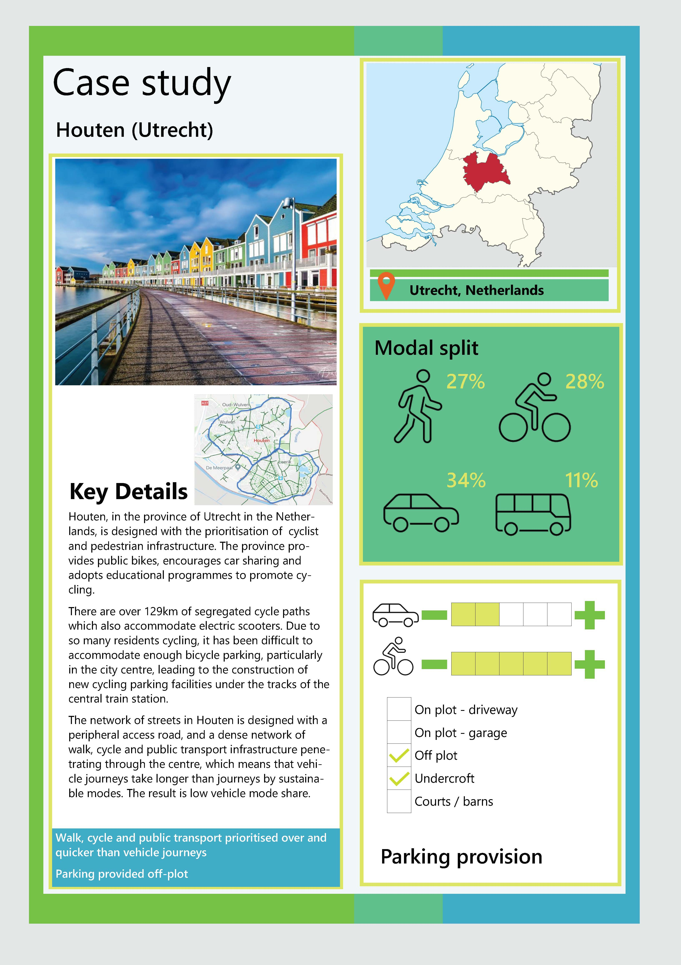

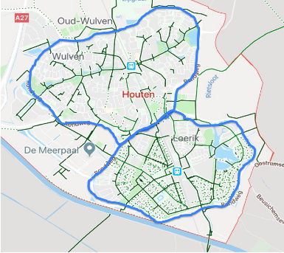
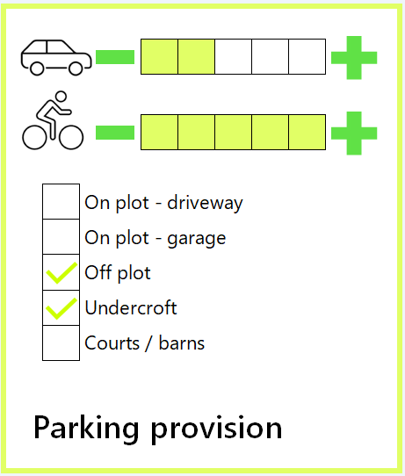
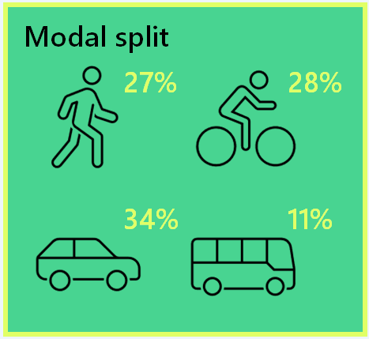

Stewardship and enforcement
Houten, in the province of Utrecht in the Netherlands, is designed with the prioritisation of cyclist and pedestrian infrastructure. The province provides public bikes, encourages car sharing and adopts educational programmes to promote cycling.
There are over 129km of segregated cycle paths which also accommodate electric scooters. Due to so many residents cycling, it has been difficult to accommodate enough bicycle parking, particularly in the city centre, leading to the construction of new cycling parking facilities under the tracks of the central train station.
The network of streets in Houten is designed with a peripheral access road, and a dense network of walk, cycle and public transport infrastructure penetrating through the centre, which means that vehicle journeys take longer than journeys by sustainable modes. The result is low vehicle mode share.

Walk, cycle and public transport prioritised over and quicker than vehicle journeys
Parking provided off-plot
  - There are a number of options for delivery mechanisms and long-term stewardship of GCs, and the Town and Country Planning Association have collated and produced numerous resources on the subject of Stewardship. Stewardship models can provide a mechanism to become self-financing and contribute to the creation and sustainment of good quality places (including key non-car infrastructure such as safe cycling and walking routes) for the long term when applied at scale across GCs or LSDs. They are critical in ensuring the longevity and quality of a place, without whole reliance on the public sector. Parking control is also essential in some areas, for example on some blue light routes or along rapid transit corridors.
  - Parking fits into this model in that stewardship can provide a mechanism by which parking restrictions are managed / enforced, but at the same, the revenue generated by parking (fines, leasing, pay & display) can be fed back into the stewardship body and other functions such as utilities, parks and public realm management. However, income from car parking should not become a “cash cow” and other sources of on-going revenue must be available to fund these functions, including service charging, ongoing developer contributions, and other grants, loans and bonds.
  - Given the good opportunity that parking restraint represents in terms of demand management, it is important to recognise that any parking control (e.g. yellow lines, controlled parking zones or paid for parking) would have associated on-going staffing costs, including enforcement officers on the ground, cameras, back office support, and maintenance of infrastructure such as surfaces, ticket machines and signage. The strategy for accommodating ad-hoc drop-offs, visitors and vehicles relating to deliveries and servicing should also be considered (for example through allowing for waiting, issuing of visitor passes, etc.).
  - Given the above, the approach to stewardship, and parking enforcement, should be considered by site promoters from the outset. Retrospectively introducing Traffic Regulation Orders or other forms of parking control once a development is operational will present challenges in terms of costs and changing embedded behaviours. An assessment of the likely consequences of enforcing or not enforcing should be undertaken when initially planning development, engaging with the North Essex and South Essex Parking Partnerships. This assessment should take into account factors such as proximity to attractors (such as stations or schools), likely car ownership and other deterrents / measures which are planned. Introducing parking enforcement when development is being planned and built means that the costs can be factored into Section 106 agreements rather than borne by the LHA. Parking controls can also be extended over areas which are not yet adopted by the LHA, further helping to embed behaviours early.

Accessibility-led Standards

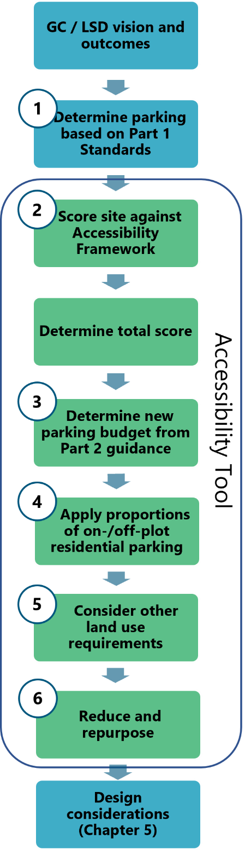
Introduction
  - An Accessibility Tool has been developed to help inform decisions around recommended parking levels for GCs and LSDs. The Tool is comprised of six main steps, which are described below. A hypothetical worked example is set out in Appendix E, providing a step-by-step application of the Tool.
  - The Accessibility Tool assumes that GCs and LSDs will be required (by LPAs/LHAs and their policies) to achieve the outcome and highest levels of accessibility, mode shift and reductions in car ownership. These strategic developments should achieve the minimum scores in the Accessibility Tool’s scoring framework, as the Evidence Base suggests that where they do not meet the minimum scores, they are unlikely to be acceptable in sustainable mobility and planning terms.
  - The Accessibility Tool recommends that a reduction in overall car parking from the more generic standards contained in Part 1 is appropriate for these higher scoring developments.
  - While the Part 2 guidance is aimed at GCs and LSDs, there is an option for LPAs to use the Accessibility Tool to inform decisions around smaller scale developments in highly accessible locations such as city / town centres or at public transport hubs.
  - In all cases and for all land uses, the Part 1 standards form a baseline from which the parking budget is calculated. The parking budget is made from the Part 1 ‘low accessibility’ standards, as these are the most generous standards from which to make reductions, and in many instances, they spatially best represent the locations of GCs and LSDs.
  - The overall recommended standards are presented as parking ‘budgets’, describing the total number of vehicle parking spaces that are recommended across a whole site / phase, leaving flexibility in terms of how and where these are integrated into masterplans.

Applying to phases of development
  - The decision tree in Figure 4-1 overleaf shows how it is anticipated the Accessibility Tool will be used at different stages of the planning process and for different phases of development. It can initially be used as an indicator of the scale of parking budget a strategic development may be able to make to parking numbers, as well as to understand more widely how accessible a development is likely to be and what infrastructure could improve that situation.
  - Following that, the Tool can be used for outline applications, if there is an idea of phases, parcels or neighbourhoods and their associated infrastructure. Parking provision is most often detailed in Full and Reserved Matters applications, and at this point it is expected that the detail of infrastructure delivery, development quanta and connectivity are also known.
  - It is important to note that the Accessibility Tool does not incentivise excessive parking provision in early phases of development – a key principle of sustainable strategic development should be early infrastructure delivery, and this is particularly so at new GCs where central Government funding is often secured to deliver such infrastructure. GCs and LSDs overall must meet the minimum thresholds against the Accessibility Tool’s scoring framework. The Tool allows for a change from the Part 1 standards where infrastructure is delivered early, but equally recognises that under-provision of parking before there are other genuine sustainable travel choices is likely to result in parking overspill. As part of the overall proposal, it is important that there are mechanisms in place to promote the delivery of sustainable transport infrastructure prior to occupation to encourage sustainable travel habits from day one. Where a greater level of parking is provided in early phases, the design component of the Part 2 guidance is important to ensure that parking does not dominate streets and places.
  - The Tool also incorporates an element of iteration back to early phases as later phases (and their associated infrastructure) are built out. Early phase parking provision should be revisited and repurposed as and when the later phases are constructed, and their sustainable travel benefits are realised.

Evidencing the approach
  - The Accessibility Tool is provided separately on the EPOA website and will be updated periodically to reflect changes to baseline accessibility levels. Applicants and their consultants should evidence the calculations and scoring undertaken for each phase of development by providing copies of the Accessibility Tool as part of the planning submission (one copy per phase / neighbourhood, if applicable).
  - Application of this guidance and the Accessibility Tool may be relevant to cumulative development, that is, sites which are adjacent or nearby but are being promoted by different landowners or developers. Infrastructure jointly delivered by neighbouring sites may sustainable mobility benefits for both, even if in isolation they fall below the definitions of an LSD or GC.
  - In these instances, decisions should be made based on what is certain and deliverable, which may result in each application being considered on its own merits. This guidance, however, encourages early and proactive discussions between developers and the LPA / LHA to establish mechanisms for building certainty, joint funding of interventions, and potential consideration as ‘one’ development within the Accessibility Tool.

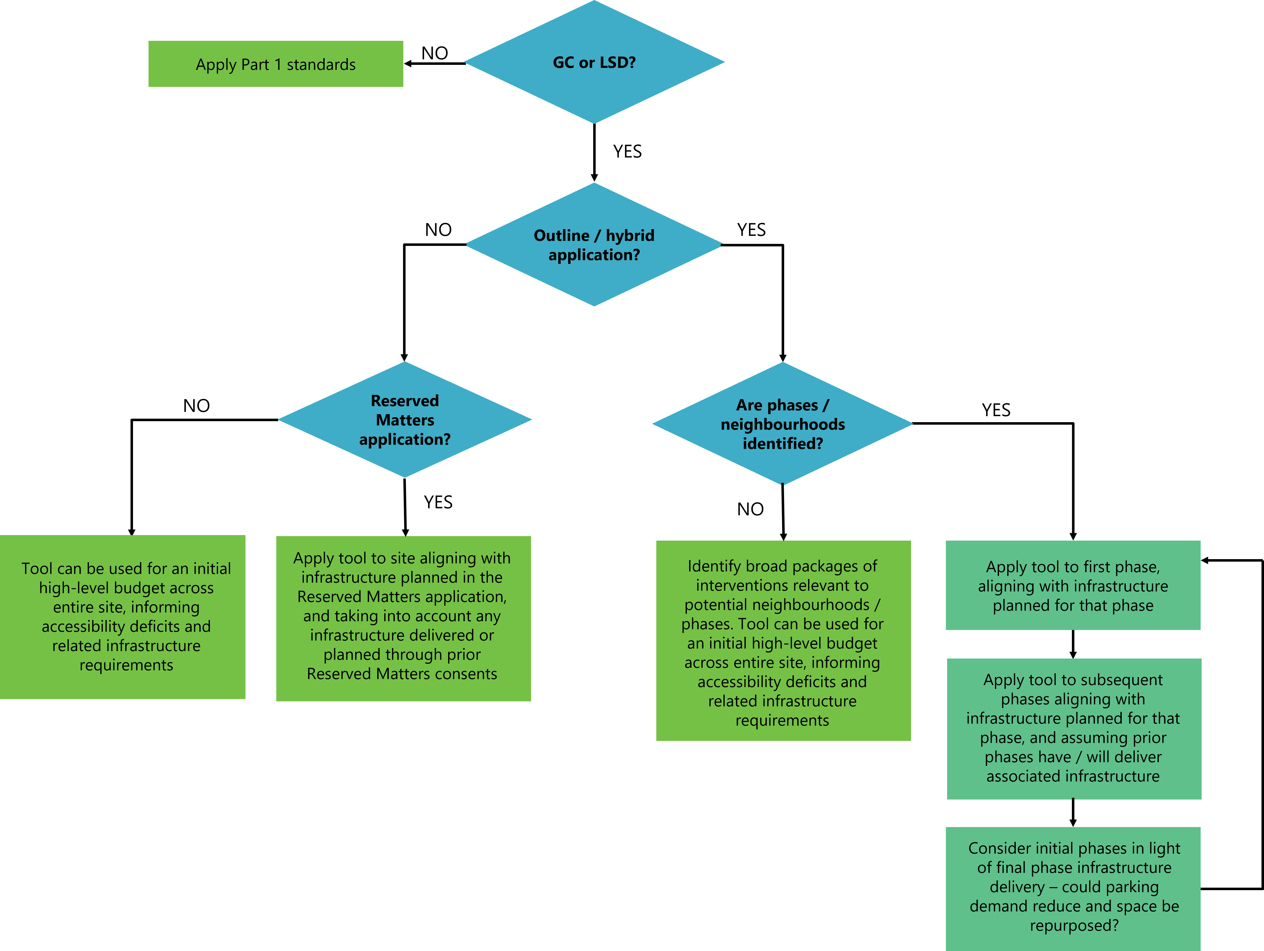
Figure 4-1: Decision tree for use of Accessibility Tool

Step 1 – Determine parking based on Part 1 standards
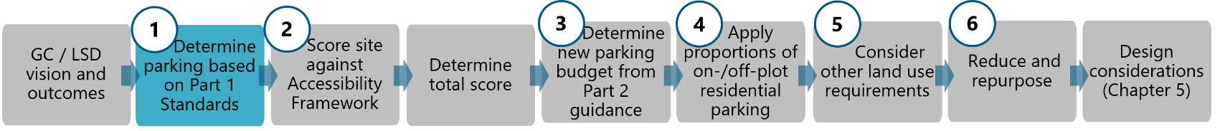
  - Initially, the Accessibility Tool calculates the C3 residential parking levels as recommended by the Part 1 standards (for ‘low accessibility’ areas). This forms the baseline against which a reduction is applied, subject to the Accessibility Tool outcomes. The Part 1 C3 standards are replicated below for ease.
Table 4-1: Part 1 standards for C3 residential development in ‘low accessibility’ areas
Use | Vehicle | Cycle | PTW | Disabled
1 bedroom | 1 space per dwelling* | 1 secure covered space per bedroom  None if garage or secure area is provided within curtilage of dwelling | Large flatted developments to provide PTW parking area(s) based on need | N/A if parking is in curtilage of dwelling  Flatted developments to provide a minimum of 5% of number of dwellings or actual need whichever is the greater
2 bedrooms | 2 space per dwelling*
3 bedrooms | 2 space per dwelling*
4+ bedrooms | 3 spaces per dwelling*
Visitor/ unallocated | 0.25 spaces per dwelling (unallocated) (rounded up to nearest whole number) | If no garage or secure area is provided within curtilage of dwelling, then 1 space per 8 dwellings for visitors | 1 space plus 1 space per 20 car spaces for first 100 car spaces, then 1 space per 30 car spaces over 100 car spaces
* Excluding garage if less than a 7m x 3m internal dimension

Step 2 – Score against Accessibility Framework
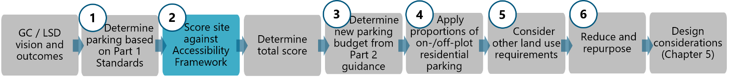
  - The strategic development being assessed will receive a score between 1 and 6 against seven metrics, drawn from the understanding of the Essex context and the ‘supporting measures’ needed alongside parking restraint to deliver good outcomes (described in Chapter 3). The summed total of these scores determines the band within which the development falls, informing the parking budget.
  - The seven metrics in the Accessibility Framework are shown in Table 4-2 overleaf and are as follows:
- Existing car ownership: is shown in Map 1 overleaf, and is derived from car ownership information from the 2011 Census and presented by Lower Super Output Area (LSOA). The colours of the mapping reflect the associated score category (1 to 6).
- Existing (commuter) car driver mode share: is shown in Map 2, and is derived from journey to work information from the 2011 Census and presented by LSOA. The colours of the mapping reflect the associated score category (1 to 6).
- Existing accessibility level: is shown in Map 3. This is made up from three key layers - listed below - which are overlaid to form one overall ‘score’ for existing connectivity levels across the EPOA area. Again, the colours of the mapping reflect the associated score category (1 to 6).
  - Accessibility to urban centres within 10- and 20-minute walking times
  - Accessibility to urban centres within 10- and 20-minute cycle times
  - Public Transport Accessibility Level (PTAL)
  - The individual maps listed above are included in Appendix A. Accessibility level maps showing more detail at district / authority level are included in Appendix C.
  - Where a site or phase is within two areas, the area covering the majority of the site should be used for scoring. Where this is not clear, the presumption should be in favour of the more positive outcome (lower car ownership / lower vehicle mode share / higher accessibility level).
  - The remaining metrics consider the proposed future situation as follows:
- Range of land uses – is informed by the availability of key facilities that will support the new development. For the largest strategic developments, it is anticipated that most of these will be delivered within the site to support internal trips and shorter trips which can be made by sustainable modes. Delivering these facilities in earlier phases of development can help to establish a local community and more sustainable travel habits for the long term.
- Public transport improvements – measured by the frequency and proximity of public transport, but as a proxy to other important considerations around quality of stops / halts, destinations of routes and priority of buses over private vehicles.
- Active mode improvement – considering the infrastructure provided for walking and cycling, ensuring safe, convenient and attractive routes to facilitate local trips compared to comparative vehicle journeys.
- Micromobility / shared transport – considering the future availability of shared mobility to increase access to sustainable and active modes, and reduce the need to own vehicles as individuals.
  - The metrics have been selected to reflect the key determinants of parking demand, as set out in the Evidence Base and the earlier chapters of this guidance. They also recognise that strategic development sites in an area with existing high levels of car dependency (low scores on the first three metrics), can overcome these influences by delivering sustainable transport-focussed interventions, including a variety of land uses (scoring well against the last four metrics). This is also true in the reverse in that a strategic development cannot usually rely solely on existing conditions and infrastructure to embed habits amongst new site occupants.
Table 4-2: Accessibility framework
Metric | 1  less potential to reduce parking provision | 2 | 3 | 4 | 5 | 6  more potential to reduce parking provision
Existing car ownership  (Map 1) | Existing area has car ownership levels higher than the Essex average (>2 vehicles per household on average) | Existing area has car ownership levels higher than the Essex average (>1.5 vehicles per household) | Existing area has car ownership levels higher than the Essex average (>1.35 per household) | Existing area has car ownership levels lower than the Essex average (<1.35 per household) | Existing area has car ownership levels lower than the Essex average (<1.2 per household) | Existing area has car ownership levels lower than the Essex average (<1 per household)
Existing car driver mode share  (Map 2) | Existing local driving mode share is higher than the Essex average (>75%) | Existing car driver mode share is higher than the Essex average (>70%) | Existing car driver mode share is higher than the Essex average (>65%) | Existing local driving mode share is lower than County average (<65%) | Existing car driver mode share is lower than the Essex average (<60%) | Existing car driver mode share is lower than the Essex average (<55%)
Existing accessibility  (Map 3) | Majority of developable masterplan area is of very low accessibility | Majority of developable masterplan area is of low accessibility | Majority of developable masterplan area is of moderate accessibility | Majority of developable masterplan is of good accessibility | Majority of developable masterplan is of high accessibility | Majority of developable masterplan area is of very high accessibility
Range of land uses* | <20% new homes are within a 15-minute walk of at least three facilities | >20% of new homes are within a 15-minute walk of at least three facilities | >40% of new homes are within a 15-minute walk of at least three facilities | >60% of new homes are within a 15-minute walk of at least three facilities | >80% of new homes are within a 15-minute walk of at least three facilities | All new homes are within a 15-minute walk of at least three facilities
Public transport improvements** | Less than 50% of the built development is within 400m of a bus service | At least 50% of the built development is within 400m of bus stop with a service operating every 30 minutes or more | At least 80% of the built development is within 400m of bus stop with a service operating every 30 minutes or more | At least 90% of the built development is within 400m of bus stop with a service operating every 30 minutes or more | At least 90% of the built development is within 400m of bus stop with a service operating every 15 minutes or more | At least 90% of the built development is within 400m of bus stop with a service operating every 10 minutes or more
Active mode improvement | None of the built development caters for active modes over cars - it is easier, quicker and more direct to access local services by car |  | Development somewhat caters for active travel - it is as easy/quick/direct to access key local services by walking/wheeling as it is by car |  | Development caters well for active travel - it is easier/quicker/more direct to access key local services by walking/wheeling than by car
Micromobility / shared transport*** | None of the built development is close to a mobility hub | <20% of the built development is within 800m of a mobility hub | >50% of the built development is within 800m of a mobility hub | >50% of the built development is within 400m of a mobility hub | >70% of the built development is within 400m of a mobility hub | >90% of the built development is within 400m of a mobility hub
*daily facilities (subject to local authority agreement) could include: convenience store, nursery, primary school, secondary school, pharmacy, GP, open space/green infrastructure, community building, post box, employment.
**average weekday daytime bus frequency. Rail accessibility may be taken into account in agreement with the LPA and LHA.
***Mobility hub to be defined according to site context and best practice guidance. They should at minimum include one public transport option and one shared transport option according to the CoMoUK accreditation document (see https://www.como.org.uk/mobility-hubs/overview-and-benefits).
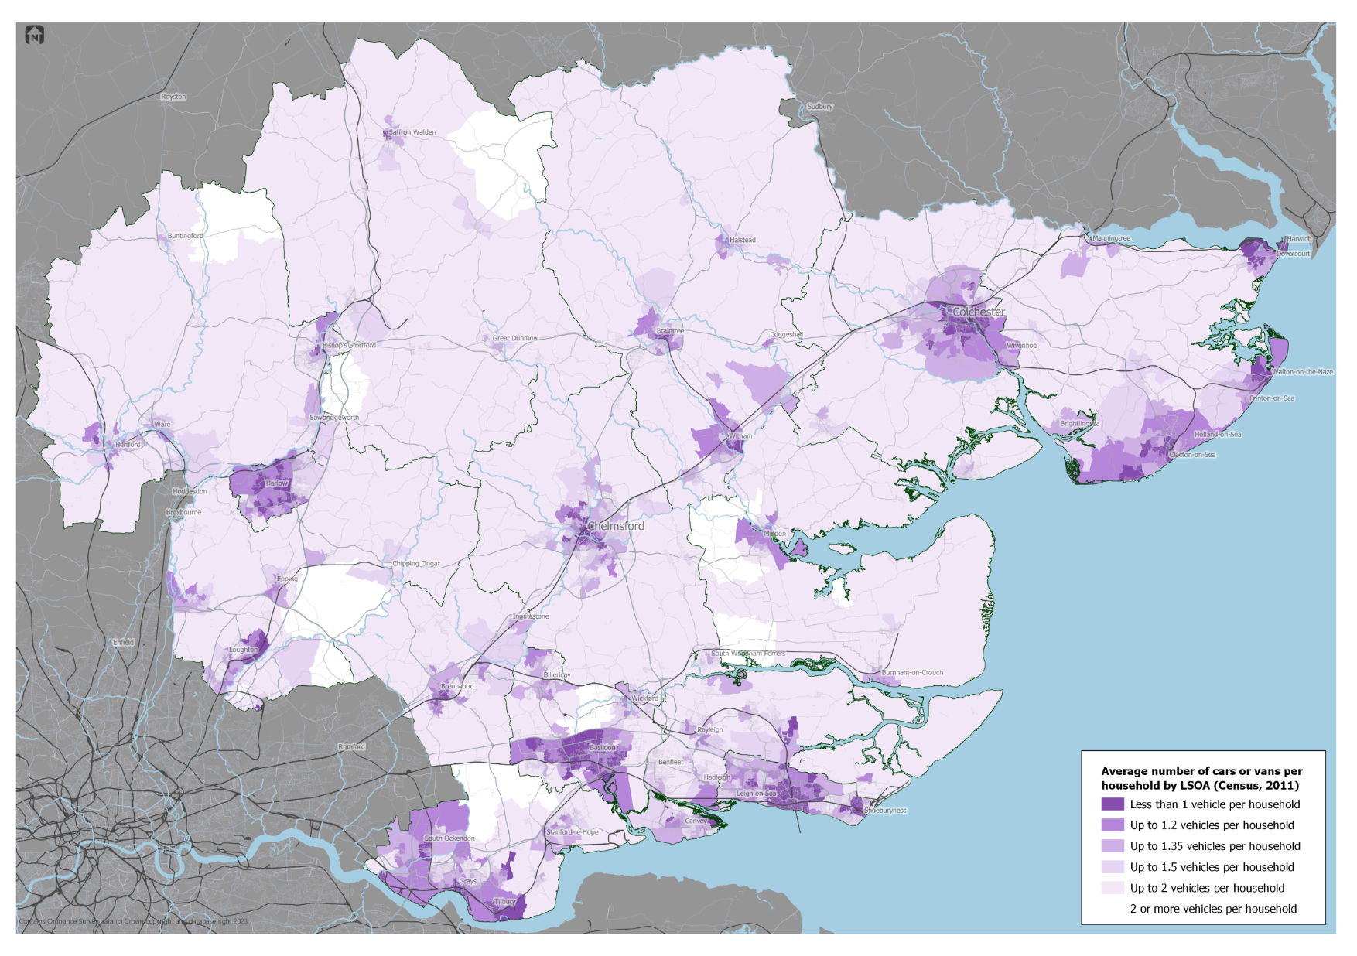
Map 1: Existing car / van ownership in Essex
Map 1
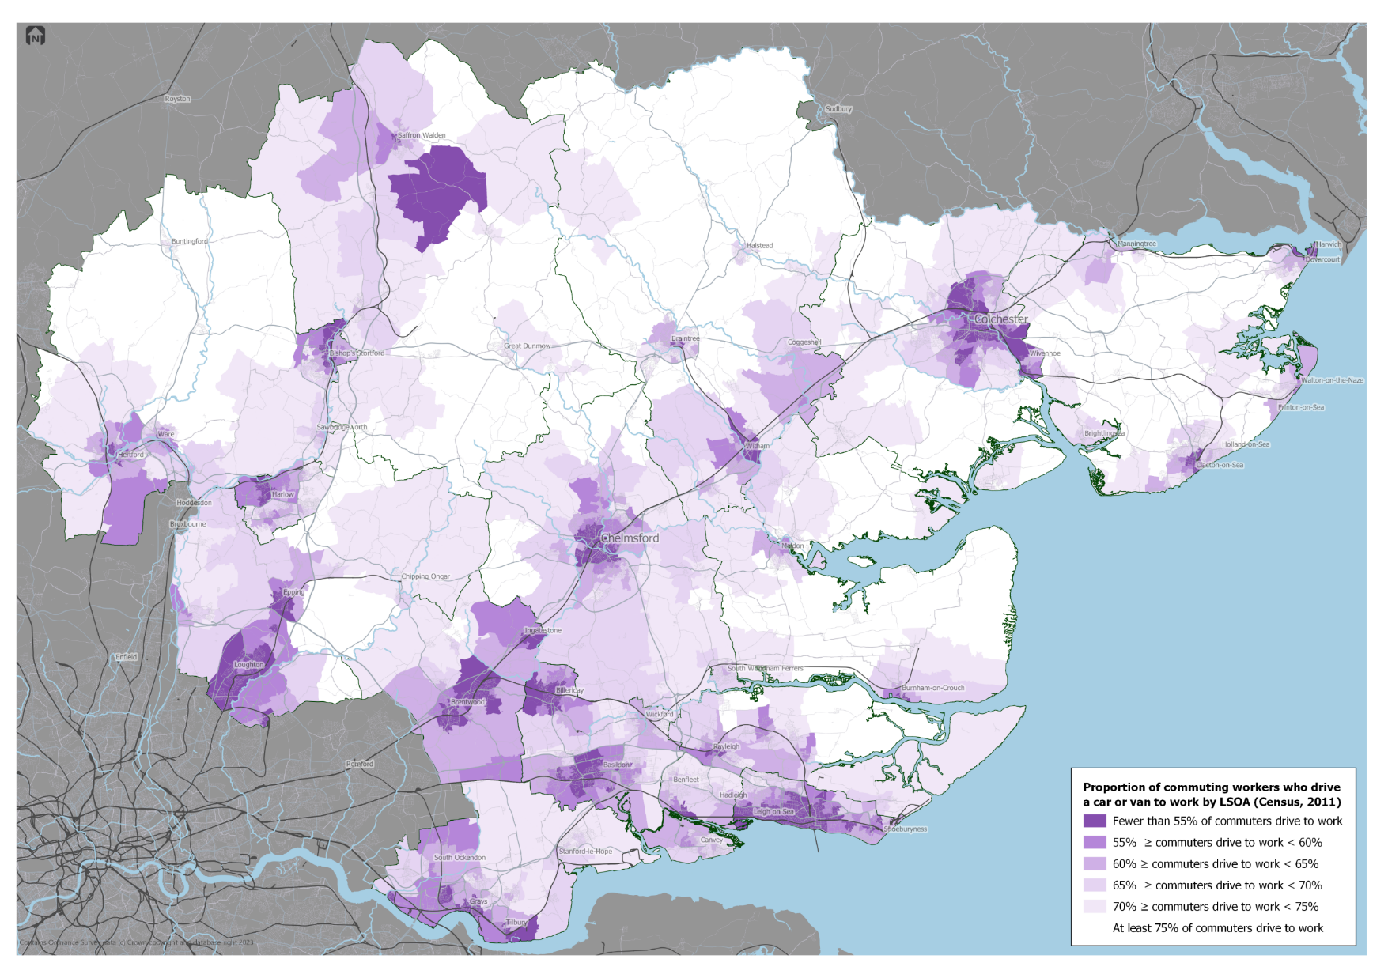
Map 2: Existing car driver mode share in Essex

Map 2
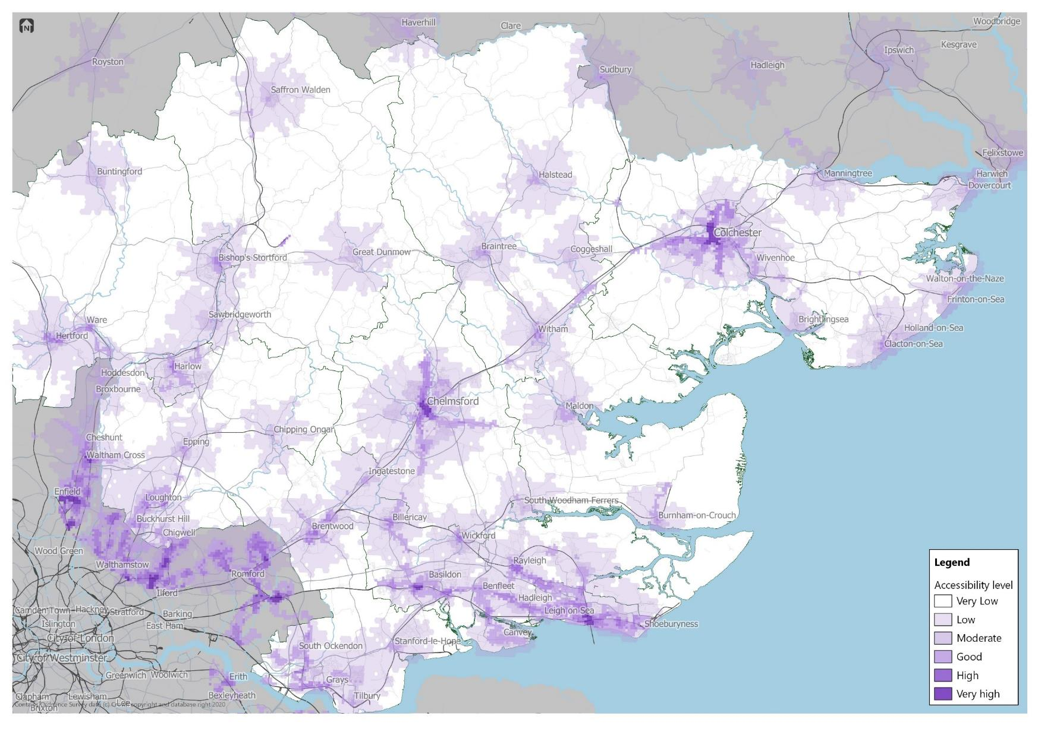
Map 3: Accessibility scores
Map 3

Step 3 – Determine parking budget
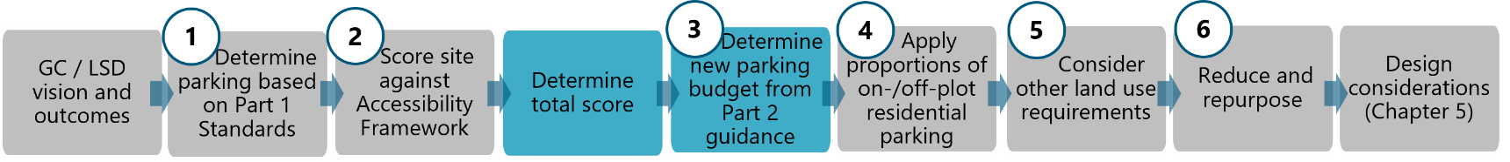
  - Summing the scores across the seven metrics results in a total. The higher the total score, the more potential for a development to achieve better sustainable transport outcomes. Based on the Evidence Base, outcomes have been associated with each of the three highest scoring categories in relation to mode share and car ownership rates. These are indications of what be expected if sustainable transport is prioritised throughout the masterplanning, design and implementation of the development but they should not be viewed as a certainty of outcome.
  - For LSDs it is expected that a score of 21 or more is achieved. For GCs this is higher, with a minimum score of 26 expected. If a site does not score this initially, then in negotiation with the LPA and LHA, consideration should be given to improving metrics 4 to 7 from Step 2 to support a more sustainable development in transport terms.
Result | 0 to 10 | 11 to 15 | 16 to 20 | 21 to 25 | 26 to 30 | 31 and above
Outcome | Likely to sustain or worsen business as usual levels of sustainable mode share and car ownership | Likely to sustain business as usual levels of sustainable mode share and car ownership | Opportunity to reach a sustainable mode share and car ownership rates around the County average | Opportunity to reach >40% sustainable mode share and car ownership rates below 1.35 per household | Opportunity to reach >50% sustainable mode share and car ownership rates below 1.2 per household | Opportunity to reach >60% sustainable mode share and car ownership rates below 1 per household
 | Development unlikely to be acceptable - higher scores need to be achieved |  |  | Minimum to be achieved by LSDs | Minimum to be achieved by GCs | Desirable for GCs
 | Standards to Apply
Part 1 ‘low accessibility’ | Apply Part 1 standards relative to accessibility level | Apply Part 1 standards relative to accessibility level | Apply Part 1 standards relative to accessibility level | Apply low reduction to Part 1 standards | Apply medium reduction to Part 1 standards | Apply high reduction to Part 1 standards
  - Where higher scores are achieved, a lower level of parking budget for residential (C3 Use Class) is recommended to further support the sustainable transport interventions proposed. These present reductions from Part 1 ‘low accessibility’ C3 standards and are presented as a total private parking budget, representing the maximum quantum of private residential vehicle parking allowable across the phase / neighbourhood. Approaches to visitor, PTW, disabled, cycle and EV parking are detailed in the following steps.
  - The onus is on the applicant to demonstrate that this overall parking budget has been provided across all of the dwelling types / sizes / tenures within the site / phase. It may be appropriate to provide some low or no-car development within the centre of a neighbourhood (e.g. apartments within the local centre), whereas more parking might be expected on the peripheries of a neighbourhood. The parking budget can be distributed as appropriate to account for this variation.
  - Chapter 5 describes the design typologies appropriate to different contexts, dwelling types and Use Classes.

Step 4 – On-/off-plot proportions
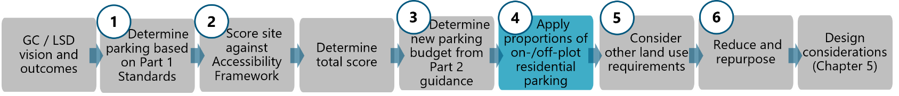
  - The total private parking budget (excludes visitor and car club spaces) is broken down further to give desired proportions of on- and off-plot parking. This reflects the findings of the Evidence Base, demonstrating that off-plot (and ideally unallocated) parking is a more efficient, and often more attractive, way of providing residential parking.
  - Higher provisions of off-plot parking are also important in planning for reducing and repurposing parking in the future (see Step 6), as it will be more straightforward and more land efficient to repurpose areas of off-plot parking which have been designed for repurposing, rather than repurposing driveway parking.
  - Within the Accessibility Tool the following recommendations are generated:
- Proportion of off-plot – derived from total private parking budget.
- Proportion of on-plot – the remainder of total parking can be allocated on-plot.
- Minimum number of additional car club spaces – these are added to the total private parking budget and are derived from total dwellings for the site / phase.
  - The levels recommended are based on the score the site / phase receives in Step 2.

Step 5 - Other land uses
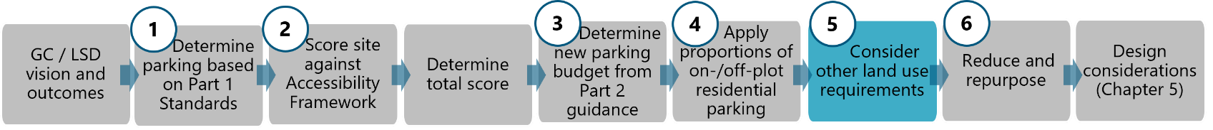
  - It is anticipated that strategic developments will incorporate other land uses beyond C3 residential dwellings, for example leisure, retail, healthcare or commercial. All journeys have an origin and a destination, and conventionally it has been accepted that trip-making is easier to influence at the origin. However, availability of parking at a destination is a key determinant of whether people choose to drive. It is recognised that some land uses are more appropriate than others to apply restrictions to, and that applicants rarely have any influence over how externally originating trips are made, however an abundance of parking at a destination contributes towards car-borne trips to that destination.
  - The approach to each non-residential land use in a strategic development is determined by the score the site/phase achieved in Step 3. Step 5 adopts three different approaches, depending on the Use Class:
- Parking to be delivered with the same reduction applied to C3 residential in Step 1; or
- Parking to be delivered with some reduction, but not as much as is applied to C3 residential; or
- Parking is to be delivered with no reductions from Part 1, irrespective of the Accessibility Tool score.
  - Reductions to apply to non-residential land uses mostly likely to be provided in a GC or LSD are set out in Appendix D. Part 1 should be consulted for any land uses not listed. The non-residential parking standards in Appendix D represent minimum standards.

Step 6 – Reduce and repurpose
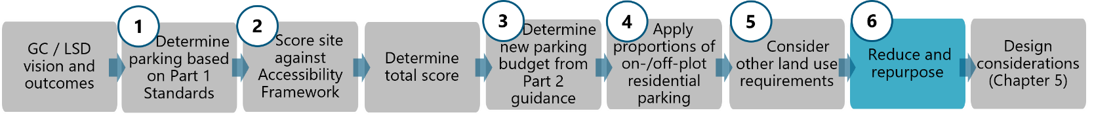
  - The final step may not be implemented in practice for some time after a phase is constructed, however an outline strategy for future reductions to parking should be developed during the planning stage. The approach of reducing parking standards over phases has been successfully adopted in Ebbsfleet Garden City (overleaf), and the Garden City parking guidance promotes ‘interim’ approaches to parking design which group together unallocated parking provision such that it could be more easily repurposed in the future.
  - It is not allowable to use further parking restraint (in isolation) to drive down car ownership where sustainable travel targets / outcomes are not being met. Instead, initial parking provision in a phase could be reduced over time because:
- Demand for car ownership / use reduces due to technological and cultural shifts.
- Demand for car ownership and car use reduces as future phases deliver new sustainable travel infrastructure and key facilities / amenities.
  - As such, the Accessibility Framework and scoring in Step 2 of the Tool is repeated in Step 6, this time envisaging a future where the entire strategic development is built out and all planned infrastructure is successfully delivered. This is likely to result in the earlier phases scoring higher against the Framework than they did in Step 2, and hence a lower total parking budget would be suggested.
  - The difference between the parking budget calculated in Step 2/3 and the potential future parking budget calculated in Step 6 should be considered in the design of parking for the phase. This will likely result in a proportion of parking needing to be designed with repurposing in mind (see Chapter 5) and may result in the proportion of off-plot parking reducing, as this is more straightforward to repurpose. Repurposing would be most appropriate in areas of off-plot, unadopted parking, where it would be delivered by the stewardship body or developer.
  - Parking for disabled people, car club vehicles and cycle parking provision should not reduce over time, in fact car club and cycle parking provision may increase as space previously used for storage of vehicles is repurposed for cycle parking. It may not be appropriate to reduce visitor parking or car parking at non-residential land uses over time; this should be considered on a case-by-case basis with the LPA and LHA.
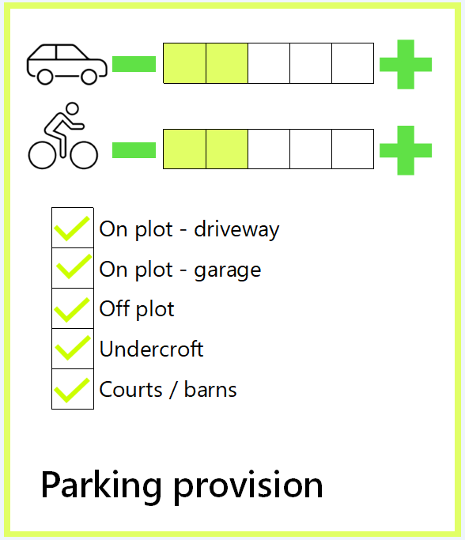
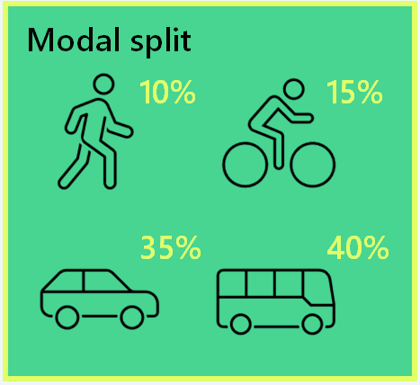
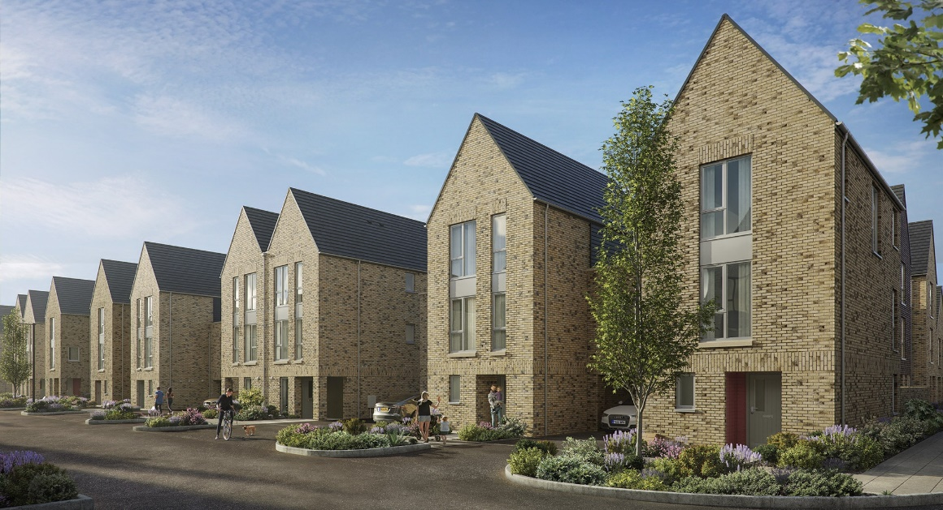
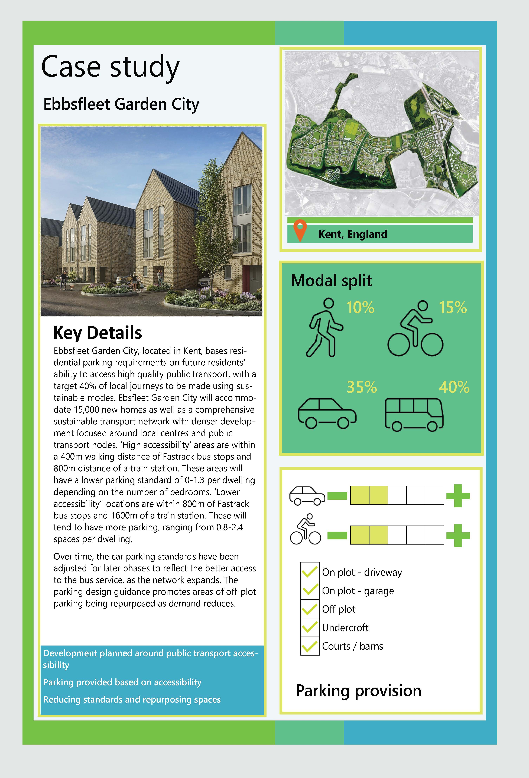
Development planned around public transport accessibility
Parking provided based on accessibility
Reducing standards and repurposing spaces
Ebbsfleet Garden City, located in Kent, bases residential parking requirements on future residents’ ability to access high quality public transport, with a target 40% of local journeys to be made using sustainable modes. Ebbsfleet Garden City will accommodate 15,000 new homes as well as a comprehensive sustainable transport network with denser development focused around local centres and public transport nodes. ‘High accessibility’ areas are within a 400m walking distance of Fastrack bus stops and 800m distance of a train station. These areas will have a lower parking standard of 0-1.3 per dwelling depending on the number of bedrooms. ‘Lower accessibility’ locations are within 800m of Fastrack bus stops and 1600m of a train station. These will tend to have more parking, ranging from 0.8-2.4 spaces per dwelling.
Over time, the car parking standards have been adjusted for later phases to reflect the better access to the bus service, as the network expands. The parking design guidance promotes areas of off-plot parking being repurposed as demand reduces.

Outcomes by Design
  - The previous chapters have given guidance on the role of parking in strategic developments and the quantity (budget) of parking to be provided based on existing and future accessibility levels. This chapter provides guidance on designing this parking into new sustainable strategic developments. The design of parking is an important element of the National Design Guide and other relevant design publications such as Building for a Healthy Life and Streets for a Healthy Life, and it plays a critical role in the feel and function of streets and spaces, influencing landscaping, placemaking, safety and amenity. Parking does not just affect how a place looks, it can also affect how happy people feel about where they live and work. Parking should feel secure, cater for demand (where other sustainable modes have been maximised) and be accessible for people with reduced mobility.
  - This chapter guides how the GC and LSD parking outcomes described in Chapter 2 can be realised through applying design principles and typologies, informed by the parking hierarchy which prioritises active and sustainable modes above single occupancy vehicles. It is not exhaustive, prescriptive or detailed design guidance for parking – further detail can be found in Part 1, the EDG, and the national design publications referenced above (amongst others). It is expected that alongside transport practitioners, architects, urban designers and masterplanners involved in the development of a GC or LSD will take an active role in ensuring that parking design achieves the outcomes.

Design principles
  - The six overarching design principles set out in overleaf should guide the design of parking in new GCs and LSDs. It should be noted that the imagery shown in this chapter is used to help illustrate and explain terminology for types of parking, and is not necessarily exemplary of successful design more widely, for example design of buildings or soft landscaping.

Figure 5-1: Design principles
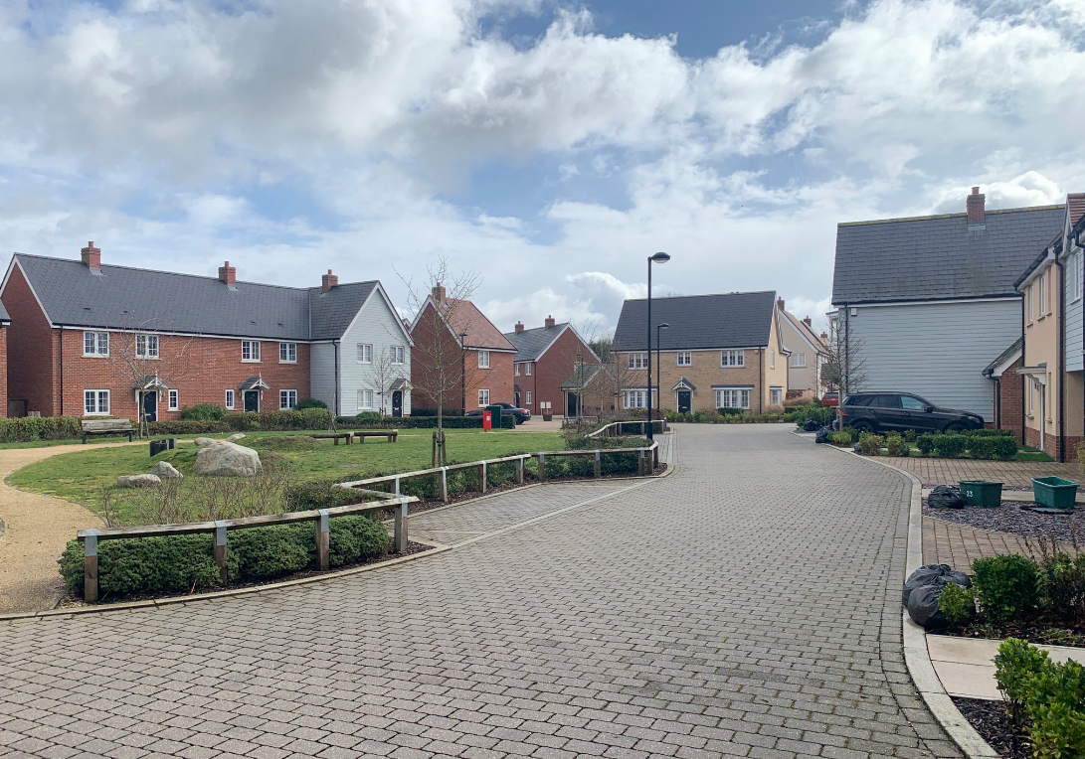
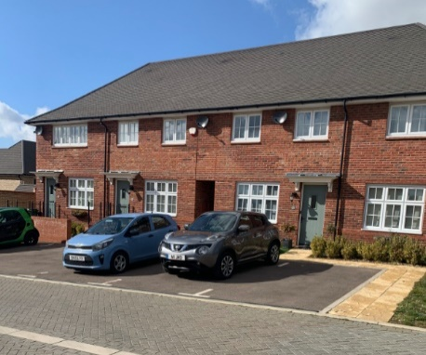
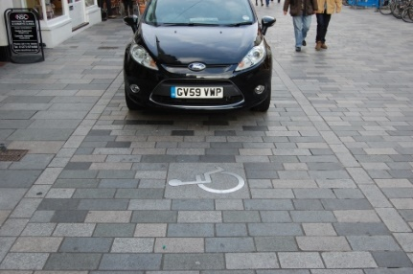
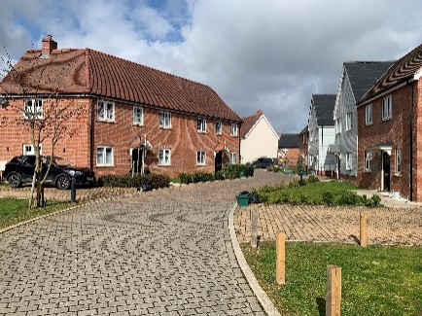
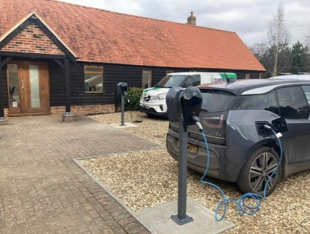
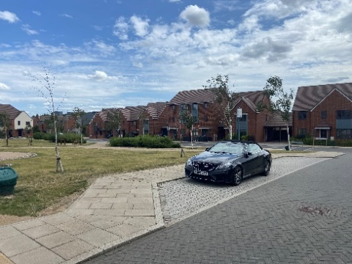
Place-led design
Car parking affects the quality of a place and how people use it. Parking should be place and design-led, embedded in wider urban design and masterplan outcomes, with typologies contained within a Design Code. Parking that is designed in isolation will result in poor outcomes.
Shared wherever possible
Allocated car parking results in inefficient use of land in residential and non-residential settings, because under used space is not available for use by other residents or neighbouring uses, at times of high demand.
Accessible to all
People with disabilities may be more likely to need to drive or need adapted cycles. Sufficient parking dedicated to disabled drivers, cyclists and wheelers should be provided for residents and visitors in convenient locations.
Secure and appropriately located
Well managed outcomes
Flexible and future-proofed
People should feel safe when parking and comfortable leaving their car or cycle behind. Active mode parking should be convenient whereas car parking should be less convenient, (aside from accessible spaces).
Design should manage out inconsiderate parking and therefore the need for enforcement is reduced. The impact on design of the necessary signs and lines should be considered, as well as mechanisms and funding for enforcement and maintenance.
Parking should be designed such that it can be repurposed in the future, if demand falls, and so that it can adapt to technologies for electrification of vehicle and micro-mobility modes.

Applying the principles

Place-led design
  - Place-led design is as important when designing areas of parking as it is when planning the built form, streets and green spaces. Parking should integrate with landscaping and public realm, sitting within it rather than dominating. Materials which complement the palette of the wider development should be used (e.g. on garage doors, surfaces), whilst recognising implications for drainage and maintenance.
  - Parking areas and lengths of bays should be screened (for example with planting) and broken up by street trees, to soften the impact of expanses of hardstanding and vehicles. Where it is provided within public spaces or streets, it should utilise sympathetic design concepts which also allow flexibility for its repurposing in the future into uses which better complement and activate the street, such as bike hangars or parklets.
  - Parking typologies and design elements relevant to the development scale and context should be embedded in Design Codes, identifying appropriate typologies for area, street or building types.
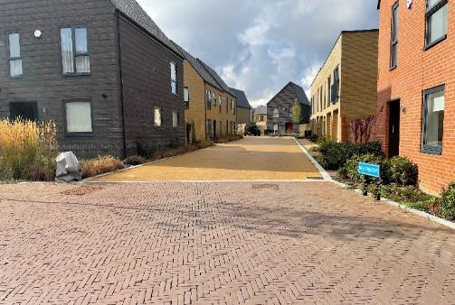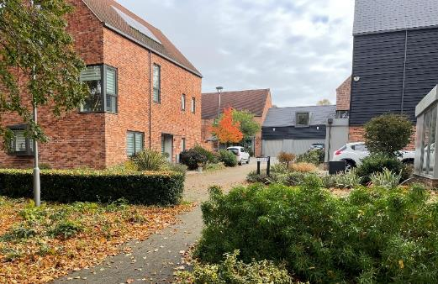
1. ITP – The Avenue (Saffron Walden). Showing parking on street and on driveways which is broken up by planting.
2. ITP – Newhall (Harlow). Showing a street which incorporates parking typologies that screen parking or take it away from the street entirely.

Shared wherever possible
  - The Evidence Base demonstrates that shared parking presents the most efficient use of space, both for residential and non-residential land uses. As some households will have one (or no) vehicle, they will not need two allocated spaces, for example. If they are shared, this allows households with more than one vehicle to make use of those spaces instead. Similarly, non-residential land uses tend to reach their peak parking demand at different times of the day, and hence shared parking can cater for peaks across the day if complementary land uses are co-located.
  - Shared parking will not always be appropriate for every dwelling or land use, and some allocated parking – for example on driveways – adds variety and depth to a street (among other placemaking measures). On-plot and allocated parking can be designed sympathetically, but should not make up the majority of parking at GCs and LSDs (as informed by the outputs of the Accessibility Tool).
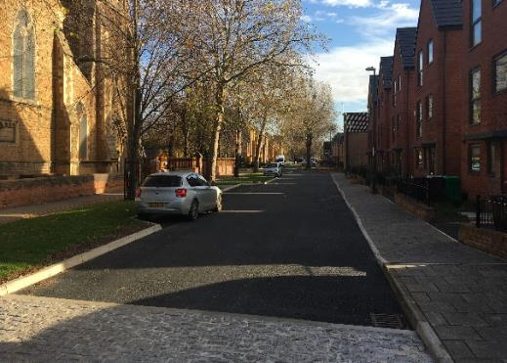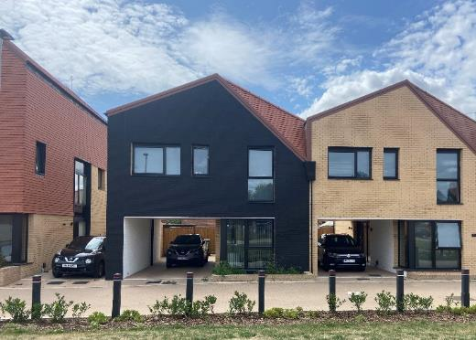
1. ITP - Arkwright Walk (Nottingham). Showing unallocated on street parking laybys.
2. ITP – Fryerns (Basildon). Showing on plot parking incorporated into driveways and undercroft.

Accessible to all
  - Not only should parking for adapted vehicles, cycles and mobility aids be abundant and convenient (never provided below the minimum Part 1 standards), but the infrastructure around it should also cater for ease of access to dwellings and destinations. Sufficient space should be provided in the vicinity of parking for all modes to allow for manoeuvrability, and use of ramps and level surfaces. Car parks should be legible and safe through provision of tactile surfaces, dropped kerbs, signage and adequate lighting. Mobility hubs should provide accessible car parking spaces as well as cycle and micro-mobility spaces. Locating these elements close to the entrance / exit of a building provides opportunity to enhance accessibility for users, as well as creating natural surveillance so storage feels more safe and secure.
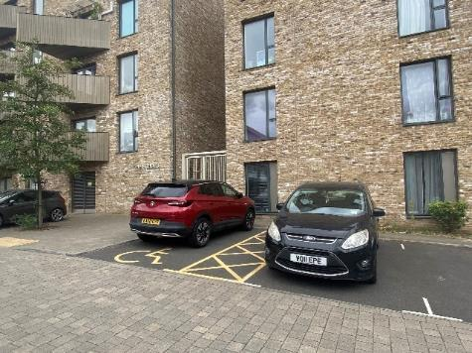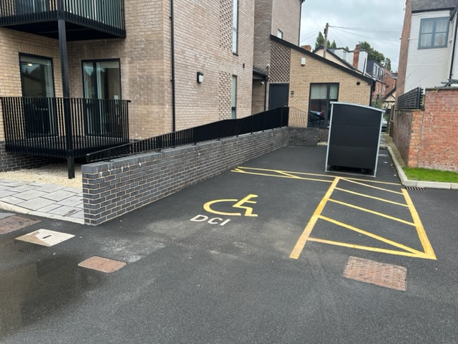
1. ITP – The Echoes (Grays). Showing a parking space for disabled people in front of a building entrance.
2. ITP – Devonshire Court (West Bridgford, Nottingham). Showing a parking space for disabled people in front of building entrances.

Secure and appropriately located
  - All areas of parking for all modes should be adequately lit, and naturally surveilled. It is very important that users feel comfortable that their vehicle, cycle, scooter etc. is secure. Where natural surveillance is not possible, the use of CCTV, shelters, lockable cages and barrier systems may help create a sense of security. People should feel safe exiting the area of parking and walking to their dwelling or destination, again through lighting and surveillance. This is particularly the case where car parking is located more distant from homes than has conventionally been the case in masterplanning.
  - In accordance with the parking hierarchy, parking should be convenient for active and micro-mobility modes, as close to the front entrances of dwellings and destinations as possible, and at every mobility hub. Aside from car club spaces and car parking for disabled people, private car parking areas should be the least convenient option in terms of walking distance to a building entrance (while ensuring they are safe, secure and well lit). This could be through provision on-street or in parking courts, or ideally, more distant from homes and destinations in parking barns, shared car parks or multi-storey car parks (see Typologies section below).
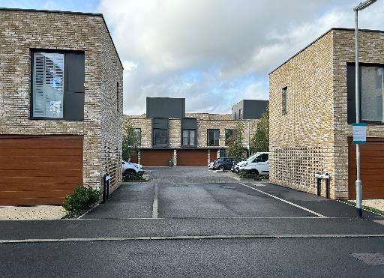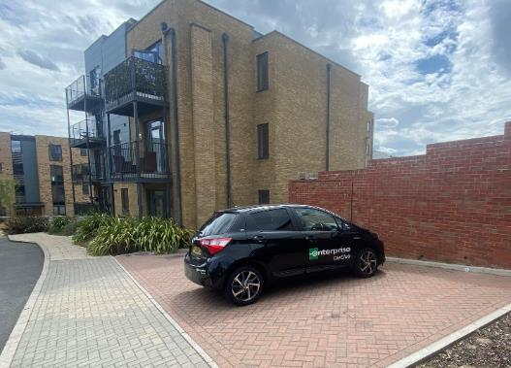
1. ITP – Ebbsfleet Valley (Ebbsfleet Garden City). Showing car parking away from building entrances.
2. ITP – Eddington (Cambridge). Showing a parking court to the rear of a development block, but with some dwellings overlooking.

Well-managed outcomes
  - The primary method of managing parking should be through high quality design, as described above. Thoughtful landscaping and geometry, and fostering a sense of place amongst site users, can be effective in ‘designing out’ indiscriminate and inappropriate parking as well as anti-social behaviour / crime. It is recognised, however, that in areas of higher demand, on important movement corridors, or near to attractions such as stations or mobility hubs, inappropriate parking can cause operational and safety problems.
  - In tandem with an effective stewardship, leasing and / or site management strategy (see Chapter 3), parking enforcement may be required in order to address overspill and achieve wider outcomes relating to placemaking. Introducing lining and signing on streets should be considered as a last resort, as they detract from quality of design and legibility. Controlled Parking Zones or Restricted Parking Zones may have lesser visual impacts but in both cases there are management costs associated with enforcement. The allocation of parking spaces should not be used as a mechanism for managing overspill (without other enforcement in place), as where there is high demand, allocations can be contravened (and it will continue to be an inefficient use of space).
  - The extent of the adopted highway should be given careful consideration in terms of whether areas of parking are adopted. On-street parking bays may be adoptable, whereas LHAs are very unlikely to adopt parking courts or barns. This could impact upon the extents and control over Traffic Regulation Orders and Controlled Parking Zones.
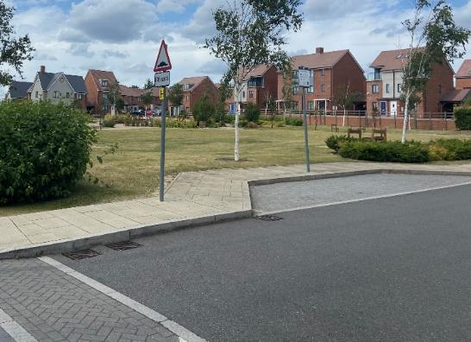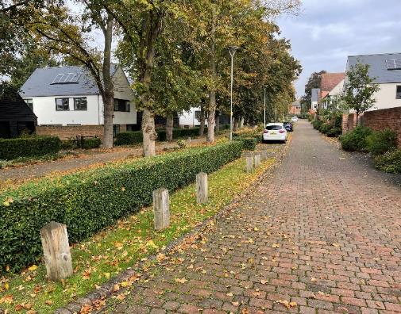
1. ITP – Ebbsfleet Valley (Ebbsfleet Garden City). Showing parking restrictions in the layby.
2. ITP – The Avenue (Saffron Walden). Showing landscaping to deter on-street parking outside of dedicated bays.

Flexible and future-proofed
  - Parking demand should reduce over time in strategic developments as behaviours change and new infrastructure is delivered through later phases. All car parking (on-street, on-plot) should be designed with flexibility in mind, whether it be repurposing to provide more parking for other modes, or to be taken back as green space. This not only relates to surfacing, materials, and construction specification, but also the location of parking areas and how they relate to frontages, drainage and land uses – for example repurposing a remote parking court, which is not overlooked, to a green space will not be effective.
  - Parking for all modes should be future proofed to adapt to new technologies and innovations so far as is possible, in residential, non-residential and mobility hub settings. This should include active charging infrastructure for cars, cycles and micro-mobility modes, and / or at minimum passive charging infrastructure for 50% of all space (aligning with Part 1 guidance). Aside from electrification, the scale and type of vehicle and cycle is likely to change over time. Parking for all modes should not be squeezed into constrained spaces which might undermine future uptake of, for example, cargo bikes.
  - The weight of EVs (heavier than conventional cars) will need to be taken into account in construction specifications of pavements and decked car parking. Maintenance and ownership of on-street, unallocated EV charging points will also require discussion with the adopting authority.
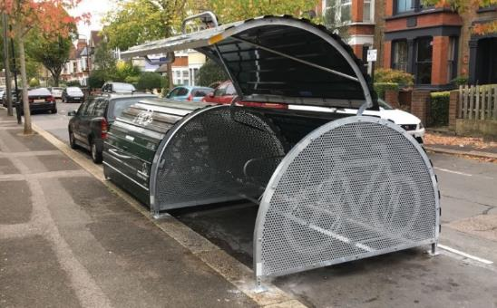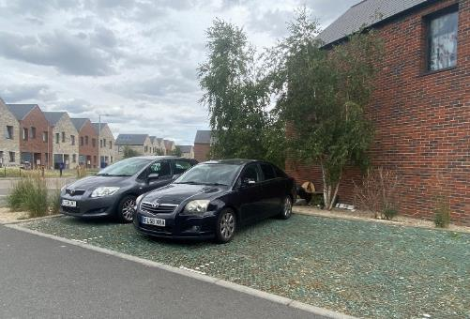
1. ITP – North View Avenue (Tilbury). Showing grasscrete parking areas, which can be more cost effective to remove compared with traditional surfaces (although maintenance implications of grasscrete should be considered).
2. Camden Council – Fleet Road. Showing a parking space repurposed for a bike hangar.

Typology matrix
  - Drawing on the above parking design principles, Table 5-1 sets out a Design Typology Matrix. This details the types of parking design which will or will not be acceptable in different contexts and for different land uses. It allows some flexibility in what is provided, with an order of preference identified. Any parking typologies which are not listed for a land use are not acceptable (see Matrix footnotes).
  - The Matrix allows applicants to interpret the total parking budgets for land uses within strategic developments into design solutions which suit the specific street, phase, or neighbourhood in question.
  - Explanatory notes are provided below the Matrix. Descriptions and design guidance for each typology follow the footnotes.

Table 5-1: Design typology matrix
On-plot (proportions informed by Accessibility Tool)
Use Class | C3/C4 |  |  |  | C2 | E(a), E(b) | E(c), E(g) | F1(b)-F1(f), F2 | F1(a)
Includes | Flats / apartments | Terraced | Semi-detached | Detached | Care homes, residential colleges | Retail | Commercial | Community | Education
On-plot cycle / e-mobility | Not applicable (i.e. no cycle parking within apartment itself) | Front of dwelling cycle storage |  |  | On-plot parking unlikely to be applicable | Not applicable
 |  | Dedicated space in undercroft / mews garage (if provided) ⁵ | Side of dwelling cycle storage
 |  |  | Dedicated space in undercroft / mews garage (if provided) ⁵
On-plot car | Not applicable (i.e. no car parking within curtilage) | Undercroft / mews garage parking⁵
 |  | Driveway – front of dwelling | Driveway – side of dwelling
 |  |  | Driveway – front of dwelling
Off-Plot (proportions informed by Accessibility Tool)
Use Class | C3/C4 |  |  |  | C2 | E(a), E(b) | E(c), E(g) | F1(b)-F1(f), F2 | F1(a)
Includes | Flats / apartments | Terraced | Semi-detached | Detached | Care homes, residential colleges | Retail | Commercial | Community | Education
Off-plot cycle / e-mobility | Cycle hub⁷ | Short stay Sheffield stands, small cycle hubs or repurposed on street car parking for visitors⁷ |  |  | Cycle hub  (may be separate long and short stay)
Off-plot car | Shared barn¹, multi-storey, basement or podium⁶ | Shared barn¹ or multi-storey⁶ |  |  | Shared barn¹ or multi-storey (shared between uses) |  |  |  | Car park (may be separate long and short stay)
 |  |  |  |  | Shared car park (shared between uses)
 | Shared on-street (low density flats only) ⁶ | Shared on street⁶ |  |  | Allocated barn¹ or multi-storey (dedicated to a land use)
 | Shared court⁶ |  |  |  | Allocated car park (dedicated to a land use)
 | Allocated barn¹, multi-storey, basement or podium | Allocated barn¹ or multi-storey
 |  | Allocated court

 | = preferred typology |  | = acceptable typology |  | = least preferable typology

Design Typology Matrix Notes
- A ‘parking barn’ refers to a similar structure to a multi-storey car park, often across fewer decks and smaller scale in its mass. It may be a surface level car park, but with shelter, enclosure, screening and some security features. See Typology Guidance section below.
- If a typology is not listed under a land use, it is not allowable except for in exceptional circumstances (e.g. where there are design influences such as conservation areas). Space constraint is not an exceptional circumstance.
- Other land uses not explicitly covered can be negotiated / based on judgement, using guidance from Part 1 and Part 2.
- Parking for other vehicles such as service vehicles and HGVs is not covered by the above table, and should be provided in accordance with Part 1 and the occupier’s requirements.
- Only undercroft integrated garage parking is allowable (described in the Typology Guidance section below). The Part 1 guidance allows garages when they are above specified dimensions. Detached / standalone garages are not allowable for vehicle storage in strategic developments because they can dominate streets and are a less efficient use of space.
- Any off-plot parking could be leased (rented by the owner). This is encouraged as a demand management mechanism where there are clear covenants in place, and measures / infrastructure are delivered to provide alternatives to those who are buying houses without default access to parking.
- Off-plot cycle parking is assumed to be shared / unallocated, and never leased.
- It should not be assumed that cycles are stored inside individual flats / apartments – dedicated space must be provided at ground floor or basement level.
- The above recommended private car parking typologies do not supersede the requirements for dedicated parking for disabled people (detailed in Part 1), which should be provided near to building entrances and provided solely for the use of disabled people.
- Some on-plot and allocated parking may be appropriate for Use Classes where mobility impaired, young or elderly users are likely, for example some uses within C2 Use Classes.

Typology guidance
  - The guidance below relates to the typologies set out in Table 5-1 and is intended to compliment guidance contained within Part 1, the EDG, and other national policy / guidance, focussing on how the typology should be designed in the context of GCs and LSDs to achieve the outcomes. The graphics and images are for illustration purposes to help describe the typology being discussed - as in some cases terminology is not yet commonplace - and these do not necessarily represent exemplar street or building design.

Cycle parking

Cycle hubs (residential and non-residential co-located cycle storage)
- Should be located conveniently near building entrances or on ground floors. Short stay / visitor parking may be outside, long stay should be inside or well sheltered. Most appropriate for flats, short stay visitor parking, and non-residential land uses.
- Must be covered, secure and well-lit, ideally with CCTV surveillance.
- Must be capable of accommodating a variety of non-standard cycles (at least the 20% of total spaces required by the Part 1 guidance), with charging points and additional passive charging provision. These spaces should be signed / painted for their use.
- Where space allows, individual cages / stands per dwelling are preferred. Otherwise, unallocated spaces should be organised into areas dedicated for blocks / floors.
- Should be integrated with other modes and shared transport facilities (e.g. at mobility hubs), where appropriate.
- Should include urban greening, and integrate renewable energy generation technologies (e.g. photovoltaic panels) where possible.
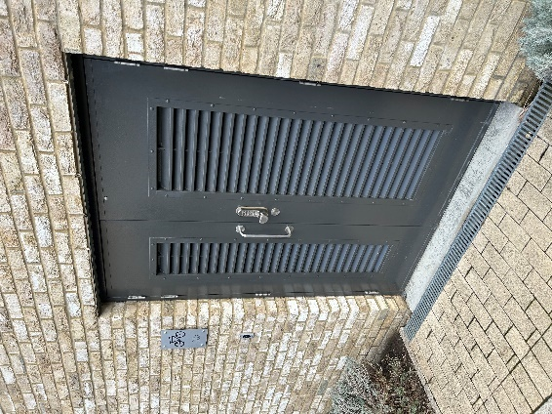
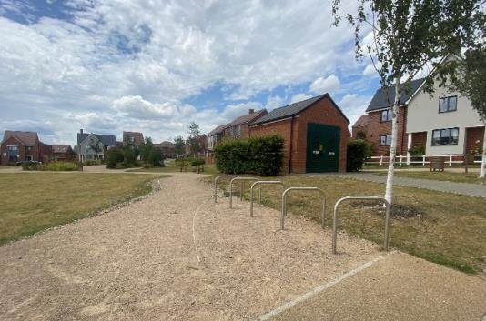
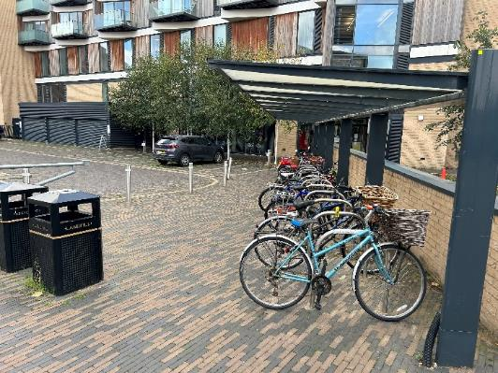
1. ITP - Eddington (Cambridge), 2. ITP – Ebbsfleet Valley (Ebbsfleet Garden City), 3. ITP – Great Kneighton (Cambridge), showing an indoor cycle hub for flats.

- Ideally located in front garden / at front of dwelling to maximise convenience and ease of use. If at side of dwelling, a clear, step-free access route must be provided. Appropriate across all densities.
- Must be covered and secure, with wall or floor anchors for securing cycles.
- Must be capable of accommodating the minimum cycle parking standard for the dwelling type / size, including as part of that space for at least one non-standard cycle such as cargo or adapted bike (per dwelling). Ideally an e-bike charging point is provided.
- Should be visible from the dwelling, but unobtrusive when viewed from the street.
- Should be in addition to storage for other household items, and to car parking space on e.g. driveways (but can be retrofitted in, where demand for car parking space is reduced).

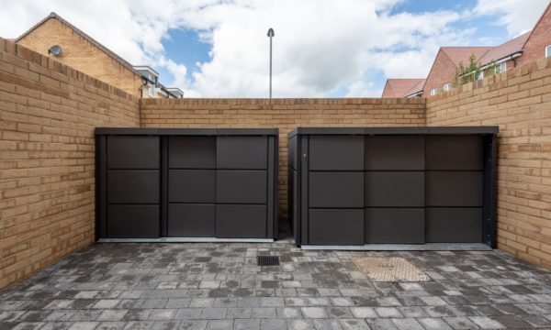
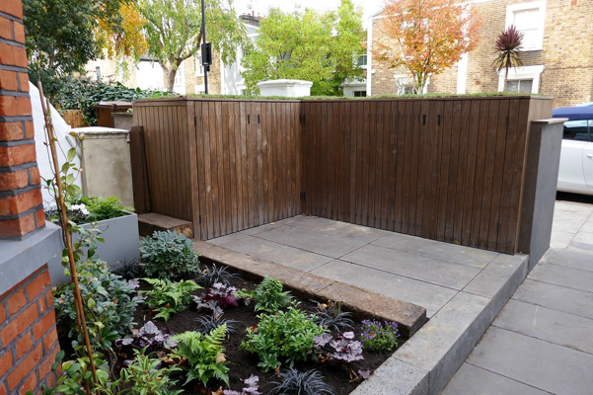
On-plot front/side cycle storage
1. Waltham Forest ‘Bike Sheds in Front Gardens’ guidance, showing cycle storage to side of dwelling.
2. Urbanspec – Brewers Hill (Dunstable), showing cycle storage in front garden.

Dedicated cycle parking in garage
- Located in undercroft to front / side of dwelling. Most appropriate in mid- to low-density areas.
- Must be dedicated spaces outwith of standard garage dimensions. Cycle parking space should not be planned to be shared with cars or other household items.
- Cycle access must be convenient, allowing for some manoeuvrability and potential for hanging space, and therefore storage to the side or front of the garage is preferred.
- Should be capable of accommodating at least one non-standard (this will require larger dimensions than the minimum in the diagrams). Ideally dedicated e-bike charging is provided.
- Garage door(s) should be secure, with wall or floor anchors for securing all cycles.
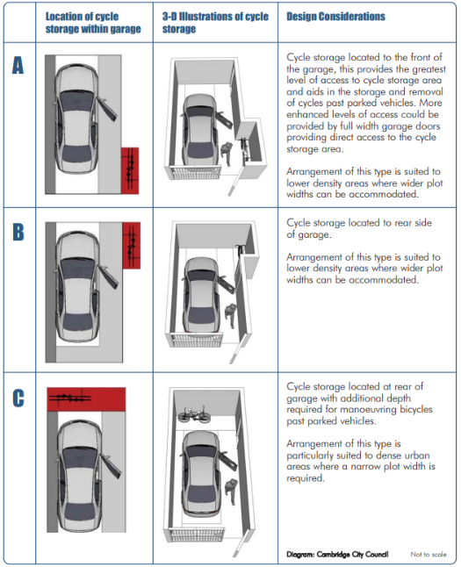
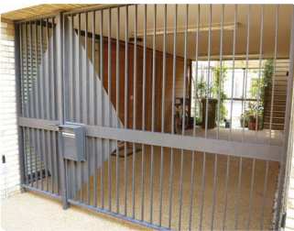
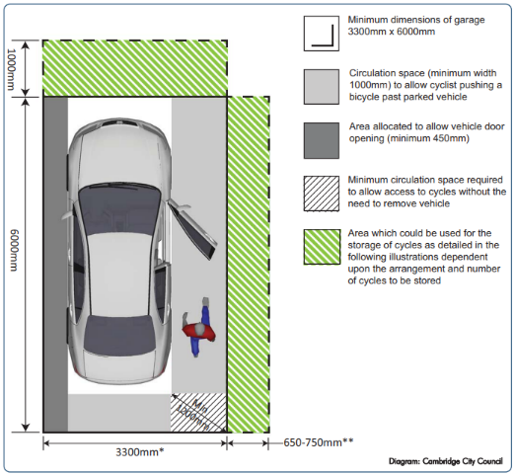
Note that the Part 2 guidance only allows integrated garages, in a mews setting, to count towards a car parking space (see Table 5-1).
1., 2. and 3. Cambridge Cycle Parking Guide

Car parking

Basement (and podium)
- Located below flats or non-residential uses. Only appropriate in high density areas.
- Should have discrete entrances and facades, where design and use of materials is consistent with or complementary to the design of the site. Space above the decked parking area could be used as communal space and should introduce planting.
- Must be internally lit, well surveilled and secure, ideally with entrances behind development blocks to deter misuse by wider public.
- If dwellings are flatted, basement and podium car parks must include secure long-stay provision for cycles and other e-mobility modes, in a more convenient location near to entrances/exits.
- Should be repurposeable (especially podium car parks) to accommodate falls in parking demand over time. Decks should have sufficient clearance to be suitable for alternative uses, and be able to accommodate additional cycle and e-mobility storage and charging.
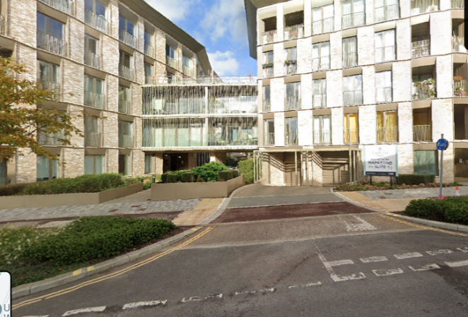
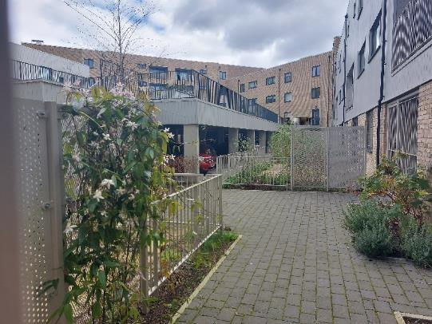
1. ITP – Eddington (Cambridge), showing podium parking.
2. Google Maps – Eddington (Cambridge), showing entrance to basement parking.
- Should be located over circa. 50m (but less than circa. 300m) walking distance from dwellings they serve. Can be used as primary parking provision for a range of densities and dwelling types.
- Whilst multi-storey car parks will typically be large structures with multiple decks, and barns are typically surface level, covered structures, the principle of off-plot, grouped parking more distant from homes is the same for both.
- Must be subject to careful design and integration, ensuring that the storage of vehicles does not dominate the landscape or streetscape, using green walls for example.
- Normally will be separate to parking for disabled people, which should be provided adjacent to buildings. Where multi-storey / barn parking removes vehicles from streets, low-trafficked streets should be capable of accommodating ad-hoc servicing and drop off from private vehicles.
- Must be secure and lit, and ideally fitted with CCTV. Car parks, and pedestrian accesses to them, must feel safe at all times.

- Cycle parking should be provided on-plot and near to dwellings. If parking for cycles is provided in multi-storey (e.g. for flats), it must be on the ground floor and in a convenient location near to entrances/exits.

- Should be repurposeable to accommodate falls in parking demand over time. Ground floor decks should have sufficient clearance to be suitable for alternative uses, and be capable of accommodating additional cycle and e-mobility storage and charging. Roof structure should be capable of accommodating leisure, food/beverage, planting or energy generation such as solar panels.

Multi-storey / parking barn
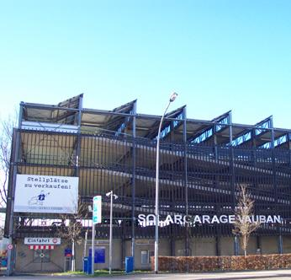
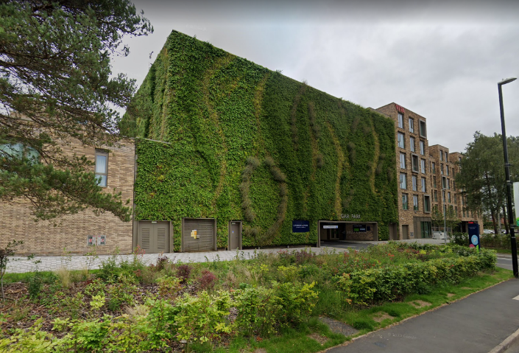
1. Granta Park Car Park (Coventry) GoogleMaps 2. Vauban im Bild – Parking barn (Vauban)

Mews Garages

- Integrated into / below dwellings, opening at street level. Most appropriate in mid-density areas.

- Should be integrated with the street scene, with careful material choices and broken up by frontages and planting.

- Mews should be activated at street-level (where the activity associated with getting into / out of vehicles is removed). Ground floor dwellings, windows and entrances, community uses and street furniture should be provided.

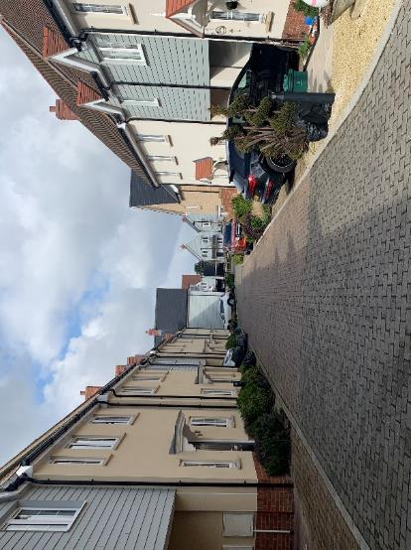
- Provides a dedicated area of storage for cars and cycles (secured by covenants), removing them from streets. Associated low-trafficked streets should be capable of accommodating ad-hoc drop-off, waiting and servicing by private vehicles.

- Streets should be configured to design out indiscriminate parking adjacent to frontages / garage doors, through geometry, setbacks, planting, surfacing and street activation (considering enforcement in some contexts).

- Every garage parking space should have access to an EV charging point.
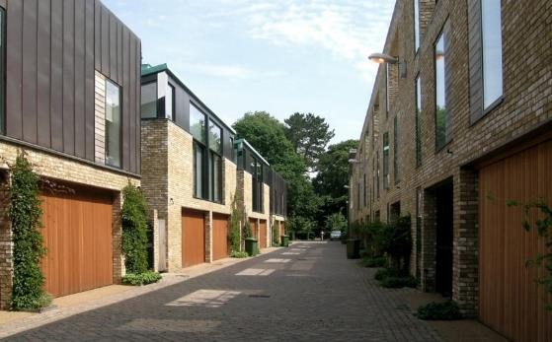

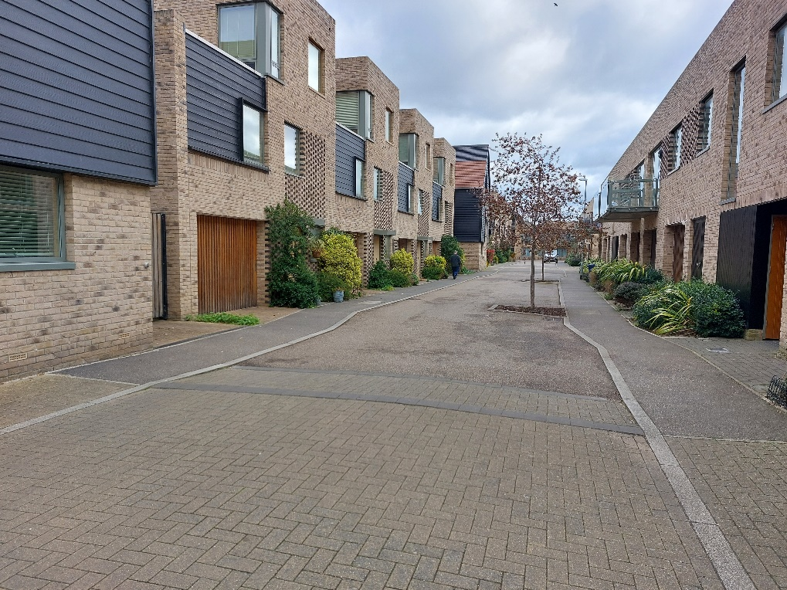
Driveways
1. ITP – Tiptree (Colchester) 2. Alison Brooks Architects – Accordia (Cambridge) 3. ITP – Great Kneighton (Cambridge)

- Ideally located to the side of dwellings in a tandem (one in front of the other) configuration. Most appropriate in mid- to low-density areas.

- Especially where tandem configurations are provided, streets should also be configured to design out indiscriminate parking outside of driveways, through geometry, setbacks, planting, surfacing and street activation (considering enforcement in some contexts).

- Every driveway parking space should have access to an EV charging point.

- Should be screened from the street scene so far as is possible with planting and boundary treatments.

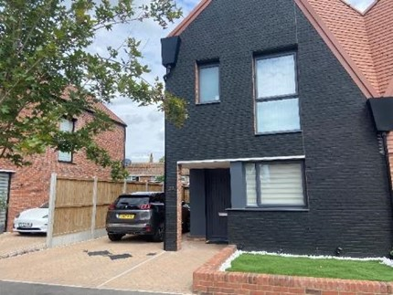
- Must not obstruct or prevent access to cycle storage; ideally cycle storage will be separate and more convenient, through provision of storage in front gardens / on street.

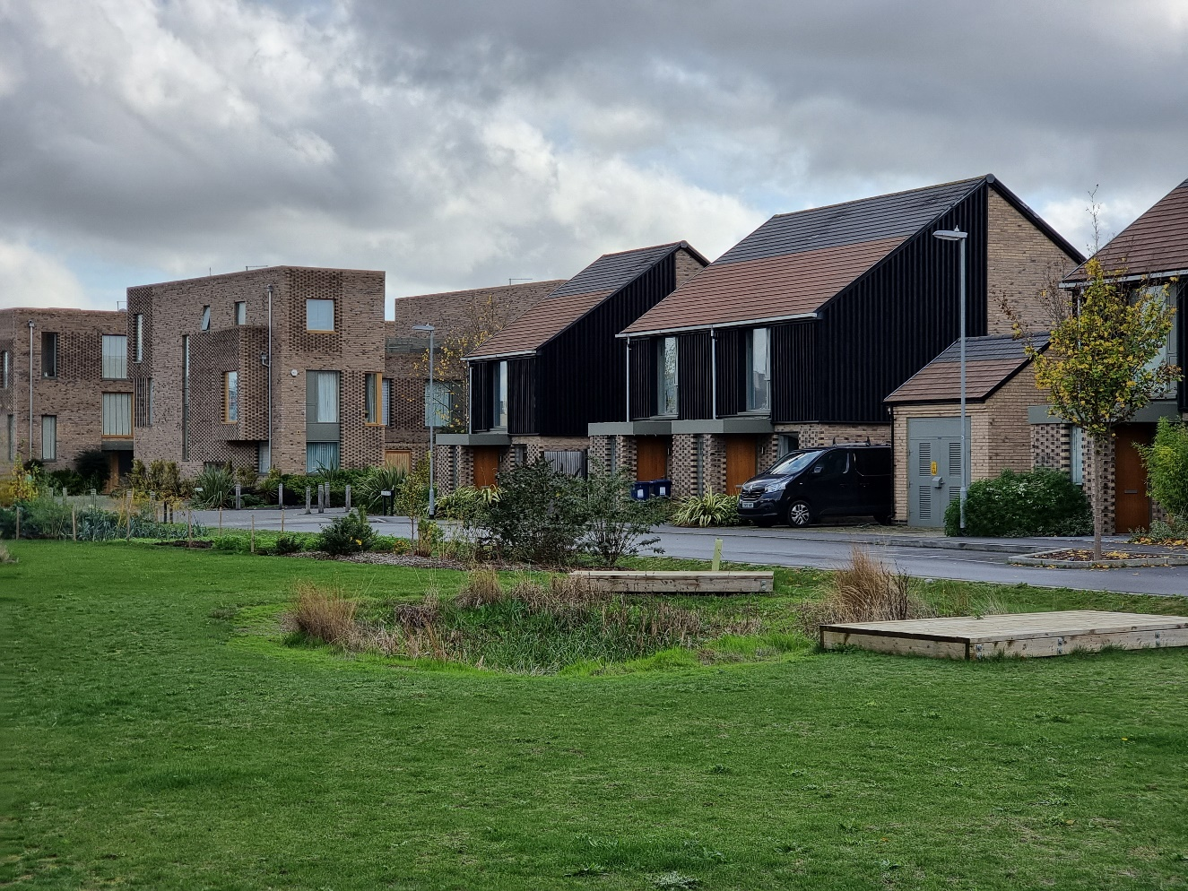

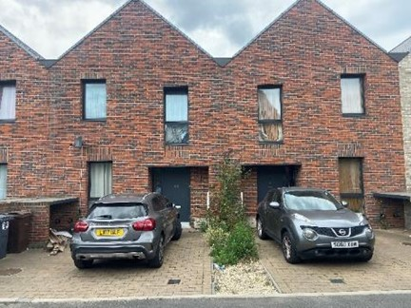
1. ITP – Great Kneighton (Cambridge) 2. ITP – Fryerns (Basildon) 3. ITP – North View Avenue (Tilbury),

On street
- Parking located on-street either in parallel (layby) form or in squares in the centre of streets. Most appropriate in mid- to low-density areas, though could be effective in some high density contexts.
- General spaces do not need to be immediately adjacent to the dwellings they serve, aside from parking for disabled people.
- Outside of delineated / marked spaces, streets should also be configured to ‘design out’ indiscriminate parking, through geometry, landscaping, surfacing and street activation (considering enforcement in some contexts).
- Ducts should be provided for passive EV charging on all streets where parking is provided. If spaces are predominantly for residential use, every space should have access to an active EV charging point.
- Should be integrated into the street scene in terms of materials and broken up / screened by planting, strees and street furniture.
- Should be repurposeable (through their geometry and surfacing), capable of transitioning to e.g. parklets and cycle hangars, if demand reduces.

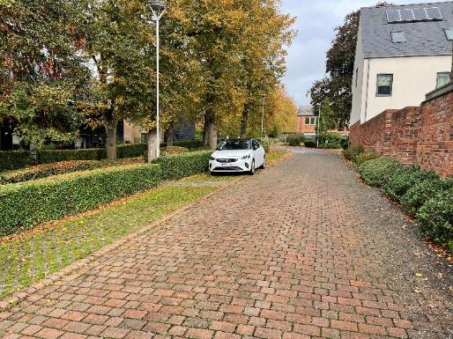
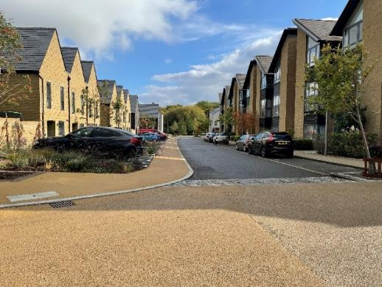
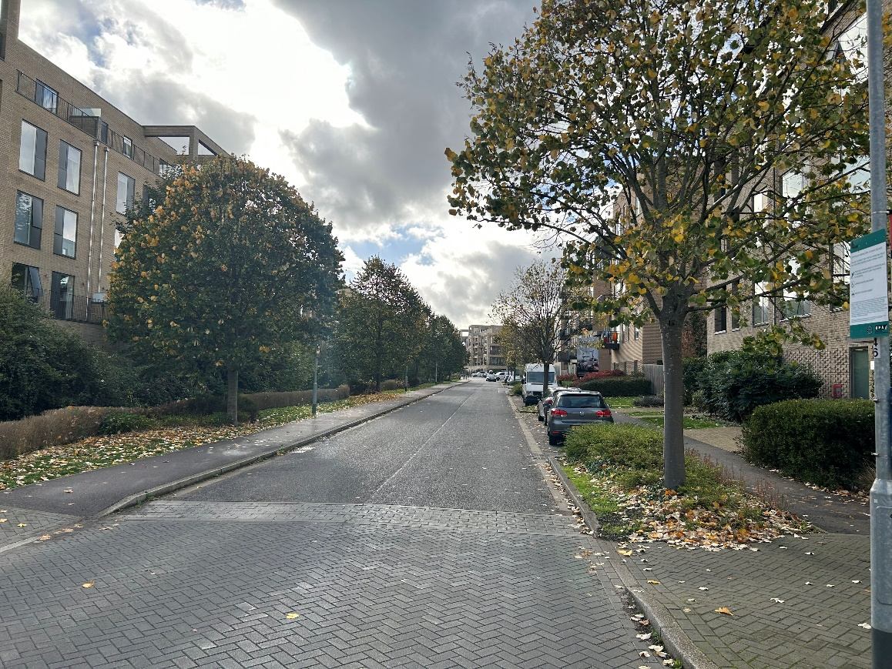
1. ITP – The Avenue (Saffron Walden) 2. ITP – Newhall (Harlow) 3. ITP – Great Kneighton (Cambridge

Parking Courts
- Ideally located in the centre of development blocks. Can be appropriate in high-, mid- or low-density areas.

- At least half of the dwellings served by the court should have frontages onto it, maximising surveillance and activation to avoid creating anti-social spaces.

- Should be easily accessible by the dwellings they serve providing safe, secure and convenient pedestrian routes to them. This should include consideration of provision of lighting, dedicated / clearly demarked pedestrian routes, and quality surface materials.
- Should serve around ten dwellings or less, to maximise efficiency whilst constraining sprawling areas of parking.

- For residential courts, every parking space should have access to an active EV charging point.

- Should complement the into the street and built form in terms of materials. To ensure these areas are not dominated by hardstanding, they should integrate planting, trees and street furniture.

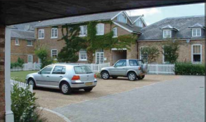
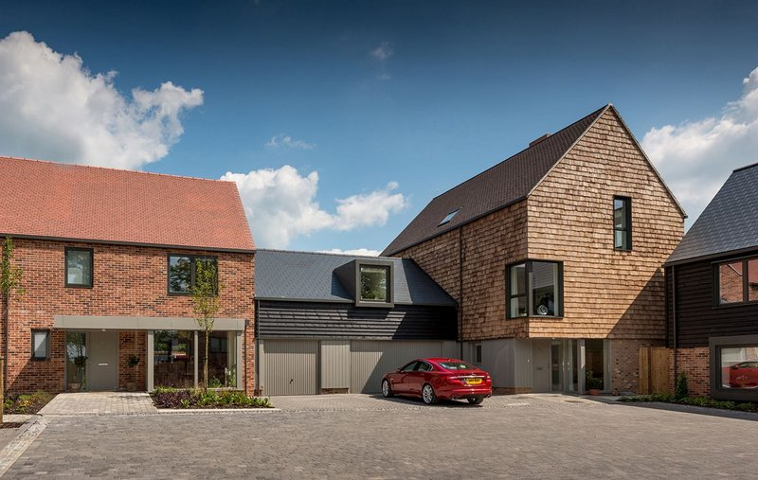
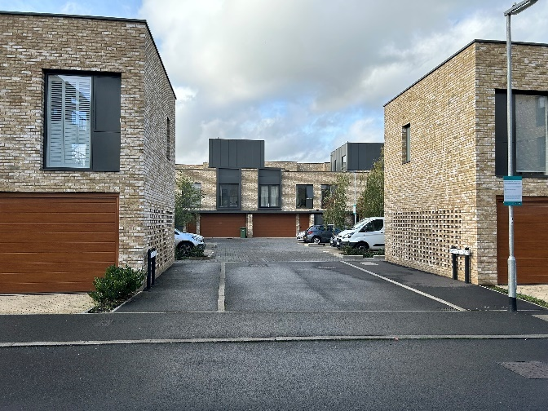
1. CIHT – Guidance Note: Residential Parking
2. RIBA – The Avenue, Saffron Walden
3. ITP – Great Kneighton (Cambridge)
1. CIHT – Guidance Note: Residential Parking
2. RIBA – The Avenue, Saffron Walden
3. ITP – Great Kneighton (Cambridge)

Shared car park
- Located near to the relevant land use(s) (e.g. local centre, employment area, community/leisure facility), ideally shared amongst land uses.
- Parking for disabled people should be located nearest to building entrances, followed by other dedicated spaces such as parent and child, EV and car share spaces.
- Should be well lit, legible and accessible, with dedicated pedestrian walkways, dropped kerbs and tactile paving.
- Should be screened from streets and dwellings, but visible from the buildings they serve.
- Large expanses of hardstanding should be avoided, broken up by attractive planting, footways, trees and pocket parks.
- Areas of car parks could be considered for repurposing if demand falls, for example conversion to additional amenity / open space connected with the land use the car park serves.
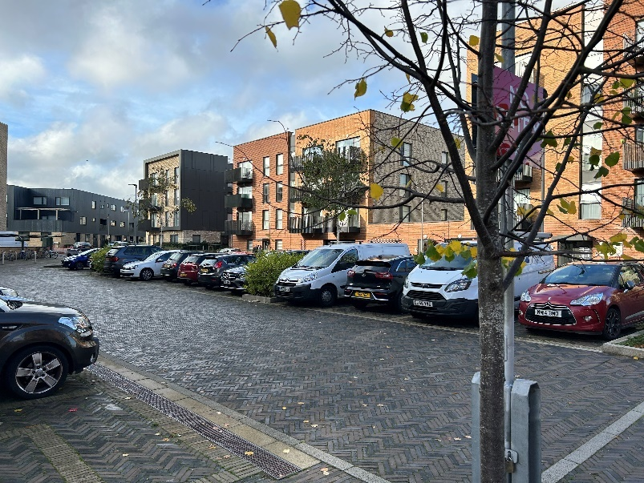
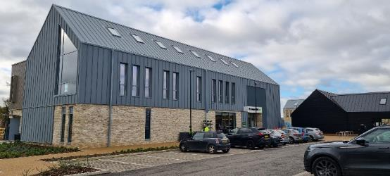
1. David Lock Associates – Houlton (Rugby) 2. ITP – Trumpington (Cambridge)
Appendix A
The context in Essex
Map 1 in the main report shows existing car ownership levels by Lower Super Output Areas across the EPOA area (and East Hertfordshire). Current car ownership in Essex is slightly above the UK average, with 82% of households having at least one car, compared to a 78% national average. More recent data also suggests that the rate of growth in car ownership in Essex is higher than the rate of population growth.
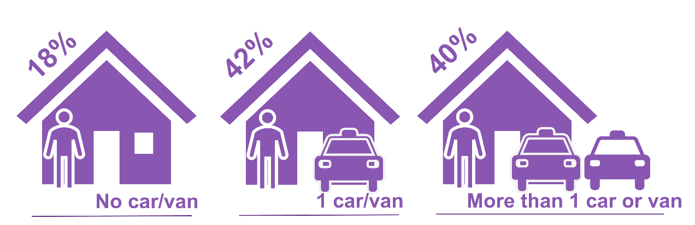
The average vehicle availability per household in Essex is 1.35 cars/vans. The Evidence Base suggests that the strongest influence on car/van ownership in Essex is density and connectivity, where denser areas with more transport options have lower ownership. The larger urban centres tend to have lowest rates of car ownership while in rural areas it is much higher. There are, however, other factors likely at play which influence car ownership, potentially including affluence, demography and cultural attitudes. These are not necessarily linear relationships, but a combination of influences.
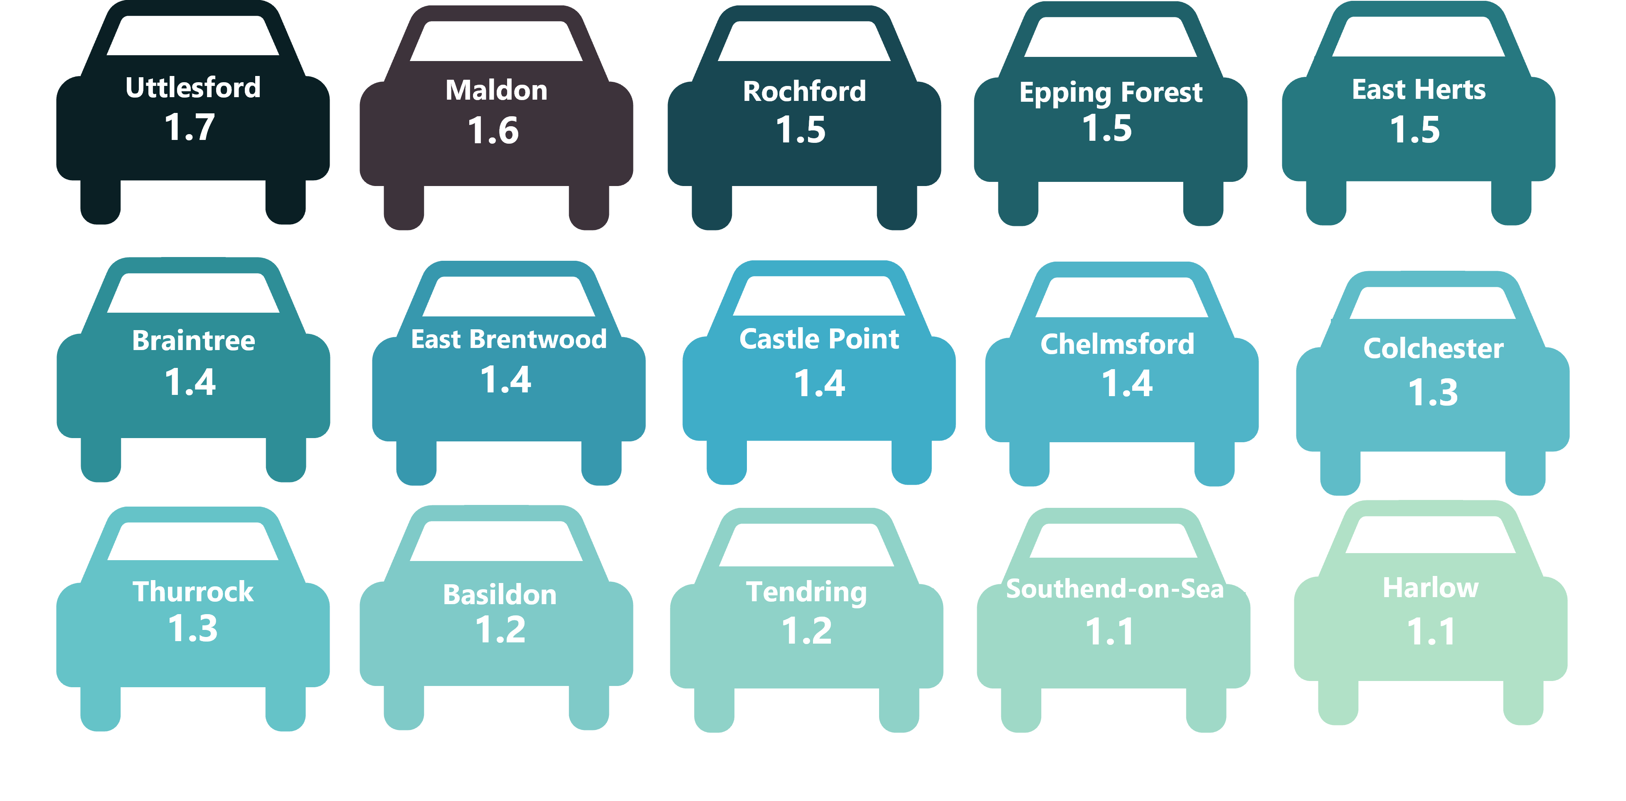
In some cases, the design and management of strategic developments has challenged these factors and delivered places with better outcomes than the areas that immediately surround them. This has happened to some degree in places in Essex (such as Beaulieu, Chelmsford) and has been very successful elsewhere in the UK, illustrated in the examples included within the main report.
This has implications when considering setting parking standards and designing parking into developments. The existing car ownership and mode share might have some influence on how a site could operate in the future. It should not, however, mean that the site is permitted to provide excessive levels of parking to pre-emptively meet travel demand, which could otherwise be directed towards more sustainable modes of travel if they are delivered instead. GCs and LSDs present opportunities to challenge the norm in areas of high existing car ownership and use, by virtue of their critical mass and potential to deliver new infrastructure at scale.

In 2018, alternative fuels made up 1% of the privately owned vehicles in Essex and this rose to 3% of all vehicles in 2021. The rate of increase in alternative fuel vehicles is, however, lower than the national rate. The increase between 2020 and 2021 was 45% (compared to 77% nationally). Whilst electric vehicles (EVs) only represent a small part of delivering sustainable outcomes, this shows that new development in Essex needs to work hard to fully facilitate electrification (reflecting the ban on sale of new petrol and diesel combustion engines in 2030).
In terms of mode share, car/van ownership in Essex does not directly or linearly relate to use of private vehicles for trip making. Map 2 in the main report shows the areas with the highest and lowest car driver mode share from the 2011 Census, and demonstrates that not all of the same areas which recorded low car / van ownership exhibit a low car driver commuter mode share (and the same is the case for areas with high car / van ownership).
Similarly, the relationship between car ownership, car use and use of other modes such as cycling is not direct or linear. The Evidence Base shows that areas with high car ownership are also often those where people cycle more, suggesting that other factors such as affluence or culture are influencing sustainable trip making. The increases in sustainable trip making are also not proportionate to the number of vehicles owned, so for example, where car ownership is double in one area compared to another, sustainable trip making does not appear to halve. This suggests that at times, multiple car households are not making use of all of their vehicles all of the time, as some trips can be fulfilled by walking, cycling or public transport.
These findings highlight the complexities associated with setting effective parking standards. Drawing on the appraisal of the Essex context has led to production of a flexible, locally contextual and nuanced piece of guidance, acknowledging that:
- There will be no ‘one size fits all’ for strategic developments in Essex, as travel patterns and car ownership vary across the County and in neighbouring authorities. There are factors directly and indirectly related to transport which can influence how a household or community view car ownership and car use.
- The characteristics of an area surrounding a new GCs and LSDs might influence how that development operates in terms of car ownership/use, but this is likely not the only influence. Strategic developments elsewhere have demonstrably challenged the norm in terms of sustainable mobility through their scale, infrastructure and design.

Appendix B
Walking, cycling and PTAL maps
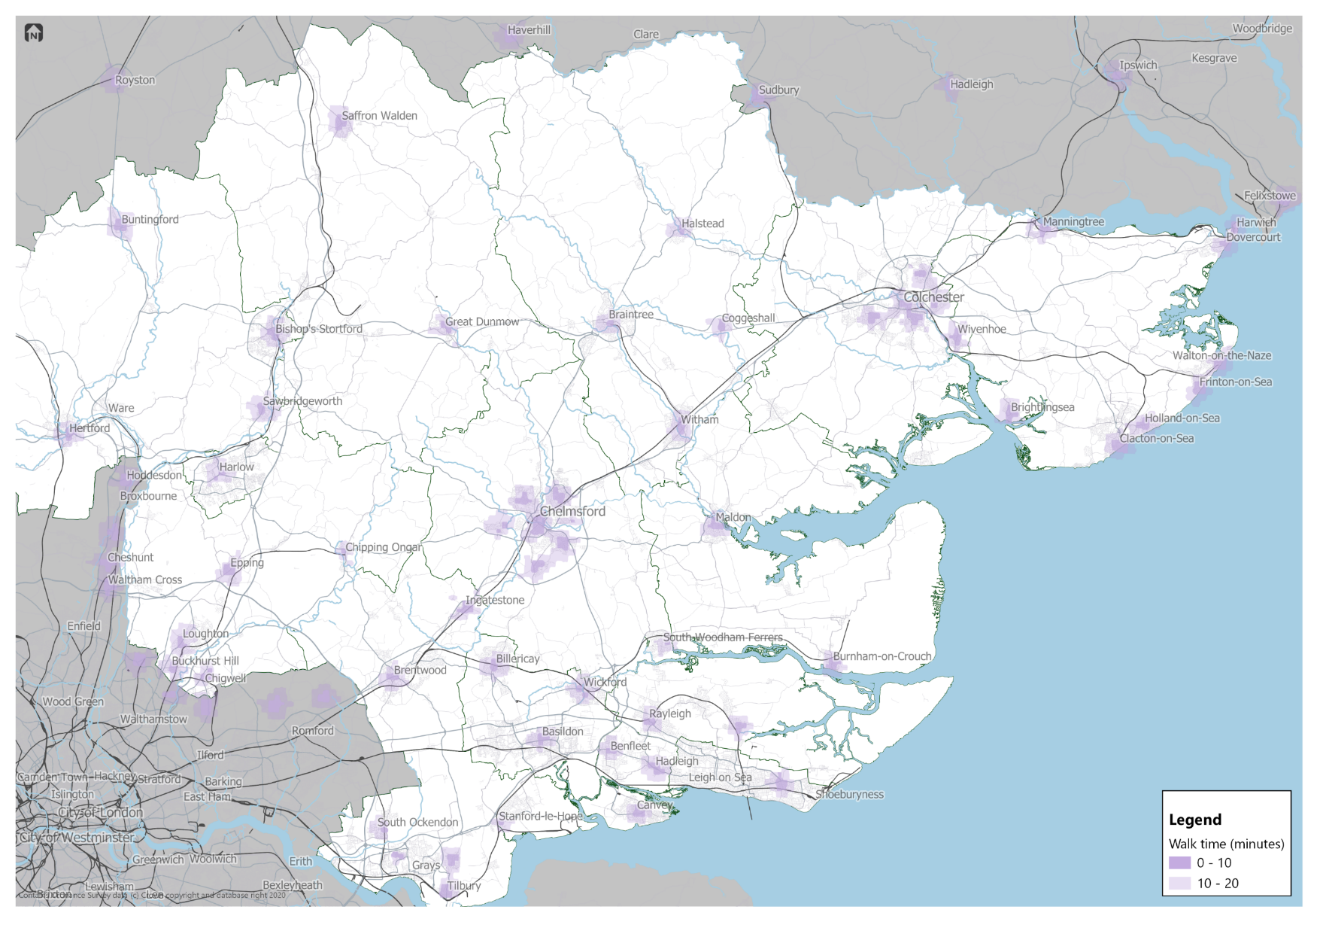
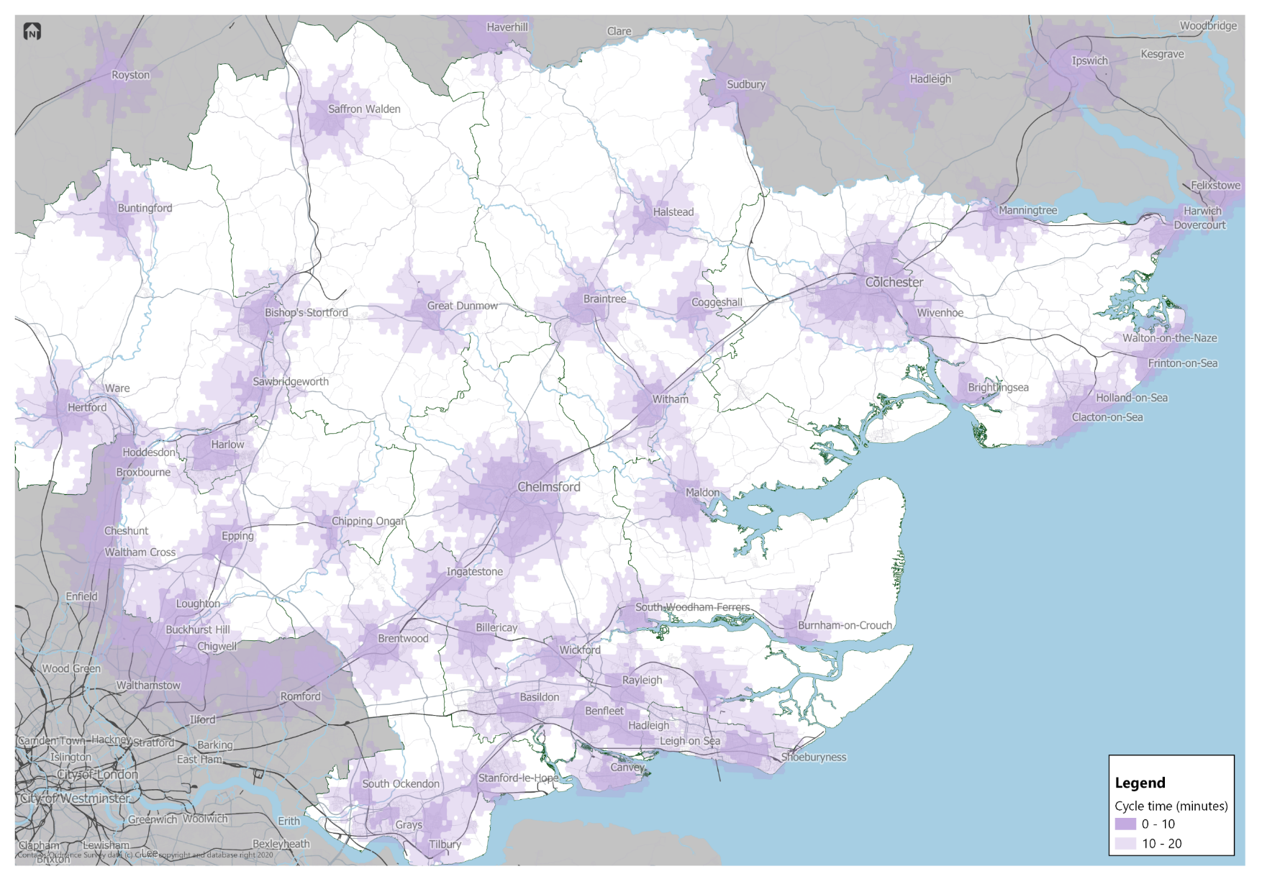
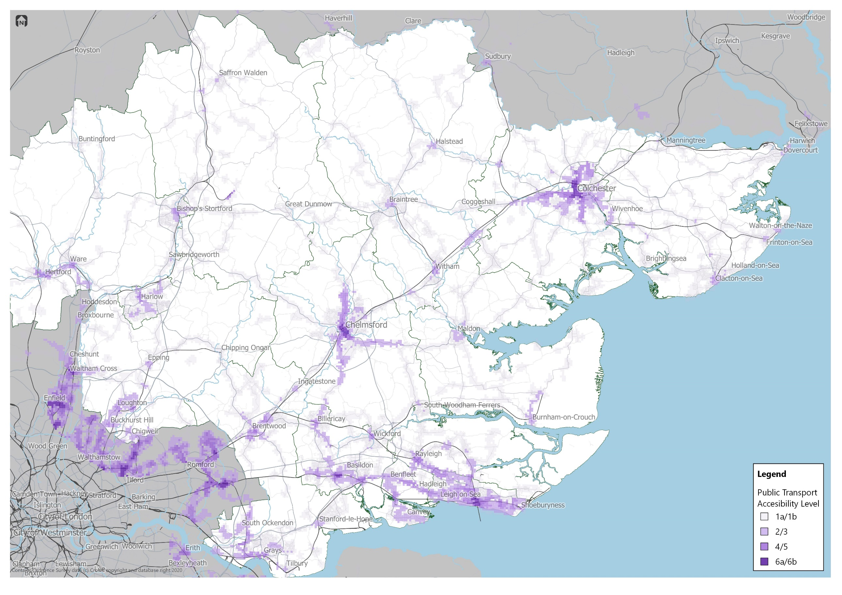
Appendix C
District Accessibility Level maps

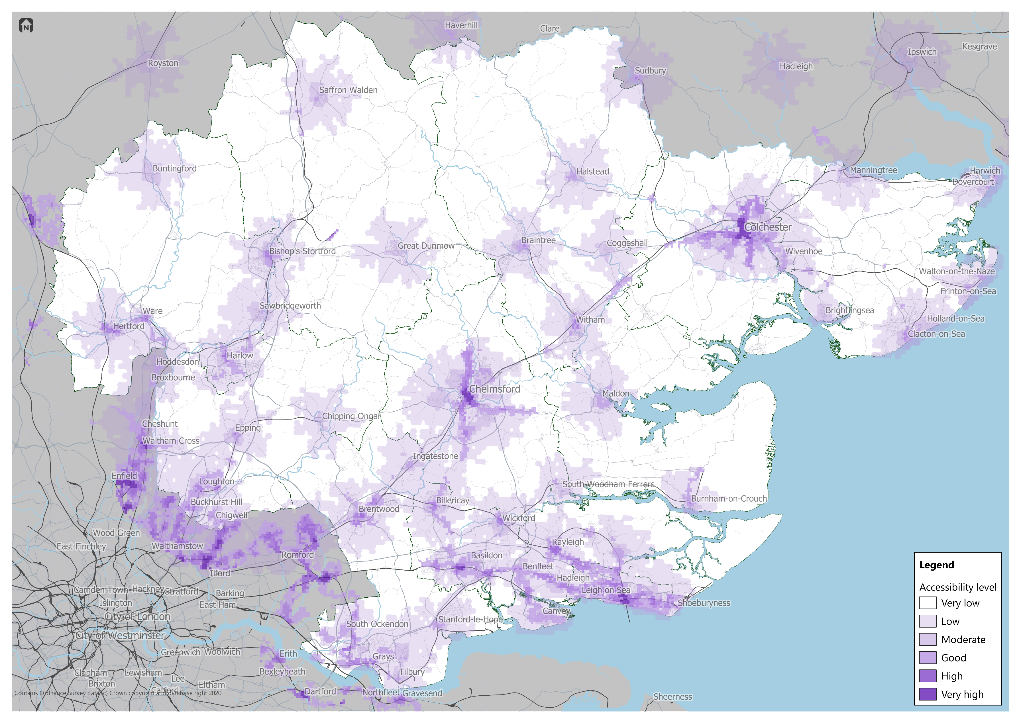

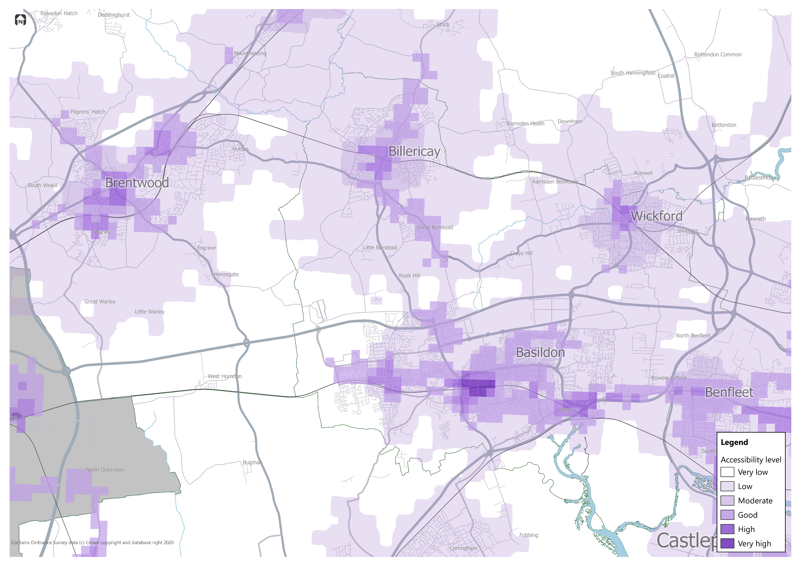
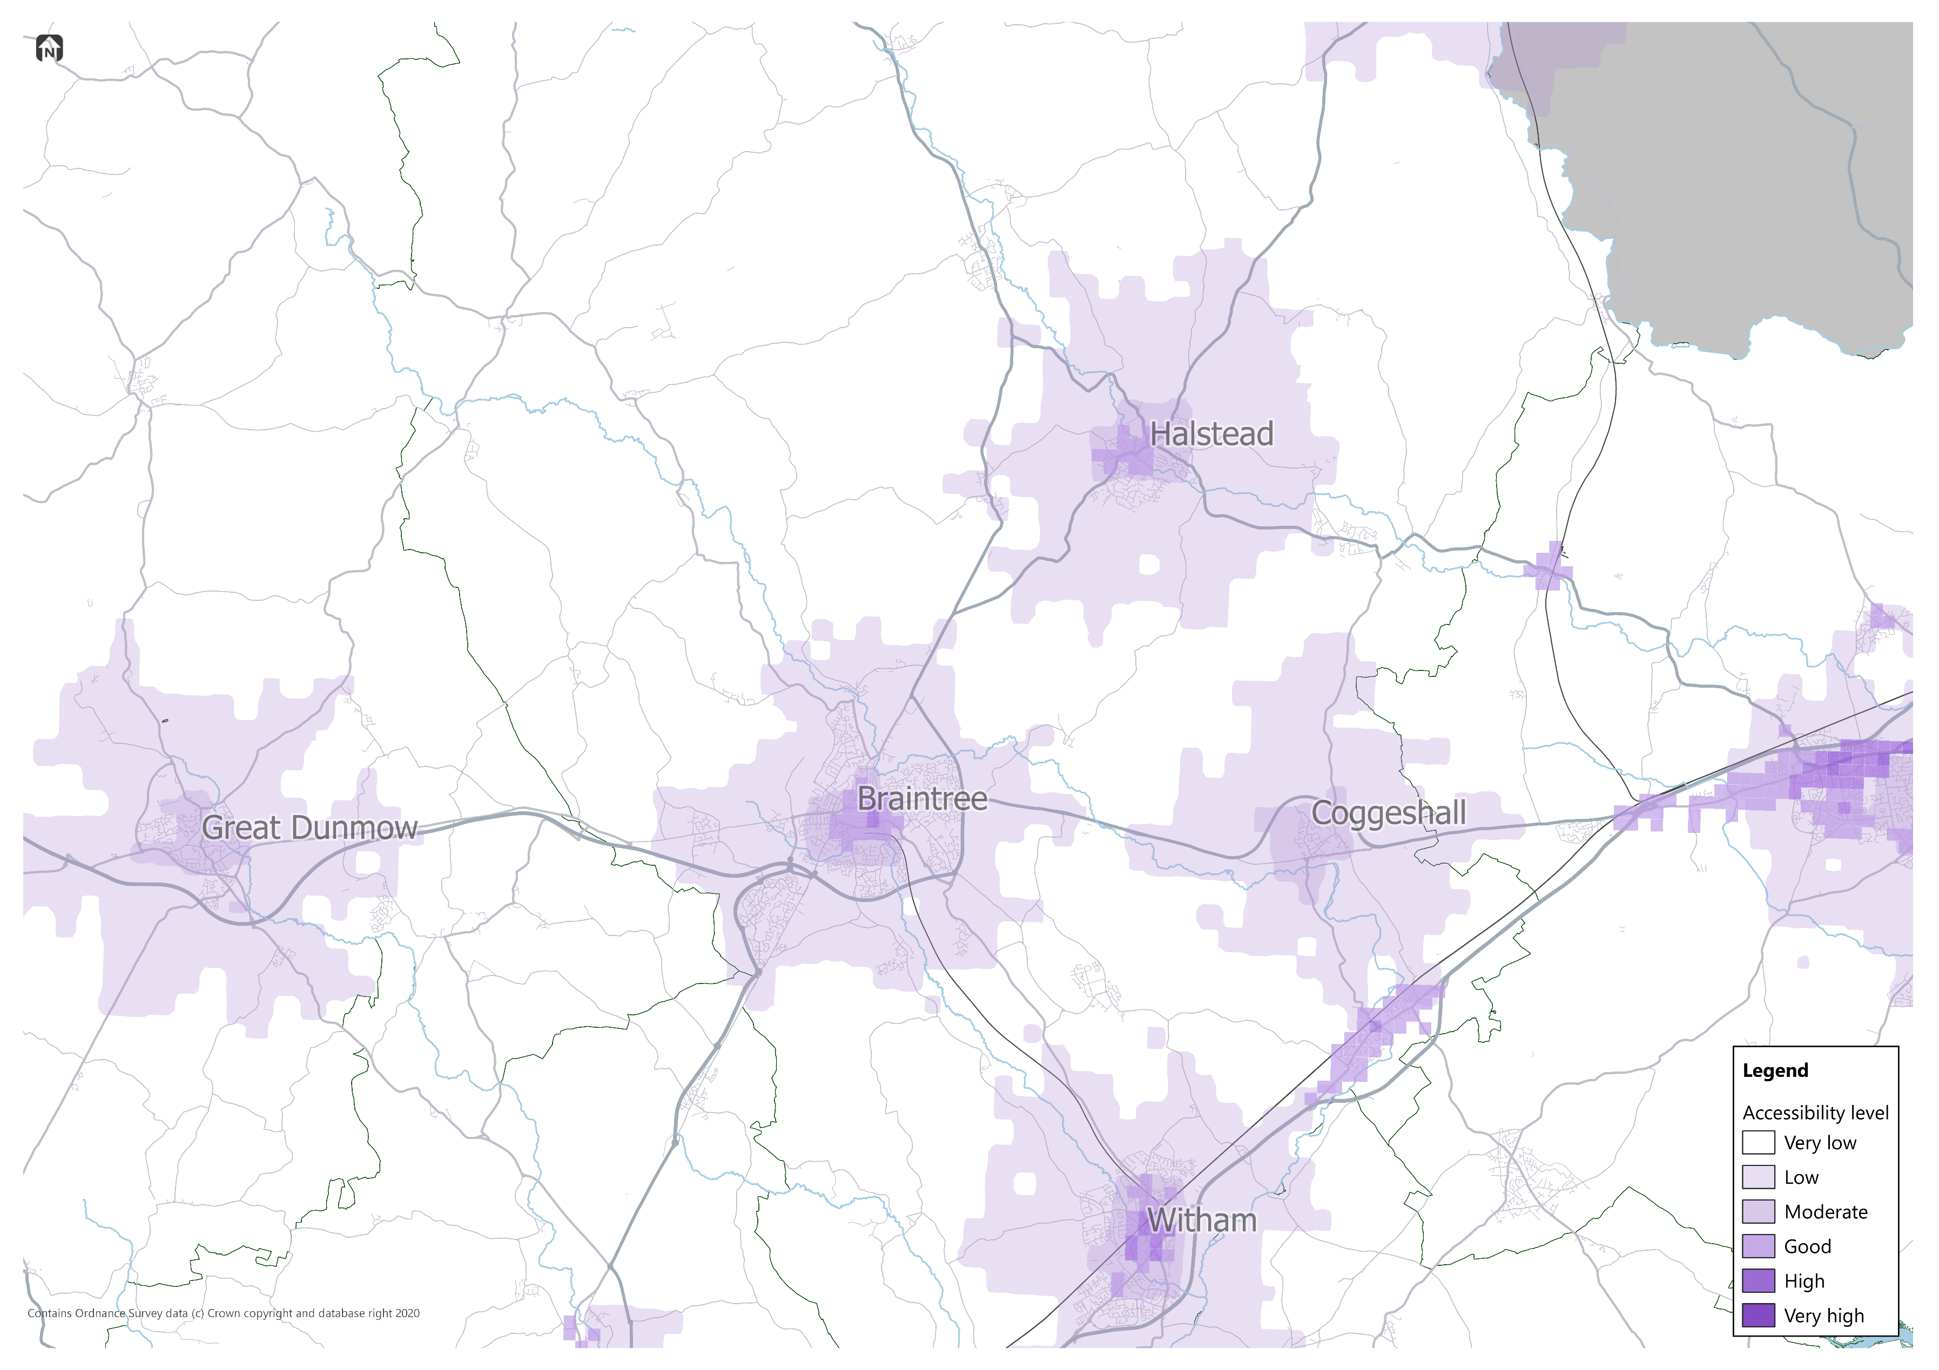

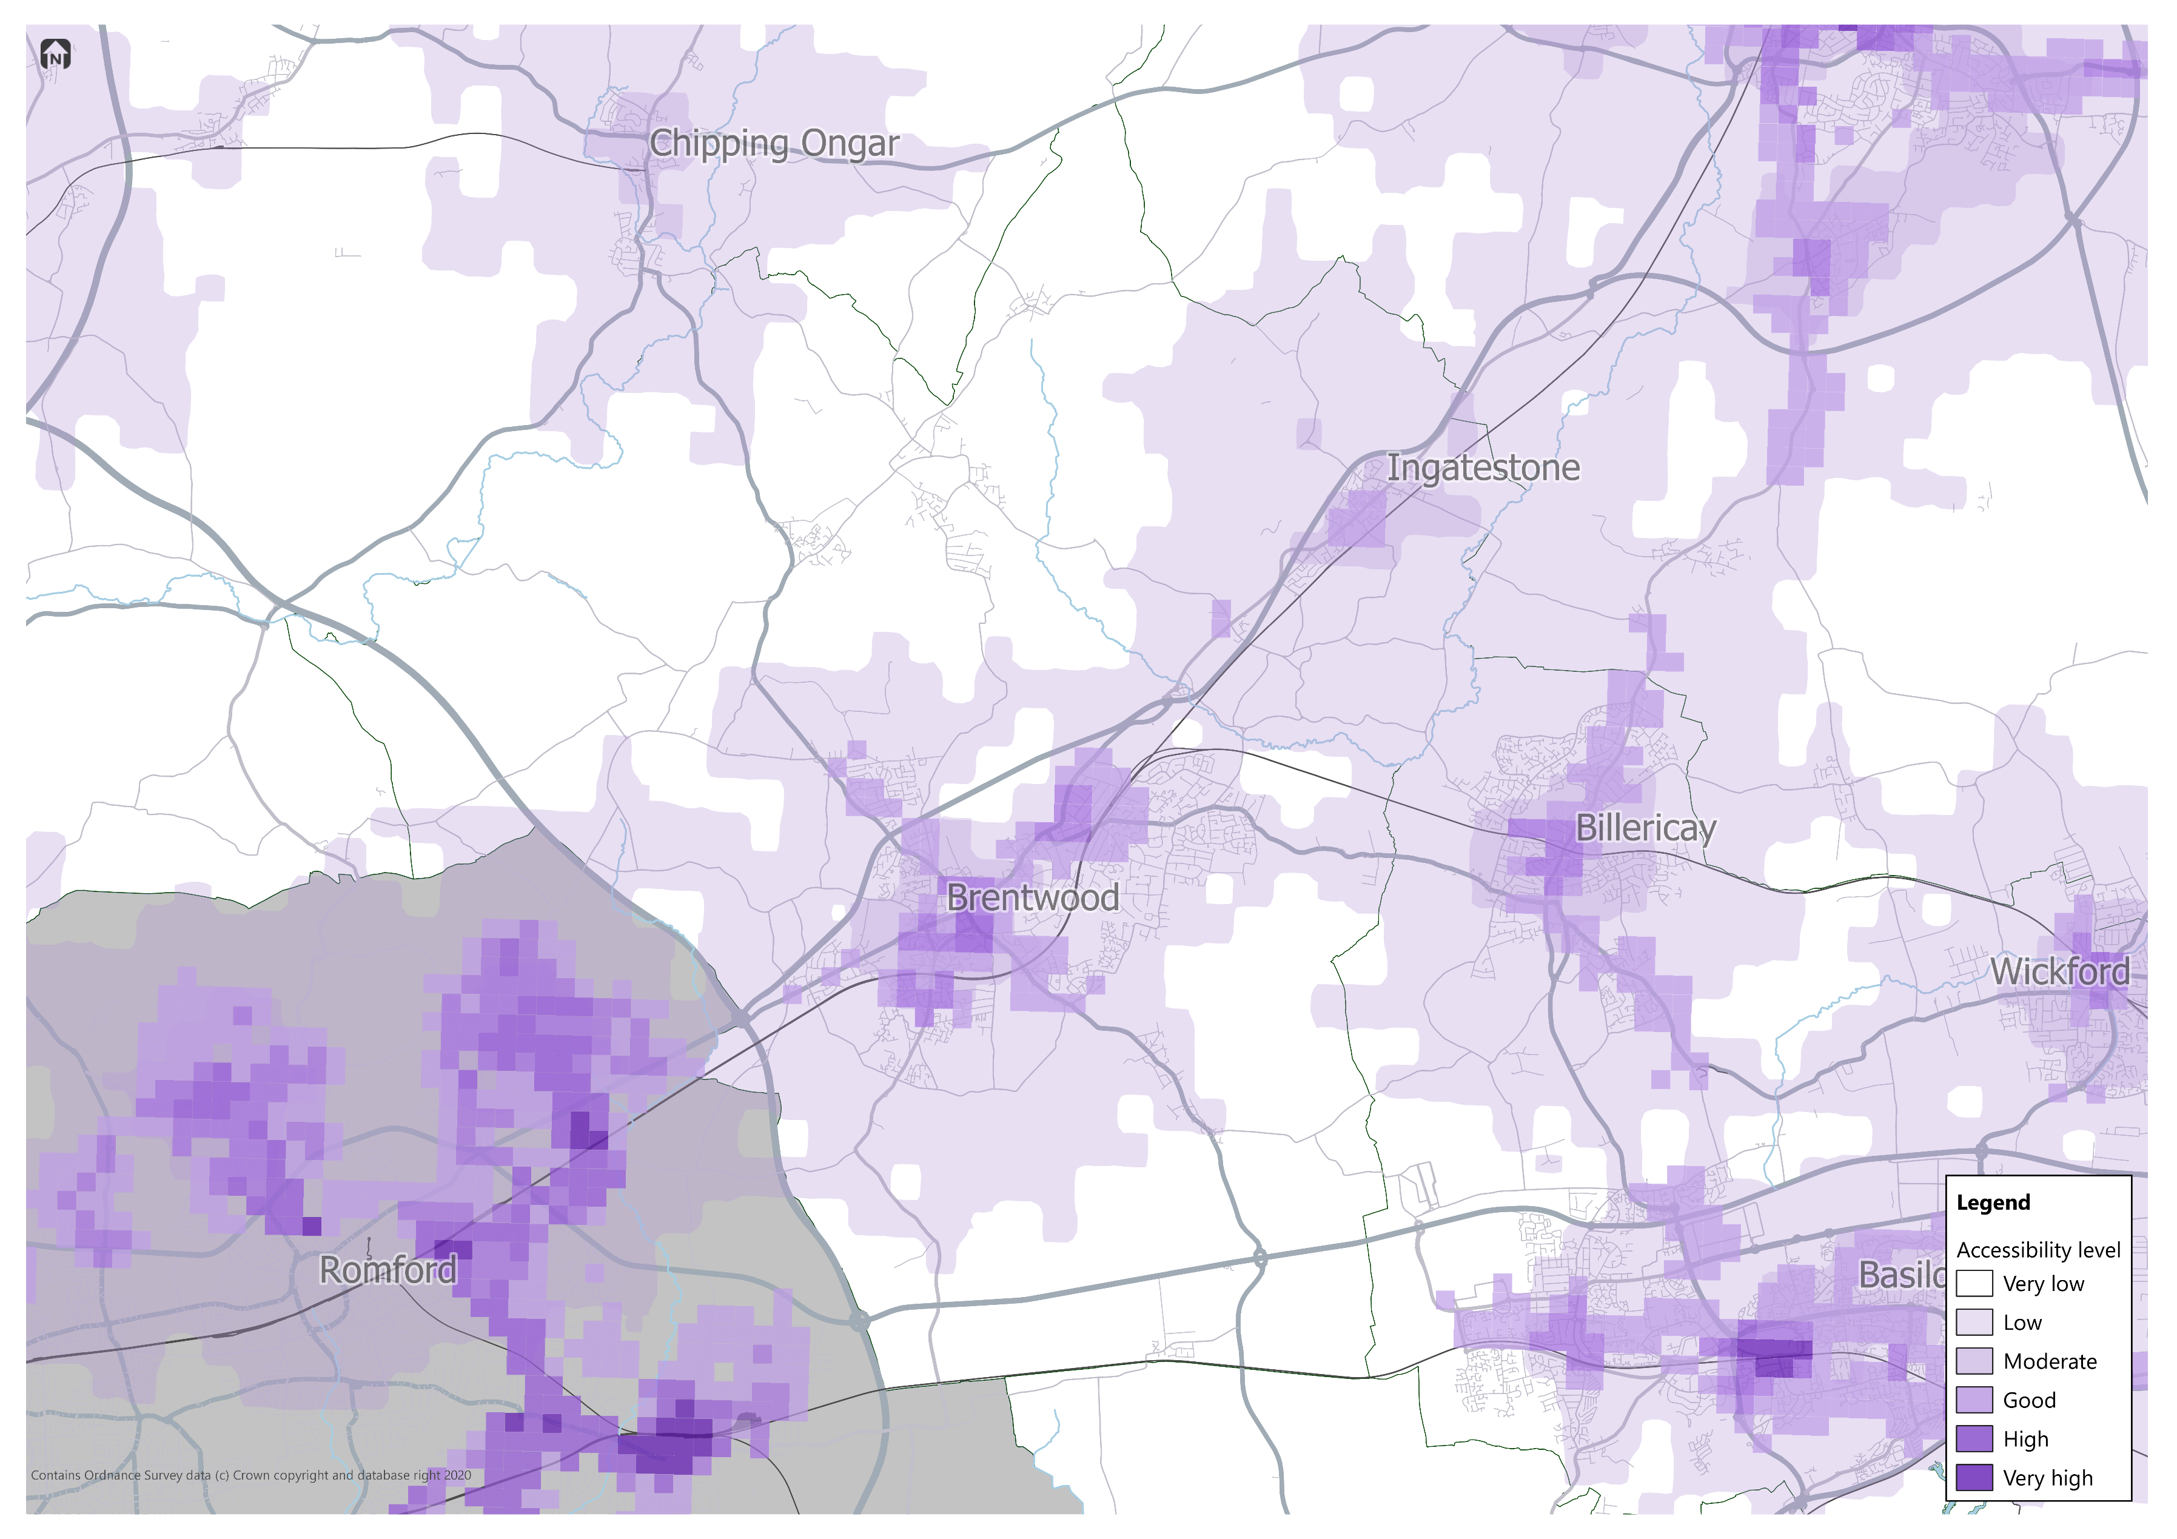

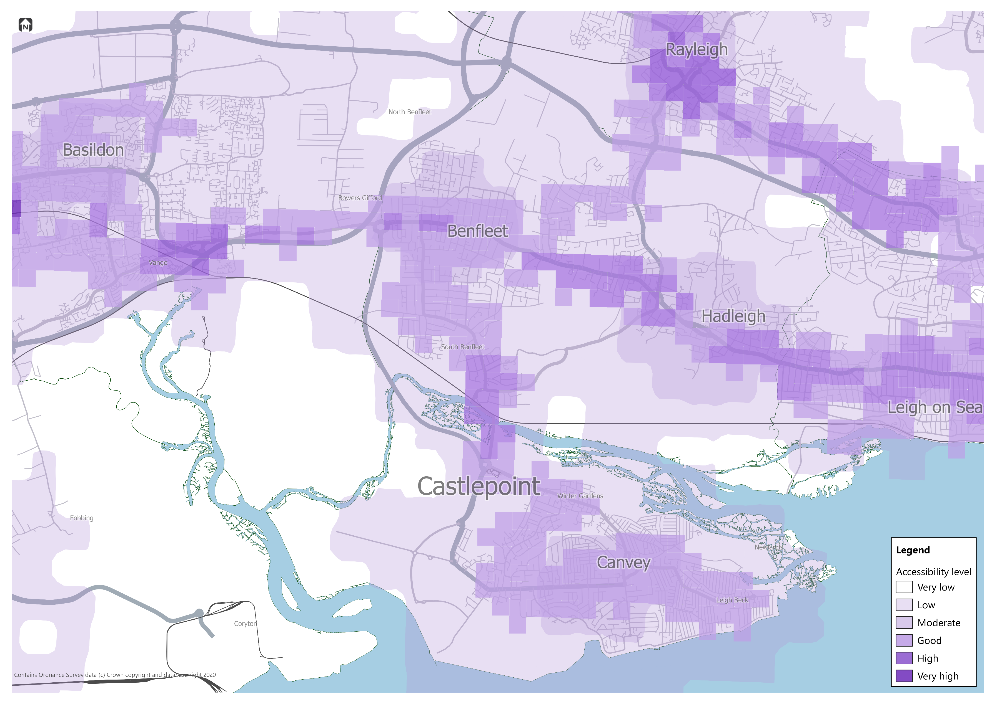

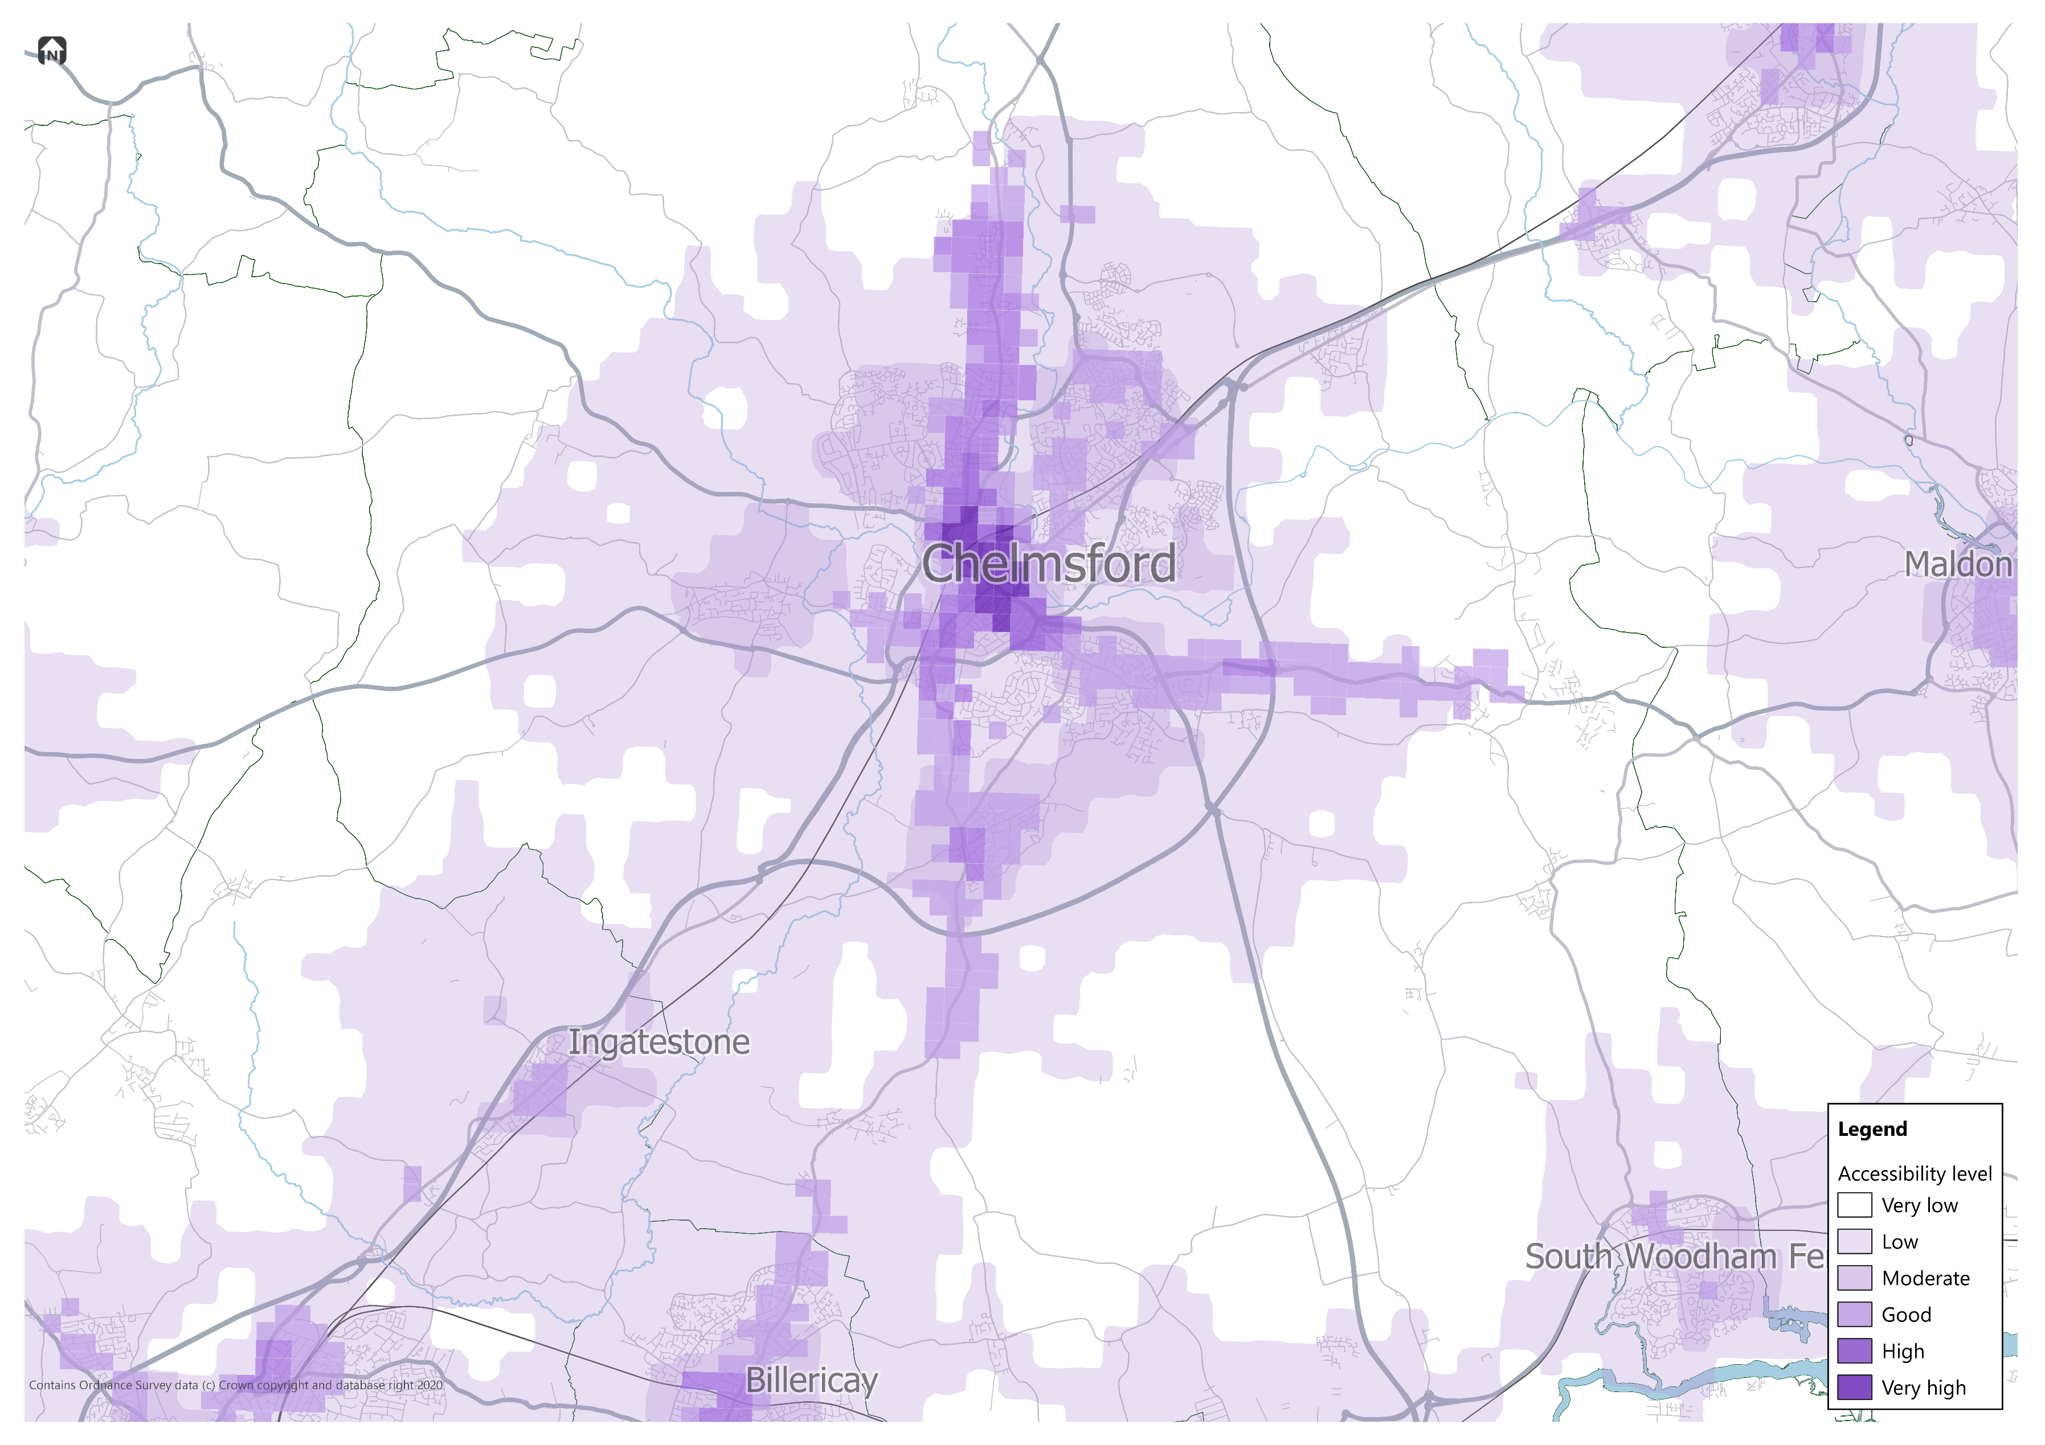

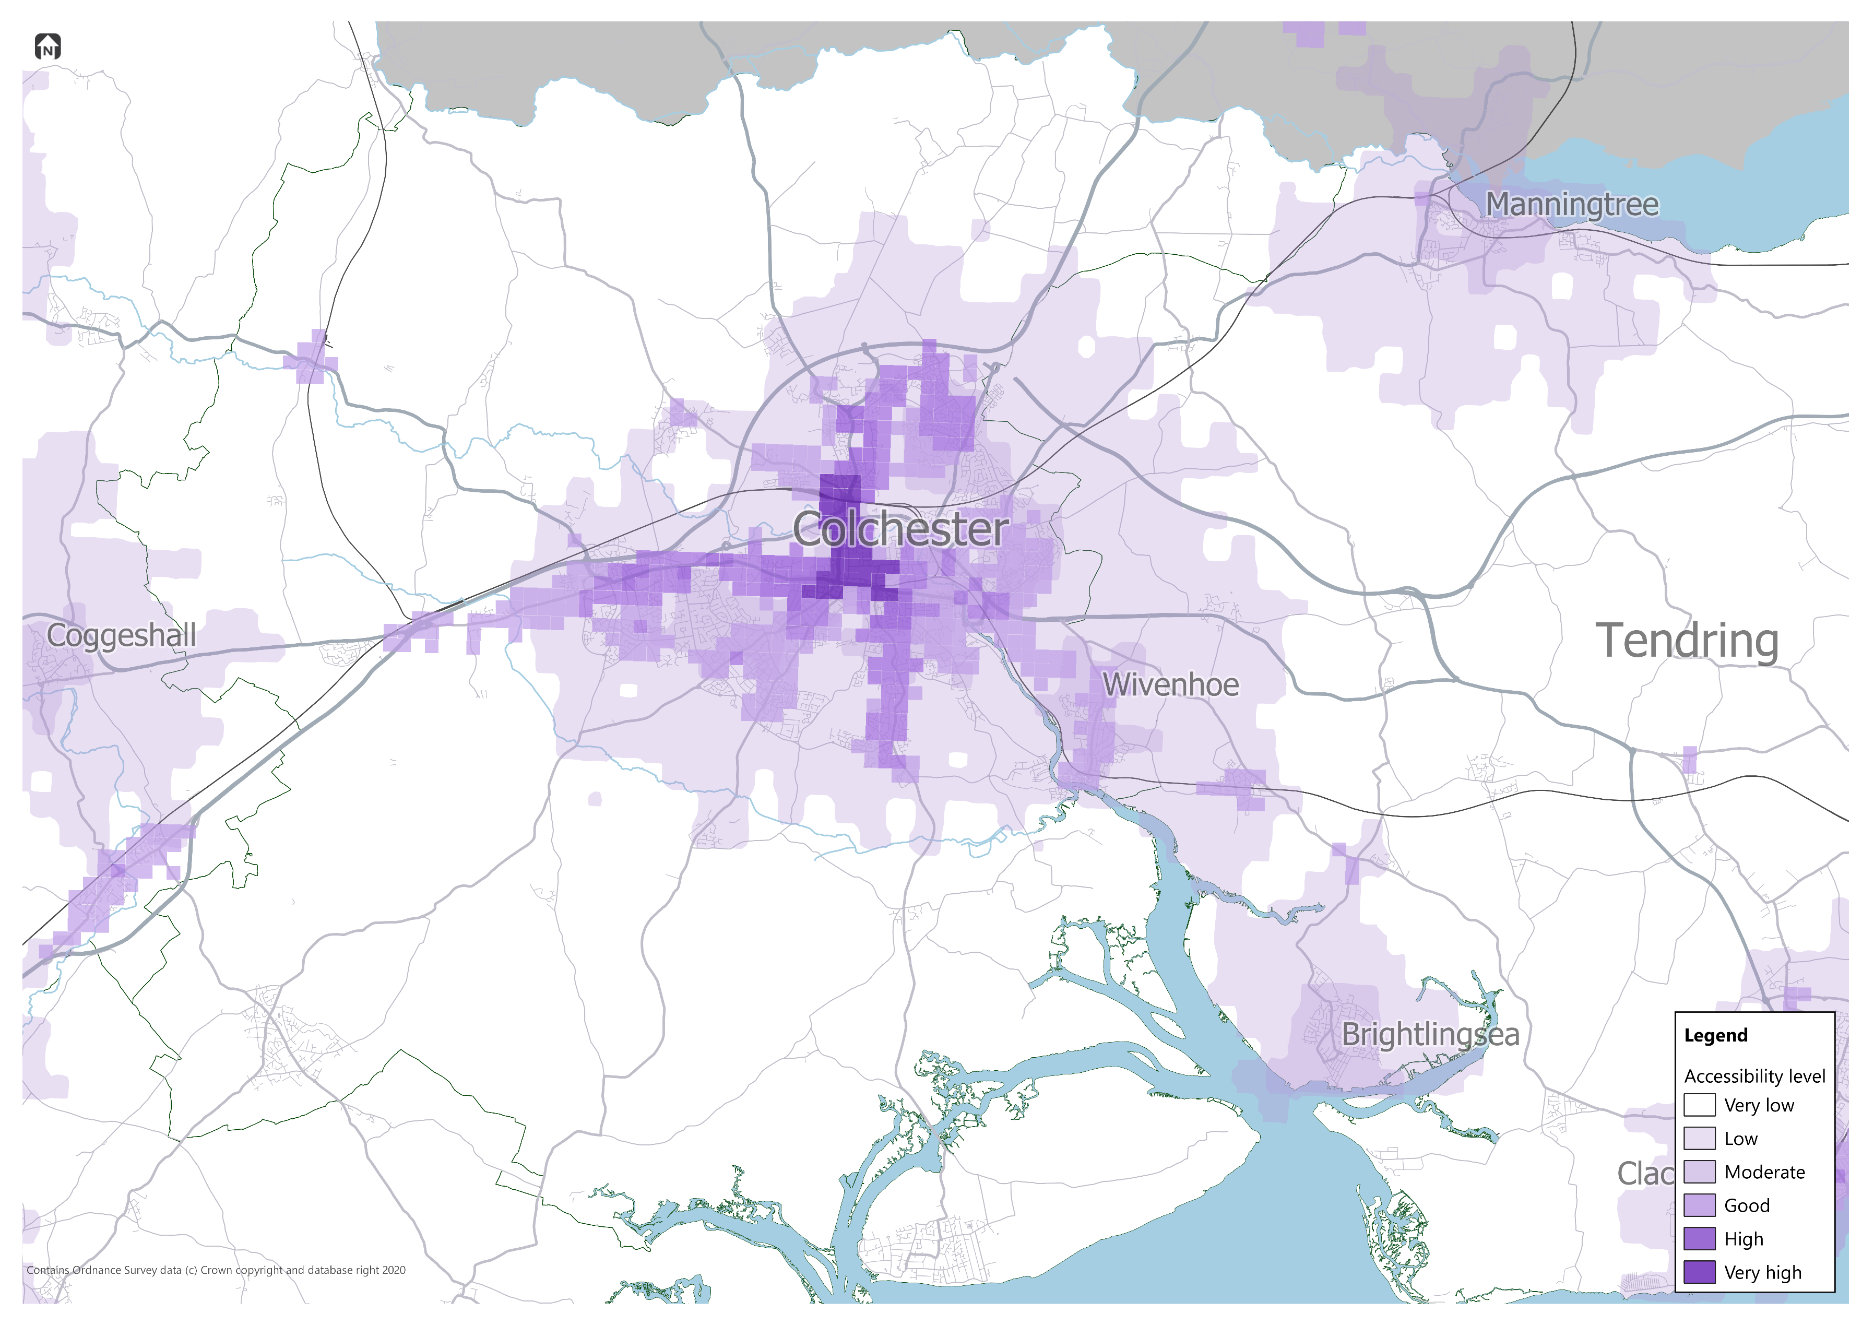

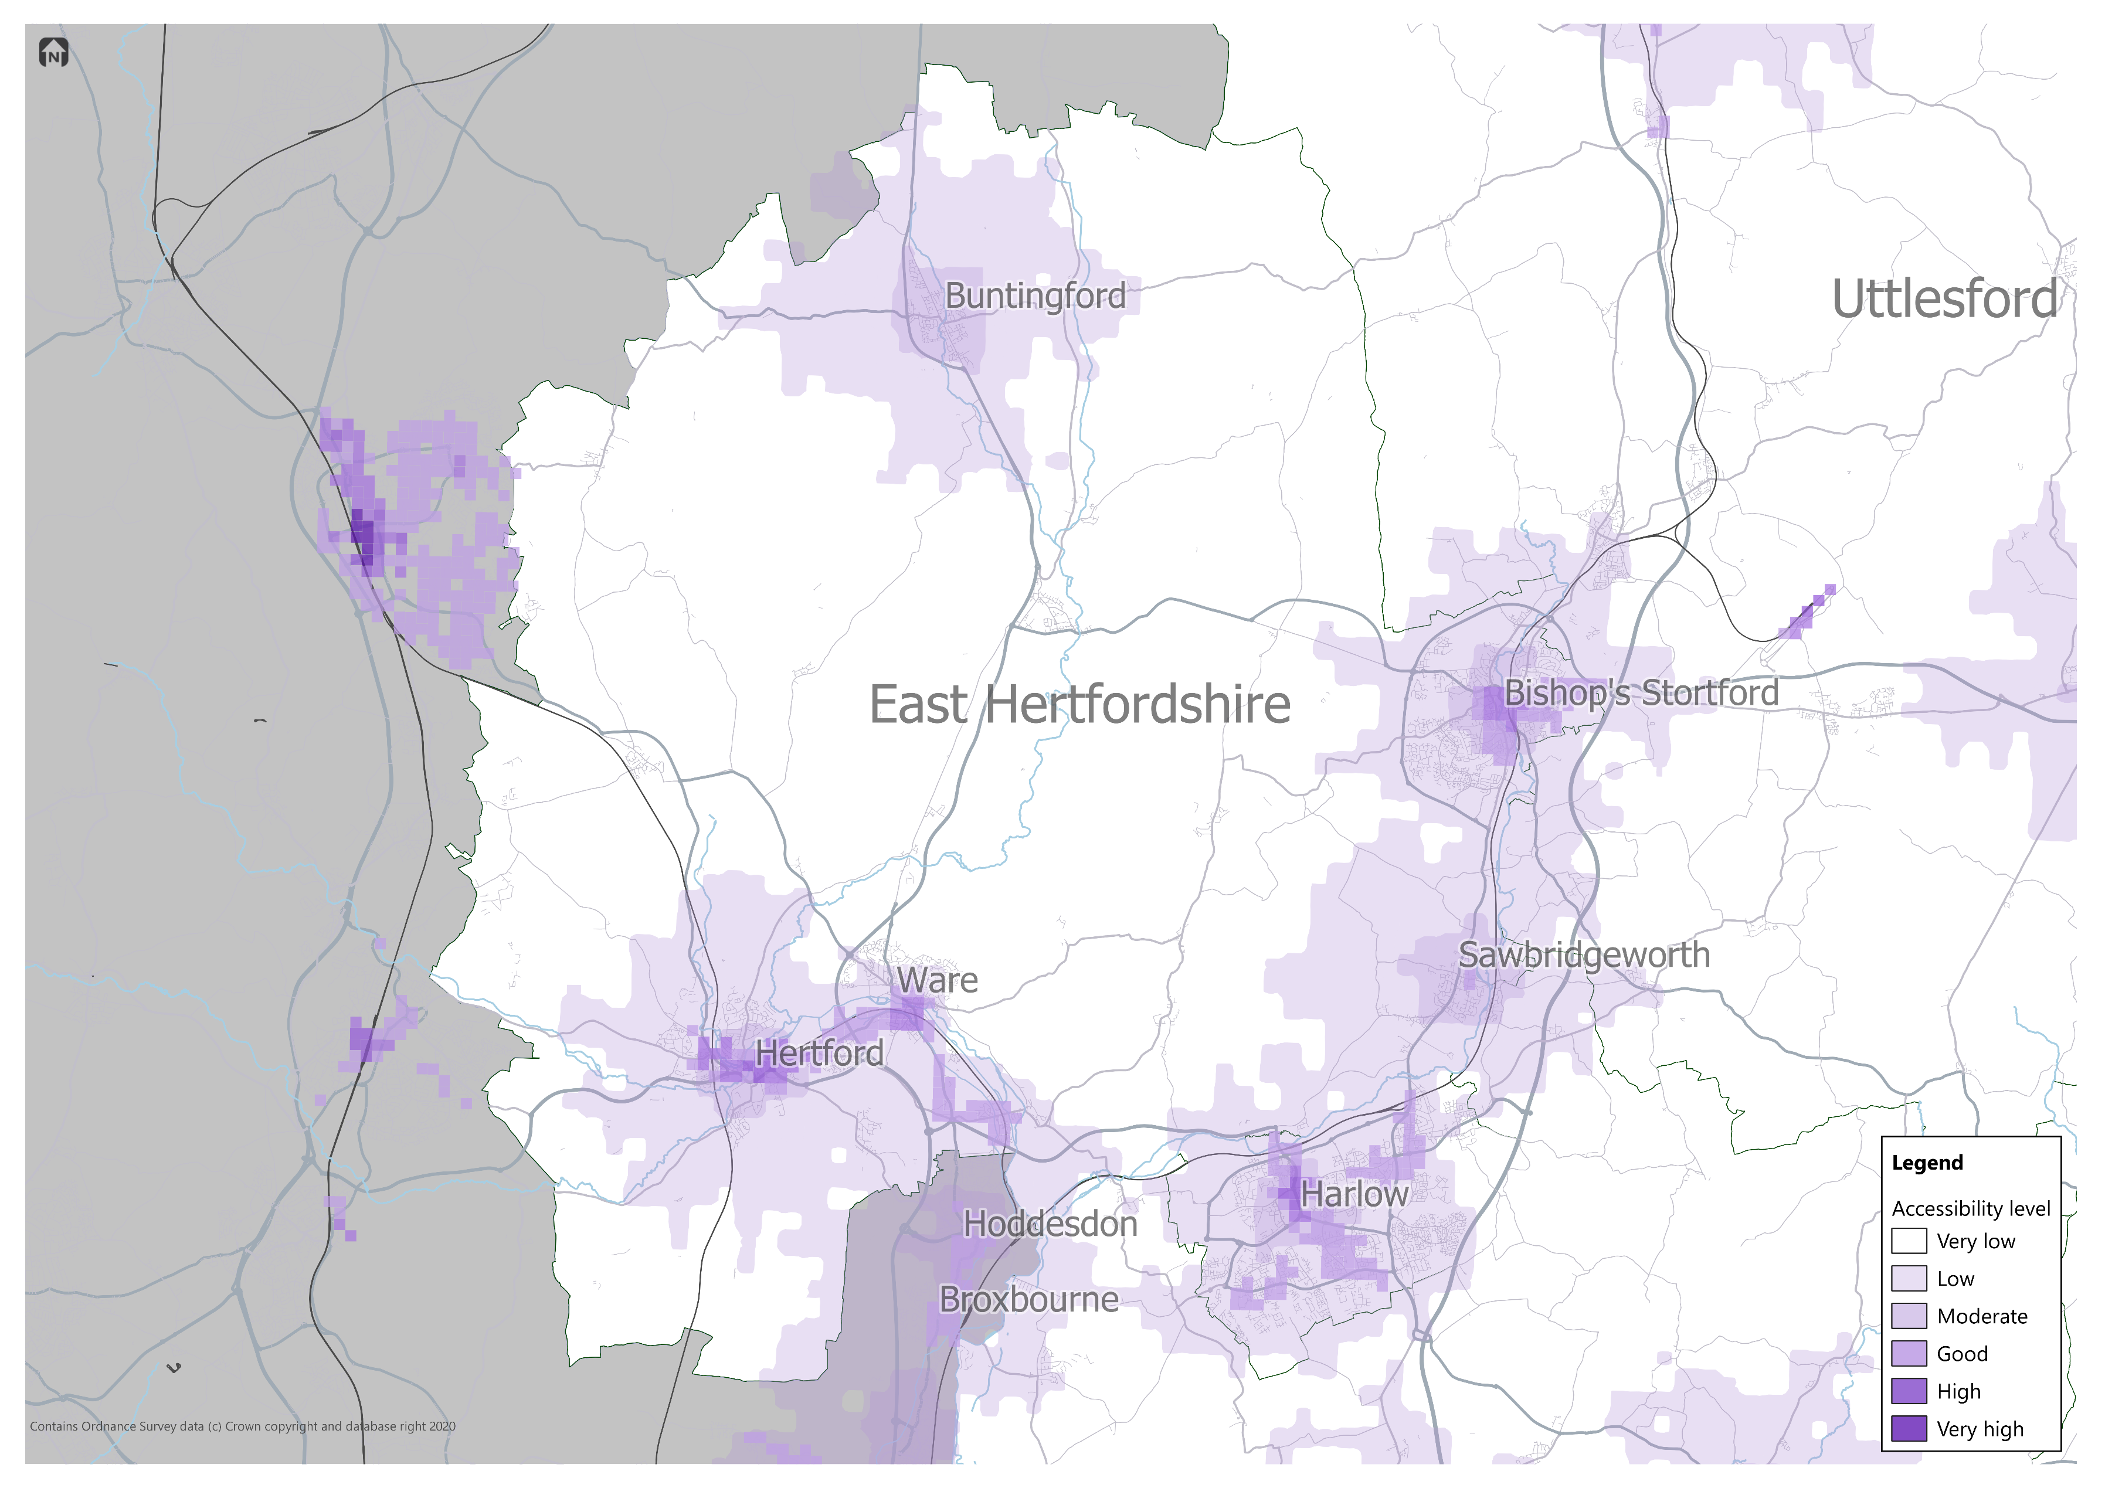

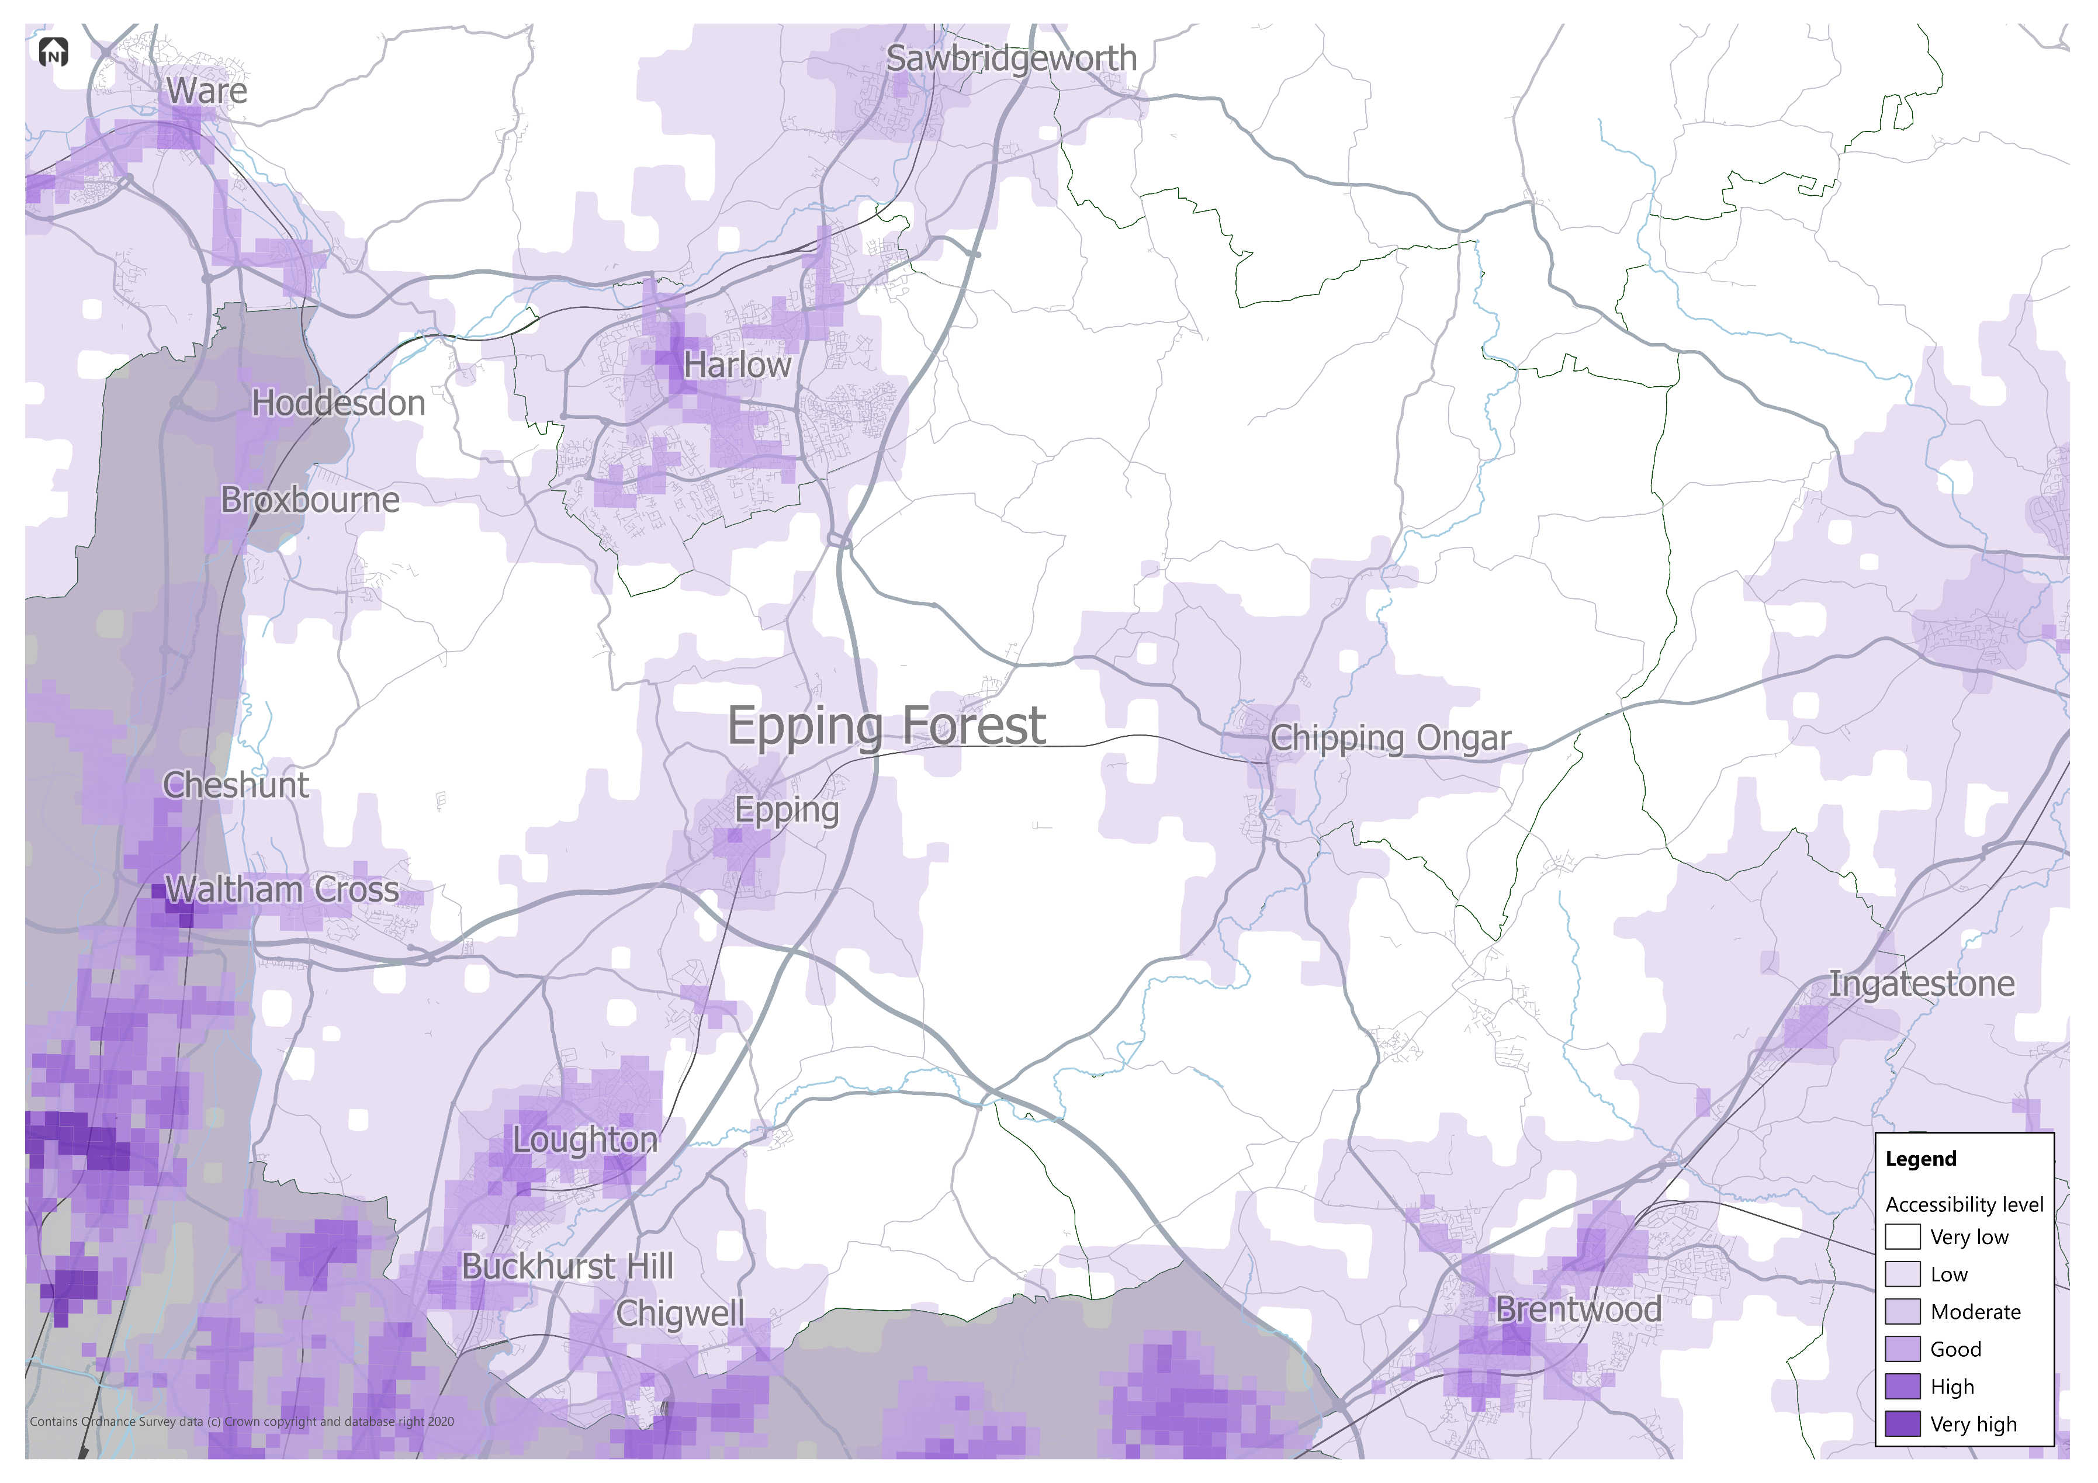

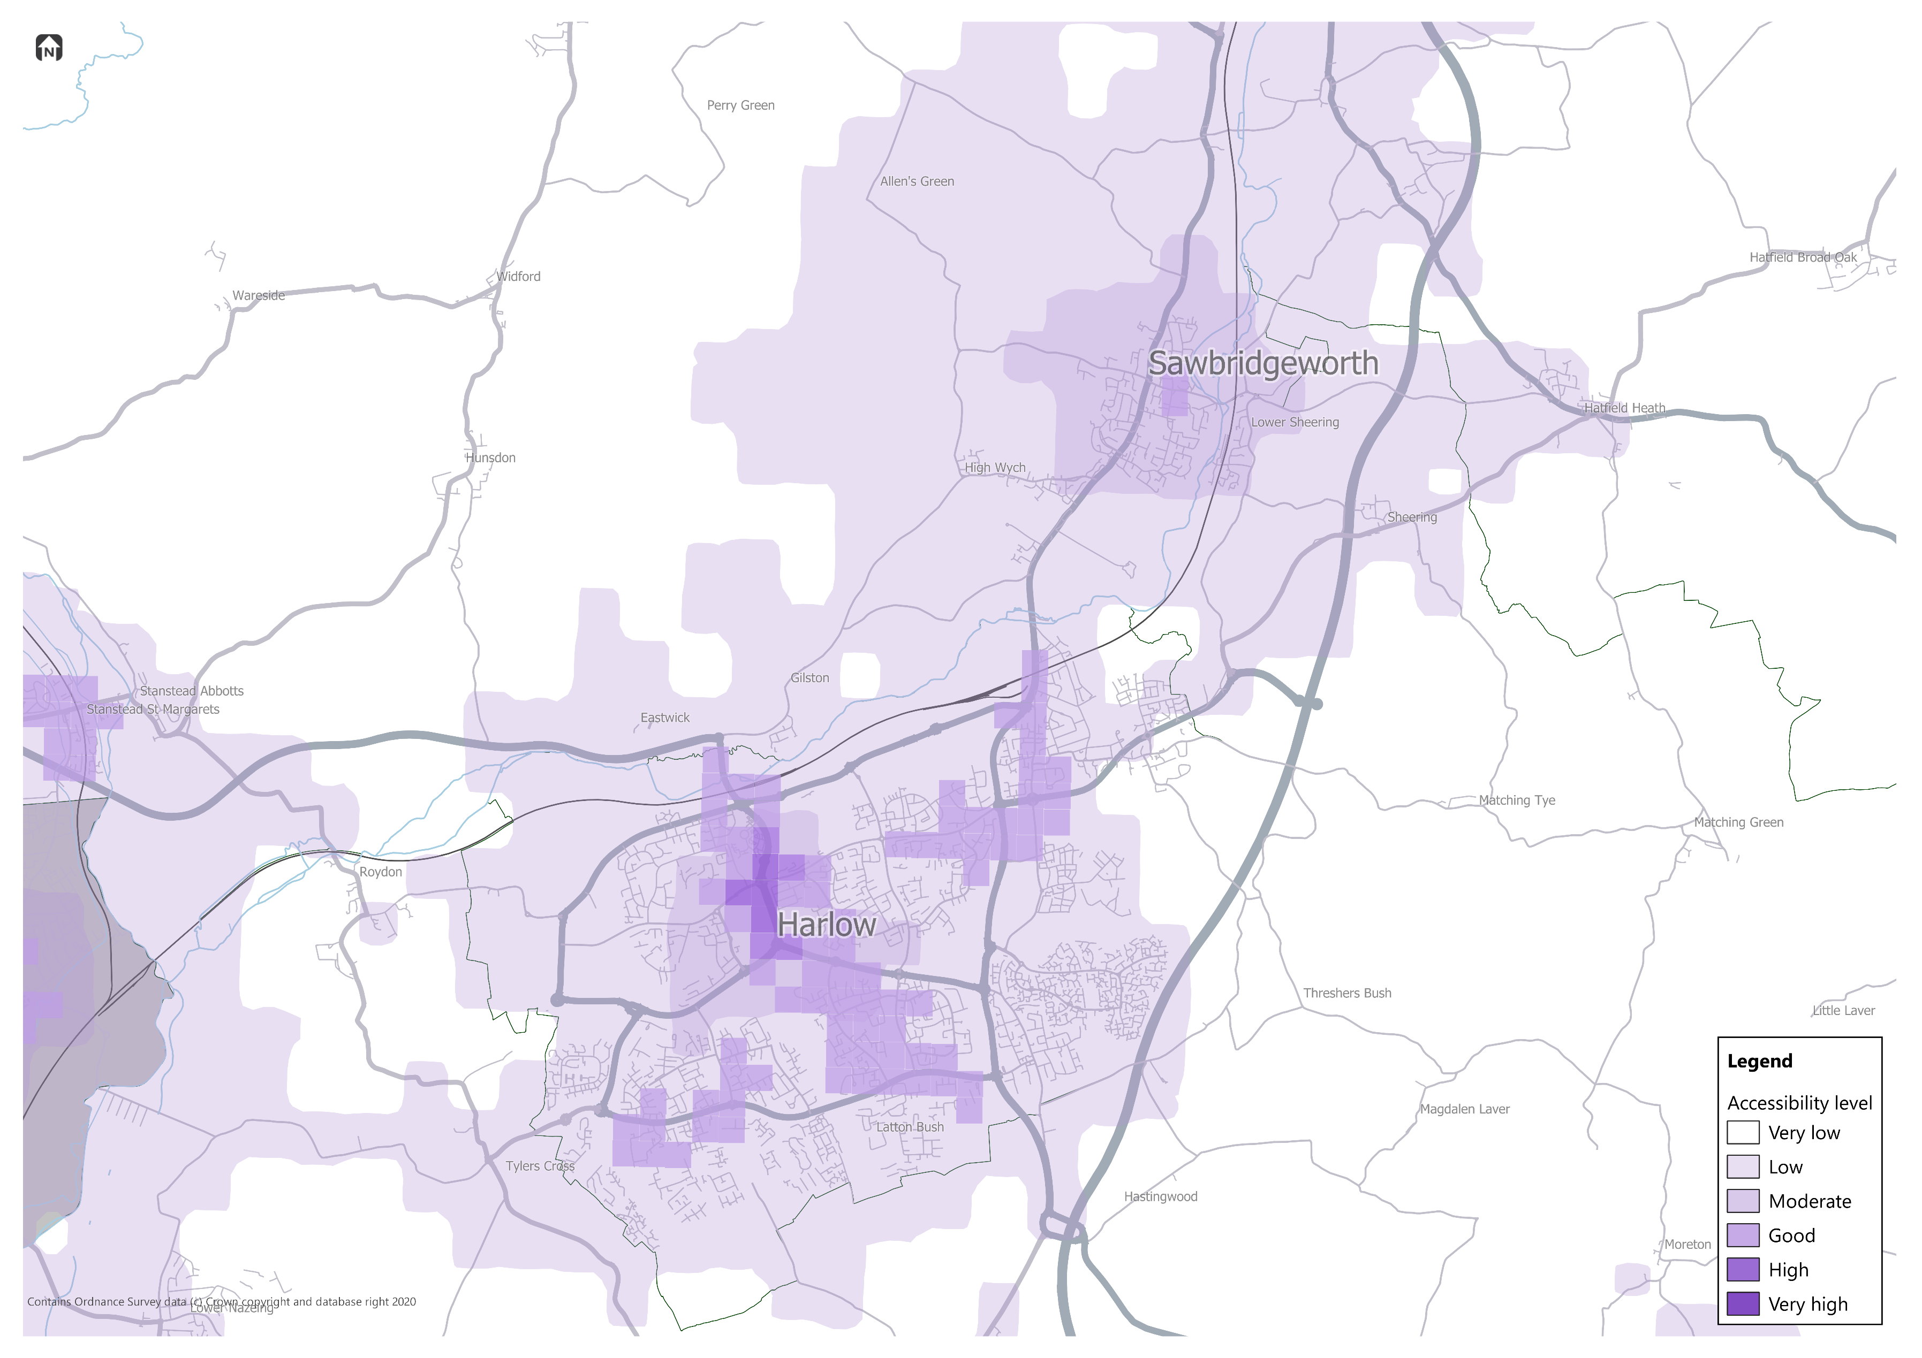

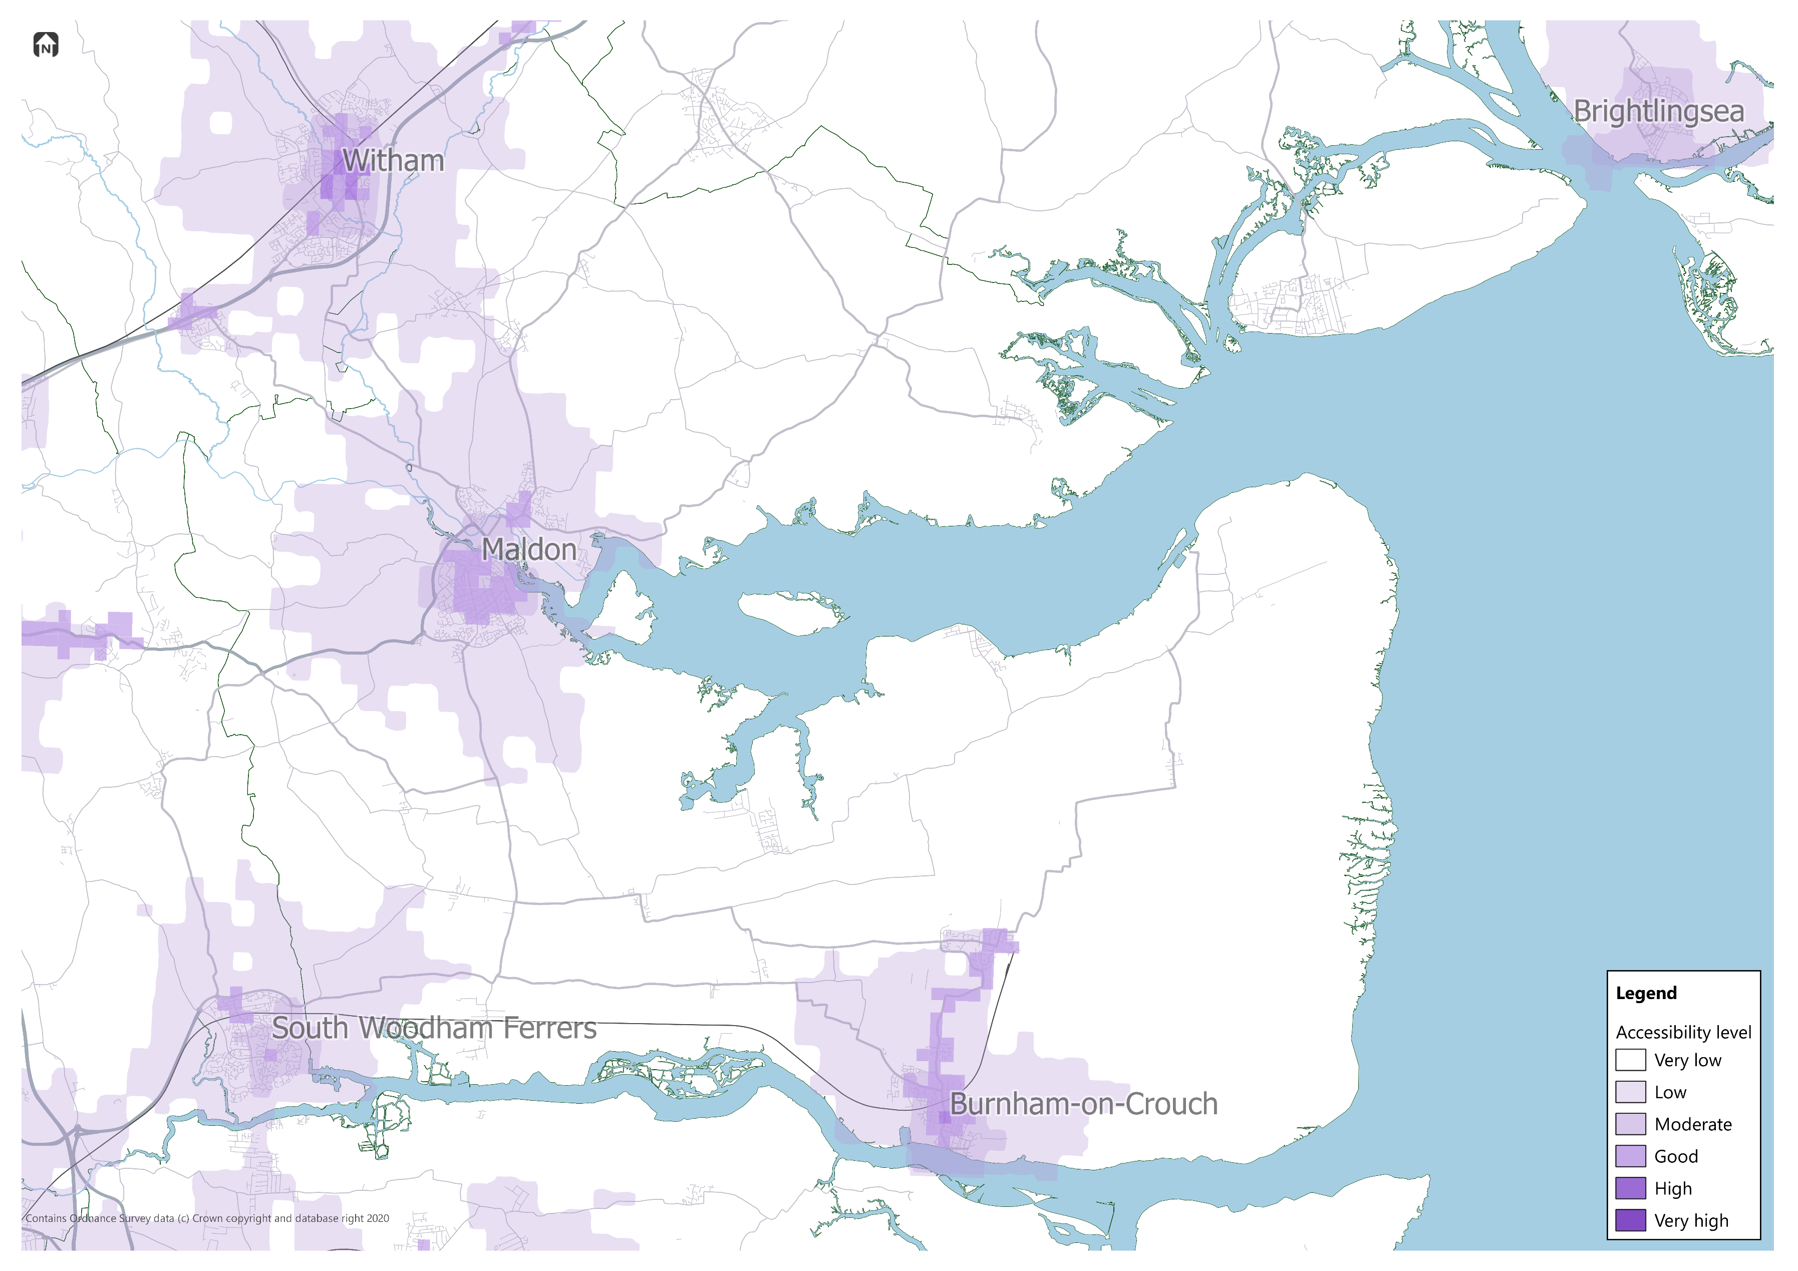

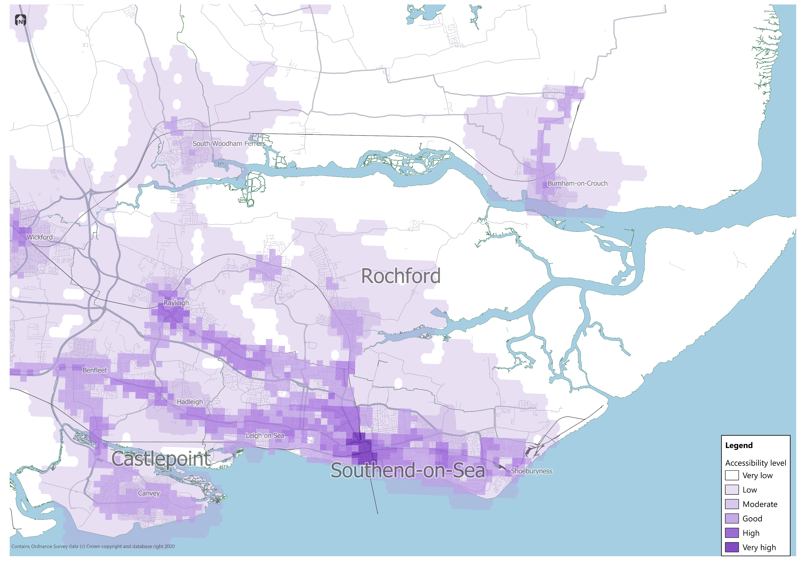

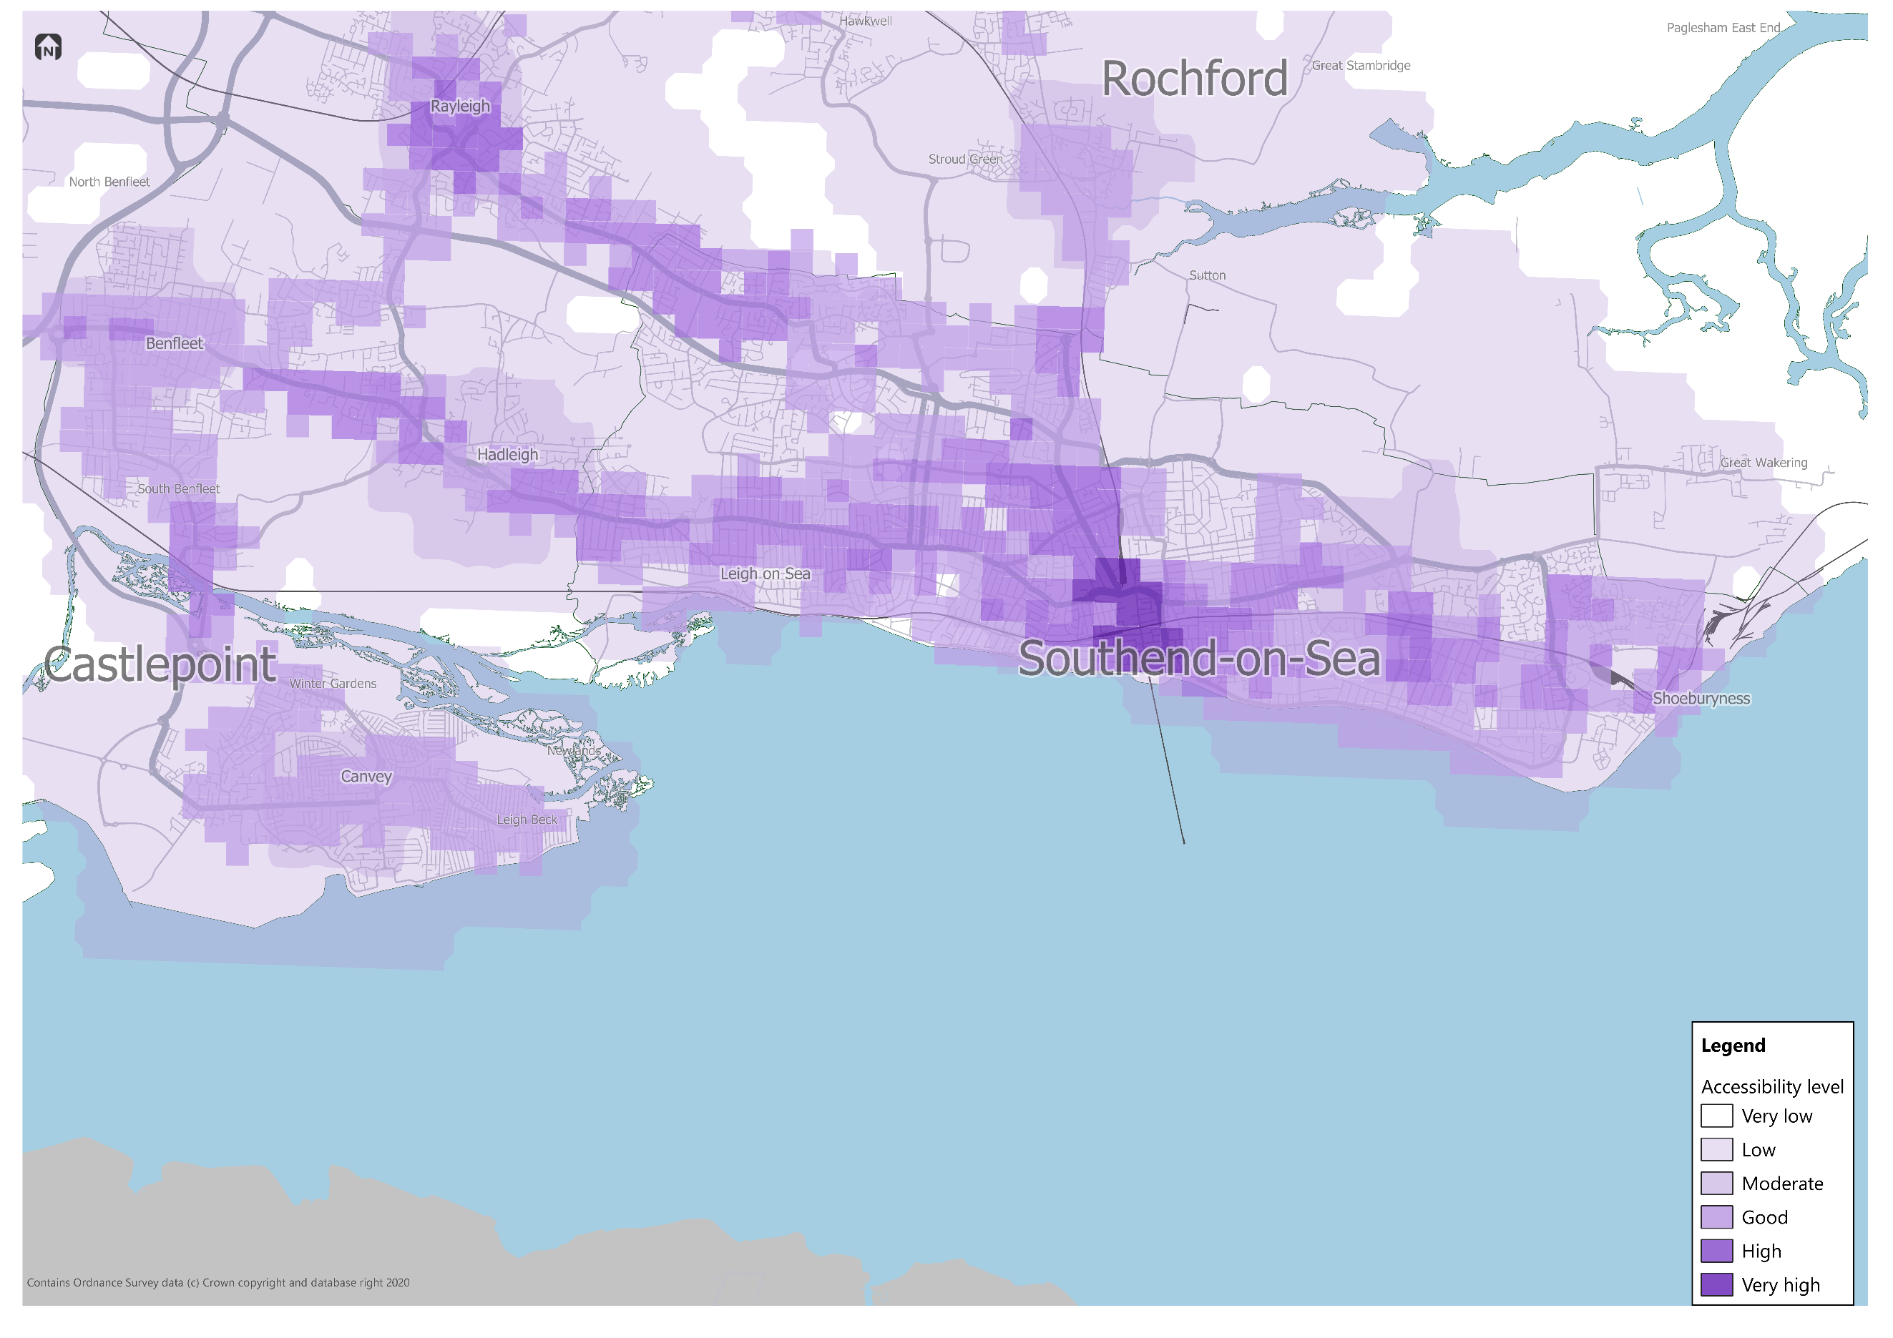

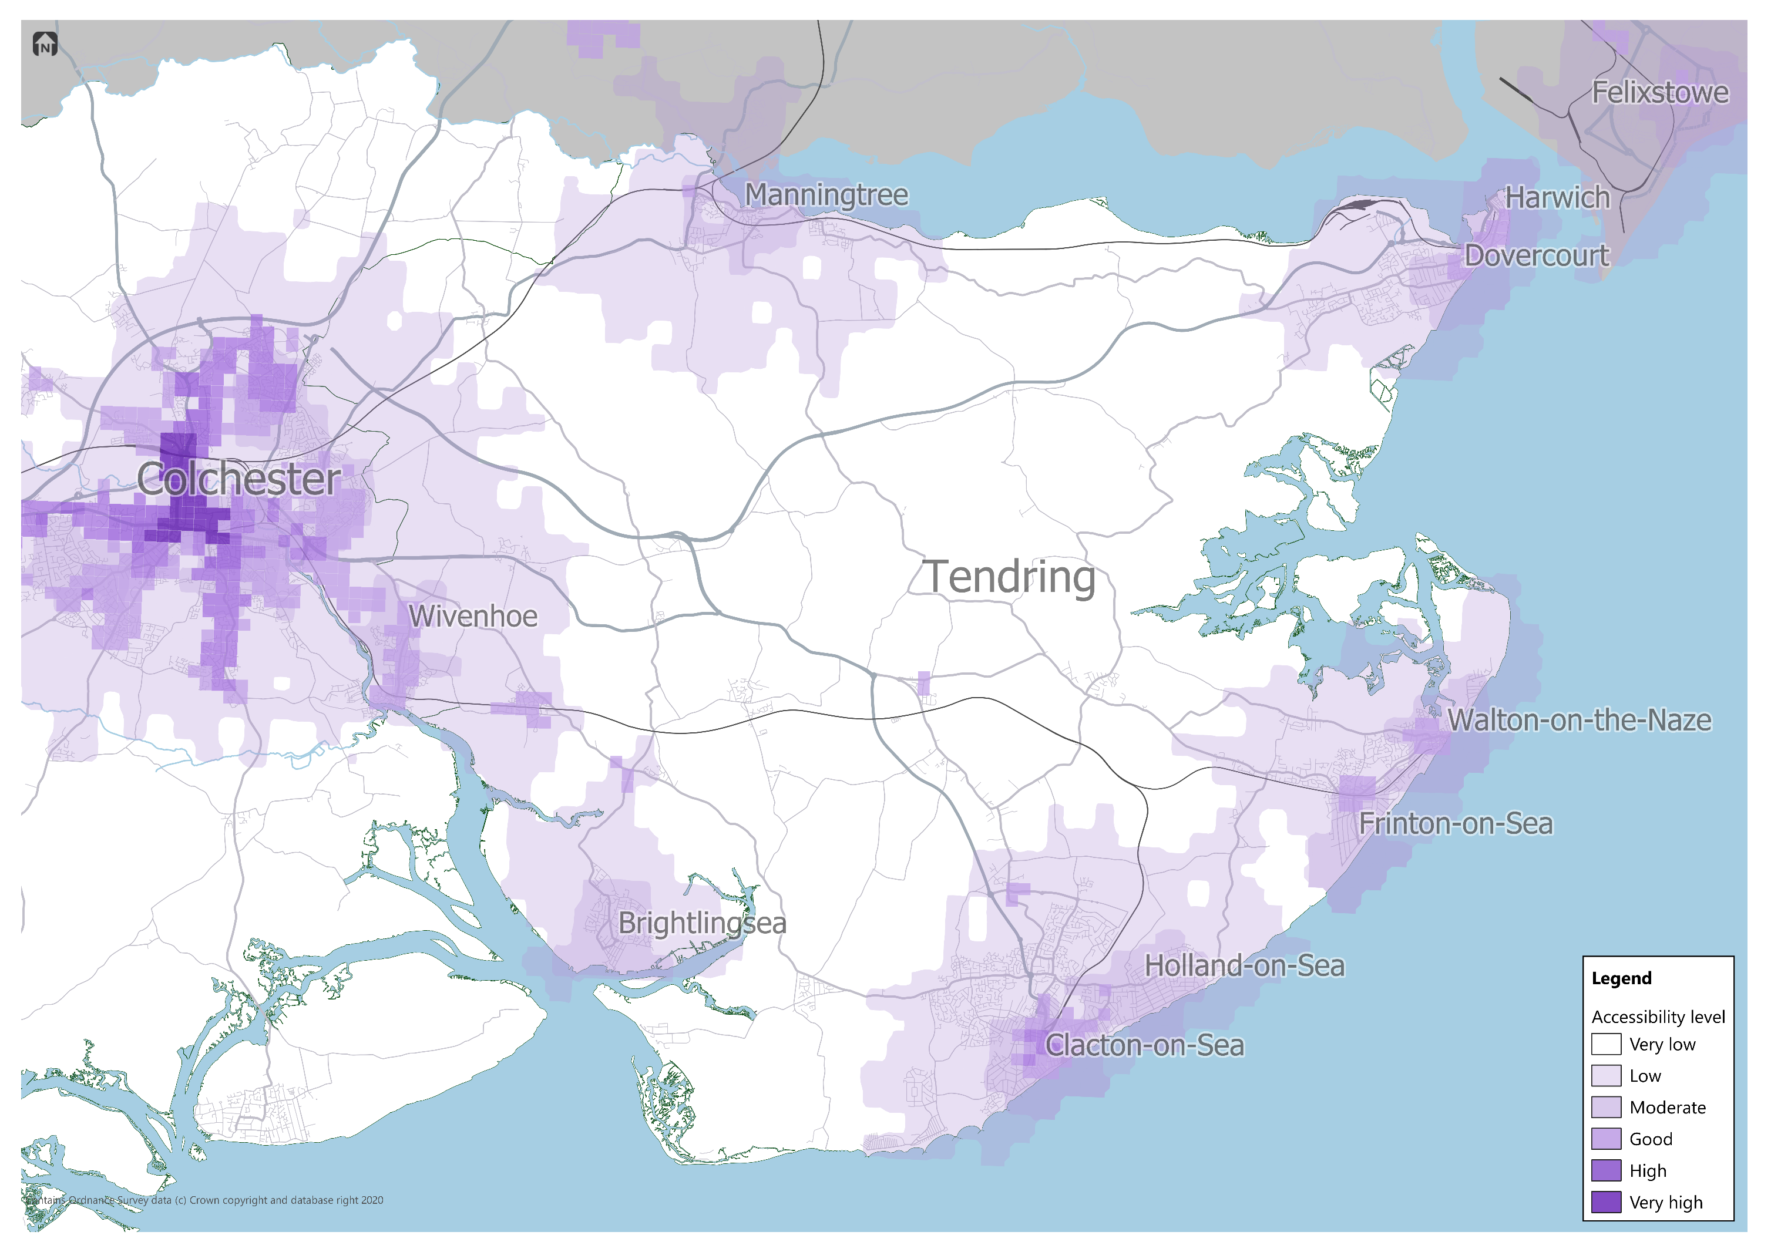

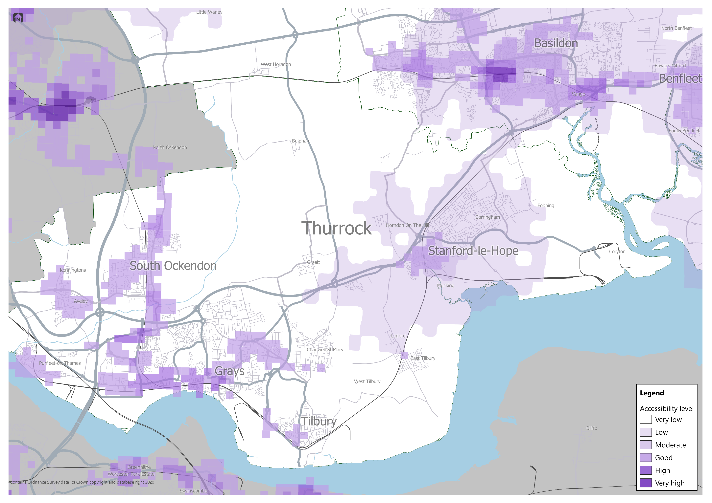

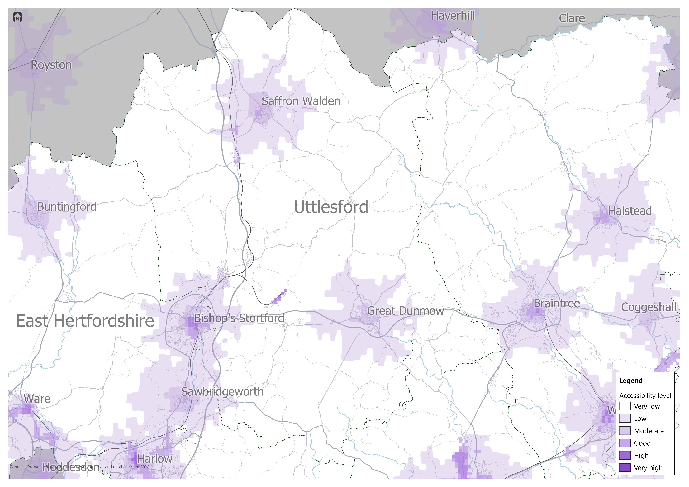

Appendix D
Vehicle parking reductions for non-residential land uses
Minimum standards for non-residential land uses
Accessibility Tool Score | 0 to 10 | 11 to 15 | 16 to 20 | 21 to 25 | 26 to 30 | 31 and above
Land use Class E(a) and E(b) - Retail
E(a) Display or retail sale of goods, other than hot food | Apply Part 1 standards |  |  | Apply 30% reduction to Part 1 standards. As with Part 1, standards for large developments, such as large department stores and shopping centres will be considered on a case-by-case basis | Apply 40% reduction to Part 1 standards. As with Part 1, standards for large developments, such as large department stores and shopping centres will be considered on a case-by-case basis | Apply 50% reduction to Part 1 standards. As with Part 1, standards for large developments, such as large department stores and shopping centres will be considered on a case-by-case basis
E(b) Sale of food and drink for consumption (mostly) on the premises | Apply Part 1 standards
Land use Class E(c) and E(g) - Commercial
E(c)(i) Financial services | Apply Part 1 standards |  |  | Apply 15% reduction from Part 1 standards. Coach parking / facilities and additional considerations for special schools should be included. | Apply 20% reduction from Part 1 standards. Coach parking / facilities and additional considerations for special schools should be included. | Apply 25% reduction from Part 1 standards. Coach parking / facilities and additional considerations for special schools should be included.
E(c)(ii) Professional services (other than health or medical services) | Apply Part 1 standards
E(c)(iii) Other appropriate services in a commercial, business or service locality | Apply Part 1 standards
E(g)(i) Offices to carry out any operational or administrative functions | Apply Part 1 standards
Land use Class E(other)
E(d): Gyms, sports halls | Apply Part 1 standards |  |  | Apply 30% reduction to Part 1 standards | Apply 40% reduction to Part 1 standards | Apply 50% reduction to Part 1 standards
E(d): Other sports facilities
E(e): Medical centres | Apply Part 1 standards |  |  | Apply 15% reduction from Part 1 standards. Coach parking / facilities and additional considerations for special schools should be included. | Apply 20% reduction from Part 1 standards. Coach parking / facilities and additional considerations for special schools should be included. | Apply 25% reduction from Part 1 standards. Coach parking / facilities and additional considerations for special schools should be included.
E(f): Crèche, childcare
E(f): Day care centre
Land use Class F1 and F2 - Local Community
F1(a): Education – Primary / Secondary | Apply Part 1 standards, including coach parking and facilities and additional considerations for special schools. |  |  | Apply 15% reduction from Part 1 standards. Coach parking / facilities and additional considerations for special schools should be included. | Apply 20% reduction from Part 1 standards. Coach parking / facilities and additional considerations for special schools should be included. | Apply 25% reduction from Part 1 standards. Coach parking / facilities and additional considerations for special schools should be included.
F1(a): Education – Further/Higher
F1(d): Public libraries or public reading rooms | Apply Part 1 standards |  |  | Apply 30% reduction from Part 1 standards. Coach parking / facilities and additional considerations for special schools should be included. | Apply 40% reduction from Part 1 standards. Coach parking / facilities and additional considerations for special schools should be included. | Apply 50% reduction from Part 1 standards. Coach parking / facilities and additional considerations for special schools should be included.
F1(f): Public worship or religious instruction (or in connection with such use) | Apply Part 1 standards |  |  | Apply 15% reduction from Part 1 standards. Coach parking / facilities and additional considerations for special schools should be included. | Apply 20% reduction from Part 1 standards. Coach parking / facilities and additional considerations for special schools should be included. | Apply 25% reduction from Part 1 standards. Coach parking / facilities and additional considerations for special schools should be included.
F2(a): Shops (mostly) selling essential goods, including food, where the shop’s premises do not exceed 280m2 and there is no other such facility within 1000m | Apply Part 1 standards |  |  | Apply 30% reduction to Part 1 standards | Apply 40% reduction to Part 1 standards | Apply 50% reduction to Part 1 standards
F2(b): Halls or meeting places for the principal use of the local community | Apply Part 1 standards
F2(c): Areas or places for outdoor sport or recreation (not involving motorised vehicles or firearms) | Apply Part 1 standards
Sui Generis
Drinking establishments | Apply Part 1 standards |  |  | Apply 30% reduction to Part 1 standards | Apply 40% reduction to Part 1 standards | Apply 50% reduction to Part 1 standards
Hot food takeaways |  |  |  | Apply 30% reduction to Part 1 standards | Apply 40% reduction to Part 1 standards | Apply 50% reduction to Part 1 standards
Rail stations - Minor | Apply Part 1 standards |  |  | Apply 15% reduction to Part 1 standards and be integrated into a mobility hub strategy for the wider site and be connected by good sustainable travel options. | Apply 20% reduction to Part 1 standards and be integrated into a mobility hub strategy for the wider site and be connected by good sustainable travel options. | Apply 25% reduction to Part 1 standards and be integrated into a mobility hub strategy for the wider site and be connected by excellent sustainable travel options.
Rail stations - Key | Apply Part 1 standards |  |  | Apply 15% reduction to Part 1 standards. Provision should include dedicated car sharing bays as part of a mobility hub strategy for the wider site and be connected by good sustainable travel options. | Apply 20% reduction to Part 1 standards. Provision should include dedicated car sharing bays as part of a mobility hub strategy for the wider site and be connected by good sustainable travel options. | Apply 25% reduction to Part 1 standards. Provision should include dedicated car sharing bays as part of a mobility hub strategy for the wider site and be connected by excellent sustainable travel options.
Accessibility Tool Score | 0 to 10 | 11 to 15 | 16 to 20 | 21 to 25 | 26 to 30 | 31 and above
Land Use C - Other Residential
C1: Hotels | Apply Part 1 standards
C2: Residential Care Home | Apply Part 1 standards |  |  | Apply 15% reduction to Part 1 standards | Apply 20% reduction to Part 1 standards | Apply 25% reduction to Part 1 standards
C2: Hospital | Apply Part 1 standards
C2: Treatment Centre
C2A: Secure Residential Institution
C2: Residential education establishments – Primary/ Secondary
C2: Residential education establishments – Further/Higher | Apply Part 1 standards |  |  | Apply Part 1 standards for FTE allocations. Consider a 15% reduction in the number of additional spaces. | Apply Part 1 standards for FTE allocations. Consider a 20% reduction in the number of additional spaces. | Apply Part 1 standards for FTE allocations. Consider a 20% reduction in the number of additional spaces.
C3: Retirement developments | Apply Part 1 standards |  |  | Apply 15% reduction to Part 1 standards | Apply 20% reduction to Part 1 standards | Apply 25% reduction to Part 1 standards
C4: House in Multiple Occupation (HMO) | Apply Part 1 standards |  |  | Apply 30% reduction to Part 1 standards | Apply 40% reduction to Part 1 standards | Apply 50% reduction to Part 1 standards

Appendix E
Accessibility Tool worked example
Step 1 – Determine parking based on Part 1 standards
Phase 3 of an example GC proposes 200 new dwellings, with 30% one-bedroom dwellings, 40% two/three-bedroom dwellings, and the remainder as four-bedrooms or more.
The total number of private car parking spaces required for Phase 3 based on the Part 1 (‘low accessibility’) C3 residential standards is 400, plus 50 for visitors. Within this a proportion of spaces are to be for disabled people and electric vehicles. Additional PTW and cycle spaces would also be provided.
Step 2 – Score against Accessibility Framework
The same phase of 200 dwellings in an example GC is proposed, as in Step 1. The Census information on Map 1 indicates existing car ownership rates in the surrounding area average to 1.4 per dwelling (Score 3).
Driver mode share for the same area was 66% on Map 2 (Score 3).
Existing accessibility levels, as indicated on Map 3, show the development currently lies across areas of low and moderate accessibility. The majority of the development area is considered ‘low’ (Score 2).
With an existing access score total of 8, this development needs to provide a good level of improvement to reach the minimum threshold for large scale developments.
With a new local centre proposed within this phase, along with some existing facilities in neighbouring, earlier phases, >80% of the dwellings can reach at least three day-to-day facilities within 15 minutes. (Score 5).
Public transport is proposed to be improved, extending an existing local route into this phase of development with bus gate access providing a more direct journey to the comparative car journey. However, the rural location of the site means that there may not be demand to justify a very frequent ‘turn up and go’ bus service (Score 4).
Active mode infrastructure caters for non-car users by making routes more direct by walking or cycling. High quality infrastructure has been designed in to make streets safe and attractive to use, and it is quicker to get to the proposed local centre and an employment hub in a neighbouring, earlier phase by walking and cycling than it is by car (Score 5/6).
A network of new mobility hubs is proposed, with a range of transport modes provided including e-bike hire and car clubs, and facilities including parcel drop-off collection points and community hubs, these centre around the proposed bus stops but also work to incorporate off site locations, integrating the development with existing communities and facilities (Score 6).
Step 3 – Determine parking budget
The proposals mean that Phase 3 of the example GC development achieves a total score of 29, which is within the acceptable range for a GC. It is clear that the developments poorly accessible location to begin with influences its ability to achieve good outcomes in terms of achieving mode shift, and reducing car dependency and dominance. The lower score on these metrics means that the development has to work harder on other metrics (such as provision of mobility hubs).
As a result of this score, the maximum private car parking budget for Phase 3 of the GC equates to 240 vehicle parking spaces, plus 50 for visitors.
Step 4 – Determining proportions
With a total private parking budget of 260 as determined in Step 3, 132 should be off-plot and 108 on-plot. This is determined by the total Step 2 score of 29.
In addition to the total budget spaces above, a further 5 car club spaces should be provided.
Compared to the Part 1 ‘Low accessibility’ standard, which would average two private spaces per dwelling (excludes visitors), the Part 2 standards result in an average of 1.2 spaces per dwelling, plus visitor and car club spaces.
Taking all types of car parking into account, this represents an overall saving of 155 parking spaces, compared with application of the Part 1 ‘Low accessibility’ standards.
Within the total car parking provision, an appropriate level of EV charging and spaces for disabled people should be delivered, based on the Part 1 standards.
460 cycle parking spaces should be provided for the 200 dwellings, with an additional 25 for visitors, giving a total of 485 cycle parking spaces across the phase for the C3 residential dwellings (assumes mix of dwelling sizes as set out in Step 1).
Chapter 5 sets out how cycle and car parking should be designed into the site.
Step 5 – Considering other land uses
With a new local centre to be delivered as part of the development, additional parking requirements are:
- Small supermarket of 900m² - Part 1 suggests 45 vehicle parking spaces (three of which are for disabled people). With a 40% reduction this equates to 27 parking spaces in total, three of which remain for disabled people.
- Three form entry primary school (infants and juniors, 30 pupils per class) – Part 1 suggests 42 vehicle parking spaces, with two space for disabled people. With a 20% reduction, this results in 34 parking spaces, with two for disabled people. Coach parking / facilities are included and appropriate facility for minibus access for the associated SEND provision.
- GP – a medical centre applies the same parking standards as Part 1. With 12 FTE and 6 consulting rooms, this equates to nine parking spaces, with significant provision for disabled people.
All cycle and PTW parking to be delivered at Part 1 standards.
Step 6 – Reduce and repurpose
The same Phase 3 of 200 dwellings in an example GC is proposed, as in previous steps, but now imagining that the two subsequent phases have also been delivered. As the location of the GC has not fundamentally changed, the scores for Metrics 1, 2 and 3 relating to existing accessibility do not significantly change (and these are also outside of the applicant’s control). This again gives an existing access total score of 8.
With a new local centre proposed within this phase, some existing facilities in neighbouring, earlier phases, and future phases planned to deliver a new secondary school and a large food retail store, all new homes in Phase 3 of the GC would be able to reach day-to-day facilities within 15 minutes. (Score 6).
Public transport will further penetrate the wider development. However, the rural location of the site means that there is still not enough demand to render a commercially viable bus to serve 90% of the built development every 15 minutes or more (Score 5).
Active mode infrastructure continues to improve and achieve the highest score for this metric (Score 5/6).
The network of mobility hubs continue to grow, giving every dwelling a range of mobility options on their doorsteps (Score 6).
The resultant total score for this indicative future for this phase is 31. This means that around 40 out of the 240 car parking space budget should be designed with repurposing in mind, and the future trigger points / strategy for repurposing identified.
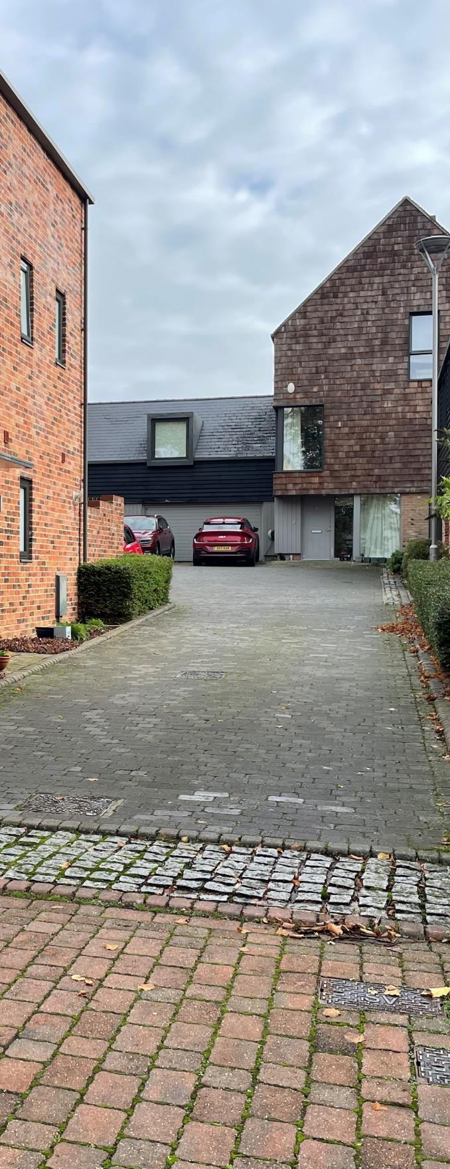

drawing on the Town and Country Planning Association’s Garden City Principles, and the Healthy New Town Principles
https://www.gov.uk/guidance/national-planning-policy-framework/9-promoting-sustainable-transport
Filtered permeability controls access by private car in order to reduce traffic levels in residential streets and to provide journey time advantage to walking, cycling and public transport
https://uploads-ssl.webflow.com/6102564995f71c83fba14d54/6230798c0eedd6b324670851_CoMoUK%20New%20Developments%20Guidance.pdf
https://www.tcpa.org.uk/resources/relevant-stewardship-resources-and-further-information/
https://www.pinsentmasons.com/out-law/guides/stewardship-vehicles-garden-communities
These are locations defined as ‘low’ or ‘very low’ accessibility according to the Accessibility Mapping used in Part 1 and included as Map 3 later in this section.
The Part 1 ‘low accessibility’ C3 standards are the same as those contained in the adopted 2009 Essex Parking Standards. The reductions from these required in this guidance have already been delivered in many well-connected, strategic developments in Essex, reflecting an organic change in approaches to sustainable development since 2009.
daily facilities (subject to local authority agreement) could include: convenience store, nursery, primary school, secondary school, pharmacy, GP, open space/green infrastructure, community building, post box, employment.

