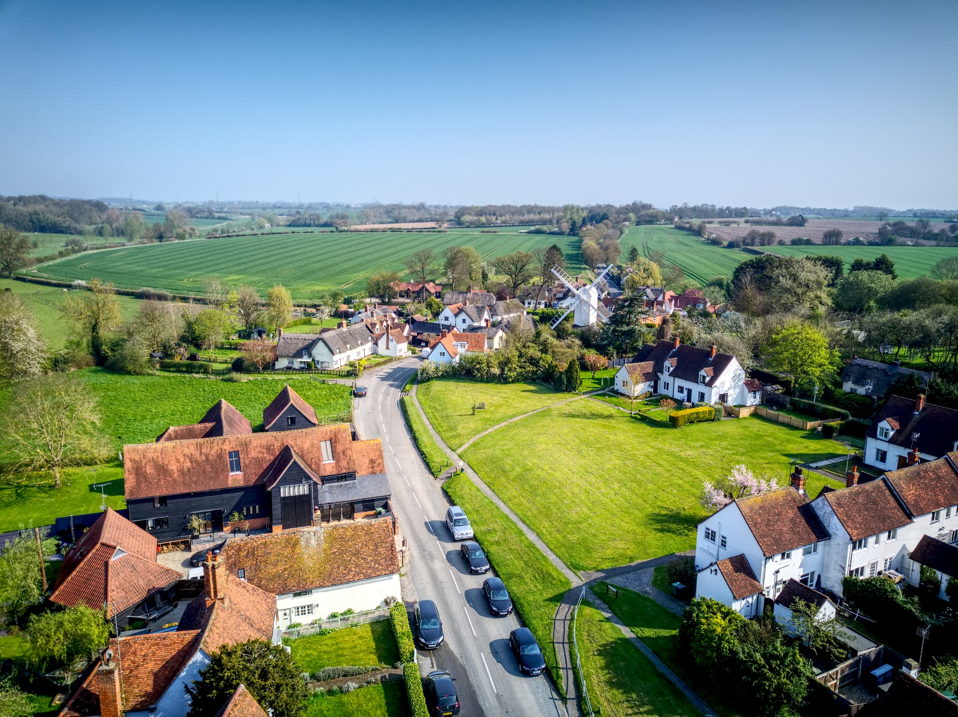
Essex Green Infrastructure Standards

Better Policy and Development for Better Place Making and Place Keeping
Workshops Summary
12 & 20 January 2022

Contents

Introduction 2
Workshop Purpose 2
Objectives 3
Attendees 3
Essex GI Standards update 3
Recap of the Essex GI Standards Journey so far 3
You Said – We Did 4
Essex GI Standards in the Policy and Development Context 5
Q & A 7
Breakout Session 11
Feedback and Next Steps 21
Workshop Evaluation 22

Introduction

Workshop Purpose

The aim of these workshops was: - to provide information on the new Essex Green Infrastructure Standards, the standards role in Planning and, its relation to the National GI Standards Framework from Natural England. To learn about the progress made in response to the 8-week consultation held during summer 2021 and explore the next steps for policy action and developments for meeting the requirements from the Environment Act (2021), 25 Year Environment Plan and National Planning Policy Framework for biodiversity net gain, contribute to Nature Recovery Networks, tackle climate change, and create green spaces and beautiful places.

Climate, ecological and health emergencies, the requirements within the Environment Act, and proposed planning reforms require a positive response and actions locally now. The Essex Green Infrastructure Standards is one of the tools that can help towards achieving this. It provides support in strengthening policy and delivering exemplar developments in place making for health and wellbeing (especially in response to the COVID-19 pandemic), nature and climate change and help deliver beautiful, sustainable, and prosperous communities.

Course Content
Workshop 1 12 January 2022: Policy – How can policy embed Green
Infrastructure to support place making and place keeping?
Workshop 2 20 January 2022: Development - Building exemplar and delivering
GI standards for better place making and keeping.

Objectives
This workshop provided an:
- Understanding of the Essex GI Standards in relation:
  - To good place making/keeping policies and for developments.
  - The ability to use the Essex GI Standards to aid effective policy development and implementation and in delivering multifunctional GI through development design to meet local priorities and needs.
  - Support to help with the preparation and review of Local Plans and other strategic documents and with the different stages of planning to ensure they meet the requirements from the Environment Act and contribute to addressing the Climate, Ecological and Health emergencies. As well as opportunities from the Green Growth agenda.
  - Delivery of exemplar developments.
- An opportunity for Stakeholders to determine the next steps of how to use the Essex GI Standards and the support needed.

Attendees
These were some of representatives that participated in the workshops:

- Essex Planning Officer Association/ Local Planning Authorities -Policy Planners, Development Management and Chief Officers,
- Essex County Council Services - Spatial Planning, Growth and Development, New Settlements, Essex Housing, Essex Highways, Flood and Water Management, Place Services
- Building Surveyor,
- Developer,
- Landscape, Green Infrastructure Officers,
- Essex Wildlife Trust,
- RSPB,
- Country Park.
- Open Space Managers and Officers,
- Environment Agency,
- Natural England
- Essex Bridle Association

Chaired by:
John Meehan, Head of Climate Adaptation and Mitigation, Essex County Council

Essex GI Standards update

RECAP OF THE ESSEX GI STANDARDS JOURNEY SO FAR

Rich Horswill, Green Infrastructure Planning Officer, ECC

In March 2020 we published our Essex GI strategy for Greater Essex, which was awarded Building with Nature Excellent Accreditation. This was in response to the recognise pressure on our environment from our population and development growth. This highlighted the importance of developing quality green spaces across Essex to help address the health climate and ecological emergency, whilst exploring opportunities from the green growth agenda.

A high-level action from this strategy presented an opportunity to take part in Natural England’s National GI Framework trials. Natural England were commissioning to review and update existing standards for GI and to develop a national framework of standards for GI, delivering the commitment in the Government 25 Year Environment Plan.

The national framework supports local areas in assessing their GI provision against these new standards and raising the bar around quantity, quality, and function of GI. The National GI Framework will provide support through an online portal and will be available in autumn 2022.

Essex Trial

Essex, working with the University of East Anglia and Northumbria University and other partners took part in the national trials from September 2020 to February 2021, and continue to feed into this process.

The GI team have already started to review and comment on the GI aspect within local plans, Neighbourhood plans, and strategic major planning applications, but felt a more structured approach is needed. Since GI is not currently a statutory requirement.

The Essex trial aimed to mainstream GI into the Essex planning process and decision making through, adapted existing tools available such as the Natural Environment Research Council, GI Planning policy assessment tool and the Essex GI Strategy's GIS spatial analysis mapping – online Green Essex Story Map.

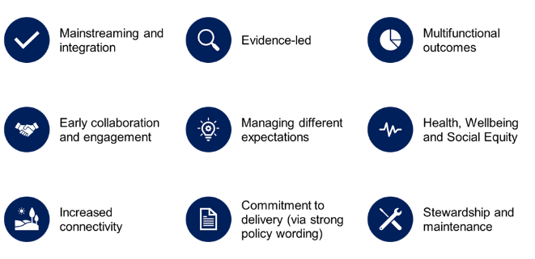

So why do we need the Essex GI standards for Essex?

It's ensured the GI standards are fit for purpose, locally orientated to meet Essex needs and meet several national and locally political requirements.

Essex GI standards along with the tools being made available, will help to strengthen GI policies and local plans and other strategic documents.

Nine principles and standards were developed because of collaboration and engagement with a broad range of stakeholders. This included three stakeholder workshops in 2020, and nine-week consultation on the principles, standards and supporting guidance.

From the support of the Essex Climate Action Commission funding was secured for two years for three new posts - two GI planning officers and a GI Delivery Officer, who started in June 2021.

YOU SAID – WE DID
Beth Harris, Green Infrastructure Planning Officer, ECC

The consultation received comments from a real wide range of audiences - Planning to members of parish councils, private businesses, community groups and individual residents. These different points of views have all been incorporated into the text to the best of our ability.
On average, 80% of those who provided a response, agreed, or strongly agreed with the principle and standards outlined in this guidance. As a result, there are no changes to the nine principles in the revised guidance. This provides the same core messages, aims, and objectives.

Consultation themes
There were areas identified needing improving and were categorized into 7 themes:

- Accessibility and language. Future consultations and workshops to use language suitable for the target audience.
- Information level. Clear definitions and guidance that is broken down to tailor each of the key community groups.
- Trust. Accountability and responsibilities for delivery of these standards.
- Enforcement. Further stakeholder engagement and guidance to develop a support programme for the delivery of the GI Strategy.
- Partnership. Further collaboration and interaction with external and internal partners and with other plans and strategies to sure this is viable.
- Complexity. Exploration and information on specialist habitats and the relationship between these and GI multifunctionality.
- Protecting Nature. Development of Local Nature Partnerships and Local Nature Recovery Networks.

Core changes to the guidance document includes:
- A separate executive non-technical guidance. The language has been simplified as best as possible, but in cases may still remain slightly inaccessible.
- Technical Guidance – Each principle now has its own section for development management and its own section for policy. The background is colour coded – purple for DM and blue for Policy.
- Additional Essex focused case studies of best practice within the technical guidance.

ESSEX GI STANDARDS IN THE POLICY AND DEVELOPMENT CONTEXT
Jayne Rogers, Environment Officer, ECC

A wide range of stakeholders and partners have been involved in the development of the Essex Green Infrastructure Standards Framework and guidance.

Guidance Structure
The overall document contents include:
- An introduction explaining the purpose of the guidance,
- A brief summary of the nine principles and standards
  - The principles are for delivering better place making and place keeping.
  - The nine associated standards define the outcome that is required to ensure the GI principles have been achieved.
- The main body of the guidance goes in more detail for each principle
  - Associated standard
(The following then divided into information for development management and for policy).
  - Why it matters?
  - How to achieve on improve these principles –the minimum expected.
  - The indicators and measures for success.
  - Links to further guidance information and case studies.
- Conclusion of what good looks like.
  - Methods of assessment and evaluation for achieving these principles and standards.
- Glossary
- Appendix of case studies that demonstrate some or all of the principles of best practice.
.
Key headlines for Policy and Development Management

The accompanying slides provide a summary of the key headlines for applying and achieving each principle for both policy and Development Management.

The key message is to explore the opportunity from multifunctional GI to deliver several benefits and not to pursue GI in its own environmental silo. This includes the importance of early collaboration and engagement (GI knows no boundaries) and to be evidence led. Recognising existing and new GI as critical infrastructure for delivery of environmental, social, and economic prosperity. An important asset to help identify a number of benefits to solve different challenges and reduce potential costs long term.
A needed to embed GI within a breadth as well as depth of policies and not just within the environmental chapter. As well as GI to be integrated across the site within the early stages of development planning and design. Demonstrating within both policy and developments a strong commitment to the delivery and long-term stewardship of good GI design within the right location.

The delivery of GI is supported by the National Panning Policy Framework i.e., Paragraph 31 and Section 12, Environment Act, 25 Year Environment Plan and Essex Climate Action Commission.

Details of the 4 case studies examples to demonstrate best practice for delivery all or majority of the nine principles for both policy and development management can be found in the technical guidance appendix and a summary within the accompany slides.

For Policy
- Chelmsford the Green Infrastructure Strategic Plan 2018-2036
- Maldon District Design Guide.

For Development Management
- Temple Farm, Chelmsford
- Rain Garden Retrofitted at Basildon Hospital, Essex

Implementation of GI Principles
The feedback from the consultation was mixed for:
- Guidance only.
- Full standard,
- A self – assessment using Natural Environment Research Council GI Planning Policy Assessment.
- External assessment using Building with Nature accreditation for example
- Support programme
.

As result of the consultation the GI team have started to have discussions with several Local Planning Authorities. The GI team are starting to place more importance on those principles and standards and will continue to use them when providing comments on policy documents and planning applications the team receives going forwards. Although the GI are not a statutory consultee or that GI is not a statutory requirement now, the comments from the GI team are still likely to carry some weight, and it's likely that if the policy documents, for instance, do not meet these standards the GI teams comments will reflect this and will push for a change before the documents are published. Similarly, the GI team would urge Local Planning Authorities and developers to give these the same weight as they would give responses by a statutory consultee.

The aim is to provide the support to deliver sustainable developments in line with meeting the requirements within the Environment Act in terms of biodiversity net gain, local nature recovery and climate change, As well as meeting requirements within National Planning Policy Framework.

Alignment of Essex GI Standards with the National GI Framework

By Essex taking part in the National GI Framework trials, learnings and our approach has been feedback to Natural England and has informed the development of their framework, including their baseline national mapping that was launched in December 2021.

Initially, at the beginning of the trials, there were few differences between the Essex GI principles and the 6 national GI principles. Namely the need for conflict management as important element to address, stronger commitment to delivery and health and wellbeing, social equity as a separate principal.

Now, the Essex GI principles align with the new 15 national GI principles, but tailored to meet more local context, which is encouraged by the National GI framework. The National GI framework, along with the Building with Nature will provide an additional high-level layer of support and external verification if required to the Essex GI standards.

Q& A

Q: For local authorities who already have GI Policies, GI Strategies, GI Principles etc – what difference will the GI standards make?

A: The GI principles and standards will help to raise awareness of GI more widely as well as re-invigorating commitment to partnerships for GI. Initiate discussions. It can for examples be a useful tool to discuss S106 agreements with developers. Or if embedded in the Public Open Space Strategy or SPD, which adopted by the council could help secure funding through section 106 agreements. This example given has happened in one of the other Natural England trial partners.

Q: When will the full Essex GI Standards Guidance be available?

A: The GI team are currently testing the Essex GI Standards with a few Local Planning Authorities on select planning applications and for major strategic developments. The feedback will help the team to refine the guidance, the teams’ responses and support available. Place Services are currently working on formatting the guidance and hopefully be available April 2022. The goal is for the standards and guidance to be included within the Essex Design Guide.

Q: How can the Essex GI Standards be applied to planning applications and where it fits in with existing policies (i.e., the provision of open space, design quality, Design Guide and requirements for amenity space etc.)? It seems like this is like something else on top of that and cross over or duplication.

A: . It is a challenging process and one of the biggest challenges is in fact that individual local plans for district and boroughs across the county are at very different stages. The GI standards will need to try and slot into that process, so that they can be picked up as part of the general planning application process. The focus of these workshops is to try to find an answer to this question – on how you want to implement so that it's that it's fully integrated and it isn't something that becomes an additional burden but actually it's something that's quite supportive and helps push forward your goals to improve the quality of space is being delivered.

At the moment, the standards are not being applied to individual household applications, due to resources. The main focus has been on larger scale developments, garden communities and the bigger individual developments that are coming forward. The important element is early engagement with developers, so it doesn't become a burden on planning managers. By building it into the planning process early on, when the GI team is asked to comment on planning applications, hopefully the key GI elements will be there - it's just ticking boxes. If the application has not covered the GI elements, then there is the opportunity to work with the developer to improve the design of their schemes in line with everything else - multifunctionality.

Q: Potential conflicts with major developments between the need to maximize density and counting numbers from profitability side from developers and vice versa for the pressure in terms of providing car parking. – i.e., trade-off between car parking and GI.
Or Improving the amount of GI on a scheme could reduce the amount of development physical built on this site.

The aim is not to look at this from the end point of view, but also embedding into policy documents when they are being revised. Therefore, when developers are doing their initial viability assessment work, they will be aware of these requirements and can build this into the overall consideration of land required to deliver an acceptable scheme. Practically, there is still work to be done and will we need to keep pushing for this to happen.
GI is not just about greenspaces like parks and open spaces, it also incorporates blue infrastructure including SuDs. When GI components are part of the integral design for the whole development, linked together to form green network across the site further combined benefits can be achieved at a strategic level. Including incorporating GI such as hedges and/or trees as part of the car parking infrastructure. Or for example, instead of road bollards use street trees or instead of traditional roofs to instal green or bio solar roofs. An open spaces can offer a range of benefits and creating multi-functional spaces increases the potential benefits. For example, sport pitches can also be designed to hold large volumes of water during heavy rain, reducing the risk of flooding elsewhere. The aim is not to plant all the GI in one location or treating each function as individual, but to take a holistic approach, focused on broad planning and multi-functional design that is weaved throughout the development can help tackle multiple, traditionally distinct, planning goals.

Q: Is there any data on cost implications for including GI in new developments?

A: Currently there is no detailed breakdown of the cost implications. It will vary quite significantly from development to development. The GI Team is working with Uttlesford in providing support to their Local Plan and looking at viability options. With the aim as best as possible to build these requirements into local plans as early as possible, so that developers can use these as the basis for designing schemes going forwards. With the potential to build that into their viability assessments. The important aspect is determining the right GI design in the right location. It is a common perception that requirements for development sites to protect and enhance biodiversity, protect local landscapes, provide for informal recreation and facilitate sustainable drainage are separate issues, each incurring additional costs. Providing these functions does not mean “doubling up” the costs but by combining these issues together and using a multi-functional approach, developers can reduce their costs, whilst at the same time
delivering a high-quality development that is a key contributor to placemaking and place keeping.

Initially to deliver good quality GI may seem like it costs significantly more, but it will take a little bit more thought to work out how that's integrated within the rest of the design. Clearly there are going to be a whole range of requirements placed on the developer. For instance, SuDs is already an understood requirement of new developments. A well-designed SuDs can also help improve the GI within a site, its accessibility, provide benefits to the natural environment and mitigate and adapt to climate change. All of these elements, without significantly increasing costs and potentially in some in some situations, actually reducing the costs for the developer.

An EU Interreg 2 Seas project - Nature Smart Cities is developing a business model to drive accelerated GI investments. The model can be applied by local authorities at multiple scales, from strategy to project level, thereby taking the existing capacity, needs and resources into account. The business model framework enables local authorities to identify the steps which need to be taken with a pick or mix approach, with some useful practical examples and approximate costs.

Design Guide?

One of the outcomes from the National GI Framework is a design guide. The ambition of the GI Team is to work with EPOA and Place Services to review and strengthen the GI elements of the Essex Design Guide.

Case Study Examples
Cornwall Design Guide, 2021, was awarded Building with Nature Policy accreditation in acknowledgement for Cornwall Council’s efforts to integrate the principles of high-quality G. It ensures GI is effective and consistently being delivered through the design, delivery, and long-term stewardship of land, supporting multiple benefit outcomes.

Worcestershire County Council in 2015 undertook a study on the viability, value and funding of GI. They advise that GI will differ from site to site according to the type and size of schemes and their cost. Early assessment and incorporation of GI into masterplanning is crucial and can avoid costs of retrofitting at a later stage. While viability assessments need to consider all the multi-functional characteristics of GI. GI will often be delivered through multiple initiatives not necessarily dedicated solely to GI. For example, a new road introduced on a site will have to deal with run-off, and therefore a sustainable drainage scheme will be introduced as part of this. The sustainable drainage could benefit habitat enhancement through planting road verges with biodiversity-rich grasses. Care should be taken to avoid costing various GI assets multiple times for each individual function they fulfil. If a particular GI corridor on a single piece of open land delivers benefits to flood risk management, biodiversity enhancements, landscape, etc. this can all be delivered through the same investment.

Funding?

Funding for GI creation, management and maintenance will need to be developed, in partnership and consider a mix of public, private third sector investment. Various government funds provide opportunities for GI funding.

Biodiversity Net Gain (BNG) will be one mechanism for funding investment in GI. BNG and District level licensing both provide funding for a 30-year management period.

The Spending Review 2021 announced a £9m Levelling Up Parks Fund, which will create over 100 green spaces across the UK on land, which is unused, undeveloped, or derelict. Further details will be announced But Government agencies such as Defra and Natural England are working closely together to ensure consistency and alignment with the national GI Framework.

Q: Within the presentation you said you would provide a consultancy service for LPA's - For pre-app I assume. Will this be a paid for service and what scale of development would you get involved in?

A: Initially the GI team are keen to engage with developers as much as possible so are not planning on charging for early engagement, but the team does have fairly limited resources so if this service become popular, they will need to charge. There are no plans to charge LPAs.

Q: In practice what weight can DM officers give the Essex GI standards when assessing an app?

A: GI is embedded in the National Model Design Code, which also already refers to the National GI Framework. The GI Framework will complement Biodiversity Net Gain (BNG) and Local Nature Recovery Strategies (LNRS) which form part of the Environment Act. It also supports the tailoring to reflect the local context. The GI Team are placing more importance on these principles and standards. DM officers will expect to see the GI standards reflected in the team’s future comments on planning applications going forwards. LPAs and developers are encouraged to give these the same weight as they would give responses by a statutory consultee. The weight of the comments provided will be determined by the corresponding district, borough, or city council.

The standards are being designed to be accessible and easy to use including for those new to GI. And this was the purpose of the workshop to understand what support will be needed. The GI team will continue working with local authorities and would like to work with developers to test the standards to support them in using and assessing their GI against the new standards.

The potential challenge of resources has also been feedback to Natural England, who are wanting to work with local authorities to provide support in using the new Natural England GI Framework.

Q: There could be smaller commercial developments and windfall housing schemes that would not be subject to requirements of the GI tool with a strict major cut-off. Perhaps developers could be directed to the guidance as a way of guiding them on how to compose a scheme, at least with the principles of GI and appropriate forms of GI to integrate into development?

A: Agree. The ambition is to include the principles within the Essex Design Guide and can also be used as a guide for small developments, community projects and even retrofitting GI into existing places. GI can be implemented at any scale. For instance, smaller developments can comprise of a minimum of single GI multifunctional element that contributes to a wider GI network, whether a tree, hedge, garden or even SuDs. They can use the principles to help understand how multifunctional GI can deliver benefits to both the built and natural environment. To provide information for better planning for good quality GI, especially those that want to go beyond the statutory minimum.

Breakout Sessions

The breakout sessions focused on the feedback from the consultation. Which received mixed responses on how the Essex GI Principles and Standards would be used, implemented and monitored or evaluated for the effectiveness of the policies that have incorporated and the developments that and implemented the GI Standards. These sessions aimed to understand how the standards would be used, the challenges that may arise and the types of support needed. The following is a summary of the key points raised to the three questions.

- How would you implement or use the Essex GI Standards?
- What support would you need for embedding or using the Essex GI Standards?
- Monitoring/evaluation
  - How should policies be evaluated to ensure that they meet the GI principles and Standards and how effective that policy has been?
  - How should we monitor or assess whether the GI standards are effective in delivering more GI?

- How would you implement or use the Essex GI Standards?
  - What are the challenges of using these standards?

Themes | Policy | Development Management
General | - Local plans across Essex are at different stages and the challenge is how to work this in.  - Some that are emerging are more easily able to integrate these standards.
Opportunities | - GI standards could be incorporated into policies but, felt that really there needs to be greater clarity.  - Potential is an SPD as an alternative way to adopting.  - The possibility of using masterplans to incorporate more individual detail for site allocations as they're coming up.  - Looking at this as an overarching framework, having a key, standards and expectations. | - To ensure this becomes second nature to developers.  - In the short term they are like to see this as additional.  - A scope for change.  - Ensuring the GI teams comments and the application of the standards support those made by the specialists in environmental fields, including that of ecology. I.e.,  - GI for different locations is designed well, and it supports the wider landscape.  - As part of our network connections from school sites and a range of different locations across the development site, making sure that the standards are used and applied in a way to ensure its suits the location and supports other service areas that are making comments.  - The Environmental Act will put most of these things into legal requirements, so therefore we will have support.  - The issue is the 2 years of waiting until that legal requirement so some developers will ignore and make difficult to enforce.  - Changes to national policy that could support, because recent changes to NPPF have placed a much bigger focus on GI.  - Build upon and/or the development of supplementary planning documents.  - The SPD will still need to be linked back to an existing local plan policy that refers to GI.  - Linking and incorporating GI into other strategies.  - I.e.; LPA’s climate change or tree strategies.
Partnerships/ Engagement | - Inform parish councils and make sure that we're working with them as well. | - Early engagement with developers.  - Raise awareness of these elements early on.
Conflict | - Challenges from biodiversity net gain, but potential policy backing from Environment Act.  - Delivering multifunctionality and delivering the benefits to people in as this is delivered.  - Conflicts between different uses. i.e. nature/planting and path maintenance.  - How the GI standards link together with other documents/standards such as open space standards. | - This is outside of policy at the moment.  - For example, a number of Essex plans have been adopted or at examination stage.  - Ensuring we, understand the difficulty of delivering something that's outside of a plan that's just been adopted.  - A recently adopted local plan which hasn't necessarily picked up elements of the GI,  - Local Plans not yet at the point of review.  - Understanding how much weight that these standards would have in terms of the adopted policy and for when DM assessing applications?  - For example, in terms of inspection or the appeal process.  - If this is not known, the risk is once it goes to appeal or inspection it is going to be thrown out because it's not statutory.  - Unless developers (exclude Highways) are required to actually do something, it is unlikely that they are going to.  - Crossing boundary issues and possible different standard/ interpretations / implementation of GI standards.
Enforcement/ Resources | - Viability.  - Having the (unlimited) resources within local authorities.  - lack of specialist support from ecologists etc.  - Mandatory, backed in policy for developers to want to push this.  - Concern in moving policy documents forward to something that the development management teams could use and that it's clear enough about how priority needs to be given to individual elements of design or how in fact that multifunctionality can be incorporated in a way that it doesn't compromise Individual elements of design guidance. | - The lack of skills (i.e., ecologist) and knowledge to be able to access what good GI looks like and if that has been delivered on the ground.  - Funding availability and reduced budgets is an issue (especially highlighted as an issue for Highways).  - i.e., long term stewardship and management, and the cost associated.  - Funding opportunities made available.  - Clear guidance (and agreement across Essex) on how ECC's GI team is going to be involved in pre-app / PPA process.  - e.g., be part of new PPAs.  - probably want to recoup cost for officers.  - Guidance would be helpful to help solve issues around future stewardship.  - Consultancy support, potentially some additional guidance in terms of ECC or districts and boroughs owned delivery of development, whether requirements are placed into design and built frameworks to make sure that these standards are placed on contractors early on.

  - What threshold should the Standards be applied too? (Development Management only)
- The size of the sites will have different scope for GI depending on where it is, whether it's a brownfield or green belt site.
- It is useful at all levels,
- Be more useful for kind of commercial developments.
- Potential to develop a set of standard guidance for small developments and a connection brownfield development
- Review on a site-by-site basis.
- Potential for other criteria as well to be apply.
- Ensuring not to exclude a site because it’s a couple of houses under If it's in a very specialist location.

General agreement
- Adopt DM definition of 10 households, 10 units plus / 0.5 ha / 1000sqm floorspace for a major development
- To be progressive and to consider when there's more awareness/ education of the standards, to decrease to 5.

Concern
- Admin issue - if the threshold is set at 10 dwellings plus there is some concern whether this level of consultation would be sustainable for the GI team.
- Cross boundary applications where there could be an issue with differing interpretations of what the GI situation there with regards to thresholds.

General comments
- Additional comments from the GI team are supported, particularly where individual LPA that already have landscape officers are pushing for change.
- Multiple voices from local authorities saying the same thing that strengthens the argument that those elements should be delivered within sites.

- What support would you need for embedding or using the Essex GI Standards? –
  - What level of engagement would you envision from the ECC GI Team?

Theme | - for Local Plans and policy creation? (Policy Only) | - regarding pre-Apps? (Development Management only)
General |  | - Pre-app engagement is critical for larger sites.  - The national and local designation could help prioritise how that resource is most efficiently used so in situations where there those designations exist, and LPA’s would prefer engagement in those situations.
Communication | - Making sure that we have the same coherent message across Essex or to ensure that we're delivering the same comments.  - A developer workshops at a county level would be really good  - Visibility of the GI team, as well as providing our professional resources to local authorities who might have limited skills or resources. | - Introductory meetings, putting a face to a name.  - Making sure that the team is as successful as possible to build confidence for people to approach the GI team early in applications stages and when they have queries and questions  - Good Contact - direct contract as soon as the applications arrives, who is leading on response, so removes any surprises and that they know what the GI team’s views are earlier early on.  - Clarity and communication across the teams.  - Collaboration and joined up thinking.
Evidence | - That we have other institutions supporting this work.  - Coordinating with other key projects i.e., SEE Park and LPA’s GI Strategies.  - Ensuring that there is appropriate evidence to back up the principles and standards.
Concern |  | - Resources on the GI team.  - When the GI roles finish if there will be funding after that.  GI team offering their services similar to SuDs to funding the team continuation.  - Schools might have parcels of land available for planting and other Schools want them.  - There's risk associated with this and money for ongoing maintenance.

  - What are your expectations for the GI team to be involved in the writing process for policies? (Policy Only)
Policy
- Helpful if there were named contacts within the team that people could liaise with.
- Web presence - Provide documentation on a website that would be easy to find and to navigate around.
- Then the later stages of the planning process with more detailed conversations around site design and potentially the options for GI team support.

  - What other resources do you have access to support this process? (Development Management only)
Development Management
- Potential part time work.
- Teams are limited and stretched on other work.
- Limited time and qualifications.
- Some LPAs have an Urban Design/ Landscape Architects, SuDs and GI officer or Climate Change Officer.
- Local Plan GI/ Blue Infrastructure policies.
- There are other members of staff promoting similar principles - weight of these responses is increased by views from a range of consultees.

- This questions explores potential monitoring/assessment opportunities that the GI Principles and Standards have been met

- Policy - How should policies be evaluated to ensure that they meet the GI principles and Standards and how effective that policy has been?
  - Do you want documents to be formally assessed? Or should it be embedded in the policy feedback mechanism and then let the GI Team know how successful its inclusion has been.
Policy
Resource
- We can't underestimate how much resourcing and time this is going to take. For example:
  - If there are updates and reviews coming and changes will need to give as much notice as possible, make people aware of kind of the changes that are going ahead.
  - Recognise that LPA’s are already stretched. Do not want to put additional burdens and pressures on the system.
  - In that there are so many people that could be seen to have a part ownership of this along the way. Whether it's in developing the policy or whether it's in the actual development. Who takes responsibility for seeing whether that's actually been implemented, but also just generally?
  - Concerned that even if you put policies in, you might not have the resources then to actually be able to enforce the policy.

Collaboration
- A need to have conversations with other partners to make sure that the benefits that come from monitoring are distributed.
- Information and knowledge are shared.
- To make sure that we're linking up with internal partners, in particular to make sure that we're providing that kind of reasoned respondents rather than taking a separate approach for GI and make sure we're incorporating things like public rights of way and then share.
- Some local authorities would like for ECC to be involved in the assessment.

Award system
- Concerns that within the planning system itself, things are done externally.
  - If we were to do it as an external assessment, to have a star system, i.e. Gold or silver star.
- Use the word review when referring to Policy.

Information level
- Different forms of engagement to provide feedback, so, at different stages, workshop engagement of the local plan process.
- Whether feedback should be in terms of GI team providing wording for text or just reviewing policy – This seems to be quite individual to district and boroughs about how they how they would like that input.

  - How often do want this to be reviewed?
Policy
Opportunities
- Planning is moving towards being heavily digitalised.
- That we need to have a lot of this information mapped and GIS based.
- Guidance is changing fairly regularly, so we need to make sure it is up to date.
- Link in with the Essex Quality Review Panel

Review period
- And then with the review side, it was that if it was to be a formal assessment, then that would be five years, but then if it was to be an award system, we could almost do that annually.
- To see if a policy can be worded in such a way that it can be reviewed at different periods, maybe throughout the life of the local plan.
- A 5-year review so that is in line with local plan reviews.

- Development Management - How should we monitor or assess whether the GI standards are effective in delivering more GI?
Communication
- Depends on a two-way discussion, about how we should deliver these standards and for monitoring.
- Keeping the standards up to date and fresh in the mind of those involved in planning.
- Raise awareness of the success and failures of the standards delivery across the districts.
- Maintain sharing information and communication long term.

Resource
- The monitoring of sites and looking at how we can tie into existing monitoring methods.
- Training for DM officers on net gain calculations.
- There was a view that with the Environment Bill will produce more resources at a district and boroughs level.
- Lack of resource once the application has been determined.
- Some LPAs do monitor delivery, but it is hard to follow up other than via enforcement.
- S106 monitoring officers in place.
  - Potential to build this into the S106 process to provide the needed resource.

Collaboration
- It is believed that there is already data missing from those that would benefit from multiple service areas.
  - Looking at how we can report that back and use what we've gained from that to illustrate the benefits of providing GI in terms of habitats, ecology, and health and wellbeing.
- To make sure that everybody has an input.

Information level
- Encourage developers to be considered as part of a developers viability assessment for applications that start to come in next year when these become more enforceable standards under the environment act.
- To monitor - Canopy Cover Assessment for the entire county.

Images from Miro Board
Policy
Figure 1: Snapshot of the discussion points from the Policy workshop.
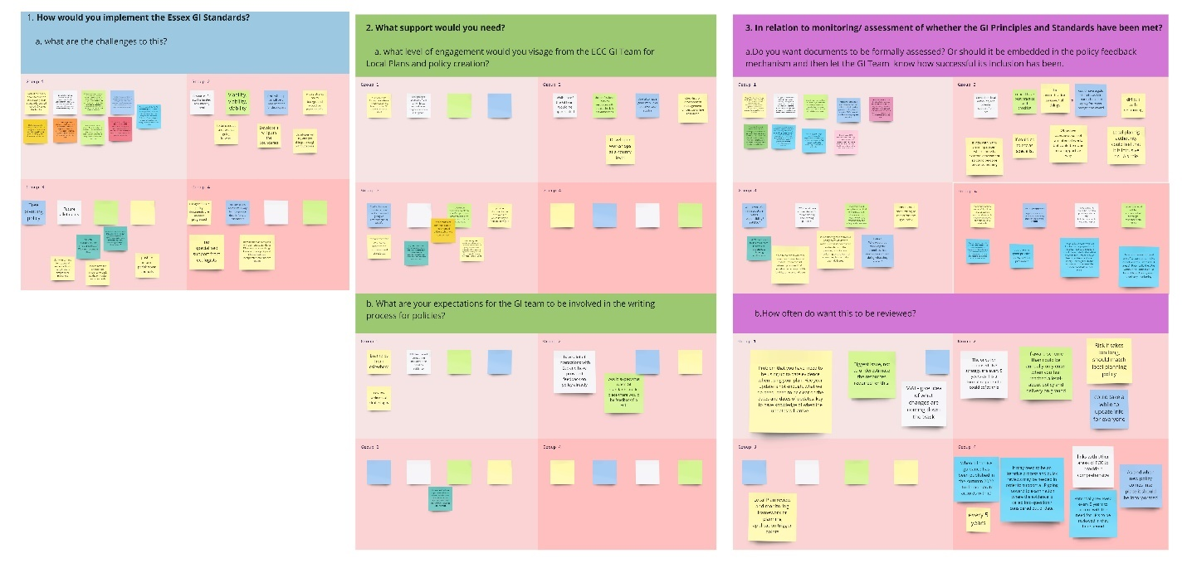
Development Management
Figure 2: Snapshot of the discussion points from the Development Management workshop.
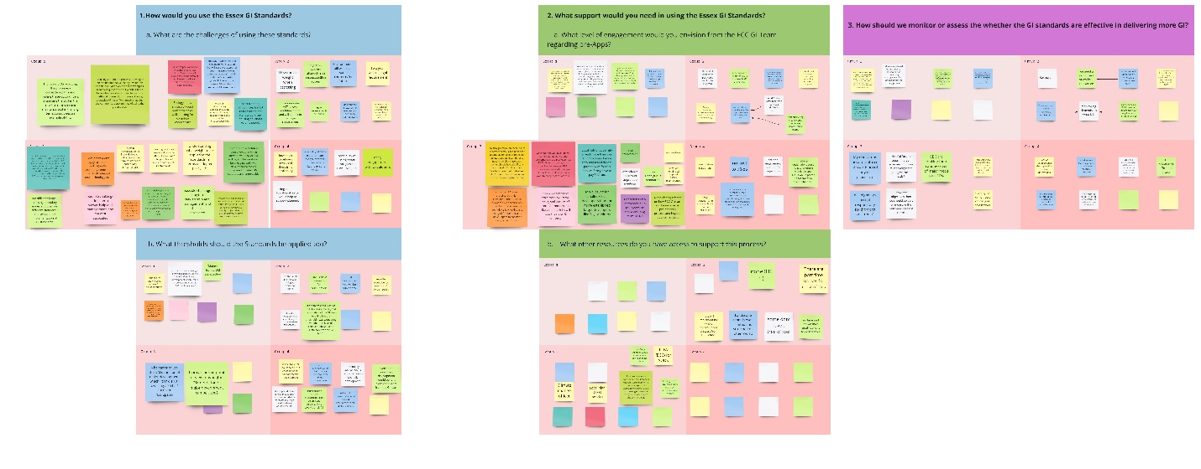

Feedback and Next Steps
Tim Simpson, Green Infrastructure and Sustainable Drainage Manager

Overall key points
The workshops highlighted that there is a need to understand how much legislative support there is to this whole process. Including making sure that in terms of DM position when the GI team respond to these applications that the responses link back and are focused on NPPF requirements. To make it easier for the DM teams to incorporate those as part of the main process. Also, the way local plans work they don't necessarily tie up with what is being asked, and the potential for the GI Team to help provide some additional support.

Table 1: Draft Essex GI Standards Framework and Guidance Action Plan
Date | Action
Current – Spring 2022 | - Continue to undertake case studies of site assessment to test the GI standards.
Spring 2022 | - Review case study test site assessments with LPAs for feedback and highlight gaps.
Feb 2022 | - The Essex GI Guidance and Non-technical Guidance is being formatted by Place Services and will be circulated once ready.
Next Steps  – April/ May 2022 | - Take the guidance through ECC internal governance process.
Autumn 2022/ 2023 | - Ensure the standards link in and align with the Local Nature Recovery Strategy.  - This includes coordinating GIS mapping from Essex GI Strategy, ASELA SEE Park and others.
Ongoing | - Communication and training Plan  - Develop support program/ training  - Organise themed workshops  - Developers focused– link in with Essex Developers Forum.  - Environmental legislation updates  (The potential to link in with Local Nature Partnership (LNP)).  - Raise awareness of GI Standards  - Clear, concise messages on GI – potential to link in with Essex is Green social media campaign and LNP.  - Increase visibility of the GI team internally and externally.  - Continue Discussions with LPAs
TBC | - Extra conversations around the potential for SPD's.
Autumn/winter 2022 | - Review GI elements and integrate into Essex Design Guide (subject to EPOA’s approval).
Summer/Autumn 2022 | - Launch Guidance  - EPOA sign off.
Ongoing/ Annually | - To regularly review the guidance in line with current changes, especially from the Environment Act and changes to Planning.
Longer – term TBC | - Evidence – building  - Undertake evidence gap analysis.
2023 | - The guidance will be web based similar to the Essex Design Guide
TBC | - The potential for the GI team to investigate and provide a high-level review for how much GI has actually been incorporated within responses

Workshop Evaluation
Feedback received from some of the attendees stated that they:

For question 1 and 2:
- Rated the workshops either excellent or good (one attendee rated fair)
- Found the following most useful:
  - presentations, (including the balance between presenters, subjects and breakouts).
  - activities
  - new information
  - meeting the GI team
  - see the strategy
  - workshops
  - good facilitation
  - To identify how a developer could improve GI through careful design considerations perhaps utilising the pre planning application consultation.

For question 3 and 4:
- Had none, most of few level of knowledge and understanding of the Essex GI standards prior to the workshop.
- Felt the workshop met their exportation.
  - Some stated they learnt something new.
  - One attendee felt it somehow met expectations.
  - Felt the event covered a huge amount but found it really interesting.
- Definitely (majority of attendees), mostly or somehow felt the Knowledge and information gained from participating in the workshop will be useful/applicable in their work.

For question 6 (regarding takeaways from the workshop).
- Really appreciated all the work that went into the event.
- Overall,
  - That it was good to have some basic knowledge of the Standards and principles.
  - To know there was a GI team at ECC that may be able to provide consultation responses and guidance/advice was really useful.
  - Very interesting and informative but it just felt a bit rushed overall.
  - How to look for opportunities to develop best practices to protect our GI and to enhance it (funding permitting).
  - Understand how DM officers can utilise the standards in their day-to-day work, as they are not adopted by policy.
  - That ECC have been very forward thinking in this and are on the same page in terms of where we want to make improvements.
  - To review the standards in more detail and understand their application to my LA
  - Inform colleagues and bring this information into the work around LNP and LNRS.

Areas for improvement (question 5)
An attendee suggested for future workshops to use Zoom so the breakout room function will be simpler.

More promotion of the event as an attendee felt that their colleagues in Highways would have been interested to attend if they were aware.

Overall attendees felt the workshop needed to be a bit longer (especially for the Development workshop). In that some of the presentations were rushed, would have liked some more question time, and could have spent more time in the breakout hearing others’ views and experiences. Especially since it’s the diversity in attendees that is such a rare opportunity to cross reference ideas or allow subgroups the opportunity to have a follow-up session (time limited) to discuss anything further.

