Meaningful Lives Matter: Equal Lives for All
Section 1:
Foreword
People with disabilities have the right to the best life they can have. But right now, they often get left out of things. The things that are important to us, and make all our lives meaningful, don’t always happen for people with disabilities.

We believe that people are disabled by barriers - things in the world around them that stop them from living a normal life - instead of by their health problem or how they are different to other people. We want to remove barriers so that people can live better lives.

We are already helping lots of people in Essex to live the best life they can. We need to make sure this is the case for every person. We want to help people get what they want and expect from their lives. To do this we will support each person by understanding who they are and what they might need across the whole of their life.

The numbers of people who have a disability and who might need help from social care is going up. We need to use our money carefully to make sure we have enough to help people in the future.

This strategy will set out the change we want to bring about. It will make a commitment to people in Essex who have a disability. It will show where we can work better together with others.

The Meaningful Lives Matter work is already helping to make life better for people with learning disabilities and autism in Essex. Now we want it to help make life better for people with sight and hearing loss and physical disabilities too.

What is this strategy about?
This strategy will help us plan what needs to change. It will include:
- How things are being done now
- How people feel about things now
- What we need to do in the future to make things better
This strategy is for people in Essex who have:
- A learning disability
- A physical disability including people with brain injury
- A sensory impairment – part or full loss of eyesight and/ or hearing.

The strategy covers people who have more than one disability or have autism as well as one of these disabilities. Some people have support from social care. Other people are not in contact with social care.
We recognise that language is important when talking about disability and autism. Different people prefer different terms. For example, some people use the terms ‘autistic people’ and ‘disabled people’, ‘neurodiverse, autistic or disabled community’, ‘people with autism’ and ‘people with disabilities’, or others. In this document we will be using the terms people with autism and people with disabilities.
People with autism might also be interested in All-age autism strategy which was developed through the Essex All Age Autism Partnership.
We are looking at the things that help people in life. This will include:
- where people live
- who they spend time with
- what they do for work or in their free time
- health services
- social care services

To write this strategy we have spoken with lots of people with disabilities and listened to their experiences and ideas. We have spoken with families and carers. We have spoken with other organisations. We learnt that for a good strategy:
- we need to keep talking and working with people
- we need to be creative and bold
- we need to measure whether we are making things better and how much.

The strategy is for the next 4 years. We can’t do everything in 4 years, but we can make a good start.
Why is this strategy important?
There are more people with disabilities living in Essex every year. About 1 in every 6 people in Essex has a long-term health problem or disability.
There are also more people with disabilities who need help every year. This is partly because some people didn’t get the help they needed during the pandemic. Other people feel more alone and are less independent since the pandemic.
The number of people with sensory impairment is set to grow from 240,000 (in 2020) to 310,000 (in 2030).
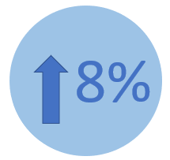
The number of people with learning
disabilities who need help from
social care will likely go up by 8%
by 2030.

Some people get help from social care. Other people don’t need as much help. Some people get help from other places. We want to make sure everyone gets the help they need. We also want to stop people’s needs getting worse.
Most people with a learning disability tell us that they have enough social contact. Most also say that they are able to spend time on things they enjoy. But over 30% of people with physical or sensory needs tell us they don’t have enough social contact. Over 40% of people with physical or sensory needs say they can’t do the things they want to do.
It is getting harder to pay for all the things we would like to. It isn’t clear how much money we will have in the future or what it will need to cover. Because of this we need to spend money carefully.
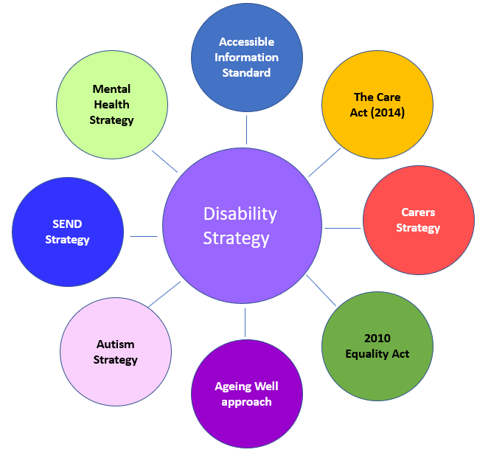
This strategy will work together with other things we have to do and choose to do:

Adult Social Care in Essex
In Adult Social Care we want to help people and communities to live the best lives they can.
This strategy will help work towards the things we want to make happen for people. We want people to:
- have friends and have people around them that they love
- be independent and feel good about themselves
- have choice and control over their lives
- be able to work if they choose to
- access meaningful activity
- get the same good health and care service as everyone else
- have a comfortable home
- be involved in their local community
- be safe.

This strategy will also be guided by how we work in Adult Social Care:
- We work together with many different organisations
- We make sure our care and support is right for each individual person
- We do everything we can to support people as close to where they live as we can.
- We are always trying to improve what we do
- We work with you to decide what is needed and what works best.
- We always try to deal with problems as soon as we can before things get worse.

There are some extra things that are important for people with disabilities:
- Individuals should feel their disability is fully understood by the people around them,
- Support should change when needs change.

Section 2
We have talked with lots of people with disabilities. They told us what they want from their lives. We have more people still to talk with but, so far, we have learned that:
- People want to have good relationships.
- People want to live somewhere that feels like home.
- People want to stay healthy, well and safe.
- People want to do things that are important to them and their community and that help them to feel part of something. This might include working in a job or learning new things.

We will look at each of these things in more detail. There are links that go between each of them and some ideas that keep coming up in all of them. For example, people want to:
- make choices
- get the care and support they need when they need it
- people to see them as they are and what they can do as well as what they can’t
- treat them with respect

Good relationships
What you told us
You told us that you want to grow and keep good relationships in your life. You like to spend time with people that you get on well with, you want to love and be loved and you want people around you who understand you and your disability too. Sometimes you also need help from other people. You might get help from your family or friends, or from a person whose job it is to help you.

Some of you feel left out from the normal things people do together. You might find it hard to access local places or not know about groups you could join. Some of you don’t feel safe going out alone. Because of this you might feel lonely or have difficulties with your health and wellbeing. The COVID-19 pandemic has made this worse for lots of you.

Some people only have a small group of people that are there for them. This means that the carers they need help from have to work very hard.

Carers and support workers don’t always understand disabilities. This might mean people don’t get support the way they need it.

What else do we know?
People with disabilities are more likely to feel lonely than other people. Over 30% of people with physical or sensory needs told us they didn’t have enough social contact. Lots of people in society don’t understand how certain health problems or disabilities affect people. Some people don’t have the right help to be able to communicate with others or to go out to places to meet people.

Lots of people who have help from social care have good conversations with their social worker. They are seen for who they are. But there aren’t enough social workers and people sometimes wait a long time to see one. Social workers are busy and can be rushed. They spend less time face-to-face with people than they used to. This sometimes means they don’t have time to help people plan for the future.

We found out lots about what carers need when we spoke with them. This can be seen in the Carers Strategy.

Where do we need to focus?
We commit to make sure that in the future:
- more people will have the chance to love others and be loved
- people will feel more of a part of their local community
- people will feel closer to other people who like the same things they do
- People will feel their staff understand them better.

Some people need help to go out, make connections and to see friends. We want to make it easy for people to find and get the help they need to keep up or make new relationships.

We are making changes to how people who work in social care help people. They will:
- understand that everyone deserves to have loving relationships
- help people to stay close to their friends and family
- help people make new friends if they want to
- understand every single person is different. This includes understanding different disabilities and understanding trauma.
- help people with their communication

To do this we will look at how we find the right staff within our services and the services we pay for. We will support staff to have the right skills and to have the time to meet with people face-to-face. We will support all staff to think about the good relationships we need and how we help other people connect and find these relationships at different times of our lives.

We will also work with communities. Communities are found in local places like the village or town where you live or where people who enjoy the same things come together. They might include groups of people who meet up to talk about a shared interest or do activities they enjoy together. We are asking communities to welcome and include people with disabilities. We want community spaces to be easy to access and feel safe.

We need to listen to and work with people with disabilities more. This will help make sure change makes things better.

A place to feel at home
What you told us
You told us that where you live is important. You want to live in a safe place that feels like home. You need your home to work for you. This means you can move around and do things within your home. It may also mean it is close to transport that you can access and places that you can go out to.

You want to have a choice in where you live. Some people want to live on their own. Most people want to live close to family and friends and feel part of their local area.

The right care and support is important to making your home work for you. Some people have to go a long way from their local area to find the right place to live with the right support.

What else do we know?
20% of people with physical or sensory needs tell us that their home doesn’t meet all their needs. There aren’t enough of the right places to live for some people with complex needs. There aren’t enough care workers in some areas.

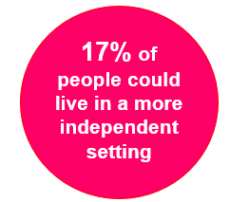
Some people could live more independently than they do now. People don’t always have information what is available.

Services aren’t always set up to help people to progress.

Where do we need to focus?
We commit to make sure that in the future:
- More people have their own home if they want this. This might be a private home or in Supported Living. This will help them to be more independent.
- More people have short term help to learn independent living skills. This could be through living with a Shared Lives host. Or it could be another option such as a short term residential services.
- There will be suitable housing options for adults with very complex needs.

To do this we are making changes to how social workers and care staff help people. They will:
- Work to help people to be more independent
- focus on what a person can do instead of what they can’t
- help people to make choices and plans.

We will also work with the care market to increase choice of places to live within Essex. We want as many people as possible to have their own front door. We will help to make sure people have the information they need to find the right home for them.

The right technology and equipment can help people to live in their own home or access the community independently. It can also help to keep people safe and reassure families without being too intrusive. We will help to make sure there is enough of this and that it is easy to find.

Staying healthy, safe and well
What you told us
You told us that looking after your health is important. You would like to stay well and be able to get help quickly if you are unwell. You also want to feel safe.

You don’t always have the right information to know about what could help you, especially early on in adult life. This makes it hard to keep yourself well. Sometimes there is a long wait for services. When you do use services you may have to repeat the same information about yourself lots of times. You may find your preferred methods of communication are not recorded.

You would like to feel more in control of your health and care. If you need help with your mental health you need this to be from someone who understands your disability.

Some people find it hard to plan for the future. Many don’t think about how their health might change over time or as they get older.

What else do we know?
Over 30% of people with disabilities say they don’t feel as safe as they would like.

Disability can be a result of illness. Disability also makes poor health more likely.
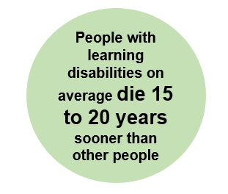
Many people with learning disabilities die earlier in life than other people. They are more likely to be unwell with physical or mental illness and not get the right treatment quickly enough.

Poor health and disability increase the need for social care. People often don’t plan ahead for changes in their health.

More people feel alone or have mental illness after the pandemic. The things that help them may have stopped or had delays.

We know that services like health and social care are not always joined up. Services can be hard to access.

Where do we need to focus?
We commit to make sure that in the future:
- More people feel that their health is good
- More people know how to feel even better
- People have the technology and equipment that helps them to live their lives.

To do this we will work with partners like the NHS to:
- grow skills and awareness around disabilities
- help stop people getting unwell where we can
- diagnose people quickly and make sure their needs are known about
- help people recover their health or increase what they can do after an illness or injury.
- make sure services help people with disabilities to be active and healthy
- give people control over their own health and care records
- help people to plan ahead for changes in health
This will include sharing information, costs and staff to make sure services join up.

To do this we will take action on things that make it more likely for people to get unwell. For example, where people don’t have a job or enough money, or live in poor housing.

We will help people get the information and treatment they need to get well and stay well. This includes young people who are leaving school or college. All services should meet the Accessible Information Standard.

Being active
What you told us
You told us that you like to do things that are important to you and your community. You want to feel part of something. Some of you would like to have a job or keep and develop the jobs you have. Some of you want to learn new things or help other people. You want to play a role in the world around you, spend time with other people and have fun.

However, it can be difficult to find a job or information about what it’s like to have a job, the support available and how having a job will impact benefits. There are also barriers in both applying for jobs and getting to work. You might feel limited in the types of jobs you can apply to.

Some people have low confidence in their skills and abilities. Lots of people feel that those around them have low expectations for them.

What else do we know?
People with disabilities are less likely to have a job than other people. If they have a job, they are less likely to be paid for the work that they do.

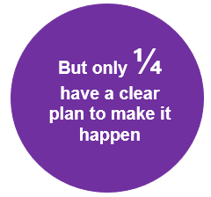
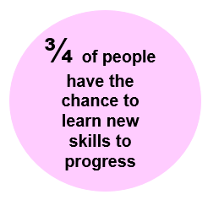

Lots of people don’t understand how certain health problems or disabilities affect people. This can make it harder to work with a disability.

Where do we need to focus?
We commit to make sure that in the future:
- More people who want to work will be able to work
- People who already work feel supported in their job and able to progress
- People have choice and control over what they do every day

To help more people with disabilities start and stay in a job we will:
- make sure this is part of conversations with social workers and support workers
- include a person’s family in conversations about getting and keeping a job
- focus on what people can do instead of what they can’t do.
- talk to businesses about why they should give more paid jobs to people with disabilities and help them to do this.
- make sure there is the right transport to get people to work

We help young people to get ready for their adult lives. An important part of this for lots of young people is getting ready to get a job and go to work.
For people who can’t work right now we will help them to do other things that are important to them. They might like to go out and about in their community more or learn a new skill or hobby.
Section 3:
How we will make it happen
We recognise that everyone with a disability has different lives, strengths and ambitions. We will need to do different things for different people to meet our ambitions. The Meaningful Lives Matter project is working towards the four goals in this strategy in the following ways:
For good relationships: Local Linked Support teams are helping people with learning disabilities build relationships with others. We would like to expand this kind of support to people with a physical or sensory need. Our “Bfriends” peer support and mentoring service is being piloted. If that goes well we will expand this across Essex.
For a place to feel home: We have “Move On Workers” to help adults move to the most suitable home for them. We are looking at developing purpose- built accommodation for people with brain injuries.
For staying healthy, safe and well: We are working with health services to make it easier for people to use services. We want to make sure staff understand, and are well trained, to look after people as they get older. We are making changes to the Essex Sensory Service. This is so it will have better advice and guidance and shorter waiting times.
For being active: We are working hard to help people get and stay in paid work. We work with local businesses to get them to give paid jobs to people with a learning disability and/or autism. We have one of the biggest inclusive employment services in the country. We are looking at how this service can grow even more. We want to work with care providers to make sure activities help people to learn new skills. We also want activities to connect people to their communities.

We will continue to make these planned changes but also:
- think about the order things need to happen in and what is most important
- continue to empower people with disabilities to work with us as partners in making sure people get the best care and support possible
- keep people up to date on what is happening using the Meaningful Lives Matter programme
- test new ideas before rolling them out
- spend money carefully and on the right things

We will make sure that other work going on supports this strategy. This includes work around:
- Social care practice and workforce
- The different services that are on offer. For example, helping to make more places suitable for people with disabilities to live.
- Joining up health and care services. For example, asking health partners to look at how their plans can keep people healthy.
- Technology
- Data and information

We will think about other ways we can make changes. This could include:
- teaching people to be more aware of disabilities and how to make sure services are easy to access
- working with a range of organisations like the police, job centres, and teams that plan new places.
- sharing information with people and communities

The Adult Leadership Team at ECC will be in charge of what needs to happen in Adult Social Care. This group has directors for different parts of Essex. It also has other senior people from ECC.

How we’ll know it’s worked
We will look to talk with people with disabilities about how things are going in their lives. We will also look at data. We want to understand how things are changing. We want to make sure things get better over time.

At the moment we can measure:
- Number of people with disabilities who have a paid job. We want this to go up.
- % of people with disabilities who live in a care-home. We want this to go down.

In the future we will measure:
- % of people who have help from social care who are moving towards their personal goals. We want this to go up.
- & of people who have help from social care who have three or more ‘good’ relationships in their life. We want this to go up.

Where we can, we will look at how things are changing in different parts of Essex. We will also look at how things are changing for people of different race, gender, and sexual orientation. This is because we want things to get better for everyone. We want the change to be fair.

