Essex Short Breaks Commissioning Strategy

2021-2026

  - “Every family needs to go on their own journey.”
Draft for consultation: July 2021

Contents

Foreword 3
Background to Short Breaks 4
The purpose of this Commissioning Strategy 5
The benefit of Short Breaks 6
The current offer 6
Using data to make decisions 7
What families have told us 8
Developing and improving the Short Breaks Offer 9
Our commissioning principles 9
Outcomes 11
Delivering the Strategy 12
Important partners in this Strategy 16
The budget 17
Measuring impact 17
5-year roadmap of intended changes 19

Foreword
As Cabinet Member for Children’s Services and Early Years I am passionately committed to improving outcomes for children and young people with special educational needs and/or disabilities (SEND) and their families. One way in which we can do this is by enabling these children and young people to participate in quality opportunities in their communities through which they can spend time with their peers and develop new interests, knowledge, and skills. We have listened to the lived experiences of families, and this has highlighted to us that there is more we can do to ensure that our offer of Short Breaks better meets needs and fully exploits the different resources we have available in Essex. We believe that improving our offer across the full spectrum of need will offer enhanced opportunities to deliver early help to both children and young people and parents and carers.
This Strategy sets out our five-year ambition to improve our Short Breaks offer. This work is happening in the context of reducing resources and off the back of a pandemic which has tested our most vulnerable families, who have demonstrated remarkable resilience throughout. By publishing our Strategy, we hope it provides reassurance to the families who rely on this support about what our intentions are and how we are seeking to improve what we do and make our offer fairer and more accessible. We will be considering not only what we can do as a Council but also what we can do by working more effectively with partners and providers.
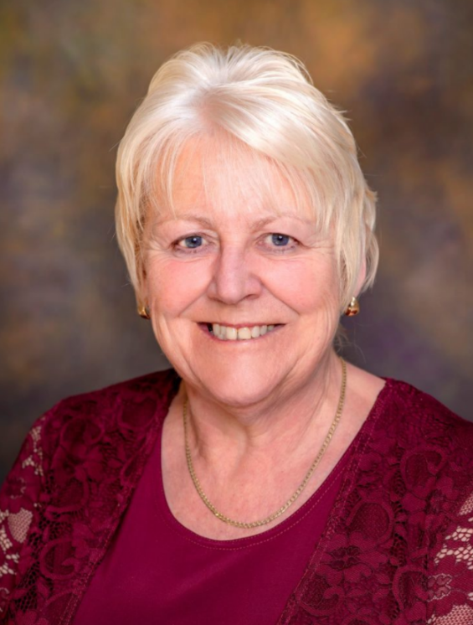
We would like to thank everyone who has contributed to the development of this Strategy, including the Essex Family Forum, the Multi-Schools Council and all the families of children with special educational needs and/or disabilities who responded to our surveys and engaged with us at our events and through interviews. We are committed to continued engagement with all relevant stakeholders as we develop our offer.
Cllr Beverley Egan
Cabinet Member for Children’s Services and Early Years, Essex County Council

Background to Short Breaks
Section 25 of the Children and Young Persons Act 2008 requires local authorities to provide short breaks for families with disabled children. Each local authority must produce a Short Breaks Service Statement so that families know what services are available, the eligibility criteria for these services and how the range of services is designed to meet the needs of the families with disabled children in the area.
The Breaks for Carers of Disabled Children Regulations 2011 set out how local authorities must provide short breaks and what they should provide, this includes: daytime care in the homes of disabled children or elsewhere; overnight care in the homes of disabled children or elsewhere; educational or leisure activities for disabled children outside their homes; and services available to assist carers in the evenings, at weekends and during the school holidays.
Access to Short Breaks should be available to any child or young person who is between 0-18 (or 0-25 in some circumstances), who has identified special educational needs and/or a disability; and who lives within the borders of Essex County Council.
There are a range of things that Local Authorities are required to do by law in respect of short breaks but there is flexibility in how Local Authorities deliver these requirements. In summary we must:
- Consider all relevant legislative requirements when we make decisions about how we provide and fund short breaks
- Assess the needs of any disabled child or young person whose family may want or need services above the level available locally without an assessment; and
- Provide short breaks to children or young people where an assessment shows that they are necessary to meet their needs, taking account of the family context

The purpose of this Commissioning Strategy
The Essex Short Breaks offer has evolved over many years and offers multiple activities and types of support to meet the vast range of needs of children and young people with SEND.
Whilst the Essex offer is good, varied, and extensive, access to this offer is not always consistent and equitable and needs are not always being met. There have been intermittent reviews of different elements of the short breaks offer but the needs and interests of children, young people and families have changed over time.
Having spoken in depth with families we know we need to look at the whole system of Short Breaks to ensure we are providing the right opportunities, at the right time, in the right place, for the right groups of children, young people and families.
There are a range of strategies and plans in place to support children and young people with SEND including the Council’s SEND Strategy, the All-Age Autism Strategy and the SEND Joint Commissioning Strategy. This Short Breaks Commissioning Strategy sets out how we plan to develop Short Breaks over the coming five years and the improvements we expect as a result. We will take forward this work in the context of other on-going work, taking care not to duplicate activity and to identify opportunities for join up and to make the best use of resources. We are committed to designing these changes and improvements with the people who matter most: the children, young people, parents, carers, and siblings for whom Short Breaks should make a difference.

The benefit of Short Breaks
Short Breaks should offer a range of services which give children and young people with SEND positive experiences that support their personal development, whilst, at the same time, giving a break to their primary carers.
Short Breaks can be in a child’s home, in the home of an approved carer, or in a community setting, for example a local sports club. Depending on eligibility, needs and interests a Short Break can be for anything from a few hours (for example attending a trampolining class), to a few days for a child or young person who may need constant care and support.
In Essex, whichever opportunity a child or young person accesses, they should expect to have enjoyable experiences, establish friendships, and develop confidence, independence, and the social and emotional skills to enable them to transition to adulthood successfully. The additional value Short Breaks brings to a family is that parents, carers and siblings have time for themselves to work, study and do the things they want to do.

The current offer
Essex spends approximately £8.3m per year to provide an extensive Short Breaks offer. There are a range of options for families across the spectrum of need. From reduced cost hire of holiday caravans and access to community clubs, to Direct Payments for those assessed by Children’s Social Care to have additional levels of need for support.
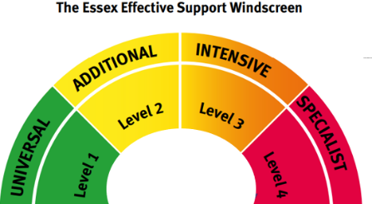
Direct Payments
Direct Homecare Provision
Overnight Respite
Foster Care
Clubs & Activities
Beach Huts and Caravans
Max Cards and tickets
Light Touch Care Hours
Light touch care
Capital & Adaptations

We also deliver a Community Capital Fund to support inclusive and accessible delivery across the programme.

Full details of these current offers can be found on the Short Breaks webpage: https://shortbreaks.essex.gov.uk/
The Short Breaks offer stretches across the spectrum of need to deliver outcomes and improve the lives of children, young people, parents and carers and aims to prevent or reduce crisis by offering as much community-based support as possible.
In addition to our Short Breaks offer we work with community groups to encourage them to be more inclusive in supporting families who wish to access local clubs and activities. We also make funds available to enable the continued development of more Changing Places in public spaces.

Using data to make decisions
Our Short Breaks offer will be informed by an up-to-date and accurate understanding of the numbers of children and young people with SEND, where they live, the types of disabilities they have and of any protected characteristics. It is also important to understand how this is likely to change over time so that we can respond effectively to needs as they develop.
We know that as of February 2021, there were approximately 3,450 children and young people registered to receive Short Breaks, and that Autism and Attention Deficit Hyperactivity Disorder (ADHD) far outweighed any other primary need. There are significantly more males accessing short breaks than females and the majority of those registered are aged 9 to 11 years.
Most of those registered are from the areas of highest deprivation, for example Colchester, Chelmsford, Basildon and Tendring, with many fewer from areas like Maldon. 86% of those registered identify as ‘white’ but in terms of protected characteristics we lack the required detailed information that will help us understand how we can design appropriate services to respond to any specific needs.
In 2020 there were 9323 children and young people with Education, Health and Care Plans (EHCPs) in Essex. The volume of EHCPs is forecast to reach 12,254 by 2025. This represents a 30.9% increase from 2020. We are further analysing data to better understand forecasting based on the home district of the child and exploring how we might better forecast by child’s need or disability type. The introduction of a Children with Disabilities Register and system developments for self-assessment will help improve data capture and reportability, and therefore forecasting too.
From the information that we have, we know some families are very well served by the Short Breaks offer, however there are others that miss out. Of those that are club members (37% of registered families), 9% attend three or more clubs, 19% attend two clubs and 72% attend one club. It is clear from our work so far there needs to be a change.

What families have told us
Listening to families’ ‘lived experiences’ enables us to make evidence-based informed decisions and, combined with the data we have available to us, will lead to positive outcomes for children and young people. Whilst the current offer is well received by many, we need to design a Short Break offer that is fair and equitable for all families across the County.
This Commissioning Strategy is founded on the views and lived experiences of over 420 families to whom we are grateful for sharing their experiences and ideas for change. This insight has helped us to understand that there needs to be:
- Clearer information on the services available
- More choice of locally based services
- Wider opportunities for children to socialise and learn new skills
- Better access to mainstream community-based clubs and activities
- Increased disability awareness for the workforce
- Better access and inclusion embedded in communities
- Life skills support for those approaching adulthood
- Support for the needs of the whole family that changes over time in line with how the needs of the family change
- More opportunities for family activities and breaks
- Good use made of learning from the pandemic to inform changes made
Children and young people told us that sense of community and routine and help with physical and mental heath are important to them. They also prioritised meeting friends and socialising, and having a range of activities, where they can learn new skills and give something back:
- “I don't like the ones [clubs] that are based at a school or a school-like setting because it's holiday time and that means no school. I don't go to any short breaks because I don't want more school.”
- “I like to see my friends at club, I enjoy the activities especially the cooking, which I am able to plan and be involved in what we cook each session. I also like to see the staff that work at the club. I love routine and the staff know me very well, I am happy and confident when I am at the club.”
- “I do think that there should be more clubs aimed at the 15- to 20-year-olds. I also believe that the [Club] is very good, but the activities are aimed more at 10yr olds.”
- “I love singing and dancing and spending time with my friends at clubs. It is lovely to do things with just other children and making new friends.”
Things they would like to change are:
- There needs to be better understanding of different types of disability
- They would like staff to listen more and to give them more time
- They like things to be fair – any rewards/systems should apply fairly to all abilities
- They would like for there to be more and different things available for them to do
- They would like more opportunities that develop their social skills
To hear directly from parent/carers you can view the film they made with us to help develop the vision for Essex Short Breaks: https://youtu.be/qcOjuOojl4w

Developing and improving the Short Breaks Offer
Family insight combined with our own data has helped us shape our Short Breaks Commissioning Strategy and as a result we will work with families and our partners to:
- Deliver a more equitable and accessible locally targeted service that meets the needs of families
- Always consider transitions age 19+ to provide smooth access to other support activities and services beyond the Short Breaks offer
- Increase awareness training with professionals and the wider community to embed better inclusion and access
- Deliver support for the whole family responding to how their needs change over time
- Provide the right information, at the right time and in the right format to enable families to better understand the support available and how they can access this

Our commissioning principles
Co-Design Children, young people and their families are integral to designing all parts of the short breaks offer with us. This will ensure that they inform and have influence over the short breaks offer. They will be encouraged and supported to participate in the decision-making processes.

Early Help Short breaks can help prevent problems which families are experiencing getting worse. The support we provide will contribute to helping families who have received a recent diagnosis to understand what is available and how the system works at this early stage. We will expand opportunities for families to access support in the community without needing to contact with statutory services such as social care.

Child and young person focused Short Break services must be centred around, and focused on, the child or young person. We will see that children and young people are provided opportunities to give regular feedback on the services they receive. We commit to sending clear messages about the valued and positive place of children and young people with SEND in their community.

Strengths-based We must build on the positive things in the lives of families with children and young people with disabilities that help them overcome difficulties. We will identify and strengthen the abilities that children and young people have, what their aspirations are for the future, and will actively support them in developing plans to achieve these. We will build on untapped sources of support in communities in developing our new offer.

Whole Family We must consider how we support the needs of the whole family and not just those of the child or young person with SEND. We will develop opportunities for families to network and support each other, including coffee mornings, local parent carer networks and informal and formal peer support buddying schemes. We will consider siblings, including those who have caring responsibilities, in our commissioning.

Empowerment Parents and Carers must be able to access information and guidance about their child’s needs and have the right information and training to enable their children to communicate their needs and wishes. We will ensure families are well supported by a range of different services both universal and specialist and will improve the choice and control families have in planning support.

All Age In Essex we want children and young people to receive help early on which will prepare them for successful transitions into adulthood. We will ensure that our system of support is tailored to meet the needs of children and young people at different ages and stages and that they are enabled to participate in age-appropriate opportunities which effectively support their development.

Whole System Other statutory partners like health services and district, borough, and city councils but also non-statutory partners such as the community and voluntary sector have a part to play. We will explore the greater role that could be played by agencies who may not typically see themselves as involved in our system of support, for example employers and business owners.

Outcomes
Outcomes are the change we expect to occur because of this Commissioning Strategy. These are:

For children and young people with SEND:
- Improved physical health
- Improved emotional health and well-being
- Safe and stable home lives
- The development of skills and abilities that help growth into adulthood
- Positive, well managed, transitions from childhood to adulthood

For parents/carers and families of children and young people with SEND:
- Improved quality of life
- Improved emotional health and well-being
- Safe and stable home environments
- Opportunities to participate in leisure, work, and study

For both children and young people with SEND and their parents/carers:
- Increased choice and control over the services received
- Children and young people with SEND being looked after in their families without the need for higher level interventions such as unplanned placements in health and social care residential facilities

For the system - providers, partners, professionals, and communities:
- Resources targeted based on need and demand
- A shift in resource and focus across our system to earlier help
- Increased awareness of the Short Breaks offers
- Increased confidence from mainstream providers in supporting families of children and young people with SEND
- Improved disability awareness and friendliness across communities in Essex
- Improved multi-agency working across the system resulting in improved alignment of systems and processes
- A strong, vibrant, and innovative provider market
- An increase in accessible and inclusive communities and mainstream opportunities in Essex

Delivering the Strategy
This Commissioning Strategy will be delivered by organising and planning our activity against 7 key objectives.

Objective 1: Parents, children and young people can access more inclusive mainstream provision across the County
Parents, children, and young people have told us that they would like to be able to access more mainstream provision in local communities. An important element to this is being able to trust that their child will be made welcome in that provision and that the staff there will be able to meet their needs. There are issues with physical accessibility, cost, facilities (such as accessible changing places), with staff training and with the friendliness with which families are received. By responding to the wants of families in making mainstream provision more accessible, we will enable a shift in demand away from services we provide. This will enable us to better target our existing offer to those least able to access community services.

What will we do:
We will engage with parents, children, and young people to identify the type of provision they would like to access and what they think the key barriers are. Families have worked with us to help us better understand what is needed; you can learn more here: https://shortbreaks.essex.gov.uk/latest-news/sharing-the-insights-from-our-research-on-how-we-can-improve/ We will continue to create collaborative spaces for feedback and development both on and offline.

We will engage with providers of mainstream services to identify how their provision could be made more accessible to children with disabilities and encourage the development of new facilities and opportunities. This will include using our capital grants schemes, working to improve local park provisions, and working with leisure centres to build inclusion into their offers.

We will work with parents, children, and young people to provide them with the support required to enable them to access mainstream provision and feel confident in doing so.

Objective 2: Parents, children and young people can access high quality information, advice, and guidance
There is a large amount of information, advice, and guidance available for families on the types of services and support they can access. We publish a Short Breaks brochure which includes our Short Breaks Service Statement. Families however frequently say that they cannot find the information they need or that the information available is not easy to understand. This means that families may be missing out and that support is not being equally accessed by all. There are a variety of on-going efforts to improve this including work on our Local Offer (http://www.essexlocaloffer.org.uk/). We need to continue to build on these and ensure they reflect our Short Breaks offer and the intentions of this Strategy.

What will we do:
We will engage regularly with parents, children, and young people to understand their views about our current information, advice and guidance offer and how this could be improved. We will do this by working with providers to hold regular development forums.

We will engage with partners across the system to identify the scope of our current offer and opportunities for alignment, improvement, and expansion.

We will through our offer, enable parents to access advice and guidance which meets their needs, reduces stress, and enables them to feel connected with local services and their local communities.

We will ensure families access help earlier in their journeys, helping them to feel stable and supported through the short breaks offer.

Objective 3: Parents, children and young people can access a community short breaks clubs and activities offer that meets need and enables good outcomes
Our current Short Breaks community offer includes max cards, caravans, and beach huts, our range of accessible clubs and activities and our light touch home care hours. This offer is valued by families and contributes to positive outcomes for both parents and children and young people. The offer however is not fairly available across the County – what you can and do access depends heavily on where you live, the type of disability a child has and their age. Parents do not feel the offer meets the needs of older children and young people well. The way we currently commission this offer is complicated and has not encouraged providers to flexibly adapt to changing needs. Providers of clubs and activities want to be more innovative, and we need to support them in this and to encourage the development of the provider market to ensure it remains sustainable.

What will we do:
We will co-design with parents, children, and young people a new community short breaks clubs and activities offer, including agreeing an approach to light touch early help care hours.

We will identify and respond to any opportunities identified by families to implement ‘quick win’ changes to our existing offer.

We will engage with our providers to encourage innovation in their current provision and to ensure the market remains sustainable.

We will ensure that all those who may benefit from the community short breaks clubs and activities offer are aware of what is available and provide clear information of how they can access it. We will do this through the delivery of a communications plan for families, schools, and providers that uses both online and offline opportunities to share information.

Objective 4: Parents feel confident to use direct payments as a means of accessing support for themselves and their child or young person
Essex County Council recognises the need to improve our direct payment offer to ensure that as many people as possible can enjoy the benefits that self-directed support brings. We have been working with adults, children and families, and carers who have lived experience of managing a direct payment to redesign our support offer to ensure it meets the needs of people who want to enjoy the flexibility and benefits of buying their own care and support. We are committed to working with adults, children, and families who access social care to ensure our direct payment support offer is as good as it can be so that as many people as possible can benefit from having a direct payment now and in the future and are properly supported to ensure they get the best out of their direct payment. We are currently working up a plan to implement the changes and make the improvements that have been highlighted through the design phase of this work.

What we will do:
We will improve the process to make it easier to take a direct payment and provide good quality information to help families make informed choices and decisions as to how to manage their support to help achieve their vision of a good life.

We will make sure good quality support is available to help families manage direct payments and that advice and support is available if they want to employ their own Personal Assistants.

We will increase the availability of more personalised care and support through increasing the number of small, local, niche care and support organisations and providing information on what is available in each area. We will also work to increase the number of Personal Assistants (PAs) working in Essex for people who want to directly employ their care and support staff.

We will improve our practice so that it is more consistent, built on relationships, transparent and flexible.

Objective 5: Parents, children and young people can access overnight short breaks provision which meets need and enables good outcomes
Some families whose children have complex needs rely on our overnight short breaks offer. Overnight short breaks are provided in Essex County Council owned residential accommodation, in residential accommodation that we commission from other providers, or in the homes of internal or external foster carers. While highly valued by families who access them, overnight short breaks do not always deliver desired outcomes and particular improvements could be made in meeting the needs of older young people. There are also efficiencies to be gained from our current system, including ensuring we are gaining maximum value for money from our own internal provision.

What will we do:
We will review our offer for overnight respite to ensure it is sustainable and meeting need.

We will expand the range of options that are available as an alternative to overnight residential care, including our foster care offer, considering improvements that could be made through developing improved commissioning frameworks for short break foster care.

We will ensure our existing provision is as efficient as possible and appropriately targeted to those most in need of support.

Objective 6: Children and young people with disabilities are supported to make successful transitions to, and achieve good outcomes in, adulthood
Parents, children, and young people have frequently told us of their concerns about how our current offer meets the needs of older young people. Parents say that they do not think our current clubs and activities offer is suitable for older young people and that the activities do not focus enough on teaching young people independence and the life skills they will need to successfully transition to adulthood. Parents worry about what is available once their young people are too old to access children’s services and would like more information about what services are available to adults. There are improvements that could be made in how children and adult services work together.

What will we do:
We will ensure that all aspects of our short breaks offer include supporting the development of life skills which will assist with preparing young people for adulthood. This will be made clear in our specifications for procuring services.

We will explore a range of options available to better support young people transitioning to adulthood.

We will improve the information that is available to parents on preparing for adulthood and transition to reduce the stress and anxiety felt around this.

We will further engage with parents and young people to understand what has worked well for them and expand on this learning in our developing offer.

Objective 7: Families in need of more intensive or specialist care feel supported to access provision that meets their needs.
Families who are assessed as requiring intensive or specialist provision such as quality home-based agency support (sometimes referred to as Direct Provision), or capital adaptations to their homes, have told us that information on the support available needs to be clearer. Social workers seeking appropriate home-based agency support for families have told us that a framework for accessing provision would make it easier to find external providers offering the right specialisms, equipment and facilitates, and that establishing clear, quality assured framework agreements would help build trust between families and providers. Our capital grants and adaptations scheme has historically delivered positive outcomes so we will continue to provide this as part of our offer. We will also seek to expand this so that more organisations can be better equipped with the tools and resources required to deliver inclusive provision.

What will we do:
We will improve the provision of home-based agency support by developing a new framework agreement with specialist providers. This will benefit families seeking to access high quality support and make our internal systems for finding this support more efficient as the framework will contain services that have been through a quality assurance process.

We will seek to expand our existing capital grants and adaptations scheme by offering a small inclusion fund for community organisations across Essex that are not currently commissioned to improve their inclusive offers.

Important partners in this Strategy
This is an Essex County Council Strategy, but we cannot improve the experiences of children, young people and families who access our Short Break offer without working in partnership with a range of other agencies. To implement this Strategy, we will engage with these partners to encourage them to work alongside us and consider what more they could do to bring about improved outcomes. Key partners we will engage with are:

Health: | Both those who commission and provide services, this includes universal services such as GPs and health visitors and specialist services for children and young people with disabilities.
Education: | Early years, schools and further education settings attended by children and young people who will also be providing help and support to them and their families.
District, Borough and City Councils: | Have responsibility for providing leisure, physical activity, cultural and community services.
Voluntary and community organisations: | Provide services and opportunities which children and young people access, including mainstream organisations and those specifically set up to meet the needs of disabled children and young people.
Businesses: | Anyone who provides a service which families with children with disabilities may want to access.

The budget
Essex is budgeted to spend £7.9m in 2021/22 increasing to nearly £8.0m by 2023/24 on the range of services that comprise Short Breaks. Within the context of on-going financial restraints, increasing demand and pandemic recovery, we are clear that Short Breaks is an area of work that remains a firm priority for Essex County Council.
The current investment in Short Breaks is equivalent to 10% of the Children and Families budget in 2021/22 where staffing costs are excluded. This is forecast to reduce to 9% by 2023/24 and reflects that Essex is needing to invest £56.5m into placement budgets in 2021/22 to support children, young people, and families. This is an increase of 8% or £4.2m compared to 2020/21.
With significant demand on Short Breaks services, a key component of this Strategy will be delivering effective outcomes efficiently within the financial resource available against rising demand. This requires working smarter and aiming to realise the potential of system change to create longer term sustainability.

Measuring impact

We will use a range of data gathering tools to measure whether the changes delivered by this Strategy are effective and impactful, from developing our technical systems which will allow for improved reporting, to continued direct engagement with families. This will ensure a rounded picture of who families are and what they want to see available. We will create a clear performance framework for ease of collating data across the County, and this will include quantitative and qualitative data.

We will know that we are seeing successful impacts when:

- More children and young people with disabilities are registered and accessing community-based provisions as part of our Early Help offer
- Parents, carers, and their children report confidence in the quality of our Short Breaks Offer
- Community Provisions feel supported in becoming more inclusive and the clubs and activities offer across the county is reported to be more equitable
- The offer is clear to services, practitioners, and families alike, and families report that they understand what the offer means for them
- Our agreed outcomes for children and young people and families are delivered

5-year roadmap of intended changes

Following consultation sessions with families and potential providers we will create a roadmap for the coming 5 years, representing the change we expect to see and acting as a visual image of accountability. Ongoing engagement with families will help us know whether we have met the milestones.
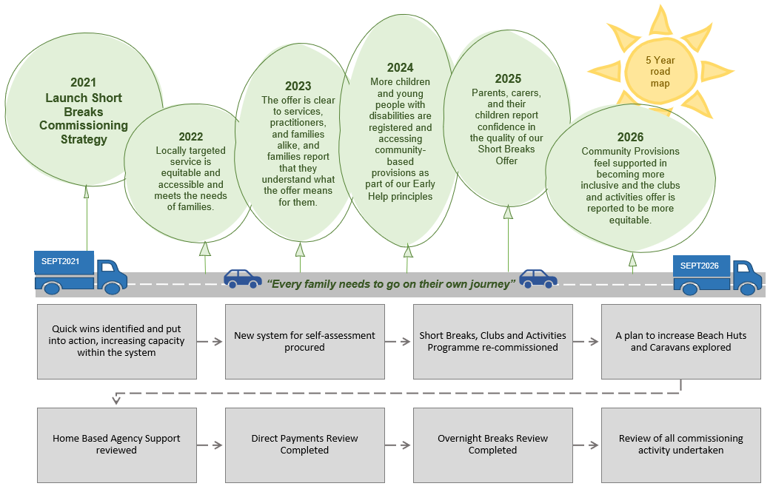

This information is issued by:
Essex County Council
Contact us:
CYPengagement@essex.gov.uk
www.essex.gov.uk

The information contained in this document can be translated, and/or made available in alternative formats, on request.
To be published September 2021 following consultation.

