APPENDIX G ESSEX PNA 2025

HOUSING DEVELOPMENT PLANS FOR PNA

Plan period to 2041 (beyond the lifetime of this PNA)
Sites that contribute to supply for the plan period are set out in each areas Land Supply Reports.

The supply can be demonstrated by sites that either have deliverable planning consents already in place, deliverable Housing & Employment Land Availability Assessment sites and known Town Centre regeneration programme sites.

All significant developments have access to existing pharmaceutical services either in the locality or in the neighbouring localities and no gaps in the provision of pharmaceutical services are identified.

Site analysis for PNA consists of strategic housing allocation of 200+ dwellings, site with planning permission and in adopted and emerging Local Plans.

- STRATEGIC SITES IN LOCAL PLANS (200 allocations or more)

  - BASILDON
There have been no newly identified sites within Basildon since the previous PNA (2022) that are strategic housing allocations of 200+ units and have planning permission during the analysis for the PNA (2025).

  - BRAINTREE
Land at Long Green Cressing
Land off Church Street, North of Grove Field, High 265
Bournebridge Hill Halstead
Land North of London Road Kelvedon

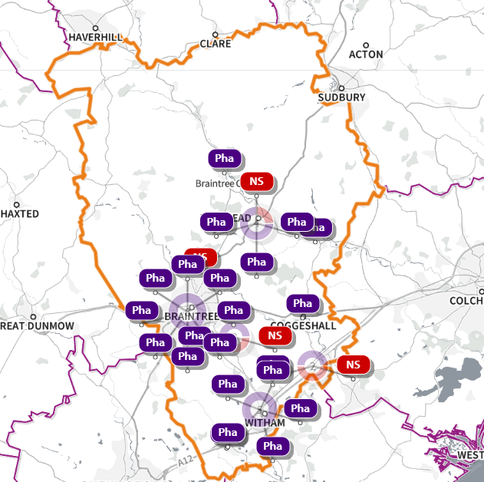
SHAPE Place • Pharmacy • Added location

1.3 BRENTWOOD
There have been no newly identified sites within Brentwood since the previous PNA (2022) that are strategic housing allocations of 200+ units and have planning permission during the analysis for the PNA (2025).
1.4 CASTLE POINT
There have been no newly identified sites within Castle Point since the previous PNA (2022) that are strategic housing allocations of 200+ units and have planning permission during the analysis for the PNA (2025).

1.5 CHELMSFORD
Former Runwell Hospital

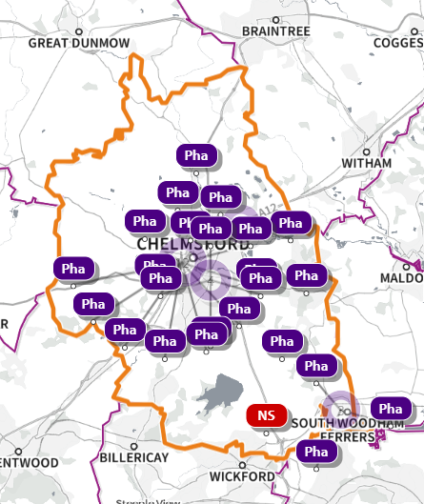
SHAPE Place • Pharmacy • Added location

1.6 COLCHESTER
Mill Road Extra Care, Land South of Axial Way
Defence Support Group (DSG), Flagstaff Road
R/O Colchester Centre, Hawkins Road

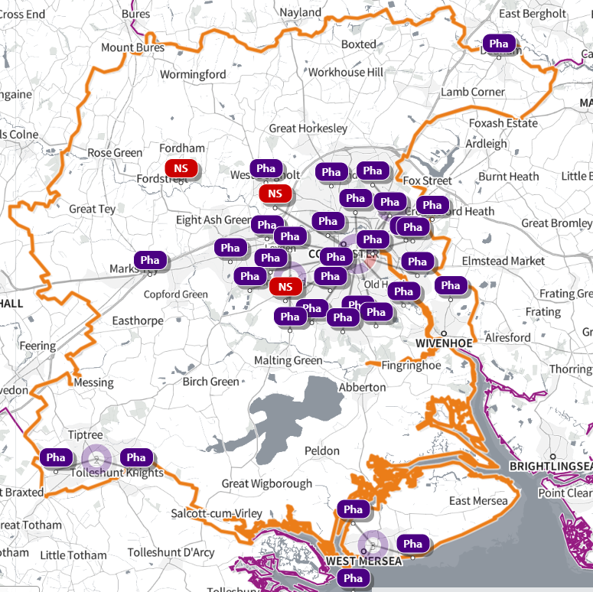
SHAPE Place • Pharmacy • Added location

1.7 Epping Forest

There have been no newly identified sites within Epping Forest since the previous PNA (2022) that are strategic housing allocations of 200+ units and have planning permission during the analysis for the PNA (2025).

1.8 Harlow

There have been no newly identified sites within Harlow since the previous PNA (2022) that are strategic housing allocations of 200+ units and have planning permission during the analysis for the PNA (2025).

1.9 Maldon
Land East of Wycke Hill Maldon Essex
South Maldon Garden Suburb
North Heybridge Garden Suburb

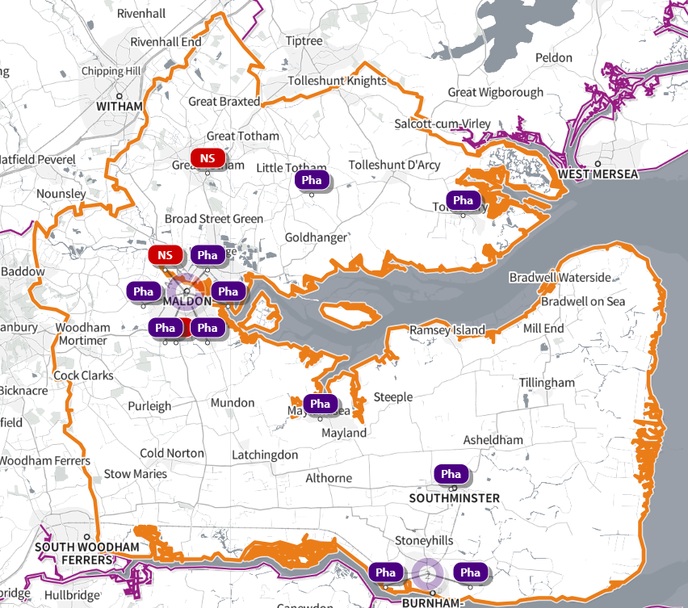
SHAPE Place • Pharmacy • Added location

1.10 Rochford
Land East of Ashingdon Road And North of Rochford, Garden Way, Rochford

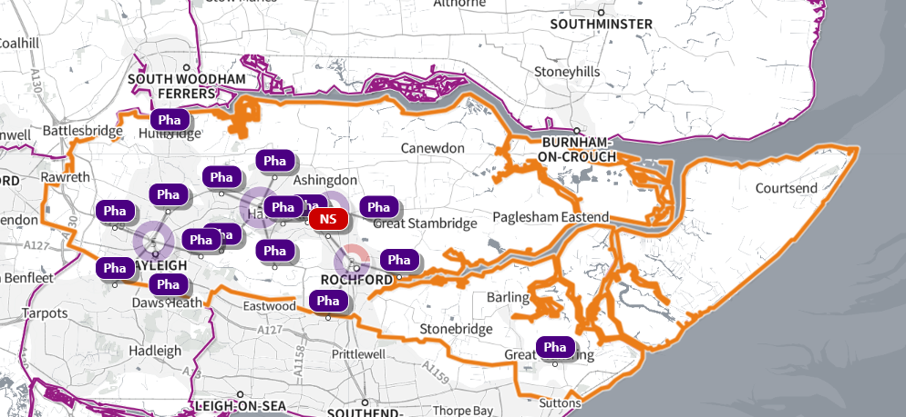
SHAPE Place • Pharmacy • Added location

1.11 Tendring
Finches Park, Kirby Cross
Samphire Meadow, Frinton
Manningtree Park, Long Road
Barleyfields, Land South of Thorpe Road

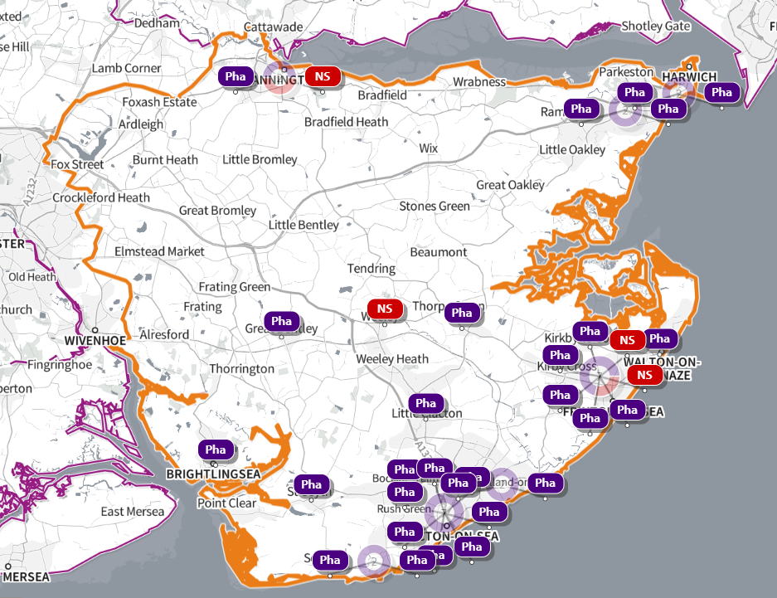
SHAPE Place • Pharmacy • Added location

1.12 Uttlesford
Land East Of Highwood Quarry Little Easton
Land South of Stortford Road, Dunmow
Land at Smiths Farm, Chelmsford Road, Great Dunmow (West of Chelmsford Road)
Land To The North West of Henham Road Elsenham
Land South Of (East Of Griffin Place) Radwinter Road Sewards End Essex
Sector 3, Woodlands Park, Great Dunmow
Helena Romanes School Parsonage Downs Dunmow
Land East of Station Road, Elsenham

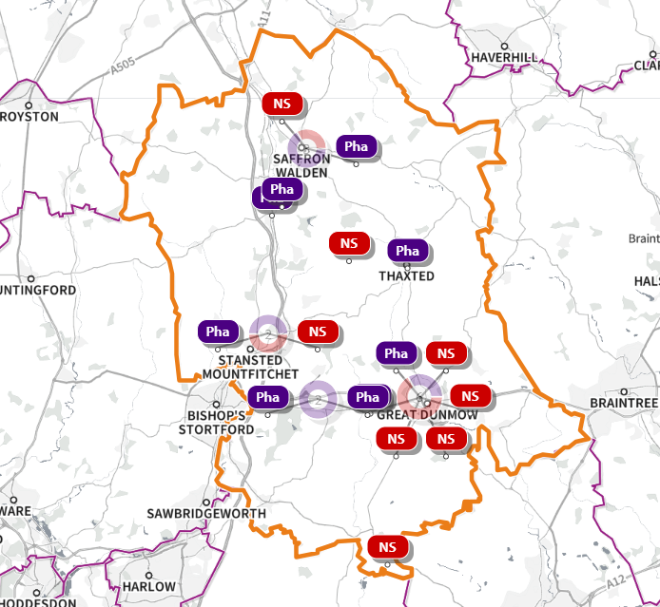
SHAPE Place • Pharmacy • Added location

Source- local plans for each district, borough, or city council in the Essex HWB area

