

Pharmaceutical Needs Assessment: Public Survey Results
Research and Citizen Insight
January 2025
Contents
Introduction 2
Methodology 2
The survey 2
Recruitment 2
Participants 3
Analysis 5
Findings 5
Pharmacy services 5
Pharmacy use 7
Conclusion 10

Introduction
The Pharmaceutical Needs Assessment (PNA) is a report of the current needs for pharmaceutical services. It is used to identify any gaps in current services and improvements that could be made to better meet the health needs of Essex residents. We want to make sure that pharmaceutical services provided in Essex are accessible and meeting health needs. It is used by NHS England to inform decisions about applications for new, or changes to existing pharmaceutical services, and the commissioning of NHS-funded services that can be provided by local community pharmacies.
As part of the PNA, public engagement is recommended to enable the Health and Wellbeing Board to better understand how pharmaceutical services are experienced, accessed and used by members of the public. The aim was to gather data on how people in Essex use pharmaceutical services, their awareness of services and what influences their choice. An online questionnaire was developed and administered to a self-selected sample across Essex.
This report provides an overview of pharmaceutical services in Essex from the perspective of residents, to assist the wider PNA in determining what services are required to meet the needs of the local population.



Methodology
This section outlines the method, recruitment strategy, sample, and approach taken to analysis.

The survey
From 13th December 2024 to 10th January 2025, we ran an online survey asking residents their opinion on pharmaceutical services provided by pharmacies, dispensing doctors, internet pharmacies and dispensing appliance contractors in the Essex area.

Recruitment
The survey was hosted on our online platform for consultations, and alternative formats including an Easy Read version was made available on request.
The survey used convenience sampling and was distributed widely across our networks and community groups, including districts and borough councils, Integrated Care Boards, Community Voluntary Sector organisations, Healthwatch Essex, GP surgeries, patient participation groups and pharmacies across Essex.

Participants
The final sample comprised of 164 respondents. This section outlines the demographic breakdown of respondents.
The majority (71%) of the respondents were female, whilst 26% were male.
Around half (61%) of the participants were aged 65+, 21% were aged 55-64, 12% aged 45-54, 10% aged 35-44, 4% 25-34, 1% aged 18-24, and a further 1% preferred not to answer.
The large majority of respondents (91%) were white English/Welsh/Scottish/Northern Irish/British, 2% any other white background, 1% African, <1% Chinese, white and Asian, other mixed/multiple ethnic background, Irish. Whilst 2% preferred not to say.

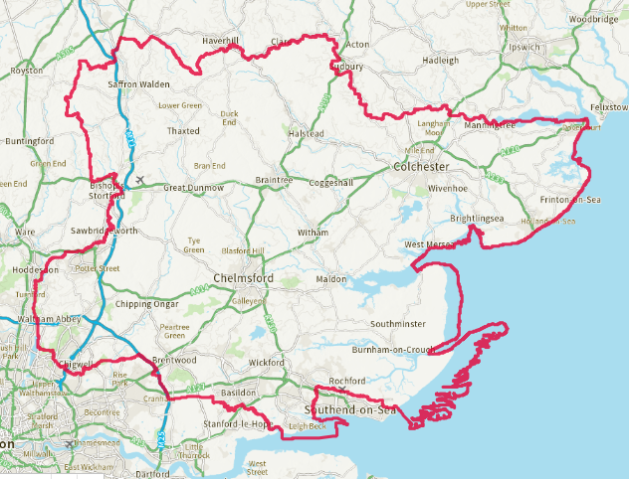
Respondents were asked to indicate their district or borough they live. A significant number of respondents were from North East Essex, particularly Colchester, while fewer were from South Essex. This disparity may be attributed to the distribution areas of the organisations sharing the survey.

Option | Total
Basildon | 5
Braintree | 12
Brentwood | 1
Castle Point | 3
Chelmsford | 12
Colchester | 91
Epping Forest | 9
Harlow | 6
Maldon | 3
Rochford | 1
Tendring | 7
Uttlesford | 4
Other | 8
Not Answered | 2

Almost half of respondents had no impairment or disability (46%) whilst a further 50% reported one or more impairments. These are listed below:


Almost a quarter (24%) of those completing the survey reported having some form of caring responsibility.

Analysis
We performed descriptive statistical analysis to help understand how pharmaceutical services are experienced, accessed and used by members of the public.

Findings
This section outlines the findings from the survey, it covers why people visit pharmacies, the services they are aware of and value, and people’s use of services.

Pharmacy services
Respondents were asked about why they use a pharmacy, the services they were aware of and which services they value. Nearly all (91%) respondents report usually using a pharmacy to get medicine on prescription, 59% to buy medicine from the pharmacy, 40% to get advice from the pharmacy, 7% said other. Of those that said other these related to having vaccinations and buying toiletries and gifts.
“Toiletries, vaccinations, vitamin supplements”
“Have flu and covid vaccines-wish I could have my pneumococcal vaccine there as difficult to get appt at GP”
“Pharmacy deliver our prescribed medicines”
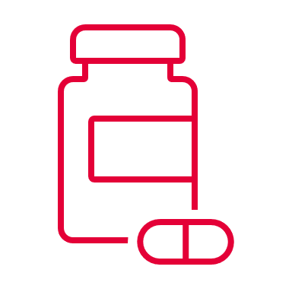
Those seeking advice were asked to give further information on the advice that they sought from the pharmacy. In total 59 additional comments were left. Of these, many respondents said they asked for medicine guidance, “which medications work best for certain issues” including both prescription and over the counter medicines. They also reported many “common ailments” and minor illnesses, which pharmacies provide advice on treating such as sore throats, coughs, colds, flu, rashes, ear infections, eye infections, and insect bites. They valued pharmacies helping to manage minor illnesses without needing a doctor’s visit. Parents often consult pharmacies for “advice on children's health matters” for treating children’s infections and minor ailments, seeking quick and reliable guidance. Pharmacies were also seen as a convenient alternative for those who have difficulty getting timely doctor appointments, offering immediate support and advice, “any issues where I was unable to get a GP appointment”. These themes highlight the broad range of reasons people turn to pharmacies for health advice and support.
“Whether over the counter or herbal remedies are compatible with the medications I am on”
“Advice on children's health matters”
“Advice on vaccines, and on what is best to buy when I am feeling unwell”
“Advice & prescription treatment rather than wait days to see a GP”
“Preliminary discussion prior to arranging doctor’s appointment which may be difficult”
“What medication would be the best or most appropriate to use”
Participants were then asked about the range of services pharmacies offer. Most respondents were aware of getting advice from a pharmacist (99%), buying over the counter medicine (99%), dispensing medicines on prescription (99%), the flu vaccination service (93%) and repeat dispensing services (85%). Whilst fewer people reported being aware of the stoma appliance customisation service (7%), immediate access to specialist drugs (13%), appliance use review (21%), supervised consumption of medicines that support stopping drug use (34%), pharmacy first service (35%) and needle and syringe service (35%). It’s interesting to note that while some services are widely recognised, others, despite their importance, are not as well-known. This could be due to not being applicable to everyone, or a lack of awareness about the specific names of these services, even if people have used them (i.e. Pharmacy First).
From the same list of services, people were asked which ones they value by selecting their top three. The results show that 87% value pharmacies for dispensing medicines, 57% advice from the pharmacist, 53% buying over the counter medicines, 34% repeat dispensing services and 25% flu vaccination services.

Pharmacy use
People were asked how frequently they use the pharmacy, most convenient times and day, and how they choose which pharmacy to visit. In terms of how often people use a pharmacy 62% said they use them monthly, 13% every three months, 12% ad-hoc, 10% weekly, and 2% every 6 months.
“And very often during the week when needed”
“Again, a lot when in need, monthly when not”
“Varies at least monthly but sometimes weekly”

Looking at the days of the week respondents find it most convenient to visit a pharmacy, the majority (60%) have no particular day they go, 26% prefer a weekday, and 14% prefer the weekend (Saturday or Sunday).
When thinking about the time of day it is most convenient to visit a pharmacy most people (43%) said between 9am and 6pm, 40% had no particular time, whilst 18% preferred to visit out of regular hours (before 9am or after 6pm).

Participants were asked if they tend to use the same pharmacy or different ones. Over half (54%) said they use the same pharmacy all of the time, 41% use different pharmacies but have one they tend to visit more, and 5% use different pharmacies with none more frequently than any other.


When looking at what impacts and influences a person’s choice of pharmacy 91% chose location, a third (33%) said opening hours, 24% availability of medicines, 5% said they consider reviews. Other things people said they consider included the availability of parking, quality of service, where their GP sends prescriptions, staff knowledge, helpfulness and friendliness.

“Parking, people. If I didn’t drive, there’s a half hourly bus”
“Availability of qualified Pharmacist”
“Staff knowledge and helpfulness”
“It’s where the GP sends my prescription”
“Range of toiletries and other non pharmaceutical products”
“Quality of the service received--changed pharmacies recently as disliked service provided by Boots and now use independent pharmacy which provides a personalised service”

It is evident that location plays an important role. Delving deeper into this we asked people about their mode of transport to the pharmacy. They gave the following responses:

 | 60% by car
 | 51% on foot
 | 5% on a bicycle
 | 3% on public transport
 | 1% by taxi

In terms of the length of people’s journey’s, most people said it takes less than 20minutes to travel to the pharmacy.

Conclusion

The survey highlights the essential role pharmacies play in providing accessible healthcare services. The majority of respondents use pharmacies primarily for obtaining prescription medicines, with a significant number also purchasing over-the-counter medications and seeking health advice. The convenience of pharmacies in managing minor illnesses and providing quick, reliable guidance, especially for children’s health, highlights their importance as an alternative to GP visits.

Awareness of pharmacy services is high for common things like advice, over-the-counter medicine, and prescription dispensing. However, there is less awareness of more specialised services, which may be due to their specific applicability or people’s lack of familiarity with service names. Despite this, the valued services align closely with those people most recognised, indicating a strong appreciation for the core functions of pharmacies.

Frequency of pharmacy use varies, with most people visiting monthly and preferring daytime hours. While many have a preferred pharmacy, location remains the primary factor influencing choice, followed by opening hours and medicine availability. In terms of travel most people travel by car or on foot, and for most the journey is under 20 minutes. This highlights the importance of pharmacies being conveniently located and accessible to meet the diverse needs of the community.

This information is issued by:
Essex County Council
Contact us:
research@essex.gov.uk
Research and Citizen Insight
Essex County Council
County Hall, Chelmsford
Essex, CM1 1QH
Essex_CC
 facebook.com/essexcountycouncil
The information contained in this document can be translated, and/or made available in alternative formats, on request.
Published January 2025

