Essex HWB Draft
Pharmaceutical Needs Assessment

May 2022

Produced for the Essex Health & Wellbeing Board by
Essex County Council Public Health & Public Health Intelligence Team

Table of Contents
Foreword and acknowledgements
Executive Summary
1 Introduction 1
1.1 The Essex Health and Wellbeing Board Pharmaceutical Needs 1
Assessment
1.2 Background and legislation 1
1.3 Local context 1
1.4 Development of the Essex PNA 2
1.5 Consultation 2
1.6 Scope of the Essex PNA 3
1.7 PNA review process 3
1.8 Localities for the purpose of the PNA 3
2 Pharmaceutical Services 5
2.1 The Community Pharmacy Contractual Framework 5
2.2 Essential services 6
2.3 Advanced services 7
2.4 Enhanced Services (LES) and Locally Commissioned Services (LCS) 8
2.5 Non commissioned, value add services 9
3 Market entry and pharmaceutical providers 11
3.1 Market entry 11
3.2 100 hours 11
3.3 Distance selling pharmacies (internet pharmacies) 12
3.4 The Pharmacy Access Scheme 2022 12
3.5 Dispensing Appliance Contractors (DACs 12
3.6 Dispensing doctors 12
3.7 Others 13
4 Community pharmacy in 2022 and beyond 13
4.1 NHS Long term plan 13
4.2 For community pharmacy 14
4.3 Integrated Care Systems 14
4.4 Pharmacy in Place 15
Table of Contents continued

4.5 Community Pharmacy Contractual Framework (CPCS) 16
4.6 Amendments to NHS regulations 16
4.7 Covid-19 pandemic 17
4.8 Pharmacy Access Scheme 19
4.9 Pharmacy Integration Fund (PhIF) 19
4.10 Local Strategies 21
5 The Essex Area 23
5.1 Demographics 23
5.2 Deprivation 30
5.3 Lifestyles 36
5.4 Education 44
5.5 Employment 45
5.6 Housing 46
5.7 Transport 49
5.8 Health 51
6 The Assessment 58
6.1 The assessment of pharmaceutical services 58
6.2 Pharmaceutical services in Essex 58
6.3 Locality of services 62
6.4 Essential services 65
6.5 Advanced services 71
6.6 Enhanced services in Essex 71
6.7 Other services providers 72
6.8 Distance-Selling Pharmacies (DSP) 73
6.9 Dispensing Appliance Contractors (DACs) 73
6.10 Pharmaceutical service provision provided from outside HWB area 74
6.11 Other 74
6.12 Housing Growth 75
7 Locality Statements 76
7.1 Basildon 76
Table of Contents continued

7.2 Braintree 89
7.3 Brentwood 100
7.4 Castle Point 110
7.5 Chelmsford 121
7.6 Colchester 133
7.7 Epping Forest 146
7.8 Harlow 158
7.9 Maldon 169
7.10 Rochford 178
7.11 Tendring 187
7.12 Uttlesford 199
8 Likely future needs to consider 207
8.1 Sustainability 207
8.2 Inequalities 208
9 Conclusion 210
10 Appendices 212
Appendix A Development of PNA and Steering Group
Appendix B Full consultation report
Appendix C List of Pharmacies in the HWB area
Appendix D List of Dispensing Doctors in the HWB area
Appendix E Public survey report
Appendix F Travel times and maps
Appendix G Housing Report

Foreword and acknowledgements

TO BE COMPLETED POST CONSULTATION

Executive Summary

TO BE COMPLETED POST CONSULTATION

Introduction

The Essex Health and Wellbeing Board Pharmaceutical Needs Assessment

This Essex Health and Wellbeing Board (HWB) Pharmaceutical Needs Assessment (PNA) supersedes previous PNAs within the HWB area.

PNAs are updated at least every three years, however the Covid-19 pandemic led to regulations being amended to allow the 2018 PNA to be extended until October 2022.

Background and legislation

Section 128A of the National Health Service Act 2006 (NHS Act 2006) requires each HWB to assess the need for pharmaceutical services in its area and to publish a statement of its assessment. Termed a ‘pharmaceutical needs assessment’, the NHS (Pharmaceutical Services and Local Pharmaceutical Services) Regulations 2013, as amended (the 2013 regulations) set out the minimum information that must be contained within a PNA and outline the process that must be followed in its development.

  - Local context

    - Purpose of the Essex Pharmaceutical Needs Assessment (PNA):
        - The PNA will be used by NHS England (or other body as identified in the regulations) when considering decisions on applications to open new pharmacies and dispensing appliance contractor premises; or applications from current pharmaceutical providers to change their existing regulatory requirements. Decisions on whether to open new pharmacies are not made by the HWBs. If a person (a pharmacist, a dispenser of appliances or in some circumstances, and normally in rural areas, GPs) wants to provide NHS pharmaceutical services, they are required to apply to the NHS to be included on a Pharmaceutical List. Pharmaceutical Lists are compiled and held by NHS England. Under the NHS (Pharmaceutical Services and Local Pharmaceutical Services) Regulations, a person who wishes to provide NHS pharmaceutical services must generally apply to NHS England to be included on a relevant list by proving they are able to meet a pharmaceutical need as set out in the relevant PNA. There are exceptions to this, such as applications for needs not foreseen in the PNA or to provide pharmaceutical services on a distance-selling (internet or mail order only) basis. NHS England will then review the application and decide if there is a need for a new pharmacy in the proposed location.
        - It will aid the HWB to work with providers to target services to the areas where they are needed, and limit duplication of services in areas where provision is adequate.
        - It will inform interested parties of the pharmaceutical needs in Essex and enable work to plan, develop and deliver pharmaceutical services for the population.
        - It will inform commissioning decisions by local commissioning bodies, including local authorities.

1.4 Development of the Essex PNA

• The process of developing the PNA has taken into account the requirement to involve and consult people about changes to health services. The specific legislative requirements in relation to development of PNAs were considered. The membership of the steering group ensured all the main stakeholders were represented. Further details are available in Appendix A.

1.5 Consultation

Section to be amended post consultation
• A statutory consultation exercise was carried out between May and August 2022 to seek and consider views from a range of key stakeholders on the draft PNA.
• A full consultation report will be included in the final PNA Appendix B.

1.6 Scope of the Essex PNA

• The services that a PNA must include are defined within both the National Health Service Act 2006 and the NHS (Pharmaceutical and Local Pharmaceutical Services) Regulations 2013, as amended.
• Pharmaceutical services may be provided by:
• A pharmacy contractor who is included in the pharmaceutical list for the area of the Health and Wellbeing Board (HWB).
• A pharmacy contractor who is included in the Local Pharmaceutical Services list for the area of the HWB.
• A dispensing appliance contractor who is included in the pharmaceutical list held for the area of the HWB and
• A doctor or GP practice that is included in the dispensing doctor list held for the area of the HWB.
• NHS England and NHS Improvement (NHSE&I) is responsible for preparing, maintaining and publishing these lists.
• Pharmacy contractors may operate as either a sole trader, partnership, or a body corporate and The Medicines Act 1968 governs who can be a pharmacy contractor.
• Whether a service falls within the scope of pharmaceutical services for the purposes of PNA depends on who the provider is and what is provided.
• The PNA has a regulatory purpose that sets the scope of the assessment. Pharmaceutical services are evident in other areas of work but are excluded from this assessment. These include prison pharmacy, secondary care, and private services where patients may be obtaining a type of pharmaceutical service that is not covered by this assessment.

1.7 PNA review process

• The PNA will be updated as required by legislation every three years. Supplementary statements will be published before this if deemed necessary.

1.8 Localities for the purpose of the PNA

• The PNA steering group considered how the areas in Essex could be defined for the PNA. The Essex HWB covers 12 district, borough, and city council areas and these were chosen as the localities.

Figure 1 Map of Essex showing localities
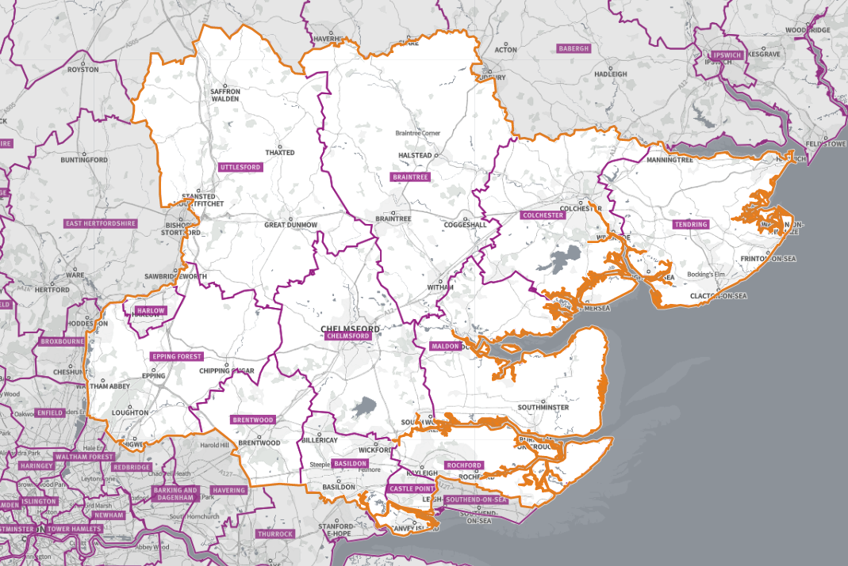
Table 1 Localities of the Essex PNA

PNA Localities
Basildon
Brentwood
Braintree
Castle Point
Chelmsford
Colchester
Epping Forest
Harlow
Maldon
Rochford
Tendring
Uttlesford

Source: SHAPE Place Atlas

Pharmaceutical Services

Pharmaceutical services provided by pharmacy contractors
Unlike for GPs, dentists and optometrists, NHSE&I does not hold contracts with the majority of pharmacy contractors. Instead, they provide services under a contractual framework, sometimes referred to as the Community Pharmacy Contractual Framework (CPCF), details of which (the terms of service) are set out in the NHS (Pharmaceutical and Local Pharmaceutical Services) Regulations 2013, as amended, and also in the Pharmaceutical Services (Advanced and Enhanced Services) (England) Directions 2013.

2.1 The Community Pharmacy Contractual Framework

2.1.1 The Community Pharmacy Contractual Framework (CPCF) was introduced in 2005. Under the framework, there are three types of service which can be provided by community pharmacy and/or appliance contractors:
- Essential services
- Advanced services
- Enhanced services (commissioned by NHSE&I)

2.1.2 Core and supplementary hours

2.1.2.1 A pharmacy has 40 core contractual hours (or 100 hours for those that have opened under the former exemption from the control of entry test), which cannot be amended without the consent of NHS England, together with supplementary hours, which are all the additional opening hours.

2.1.2.2 A pharmacy may also have more than 40 core hours where it has made an application based on that higher number, and NHS England has agreed that application.

2.2 Essential services

2.2.1 As part of the CPCF, Essential services are one of the three types of services which must be provided by community pharmacies, including distance selling pharmacies.
Table 2 Provision included in the contractual framework for Essential services
Service | Description
Dispensing Medicines | The safe supply of medicines or appliances. Advice is given to the patient about the medicines being dispensed and how to use them. Records are kept of all medicines dispensed and significant advice provided, referrals, and interventions are made. The Electronic Prescription Service (EPS) enables prescriptions to be sent electronically from a prescriber to the dispenser preventing unnecessary journeys for patients.
Repeat Dispensing/ Electronic repeat dispensing | The management of repeat medication for up to one year, in partnership with the patient and prescriber. The patient will return to the pharmacy for repeat supplies, without first having to visit the GP surgery. Before each supply the pharmacy will ascertain the patient’s need for a repeat provision of a particular medicine.
Disposal of unwanted medicines | Pharmacies accept unwanted medicines from individuals. The medicines are then safely disposed of.
Promotion of Healthy Lifestyles (Public Health) | Pharmacies are required to participate in up to six health campaigns at the request of NHSE&I. This generally involves the display and distribution of leaflets provided by NHSE&I.  In addition, pharmacies are required to promote healthy lifestyles, which includes providing advice to people who appear to have diabetes, be at risk of coronary heart disease (especially those with high blood pressure), or smoke, or are overweight.
Signposting patients to other healthcare providers | Pharmacists and staff will refer patients to other healthcare professionals or care providers when appropriate.
Support for Self-Care | The provision of advice and support by pharmacy staff to enable people to derive maximum benefit from caring for themselves and/or their families.
Discharge Medicines Service | The service was introduced in 2021 and aims to reduce the risk of medication problems when a person is discharged from hospital.  Patients are digitally referred to their pharmacy after discharge from hospital. Using the information in the referral, pharmacists can compare the patient’s medicines at discharge to those they were taking before admission to hospital. A check is also made when the first new prescription for the patient is issued and a consultation with the patient and/or their carer will help to ensure that they understand which medicines the patient should now be using.

Underpinning the provision of all these services is the requirement on each contractor to participate in a system of clinical governance. This system of clinical governance supports the provision of excellent care; requirements include:

- Patient and public involvement programme
- Clinical audit programme
- Risk management programme
- Clinical effectiveness programme
- Staffing and staff management programme
- Information governance programme
- Premises standards programme

2.3 Advanced Services

Advanced services are those services that pharmacy and dispensing appliance contractors may choose to provide if they meet the required standards.
Table of Provision included in the contractual framework for Advanced Services (as of May 2022)
Service | Description
New Medicines Service (NMS) | The New Medicines Service (NMS) is designed to provide early support to patients to maximise the benefits of the medication they have been prescribed, and to minimise problems and side-effects, while informing the patients on the best ways to self-manage their Long Term Conditions (LTCs)
Community pharmacy seasonal influenza vaccination | Each year from September through to March the NHS runs a seasonal flu vaccination campaign aiming to vaccinate all eligible patients who are at risk of developing more serious complications from the virus. The accessibility of pharmacies, their extended opening hours, and the option to walk in without an appointment have proved popular with patients seeking vaccinations.
Community Pharmacist Consultation Service (CPCS) | NHS Community Pharmacist Consultation Service (CPCS) was launched in October 2019 and the majority of community pharmacies have registered to provide the service. Initially the service took referrals to community pharmacies from the NHS 111 call service and subsequently the service was expanded to take referrals from 111 online. The latest development is for pharmacies to take referrals from GP practices; this is referred to as GP CPCS. The CPCS is intended to relieve pressure on the wider NHS by connecting patients with a community pharmacy, as their first resort for repeat medications where the patient has run out of medication and for health consultations for a set list of minor ailments
Hepatitis C testing service | The Community Pharmacy Hepatitis C Antibody Testing Service was added to the Community Pharmacy Contractual Framework (CPCF) in 2020. The service is focused on provision of point of care testing (POCT) for Hepatitis C (Hep C) antibodies to people who inject drugs (PWIDs), i.e., individuals who inject illicit drugs, e.g., steroids or heroin, but who haven’t yet moved to the point of accepting treatment for their substance use. Where people test positive for Hep C antibodies, they are referred for a confirmatory test and treatment, where appropriate.
Hypertension case-finding service | The prevention of cardiovascular problems and identification of people with raised blood pressure. The service has two stages – the first is identifying people at risk of hypertension and offering them blood pressure measurement.  - the second stage, where clinically indicated, is offering 24 hour ambulatory blood pressure monitoring (ABPM). The blood pressure test results will then be shared with the patient’s GP to inform a potential diagnosis of hypertension.
Smoking Cessation Service (CSC) following hospital discharge | In 2020/21 a Pharmacy Integration Fund pilot on smoking cessation began to test a new model of working in which community pharmacies managed the continuing provision of smoking cessation support initiated in secondary care following patient discharge from hospital.  The hospital establishes the smoking status of all admitted patients followed by brief advice, personalised counselling, timely nicotine replacement therapy (NRT) or pharmacotherapy, and follow-up of the patient after discharge. This service enables NHS trusts to transfer patients for smoking cessation support into the community.
Appliance and Stoma services | Whilst pharmacies are required to dispense valid NHS prescriptions for all drugs, both they and dispensing appliance contractors may choose which appliances they provide in their normal course of business. They may choose to provide a certain type of appliance, or types of appliances, or they may choose to provide all appliances. Some pharmacies may choose not to provide any appliances. A large proportion of patients who are regular users of appliances will have them delivered, often by dispensing appliance contractors based throughout the country. There are two appliance advanced services that pharmacies and dispensing appliance contractors may choose to provide:  • Appliance Use Reviews (AUR), and  • Stoma Appliance Customisation (SAC)

2.3.1 Advanced services decommissioned:
- Medicines Use Reviews (MURs)
- NHS Urgent Supply Advanced Scheme (NUMSAS)
- During the Covid-19 pandemic, the community pharmacy Covid-19 lateral flow device distribution service and community pharmacy Covid-19 medicines delivery service were commissioned from community pharmacies. These are now decommissioned.

2.4 Local Enhanced Services (LES) and Locally Commissioned Services (LCS)

2.4.1 This third group of services provided as part of the Community Pharmacy Contractual Framework could be commissioned locally by the NHS England area team, Clinical Commissioning Groups (CCGs) or Local Authorities (LA) in order to meet the needs of their population (Note: CCGs are being abolished and being replaced by Integrated Care Systems (ICSs).

2.4.2 Local services that are commissioned by the NHS England are called Local Enhanced Services (LES).

2.4.3 Locally commissioned services by the LA or CCGs such as public health services are not considered to be LESs. Services commissioned from LA and CCGs fall outside the definition of enhanced services, they have no bearing on pharmacy applications; they are only included in this assessment to secure improvements or better access to pharmaceutical services.

2.4.4 These services are considered LES if the LA or CCG ask NHS England to commission them on their behalf.

2.5 Non commissioned, value add services

2.5.1 Community pharmacies provide some services that are not commissioned from any particular sources and have no bearing on pharmacy applications. These services add value to the local provision. They can include:
- Repeat prescription collection and delivery service
- Travel advice and vaccinations
- Screening services
- Dispensing of private prescriptions
- Sales of over-the-counter medicines

Pharmaceutical services provided by dispensing appliance contractors

As with pharmacy contractors, NHSE&I hold contracts with dispensing appliance contractors. Dispensing appliance contractors provide the following services for appliances (not drugs) for example catheters and colostomy bags, which fall within the definition of pharmaceutical services:

- Dispensing of prescriptions (both electronic and non-electronic), including urgent supply without a prescription
- Dispensing of repeatable prescriptions
- Home delivery service for some items
- Supply of appropriate supplementary items (e.g., disposable wipes and disposal bags)
- Provision of expert clinical advice regarding the appliances and
- Signposting

They may also choose to provide advanced services. If they do choose to provide them then they must meet certain requirements and must be fully compliant with their terms of service and the clinical governance requirements. The two advanced services that they may provide are:

- Stoma Appliance Customisation (SAC)
- Appliance Use Review (AUR)

As with pharmacies, dispensing appliance contractors are required to participate in a system of clinical governance.
Dispensing appliance contractors are required to open at least 30 hours per week, and these are referred to as core opening hours. They may choose to open for longer and these additional hours are referred to as supplementary opening hours.
The proposed opening hours for each dispensing appliance contractor are set out in the initial application, and if the application is granted and the dispensing appliance contractor subsequently opens then these form the dispensing appliance contractor’s contracted opening hours.

Dispensing doctor services
The NHS (Pharmaceutical and Local Pharmaceutical Services) Regulations 2013, allow doctors to dispense to eligible patients in certain circumstances. In summary:
- Patients must live in a ‘controlled locality’ (an area which has been determined by NHS England and NHS Improvement or a preceding organisation as rural in character), more than 1.6km (measured in a straight line) from a pharmacy (excluding distance selling premises) and
- Their practice must have premises approval and consent to dispense to that area

A dispensing practice can also undertake a dispensing review of use of medicines (DRUM). This is a face-to face review with a patient to find out about their experiences with prescribed medicines and aims to help identify any problems that might be occurring.

Distance Selling Pharmacies services
Distance selling pharmacies or mail order pharmacies, often known as ‘online pharmacies’, operate over the internet and send orders to customers through the mail or parcel services free of charge. The National Health Service (Pharmaceutical and Local Pharmaceutical Services) Regulations 2013 stipulate the requirements for distance selling pharmacies. These pharmacies must provide the full range of essential services during opening hours to all persons in England presenting prescriptions but cannot provide essential services face to face, they must have a responsible pharmacist in charge of the business at the premises throughout core and supplementary opening hours and they must be registered with the General Pharmaceutical Council (GPhC).

Necessary services
Necessary services are pharmaceutical services which have been assessed as required to meet a pharmaceutical need. This should include their current provision (within the HWB area and outside of the area) and any current or likely future gaps in provision.
Any services not considered as necessary pharmaceutical services are therefore deemed to be other relevant services which can be provided as an optional service by pharmaceutical contractors and are often also delivered by other providers within the HWB area.

Other NHS services
Some NHS services reduce the need for pharmaceutical services, in particular the dispensing service, these include:

- Hospital pharmacies
- Personal administration of items by GP practices
- GP out of hours service (as it may give patients a course of treatment rather than a prescription)
- Public health services commissioned by the local authority
- Prison pharmacy services (where relevant),
- Substance misuse services, and
- Flu vaccination by GP practices

NHS services that increase the demand for pharmaceutical services include:

- GP out of hours services (where a prescription is issued)
- Walk-in centres and minor injury units (where a prescription is issued)
- GP extended access hubs
- Community nursing prescribing
- Dental services
- End of life services, and
- Services that have been moved into the primary care setting

Market entry and pharmaceutical providers

3.1 Market Entry If a person wants to provide pharmaceutical services, they are required to apply to the NHS to be included in a pharmaceutical list. Pharmaceutical lists are compiled and as of May 2022 are held by NHSE&I. This is commonly known as the NHS “market entry” system.

Under the 2013 regulations, a person who wishes to provide pharmaceutical services must apply to NHSE&I to be included in the relevant pharmaceutical list by proving they are able to meet a need for, or improvements or better access to, pharmaceutical services as set out in the relevant PNA.
There are exceptions to this, such as applications for benefits not foreseen in the PNA or to provide pharmaceutical services on a distance-selling (internet or mail order only) basis.
Pharmaceutical lists are currently maintained by NHS England and so applications for consolidations, new, additional, or relocated premises must be made to the local NHS England Area Team.

3.2 100 hours
3.2.1 Certain pharmacies opened under previous regulations undertaking to provide pharmaceutical services for 100 hours a week. NHS England may not vary or remove the 100-hour conditions on premises that were granted their contract under the 100 hour application exemption.

3.3 Distance selling pharmacies (internet pharmacies)
3.3.1 Patients have the right to access pharmaceutical services from any community pharmacy including Distance Selling Pharmacies (DSP) of their choice and therefore can access any of the many distance selling pharmacies available nationwide.
3.3.2 New conditions have been introduced in the regulations, which require all distance selling pharmacies (including those admitted under the 2005 regulations) to be able to provide essential services safely, without face-to-face contact at the premises and ensure that persons anywhere in England are able to access the essential services.

3.4 The Pharmacy Access Scheme 2022
3.4.1 The aim of the Pharmacy Access Scheme (PhAS) is to ensure that a baseline level of patient access to NHS community pharmaceutical services in England is protected.
3.4.2 The PhAS has been designed to capture the pharmacies that are most important for patient access, specifically those pharmacies where patient and public access would be materially affected should they close. The PhAS takes isolation and need levels into account.
3.4.3 The objective of the 2022 PhAS is to create a scheme that is more targeted and representative of the pharmacy market as it is now, and that better targets support to pharmacies that are deemed essential for local provision of physical NHS pharmaceutical services.
3.4.4 Pharmacies in areas with dense provision of pharmacies remain excluded from the scheme. In areas with high numbers of pharmacies, public access to NHS pharmaceutical services is not at risk.
3.4.5 DSPs, dispensing appliance contractors, Local Pharmaceutical Services (LPS) contractors, and dispensing doctors remain ineligible for the scheme.
3.4.6 As at May 2022, the list of PhAS contractors in the Essex HWB area is subject to appeal with NHSE&I and is therefore not included in this PNA.

3.5 Dispensing Appliance Contractors (DACs)
3.5.1 Appliance contractors provide services to people who need appliances such as stoma and incontinence care aids, trusses, hosiery, surgical stockings and dressings. They do not supply drugs. However, pharmacies and dispensing doctors can also dispense appliances.

3.6 Dispensing doctors
3.6.1 Provision for doctors to provide pharmaceutical services in certain circumstances has been made in various NHS Acts and Regulations for many decades. Doctors in certain localities are allowed to offer a dispensing service to eligible patients living in rural areas, as defined in the pharmaceutical regulations. Dispensing Review of Use of Medicines (DRUMs) are offered by dispensing doctors but covered by-separate regulations and therefore outside the scope of this PNA. This PNA does not define rurality.

3.7 Others
3.7.1 Pharmaceutical services are provided by other services which this PNA makes no assessment of. These include arrangements for:
• Military personnel
• Prison population
• Hospital patients
• Services provided across the border in other HWB areas
• Private providers

Community pharmacy in 2022 and beyond

NHS Long Term Plan

4.1.1 In January 2019, NHS England published the NHS Long Term Plan, setting out its priorities for healthcare over the next ten years and showing how the NHS funding settlement will be used.

A key theme of the plan is prevention, as NHS England says it believes 500,000 lives could be saved over the next ten years by focusing on prevention and early detection. The NHS will focus on its aim to make the population ‘fit for the future’ by:

Enabling everyone to get the best start in life.

Helping communities to live well; and

Helping people to age well.

Other measures include:

Improving out-of-hospital care by supporting primary medical and community health services.

Providing better care for major health conditions, such as cardiovascular disease, respiratory conditions, and diabetes.

Supporting those admitted to hospital with smoking/alcohol addiction.

Supporting older people through more personalised care and stronger community and primary care services; and

Making digital health services a mainstream part of the NHS, so that in five years’ time, patients in England will be able to access online GP consultations.

For community pharmacy, the plan states:

NHS England will work with Government to make greater use of community pharmacists’ skills and opportunities to engage patients.

NHS England and the Government will explore further efficiencies through reform of reimbursement and wider supply arrangements.

NHS England will work with community pharmacists and others to provide opportunities for the public to check their health, through tests for high blood pressure and other high-risk conditions; and

From 2019, NHS 111 will start direct booking into GP practices across the country, as well as referring on to community pharmacies who can support urgent care and promote patient self-care and self-management.

NHS England also makes several mentions of pharmacists, noting the role that they will play in local Primary Care Networks (PCNs). Pharmacists may be involved in helping to identify and treat people with high-risk conditions, undertaking a range of medicine reviews, including educating patients on the correct use of inhalers, and offering medicine reviews to care home residents.

Integrated Care Systems

The NHS Long Term Plan confirmed that all parts of England would be served by an Integrated Care System (ICS) from April 2021 (delayed due to the COVID-19 pandemic), building on the lessons of the earliest systems and the achievements of earlier work through sustainability and transformation partnerships and vanguards.

In Essex, the three integrated care systems are collaborating with their partners at system level to look at the infrastructure needed to support this reform. This has led to the development of Alliances and health care partnerships which will focus on place-based delivery, working with partners to address health and health inequalities at a local level.

The five Essex CCGs and two neighbouring unitary local authorities will become:
- Mid and South Essex ICS
- West Essex and Hertfordshire ICS
- North East Essex and Suffolk ICS

NHSE&I has confirmed the intention to delegate some NHS England commissioning functions to ICSs from 2022.

Pharmacy in Place

The NHS Long Term Plan set out the requirements for the establishment of ICS’s that will enable the streamlining of commissioning decisions at a system level for place. This includes supporting providers to partner with local government and other community organisations on population health and service redesign. It is predicated on a radical uplift in prevention and early interventions that can reduce hospital stays and strengthen people’s capacity and ability to take greater control over management of their own health.

In particular, each ICS will be responsible for:
• Bringing commissioners and providers together in new collaborative ways of working
• Providing system leadership on the basis of place for distinct geographical areas that cover approximately 1 – 3
million people
• Integrating services across sectors and organisations including acute and community, mental and physical health
and social care
• Improving population health and reducing health inequalities

Community Pharmacy is directly relevant to delivering some of the top priorities for ICSs in the coming year:
• Delivering the NHS COVID-19 vaccination programme and continuing to meet the needs of patients with COVID-19
• Service transformation including expanding primary care capacity to improve access, local health outcomes, and address health inequalities
• Transforming community and urgent and emergency care to prevent inappropriate attendance at emergency departments

Community Pharmacies are ideally placed to meet a much broader range of needs for local populations and support the ICS in achieving its priorities for service transformation and addressing health inequalities.

Community Pharmacy Contractual Framework (CPCF)

In July 2019, Pharmaceutical Services Negotiating Committee, NHSE&I and the Department of Health and Social Care (DHSC) agreed a five-year deal for community pharmacies, guaranteeing funding levels until 2023/24. The deal secured pharmacy funding and sets out a clear vision for the expansion of clinical service delivery over the next five years, in line with the NHS Long Term Plan.

Amendments to NHS regulations

In 2021/22, the following changes were made to the NHS Regulations:

a pandemic provision; and

amendments to the market entry provisions so that NHSE&I may refuse any application that results in an oversupply of Essential services, including those seeking only a minor increase in opening hours.

Consolidations

In December 2016, amendments to the 2013 Regulations come into force which facilitate pharmacy business consolidations from two sites on to a single existing site. Importantly, a new pharmacy would be prevented from stepping in straight away if a chain closes a branch or two pharmacy businesses merge and one closes. This would protect two pharmacies that choose to consolidate on a single existing site, where this does not create a gap in provision.

Other relevant changes include the introduction of a Pharmacy Access Scheme and a quality payment scheme.

COVID-19 pandemic

The COVID-19 pandemic placed greater demands on health systems and community pharmacies. Community pharmacists had to adapt and adopt changes to healthcare services provided, and to remain open during the pandemic to provide for the pharmaceutical needs of the population.

The commitment of the pharmacy profession to patient care, and the hard work and determination to sustain medicines supply and key pharmaceutical care services throughout the pandemic, has been recognised.

During COVID-19, pharmacies have benefitted from increased flexibility in opening hours. This protected time with limited interruptions has enabled pharmacists to deal with complex queries and prioritise workloads.

In response to the pandemic, two Advanced Services were commissioned by NHSE&I:
- Pandemic delivery service and
- COVID-19 lateral flow test provision

Pandemic delivery service
- A pandemic delivery service was launched in early April 2020, Government restrictions meant most people had to stay at home, as part of the efforts to control the spread of coronavirus, but people could leave their homes for healthcare reasons, such as visiting a pharmacy.
- The service was originally commissioned across England to support clinically extremely vulnerable (CEV) patients until 31 July 2020, with some specified local outbreak areas continuing to be covered by the service until 5 October 2020.
- Provision of the service to CEV patients ended on 31 March 2021, when shielding for that group of patients was paused.
- From 16 March 2021 to 5 March 2022, people who had been notified of the need to self-isolate by NHS Test and Trace were able to access support for the delivery of their prescriptions from contractors.

COVID-19 lateral flow device distribution service
- The COVID-19 lateral flow device distribution service was decommissioned on 31 March 2022.
- This service, which pharmacy contractors could choose to provide, aimed to improve access to asymptomatic COVID-19 testing by making lateral flow device (LFD) test kits readily available at community pharmacies. The service was part of the NHS Test and Trace offering to the public for people to self-administer the tests away from the pharmacy, for example, at home.

COVID-19 vaccination service

In response to the pandemic, NHSE further commissioned a Local Enhanced Service from community pharmacies to support the COVID-19 vaccination programme.

Community pharmacy played a critical role in the success of the COVID-19 vaccination programme. Through their strong relationships in local places and neighbourhoods, community pharmacies have helped to tackle vaccine inequalities and improve vaccination take-up.

The next phase of the COVID-19 vaccination programme will offer revaccination boosters (with additional vaccine) for those at the highest risk, to maintain protection against the risk of severe illness, and continue to offer initial vaccinations to those Patients who did not take up or were previously not eligible to receive vaccination in phases 1 and 2.

The COVID-19 vaccination programme: phase 3 will be delivered alongside the seasonal influenza vaccination programme, which runs each autumn.

COVID-19 has clearly demonstrated the value of virtual consultations and enabling people to engage with health professionals is critical to the sustainability of the NHS. Patients have benefited from the multi-disciplinary virtual ward rounds and meetings facilitated through digital technology across primary and secondary care.

It’s imperative that people can benefit from these digital options when consulting with a pharmacist where appropriate. Access to digital consultation tools and equipment in all pharmacy settings can help to deliver:
- Improved convenience
- Reduced carbon footprint
- Improved safety for patients

It is recognised that these platforms are not always suitable for all patients and should enhance, rather than replace access to face-to-face care. There needs to be flexibility in the delivery of service to balance access and not widen the health inequalities gap.

Pharmacy Access Scheme

The Pharmacy Access Scheme (PhAS) was introduced to support access where pharmacies are sparsely spread, and patients depend on them most.

A pharmacy is eligible for the PhAS if it meets all of the following three criteria:
• The pharmacy is more than a mile away from its nearest pharmacy by road.
• The pharmacy is on the pharmaceutical list as of 1 September 2016; and
• The pharmacy is not in the top quartile by dispensing volume.

Nationally, 1356 pharmacies will receive funding from the PhAS on the basis of these criteria. (A list of Essex pharmacies affected is not currently available due to ongoing appeals)

Pharmacy Integration Fund

The Pharmacy Integration Fund (PhIF) was established in 2016 to accelerate the integration of:

Pharmacy professionals across health and care systems to deliver medicines optimisation for patients as part of an integrated system.

Clinical pharmacy services into PCNs building on the NHS Five Year Forward View and NHS Long Term Plan.

The NHS Long Term Plan is the driver for determining the priorities for the Pharmacy Integration Programme. The ambition in the NHS Long Term Plan to move to a new service model for the NHS sets out five practical changes that need to be achieved over the five-year period 2019 to 2024:

Boosting “out of hospital care” to dissolve the historic divide between primary and community health services

Redesign and reduce pressure on emergency hospital services

Deliver more personalised care when it is needed to enable people to get more control over their own health

Digitally enable primary and outpatient care to go mainstream across the NHS

Local NHS organisations to focus on population health and local partnerships with local authority funded services and through new Integrated Care Systems (ICSs) everywhere.

The Pharmacy Integration Programme is currently providing support to the following workstreams:

Exploring the routine monitoring and supply of contraception (including some long-acting reversible contraceptives) in community pharmacy.

The GP referral pathway to the NHS Community Pharmacist Service (CPCS).

The NHS 111 referral pathway to the NHS Community Pharmacist Consultation Service (CPCS).

The Hypertension Case-Finding Pilot – members of the public over 40 years can have their blood pressure checked by the community pharmacy team.

The Smoking Cessation Transfer of Care Pilot – hospital inpatients (including antenatal inpatients) will be able to continue their stop smoking journey within community pharmacy upon discharge.

Palliative Care and end of life medicines supply service building on the experience of the COVID-19 pandemic.

Structured medication reviews in PCNs for people with a learning disability, autism or both, linking with the STOMP programme.

Expanding the existing New Medicines Service (NMS).

Developing and testing peer and professional support networks for all pharmacists and pharmacy technicians working in PCNs including general practice, community pharmacy and community services linking with secondary care consultant pharmacists and clinical pharmacy specialist roles.

Exploring a national scheme for pharmacists and pharmacy technicians to gain access to essential medicines information resources working with SPS Medicines Information Services.

Workforce development for pharmacy professionals in collaboration with Health Education England (HEE)

Local Strategies

Joint Health and Wellbeing Strategy

Every local area must have a Joint Health and Wellbeing Strategy (JHWS) setting out the priorities identified through the Joint Strategic Needs Assessment (JSNA) that local government, the NHS and other partners will deliver together through the HWB. The JHWS is intended to set ‘a small number of key strategic priorities for action’, where there is an opportunity for partners working through the HWB to ‘have a real impact’ through local initiatives and action and leading to an improvement in health and wellbeing outcomes and a reduction in health inequalities. The JHWS is jointly owned by partners through the Essex Health and Wellbeing Board including the NHS through their membership, the District, Borough and City Councils’ Health and Wellbeing Partnership Boards, the Police, Fire and Crime Commissioner, Safeguarding Boards, and the voluntary and community sector.

This strategy has been designed to be read in conjunction with the JSNA which provides the latest insight and evidence base. The JSNA will be a ‘live’ resource that all organisations within the system can access through the Essex Open Data platform where other data, intelligence and evidence is also held.

The strategy sets out how the area want to work collectively as a partnership to deliver this strategy, the importance of working with local communities, and how the JHWS links with other strategies and policies locally including the NHS Long Term Plan.

This strategy (in draft as of May 2022) articulates a shared vision for health and wellbeing in Essex setting out the critical issues as identified in the Essex JSNA, the agreed priorities of member organisations and wider system partners, key countywide strategic priorities, and the agreed outcomes and how to measure and assess progress.

As part of the development of this strategy five key overarching priority areas have been identified:

- Improving Mental Health and Wellbeing
- Physical Activity and Healthy Weight
- Supporting long term independence
- Alcohol and Substance Misuse
- Health Inequalities & The Wider Determinants of Health

Essex Joint Strategic Needs Assessment

The Joint Strategic Needs Assessment (JSNA) is a statutory process for HWBs to identify and improve the current and future health, wellbeing, and social care needs of their area. The purpose is to inform strategic decision making, commissioning of services and reduce inequalities for all ages.

The JSNA encompasses a wide variety of themes and strands of knowledge such as social and demographic descriptions of the population, economic analyses, population projections, analyses of mortality, the prevalence of different diseases, usage of hospital and other health services, survey data on lifestyle factors and well-being.

This PNA draws upon the JSNA as it stands at the time of writing, but readers are advised to consult the JSNA webpages for regular updates.

Whilst the PNA is primarily a document for NHS England and local stakeholders to use to make commissioning decisions, the PNA alongside the JSNA might also be of wider use as a reference to understanding the health needs of the residents of Essex.

Local Integrated Care Systems

All three ICS’s across Essex have identified their priorities and local plans working on the wider determinants of health in partnership at local health and care system levels.

Further details on each ICS are available on their respective websites

The Essex Area

5.1 Demographics

According to Office for National Statistics mid-year 2020 population estimates, Essex overall has a population size of 1,497,759, with 60% of the population aged 16-64 years. The table below shows the population count for Essex and each Essex District, and the figure below shows the Essex population pyramid for Essex in 2020. Essex has a larger older population in comparison to the nation and region, and a smaller younger population.

Area | Under 16 years | 16 to 64 years | 65+ years | Total Population (2020)
Essex | 284090 | 903757 | 309912 | 1497759
Basildon | 39908 | 115403 | 32247 | 187558
Braintree | 29323 | 92272 | 31496 | 153091
Brentwood | 14440 | 47161 | 15641 | 77242
Castle Point | 15548 | 51883 | 23093 | 90524
Chelmsford | 34342 | 110478 | 34729 | 179549
Colchester | 36968 | 126176 | 34056 | 197200
Epping Forest | 25334 | 80919 | 25922 | 132175
Harlow | 19950 | 53914 | 13416 | 87280
Maldon | 10723 | 38034 | 16644 | 65401
Rochford | 15073 | 52177 | 20377 | 87627
Tendring | 24124 | 79178 | 44051 | 147353
Uttlesford | 18357 | 56162 | 18240 | 92759
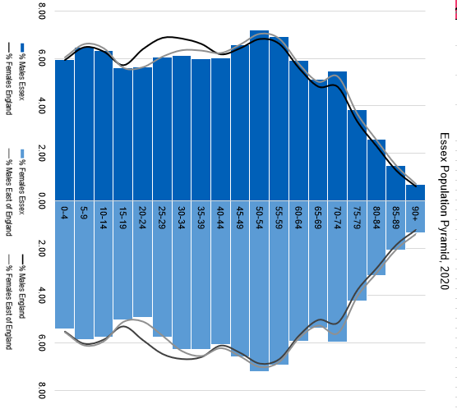

The population in Essex is projected to increase over the next 3, 5 and 10 years. Compared to 2020 mid-year estimates, ONS project that the total population size of Essex is going to increase by 1.9% to 1,526,137 people in 2023, by 3.0% to 1,542,867 in 2025, and by 5.5% to 1,580,618 in 2030. The older age groups especially from 75+ years are projected to see largest increases, along with some younger groups.

The figure below shows the Essex projected population change by age (%):

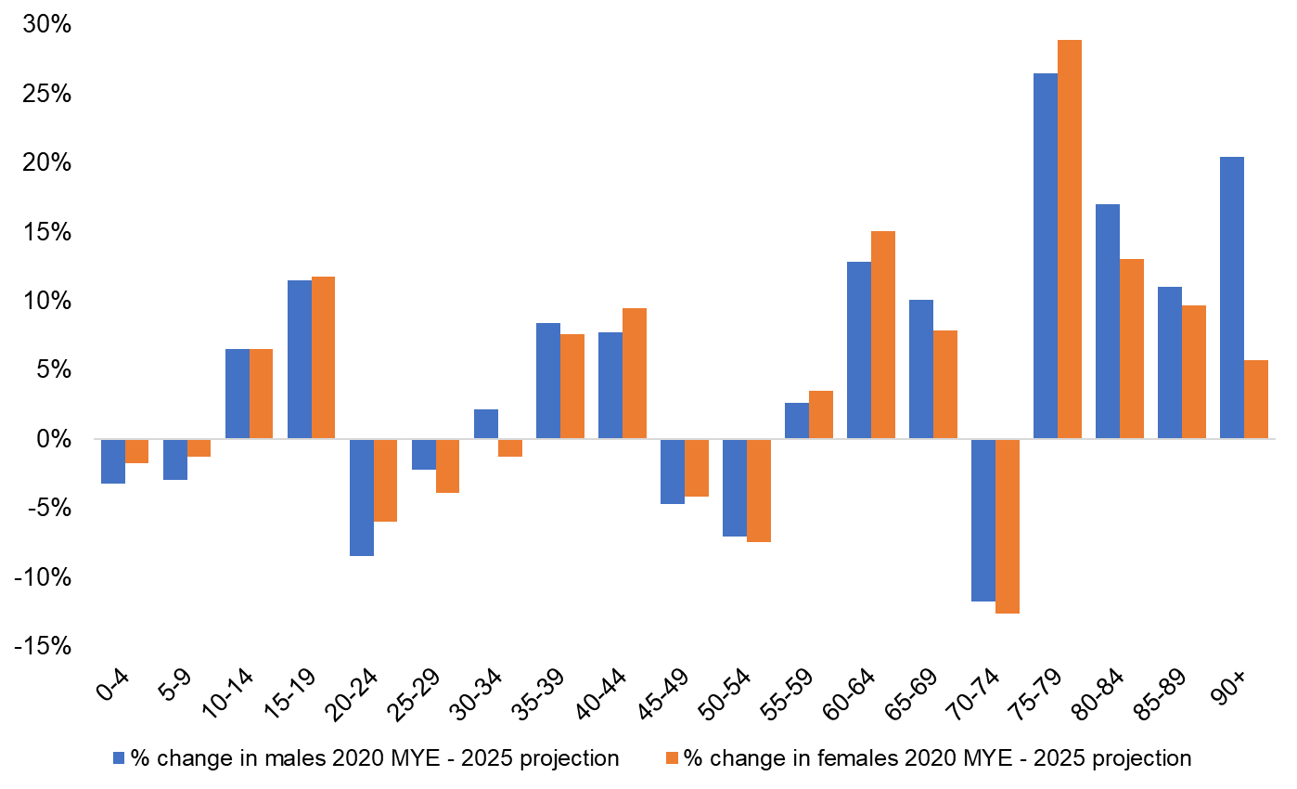

The table below provides the population current count and projections underlying this above chart:

Age Group | 2020 | 2023 | 2025 | 2030
0-4 | 84837 | 82385 | 82697 | 83113
5-9 | 92124 | 92131 | 90107 | 87755
10-14 | 90276 | 94810 | 96138 | 93372
15-19 | 79454 | 84750 | 88673 | 94175
20-24 | 78948 | 73555 | 73176 | 82185
25-29 | 88365 | 87368 | 85633 | 80815
30-34 | 92900 | 94127 | 93238 | 89743
35-39 | 91819 | 96364 | 99109 | 98849
40-44 | 90336 | 96541 | 98108 | 103993
45-49 | 98391 | 92291 | 94042 | 101512
50-54 | 107953 | 104186 | 100079 | 95980
55-59 | 103809 | 107336 | 106961 | 99688
60-64 | 88635 | 96006 | 100985 | 104450
65-69 | 78623 | 82165 | 85621 | 97967
70-74 | 85587 | 76599 | 75106 | 81800
75-79 | 60382 | 75619 | 77149 | 68198
80-84 | 43210 | 44976 | 49592 | 63497
85-89 | 26796 | 28558 | 29531 | 34490
90+ | 15314 | 16370 | 16924 | 19037
Total Population | 1497759 | 1526137 | 1542867 | 1580618

Birth Rate

Fertility Rate

General Fertility rate Essex – per 1,000 female population

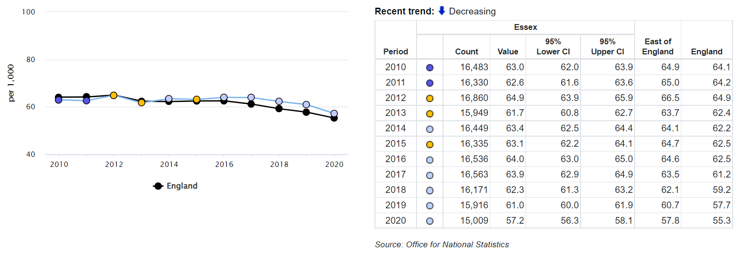

      - The birth rate per 1,000 female population aged 15 to 44 years in Essex for 2020 was 57.2. Essex has generally trended below or similar to the average for the region but has in recent years fallen at a slower rate than the National average, meaning Essex has been higher than the National average for general fertility rate since 2016.

Ethnicity

Essex local authority populations by ethnic group
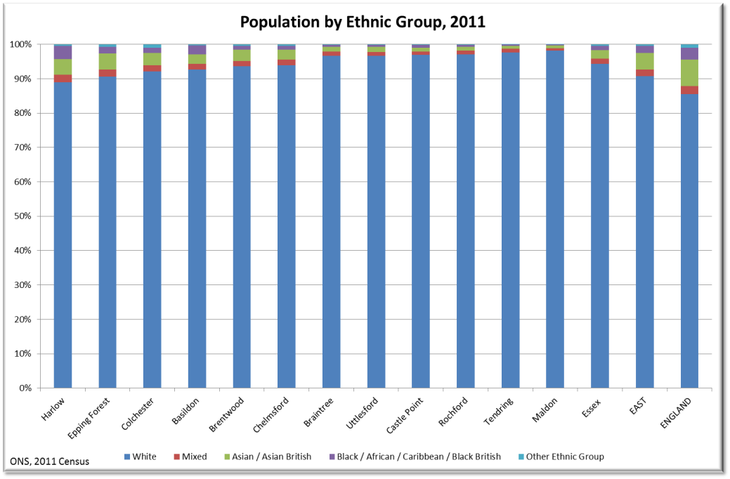

The population of Essex is less ethnically diverse than the Eastern region and England. The Black and Minority Ethnic (BME) population constitutes around 5.7 % of the people living in Essex compared to 9.2 and 14.5 % in the Eastern region and England respectively. The highest proportion of BMEs live in Harlow (11%) and the lowest proportion in Maldon (2%).

      - Essex has become more diverse with the areas closest to London and the largest towns having the highest concentrations of people from BME groups.
      - The 2011 census reported the highest concentration of ethnic minorities (including white other, Irish and traveller) is in the young population, specifically people aged 0 to 24 (4 %) and 25 to 49 (5 %).
      - Essex has a significant gypsy and traveller community; this population group tend towards unhealthy lifestyles and about 50 % live with long term conditions which could be supported by services available from pharmacies.
      - There are 11 permanent sites across Essex for the gypsy and traveller community. There are currently in place a range of services available to the gypsy and traveller community including both adult and child education services and local health services; however, it has long been recognised that engagement with these communities is challenging and more work is needed to promote better health and social care outcomes. It is becoming more customary for gypsy and travelling families to live in more formal style of housing.
      - Some ethnic populations have increased health problems in certain disease areas, e.g., south East Asians; have an increased risk of diabetes whereas ethnic populations with fairer skin are more likely to suffer from skin cancer.
      - Community pharmacies located within areas where there are large population of a certain ethnic groups should be encouraged to provide services

such as signposting and healthy lifestyle advice that are targeted to achieve improved health outcomes in those populations.

Religion

Essex local authority populations by religion
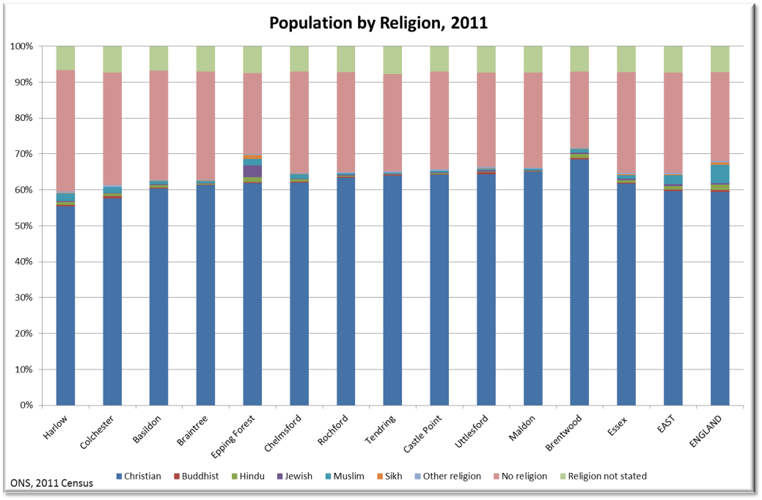

    - The majority of the Essex population declare their religion to be Christian (62 %) with a further third of the population not stating or declaring ‘no religious belief’. The remaining 3 % of the population stating another religion is slightly lower than the Eastern region 5 % and the national 8.7 %. The two largest religious groups by local authority are found in Harlow, 2.1 % Muslim and 3.2 % Jewish in Epping Forest.

Protected Characteristics

    - The above demographic areas (age, sex, pregnancy, ethnicity and religious belief) form part of the ‘protected characteristics’ which are safe-guarded in law against discrimination. The full list includes:

Age

Sex

Being pregnant or having a child

Race including colour, nationality, ethnic or national origin

Religion, belief or lack of religion/belief

Being or becoming a transsexual person

Being married or in a civil partnership

Disability

Sexual orientation

      - Certain groups within and across these characteristics have an increased risk of discrimination and social exclusion, which can lead to poor health and social care outcomes.
      - Whilst data on some of these protected characteristics is available and presented in this PNA, not all areas have good quality local coverage. However, for those groups not explored in detail, no specific pharmaceutical needs have been identified and all available and planned services are deemed accessible to these groups and their needs can be met by provision of necessary services.

  - Deprivation

5.2.1 The Index of Multiple Deprivation (IMD)
The Index of Multiple Deprivation (IMD) is the official overall measure of relative deprivation experienced by people living in an area in England. It follows an established methodological framework in broadly defining deprivation to encompass a wide range of an individual’s living conditions. It is based on 39 separate indicators, organized across seven distinct domains of deprivation, such as income, housing, employment, crime and environment, as shown in figure X below.
These are combined and weighted to calculate the IMD, calculated for every for every Lower-layer Super Output Area (LSOA)*, or neighbourhood, in England. This is a relative measure of deprivation rather than an absolute scale, so a neighbourhood ranked 100th is more deprived than a neighbourhood ranked 200th, but this does not mean that it is twice as deprived.
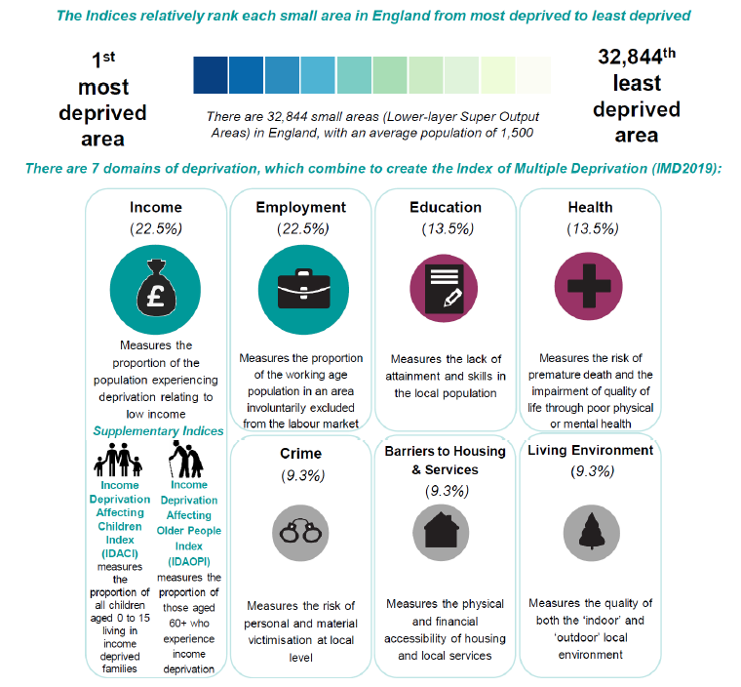

*A LSOA is a small geographical area for the reporting of small area statistics, developed by the Office for National Statistics. They comprise on average of 1,500 residents or 650 households.

Essex has some of the least deprived and some of the most deprived areas in the country. Essex has 75 (out of 872) of its’ LSOAs that are among the top 20% most deprived areas nationally, and 225 of its’ LSOA among the top 20% least deprived areas nationally. The most deprived areas in Essex tend to be more focused in and around the larger towns, in condensed pockets and these are most common in Tendring (27 LSOAs), Basildon (26 LSOAs) and Colchester (11 LSOAs).

An area located in Tendring (in Jaywick; LSOA name: Tendring 018A) has been identified as the topmost deprived community across the whole of England. Tendring also has another LSOA (in Clacton-on-Sea; LSOA name: Tendring 016B) that has been identified as the 14th most deprived community across England.

The districts Uttlesford, Brentwood, Rochford and Chelmsford are considered less deprived, with, for example, 44 of the LSOAs in Chelmsford among 10% least deprived areas nationally.

The figure below shows the population count and percentage living in the top 20% most deprived and top 20% least deprived areas nationally.

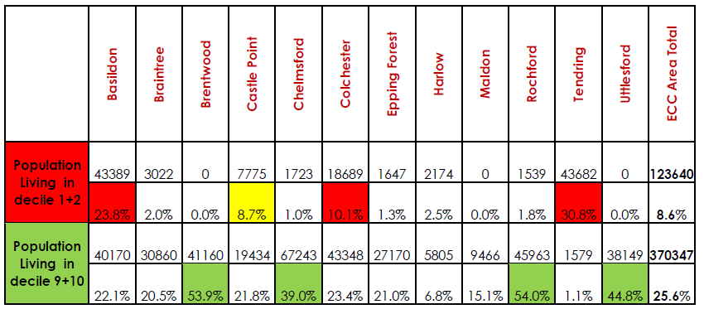

5.2.3 Many of the most deprived areas also experience the lowest levels of life expectancy, higher premature mortality rates, poor educational achievements including reaching a good level of development at reception, higher levels of teenage pregnancy, poor housing (including overcrowding and fuel poverty i.e. high proportional spending on heating their accommodation), and generally higher levels of social and health care needs, with for example higher prevalence of long term conditions than areas less deprived. More information can be explored in the Health Inequalities and Covid-19 Report Health Inequalities and COVID-19 – Essex Open Data and in the JSNA.

Figure of Indices of Multiple Deprivation (2019) across Essex
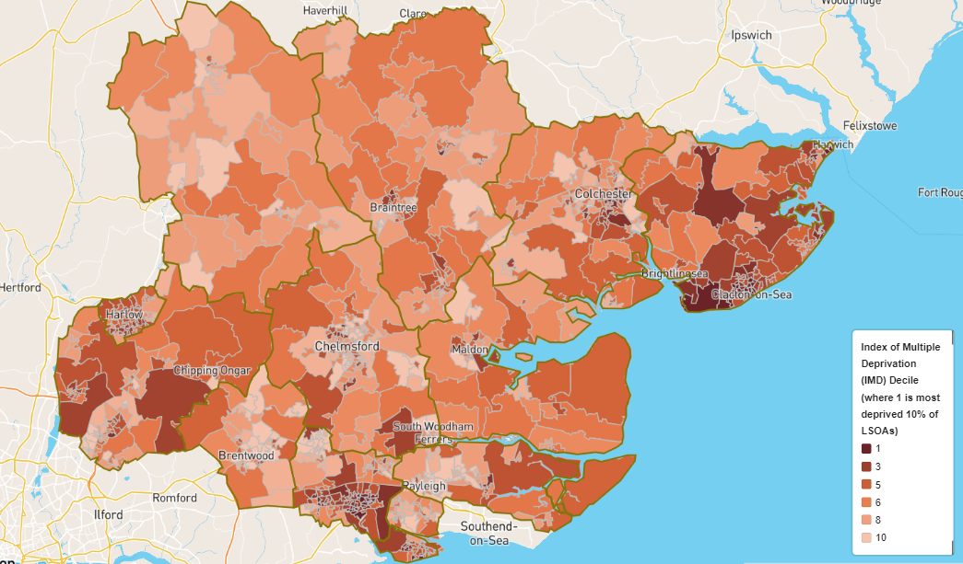

5.2.4 Figure above shows areas of Essex divided by deprivation deciles from those in the most deprived areas (dark orange) to those in the least deprived areas (light orange). The places experiencing the greatest levels of deprivation include the Tendring, Basildon and Harlow districts. The least deprivation is experienced in Uttlesford, Brentwood, Chelmsford and Rochford.
Figure of Income deprivation affecting children across the Essex area (2019)
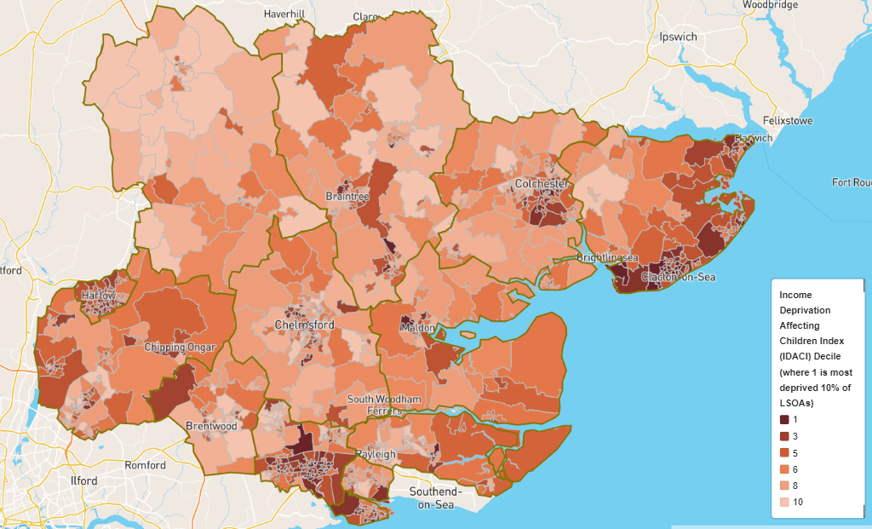

5.2.5 Figure above displays areas in dark orange which have the greatest proportion of children aged 0-15 years old living in households which are deemed to have low incomes. The map shows that the areas with the highest concentration of children living in income deprived households are around Tendring and Basildon.

Figure of Income deprivation affecting older people across the Essex area (2019)

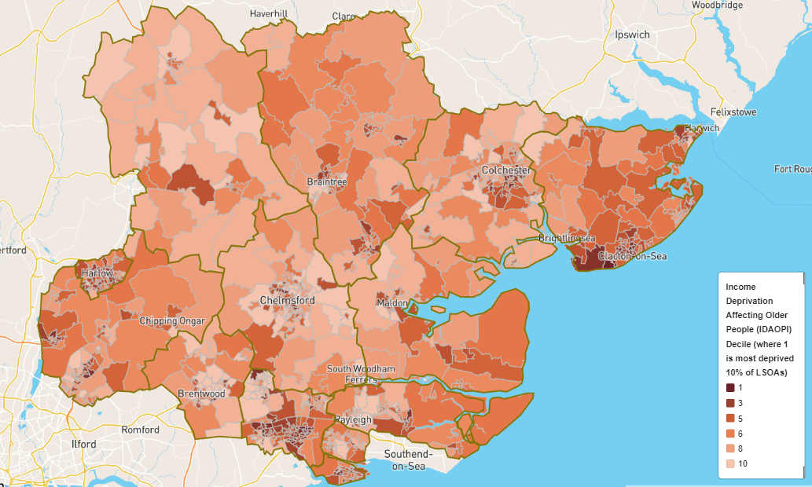

5.2.6 Figure above shows older people who are living in households who are experiencing income deprivation. Again, the highest concentration of low income older people can be found in Basildon and Tendring.
    - There is a correlation between higher prevalence of long-term conditions and health inequalities (the unfair or avoidable differences in health status or health determinates between population groups). Access to community pharmacies within deprived communities is important to support their health needs. Commissioners can target specific disease areas particularly focusing in the areas of highest health need which generally follow the pattern of deprivation. Pharmacies in these areas should actively seek to promote health improvement and relevant services.

  - Lifestyles

5.3.1 Physical Activity

5.3.1.1 Physical activity can contribute significantly to people’s general physical health and wellbeing, reducing the risk of premature death from heart attacks, stroke and diabetes and improves mental health, reduces the risk of falls and protecting people from becoming overweight and obese.
      - The ability to keep active and independent depends greatly on mobility. Mobility can be seriously limited because of age, by the effects of falls and physical inactivity.

Figure of Health benefiting physical activity levels by Essex local authority area
Percentage of adults doing 150+ minutes physical activity per week – 2020/21

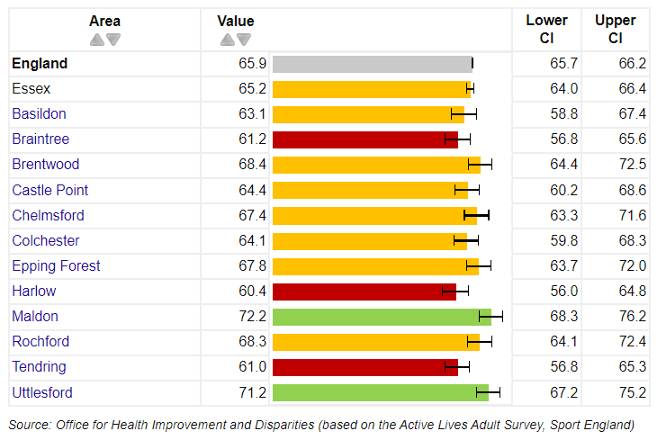
      - Whilst the percentage of adults in Essex meeting the recommended levels to benefit their health (150 minutes of moderate intensity physical activity per week) is just below the national average at 65.2%, there is some variation amongst the districts in Essex. Braintree, Harlow and Tendring districts have physical activity levels that are statistically significantly lower than the national average with 61.2%, 60.4% and 61% respectively. The Maldon and Uttlesford districts have a statistically significantly greater percentage of physically active adults than the national average at 72.2% and 71.2%.

    - Nutrition, Diet and Obesity

Diet and nutrition are key contributors to the prevention of chronic ill health and to some extent social exclusion. The challenge of tackling obesity (increasing in prevalence) and associated chronic diseases means looking at this issue before the child is born right through to old age. A health, balance diet that includes fruits and vegetables, can contribute to reducing the risk of cardiovascular disease (CVD), obesity and some cancers.

Figure of Excess weight adults by Essex local authority area
Percentage of adults classified as overweight or obese (18+) - 2020/21

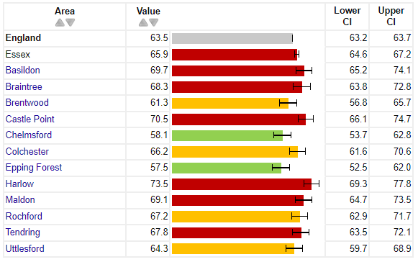
      - In 2020/21 65.9% of adults were classed as overweight or obese which is statistically significantly greater than that of the national average of 63.5%. Half of the districts in Essex are also statistically greater than the national average, with Chelmsford and Epping Forest statistically significantly lower at 58.1% and 57.5%.

    - Sexual health

      - Unprotected sex can lead to sexually transmitted diseases (STIs), unwanted pregnancy and preventable terminations. The health and social consequences associated with contracting STIs, such as human immunodeficiency virus (HIV), are enormous to the individual, their relatives and the health economy. HIV sufferers can feel excluded, and people are often so worried about stigmatisation that they avoid checking whether they may have contracted a STI following unprotected sex.
      - 42.4% of people diagnosed with HIV in England are diagnosed late; this figure decreases to 37.3% in Essex. Tendring (62.5%), Rochford, Maldon and Epping Forest (all 50%) have significantly higher proportion of those with HIV diagnosed late compared to the national average.
Figure X Sexually Transmitted Infections by Essex local authority area
New STI diagnosis rate per 100,000 (aged <25) – 2020 (excluding Chlamydia)
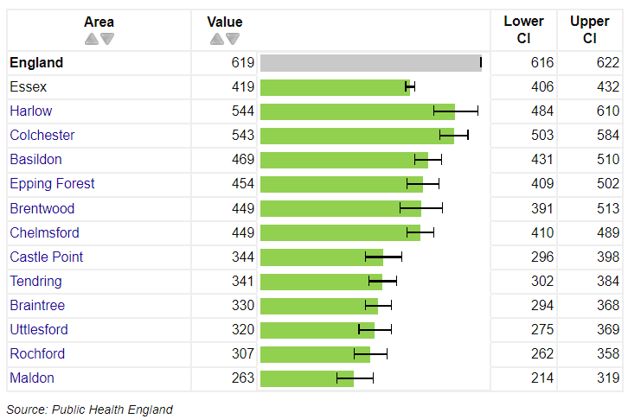
      - Essex and all its districts have an STI diagnosis rate that has been trending lower than the national average. The under 18 conception rates (15-17 year olds) are highest in Basildon (19.9), Tendring (18.5), Harlow (19.4) and Castle Point (15.2), their rates are higher than England.
      - Good contraceptive services can keep the demand for terminations low and reduce the risk of teenage pregnancy.

    - Substance misuse

      - Substance misuse is the continued abuse of substances which has a detrimental effect on a person’s mental and physical health.

Figure of Substance misuse – alcohol related harm by Essex local authority area
Admission episodes for alcohol related conditions (Narrow) – per 100,000

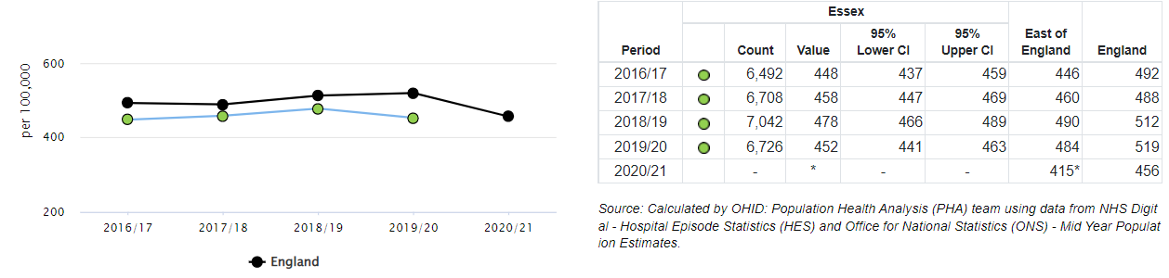
      - Admissions to hospital where the primary diagnosis is an alcohol-attributable code, or a secondary diagnosis is an alcohol-attributable external cause code in Essex are statistically significantly fewer than the national average. Of the districts that had complete data for 2020/21 Harlow and Tendring had admission rates significantly greater than the national average at 749/100,000 and 688/100,000 respectively
      - People who regularly binge drink (women who drink more than 6 units of alcohol a day (or more than 35 units a week) and men who regularly drink more than 8 units a day (or 50 units a week) are at the highest risk of alcohol related harm.
      - This behaviour increases the risk of CVD, cirrhosis, poor mental health, unemployment, accidental injury and death.
      - Women who drink heavily during pregnancy put their baby at risk and consequential disorders can lead to lifelong intellectual and behavioural problems for the child.
      - Early identification and referral of people with a drinking problem is important to slow down these gradual increases in morbidity, especially as it is estimated that only 13.2% of these people access an alcohol treatment programme annually.
      - Essex has introduced “DontBottleitUp” which is a brief intervention tool available to all its residents. “DontBottleItUp” allows you to work out what level of risk you are at as a result of your drinking, to access personalised advice online and, where appropriate, find out where you can get face-to-face support locally.

Figure of Substance misuse – illicit drugs by Essex local authority area
Estimated prevalence of opiate and/or crack cocaine use – per 1,000 – 2016/17
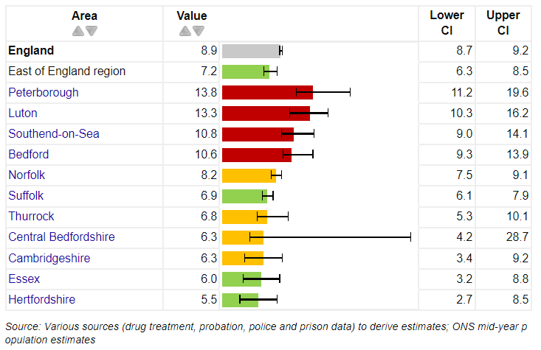
      - Use of Illicit drugs in Essex, as measured by opiate and crack cocaine, is lower than the national average, at 6 per 1,000 of the 15–64-year-old population it ranks as 2nd lowest in the region.
      - People with drug misuse problems are more likely to live in and be from more deprived communities and are likely to concentrate (especially for illicit substance users) in conurbations (e.g., Clacton, Basildon) where drugs and the means to pay for them are more readily available.
      - They are also more likely to be experiencing a range of health and social care related issues and will be linked to a number of services such as Mental Health, Primary Care and other non-medical service provision.

    - Smoking
      - Smoking is the UK’s single greatest cause of preventable illness and early death.
Figure of Adult smoking prevalence by Essex local authority area
Smoking Prevalence in adults (18+) - current smokers (GPPS) 2019/20 – Proportion %
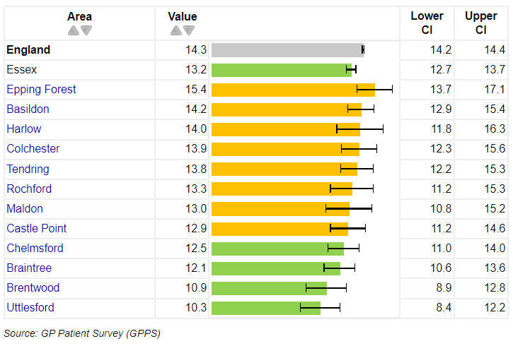

      - The GP Patient survey (2019/20) recorded 13.2% of Essex resident responders as current smokers which is lower than the national average. The majority of the districts in Essex also have rates lower than England. However, Harlow, Basildon and Harlow all have similar or greater levels of current smokers. It is important to consider these results in the context of these figures being based on survey responses e.g., the number of responses received per district.
      - Smoking in pregnancy is associated with poor pregnancy outcomes, and exposure of infants to second-hand smoke is associated with death in infancy. Smoking is more common in more deprived women. The variation in smoking habits in pregnancy between socioeconomic groups accounts for about one third of the difference in stillbirth rates and infant mortality rates.
      - The smoking cessation services from pharmacies provide one to one support and advice to people who want to give up smoking. The pharmacy service helps to increase choice and improve access to NHS Stop Smoking Services.
      - The pharmacy facilitates access to, and where appropriate, supply of pharmacological and non-pharmacological stop smoking aids. This includes supply of nicotine replacement products.
    - Lifestyles and the PNA

      - Lifestyle factors have a recognised effect on health. Smoking, drinking at harmful levels and obesity can all lead to long term conditions. Community pharmacy is well placed to provide accessible screening services, support patients at earlier stages and provide interventions that will reduce the burden of these conditions on the person and health and social care services.
      - Pre-birth to five are considered key developmental years for a child’s health and wellbeing habits and foundations. Parental and in particular maternal characteristics and behaviour during pre-conception, the antenatal period and post birth play key roles in the child’s development alongside the general wider determinants of health such as family income, access to health care interventions such as immunisations and access to early education.
      - A number of national screening and assessment programmes are in place to support the early identification of health and social care needs. In the past 2 to 3 years a number of new schemes have been implemented across Essex which will specifically target risk factors associated with health inequalities.
      - Essex County Council commissions a local Health Check programme (NHS Health check), primarily through GP services. This programme helps identify people at risk of conditions, such as diabetes and CVD but will also help identify those who need to be encouraged to lead a healthier lifestyle. In areas, where uptake to the checks has been low, especially with hard-to-reach groups, external providers have been commissioned including community pharmacies.
      - A more comprehensive alcohol pathway is being developed across Essex to ensure that we can identify people who are dependent drinkers as well as consuming harmful levels of alcohol and signpost them to services to help them. The “DontBottleitUp” service is available across Essex, with additional liaison nurses based in acute hospitals to provide timely assessment of people at risk of alcohol abuse.
      - Implementing broad lifestyle interventions aimed at supporting people to make healthier choices is important in tackling the gap in health inequalities.
      - Targeted social marketing is used to improve health and social wellbeing and reduce stigma (e.g., promoting the uptake of Chlamydia screening is helping to de-stigmatise perceptions about STIs).
      - The use of marketing has helped improve flu and childhood immunisation rates. There is also an Essex wide website, via Facebook, to promote health and wellbeing and to signpost people to relevant services. Pharmacies can enhance these community-based interventions in their daily contact with the local population as part of their essential pharmacy contract.
      - Early interventions with medicines and their appropriate use for those patients diagnosed with long term conditions can also prevent further deterioration.
      - A number of well-established national public health strategies are in place for the surveillance, prevention and control of infectious diseases. Currently of particular interest in infectious disease control, are the threat of COVID-19 pandemic, Influenza, hospital acquired infections (such as MRSA), the increase in Blood Borne diseases (such as Hepatitis B/C and HIV) and the increase of certain infections (for example, Tuberculosis and Measles).
      - Preventing the spread of these diseases is of paramount importance as the outcome of contracting them may shorten life.
      - A number of immunisation programmes are in place to ensure that the population acquire a good level of immunity from childhood into older age.
      - The provision of targeted specialist services, Hepatitis B/C vaccination via drug services and the Needle and Syringe Programme (NSP), is helping to prevent the spread of Blood Borne Viruses (BBV).
      - Community pharmacies in Essex provide a range of services which support the prevention and improved management of long term conditions. These include:
- Health promotion advice. Pharmacies are ideally placed to support local campaigns to deliver healthy lifestyle messages. The pharmacy contract also requires pharmacies to participate in up to 6 Public Health campaigns annually.
- Targeted medicines reviews. These can promote adherence with the prescribed medication regimen. This helps to improve outcomes for patients.
- Smoking cessation services
- Sexual Health services
- Substance misuse services
- Some pharmacies provide a range of screening tests including cholesterol testing and measuring blood pressure as non-NHS services
- Some pharmacies provide NHS Health Checks. The benefits of using pharmacy as a provider include choice and accessibility for patients and additional capacity to support the delivery of the mandatory Public Health programme as commissioned by local authorities.

  - Education

5.4.1 GCSE attainment
Figure of GCSE Attainment by Essex local authority area
District level variation in the percentage of children achieving 9-4 in English and Maths at GCSE
 | % achieving 9-4 in English & Maths (KS4)
 | 2017 | 2018 | 2019
Basildon | 60.7 | 59.2 | 57.5
Braintree | 61.6 | 60.9 | 59.3
Brentwood | 78.5 | 75.9 | 73.7
Castle Point | 63.1 | 62.3 | 62.5
Chelmsford | 71.9 | 71.7 | 69.7
Colchester | 68.4 | 66.4 | 70.9
Epping Forest | 67.2 | 67.4 | 67.4
Harlow | 57.8 | 58.4 | 52.9
Maldon | 55.2 | 58.7 | 57.8
Rochford | 69.3 | 60.5 | 65.0
Tendring | 52.0 | 47.8 | 51.5
Uttlesford | 72.9 | 69.2 | 73.5

      - The percentage of pupils achieving 9-4 in English and Maths at GSCE was lowest in Tendring in 2019 at 51.5%, although this was an increase on the levels in 2018. The highest attainment levels were in Brentwood at 73.7%. Looking at improvements from 2018 to 2019 attainment levels we see that only 5 districts achieved this, Castle Point, Colchester, Rochford, Tendring and Uttlesford, whilst Epping Forest remained the same at 67.4%.

More information on education and skills across Essex can be explored in the latest Joint Strategic Needs Assessment products available on https://data.essex.gov.uk/

5.5 Employment

5.5.1 Unemployment
Figure of Residents claiming Jobseeker’s Allowance or Universal Credit Essex local authority area
Proportion of residents aged 16-64 claiming Jobseeker’s Allowance or Universal Credit by district (March 2022)

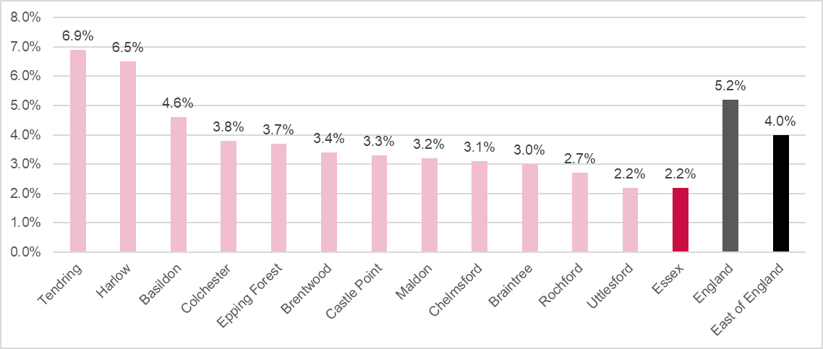

    - In March 2022, the proportion of working-age residents in Essex receiving employment support stood at 2.2% (29,590), slightly below the East of England figure of 4% and below the England average of 5.2%. The proportion of working-age residents receiving employment support was above the England average in two areas within Essex: Harlow (6.5%) and Tendring (6.9%). Basildon and Tendring represent the areas with the highest number of claimants at 4,570 and 4,025 respectively.

      - Socioeconomic groups

NOMIS provides further information on employment with the ‘Standard Occupational Classification SOC 2010’, within this it shows that the overall majority of people in Essex (47.5% or 348,200 people) are employed in the SOC Major Group 1-3, which are occupations classified as Managers, Directors and Senior officials, or Professional occupations or Associate Professional &Technical. This is slightly lower than East of England (48.2%) and England (50.2%). The smallest proportion of people in Essex work in SOC Major Group 8-9 (14.3% or 104,900 people), these are Process Plant & Machine Operative or Elementary Occupations. This is lower than is seen in East of England (14.8%) and England (15%).

More information on employment across Essex can be explored in the latest Joint Strategic Needs Assessment products available on https://data.essex.gov.uk/

  - Housing

5.6.1 Fuel poverty
The Low Income Low Energy Efficiency (LILEE) indicator considers a household to be fuel poor if:
- it is living in a property with an energy efficiency rating of band D, E, F or G; and
- its disposable income (income after housing costs and energy needs) would be below the poverty line (defined as an equivalised disposable income of less than 60% of the national median).

Figure of Fuel Poverty by Essex local authority area
Proportion of fuel poor households by district (2019)

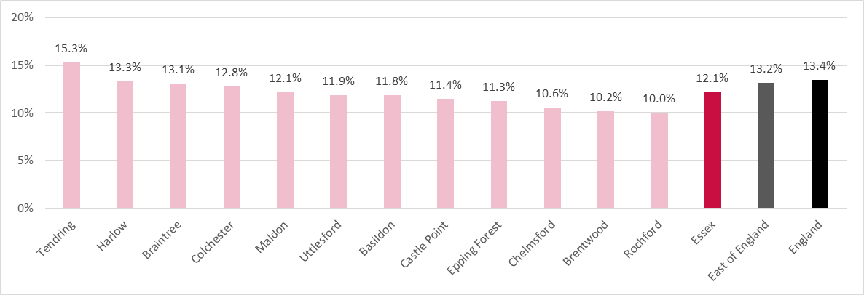

      - Although the proportion of fuel poor households in Essex (12.1%) falls below the regional and national averages of 13.2% and 13.4%, 76,236 households in Essex were estimated to be in fuel poverty (based on 2019 data).
      - Across Essex districts the proportion of households classified as fuel poor ranges from 10.0% in Rochford to 15.3% in Tendring.

    - Homelessness
Figure of Homelessness by Essex local authority area
Homelessness: Households in temporary accommodation rate per 1,000 households 2020/21
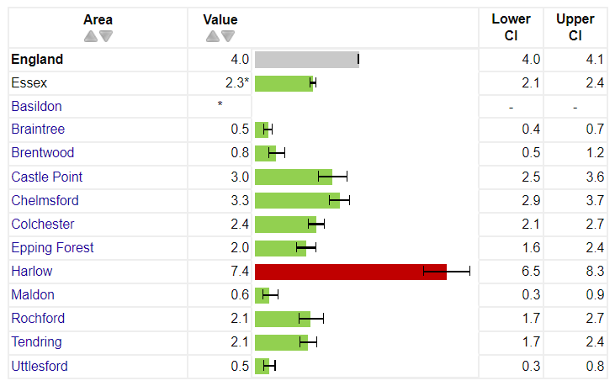

      - Essex has a rate of homelessness that is lower than the national average at 2.3 per 1,000. However, there is variation amongst the districts in Essex with Harlow experiencing statistically greater rates than the national average at 7.4 per 1,000. Compared with Braintree and Uttlesford who are experiencing the lowest rate at 0.5 per 1,000.

More information on housing across Essex can be explored in the latest Joint Strategic Needs Assessment products available on https://data.essex.gov.uk/

  - Transport

5.7.1 Car ownership
Figure of Households with no cars or vans by Essex local authority area
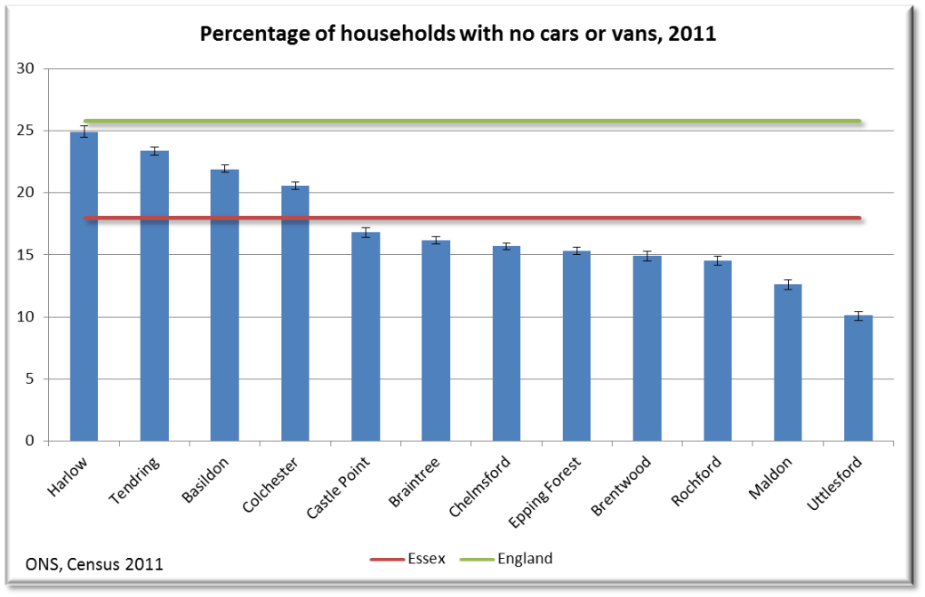
      - Harlow has the largest proportion of households which do not have a car or van (25 %), which is significantly greater than the other Essex areas. Uttlesford has the fewest ‘carless’ households, with only 10 % not having a car or van.
      - Harlow is the smallest Essex local authority in geographical terms, residents may rely more on other forms of transport to access local services.
      - The Tendring district has the second largest percentage of households without a car or van (23 %), with Tendring being a largely rural district area this may cause problems with accessing services. The Essex average at 18 % of households is lower than the national percentage of 26 %.

    - Access to Services and Transport
      - Access to services, regardless of the purpose (e.g., to work, hospital, educational establishment, recreational activities), is closely linked to transportation. The chosen modes of travel (walking, cycling or motorised) can vary according to people’s means (can they afford a car or bus fare), their personal mobility (are they able to walk or cycle) and the availability of public or alternative transport. It is also important to note that lack of transport may not always be a factor in addressing inequity in access to services, as issues such as homelessness and lack of information also have an effect.

    - Impact on Community Health and Wellbeing
      - People have become more dependent on the use of private cars for their journeys, including short ones, instead of walking or cycling to their chosen destination, thus contributing to a reduction in physical activity.
      - Transport links have an effect on access to healthcare.
      - For people that have problems with access to reliable transport, some community pharmacies provide a voluntary delivery services and distance selling pharmacies increase choice and access for patients.
      - It has been shown that there is access to a pharmacy or dispensing doctor within 20 minutes of a car drive across Essex. Most journeys to a pharmacy take significantly less than 20 minutes.
      - From the patient/resident survey, 50 % of responses said they travelled to their pharmacy by car, 45 % on foot, 3 % by public transport and 1 % by bicycle.
      - 90 % of the responses travelled less than 2 miles to their pharmacy on their last visit and 95 % felt this travel distance was reasonable.

  - Health

    - Life expectancy
      - Data on years of life lost show that for males the main causes of premature death are coronary heart disease, lung cancer and stroke and for females it is breast cancer, lung cancer and coronary heart disease.
Figure of Trend in life expectancy from birth, males
Life expectancy at birth - Essex
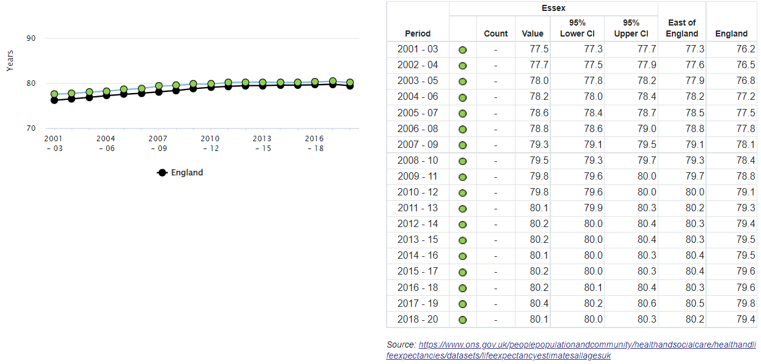

Figure X Trend in life expectancy from birth, females
Life expectancy at birth - Essex
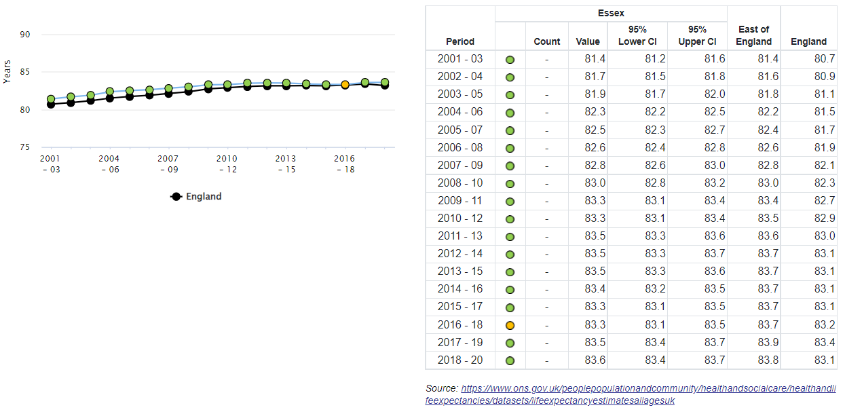

      - Overall, life expectancy for males in Essex had been slightly increasing until 2018-20, which saw a small decrease, likely to be influenced mainly by 2020 and Covid-19. Whilst remaining above the national average but just below the regional average. Life expectancy for females has increased steadily and was above the national average and slightly below the region in 2018-20. For both males and females Tendring has the worst life expectancy in Essex at 78.2 and 82 years respectively. The greatest life expectancy for both males and females is seen for residents of Uttlesford at 82.6 years and 85.4 years respectively.

    - Disability

Figure of Disability-free life expectancy at birth, males
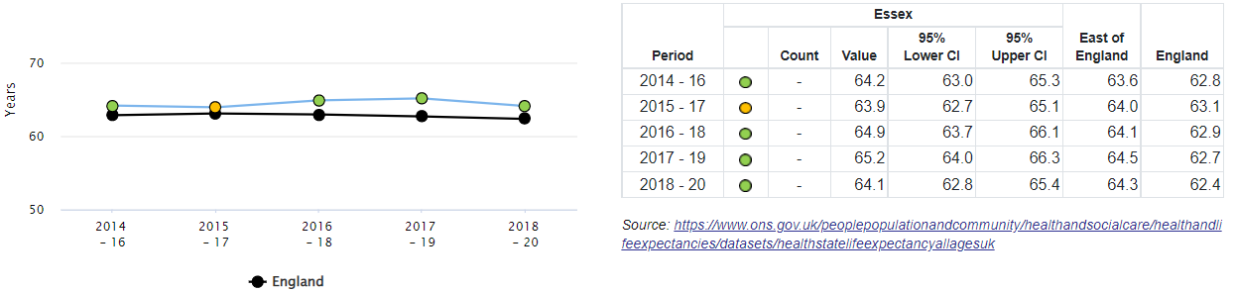

Figure of Disability-free life expectancy at birth, females
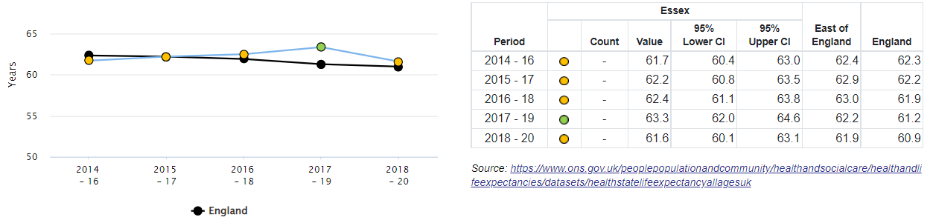

      - The average numbers of years from birth that people in Essex could expect to live without a long lasting, physical or mental health condition that limits daily activities had been steadily increasing for both males and females, however both saw decreases in the latest time period 2018-20, although both remain above the national level, but just below the region.

    - Carers

      - Pharmacies must comply with the Equality Act 2010. Support for patients can include, amongst other interventions, large print labels on medicines, provision of easy open containers and reminder charts to take medicines.

Figure of Provision of unpaid care
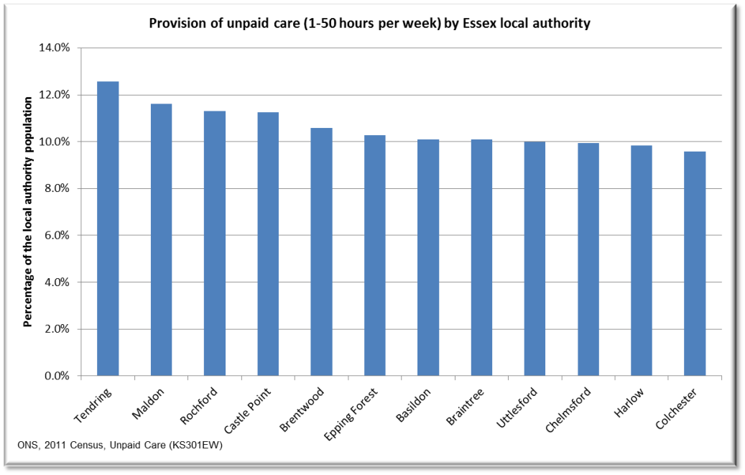

      - Tendring district has the highest proportion of its residents providing unpaid care (care provided to family members, friends, neighbours or others who are disabled, elderly or have long-term health problems, excludes general childcare), 13 %. This compares to just under 10 % for Colchester and Harlow. Across the Essex area around 7 % of the population provide 1 to 19 hours per week of unpaid care, ranging from 2 % in some communities up to 12 %. For those providing 50 or more hours per week the average across Essex is 2 % with a range of 0-8 %.

    - Disease prevalence
      - It is important that pharmacists can recognise symptoms of a notifiable disease in order to appropriately refer patients who may present for advice and treatment.
      - They should understand how an outbreak is being managed to be able to offer appropriate advice and reassurance to the public.
      - Community pharmacies provide services which are easy to get to and are accessible in terms of location, opening hours and waiting times, this mean that people will be more likely to attend.
      - Most pharmacies across Essex provide sexual health services and many are providing vaccinations contributing to health protection outcomes.

Meeting the needs of specific populations
Table Supporting the needs of specific populations
Protected Characteristic | How pharmacy can support the specific population
Age | - Age has an influence on which medicine and method of delivery is prescribed.  - Older people have a higher prevalence of illness and take many medicines. The medicines management of older people is complicated by multiple disease, complex medication regimes and the aging process affecting the body’s capacity to metabolise and eliminate medicines from it.  - Community pharmacies can support people to live independently by supporting optimisation of use of medicines, support with ordering, re-ordering medicines, home delivery to the housebound and appropriate provision of multi-compartment compliance aids and other interventions such as reminder charts to help people to take their medicines.  - Supporting independence by offering:  - Reablement services following discharge from hospital  - Falls assessments  - Supply of daily living aids  - Identifying emerging problems with people’s health  - Signposting to additional support and resources  - Younger people similarly have different abilities to metabolise and eliminate medicines from their bodies.  - Advice can be given to parents on the optimal way to use the medicine and appliance and provide explanations on the variety of ways available to deliver medicines.  - Pharmacy staff provide broader advice when appropriate to the patient or carer on the medicine, for example its possible side effects and significant interactions with other substances.  - The safe use of medicines for children and older people is one where pharmacies play an essential role.
Disability | - Pharmacies deliver services in line with the Equality Act 2010.  - It is recognised that there may be a variety of reasons why people are unable to take their medicines, including both physical and mental impairment.  - Each pharmacy should have a robust system for assessment and auxiliary aid supply that adheres to clinical governance principles.  - Availability of large print labels, hearing loop, supply of original packs with braille are all examples of support that can be available where appropriate.
Gender | - It is recognised that men are often less likely to access healthcare services. Community pharmacies are ideally placed for self-care by providing advice and support for people to derive maximum benefit from caring for themselves or their families.  - When necessary, the access to advice, provision of over the counter medications and signposting to other services is available as a walk in service without the need for an appointment.  - Community pharmacy is a socially inclusive healthcare service providing a convenient and less formal environment for those who do not choose to access other kinds of health service.
Race | - Language can be a barrier to delivering effective advice on medicines, health promotion and public health interventions.  - There are opportunities to access translation services that should be used when considered necessary.
Religion | - Pharmacies can provide advice to specific religious groups on medicines derived from animal sources and during periods of fasting.
Pregnancy and maternity | - Pharmacies can provide advice to pregnant mothers on medicines and self-care. They have the expertise on advising on which medicines are safe for use in pregnancy and during breast feeding.
Sexual orientation | - No specific needs are identified
Gender reassignment | - Provision of necessary medicines and advice on adherence and side effects
Marriage and civil partnership | - No specific needs are identified

The Assessment

The assessment of pharmaceutical services

The assessment was undertaken with due consideration of the requirements in the NHS (Pharmaceutical and Local Pharmaceutical Services) Regulations 2013, as amended and a variety of data sources.

Pharmaceutical services in Essex
Table Numbers of providers of pharmaceutical services in the Essex HWB area by locality as of May 2022
Locality |  | Type Of Pharmaceutical Contract
 |  | Total Number of Community Pharmacies:  251 across Essex | Dispensing Doctor | Dispensing Appliance Contractor | Distance Selling Pharmacy (7)
 |  | All Pharmacies including 100 Hour
1 | Basildon | 35 | 0 | 0 | 0
2 | Braintree | 22 | 7 | 0 | 0
3 | Brentwood | 13 | 1 | 0 | 1
4 | Castle Point | 18 | 0 | 1 | 0
5 | Chelmsford | 28 | 7 | 1 | 0
6 | Colchester | 32 | 5 | 1 | 1
7 | Epping Forest | 23 | 1 | 0 | 1
8 | Harlow | 16 | 0 | 0 | 2
9 | Maldon | 11 | 7 | 0 | 1
10 | Rochford | 16 | 2 | 1 | 1
11 | Tendring | 29 | 8 | 0 | 0
12 | Uttlesford | 8 | 8 | 1 | 0
TOTAL |  | 251 | 46 | 5 | 6

6.2.1 A full list of community pharmacies providing services under the Regulations across the Essex HWB area is provided in Appendix C.

Dispensing Appliance Contractors (DACs) registered in the Essex HWB area as of May 2022:
      - Fittleworth Medical Limited, D41-42 Moorside Business, Eastgates, Colchester, CO1 2ZF
      - Jade-Euro-Med 14, Hanningfield Ind Est, Old Church Road, East Hanningfield, CM3 8AB
      - Patient Choice Ltd, 102 Main Road, Hockley, SS5 4QS
      - Ward Mobility Limited, 72 Furtherwick Road, Canvey Island, SS8 7AJ
      - Independence Direct, Suite 16, 3rd Floor, Endeavour House, Coopers End Road, Stansted, CM24 1SJ

Distance selling Pharmacies (DSPs) registered in the Essex HWB area as of May 2022:
      - Pills2u Ltd, Unit 3, Church Road, Hockley SS5 6AE
      - Lloyds Pharmacy Healthcare, Unit 4, Scimitar Park, Roydon Road, Harlow CM19 5GU
      - Total Medcare Limited, Unit 1 Knight House, Lenthall Road, Loughton IG10 3UD
      - Medplus Healthcare Limited, Unit 5 Warley Street, Upminster RM14 3PJ
      - Wel Pharm Ltd, 4 Phoenix Court, Hawkins Road, Colchester CO2 8JY
      - Greenway, Promising Healthcare, Unit 78 Greenway Business Centre, Harlow CM19 5QE
      - SimplyMeds Online, Unit K2, Beckingham Business Park, Tolleshunt Major, Maldon CM9 8LZ

A full list of dispensing doctor practices in the HWB area is provided in Appendix D.

Table : Number of dispensing doctor practices in the HWB area by Clinical Commissioning Group (CCG)
Dispensing Doctor Pharmaceutical Provision as of May 2022
Mid Essex | 21
North East Essex | 13
West Essex | 9
Castle Point & Rochford | 2
Basildon & Brentwood | 1

Locality of services

As of May 2022, there are 258 (not including Southend & Thurrock) pharmacies spread across the Essex HWB area (including 7 DSPs), as shown below. A map of pharmacy locations is also provided in each locality section.

Figure X Pharmacy locations across Essex
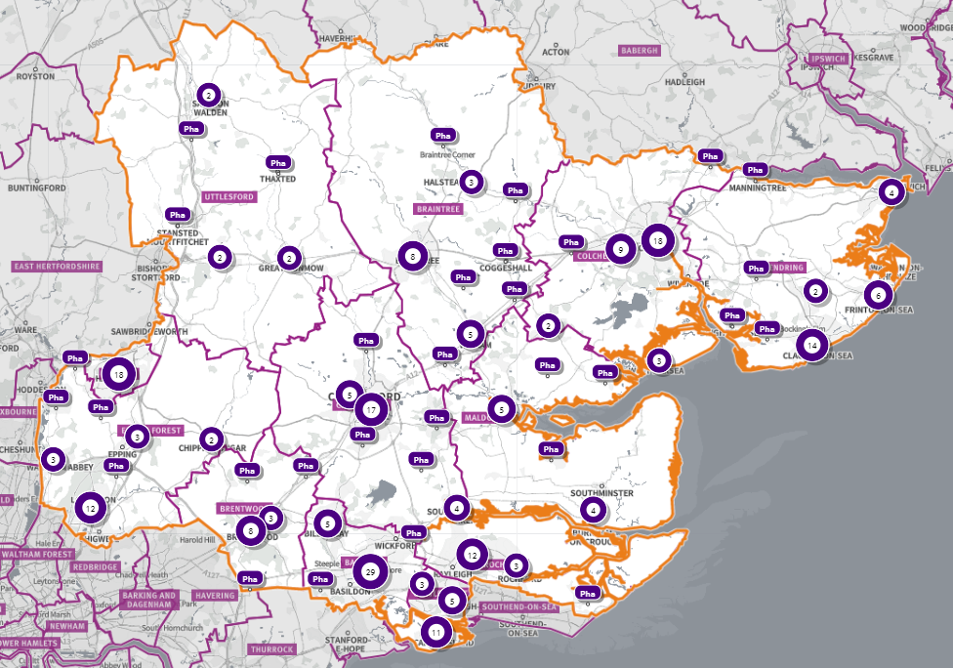
Source: Shape Place Atlas (as at 22/03/22)

With a 1.6km (1 mile) buffer zone: There are 347 pharmacies across Essex within a 1.6km buffer zone as shown in map below:

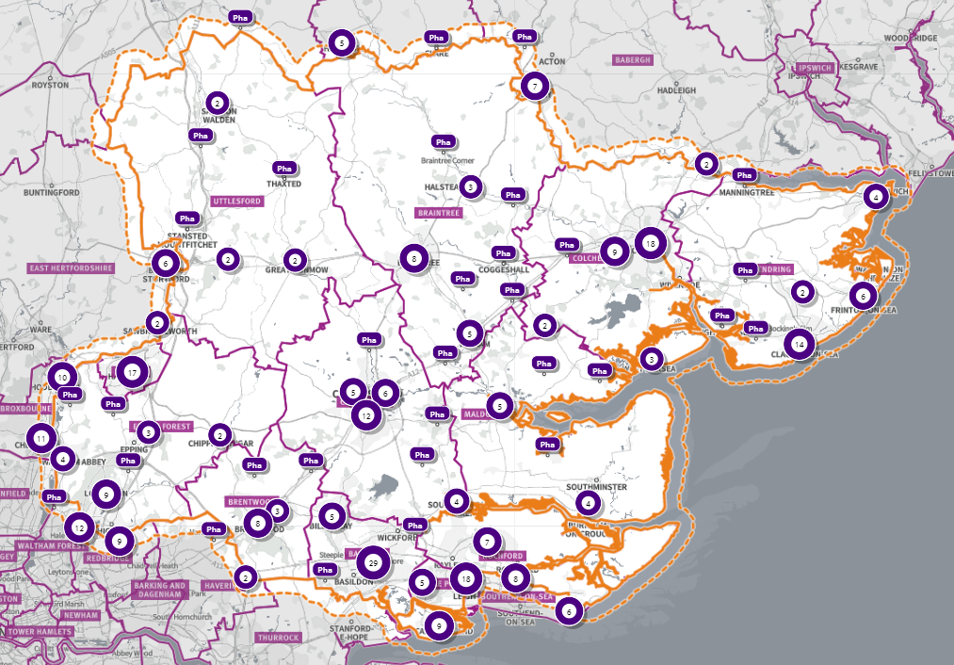
Source: SHAPE Place Atlas (as at 22/03/22)

Analysis from the public survey undertaken (Appendix E) shows that:

96% of respondents usually visit a pharmacy to get medicines on prescription, 65% to buy medicine and 53% to get advice.

With regards to frequency of pharmacy use, the majority of respondents usually visit pharmacies monthly (63%) and during the regular weekday business hours (between 9am and 5pm) (46.5%).

Regarding the services that pharmacies might provide, most respondents are aware of buying over the counter medicine, dispensing medicines on prescription and dispensing services. On the other hand, 85% of participants were not aware of hepatitis testing service, stoma appliance customisation service (87.29%), appliance use review (78%), immediate access to specialist drugs (74%), and needle exchange (68%).

Participants also valued the personal approach established with their friendly pharmacist, particularly the possibility of seeing a specialist face to face.

Regarding the most convenient day to use the pharmacy, respondents seem not to have a preferred day; 62% reported 'no particular day', followed by 'week-day' (Monday to Friday) (27%) and on 'Saturday' (10.2%). Only 1% have chosen 'Sunday' as the most convenient day to use a pharmacy.

Of those replying to the survey, 83% have a reasonable distance to travel to the pharmacy equating to less than 20 minutes, 14% had travelled between 20 and 30 minutes, and 3% had travelled between 30-45 minutes. 61% made the trip by car, and 34% had travelled on foot—only 3% used public transport and 2% a bicycle.

When asked what influenced their choice to visit a pharmacy, 90% of responders reported convenient location, 39.42% the opening hours, and 7% medication reviews. However, when participants were asked to specify the main reasons that influence their choice, the majority reported the reliability and good service of the pharmacy, the quickness in dispensing medications, and friendly customer service.

Essential services – as defined in Chapter 1 of this report.

These are mandatory services within the pharmacy contractual framework and are monitored by the NHS England team. All NHS contracted pharmacy premises must provide these services so they can be used across the county to focus on supporting the local population to reduce health inequalities. Essential services are all considered to be necessary pharmaceutical services for our population.

Travel times

Travel times to services vary depending on urban and rural geographies.

Table shows journey times to key services by mode of travel 2019
Department for Transport statistics
Average minimum travel time¹ to reach the nearest key services by mode of travel, Local Authority, England, 2019
 |  |  |  |  | Minutes
 | Local authority | Average of 8 key services ²
 |  | Public transport / Walking | Cycle | Car | Walking
Region |  | 2019 | 2019 | 2019 | 2019
East | Essex | 19.6 | 18.4 | 11.3 | 33.7
East | Basildon | 15.8 | 13.5 | 9.6 | 24.1
East | Braintree | 23.3 | 21.8 | 12.3 | 39.6
East | Brentwood | 18.5 | 17.6 | 11.3 | 34.1
East | Castle Point | 17.3 | 15.9 | 10.2 | 30.3
East | Chelmsford | 18.2 | 15.9 | 10.7 | 30.6
East | Colchester | 18.7 | 16.7 | 11.3 | 32.6
East | Epping Forest | 20.6 | 16.9 | 11.3 | 34.0
East | Harlow | 13.8 | 11.9 | 9.2 | 18.5
East | Maldon | 27.7 | 29.2 | 14.8 | 50.3
East | Rochford | 17.8 | 15.3 | 10.6 | 30.6
East | Tendring | 21.3 | 24.7 | 12.4 | 38.4
East | Uttlesford | 26.6 | 25.9 | 13.3 | 51.1
- A maximum value of 120 minutes is used where journey times exceed 120 minutes. This means that for some service by mode combinations (particularly for walking and smaller destination sets), the average provided is lower than would actually be the case in reality.2.
- The average of minimum journey times to medium sized centres of employment (500-4999 jobs), primary schools, secondary schools, further education, GPs, hospitals, food stores and town centres.
Changes in journey times over time may result from changes in the number or locations of key service destinations from year to year, or from changes to the road network or to public transport service timetables and coverage. Although a consistent method has been used to produce these statistics, it is also still possible that changes to underlying data sets could affect the results, therefore robust conclusions cannot be made about changes over time.

On average, in England, for those living in rural areas, the minimum travel time to the nearest GP using public transport or walking is 23 minutes, or 42 minutes if the journey were to be walking only.

This compares to 11 minutes and 13 minutes respectively in urban areas. For people in the most isolated rural settings, the minimum journey time is estimated at to be at least 57 minutes.

For the purposes of the PNA assessment analysis was undertaken on access to a community pharmacy by public transport, walking and driving. Travel time maps are shown in Appendix F. Considering the average travel times to key services in table x above, the following measures have been considered:

Average minimum travel time to reach the nearest key services by mode of travel, Local Authority, England, 2019
Transport method | Essex average (minutes) | Longest time (minutes)
Public Transport/walking | 19.6 | 27.7 (Maldon)
Cycle | 18.4 | 29.2 (Maldon)
Car | 11.3 | 14.8 (Maldon)
Walking | 33.7 | 50.3 (Maldon)

A travel time analysis was conducted specifically for pharmacies across Essex, full results are found in the appendix F.

The areas that see some of the longer travel times are relatively not that deprived.

The longest times to travel by whatever method chosen are areas in IMD 2019 Deciles 5 – 7 most frequently, with for example 24% of the Essex population in IMD Decile 6 (among 5th least deprived areas nationally) estimated to be over a 30-minute walk to a pharmacy.

Longer travel times are seen in areas classified as ‘Rural village and dispersed’. For example, 75% of the population in areas of this classification are over a 30-minute walk away and 26% over a 30-minute public transport journey away. Residents living in these areas would have similar travel times to access other key services. Overall, across Essex, generally residents are within a relatively short travel time whichever method is chosen – 99.9% of the Essex population could get to a pharmacy in a 20-minute drive, 95% a 20-minute public transport journey or 83% within a 20-minute walk. Residents have to travel for longer if they walk, 11% over 30-minute walk away.

It is estimated that 1,496,293 (99%) individuals across Essex have access to one of 347 pharmacies across Essex and within a 1.6km buffer zone around Essex within a 20-minute drive. This spans 871 of the LSOAs across Essex, as shown on map x below highlighted in green.

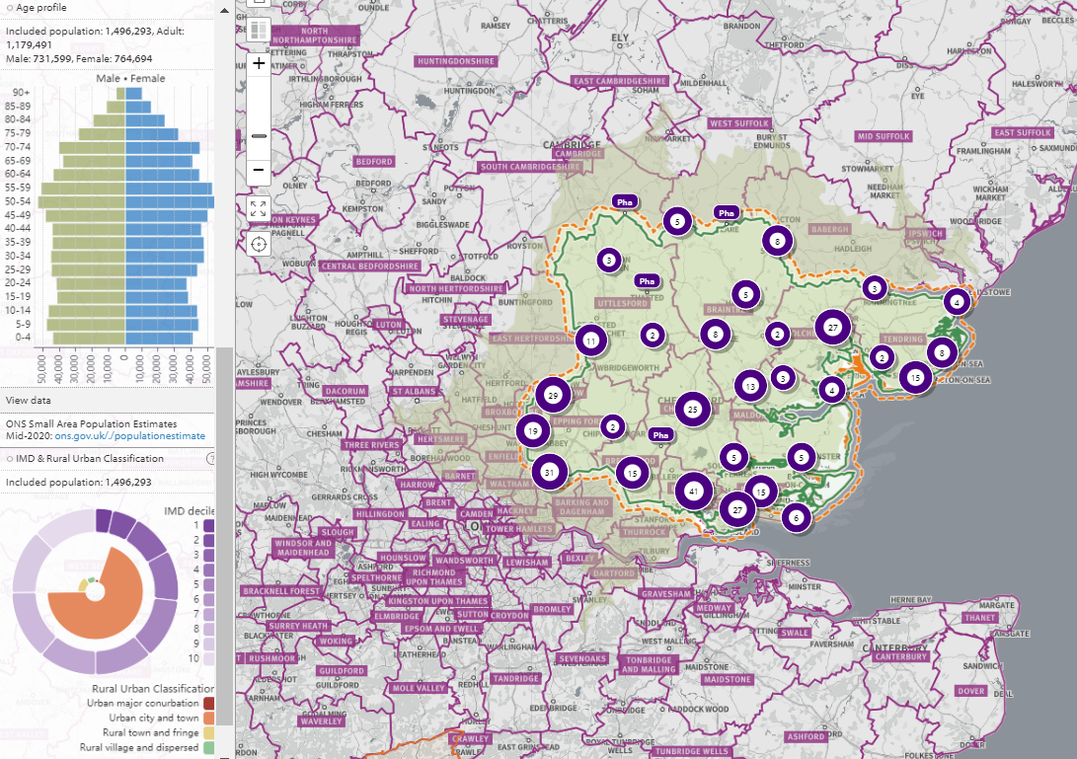

All residents across all districts can drive to a pharmacy or dispensing doctor within 20 minutes, but for 1 LSOA in Colchester (1,466 people; LSOA code: E01021694, LSOA name: Colchester 019D). This LSOA is also over a 30 -minute walk to pharmacy or dispensing doctor. It is estimated this LSOA can reach a pharmacy via a 10-to-20-minute public transport journey (by ferry). This LSOA is a ‘rural village and dispersed’ area that faces geographical challenges for access to multiple services due to a tidal river that runs through Mersea, cutting off road access at certain times. This is in IMD Decile 5, amongst the 50% most deprived areas nationally.

The availability of choice

Community pharmacies improve access to healthcare and increase the choice available to residents.

Access to a greater range of services is generally available in urban areas and this applies to pharmaceutical services. All the large towns in Essex have more than one pharmacy in the town centre in addition to those in the surrounding suburbs.

In rural areas, services and businesses are not always available in the immediate locality and public transport may be less frequent or non-existent. Residents of these areas may have to make arrangements for shopping and other services including pharmaceutical services.

Those patients who are eligible to be on their doctor’s dispensing list can choose this option. In addition, patients can choose to access services via neighbouring HWB pharmacies and through Distance Selling Pharmacies (383 in England at May 2022) who are required to provide Essential services to any residents in England.

Dispensing locations

Table below shows where the prescriptions issued by prescribers in each CCG area are dispensed (January 2022). For example, 91% of prescriptions issued by Basildon and Brentwood CCG prescribers are dispensed within the area. The rest are dispensed in other areas or by online pharmacies.

Between 80% and 93% of prescriptions generated in the area are dispensed within the same area, some are dispensed within the wider Essex network of localities and others are dispensed in neighbouring HWB areas providing improved access and choice for our residents. Further dispensing provision is available to all residents via distance selling pharmacies (online); between 3-5% of items were dispensed online for residents of the HWB area.

Table Dispensing locations for prescription items issued by Essex CCGs prescribers
Prescriber Location | Dispensed in area % | Dispensed out of area including neighbouring areas (online) %
Basildon and Brentwood CCG | 91% | 9% (5% online)
Castle Point and Rochford CCG | 93% | 7% (3% online)
Mid Essex CCG | 80% | 20% (3% online)
North East Essex CCG | 89% | 11% (5% online)
West Essex CCG | 86% | 14% (5% online)

Sources: CCG ePACT data Jan 2022

Advanced services
    - Any contractor may choose to provide Advanced Services. There are requirements which need to be met in relation to premises, training, or notification to the NHS England Area team.

The New Medicines Service (NMS) and Community Pharmacy Consultation Service (CPCS) advanced services are necessary pharmaceutical services for our population. All other services are considered relevant.
Table the percentage of community pharmacies per locality signed up to provide Advanced Services (data sourced from NHSE&I). Details of individual pharmacy providers can be seen in each locality report.
Advanced service Locality | Basildon | Braintree | Brentwood | Castle Point | Chelmsford | Colchester | Epping Forest | Harlow | Maldon | Rochford | Tendring | Uttlesford
New Medicines Service (NMS) | 80% | 81% | 92% | 78% | 79% | 85% | 96% | 78% | 100% | 100% | 90% | 88%
Community Pharmacy Consultation Service (CPCS) | 37% | 32% | 46% | 28% | 57% | 45% | 38% | 61% | 55% | 44% | 45% | 63%
Hypertension case-finding service | 54% | 41% | 46% | 56% | 50% | 55% | 58% | 56% | 45% | 44% | 35% | 75%
Community Pharmacy Influenza service (awaiting data) | 100% | 100% | 100% | 94% | 97% | 94% | 72% | 94% | 100% | 94% | 100% | 89%

Data shows that Advanced Services are used, but information is skewed due to the pandemic. Currently, there is no data recorded on the use of community pharmacy hepatitis C antibody testing service locally. The Stop Smoking Service started in March 2022, and therefore no activity data is available at the time of writing. The number of providers of AUR and SAC data is also very low locally and nationally.

Enhanced services in Essex

The Pharmaceutical Services (England) Directions 2013 lists services that can be commissioned from pharmaceutical providers.

Enhanced services provided by pharmacy contractors either as enhanced services (LES) commissioned by NHS England or locally commissioned service (LCS) by local authority, CCG or another local organisation.

This is a reflection of whether a service is commissioned from a pharmacy; however, the service could also be commissioned from other providers:
      - Enhanced services commissioned in the area include Needle and Syringe Provision, Palliative care drugs provision, Patient Group Direction Services (as part of sexual health services, smoking cessation and seasonal flu), Screening Service, Seasonal Influenza, Sexual Health Services, Stop Smoking Service, Supervised Administration Service
      - Enhanced services not commissioned in the area include Anticoagulant Monitoring Service, Care Home Service, Disease Specific Medicines Management Service, Gluten Free Food Supply Service, Independent Prescribing Service, Home Delivery Service, Language Access Service, Medication Review Service, Medicines Assessment and Compliance Support Service, Minor Ailment Scheme, Pharmacy Out of Hours Services, Prescriber Support Service, Schools Service, Supplementary Prescribing Service

Other services providers

Dispensing doctors
Figure Dispensing doctors in the Essex HWB area
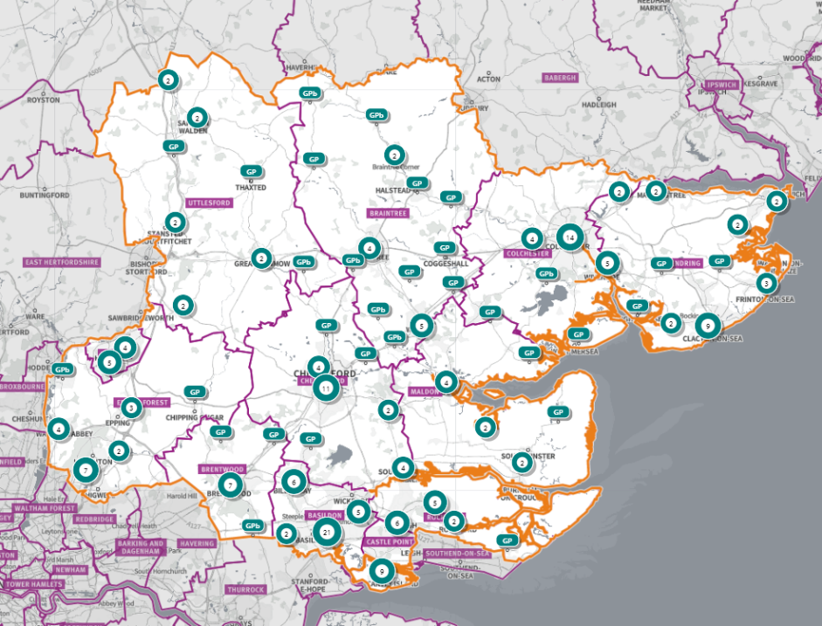

As of May 2022, there are 46 dispensing doctor practices across Essex.

A full list of dispensing doctor practices in Essex is provided in Appendix D.

Provision for doctors to provide pharmaceutical services in certain circumstances has been made in various NHS Acts and Regulations for many decades. Doctors in certain localities are allowed to offer a dispensing service to eligible patients. To be eligible, patients must meet the requirements which are:
- patients must live in a rural area more than 1.6 km from a community pharmacy
- patients must have requested to be on the dispensing list,
- patients who satisfy NHS England that they would have serious difficulty in obtaining services from a pharmacy

Dispensing services are available to these patients during surgery opening hours. Dispensing is the only pharmaceutical service available to these patients (although many other services are provided by GP practices).

In many rural areas patients are used to travelling to a neighbouring village/town for shopping and other services. and are likely to have access to a pharmacy there for over-the-counter medication and advice on the use of their medicines, in addition to the dispensing service they use locally and via distance selling pharmacies.

Distance-selling pharmacies (DSP)

A DSP provides services as per the Pharmaceutical Regulations 2013. It may not provide Essential Services face-to-face, and therefore provision is by mail order and/or wholly internet. As part of the terms of service for DSPs, provision of all services offered must be offered throughout England to anyone who requested them.

It is therefore likely that patients within the HWB area will be receiving pharmaceutical services from a DSP outside of it. There are currently 7 DSPs with a registered address within the Essex HWB area.

Figures for 2020-21 show that in England there were 372 DSPs, accounting for 3.2% of the total number of pharmacies.

Dispensing Appliance Contractors (DACs)

There are 5 Dispensing Appliance Contractors (DACs) with a registered address within the HWB area, however DAC services are available to the population from elsewhere in the UK. Appliances may also be dispensed from community pharmacies.

As part of the Essential Services of appliance contractors, a free delivery service is available to all patients. It is therefore likely that patients will obtain appliances delivered from DACs outside the HWB area. There were 112 DACs in England in 2020-21.

Pharmaceutical service provision provided from outside the HWB area
      - The Essex HWB is bordered by many neighbouring HWB areas: Southend- on Sea, Thurrock, Suffolk, Hertfordshire, and some London boroughs. Good travel access also provides access to further pharmaceutical provision in neighbouring HWB areas and beyond. DSPs provide further availability of pharmaceutical services.

Other

Across the HWB area, several healthcare providers use some pharmaceutical services. This includes (list not exhaustive):
- Mid and South Essex NHS Foundation Trust
- Princess Alexandra Hospital NHS Trust
- East Suffolk & North Essex NHS Foundation Trust
- Ramsay Healthcare Springfield Hospital
- Hertfordshire Partnership University NHS Foundation Trust
- Essex Partnership University NHS Foundation Trust
- North East London NHS Foundation Trust
- Cambridge University Hospital NHS Foundation Trust
- Barts Health Trust
- Whipps Cross University Hospital
- Uplands Rehabilitation Centre
- Provide Community Interest Company
- IC24 GP emergency care

Housing growth

All significant developments that are expected to be realised up to the housing plan period of 2033 are shown in Appendix G. This is the date at which data was available. Not all these developments will be realised during the lifetime of this PNA.

New ways of delivering pharmaceutical services are also being considered by the Department of Health and Social Care (DHSC), which would increase the capacity of existing providers.

As part of the Community Pharmacy Contractual Framework (CPCF) 5-year deal (2019 to 2024), the government committed to pursuing legislative change to enable all community pharmacies to benefit from ‘hub and spoke’ dispensing models, with the intention of supporting efficiencies for pharmacies and freeing up pharmacists and their teams for other tasks such as providing clinical services to patients. A consultation is currently underway.

Hub and spoke dispensing are where parts of the dispensing process are undertaken in separate pharmacy premises. Typically, there are many ‘spoke’ pharmacies to one ‘hub’ pharmacy. The concept is that the simple, routine aspects of assembling prescriptions can take place on a large scale in a ‘hub’ that usually makes use of automated processes. This means that pharmacists and other staff in the ‘spokes’ are freed up to provide more direct patient care.

Any housing delivered during the lifetime of this PNA has access to current provision and would also have access to provision from neighbouring areas and from DSPs. New technology, digital solutions and hub and spoke models would be able to provide increased access to pharmaceutical services.

All significant developments that are expected to be realised during the lifetime of this PNA have access to existing pharmaceutical services either in the locality or in the neighbouring localities and no gaps are identified.

7 Locality Statements

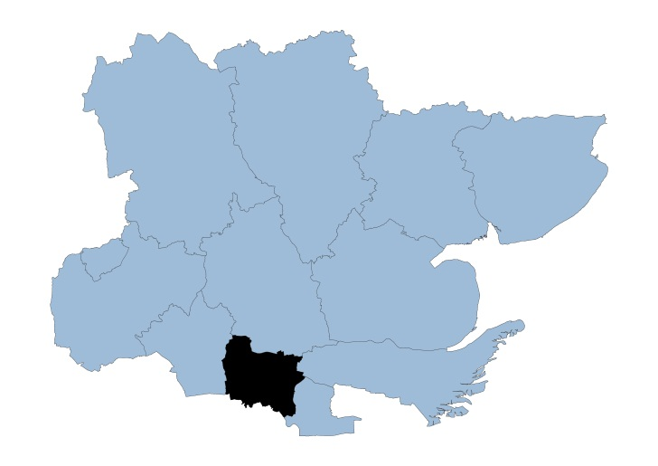
7.1

Basildon Locality

The Basildon district is situated in the southern part of Essex, 30 miles east of London. Covering some 110 square kilometers, the district includes the towns of Basildon, Billericay and Wickford.

Basildon has the largest population of the Essex districts at 187,558, giving a population density of 1,705 people per square km. 89.5% of the population are White British.

In the Indices of Multiple Deprivation 2019, Basildon was in the 40% of most deprived Lower Tier Local Authorities (LTLAs) nationally. This contains 110 LSOAs, of which 26 are ranked in the bottom two most deprived deciles nationally; equivalent to 23.6%.

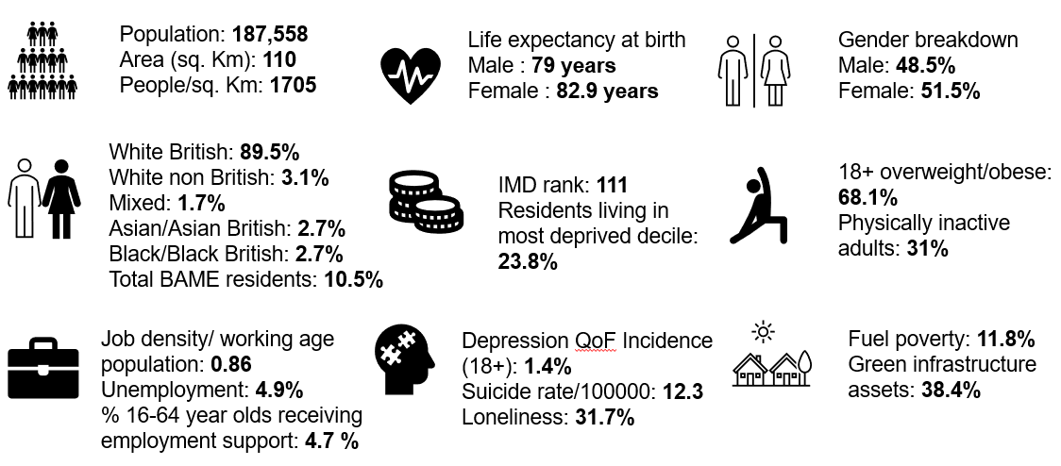

Further details can be accessed in the Essex Joint Strategic Needs Assessment https://data.essex.gov.uk/

Map of Basildon Pharmacies

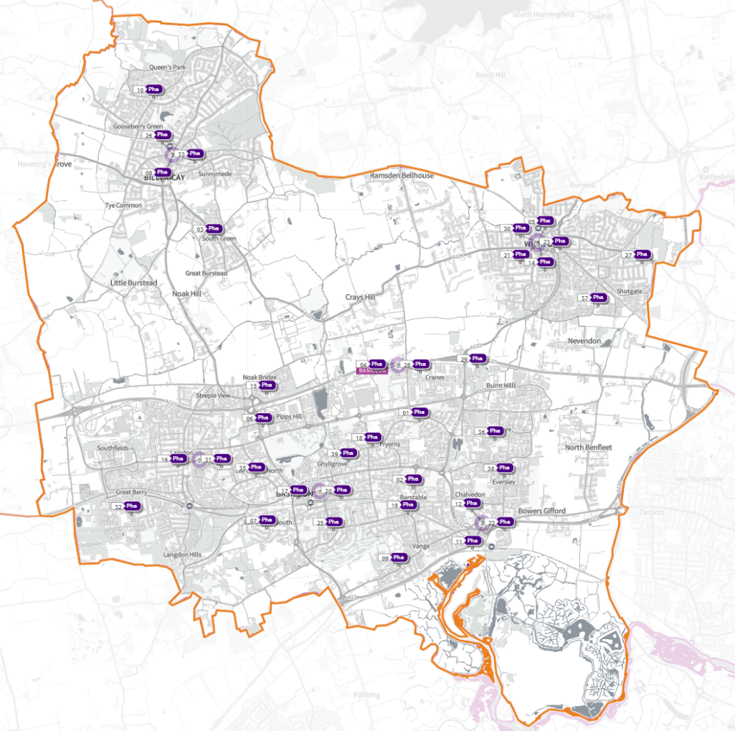 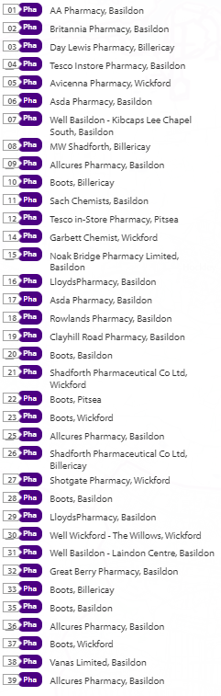
Source: Shape Place Atlas (as at 22/03/22)

Pharmaceutical services provision in the locality

Provision

The information contained in this report was obtained from NHS England (NHSE), local commissioners and a contractor survey.

Opening hours were obtained via the NHSE pharmacy contracts team.

Service provision for advanced services was obtained via NHSE, NHS Business Services Authority (NHSBSA) and with the support of the local LPC (Local Pharmaceutical Committee).

- Access

Appendix F shows that using the base population data on the SHAPE Place Atlas platform, it is possible to calculate the Essex population (and by district) that are estimated to have a journey time either within 20 minutes, 20 - 30 minutes or over 30 minutes to a pharmacy across Essex and within a 1.6km buffer zone around Essex by each journey method.

Overall, across Essex, generally residents are within a relatively short travel time whichever method is chosen:
- 99.9% of the Essex population could get to a pharmacy in a 20-minute drive.
- 95% a 20-minute public transport journey.
- 83% within a 20-minute walk. Residents have to travel for longer if they walk.
- 11% over 30-minute walk away.
- Basildon residents can drive to a pharmacy within 20 minutes.
- Most residents can get to a pharmacy within a 20-minute journey on public transport in most districts. However, some districts see a relatively high % of their population having to travel for longer (Braintree, Maldon, Uttlesford 20-30 minutes; Braintree, Epping Forest, Uttlesford over 30 minutes).
- Most residents can get to a pharmacy within 20-minute walk in most districts. Some districts however see a relatively higher % of their population that’d have to walk further (Braintree, Brentwood, Uttlesford 20-30 minutes; Braintree, Maldon, Uttlesford over 30 minutes).

Travel time to access pharmaceutical services are no longer than journey times to access key services as shown in section 6 of this report.

From the results of the public survey (Appendix E) 83% of residents stated that they had a reasonable distance to travel to the pharmacy equating to less than 20 minutes, 14% had travelled between 20 and 30 minutes, and 3% had travelled between 30-45 minutes. 61% made the trip by car, and 34% had travelled on foot—only 3% used public transport and 2% a bicycle.

Basildon residents also have access to pharmacies in neighbouring HWB areas and DSPs in England. Analysis of dispensing flows in the Basildon and Brentwood CCG area shows that 91% of prescriptions in the CCG are dispensed within the area and 9% out of area including 5% by distance selling pharmacies.

Pharmaceutical services in the locality
Table Number and type of providers of pharmaceutical services in the area
Type Of Contract | Basildon
Total Number of Community Pharmacies | 35
Dispensing Doctors | None
Dispensing Appliance Contractor | None
Distance Selling Pharmacies | None

Basildon pharmacies service provision
Table Pharmacy contractors in the locality and provision of commissioned services
* Friday hours are taken as standard for Mon- Fri
Services key:
Services 1 & 2 are NHSE commissioned Advanced necessary services
Services 3-6 are NHSE commissioned Advanced services
Service 7 is an NHSE commissioned Enhanced service
Services 8 & 9 are CCG locally commissioned services
Services 10-14 are local authority locally commissioned services

Service code |  |  |  |  |  |  |  | 1 | 2 | 3 | 4 | 5 | 6 | 7 | 8 | 9 | 10 | 11 | 12 | 13 | 14
Organisation code | Town | Postcode | Town | Postcode | Hours: M - F* OPENING SUPPLEMENTARY | Hours: Sat OPENING SUPPLEMENTARY | Hours: Sun OPENING  SUPPLEMENTARY | NMS | CPCS | SAC | SCS | HYPERTENSION | FLU Vaccination | COVID Vaccination | PALLAITIVE CARE | WARFARIN SUPPLY  SERVICE | SEXUAL HEALTH | SMOKING CESSATION | NHS Health Checks | NEEDLE EXCHANGE | SUPERVISED CONSUMPTION
FHW69 | AA Pharmacy | 98 Whitmore Way | Basildon | SS14 3JT | 9:00 – 18.00 |  |  | ✓ |  |  | ✓ | ✓ | ✓
 |  |  |  |  | 13:00 - 13:30  & 17:30 - 18:00 | 9:00 - 13:00 | Closed
FDN82 | Allcures Pharmacy | 1 Marsh View Court, London Road | Basildon | SS16 4QW | 9:00 – 18.00 |  |  | ✓ | ✓ |  | ✓ |  | ✓ |  |  |  |  | ✓ |  | ✓ | ✓
 |  |  |  |  | 13:00 - 13:30 &  17:30 - 18:00 | Closed | Closed
FN057 | Allcures Pharmacy | 144 Clayhill Road | Basildon | SS16 5DF | 9:00 - 17: 00 |  |  | ✓ |  |  |  |  | ✓
 |  |  |  |  | 17:00 - 18:00 | Closed | Closed
FTN74 | Allcures Pharmacy | 7 Felmores End | Basildon | SS13 1PN | 9:00 - 17:30 |  |  | ✓ | ✓ |  |  |  | ✓
 |  |  |  |  | 17:00 - 17:30 | Closed | Closed
FWL99 | Allcures Pharmacy | 562 Whitmore Way | Basildon | SS14 2ER | 9:00 - 17:30 |  |  | ✓ |  |  | ✓ |  | ✓ |  |  |  |  |  |  |  | ✓
 |  |  |  |  | 13:00 - 13:30 | Closed | Closed
FC547 | Asda Pharmacy | Heron Retail Park, Miles Gray Road | Basildon | SS14 3AF | 9:00 - 21:00 | 9:00 - 21:00 |  | ✓ | ✓ |  |  | ✓ | ✓ |  |  |  | ✓
 |  |  |  |  | 12:30 - 14:30 &  18:00 - 21:00 | 12:30 - 14:30 &  16:00 - 21:00 | 10:00 - 13:00
FH090 | Asda Pharmacy | Eastgate Shopping Centre | Basildon | SS14 1AE | 8:00 - 20:00 | 08:00 -20:00 |  | ✓ | ✓ |  |  | ✓ | ✓ |  |  |  | ✓ | ✓
 |  |  |  |  | 8:00 - 9:00 &  12.30 - 14:30 &  18:00 - 20:00 | 8:00 - 9:00 &  12.30 - 14:30 &  16:00 - 20:00 | 10:00 - 13:00
FAX06 | Avicenna Pharmacy | 20 London Road | Wickford | SS12 0AN | 9:00 - 19:00 |  |  | ✓ |  |  |  | ✓ | ✓ |  |  |  | ✓ |  |  | ✓ | ✓
 |  |  |  |  | 17:00 - 19:00 | 9:00 - 13:00 | Closed
FE004 | Boots | 10-11 The Pantiles, Queens Park Avenue | Billericay | CM12 0UA | 8:30 - 18:30 | 9:00 -13:00 |  |  |  |  |  |  | ✓
 |  |  |  |  | 8:30 - 9:00 &  13.30 - 14:30 &  18:00 - 18:30 | 13:00 - 17:30 | Closed
FJ061 | Boots | 25 Town Square | Basildon | SS14 1BA | 9:00 - 17:30 | 9:00 - 17:30 |  |  |  |  |  | ✓ | ✓ | ✓ |  |  | ✓ |  |  | ✓ | ✓
 |  |  |  |  | 14:00 - 15:00 &  17:00 - 17:30 | 14:00 - 17:30 | 10:00 - 14:00
FJX14 | Boots | 8 Northlands Pavement | Basildon | SS13 3DU | 9:00 - 18:00 | 9:00 - 17:00 |  |  |  |  |  |  | ✓ |  |  |  |  |  |  |  | ✓
 |  |  |  |  | 13:00 - 13:30 | 13:00 - 13:30 &  14:00 - 17:00 | Closed
 |  |  |  |  | Closed 13:30 - 14:00 | Closed 13:30 - 14:00
FKP09 | Boots | 16 Willowdale Centre | Wickford | SS12 0RA | 8:30 - 18:30 | 9:00 - 17:15 |  | ✓ |  |  |  | ✓ | ✓
 |  |  |  |  | 8:30 - 9.30 &  14:00 - 15:00 &  17:30 - 18:30 | 9:00 - 9:30 &  14:00 - 15:00 &  15:30 - 17:15 | 10:00 - 16:00
FP755 | Boots | Unit 6B, Mayflower Retail Park | Basildon | SS14 3HZ | 10:00 - 18:00 | 9:00 - 15:00 |  |  |  |  |  |  | ✓ |  |  |  | ✓
 |  |  |  |  | 14:00 - 15:00 | 12:00 - 13:00 | 10:00 - 16:00
FQE10 | Boots | 64-66 High Street | Billericay | CM12 9BS | 8:30 - 17:30 | 8:30 - 17:30 |  | ✓ |  |  |  |  | ✓ |  |  |  | ✓ |  |  |  | ✓
 |  |  |  |  | 8:30 - 9:00 &  13:00 - 14:00 | 8:30 - 9:00 &  11:30 - 17:30 | 10:00 - 13:00
FTJ17 | Boots | 31 Ballards Walk | Basildon | SS15 5HL | 8:30 - 18:00 | 9:00 - 13:00 |  |  |  |  |  | ✓ | ✓ |  |  |  |  |  |  |  | ✓
 |  |  |  |  | 08:30 - 9:00 &  13:00 - 14:00 | 13:00 - 14:00 | Closed
FVK93 | Boots | 5 Silva Island Way | Wickford | SS12 9NR | 8:30 - 18:30 | 9:00 - 17:30 |  |  |  |  |  | ✓ | ✓
 |  |  |  |  | 8:30 - 9:00 &  13:00 - 14:00 &  18:00 - 18:30 | 13:00 - 17:30 | Closed
FRH64 | Britannia Pharmacy | 213 Timberlog Lane | Basildon | SS14 1PB | 9:00 - 19:00 |  |  | ✓ |  |  | ✓ | ✓ | ✓ |  |  |  |  | ✓ |  |  | ✓
 |  |  |  |  | 17:00 - 19:00 | 9:00 - 16:00 | Closed
FHV32 | Clayhill Road Pharmacy | 465 Clayhill Road | Basildon | SS16 4EX | 9:00 - 18:30 |  |  | ✓ |  |  |  |  | ✓
 |  |  |  |  | 13:00 - 14:00 &  18:00 - 18:30 | 9:00 - 12:00 | Closed
FA380 | Day Lewis Pharmacy | 6 Grange Road | Billericay | CM11 2RB | 9:00 - 18:00 |  |  | ✓ |  |  |  | ✓ | ✓ |  |  | ✓ | ✓ |  |  | ✓ | ✓
 |  |  |  |  |  | 09:00 - 13:00 | Closed
 |  |  |  |  | Closed 13:00 - 14:00
FG064 | Garbett Chemist | 23 High Street | Wickford | SS12 9AE | 09:00 - 18:00 | 09: 00 - 17:30 |  | ✓ | ✓ |  |  |  | ✓ |  |  | ✓ | ✓ | ✓
 |  |  |  |  | 13:00 - 14:15 &  17:30 - 18:00 | 13:00 - 17:30 | Closed
 |  |  |  |  |  | Closed 12:45 - 13:00
FQC91 | Great Berry Pharmacy | Unit 4, Great Berry Centre, Nightingales | Basildon | SS16 6SA | 09:00 - 20:00  13:00 - 14:00 &  18:00 - 20:00 |  |  | ✓ | ✓ |  | ✓ | ✓ | ✓ |  |  |  | ✓ | ✓ | ✓
 |  |  |  |  |  | 09:00 - 18:00 | Closed
FP779 | Lloyds Pharmacy (100-hour Pharmacy) | Cricketers Way | Basildon | SS13 1SA | 07:00 - 23:00 | 07:00 - 22:00 | 10:00 - 16:00 | ✓ |  |  |  | ✓ | ✓
FD812 | MW Shadforth | 49 High Street | Billericay | CM12 9AX | 08:45 - 18:15 | 9:00 – 17.00 |  | ✓ |  |  |  |  | ✓ |  |  | ✓ | ✓
 |  |  |  |  | 8:45 - 9:00 &  13:00 - 14:15 &  17:30 - 18:15 | 13:00 - 17:00 | Closed
 |  |  |  |  |  | Closed 12: 45 - 13:00
FGC13 | Noak Bridge Pharmacy Limited | 147 Coppice Lane | Basildon | SS15 4JS | 09:00 - 18:45 | 9:00 - 13:00 |  | ✓ | ✓ |  |  | ✓ | ✓
 |  |  |  |  | 13:00 - 14:00 &  18:00 - 18:45 |  | Closed
FHF92 | Rowlands Pharmacy | 418 Whitmore Way | Basildon | SS14 2HB | 9:00 - 17:30 | 9:00 - 13:00 |  | ✓ | ✓ |  |  |  | ✓ | ✓ |  |  |  | ✓
 |  |  |  |  | 13:00 - 13:30 &  13:50 - 14:00 | 11:30 - 13:00 | Closed
 |  |  |  |  | Closed 13:30 - 13:50
FEL23 | Sach Chemists | 10 Broadway North | Basildon | SS13 3AT | 9:00 - 18:00 | 9:00 - 13:00 |  | ✓ |  |  | ✓ | ✓ | ✓ | ✓ |  |  |  | ✓ | ✓
 |  |  |  |  | 13:00 - 14:00 |  | Closed
FJR90 | Shadforth Pharmaceutical Co Ltd | 53 High Street | Basildon | SS12 9AQ | 09:00 - 17:30 | 9:00 - 13:00 |  | ✓ | ✓ |  |  |  | ✓ |  |  | ✓ | ✓ | ✓
 |  |  |  |  | 14:00 - 14:20 &  17:20 - 17:30 |  | Closed
FNC77 | Shadforth Pharmaceutical Co Ltd | 25 Stock Road | Billericay | CM12 0AH | 9:00 - 18:30 |  |  | ✓ | ✓ |  |  |  | ✓ |  |  |  | ✓
 |  |  |  |  | 13:00 - 14:00 &  18:00 - 18:30 | 9:00 - 13:00 | Closed
FP449 | Shotgate Pharmacy | 312 Southend Road | Wickford | SS11 8QW | 9:00 - 18:00 |  |  | ✓ |  |  |  | ✓ | ✓
 |  |  |  |  | 17:00 - 18:00 | 9:00 - 12:00 | Closed
FA473 | Tesco In-store Pharmacy | Mayflower Retail Park | Basildon | SS14 3HZ | 8:00 - 20:00 | 8:00 - 20:00 |  | ✓ | ✓ |  |  |  | ✓ | ✓
 |  |  |  |  | 8:00 - 9:00 &  13:00 - 14:00 &  17:00 - 20:00 | 8:00 - 9:00 &  13:00 - 14:00 &  17:00 - 20:00 | 10:00 - 13:00
FF009 | Tesco In-store Pharmacy | Off Station Lane | Pitsea | SS13 3JU | 8:00 - 21:00 | 8:00 - 21:00 |  | ✓ |  |  |  |  | ✓ | ✓
 |  |  |  |  | 8:00 - 9:00 &  13:00 - 14:00 &  16:00 - 21:00 | 8:00 - 9:00 &  13:00 - 14:00 &  16:00 - 21:00 | 10:00 - 13:00
FW294 | Vanas Limited | 134 Rectory Road | Basildon | SS13 2AJ | 9:00 - 18:30 |  |  | ✓ | ✓ |  | ✓ | ✓ | ✓ |  |  |  | ✓ | ✓
 |  |  |  |  | 17:30 - 18:30 | 9:00 - 13:00 | Closed
 |  |  |  |  | Closed 13:00 - 13:30
FD329 | Well Basildon - Kibcaps Lee Chapel South | 1 Kibcaps, Lee Chapel South | Basildon | SS16 5SA | 9:00 - 18:00 |  |  | ✓ |  |  |  | ✓ | ✓ |  |  |  |  | ✓ | ✓
 |  |  |  |  | 13:00 - 14:00 | Closed | Closed
FQ898 | Well Basildon - Laindon Centre | Unit 1, Laindon Temporary Shops | Laindon | SS15 5PS | 8:30 - 18:00 |  |  |  |  |  | ✓ | ✓ | ✓ |  |  |  |  |  |  |  | ✓
 |  |  |  |  | 8:30 - 9:00 &  13:00 - 14:00 | 9:00 - 13:00 | Closed
FQ122 | Well Wickford - The Willows | Unit 12, Willowdale Shopping Centre | Wickford | SS12 9AT | 9:00 - 18:00 |  |  | ✓ | ✓ |  |  | ✓ | ✓
 |  |  |  |  | 13:00 - 14:00 | Closed | Closed

Basildon opening hours
- Weekday opening hours were taken from Friday as a standard.

Monday to Friday, all 35 community pharmacies are open between the hours of 9:00am to 17:00

Earliest opening time is 7.00 and latest closing time is 23.00
- On Saturdays 30 of the pharmacies open, 13 of these only open for the morning and the rest of the pharmacies remain open into the afternoon. Earliest opening time is 7.00 and latest closing time is 22.00
- On Sundays nine pharmacies open and there is provision between 10:00 until 16:00

Services (data January 2022)

There is good access to commissioned services within the locality.
The necessary services of NMS and CPCS are provided by almost all the pharmacies.
The NHSE commissioned services that are not provided by pharmacies are delivered by other organisations in the locality.

Housing (Appendix G)

The impact of local housing development plans on provision of pharmaceutical services has been considered but has not identified any gaps in pharmaceutical services provision in the area during the lifetime of this PNA.

No gaps in the provision of necessary pharmaceutical services have been identified in the Basildon locality

No gaps in pharmaceutical services have been identified that if provided either now or in the future would secure improvements or better access to relevant services across the Basildon locality

7.2

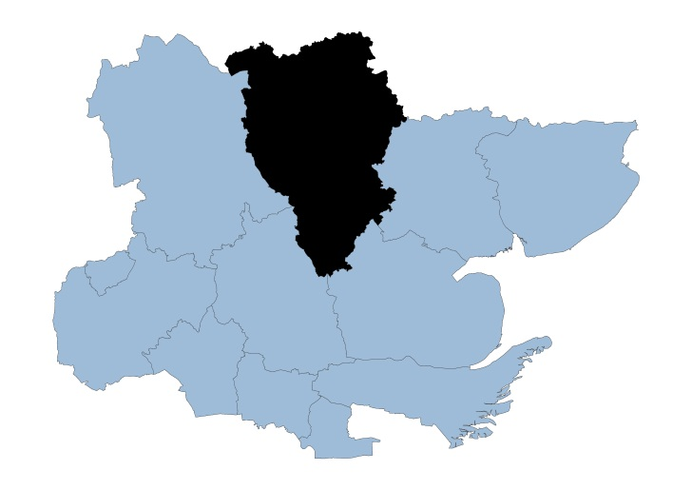

Braintree Locality

Covering approximately 612 square kilometers, the Braintree district is the second largest Essex local authority in terms of geographical area (Uttlesford is the largest).

The district consists of the two large market towns of Braintree and Halstead along with the 1970’s urban ‘expanded town’ of Witham interconnected with many smaller villages and rural areas.

Braintree has a population of 153,091 and 250 residents per square km and is the third least densely populated among the Essex districts. 93% of the population are of White British ethnicity.

With a rank of 303 out of 317, Braintree is placed in the in the upper 40% of least deprived Lower Tier Local Authorities (LTLAs) nationally.

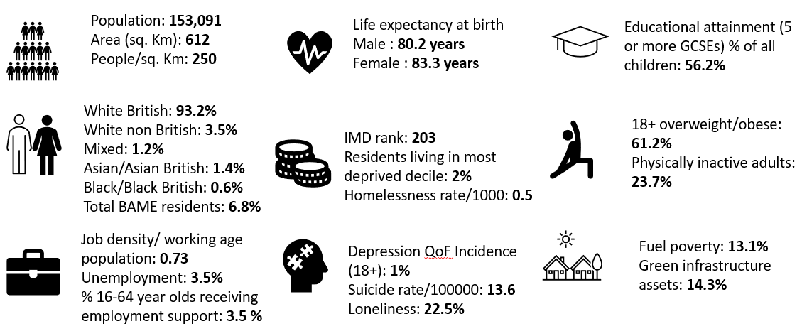

Further details can be accessed in the Essex Joint Strategic Needs Assessment https://data.essex.gov.uk/

Map of Braintree Pharmacies

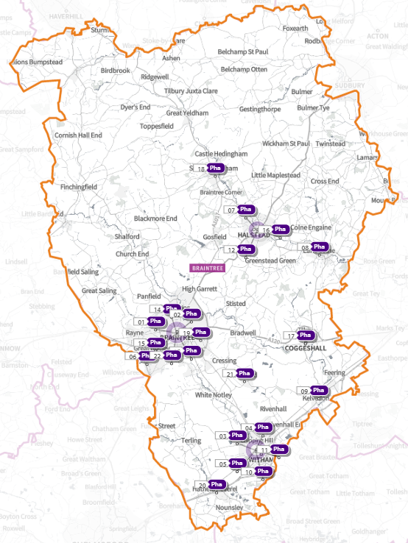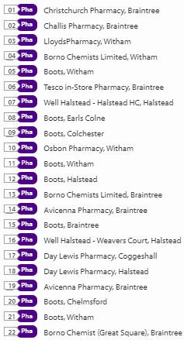
Source: Shape Place Atlas (as at 22/03/22)

Provision

The information contained in this report was obtained from NHSE, local commissioners and a contractor survey.

Opening hours were obtained via the NHSE pharmacy contracts team.

Service provision for advanced services was obtained via NHSE, NHSBSA and with the support of the local LPC.

Access

Appendix F shows that using the base population data on the SHAPE Place Atlas platform, it is possible to calculate the Essex population (and by district) that are estimated to have a journey time either within 20 minutes, 20 - 30 minutes or over 30 minutes to a pharmacy across Essex and within a 1.6KM buffer zone around Essex by each journey method.

Overall, across Essex, generally residents are within a relatively short travel time whichever method is chosen:
- 99.9% of the Essex population could get to a pharmacy in a 20-minute drive.
- 95% a 20-minute public transport journey
- 83% within a 20-minute walk. Residents have to travel for longer if they walk.
- 11% over 30-minute walk away.
- Braintree residents can drive to a pharmacy within 20 minutes.
- Most residents can get to a pharmacy within a 20-minute journey on public transport in most districts. However, some districts see a relatively high % of their population having to travel for longer (Braintree, Maldon, Uttlesford 20-30 minutes; Braintree, Epping Forest, Uttlesford over 30 minutes)
- Most residents can get to a pharmacy within 20-minute walk in most districts. Some districts however see a relatively higher % of their population that’d have to walk further (Braintree, Brentwood, Uttlesford 20-30 minutes; Braintree, Maldon, Uttlesford over 30 minutes).

Travel time to access pharmaceutical services are no longer than journey times to access key services as shown in section 6 of this report.

From the results of the public survey (Appendix E) 83% of residents stated that they had a reasonable distance to travel to the pharmacy equating to less than 20 minutes, 14% had travelled between 20 and 30 minutes, and 3% had travelled between 30-45 minutes. 61% made the trip by car, and 34% had travelled on foot—only 3% used public transport and 2% a bicycle.

Braintree residents also have access to dispensing doctors, pharmacies in neighbouring HWB areas and distance selling pharmacies in England. Analysis of dispensing flows in the Mid Essex CCG area shows that 80% of prescriptions generated in the CCG are dispensed within the area and 20% out of area including 3% by distance selling pharmacies.

Pharmaceutical services in the locality
Table Number and type of providers of pharmaceutical services in the area
Type Of Contract | Braintree
Total Number of Community Pharmacies | 22
Dispensing Doctors | 7
Dispensing Appliance Contractors | 0
Distance Selling Pharmacies | 0

Table of Pharmacy contractors in the locality and provision of commissioned services
* Friday hours are taken as standard for Mon- Fri
Services key:
Services 1 & 2 are NHSE commissioned Advanced necessary services
Services 3-6 are NHSE commissioned Advanced services
Service 7 is an NHSE commissioned Enhanced service
Service 8 is a CCG locally commissioned services
Services 9-13 are local authority locally commissioned services

Service code |  |  |  |  |  |  |  | 1 | 2 | 3 | 4 | 5 | 6 | 7 | 8 | 9 | 10 | 11 | 12 | 13
Organisation code | Trading Name | Address line | Town | Postcode | Hours: M - F* OPENING HOURS SUPPLEMENTARY | Hours: Sat OPENING HOURS SUPPLEMENTARY | Hours: Sun OPENING HOURS  SUPPLEMENTARY | NMS | CPCS | SAC | SCS | HYPERTENSION | FLU Vaccination | COVID Vaccination | PALLAITIVE CARE | SEXUAL HEALTH | SMOKING CESSATION | NHS Health Checks | NEEDLE EXCHANGE | SUPERVISED CONSUMPTION
FLQ23 | Avicenna Pharmacy | Trinovantion Way | Braintree | CM7 3JN | 9:00 - 18:30 |  |  | ü | ü |  |  |  | ü |  |  | ü
 |  |  |  |  | 13:00 - 14:00&  18:00 - 18:30 | Closed | Closed
FWF16 | Avicenna Pharmacy | 70 Coggeshall Road | Braintree | CM7 9BY | 8:00 - 18:00 |  |  | ü | ü |  |  | ü | ü | ü |  | ü | ü
 |  |  |  |  | 8:00 - 9:00 &  17:00 - 18:00 | 9:00 - 13:00 | Closed
FCC02 | Boots | 42 Newland Street | Witham | CM8 2AR | 9:00 - 19:00 | 9:00 - 17:00 | Closed | ü |  |  |  |  | ü
 |  |  |  |  | 18:00 - 19:00 | 14:00 - 17:00
 |  |  |  |  | Closed 13:00 - 14:00 | Closed 13:00 - 14:00
FJA38 | Boots | 50 High Street, Earls Colne | Braintree | CO6 2PB | 8:30 - 18:30 | 9:00 - 13:00 |  |  |  |  |  |  | ü |  |  |  | ü
 |  |  |  |  | 8:30 - 9:00 &  13:00 - 14:00 &  17:30 - 18:30 | 11:30 - 13:00 | Closed
FJJ41 | Boots | 72A & 72B High Street, Kelvedon | Colchester | CO5 9AE | 9:00 - 19:00 |  |  |  |  |  |  |  | ü |  |  | ü
 |  |  |  |  | 13:00 - 14:00 &  18:00 - 19:00 | 9:00 - 17:00 | Closed
FKK58 | Boots | 4 Spa Road | Witham | CM8 1NE | 9:00 - 18:00 | 9:00 - 18:00 |  |  |  |  |  |  | ü
 |  |  |  |  | 13:00 - 13:30 | 13:00 - 18:00 | Closed
 |  |  |  |  | Closed 13:30 - 14:00
FL500 | Boots | 69-71 High Street | Halstead | CO9 2JD | 9:00 - 17:30 | 9:00 - 17:30 |  | ü |  |  |  |  | ü
 |  |  |  |  | 9:00 - 9:30 &  17:15 - 17:30 | 9:00 - 9:30 &  17:00 - 17:30 | Closed
 |  |  |  |  | Closed 13:00 - 14:00 | Closed 13:00 - 14:00
FM273 | Boots | 7 George Yard | Braintree | CM7 1RB | 9:00 - 17:30 | 8:45 - 17:30 |  | ü |  |  | ü | ü | ü |  |  | ü
 |  |  |  |  | 16:00 - 17:30 | 8:45 - 9:00 &  13:00 - 14:00 &  16:30 - 17:30 | 10:00 - 16:00
FWM30 | Boots | 3 Hadfelda Square | Hatfield Peverel | CM3 2HD | 9:00 -18:30 | 9:00 - 17:00 |  |  | ü |  | ü |  | ü |  |  |  | ü
 |  |  |  |  | 13:00 - 14:00 &  18:00 - 18:30 | 13:30 - 17:00 | Closed
 |  |  |  |  |  | Closed 13:00 - 13:30
FXF67 | Boots | 3-4 The Broadway, Silver End | Witham | CM8 3RQ | 9:00 - 19:00 | 9:00 - 17:00 |  | ü | ü |  |  | ü | ü
 |  |  |  |  | 13:00 - 14:00 &  18:00 - 19:00 | 13:00 - 17:00 | Closed
FM447 | Borno Chemist (Great Square) | 10 Great Square | Braintree | CM7 1UA | 9:00 - 19:00 | 9:00 - 17:30 |  | ü |  |  |  |  | ü |  |  |  | ü
 |  |  |  |  | 12:00 - 14:00 &  17:30 - 19:00 | 12:00 - 14:00
FAP90 | Borno Chemists Limited | 124 Newland Street | Witham | CM8 1BA | 9:00 - 19:00 |  |  | ü | ü |  |  |  | ü |  |  | ü
 |  |  |  |  | 17:00 - 19:00 | 8:30 - 12:30 | Closed
FLM31 | Borno Chemists Limited | Colne House, 96 Mount Chambers, Coggeshall Road | Braintree | CM7 9BY | 8:30 - 18:30 |  |  | ü | ü |  |  |  | ü
 |  |  |  |  | 8:30 - 9:00 &  14:00 - 15:00 &  18:00 - 18:30 | Closed | Closed
FPM74 | Challis Pharmacy | 35 Masefield Road | Braintree | CM7 1AA | 8:30 - 18:00 | 9:00 - 17:00 |  | ü |  |  |  |  | ü | ü |  | ü
 |  |  |  |  | 8:30 - 9:00 &  13:00 - 14:00 &  17:00 - 18:00 | 13:00 - 17:00 | Closed
FCM69 | Christchurch Pharmacy | Mace Avenue | Braintree | CM7 2AE | 8:30 - 19:00 |  |  | ü |  |  | ü | ü | ü | ü | ü | ü | ü
 |  |  |  |  | 8:30 - 9:00 &  13:00 - 14:00 &  18:00 - 19:00 | 9:00 - 13:00 | Closed
FTR88 | Day Lewis Pharmacy | 1 Doubleday Corner | Coggeshall | CO6 1NJ | 9:00 - 18:30 |  |  | ü |  |  |  | ü | ü |  |  |  | ü
 |  |  |  |  | 18:00 - 18:30 | 9:00 - 13:00 | Closed
 |  |  |  |  | Closed 13:00 - 14:00
FW791 | Day Lewis Pharmacy | 132-134 Swan Street | Halstead | CO9 3PP | 9:00 - 17:30 | 9:00 - 13:00 |  | ü |  |  |  | ü | ü |  |  | ü | ü
 |  |  |  |  | 17:18 - 17:30 |  | Closed
 |  |  |  |  | Closed 13:00 - 14:00
FA549 | Lloyds Pharmacy | 5 Newland Street | Witham | CM8 2AF | 09:00 - 19:00 | 09:00 - 17:30 |  | ü |  |  |  | ü | ü | ü |  |  | ü
 |  |  |  |  | 12:30 - 15:30 | 11:30 - 15:00 | Closed
FKE19 | Osbon Pharmacy | Unit 1, 1 Potter Court Flemming Way | Witham | CM8 2ZJ | 9:00 - 19:00 | 9:00 - 17:00 |  | ü | ü |  |  |  | ü | ü
 |  |  |  |  | 13:00 - 14:00 &  18:00 - 19:00 | 13:00 - 17:00 | Closed
FE712 | Tesco In-store Pharmacy | The Square, Great Notley | Braintree | CM77 7WW | 8:00 - 20:00 | 8:00 - 20:00 |  | ü |  |  |  |  | ü |  |  | ü
 |  |  |  |  | 8:00 - 9:00 &  17:00 - 20:00 | 8:00 - 9:00 &  15:00 - 20:00 | 10:00 - 16:00
 |  |  |  |  | Closed 13:00 - 14:00 | Closed 13:00 - 14:00
FEJ25 | Well Halstead - Halstead Hc | Signal House Factory Lane West | Halstead | CO9 1EX | 9:00 - 17:30 | 9:00 - 17:00 |  | ü |  |  | ü | ü | ü
 |  |  |  |  | 9:00 - 9:30 &  17:15 - 17:30 | 9:00 - 9:30 | Closed
FPL44 | Well Halstead - Weavers Court | 12 Weavers Court | Halstead | CO9 2JN | 9:00 - 17:30 |  |  | ü |  |  |  | ü | ü |  | ü | ü
 |  |  |  |  | 13:00 - 13:30 | Closed | Closed

Braintree opening hours
- Weekday opening hours were taken from Friday as a standard.

Monday to Friday, all 22 community pharmacies are open between the hours of 9:00 to 17:00

Earliest opening time is 8.00 and latest closing time is 20.00

- On Saturdays 19 pharmacies are open in the morning and 13 of the pharmacies remain open in the afternoon. The latest closing time is 20.00

- On Sundays two pharmacies are open from 10:00 until 16:00

Services (data January 2022)
There is good access to commissioned services within the locality.
The necessary services of NMS and CPCS are provided by almost all the pharmacies.
The NHSE commissioned services that are not provided by pharmacies are delivered by other organisations in the locality.

Housing (Appendix G)

The impact of local housing development plans on provision of pharmaceutical services has been considered but has not identified any gaps in pharmaceutical services provision in the area during the lifetime of this PNA.

No gaps in the provision of necessary pharmaceutical services have been identified in the Braintree locality

No gaps in pharmaceutical services have been identified that if provided either now or in the future would secure improvements or better access to relevant services across the Braintree locality

7.3

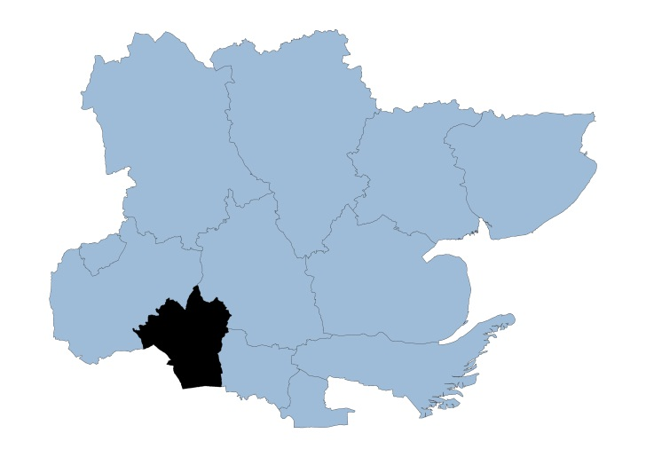

Brentwood Locality

The borough of Brentwood covers approximately 153 square kilometres and is situated in the southwest of Essex and is a town conveniently situated for London, the surrounding countryside and villages.

Brentwood has a population of 77,242 with 504 people living per square km. 89.2% of the population is White British ethnicity.

In the Indices of Multiple Deprivation 2019, Brentwood was ranked 287 out of 317 lower tier authorities in England. This places Brentwood in the 10% of least deprived Lower Tier Local Authorities (LTLAs) nationally.

As of 2019 the Brentwood area contains 46 LSOAs of which none are ranked in the bottom two most deprived deciles nationally.

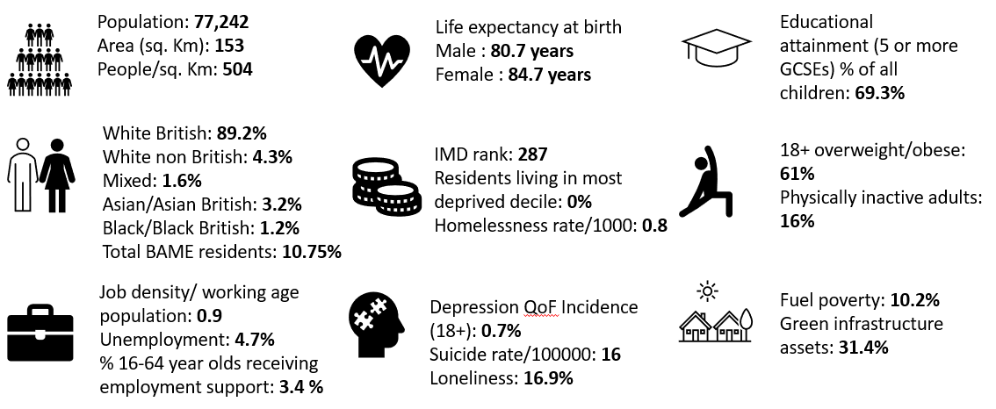

Further details can be accessed in the Essex Joint Strategic Needs Assessment https://data.essex.gov.uk/

Map of Brentwood Pharmacies

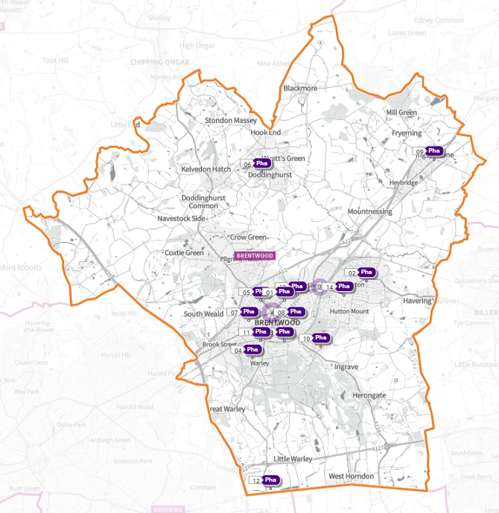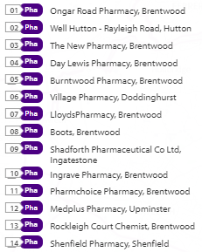

Source: Shape Place Atlas (as at 22/03/22)

Provision

The information contained in this report was obtained from NHSE, local commissioners and a contractor survey.

Opening hours were obtained via the NHSE pharmacy contracts team.

Service provision for advanced services was obtained via NHSE, NHSBSA and with the support of the local LPC.

Access

Appendix F shows that using the base population data on the SHAPE Place Atlas platform, it is possible to calculate the Essex population (and by district) that are estimated to have a journey time either within 20 minutes, 20 - 30 minutes or over 30 minutes to a pharmacy across Essex and within a 1.6KM buffer zone around Essex by each journey method.

Overall, across Essex, generally residents are within a relatively short travel time whichever method is chosen:
- 99.9% of the Essex population could get to a pharmacy in a 20-minute drive.
- 95% a 20-minute public transport journey.
- 83% within a 20-minute walk. Residents have to travel for longer if they walk.
- 11% over 30-minute walk away.
- Brentwood residents can drive to a pharmacy within 20 minutes
- Most residents can get to a pharmacy within a 20-minute journey on public transport in most districts. However, some districts see a relatively high % of their population having to travel for longer (Braintree, Maldon, Uttlesford 20-30 minutes; Braintree, Epping Forest, Uttlesford over 30 minutes)

- Most residents can get to a pharmacy within 20-minute walk in most districts. Some districts however see a relatively higher % of their population that’d have to walk further (Braintree, Brentwood, Uttlesford 20-30 minutes; Braintree, Maldon, Uttlesford over 30 minutes).

Travel time to access pharmaceutical services are no longer than journey times to access key services as shown in section 6 of this report.

From the results of the public survey (Appendix E) 83% of residents stated that they had a reasonable distance to travel to the pharmacy equating to less than 20 minutes, 14% had travelled between 20 and 30 minutes, and 3% had travelled between 30-45 minutes. 61% made the trip by car, and 34% had travelled on foot—only 3% used public transport and 2% a bicycle.

Brentwood residents also have access to dispensing doctors, pharmacies in neighbouring HWB areas and distance selling pharmacies in England. Analysis of dispensing flows in the Basildon and Brentwood CCG area shows that 91% of prescriptions in the CCG are dispensed within the area and 9% out of area including 5% by distance selling pharmacies.

Pharmaceutical services in the locality
Table Number and type of providers of pharmaceutical services in the area
Type Of Contract | Brentwood
Total Number of Community Pharmacies | 13
Dispensing Doctors | 1
Dispensing Appliance Contractors | 0
Distance Selling Pharmacies | 1

Table x Pharmacy contractors in the locality and provision of commissioned services
* Friday hours are taken as standard for Mon- Fri
Services key:
Services 1 & 2 are NHSE commissioned Advanced necessary services
Services 3-6 are NHSE commissioned Advanced services
Service 7 is an NHSE commissioned Enhanced service
Service 8 is a CCG locally commissioned services
Services 9-13 are local authority locally commissioned services

Service Code |  |  |  |  |  |  |  | 1 | 2 | 3 | 4 | 5 | 6 | 7 | 8 | 9 | 10 | 11 | 12 | 13 | 14
Organisation code | Trading Name | Address line | Town | Postcode | Hours: M - F* OPENING HOURS SUPPLEMENTARY | Hours: Sat OPENING HOURS SUPPLEMENTARY | Hours: Sun OPENING HOURS  SUPPLEMENTARY | NMS | CPCS | SAC | SCS | HYPERTENSION | FLU Vaccination | COVID Vaccination | PALLAITIVE CARE | WARFARIN SUPPLY | SEXUAL HEALTH | SMOKING CESSATION | NHS Health Checks | NEEDLE EXCHANGE | SUPERVISED CONSUMPTION
FR398 | Boots | 51 High Street | Brentwood | CM14 4RH | 8:30 - 18:00 | 8:30 - 18:00 |  | ü |  |  |  |  | ü |  |  |  | ü
 |  |  |  |  | 8:30 - 9:00 &  14:00 - 15:00 &  17:00 - 18:00 | 8:30 - 9:00 &  14:00 - 18:00 | 10:00 - 16:00
FEM29 | Burntwood Pharmacy | 27 Shenfield Road | Brentwood | CM15 8AG | 8:30 - 18:30 |  |  | ü | ü |  |  |  | ü |  |  |  | ü | ü
 |  |  |  |  | 8:30 - 9:00 &  13:00 - 14:00 &  18:00 - 18:30 | 9:00 - 13:00 | Closed
FD285 | Day Lewis Pharmacy | Pastoral Way | Brentwood | CM14 5WF | 9:00 - 18:30 |  |  | ü |  |  |  | ü | ü |  |  |  | ü | ü
 |  |  |  |  | 13:00 - 14:00 &  18:00 - 18:30 | 9:00 - 13:00 | Closed
FW781 | Ingrave Pharmacy | 21 East Ham Crescent | Brentwood | CM13 2BN | 9:00 - 18:00 |  |  | ü |  |  | ü | ü | ü |  |  |  |  | ü
 |  |  |  |  |  | Closed | Closed
FLQ00 | Lloyds Pharmacy | 51 William Hunter Way | Brentwood | CM14 4WQ | 8:00 - 21:00 | 8:00 - 21:00 |  | ü | ü |  |  | ü | ü
 |  |  |  |  | 8:00 - 9:00 &  13:00 - 14:00 &  17:00 - 21:00 | 8:00 - 9:00 &  13:00 - 14:00 &  15:00 - 21:00 | 10:00 - 16:00
FE752 | Ongar Road Pharmacy | 249 Ongar Road | Brentwood | CM15 9DZ | 9:00 - 18:00 |  |  | ü | ü |  | ü | ü | ü |  |  |  |  | ü
 |  |  |  |  | 17:00 - 18:00 | Closed | Closed
FJM44 | Pharmchoice Pharmacy (100-hour Pharmacy) | 9 Ingrave Road | Brentwood | CM15 8AP | 7:30 - 22:00 | 7:30 - 22:00 | 9:00 - 22:00 | ü | ü |  |  |  | ü |  | ü |  |  | ü
FKX21 | Rockleigh Court Chemist | 138 Hutton Road | Brentwood | CM15 8NL | 9:00 - 18:30 |  |  |  |  |  |  |  | ü
 |  |  |  |  | 18:00 - 18:30 | 9:00 - 12:00 | Closed
 |  |  |  |  | Closed 13:00 - 14:00
FRP97 | Shadforth Pharmaceutical Co Ltd | 80 High Street | Ingatestone | CM4 9DW | 9:00 - 18:00 | 9:00 - 16:00 |  | ü | ü |  |  |  | ü |  |  |  | ü | ü
 |  |  |  |  | 13:00 - 14:00 &  17:30 - 18:00 | 11:30 - 16:00 | Closed
FWL37 | Shenfield Pharmacy | 222 Hutton Road | Shenfield | CM15 8PA | 9:00 - 18:00 |  |  | ü |  |  |  |  | ü
 |  |  |  |  |  | Closed | Closed
 |  |  |  |  | Closed 13:00 - 14:00
FCN73 | The New Pharmacy | 33A High Street | Brentwood | CM14 4RG | 9:30 - 17:30 | 9:30 - 17:30 |  | ü |  |  |  | ü | ü |  |  |  | ü
 |  |  |  |  | 17:00 - 17:30 | 12:00 - 17:30 | Closed
FJ407 | Village Pharmacy | 86 Church Lane | Brentwood | CM15 0NG | 9:00 - 18:00 |  |  | ü | ü |  | ü |  | ü
 |  |  |  |  | 17.00 - 18:00 | 9:00 - 17:00 | Closed
FCF02 | Well Hutton | 201 Rayleigh Road | Hutton | CM13 1LZ | 8:30 - 18:00 |  |  | ü |  |  |  | ü | ü
 |  |  |  |  | 8:30 - 9:00 &  13:00 - 14:00 | 9:00 - 13:00 | Closed
FJR27 | MediPlus Pharmacy (DSP) | Unit 5, Upminster TP, Warley Street | Upminster | RM14 3PJ | 9:00 - 18:00  Closed 13.00- 14.00 | Closed | Closed | N/A | N/A | N/A | N/A | N/A | N/A | N/A | N/A | N/A | N/A | N/A | N/A | N/A | N/A

Brentwood opening hours
- Weekday opening hours were taken from Friday as a standard.

Monday to Friday, all 13 community pharmacies are open between the hours of 9:00 to 17:00

Earliest opening time is 7.30 and latest closing time is 22.00

- On Saturdays 10 of the pharmacies are open in the morning and 6 of these pharmacies remain open in the afternoon. The latest closing time is 22.00

- On Sundays three pharmacies are open between 1.00 – 16.00, longest opening hours are 9.00 to 22.00

Services (data January 2022)
There is good access to commissioned services within the locality.
The necessary services of NMS and CPCS are provided by almost all the pharmacies.
The NHSE commissioned services that are not provided by pharmacies are delivered by other organisations in the locality.
Housing (Appendix G)

The impact of local housing development plans on provision of pharmaceutical services has been considered but has not identified any gaps in pharmaceutical services provision in the area during the lifetime of this PNA.

No gaps in the provision of necessary pharmaceutical services have been identified in the Brentwood locality

No gaps in pharmaceutical services have been identified that if provided either now or in the future would secure improvements or better access to relevant services across the Brentwood locality

7.4

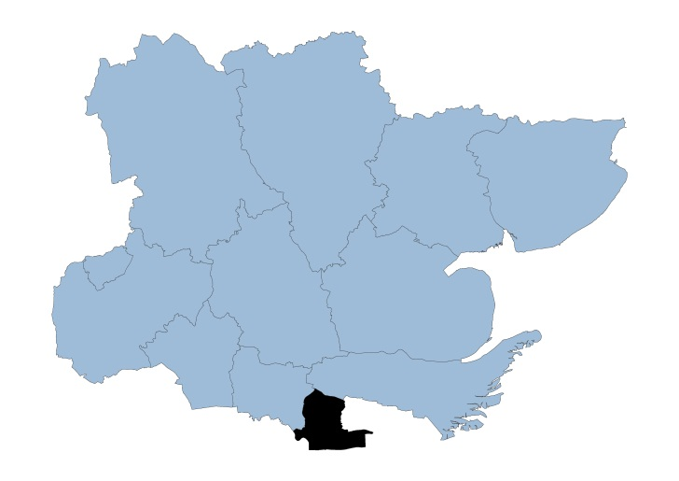

Castle Point Locality

The borough of Castle Point is situated on the coastline of Southeast Essex and has an area of approximately 45 square kilometers.

Castle Point has a population of 90,524, and the second most densely populated district with 2,026 people living per square km. 95.4% of the population is of White British ethnicity.

In the Indices of Multiple Deprivation 2019 the Castle Point Local Authority area was ranked 182 out of 317 lower tier authorities in England. This places Castle Point in the 50% of least deprived Lower Tier Local Authorities (LTLAs) nationally.

As of 2019 the Castle Point area contains 57 LSOAs of which 5 are ranked in the bottom two most deprived deciles nationally.

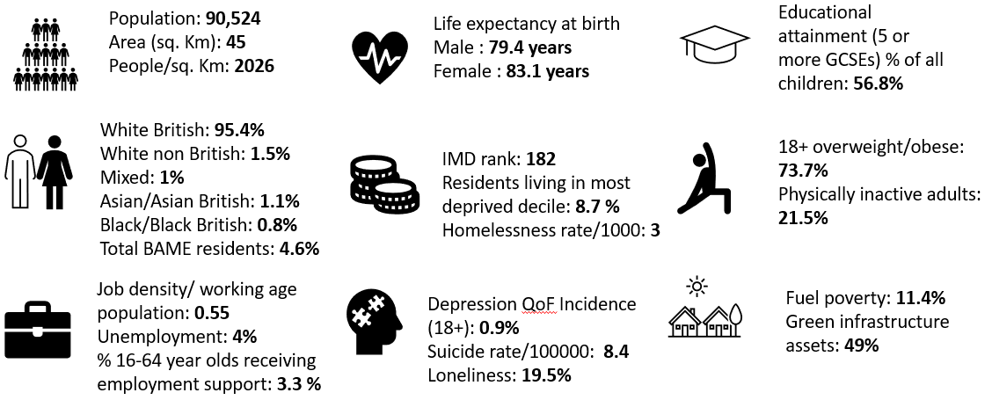

Further details can be accessed in the Essex Joint Strategic Needs Assessment https://data.essex.gov.uk/

Map of Castle Point Pharmacies

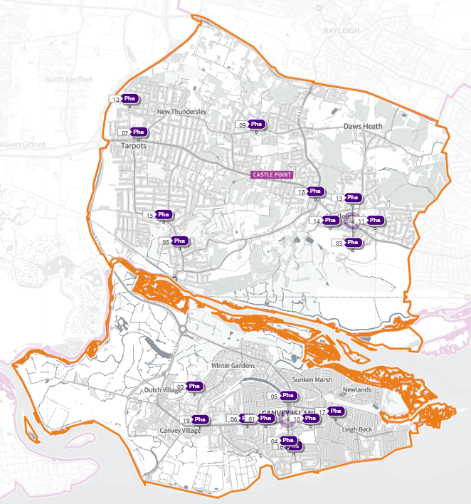 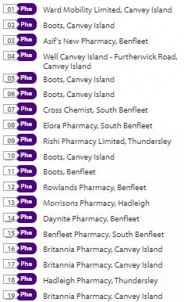
Source: Shape Place Atlas (as at 22/03/22)

Provision

The information contained in this report was obtained from NHSE, local commissioners and a contractor survey.

Opening hours were obtained via the NHSE pharmacy contracts team.

Service provision for advanced services was obtained via NHSE, NHSBSA and with the support of the local LPC.

Access

Appendix F shows that using the base population data on the SHAPE Place Atlas platform, it is possible to calculate the Essex population (and by district) that are estimated to have a journey time either within 20 minutes, 20 - 30 minutes or over 30 minutes to a pharmacy across Essex and within a 1.6KM buffer zone around Essex by each journey method.

Overall, across Essex, generally residents are within a relatively short travel time whichever method is chosen:
- 99.9% of the Essex population could get to a pharmacy in a 20-minute drive.
- 95% a 20-minute public transport journey.
- 83% within a 20-minute walk. Residents have to travel for longer if they walk.
- 11% over 30-minute walk away.
- Castle Point residents can drive to a pharmacy within 20 minutes.

- Most residents can get to a pharmacy within a 20-minute journey on public transport in most districts. However, some districts see a relatively high % of their population having to travel for longer (Braintree, Maldon, Uttlesford 20-30 minutes; Braintree, Epping Forest, Uttlesford over 30 minutes)

- Most residents can get to a pharmacy within 20-minute walk in most districts. Some districts however see a relatively higher % of their population that’d have to walk further (Braintree, Brentwood, Uttlesford 20-30 minutes; Braintree, Maldon, Uttlesford over 30 minutes).

Travel time to access pharmaceutical services are no longer than journey times to access key services as shown in section 6 of this report.

From the results of the public survey (Appendix E) 83% of residents stated that they had a reasonable distance to travel to the pharmacy equating to less than 20 minutes, 14% had travelled between 20 and 30 minutes, and 3% had travelled between 30-45 minutes. 61% made the trip by car, and 34% had travelled on foot—only 3% used public transport and 2% a bicycle.

Castle Point residents also have access to pharmacies in neighbouring HWB areas and distance selling pharmacies in England. Analysis of dispensing flows in the Castle Point and Rochford CCG area shows that 93% of prescriptions generated in the CCG are dispensed within the area and 7% out of area including 3% by distance selling pharmacies.

Pharmaceutical services in the locality

Table Number and type of providers of pharmaceutical services in the area
Type Of Contract | Castle Point
Total Number of Community Pharmacies | 18
Dispensing Doctors | 0
Dispensing Appliance Contractors | 1
Distance Selling Pharmacies | 0

Table of Pharmacy contractors in the locality and provision of commissioned services
* Friday hours are taken as standard for Mon- Fri
Services key:
Services 1 & 2 are NHSE commissioned Advanced necessary services
Services 3-6 are NHSE commissioned Advanced services
Service 7 is an NHSE commissioned Enhanced service
Service 8 is a CCG locally commissioned services
Services 9-13 are local authority locally commissioned services

Service Code |  |  |  |  |  |  |  | 1 | 2 | 3 | 4 | 5 | 6 | 7 | 8 | 9 | 10 | 11 | 12 | 13
Organisation code | Trading Name | Address line | Town | Postcode | Hours: M - F* OPENING HOURS SUPPLEMENTARY | Hours: Sat OPENING HOURS SUPPLEMENTARY | Hours: Sun  OPENING HOURS SUPPLEMENTARY | NMS | CPCS | SAC | SMOKING ADV SERVICE | HYPERTENSION | FLU Vaccination | COVID Vaccination | PALLAITIVE CARE | SEXUAL HEALTH | SMOKING CESSATION | NHS Health Checks | NEEDLE EXCHANGE | SUPERVISED CONSUMPTION
FE106 | Asif's New Pharmacy | 249 - 251 London Road | Benfleet | SS7 2RF | 8:30 - 19:00 |  |  | ü | ü | ü |  |  | ü | ü |  | ü
 |  |  |  |  | 8:30 - 9:00 &  18:00 - 19:00 | 9:00 - 18:00 | Closed
FDQ37 | Benfleet Pharmacy | 299 High Road | South Benfleet | SS7 5HA | 8.30 - 18:30 | 9:00 - 17:30 |  | ü |  |  | ü | ü | ü
 |  |  |  |  | 12:00 - 15:00 | 11: 30 - 15:00 | Closed
FD403 | Boots | The Health Centre, Third Avenue | Canvey Island | SS8 9SU | 8:30 - 18:30 | 9:00 - 12:30 |  |  |  |  |  | ü | ü
 |  |  |  |  | 8:30 - 9:00 &  13:00 - 14:00 &  18:00 - 18:30 |  | Closed
FET19 | Boots | Central Canvey PCC, Long Road | Canvey Island | SS8 0JA | 7:45 - 19:45 |  |  |  |  |  |  |  | ü
 |  |  |  |  | 7:45 - 9:00 &  13:00 - 14:00 &  18:00 - 19:45 | 9:00 - 17:30 | Closed
FFF58 | Boots | 171 Long Road | Canvey Island | SS8 0JD | 9:00 - 18:00 | 9:00 - 17:30 |  |  |  |  |  |  | ü |  |  |  | ü
 |  |  |  |  | 13:00 - 14:00 | 13:00 - 17:30 | Closed
FNA55 | Boots | 33-37 Furtherwick Road | Canvey Island | SS8 7AG | 8:30 - 17:30 | 8:30 - 17:30 |  | ü | ü |  |  |  | ü |  |  | ü | ü
 |  |  |  |  | 8:30 - 9:30 &  14:00 - 15:00 | 8:30 - 9:30 &  14:00 - 15:00 &  15:30 - 17:30 | Closed
FNN94 | Boots | 241/243 London Road | Benfleet | SS7 2RF | 9:00 - 18:30 | 9:00 - 17:00 |  |  | ü |  |  |  | ü |  |  | ü
 |  |  |  |  | 13:00 - 14:00 &  18:00 - 18:30 | 14:00 - 17:00 | Closed
 |  |  |  |  |  | Closed 13:00 - 14:00
FGN22 | Britannia Pharmacy | 236 Furtherwick Road | Canvey Island | SS8 7BY | 9:00 - 19:00 | 9:00 - 18:00 |  | ü |  |  | ü | ü | ü |  |  |  | ü
 |  |  |  |  | 13:00 - 14:00 &  17:00 - 19:00 | 14:00 - 18:00 | Closed
FJT74 | Britannia Pharmacy | 193 High Street | Canvey Island | SS8 7RN | 9:00 - 18:00 |  |  | ü | ü |  | ü | ü | ü |  |  |  | ü
 |  |  |  |  | 13:00 - 14:00 | Closed | Closed
FWW06 | Britannia Pharmacy | 363 Long Road | Canvey Island | SS8 0JQ | 9:00 - 18:00 |  |  | ü |  |  | ü | ü | ü |  |  |  | ü
 |  |  |  |  | 17:00 - 18:00 | Closed | Closed
FFQ50 | Cross Chemist | 133 London Road | South Benfleet | SS7 5UH | 9:00 - 18:00 |  |  | ü |  |  | ü | ü | ü | ü |  | ü | ü
 |  |  |  |  | 13:00 - 14:00 | 9:00 - 15:00 | Closed
FA235 | Daynite Pharmacy | 261 London Road | Hadleigh | SS7 2BN | 10:00 - 23:00 |  |  | ü | ü |  |  | ü | ü
 |  |  |  |  | 18:00 - 23:00 | 19:00 - 23:00 | 10:00 - 23:00
FLE07 | Elora Pharmacy | 115-117 High Road | South Benfleet | SS7 5LN | 8:30 - 18:30 |  |  | ü | ü |  | ü | ü | ü | ü |  | ü | ü
 |  |  |  |  | 8:30 - 9:00 &  13:00 - 14:00 &  18:00 - 18:30 | 8:30 - 13:00 | Closed
FL312 | Hadleigh Pharmacy | 298 Kiln Road | Thundersley | SS7 1QT | 9:00 - 18:30 |  |  | ü |  |  | ü | ü |  |  |  | ü | ü
 |  |  |  |  | 18:00 - 18:30 | 9:00 - 13:00 | Closed
FY948 | Morrisons Pharmacy | 175 London Road | Hadleigh | SS7 2RB | 9:00 - 20:00 | 9:00 - 18:00 |  | ü |  |  |  |  | ü
 |  |  |  |  | 13:00 - 14:00 &  17:00 - 20:00 | 13:00 - 14:00 &  15:00 - 18:00 | 10:00 - 16:00
FN893 | Rishi Pharmacy | 84 Hart Road | Benfleet | SS7 3PE | 8:30 - 18:30 |  |  | ü |  |  |  |  | ü
 |  |  |  |  | 8:30 - 9:00 &  13:00 - 14:00 &  18:00 - 18:30 | 8:30 - 17:30 | Closed
FRH45 | Rowlands Pharmacy | 96 Arundel Road | Benfleet | SS7 4EF | 9:00 - 18:30 |  |  | ü |  |  |  |  | ü
 |  |  |  |  | 13:20 - 14:00 &  18:00 - 18:30 | 9:00 - 13:00 | Closed
 |  |  |  |  | Closed 13:00 - 13:20
FEA83 | Well Canvey Island - Furtherwick Road | 97-99 Furtherwick Road | Canvey Island | SS8 7AY | 8:30 - 19:00 |  |  | ü |  |  |  | ü | ü |  |  | ü |  | ü
 |  |  |  |  | 8:30 - 8:45 &  13:00 - 15:15 | Closed | Closed
FA133 | Ward Mobility Limited (DAC) | 72 Furtherwick Road | Canvey Island | SS8 7AJ | 9:00 - 16:30 | 9:00 - 15:00 |  | N/A | N/A | N/A | N/A | N/A | N/A | N/A | N/A | N/A | N/A | N/A | N/A | N/A

Castle Point opening hours
- Weekday opening hours were taken from Friday as a standard.

Monday to Friday, all 18 community pharmacies are open between the hours of 9:00 to 17:00

Earliest opening time is 7.45 and latest closing time is 23.00

- On Saturdays 15 pharmacies are open in the morning and 11 of the pharmacies remain open in the afternoon. The latest closing time is 23.00

- On Sundays two pharmacies are open, earliest opening is 10.00 and latest closing is 23.00

Services (data January 2022)
There is good access to commissioned services within the locality.
The necessary services of NMS and CPCS are provided by many of the pharmacies.
The NHSE commissioned services that are not provided by pharmacies are delivered by other organisations in the locality.

Housing (Appendix G)

The impact of local housing development plans on provision of pharmaceutical services has been considered but has not identified any gaps in pharmaceutical services provision in the area during the lifetime of this PNA.

No gaps in the provision of necessary pharmaceutical services have been identified in the
Castle Point locality

No gaps in pharmaceutical services have been identified that if provided either now or in the future would secure improvements or better access to relevant services across the Castle Point locality

7.5

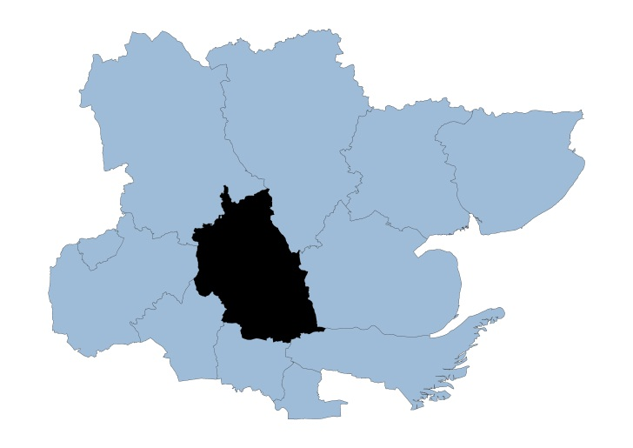

Chelmsford Locality

Covering approximately 339 square kilometers, the Chelmsford borough is situated at the heart of Essex and was granted city status in 2012.

The borough consists of two main urban areas - the county town of Chelmsford and the town of South Woodham Ferrers - along with villages and other rural areas. Chelmsford has a population of 179,549 and 530 people live per square km.

In the Indices of Multiple Deprivation 2019 the Chelmsford Local Authority area was ranked 260 out of 317 lower tier authorities in England. This places Chelmsford in the top 20% of least deprived Lower Tier Local Authorities (LTLAs) nationally.

As of 2019 the Chelmsford area contains 107 LSOAs of which 1 is ranked in the bottom two most deprived deciles nationally. This is equivalent to 0.9% of LSOAs in the area and is lower than the average for Essex.

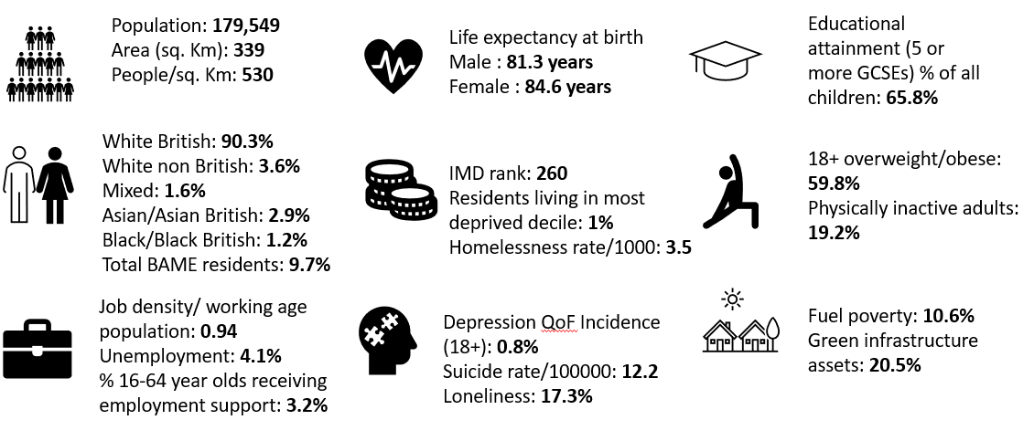
Further details can be accessed in the Essex Joint Strategic Needs Assessment https://data.essex.gov.uk/

Map of Chelmsford Pharmacies

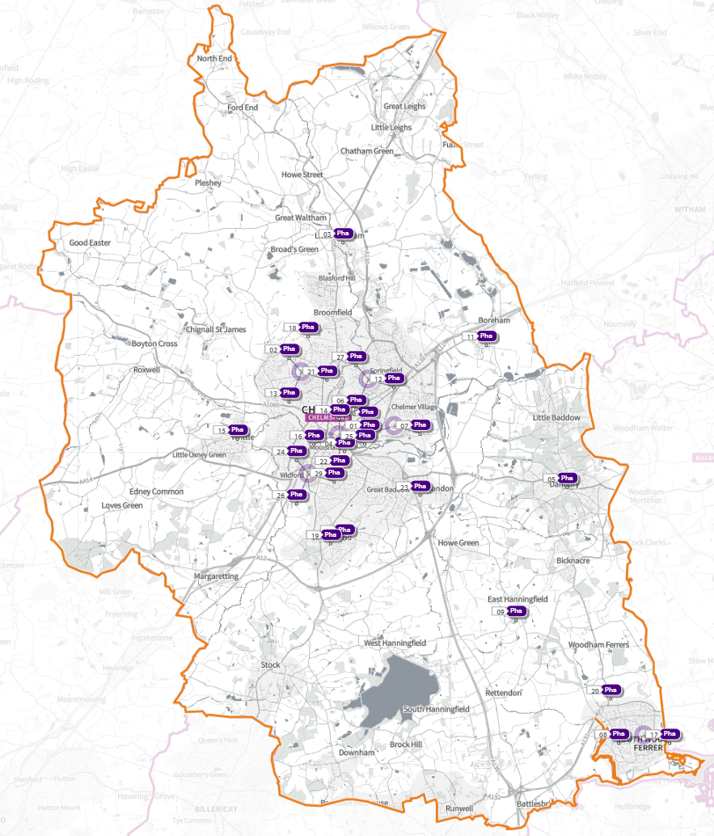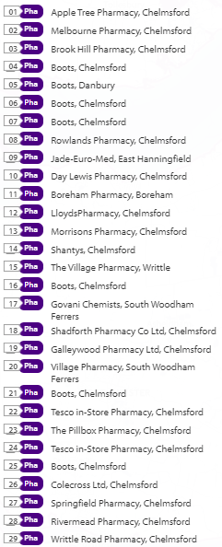
Source: Shape Place Atlas (as at 22/03/22)

Provision

The information contained in this report was obtained from NHSE, local commissioners and a contractor survey.

Opening hours were obtained via the NHSE pharmacy contracts team.

Service provision for advanced services was obtained via NHSE, NHSBSA and with the support of the local LPC.

Access

Appendix F shows that using the base population data on the SHAPE Place Atlas platform, it is possible to calculate the Essex population (and by district) that are estimated to have a journey time either within 20 minutes, 20 - 30 minutes or over 30 minutes to a pharmacy across Essex and within a 1.6KM buffer zone around Essex by each journey method.

Overall, across Essex, generally residents are within a relatively short travel time whichever method is chosen:
- 99.9% of the Essex population could get to a pharmacy in a 20-minute drive.
- 95% a 20-minute public transport journey.
- 83% within a 20-minute walk. Residents have to travel for longer if they walk.
- 11% over 30-minute walk away.
- Chelmsford residents can drive to a pharmacy within 20 minutes.
- Most residents can get to a pharmacy within a 20-minute journey on public transport in most districts. However, some districts see a relatively high % of their population having to travel for longer (Braintree, Maldon, Uttlesford 20-30 minutes; Braintree, Epping Forest, Uttlesford over 30 minutes.)
- Most residents can get to a pharmacy within 20-minute walk in most districts. Some districts however see a relatively higher % of their population that’d have to walk further (Braintree, Brentwood, Uttlesford 20-30 minutes; Braintree, Maldon, Uttlesford over 30 minutes).

Travel time to access pharmaceutical services are no longer than journey times to access key services as shown in section 6 of this report.

From the results of the public survey (Appendix E) 83% of residents stated that they had a reasonable distance to travel to the pharmacy equating to less than 20 minutes, 14% had travelled between 20 and 30 minutes, and 3% had travelled between 30-45 minutes. 61% made the trip by car, and 34% had travelled on foot—only 3% used public transport and 2% a bicycle.

Chelmsford residents also have access to dispensing doctors, pharmacies in neighbouring HWB areas and distance selling pharmacies in England. Analysis of dispensing flows in the Mid Essex CCG area shows that 80% of prescriptions generated in the CCG are dispensed within the area and 20% out of area including 3% by distance selling pharmacies.

Pharmaceutical services in the locality
Table Number and type of providers of pharmaceutical services in the area
Type Of Contract | Chelmsford
Total Number of Community Pharmacies | 28
Dispensing Doctors | 7
Dispensing Appliance Contractors | 1
Distance Selling Pharmacies | 0

Table of Pharmacy contractors in the locality and provision of commissioned services
* Friday hours are taken as standard for Mon- Fri
Services key:
Services 1 & 2 are NHSE commissioned Advanced necessary services
Services 3-6 are NHSE commissioned Advanced services
Service 7 is an NHSE commissioned Enhanced service
Service 8 is a CCG locally commissioned services
Services 9-13 are local authority locally commissioned services

Service Key |  |  |  |  |  |  |  | 1 | 2 | 3 | 4 | 5 | 6 | 7 | 8 | 9 | 10 | 11 | 12 | 13
Organisation code | Trading Name | Address line | Town | Postcode | Hours: M - F* OPENING HOURS SUPPLEMENTARY | Hours: Sat OPENING HOURS SUPPLEMENTARY | Hours: Sun OPENING HOURS  SUPPLEMENTARY | NMS | CPCS | SAC | SCS | HYPERTENSION | FLU Vaccination | COVID Vaccination | PALLAITIVE CARE | SEXUAL HEALTH | SMOKING CESSATION | NHS Health Checks | NEEDLE EXCHANGE | SUPERVISED CONSUMPTION
FL640 | Apple Tree Pharmacy | 6 Chelmer Village Square | Chelmsford | CM2 6RF | 9:00 - 18:00 |  |  | ü |  |  |  | ü | ü | ✓ |  | ü
 |  |  |  |  | 13:00 - 14:00 | 9:00 - 13:00 | Closed
FE489 | Boots | 1 The Vineyards | Chelmsford | CM2 7QS | 9:00 - 18:30 | 9:00 - 17:00 |  |  | ü |  |  |  | ü
 |  |  |  |  | 17:30 - 18:30 | 13:30 - 17:00 | Closed
 |  |  |  |  | Closed 12:30 - 13:30 | Closed 12:30 - 13:30
FHG91 | Boots | Eves Corner, Maldon Road | Danbury | CM3 4QF | 8:30 - 18:30 | 8:30 - 17:00 |  | ü | ü |  |  | ü | ü
 |  |  |  |  | 8:30 - 9:00 &  13:00 - 14:00 &  17:30 - 18:30 | 8:30 - 9:00 &  11:30 - 17:00 | Closed
FL401 | Boots | 10-12 Torquay Road | Chelmsford | CM1 6NF | 9:00 - 18:00 |  |  |  |  |  |  |  | ü
 |  |  |  |  | 13:00 - 14:00 | 9:00 -17:00 | Closed
FM336 | Boots | Unit B2, Chelmer Village Retail Park | Chelmsford | CM2 6XE | 9:00 - 20:00 | 9:00 – 20:00 |  | ü | ü |  |  |  | ü |  |  | ü | ü
 |  |  |  |  | 14:00 - 15:00 &  17:00 - 20:00 | 14:00 - 20:00 | 11:00 - 17:00
FPD07 | Boots | 43 High Chelmer | Chelmsford | CM1 1DD | 8:30 - 18:00 | 8:30 - 18:00 |  | ü |  |  |  | ü | ü |  |  | ü | ü
 |  |  |  |  | 8:30 - 9:00 &  12:00 - 13:00 &  17:00 - 18:00 | 8:30 - 9:00 &  12:00 - 13:00 &  15:00 - 18:00 | 10:30 - 16:30
FQJ94 | Boots | 133 Sunrise Avenue | Chelmsford | CM1 4JW | 9:00 - 18:00 | 9:00 - 17:30 |  |  |  |  |  | ü | ü |  |  | ü
 |  |  |  |  | 13:00 - 14:00 | 13:00 - 17:30 | Closed
FWF28 | Boots | 51A Moulsham Street | Chelmsford | CM2 0HY | 9:00 - 18:30 | 9:00 - 13:00 |  |  |  |  |  |  | ü
 |  |  |  |  | 14:00 - 15:00 &  18:00 - 18:30 | 13:00 - 17:30 | Closed
FNH19 | Boreham Pharmacy | The Laurels, Juniper Road | Boreham | CM3 3DX | 8:30 - 18:30 |  |  | ü |  |  | ü |  | ü |  |  |  | ü
 |  |  |  |  | 8:30 - 9:00 &  18:00 - 18:30 | 9:00 - 12:00 | Closed
 |  |  |  |  | Closed 13:00 - 14:00
FE215 | Brook Hill Pharmacy | 30 Brook Hill | Chelmsford | CM3 3LL | 8:30 - 18:30 |  |  |  |  |  |  |  | ü
 |  |  |  |  | 8:30 - 9:00 &  17:00 - 18:30 | 8:00 - 12:00 | Closed
FXM66 | Colecross | 1 Hylands Parade, Wood Street | Chelmsford | CM2 8BW | 9:00 - 18:00 |  |  | ü | ü |  |  | ü | ü | ✓ |  | ü
 |  |  |  |  | 13:00 - 14:00 | 9:00 - 13:00 | Closed
FN033 | Day Lewis Pharmacy | 136 Gloucester Avenue | Chelmsford | CM2 9LG | 9:00 - 18:00 |  |  | ü | ü |  |  | ü |  |  |  | ü | ü
 |  |  |  |  | 17:00 - 18:00 | 9:00 - 13:00 | Closed
FQ192 | Galleywood Pharmacy Ltd | 39 Watchhouse Road | Chelmsford | CM2 8PU | 9:00 - 17:30 | 9:00 - 13:00 |  | ü |  |  |  |  | ü | ✓
 |  |  |  |  | 13:00 - 14:00 |  | Closed
FPE21 | Govani Chemists | 14 Queen Elizabeth Square | South Woodham Ferrers | CM3 5TD | 8:30 - 18:30 |  |  | ü | ü |  |  | ü | ü
 |  |  |  |  | 8:30 - 9:00 &  13:00 - 14:00 &  18:00 - 18:30 | 9:30 - 17:00 | Closed
FNL09 | Lloyds Pharmacy (100-hour Pharmacy) | 2 White Hart Lane | Chelmsford | CM2 5PA | 7:00 - 23:00 | 7:00 - 22:00 | 10:00 - 16:00 | ü | ü |  |  | ü | ü
FD477 | Melbourne Pharmacy | 18 Melbourne Parade | Chelmsford | CM1 2DW | 9:00 - 18:00 |  |  | ü | ü |  | ü | ü | ü | ✓ |  | ü | ü
 |  |  |  |  | 17:00 - 18:00 | 9:00 - 12:30 | Closed
FNW43 | Morrisons Pharmacy | Dickens Place, Copperfield Road | Chelmsford | CM1 4UX | 8:00 - 20:00 | 8:00 - 19:00 |  | ü |  |  |  |  | ü |  |  | ü
 |  |  |  |  | 8:00 - 9:00 &  17:00 - 20:00 | 8:00 - 9:00 &  15:00 - 19:00 | 10:00 - 16:00
 |  |  |  |  | Closed 13:00 - 14:00 | Closed 13:00 - 14:00
FPC79 | Rivermead Pharmacy | Unit 3&4 Rivermead Gate, Rectory Lane | Chelmsford | CM1 1TR | 8:30 - 18:30 |  |  | ü |  |  |  |  | ü |  |  | ü
 |  |  |  |  | 8:30 - 9:00 &  13:00 - 13:30 &  17:30 - 18:30 | Closed | Closed
FM403 | Rowlands Pharmacy | 6 Brickfields Road | Chelmsford | CM3 5XB | 9:00 - 18:00 |  |  | ü | ü |  |  |  | ü
 |  |  |  |  | 13:20 - 14:00 | Closed | Closed
 |  |  |  |  | Closed 13:00 - 13:20
FPK31 | Shadforth Pharmaceutical Co Ltd | 253 Broomfield Road | Chelmsford | CM1 4DP | 8:30 - 18:30 |  |  | ü | ü |  |  |  | ü |  |  | ü
 |  |  |  |  | 8:30 - 9:00 &  13:00 - 13:30 &  17:30 - 18:30 | 9:00 - 13:00 | Closed
FP682 | Shantys | 62 Baddow Road | Chelmsford | CM2 0DL | 9:00 - 18:30 |  |  | ü | ü |  |  | ü | ü
 |  |  |  |  | 18:00 - 18:30 | Closed | Closed
 |  |  |  |  | Closed 13:00 - 14:00
FH505 | Springfield Pharmacy | 1 Clematis Tye, Crocus Way | Chelmsford | CM1 6GL | 9:00 - 18:30 |  |  |  |  |  |  |  | ü
 |  |  |  |  | 18:00 - 18:30 | 9:00 - 13:00 | Closed
 |  |  |  |  | Closed 13:00 -14:00
FQR56 | Tesco In-store Pharmacy | 47-53 Springfield Rd | Chelmsford | CM2 6QT | 8:00 - 20:00 | 8:00 - 20:00 |  | ü | ü |  |  |  | ü |  |  |  | ü
 |  |  |  |  | 8:00 - 9:00 &  16:30 - 20:00 | 8:00 - 9:00 &  16:30 - 20:00 | 11:00 - 17:00
 |  |  |  |  | Closed 13:00 - 14:00 | Closed 13:00 - 14:00
FW239 | Tesco In-store Pharmacy (100-hour Pharmacy) | Princes Road | Chelmsford | CM2 9XW | 6:30 - 22:30 | 6:30 - 22:00 | 10:00 - 16:00 | ü | ü |  |  |  | ü |  | ü
FR890 | The Pillbox Pharmacy | 152 Meadgate Avenue | Chelmsford | CM2 7LJ | 9:00 - 18:30 |  |  | ü |  |  |  | ü | ü | ✓
 |  |  |  |  | 17:00 - 18:30 | 9:00 - 12:00 | Closed
FP905 | The Village Pharmacy | 52 The Green | Writtle | CM1 3DU | 9:00 - 18:30 | 9:00 - 13:00 |  | ü | ü |  |  | ü | ü |  |  | ü | ü
 |  |  |  |  | 17:30 - 18:30 | 12:00 - 13:00 | Closed
 |  |  |  |  | Closed 13:00 - 14:00
FQH29 | Village Pharmacy | 36-38 Hullbridge Road | South Woodham Ferrers | CM3 5NG | 9:00 - 18:30 | 9:00 - 13:00 |  | ü | ü |  |  | ü | ü
 |  |  |  |  | 13:00 - 14:00 &  17:30 - 18:30 |  | Closed
FTG17 | Writtle Road Pharmacy | Unit 1A, Crompton Building, Writtle Road | Chelmsford | CM1 3RW | 8:00 - 18:30 |  |  | ü | ü |  | ü | ü | ü | ✓
 |  |  |  |  | 8:00 - 9:30 &  17:30 - 18:30 | 9:00 - 15:00 | Closed
FMG28 | Jade-Euro-Med (DAC) | 14 Hanningfield Ind Est, Old Church Road | East Hanningfield | CM3 8AB | 9:00 - 17:00 |  |  | N/A | N/A | N/A | N/A | N/A | N/A | N/A | N/A | N/A | N/A | N/A | N/A | N/A

Chelmsford opening hours
- Weekday opening hours were taken from Friday as a standard.

Monday to Friday, all 28 community pharmacies are open between the hours of 9:00 to 17:00

Earliest opening time is 6.30 and latest closing time is 23.00
- On Saturdays 25 pharmacies are open in the morning and 13 of the pharmacies remain open in the afternoon. The latest closing time is 22.00
- On Sundays six pharmacies are open, earliest opening is 10.00 and latest closing is 17.00

Services (data January 2022)
There is good access to commissioned services within the locality.
The necessary services of NMS and CPCS are provided by many of the pharmacies.
The NHSE commissioned services that are not provided by pharmacies are delivered by other organisations in the locality.

Housing (Appendix G)
The impact of local housing development plans on provision of pharmaceutical services has been considered but has not identified any gaps in pharmaceutical services provision in the area during the lifetime of this PNA.

No gaps in the provision of necessary pharmaceutical services have been identified in the
Chelmsford locality

No gaps in pharmaceutical services have been identified that if provided either now or in the future would secure improvements or better access to relevant services across the Chelmsford locality

7.6

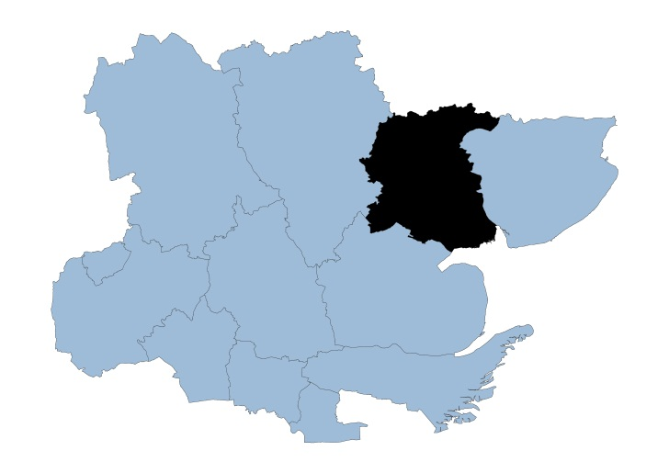

Colchester Locality

The borough of Colchester is situated in the North East of Essex and covers an area of approximately 328 square kilometers. The main settlement is Colchester, which was recently granted City-status to mark the Queen’s Platinum Jubilee year, but there are many surrounding small towns and villages of which the largest are Stanway, Tiptree, West Mersea and Wivenhoe.

Colchester district has a population of 197,200 with 601 people living per square km, making it the most populous district in Essex. 87.5% of the population are White British ethnicity. In the Indices of Multiple Deprivation 2019 the Colchester Local Authority area was ranked 181 out of 317 lower tier authorities in England. This places Colchester in the upper 50% of least deprived Lower Tier Local Authorities (LTLAs) nationally.

As of 2019 the Colchester area contains 105 LSOAs of which 11 are ranked in the bottom two most deprived deciles nationally. This is equivalent to 10.5% of LSOAs in the area.

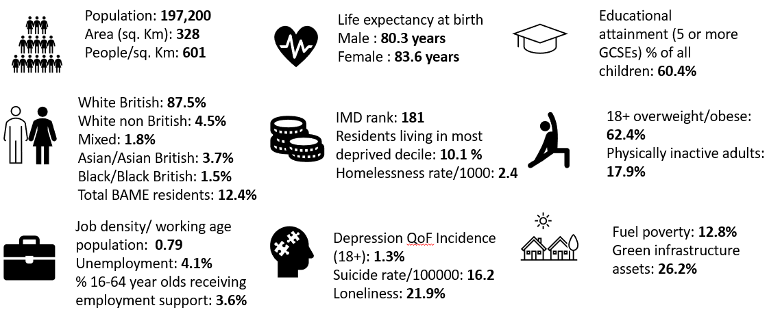

Further details can be accessed in the Essex Joint Strategic Needs Assessment https://data.essex.gov.uk/

Map of Colchester Pharmacies

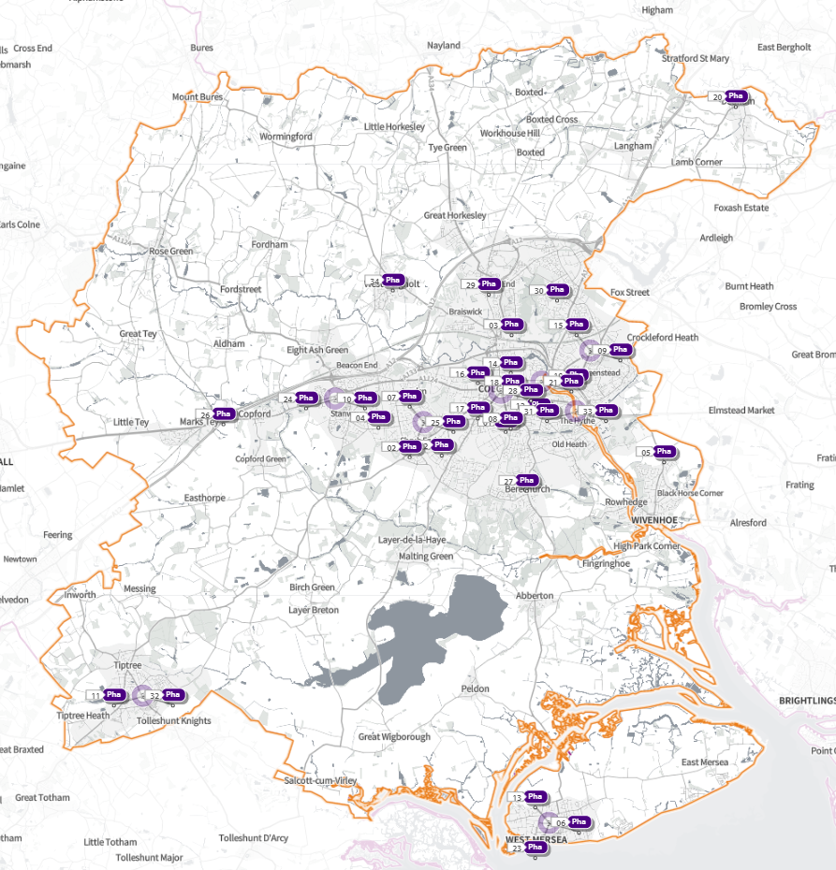 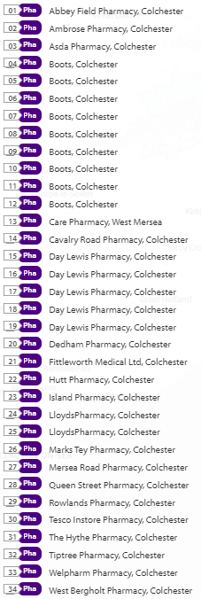
Source: Shape Place Atlas (as at 22/03/22)

Provision

The information contained in this report was obtained from NHSE, local commissioners and a contractor survey.

Opening hours were obtained via the NHSE pharmacy contracts team.

Service provision for advanced services was obtained via NHSE, NHSBSA and with the support of the local LPC.

Access

Appendix F shows that using the base population data on the SHAPE Place Atlas platform, it is possible to calculate the Essex population (and by district) that are estimated to have a journey time either within 20 minutes, 20 - 30 minutes or over 30 minutes to a pharmacy across Essex and within a 1.6KM buffer zone around Essex by each journey method.

Overall, across Essex, generally residents are within a relatively short travel time whichever method is chosen:
- 99.9% of the Essex population could get to a pharmacy in a 20-minute drive.
- 95% a 20-minute public transport journey.
- 83% within a 20-minute walk. Residents have to travel for longer if they walk.
- 11% over 30-minute walk away.
- Colchester residents can drive to a pharmacy within 20 minutes
- Most residents can get to a pharmacy within a 20-minute journey on public transport in most districts. However, some districts see a relatively high % of their population having to travel for longer (Braintree, Maldon, Uttlesford 20-30 minutes; Braintree, Epping Forest, Uttlesford over 30 minutes).
- Most residents can get to a pharmacy within 20-minute walk in most districts. Some districts however see a relatively higher % of their population that’d have to walk further (Braintree, Brentwood, Uttlesford 20-30 minutes; Braintree, Maldon, Uttlesford over 30 minutes).

Travel time to access pharmaceutical services are no longer than journey times to access key services as shown in section 6 of this report.

From the results of the public survey (Appendix E) 83% of residents stated that they had a reasonable distance to travel to the pharmacy equating to less than 20 minutes, 14% had travelled between 20 and 30 minutes, and 3% had travelled between 30-45 minutes. 61% made the trip by car, and 34% had travelled on foot—only 3% used public transport and 2% a bicycle.

Colchester residents also have access to dispensing doctors, pharmacies in other HWB areas and distance selling pharmacies in England. Analysis of dispensing flows in the North East Essex CCG area shows that 89% of prescriptions generated in the CCG are dispensed within the area and 11% out of area including 5% by distance selling pharmacies.

Pharmaceutical services in the locality
Table Number and type of providers of pharmaceutical services in the area
Type Of Contract | Colchester
Total Number of Community Pharmacies | 33
Dispensing Doctors | 5
Dispensing Appliance Contractors | 1
Distance Selling Pharmacies | 1

Table of Pharmacy contractors in the locality and provision of commissioned services
* Friday hours are taken as standard for Mon- Fri
Services key:
Services 1 & 2 are NHSE commissioned Advanced necessary services
Services 3-6 are NHSE commissioned Advanced services
Service 7 is an NHSE commissioned Enhanced service
Service 8 is a CCG locally commissioned services
Services 9-13 are local authority locally commissioned services

Service Key |  |  |  |  |  |  |  | 1 | 2 | 3 | 4 | 5 | 6 | 7 | 8 | 9 | 10 | 11 | 12 | 13
Organisation code | Trading Name | Address line | Town | Postcode | Hours: M - F* OPENING HOURS SUPPLEMENTARY | Hours: Sat OPENING HOURS SUPPLEMENTARY | Hours: Sun OPENING HOURS  SUPPLEMENTARY | NMS | CPCS | SAC | SCS | HYPERTENSION | FLU Vaccination | COVID Vaccination | PALLAITIVE CARE | SEXUAL HEALTH | SMOKING CESSATION | NHS Health Checks | NEEDLE EXCHANGE | SUPERVISED CONSUMPTION
FTA74 | Abbey Field Pharmacy | Abbey Field Medical Centre, Ypres Road | Colchester | CO2 7UW | 8:30 – 18:00 |  |  | ü | ü |  |  | ü | ü |  |  | ü
 |  |  |  |  | 8:30 - 9:00 &  17:30 - 18:00 | 9:00 - 13:00 | Closed
FXG91 | Ambrose Pharmacy (100 Hour Pharmacy) | 76 Ambrose Avenue | Colchester | CO3 4LN | 8:00 - 22:30 | 8:00 - 22:30 | 8:00 - 21:00 | ü |  |  |  | ü | ü |  | ü | ü
FWM54 | Asda Pharmacy (100 Hour Pharmacy) | Unit 9 Turner Rise, Petrolea Close | Colchester | CO4 5TU | 7:00 - 23:00 | 7:00 - 22:00 | 10:00 - 16:00 | ü |  |  |  | ü | ü |  |  | ü | ü
FD158 | Boots | Fiveways Superstore, Peartree Road | Colchester | CO3 0JX | 8:30 - 19:00
 |  |  |  |  | 8:30 - 9:00 &  13:00 - 14:00 &  18:00 - 19:00 | 8:30 - 13:00 &  14:00 - 17:00
 |  |  |  |  |  | Closed 13:00 - 14:00
FGG82 | Boots | 11 Vine Parade, Wivenhoe | Colchester | CO7 9HA | 9:00 - 18:30 | 9:00 - 17:00 |  | ü | ü |  |  |  | ü
 |  |  |  |  | 18:00 - 18:30 | 14:00 - 17:00 | Closed
 |  |  |  |  | Closed 13:00 - 14:00 | Closed 13:00 - 14:00
FHH99 | Boots | 37 Barfield Road. West Mersea | Colchester | CO5 8QX | 8:30 - 17:30 | 9:00 - 17:00 |  |  |  |  |  | ü | ü
 |  |  |  |  | 8:30 - 9:00 | 11:30 - 13:00 &  14:00 - 17:00 | Closed
 |  |  |  |  | Closed 13:00 - 14:00 | Closed 13:00 - 14:00
FMP08 | Boots (100 Hour Pharmacy) | 2/4 West Parade, Plume Avenue | Colchester | CO3 4PG | 8:00 - 23:00 | 8:00 - 23:00 | 09:00 - 19:00 | ü |  |  |  |  | ü |  |  |  | ü
FQ064 | Boots | 5-6 Lion Walk | Colchester | CO1 1LX | 8:30 - 17:30 | 8:30 - 17:30 |  | ü | ü |  |  | ü | ü |  |  | ü
 |  |  |  |  | 8:30 - 9:30 &  17:00 - 17:30 | 8:30 - 9:30 &  17:00 - 17:30 | 10:30 - 16:30
 |  |  |  |  | Closed 14:00 - 15:00 | Closed 14:00 - 15:00
FQL97 | Boots | St Edmunds Centre, Tamarisk Way. Greenstead | Colchester | CO4 3GW | 9:00 - 18:30 |  |  |  |  |  |  |  | ü |  |  | ü | ü
 |  |  |  |  | 18:00 - 18:30 | 9:00 - 17:00 | Closed
 |  |  |  |  | Closed 13:00 - 14:00
FWC44 | Boots (100 Hour Pharmacy) | Unit 9 Tollgate West. Stanway | Colchester | CO3 8RG | 8:00 - 24:00 | 8:00 - 24:00 | 10:00 - 24:00 | ü |  |  |  |  |  |  |  | ü | ü
 |  |  |  |  |  | 22:00 - 24:00 | 16:00 - 24:00
FWP44 | Boots | 3-5 The Centre, Church Road. Tiptree | Colchester | CO5 0HF | 8:30 - 19:00 | 8:30 - 17:30 |  | ü |  |  |  | ü | ü |  |  | ü
 |  |  |  |  | 8:30 - 9:00 &  13:00 - 14:00 &  18:00 - 19:00 | 8:30 - 9:00 &  13:00 - 17:30 | Closed
FXK05 | Boots | 118 Military Road | Colchester | CO1 2AR | 8:30 - 18:30 |  |  |  | ü |  |  |  | ü |  |  | ü | ü
 |  |  |  |  | 8:30 - 9:00 &  13:00 - 14:00 &  18:00 - 18:30 | 9:00 - 17:00 | Closed
FCX92 | Care Pharmacy (100 Hour Pharmacy) | Retail Unit 1, 37/39 Kingsland Road. West Mersea | Colchester | CO5 8RA | 7:00 - 21:00 | 6:00 - 21:00 | 6:00 - 21:00 | ü |  |  |  |  | ü
FRH62 | Cavalry Road Pharmacy | 15 Cavalry Road | Colchester | CO2 7GH | 8:00 - 20:00 |  |  | ü |  |  |  | ü | ü |  | ü
 |  |  |  |  | 8:00 - 9:00 &  13:00 - 14:00 &  18:00 - 20:00 | 8:00 - 13:00 | Closed
FAX47 | Crouch End Pharmacy | 77 Crouch Street | Colchester | CO3 3EZ | 9:00 - 18:00 |  |  | ü |  |  |  | ü | ü |  |  | ü
 |  |  |  |  | 13:00 - 14:00 | Closed | Closed
FCF12 | Day Lewis Pharmacy | 338 Harwich Road | Colchester | CO4 3HP | 9:00 - 18:00 | 9:00 - 13:00 | 12:00 - 14:00 | ü | ü |  |  | ü | ü |  |  |  | ü
 |  |  |  |  |  |  | 13:00 - 14:00
 |  |  |  |  | Closed 13:00 - 13:30
FE605 | Day Lewis Pharmacy | 7 Priory Walk | Colchester | CO1 1LG | 9:00 - 17:30 |  |  | ü |  |  | ü | ü | ü |  |  | ü | ü
 |  |  |  |  | 13:30 - 14:00 | 9:00 - 13:00 | Closed
FPQ30 | Day Lewis Pharmacy | 38 St.Christopher Road | Colchester | CO4 0NA | 9:00 - 17:30 |  |  | ü | ü |  |  | ü | ü |  |  | ü | ü
 |  |  |  |  | 17:00 - 17:30 | 9:00 - 13:00 | Closed
FTG75 | Dedham Pharmacy | High Street | Dedham | CO7 6DE | 9:00 - 17:00 | 9:00 - 14:00 |  | ü | ü |  |  | ü | ü
 |  |  |  |  |  |  | Closed
 |  |  |  |  | Closed 13:00 - 14:00
FC645 | Hutt Pharmacy | 4 The Square, Iceni Way | Colchester | CO2 9EB | 9:00 - 18:00 |  |  | ü | ü |  |  |  | ü |  |  | ü | ü
 |  |  |  |  |  | 9:00 - 13:00 | Closed
 |  |  |  |  | Closed 13:00 - 14:00
FK840 | Island Pharmacy (100 Hour Pharmacy) | 4 & 5 Kingsway, Barfield Rd. West Mersea | Colchester | CO5 8QT | 7:00 - 23:00 | 7:00 - 21:00 | 10:30 - 16:30 | ü |  |  |  |  | ü
FQ682 | Lloyds Pharmacy | 1 Western Approach, Stanway | Colchester | CO3 8AA | 8:00 - 22:00 | 8:00 - 20:00 | 10:00 - 16:00 | ü |  |  |  | ü | ü
 |  |  |  |  | 8:00 - 9:00 &  12:00 - 15:00 &  18:00 - 22:00 | 8:00 - 9:00 &  13:00 - 20:00
FQK85 | Lloyds Pharmacy | 102 The Commons, Prettygate | Colchester | CO3 4NW | 8:45 - 18:00 | 9:00 - 17:30 |  | ü | ü |  |  | ü | ü |  |  | ü
 |  |  |  |  | 11:45 - 14:00 | 13:00 - 17:30 | Closed
FEL66 | Marks Tey Pharmacy | 89 London Road | Colchester | CO6 1EB | 8:30 - 17:30 | 9:00 - 14:00 |  | ü | ü |  |  | ü | ü
 |  |  |  |  | 8:30 - 9:00 &  13:00 - 14:00 |  | Closed
FN556 | Mersea Road Pharmacy | 358 Mersea Road | Colchester | CO2 8RB | 9:00 - 18:30 | 9:00 - 13:00 |  | ü | ü |  |  | ü | ü |  |  | ü | ü
 |  |  |  |  | 12:30 - 14:30 | 9:00 - 9:30 &  12:00 - 13:00 | Closed
FJH41 | Priory Pharmacy | 81A East Hill | Colchester | CO1 2QW | 8:30 - 18:30 |  |  | ü |  |  |  | ü | ü |  |  | ü
 |  |  |  |  | 8:30 - 9:00 &  18:00 - 18:30 | Closed | Closed
 |  |  |  |  | Closed 13:00 - 14:00
FV129 | Queen Street Pharmacy (100 Hour Pharmacy) | 12 Queen Street | Colchester | CO1 2PJ | 7:00 - 23:00 | 7:00 - 21:00 | 10:30 - 16:30 | ü | ü |  | ü |  | ü |  |  | ü
FT659 | Rowlands Pharmacy | 13 Nayland Road | Colchester | CO4 5EG | 9:00 - 18:00 |  |  | ü |  |  |  |  | ü
 |  |  |  |  |  | Closed | Closed
 |  |  |  |  | Closed 13:00 - 14:00
FTC16 | Tesco In-store Pharmacy | The In-Store Pharmacy, Highwoods | Colchester | CO4 9ED | 8:00 - 20:00 | 8:00 - 20:00 |  | ü | ü |  | ü |  | ü |  |  |  | ü
 |  |  |  |  | 8:00 - 9:00 &  13:00 - 14:00 &  16:30 - 20:00 | 8:00 - 9:00 &  13:00 - 14:00 &  16:30 - 20:00 | 10:00 - 16:00
FGW89 | The Hythe Pharmacy | 2 Hythe Quay | Colchester | CO2 8JB | 9:00 - 18:00 |  |  | ü | ü |  | ü |  | ü |  | ü | ü | ü
 |  |  |  |  | 13:00 - 14:00 | 9:00 - 13:00 | Closed
FPP46 | Tiptree Pharmacy (100-Hour Pharmacy) | Unit 4, 80 Church Road | Colchester | CO5 0HB | 8:00 - 22:30 | 8:00 - 22:00 | 9:00 - 22:00 | ü | ü |  | ü |  | ü |  | ü
FW890 | West Bergholt Pharmacy | 39 Chapel Road | Colchester | CO6 3JB | 9:00 - 18:00 |  |  |  |  |  |  | ü | ü
 |  |  |  |  |  | 9:00 - 13:00 | Closed
 |  |  |  |  | Closed 13:00 - 14:00
FQV90 | Welpharm Pharmacy (DSP) | 4 Phoenix Court, Hawkins Road | Colchester | CO2 8JY | 9:00 - 17:00 |  |  | ü
 |  |  |  |  |  | Closed | Closed
FWC51 | Fittleworth Medical Ltd (DAC) | D41-D42 Moorside Business | Colchester | CO1 2ZF | 9:00 - 15:00 |  |  | N/A | N/A | N/A | N/A | N/A | N/A | N/A | N/A | N/A | N/A | N/A | N/A | N/A

Colchester opening hours
- Weekday opening hours were taken from Friday as a standard.

Monday to Friday, all 33 community pharmacies are open between the hours of 9:00 to 17:00

Earliest opening time is 7.00 and latest closing time is 24.00
- On Saturdays 29 pharmacies are open in the morning and 19 of the pharmacies remain open in the afternoon. The latest closing time is 24.00
- On Sundays 12 pharmacies are open, earliest opening is 6.00 and latest closing is 24.00

Services (data January 2022)
There is good access to commissioned services within the locality.
The necessary services of NMS and CPCS are provided by many of the pharmacies.
The NHSE commissioned services that are not provided by pharmacies are delivered by other organisations in the locality.

Housing (Appendix G)

The impact of local housing development plans on provision of pharmaceutical services has been considered but has not identified any gaps in pharmaceutical services provision in the area during the lifetime of this PNA.

No gaps in the provision of necessary pharmaceutical services have been identified in the
Colchester locality

No gaps in pharmaceutical services have been identified that if provided either now or in the future would secure improvements or better access to relevant services across the Colchester locality

7.7

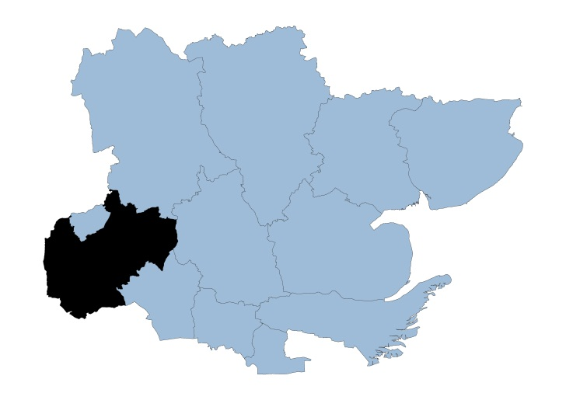

Epping Forest Locality

Epping Forest district covers an area of 339 square kilometers, the key population centers are the commuter towns of Loughton, Chigwell and Buckhurst Hill, as well as the market towns of Epping, Waltham Abbey and Ongar. Epping Forest has a population of 132,175 with 390 people living per square km.

14.7% of the population is of BAME ethnicity which makes it the second most diverse among all Essex districts. Epping forest was ranked 200 out of 317 lower tier local authorities placing it among the upper 40% of the least deprived local authorities nationally.

Only 1.3% of the total population live in the most deprived deciles.

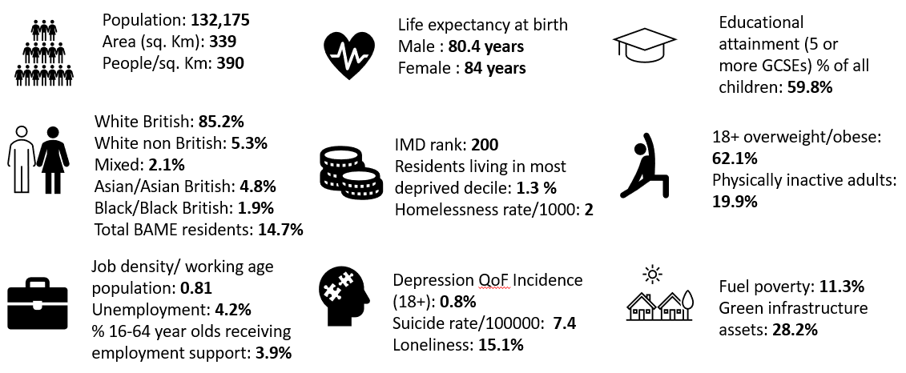

Further details can be accessed in the Essex Joint Strategic Needs Assessment https://data.essex.gov.uk/

Map of Epping Forest Pharmacies

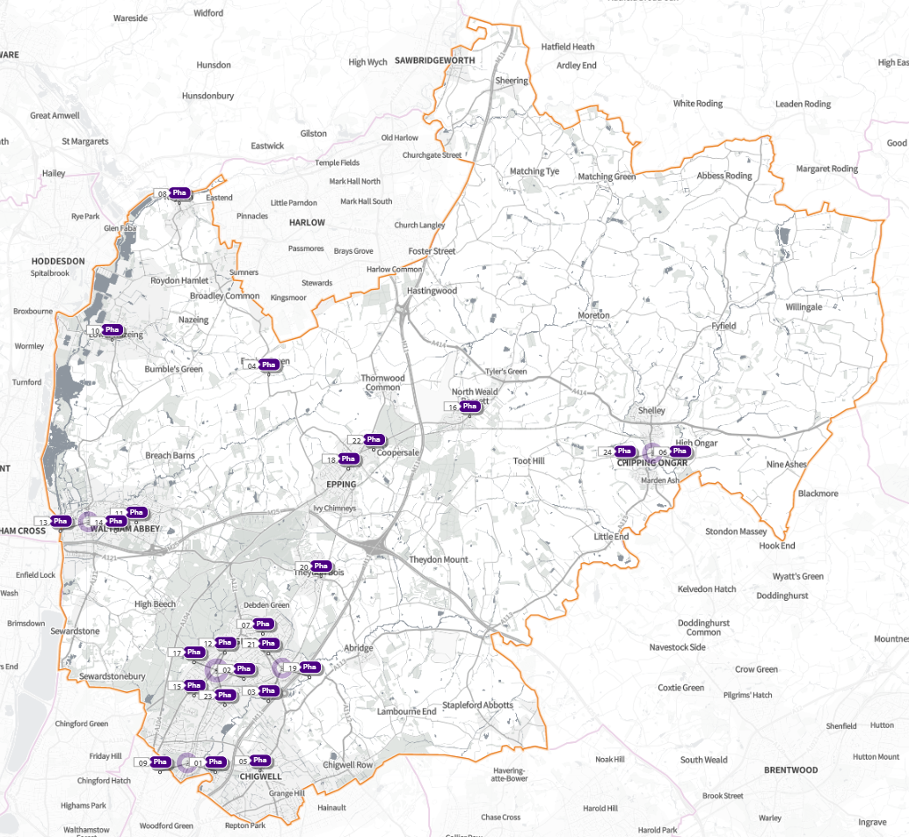 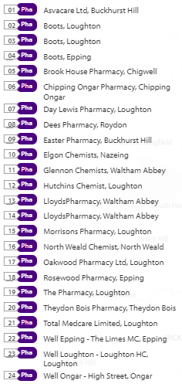
Source: Shape Place Atlas (as at 22/03/22)

Provision

The information contained in this report was obtained from NHSE, local commissioners and a contractor survey.

Opening hours were obtained via the NHSE pharmacy contracts team.

Service provision for advanced services was obtained via NHSE, NHSBSA and with the support of the local LPC.

Access

Appendix F shows that using the base population data on the SHAPE Place Atlas platform, it is possible to calculate the Essex population (and by district) that are estimated to have a journey time either within 20 minutes, 20 - 30 minutes or over 30 minutes to a pharmacy across Essex and within a 1.6KM buffer zone around Essex by each journey method.

Overall, across Essex, generally residents are within a relatively short travel time whichever method is chosen:
- 99.9% of the Essex population could get to a pharmacy in a 20-minute drive.
- 95% a 20-minute public transport journey.
- 83% within a 20-minute walk. Residents have to travel for longer if they walk.
- 11% over 30-minute walk away.
- Epping Forest residents can drive to a pharmacy within 20 minutes.
- Most residents can get to a pharmacy within a 20-minute journey on public transport in most districts. However, some districts see a relatively high % of their population having to travel for longer (Braintree, Maldon, Uttlesford 20-30 minutes; Braintree, Epping Forest, Uttlesford over 30 minutes).
- Most residents can get to a pharmacy within 20-minute walk in most districts. Some districts however see a relatively higher % of their population that’d have to walk further (Braintree, Brentwood, Uttlesford 20-30 minutes; Braintree, Maldon, Uttlesford over 30 minutes).

Travel time to access pharmaceutical services are no longer than journey times to access key services as shown in section 6 of this report.

From the results of the public survey (Appendix E) 83% of residents stated that they had a reasonable distance to travel to the pharmacy equating to less than 20 minutes, 14% had travelled between 20 and 30 minutes, and 3% had travelled between 30-45 minutes. 61% made the trip by car, and 34% had travelled on foot—only 3% used public transport and 2% a bicycle.

Epping Forest residents also have access to dispensing doctors, pharmacies in other HWB areas and distance selling pharmacies in England. Analysis of dispensing flows in the West Essex CCG area shows that 86% of prescriptions generated in the CCG are dispensed within the area and 14% out of area including 5% by distance selling pharmacies.

Pharmaceutical services in the locality
Table Number and type of providers of pharmaceutical services in the area
Type Of Contract | Epping Forest
Total Number of Community Pharmacies | 24
Dispensing Doctors | 1
Dispensing Appliance Contractors | 0
Distance Selling Pharmacies | 1

Table of Pharmacy contractors in the locality and provision of commissioned services

* Friday hours are taken as standard for Mon- Fri
Services key:
Services 1 & 2 are NHSE commissioned Advanced necessary services
Services 3-6 are NHSE commissioned Advanced services
Service 7 is an NHSE commissioned Enhanced service
Service 8 is a CCG locally commissioned services
Services 9-13 are local authority locally commissioned services

Service Key |  |  |  |  |  |  |  | 1 | 2 | 3 | 4 | 5 | 6 | 7 | 8 | 9 | 10 | 11 | 12 | 13
Organisation code | Trading Name | Address line | Town | Postcode | Hours: M - F* OPENING HOURS SUPPLEMENTARY | Hours: Sat OPENING HOURS SUPPLEMENTARY | Hours: Sun OPENING HOURS  SUPPLEMENTARY | NMS | CPCS | SAC | SCS | HYPERTENSION | FLU Vaccination | COVID Vaccination | PALLAITIVE CARE | SEXUAL HEALTH | SMOKING CESSATION | NHS Health Checks | NEEDLE EXCHANGE | SUPERVISED CONSUMPTION
FM777 | AsvaCare Ltd | 32 Queens Road | Buckhurst Hill | IG9 5BY | 9.00 - 18.30 |  | Closed | ✓ | ✓ |  | ✓ | ✓ | ✓ | ✓ | ✓ | ✓ |  |  | ✓
 |  |  |  |  | 17.00 - 18.30 | 9.00 -17.30
FRL76 | Boots | 230 High Road | Loughton | IG10 1EZ | 9.00 -17.30 | 9.00 -17.30 | Closed |  | ✓ |  |  |  | ✓ |  | ✓
 |  |  |  |  | 9.00 - 9.30 Closed 13.00 - 14.00 | 9.00- 10.00 & 16.00- 17.30 Closed 13.00 - 14.00
FVE03 | Boots | 18 The Broadway | Loughton | IG10 3ST | 8.45- 17.30 | 8.45- 17.30 |  | ✓ | ✓ |  |  |  | ✓ |  | ✓
 |  |  |  |  | 8.45 - 9.00, 13.30 - 14.30 & 17.00 - 17.30 | 8.45 - 9.00, 13.30 - 14.30 & 17.00 - 17.30 | Closed
FVK13 | Boots | 223 High Street | Epping | CM16 4BL | 9.00- 17.30 | 9.00 - 17.30 |  | ✓ |  |  |  |  | ✓ |  | ✓ | ✓
 |  |  |  |  | 9.00 - 10.00 & 17.00- 17.30 | 9.00 - 10.00 & 16.00 - 17.30 Closed 14.00 - 15.00 | Closed
FG311 | Brook House Pharmacy | 20 Brook Parade, High Road | Chigwell | IG7 6PF | 9.00 - 19.00 |  |  | ✓ |  |  |  | ✓
 |  |  |  |  | 17.00 - 19.00 | 9.00 - 17.30 | Closed
FA684 | Chipping Ongar Pharmacy | 205 High Street | Chipping Ongar | CM5 9JG | 8.30 - 18.30 | 9.00 - 13.00 |  | ✓ |  |  |  | ✓ | ✓ |  | ✓ | ✓ | ✓
 |  |  |  |  | 8.30 - 9.00, 12.30 - 14.00 & 18.00 - 18.30 | 9.00 - 9.30 & 12.00 -13.00 | Closed
FP522 | Day Lewis Pharmacy | 48 Pyrles Lane | Loughton | IG10 2NN | 9.00 - 18.00 | 9.00 - 13.00 |  | ✓ | ✓ |  |  | ✓ | ✓ | ✓ |  | ✓ |  |  | ✓ | ✓
 |  |  |  |  |  |  | Closed
FCV41 | Dees Pharmacy | 100 High Street | Roydon | CM19 5EE | 9.00 - 18.00 |  |  | ✓ |  |  |  |  | ✓ |  |  | ✓ | ✓
 |  |  |  |  |  | 9.00 - 17.00 | Closed
FTC47 | Easter Pharmacy | 54 Station Way | Buckhurst Hill | IG9 6LL | 9.00 - 18.00 |  |  | ✓ | ✓ |  | ✓ | ✓ |  | ✓ | ✓ | ✓ | ✓
 |  |  |  |  | 13.00 - 14.15 & 17.30 - 18.00 | 9.00 - 17.30 | Closed
FFQ99 | Elgon Chemists | 6-8 Nazeingbury Parade | Nazeing | EN9 2JL | 9.00 - 17.30 |  | Closed | ✓
 |  |  |  |  | 13.00 - 13.30 | 9.00 - 13.00
FW139 | Glennon Chemists | 8 Hillhouse, Ninefields Estate | Waltham Abbey | EN9 3EL | 9.00 - 18.30 | 9.00 - 17.00 |  | ✓ | ✓ |  |  |  | ✓ |  | ✓ |  |  |  |  | ✓
 |  |  |  |  | Closed 13.00 - 14.30 | 10.30 - 17.00 | Closed
FDC61 | Hutchins Chemist | 197 High Road | Loughton | IG10 4LF | 9.00 - 18.30 | 9.00 - 17.00 |  | ✓ |  |  | ✓ | ✓ | ✓
 |  |  |  |  | 17.30 - 18.30 Closed 13.00 - 14.00 | 11.30 - 17.00 Closed 13.00 - 14.00 | Closed
FTH60 | Lloyds Pharmacy | Thrift Cottage Site, Sewardstone Road | Waltham Abbey | EN9 1NP | 8.30 - 20.00 |  |  | ✓ |  |  |  | ✓ |  |  |  | ✓
 |  |  |  |  | 8.30 - 9.00, 11.30 - 12.30 & 18.00 - 20.00 | 9.00 - 14.00 | Closed
FX100 | Lloyds Pharmacy | 10 Sun Street | Waltham Abbey | EN9 1EE | 8.39 - 18.30 | 8.30 - 17.00 |  | ✓ | ✓ |  |  | ✓ |  |  |  |  |  |  |  | ✓
 |  |  |  |  | 8.30 -9.00 & 12.30 - 15.30 | 8.30 - 9.00 & 12.30 - 13.00 | Closed
FER40 | Morrisons Pharmacy | 246-250 High Road | Loughton | IG10 1RB | 8.30 - 20.00 | 8.00 - 19.00 8.00 - 9.00, 13.00 - 14.00 & 15.00 - 19.00 |  | ✓ |  |  |  |  | ✓
 |  |  |  |  | 8.30 - 9.00, 13.00 - 14.00 & 17.00 - 20.00 |  | 11.00 - 17.00
FLR33 | North Weald Chemist | 48 High Road | North Weald | CM16 6BU | 9.00 - 18.30 | 9.00 - 17.30 |  | ✓ |  |  |  |  |  |  | ✓
 |  |  |  |  | 13.00 - 14.00 & 17.30 - 18.30 | 11.30 - 17.30 | Closed
FYE61 | Oakwood Pharmacy Ltd | 118 Roding Road | Loughton | IG10 3EJ | 9.00 - 18.30 |  |  | ✓ |  |  |  |  |  |  | ✓
 |  |  |  |  | 17.00 - 18.30 | 9.00 - 17.00 | Closed |  |  |  |  |  | ✓
FPH02 | Rosewood Pharmacy | 283-284 High Street | Epping | CM16 4DA | 9.00 - 18.00 | 9.00 - 17.30 | Closed | ✓ |  |  |  | ✓ | ✓
 |  |  |  |  | 12.30 - 14.30 | 11.30 - 15.00
FY418 | The Pharmacy | 36 The Broadway | Loughton | IG10 3ST | 9.00 - 18.00 | 9.00 - 17.30 |  | ✓ |  |  |  |  |  |  |  |  |  |  | ✓
 |  |  |  |  | 13.00 - 14.00 & 17.00 - 18.00 | 14.00 - 17.30 | Closed |  |  |  |  |  | ✓
FX480 | Theydon Bois Pharmacy | 10 Forest Drive | Theydon Bois | CM16 7EY | 9.00 - 17.30 | 9.00 - 17.00 |  | ✓ | ✓ |  | ✓ | ✓ |  | ✓ | ✓ | ✓ | ✓
 |  |  |  |  | Closed 13.00 - 14.00 | 15.00 - 17.00 | Closed
FEE11 | Well Epping - The Limes Mc | The Limes Medical Centre, The Plain | Epping | CM16 6TL | 9.00 - 18.30 |  |  | ✓ |  |  |  | ✓ | ✓ |  | ✓
 |  |  |  |  | 13.00 - 14.30 | Closed | Closed
FG181 | Well Loughton - Loughton Hc | Loughton Health Centre, The Drive | Loughton | IG10 1HW | 8.30 - 18.30 | Closed |  | ✓ |  |  |  | ✓ |  |  |  |  |  | ✓
 |  |  |  |  | 12.30 - 14.30 |  | Closed |  |  |  |  |  | ✓
FAM66 | Well Ongar - High Street | 198-202 High Street | Ongar | CM5 9JJ | 8.30 - 18.30 |  |  | ✓ |  |  |  | ✓ | ✓ |  | ✓ | ✓
 |  |  |  |  | 8.30 - 9.00, 13.00 - 14.00 & 18.00 - 18.30 | Closed | Closed
FGE68 | Total Medcare Limited (DSP) | Unit 1, Knight House, Lenthall Road | Loughton | IG10 3UD | 9.00 - 17.30 |  |  | ✓ | ✓ |  |  | ✓ | ✓ |  | ✓
 |  |  |  |  | Closed 13.00 - 13.30 | 9.00 - 12.00 | Closed

Epping Forest opening hours
- Weekday opening hours were taken from Friday as a standard.

Monday to Friday, all 24 community pharmacies are open between the hours of 9:00 to 17:00

Earliest opening time is 8.30 and latest closing time is 20.00
- On Saturdays 21 pharmacies are open in the morning and 16 of the pharmacies remain open in the afternoon. The latest closing time is 19.00
- On Sundays 1 pharmacy is open between 11.00 and 17.00

Services (data January 2022)
There is good access to commissioned services within the locality.
The necessary services of NMS and CPCS are provided by many of the pharmacies.
The NHSE commissioned services that are not provided by pharmacies are delivered by other organisations in the locality.

Housing (Appendix G)

The impact of local housing development plans on provision of pharmaceutical services has been considered but has not identified any gaps in pharmaceutical services provision in the area during the lifetime of this PNA.

No gaps in the provision of necessary pharmaceutical services have been identified in the
Epping Forest locality

No gaps in pharmaceutical services have been identified that if provided either now or in the future would secure improvements or better access to relevant services across the Epping Forest locality

7.8

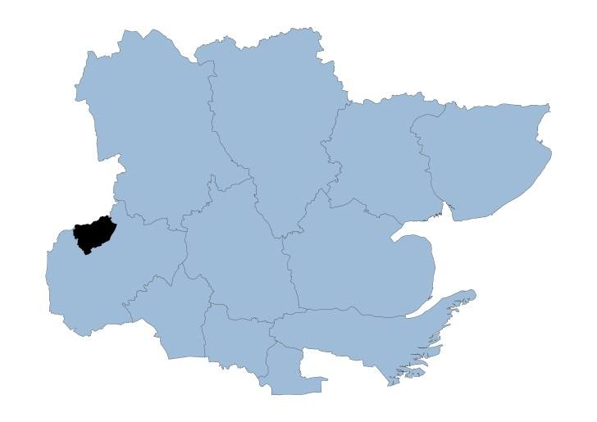

Harlow Locality

Harlow covers an area of 31 square kilometers and is one of several ‘new towns’ built in the 1950’s to provide social housing to people living in London. The town was built on a theme of neighbourhoods around the town center. Each of the original seven neighbourhoods has necessary amenities – shops, schools, church, health center and district council neighbourhood offices. The aim across the town was to have large areas of green open spaces - most of which have been preserved.

Harlow has a population of 87,280 and is the most densely populated district in Essex with 2,858 people per square km. Harlow is also one of the more diverse districts with 16.1% of residents of Black Asian Minority Ethnicity (BAME), which is highest among all Essex districts.

In the Indices of Multiple Deprivation 2019 the Harlow Local Authority area was ranked 100 out of 317 lower tier authorities in England. This places Harlow in the lower 40% of most deprived Lower Tier Local Authorities nationally. As of 2019 the Harlow area contains 54 LSOAs of which 1 is ranked in the bottom two most deprived deciles nationally.

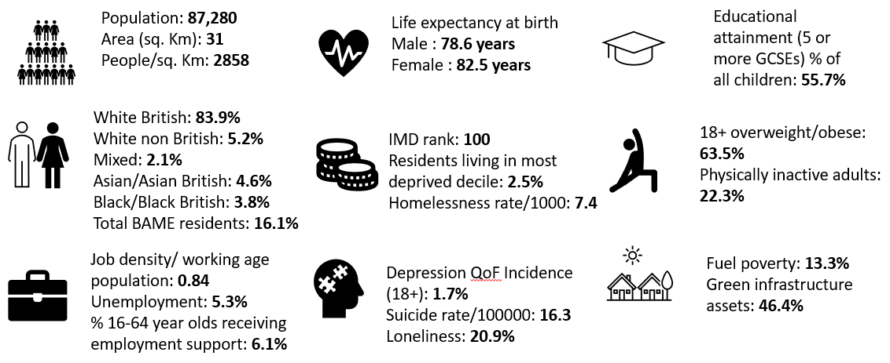

Further details can be accessed in the Essex Joint Strategic Needs Assessment https://data.essex.gov.uk/

Map of Harlow Pharmacies

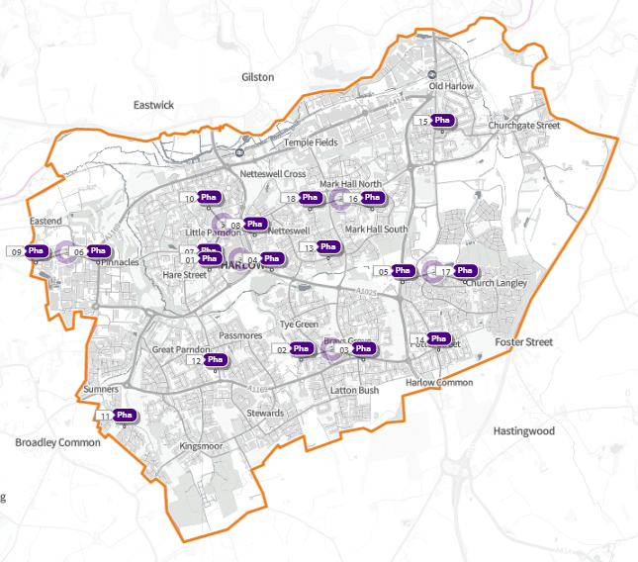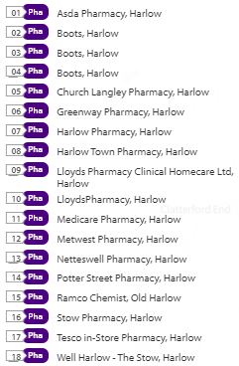
Source: Shape Place Atlas (as at 22/03/22)

Provision

The information contained in this report was obtained from NHSE, local commissioners and a contractor survey.

Opening hours were obtained via the NHSE pharmacy contracts team.

Service provision for advanced services was obtained via NHSE, NHSBSA and with the support of the local LPC.

Access

Appendix F shows that using the base population data on the SHAPE Place Atlas platform, it is possible to calculate the Essex population (and by district) that are estimated to have a journey time either within 20 minutes, 20 - 30 minutes or over 30 minutes to a pharmacy across Essex and within a 1.6KM buffer zone around Essex by each journey method.

Overall, across Essex, generally residents are within a relatively short travel time whichever method is chosen:
- 99.9% of the Essex population could get to a pharmacy in a 20-minute drive.
- 95% a 20-minute public transport journey.
- 83% within a 20-minute walk. Residents have to travel for longer if they walk.
- 11% over 30-minute walk away.
- Harlow residents can drive to a pharmacy within 20 minutes.
- Most residents can get to a pharmacy within a 20-minute journey on public transport in most districts. However, some districts see a relatively high % of their population having to travel for longer (Braintree, Maldon, Uttlesford 20-30 minutes; Braintree, Epping Forest, Uttlesford over 30 minutes).
- Most residents can get to a pharmacy within 20-minute walk in most districts. Some districts however see a relatively higher % of their population that’d have to walk further (Braintree, Brentwood, Uttlesford 20-30 minutes; Braintree, Maldon, Uttlesford over 30 minutes).

Travel time to access pharmaceutical services are no longer than journey times to access key services as shown in section 6 of this report.

From the results of the public survey (Appendix E) 83% of residents stated that they had a reasonable distance to travel to the pharmacy equating to less than 20 minutes, 14% had travelled between 20 and 30 minutes, and 3% had travelled between 30-45 minutes. 61% made the trip by car, and 34% had travelled on foot—only 3% used public transport and 2% a bicycle.

Harlow residents also have access to pharmacies in other HWB areas and distance selling pharmacies in England. Analysis of dispensing flows in the West Essex CCG area shows that 86% of prescriptions generated in the CCG are dispensed within the area and 14% out of area including 5% by distance selling pharmacies.

Pharmaceutical services in the locality
Table Number and type of providers of pharmaceutical services in the area
Type Of Contract | Harlow
Total Number of Community Pharmacies | 16
Dispensing Doctors | 0
Dispensing Appliance Contractors | 0
Distance Selling Pharmacies | 2

Table Pharmacy contractors in the locality and provision of commissioned services

* Friday hours are taken as standard for Mon- Fri
Services key:
Services 1 & 2 are NHSE commissioned Advanced necessary services
Services 3-6 are NHSE commissioned Advanced services
Service 7 is an NHSE commissioned Enhanced service
Service 8 is a CCG locally commissioned services
Services 9-13 are local authority locally commissioned services

Service Code |  |  |  |  |  |  |  |  |  |  |  |  |  |  | 1 |  | 2 |  | 3 |  | 4 |  | 5 | 6 |  | 7 |  | 8 |  | 9 |  |  | 10 |  | 11 | 12 | 13
Organisation code |  | Trading Name | Address line |  | Town |  |  | Postcode | Hours: M - F* OPENING HOURS SUPPLEMENTARY |  | Hours: Sat OPENING HOURS SUPPLEMENTARY |  |  | Hours: Sun OPENING HOURS SUPPLEMENTARY |  | NMS |  | CPCS | SAC | SCS |  | HYPERTENSION |  |  | FLU Vaccination |  | COVID Vaccination |  | PALLAITIVE CARE |  | SEXUAL HEALTH | SMOKING CESSATION |  | NHS Health Checks |  | NEEDLE EXCHANGE | SUPERVISED CONSUMPTION
FLH17 |  | Asda Pharmacy (100 Hour Pharmacy) | Water Gardens |  | Harlow |  |  | CM20 1AN | 7.00 - 23.00 |  | 7.00 - 22.00 |  |  | 11.00 - 17.00 |  | ✓ |  | ✓ |  |  |  | ✓ |  |  | ✓ |  |  |  | ✓ |  | ✓ | ✓ |  |  |  |  | ✓
FCX16 |  | Boots | 5 Bush House, Bush Fair |  | Harlow |  |  | CM18 6NS | 9.00 - 18.00 |  |  |  |  | Closed |  |  |  | ✓ |  |  |  |  |  |  | ✓
 |  |  |  |  |  |  |  |  | 13.00 - 14.00 |  | 9.00 - 17.00
FNQ36 |  | Boots | 9 North House, Bush Fair |  | Harlow |  |  | CM18 6PA | 8.30 - 18.30 |  | 9.00 - 17.00 |  |  |  |  |  |  | ✓ |  |  |  |  |  |  | ✓ |  |  |  | ✓ |  |  |  |  |  |  | ✓ | ✓
 |  |  |  |  |  |  |  |  | 8.30 - 9.00, 12.30 - 13.30 & 18.00 - 18.30 |  | 12.30 - 17.00 |  |  | Closed
FTV09 |  | Boots | 37 Broadwalk |  | Harlow |  |  | CM20 1JA | 8.30- 17.30 |  | 8.30 - 18.00 |  |  |  |  | ✓ |  | ✓ |  |  |  | ✓ |  |  | ✓ |  |  |  | ✓
 |  |  |  |  |  |  |  |  | 8.30 - 10.00 & 17.00 - 17.30 |  | 8.30 - 10.00 & 16.00 - 18.00 |  |  | 10.00 - 16.00
FHF14 |  | Church Langley Pharmacy | Florence Nightingale Health Centre, Minton lane |  | Harlow |  |  | CM17 9TG | 9.00 - 18.30 |  |  |  |  |  |  | ✓ |  | ✓ |  |  |  |  |  |  | ✓
 |  |  |  |  |  |  |  |  | 13.00 - 14.00 & 18.00 - 18.30 |  | Closed |  |  | Closed
FD523 |  | Harlow Pharmacy (100 Hour Pharmacy) | Unit 2, Wych Elm |  | Harlow |  |  | CM20 1QR | 8.00 - 23.00 |  | 8.00 - 22.00 |  |  | 8.00 - 22.00 |  | ✓ |  | ✓ |  | ✓ |  | ✓ |  |  | ✓ |  | ✓ |  | ✓ |  | ✓ | ✓
FCP20 |  | Harlow Town Pharmacy | 5 Market House, Stone Cross |  | Harlow |  |  | CM20 1BL | 9.00 - 17.30 |  | Closed |  |  |  |  | ✓ |  | ✓ |  |  |  | ✓ |  |  | ✓ |  |  |  |  |  | ✓ | ✓ |  |  |  |  | ✓
 |  |  |  |  |  |  |  |  | 13.00 - 13.30 |  |  |  |  | Closed
FE570 |  | Lloyds Pharmacy | Fifth Avenue, Allende Ave |  | Harlow |  |  | CM20 2AG | 8.30 - 21.00 |  | 8.30 - 21.00 |  |  |  |  | ✓ |  |  |  |  |  | ✓ |  |  | ✓
 |  |  |  |  |  |  |  |  | 8.30 - 9.00, 12.00 - 15.00 & 19.00 - 21.00 |  | 8.30 - 9.00 & 14.00 - 21.00 |  |  | 10.00 - 16.00
FLV19 |  | Medicare Pharmacy | 1 Sumners Hatch, Broadley Road |  | Harlow |  |  | CM19 5RD | 9.00 - 18.30 |  |  |  |  |  |  | ✓ |  | ✓ |  |  |  | ✓ |  |  | ✓ |  |  |  |  |  | ✓ | ✓
 |  |  |  |  |  |  |  |  | 18.00 - 18.30 & Closed 12.30 - 13.30 |  | Closed |  |  | Closed
FFP42 |  | Metwest Pharmacy | Unit 2, Lister House Health Centre, Abercrombie Way |  | Harlow |  |  | CM18 6YJ | 9.00 - 18.30 |  |  |  |  | Closed |  | ✓ |  |  |  | ✓ |  | ✓ |  |  | ✓ |  |  |  |  |  | ✓ | ✓ |  |  |  | ✓ | ✓
 |  |  |  |  |  |  |  |  | 13.00 - 14.00 & 18.00 - 18.30 |  | 9.00 - 13.00
FWF31 |  | Netteswell Pharmacy | 1 Pypers Hatch, Maddox Road |  | Harlow |  |  | CM20 3NG | 9.00 - 19.00 |  |  |  |  |  |  |  |  | ✓ |  |  |  |  |  |  | ✓ |  | ✓ |  |  |  |  | ✓ |  |  |  | ✓
 |  |  |  |  |  |  |  |  | 13.00 - 14.00 |  | 9.00 - 13.00 |  |  | Closed
FKE56 |  | Potter Street Pharmacy | 12 Prentice Place, Potter Street |  | Harlow |  |  | CM17 9BG | 9.00 - 18.00 |  |  |  |  |  |  | ✓ |  | ✓ |  |  |  |  |  |  | ✓ |  |  |  | ✓ |  | ✓ |  |  |  |  | ✓
 |  |  |  |  |  |  |  |  | 13.00 - 14.00 |  | Closed |  |  | Closed
FRC09 |  | Ramco Dispensing Chemist | 43/45 High Street |  | Old Harlow |  |  | CM17 0DN | 9.00 - 18.30 |  |  |  |  |  |  | ✓ |  |  |  |  |  |  |  |  | ✓ |  |  |  |  |  |  |  |  |  |  |  | ✓
 |  |  |  |  |  |  |  |  | 13.00 - 13.30 & 17.00 - 18.30 |  | 10.00 - 17.00 |  |  | Closed
FCP78 |  | Stow Pharmacy | 16 The Stow, Mark Hall |  | Harlow |  |  | CM20 3AH | 9.00 - 17.30 |  | 9.00 - 17.30 |  |  |  |  | ✓ |  | ✓ |  |  |  | ✓ |  |  | ✓ |  | ✓ |  |  |  |  |  |  |  |  |  | ✓
 |  |  |  |  |  |  |  |  | 9.00 - 10.00 & 17.00 - 17.30 |  | 9.00 - 10.00, 14.00 - 15.00 & 16.00 - 17.30 |  |  | Closed
FM358 |  | Tesco In-store Pharmacy (100 Hour Pharmacy) | Church Langley Way |  | Harlow |  |  | CM17 9TE | 6.30 - 22.30 |  | 6.30 - 22.00 |  |  | 10.00 - 16.00 |  | ✓ |  |  |  |  |  |  |  |  |  |  |  |  | ✓
FW755 |  | Well Harlow - The Stow | 107 The Stow |  | Harlow |  |  | CM20 3AS | 8.30 - 18.30 |  |  |  |  |  |  | ✓ |  |  |  | ✓ |  | ✓ |  |  | ✓ |  |  |  | ✓ |  |  |  |  | ✓ |  | ✓ | ✓
 |  |  |  |  |  |  |  |  | 8.30 - 9.00, 13.00 - 14.00 & 18.00 - 18.30 |  | Closed |  |  | Closed
FKL27 | Lloyds Pharmacy Clinical Homecare Ltd (DSP) |  |  | Unit 4, Scimitar Park, Roydon Road |  | Harlow | CM19 5GU |  |  | 9.00- 17.30  17.00 – 17.30 |  | Closed | Closed |  | N/A
FR251 | Greenway Pharmacy (DSP) |  |  | Unit 78 Greenway Business Centre (DSP) |  | Harlow | CM19 5QE |  |  | 9.00- 17.30  17.00 – 17.30 |  | Closed | Closed |  | N/A

Harlow opening hours
- Weekday opening hours were taken from Friday as a standard.

Monday to Friday, all 16 community pharmacies are open between the hours of 9:00 to 17:00

Earliest opening time is 6.30 and latest closing time is 23.00
- On Saturdays 11 pharmacies are open in the morning and 9 of the pharmacies remain open in the afternoon. The latest closing time is 22.00
- On Sundays 5 pharmacies open, longest opening times are 8.00 to 22.00

Services (data January 2022)
There is good access to commissioned services within the locality.
The necessary services of NMS and CPCS are provided by many of the pharmacies.
The NHSE commissioned services that are not provided by pharmacies are delivered by other organisations in the locality.

Housing (Appendix G)

The impact of local housing development plans on provision of pharmaceutical services has been considered but has not identified any gaps in pharmaceutical services provision in the area during the lifetime of this PNA.

No gaps in the provision of necessary pharmaceutical services have been identified in the
Harlow locality

No gaps in pharmaceutical services have been identified that if provided either now or in the future would secure improvements or better access to relevant services across the Harlow locality

7.9

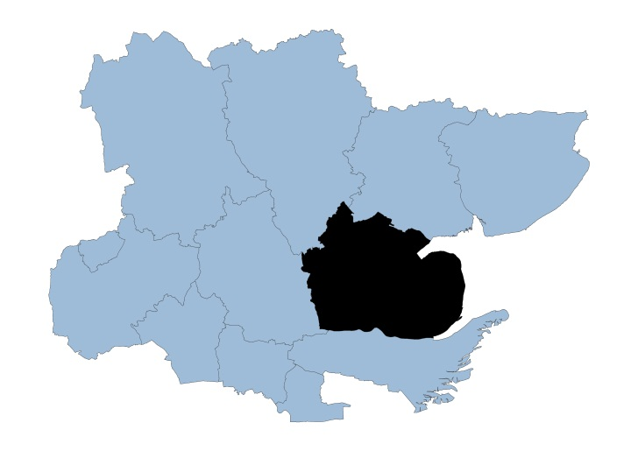

Maldon Locality

The Maldon district has a coastal border stretching from the Burnham–on-Crouch estuary, round the Dengie peninsula up to the nuclear facility at Bradwell on the River Blackwater covering an area of 358 square kilometers.

The district is home to the towns of Maldon, Burnham-on-Crouch and Heybridge along with several smaller villages: it is sparsely populated outside of the towns. With a population of 65,401 it is one of the least populous Essex districts with 183 people living per square km. 95.8% of the population are of White British ethnicity.

In the Indices of Multiple Deprivation 2019 the Maldon Local Authority area was ranked 211 out of 317 Lower Tier Local Authorities (LTLAs) in England. This places Maldon in the upper 40% of least deprived LTLAs nationally. Maldon is also one of the three LTLAs in Essex which has no residents in the bottom 1&2 deciles.

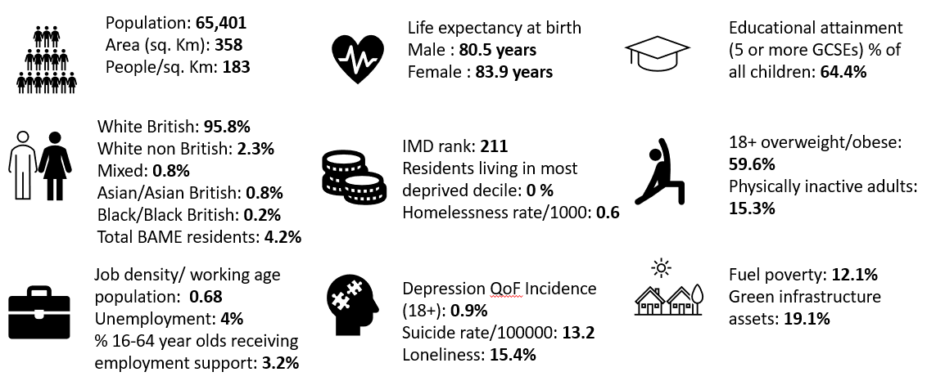

Further details can be accessed in the Essex Joint Strategic Needs Assessment https://data.essex.gov.uk/

Map of Maldon Pharmacies

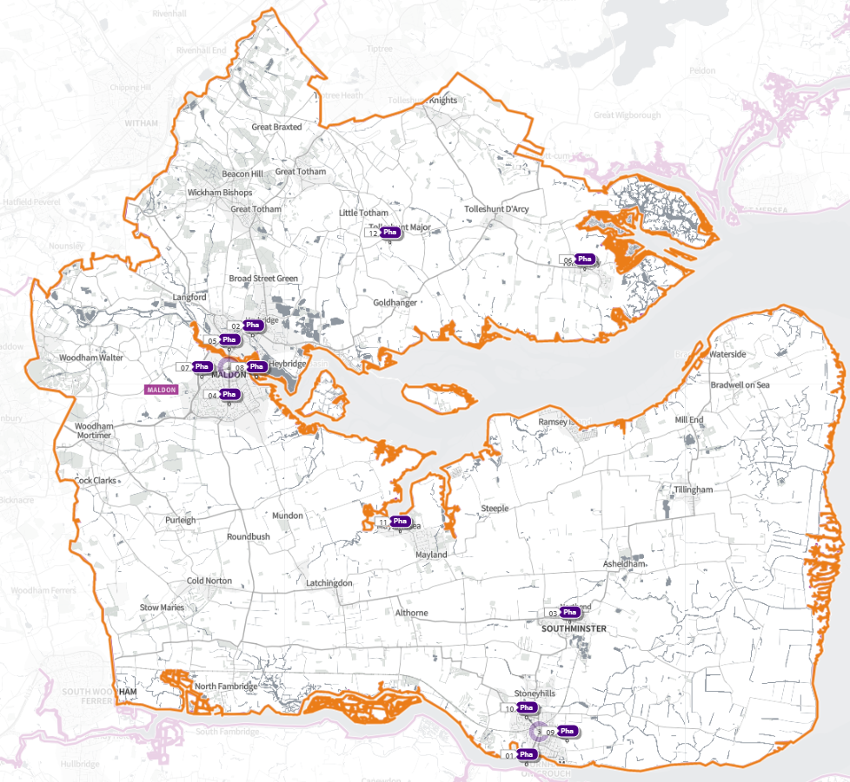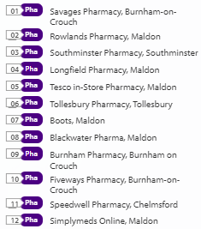
Source: Shape Place Atlas (as at 22/03/22)

Provision

The information contained in this report was obtained from NHSE, local commissioners and a contractor survey.

Opening hours were obtained via the NHSE pharmacy contracts team.

Service provision for advanced services was obtained via NHSE, NHSBSA and with the support of the local LPC.

Access

Appendix F shows that using the base population data on the SHAPE Place Atlas platform, it is possible to calculate the Essex population (and by district) that are estimated to have a journey time either within 20 minutes, 20 - 30 minutes or over 30 minutes to a pharmacy across Essex and within a 1.6KM buffer zone around Essex by each journey method.

Overall, across Essex, generally residents are within a relatively short travel time whichever method is chosen:
- 99.9% of the Essex population could get to a pharmacy in a 20-minute drive.
- 95% a 20-minute public transport journey.
- 83% within a 20-minute walk. Residents have to travel for longer if they walk.
- 11% over 30-minute walk away.
- Maldon residents can drive to a pharmacy within 20 minutes.
- Most residents can get to a pharmacy within a 20-minute journey on public transport in most districts. However, some districts see a relatively high % of their population having to travel for longer (Braintree, Maldon, Uttlesford 20-30 minutes; Braintree, Epping Forest, Uttlesford over 30 minutes)
- Most residents can get to a pharmacy within 20-minute walk in most districts. Some districts however see a relatively higher % of their population that’d have to walk further (Braintree, Brentwood, Uttlesford 20-30 minutes; Braintree, Maldon, Uttlesford over 30 minutes).

Travel time to access pharmaceutical services are no longer than journey times to access key services as shown in section 6 of this report.

From the results of the public survey (Appendix E) 83% of residents stated that they had a reasonable distance to travel to the pharmacy equating to less than 20 minutes, 14% had travelled between 20 and 30 minutes, and 3% had travelled between 30-45 minutes. 61% made the trip by car, and 34% had travelled on foot—only 3% used public transport and 2% a bicycle.

Maldon residents also have access to dispensing doctors, pharmacies in other HWB areas and distance selling pharmacies in England. Analysis of dispensing flows in the Mid Essex CCG area shows that 80% of prescriptions generated in the CCG are dispensed within the area and 20% out of area including 3% by distance selling pharmacies.

Pharmaceutical services in the locality
Table Number and type of providers of pharmaceutical services in the area
Type Of Contract | Maldon
Total Number of Community Pharmacies | 11
Dispensing Doctors | 7
Dispensing Appliance Contractors | 0
Distance Selling Pharmacies | 1

Table of Pharmacy contractors in the locality and provision of commissioned services
* Friday hours are taken as standard for Mon- Fri
Services key:
Services 1 & 2 are NHSE commissioned Advanced necessary services
Services 3-6 are NHSE commissioned Advanced services
Service 7 is an NHSE commissioned Enhanced service
Service 8 is a CCG locally commissioned services
Services 9-13 are local authority locally commissioned services

Service code |  |  |  |  |  |  |  | 1 | 2 | 3 | 4 | 5 | 6 | 7 | 8 | 9 | 10 | 11 | 12 | 13
Organisation code | Trading Name | Address line | Town | Postcode | Hours: M - F* OPENING HOURS SUPPLEMENTARY | Hours: Sat OPENING HOURS SUPPLEMENTARY | Hours: Sun OPENING HOURS SUPPLEMENTARY | NMS | CPCS | SAC | SCS | HYPERTENSION | FLU Vaccination | COVID Vaccination | PALLAITIVE CARE | SEXUAL HEALTH | SMOKING CESSATION | NHS Health Checks | NEEDLE EXCHANGE | SUPERVISED CONSUMPTION
FPH83 | Blackwater Pharma | Princes Road | Maldon | CM9 5GP | 7.00 – 22.00 | 7.00 – 22.00 | 10.00 – 20.00 | ✓ | ✓
 |  |  |  |  |  |  |  |  |  |  |  | ✓ | ✓ |  | ✓ | ✓ | ✓
FT346 | Boots | 54 High Street | Maldon | CM9 5PN | 9.00 – 17.30 | 9.00 - 17.30 | Closed
 |  |  |  |  | 9.00 - 9.15 & 17.00 - 17.30 | 9.00 - 9.15 & 16.30 - 17.30 |  | ✓ |  |  |  |  | ✓ |  |  | ✓ |  |  | ✓ | ✓
 |  |  |  |  | Closed  14.00- 15.00 | Closed  14.00- 15.00
FKK89 | Burnham Pharmacy (100 Hour Pharmacy) | Foundry Lane | Burnham-On-Crouch | CM0 8SJ | 7.00 - 22.30 | 7.00 - 22.30 | 10.00 - 17.00
 |  |  |  |  |  |  |  | ✓ |  |  |  |  | ✓
FLK60 | Fiveways Pharmacy | 3 Foundry Lane | Burnham-On-Crouch | CM0 8BL | 9.30 – 16.00 | 9.00 – 13.00 | Closed
 |  |  |  |  | 13.30 - 14.30 |  |  | ✓ | ✓ |  |  | ✓ | ✓ |  |  |  |  |  | ✓
FMP05 | Longfield Pharmacy | Longfield Medical Centre, Princes Road | Maldon | CM9 5DF | 8.00 - 18.30
 |  |  |  |  | 8.00 – 9.00, 13.00 – 14.00 & 18.15 - 18.30 | 9.00 – 13.00 | Closed | ✓ |  |  | ✓ | ✓ | ✓
FA007 | Rowlands Pharmacy | 10,10A & 10B Bentalls Ctr, Colchester Road | Maldon | CM9 4GD | 9.00 - 17.30
 |  |  |  |  | 13.20 - 13.30 | 9.00 – 1.00 |  | ✓ | ✓ |  |  |  | ✓ |  |  | ✓ | ✓
 |  |  |  |  | Closed 13.00 - 13.20
FD637 | Savages Pharmacy | 22 Station Road | Burnham-On-Crouch | CM0 8BQ | 9.00 – 18.00
 |  |  |  |  |  | 9.00 – 13.00 | Closed | ✓ | ✓ |  |  | ✓ | ✓ |  |  | ✓
Closed
12.30 - 13.30
FET17 | Southminster Pharmacy | 15 High Street | Southminster | CM0 7AA | 8.45 - 17.45 |  | Closed
 |  |  |  |  |  | 9.00 – 13.00 |  | ✓ |  |  |  |  | ✓
 |  |  |  |  | Closed 13.00 – 14.00
FPJ61 | Speedwell Pharmacy | Imperial Avenue | Chelmsford | CM3 6AH | 8.00 – 17.30
 |  |  |  |  | 13.00 – 14.00 &  17.00 - 17.30 | Closed | Closed | ✓ |  |  |  | ✓ | ✓ |  |  |  | ✓
FMY18 | Tesco In-store Pharmacy | Fullbridge Road | Maldon | CM9 4LE | 8.00 - 20.00 | 8.00 - 20.00
 |  |  |  |  | 8.00 – 9.00, 14.00 – 15.00  & 16.30 – 20.00 | 8.00 – 9.00, 14.00 – 15.00  & 16.30 – 20.00 | 10.00 – 16.00 | ✓ | ✓ |  |  |  | ✓ | ✓ |  | ✓
FRC59 | Tollesbury Pharmacy | 12A East Street | Maldon | CM9 8QD | 9.00 - 17.30
 |  |  |  |  | 13.00 - 13.30 | 9.00 – 13.00 | Closed | ✓ | ✓ |  |  |  | ✓ | ✓
FX730 | SimplyMeds Online (DSP) | Unit K2, Beckingham Business Park | Maldon | CM9 8LZ | 9.00 – 18.00
 |  |  |  |  |  | Closed | Closed | N/A | N/A | N/A | N/A | N/A | N/A | N/A | N/A | N/A | N/A | N/A | N/A | N/A
 |  |  |  |  | Closed 13.00 – 14.00

Maldon opening hours
- Weekday opening hours were taken from Friday as a standard.

Monday to Friday, all 11 community pharmacies are open between the hours of 9:00 to 17:00

Earliest opening time is 7.00 and latest closing time is 22.30
- On Saturdays 9 pharmacies are open in the morning and 3 of the pharmacies remain open in the afternoon. The earliest opening time is 7.00 and the latest closing time is 22.30
- On Sundays 3 pharmacies open, longest opening times are 10.00 to 20.00

Services (data January 2022)
There is good access to commissioned services within the locality.
The necessary services of NMS and CPCS are provided by many of the pharmacies.
The NHSE commissioned services that are not provided by pharmacies are delivered by other organisations in the locality.

Housing (Appendix G)
The impact of local housing development plans on provision of pharmaceutical services has been considered but has not identified any gaps in pharmaceutical services provision in the area during the lifetime of this PNA.

No gaps in the provision of necessary pharmaceutical services have been identified in the
Maldon locality

No gaps in pharmaceutical services have been identified that if provided either now or in the future would secure improvements or better access to relevant services across the Maldon locality

7.10

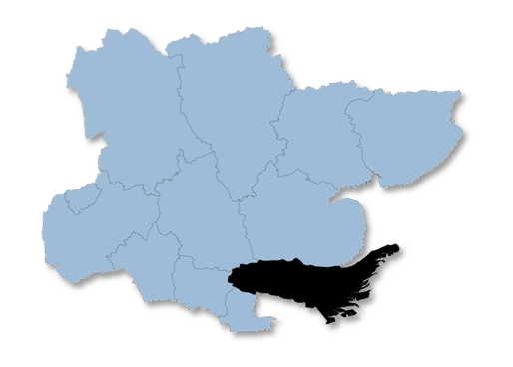

Rochford Locality

Rochford covers an area of 167 square kilometers and is predominantly rural in its character. It has miles of coastline as well as vast areas of countryside. Rochford has a population of 87,627 with 524 people living per square km. 95.6% of the population are of a White British ethnicity.

In the Indices of Multiple Deprivation 2019 the Rochford Local Authority area was ranked 286 out of 317 lower tier authorities in England. This places Rochford in the upper 10% of least deprived Lower Tier Local Authorities (LTLAs) nationally. Compared to the other local authority areas in Essex, Rochford is ranked as 10th out of 12 in the county for overall deprivation.

Rochford is also one of three areas in Essex which fall into the 10% least deprived areas nationally. As of 2019 the Rochford area contains 53 LSOAs of which 1 is ranked in the bottom two most deprived deciles nationally.

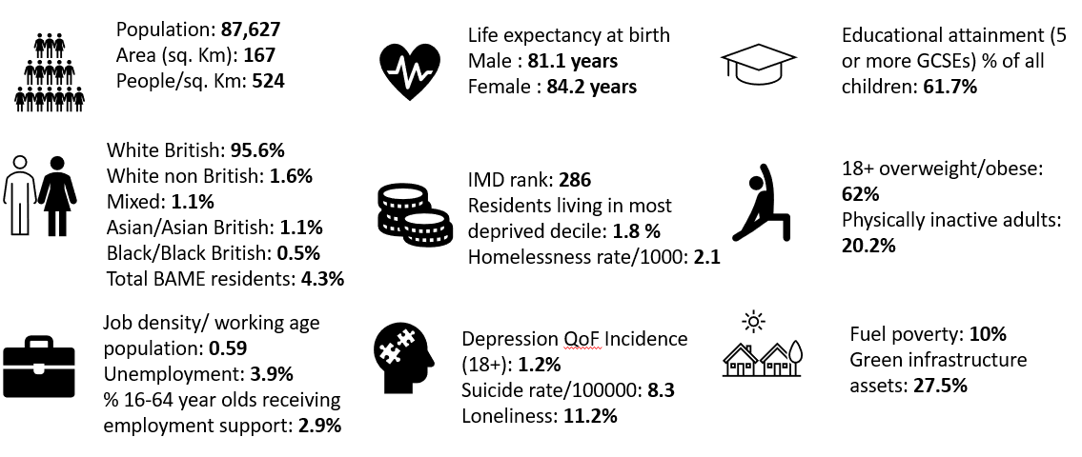
Further details can be accessed in the Essex Joint Strategic Needs Assessment https://data.essex.gov.uk/

Map of Rochford Pharmacies

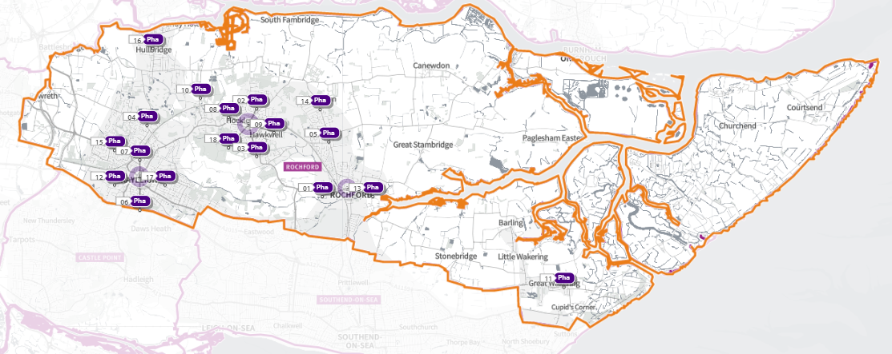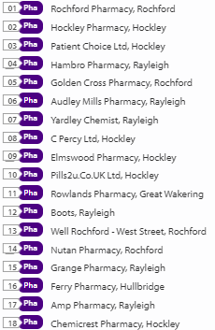
Source: Shape Place Atlas (as at 22/03/22)
Provision

The information contained in this report was obtained from NHSE, local commissioners and a contractor survey.

Opening hours were obtained via the NHSE pharmacy contracts team.

Service provision for advanced services was obtained via NHSE, NHSBSA and with the support of the local LPC.

Access

Appendix F shows that using the base population data on the SHAPE Place Atlas platform, it is possible to calculate the Essex population (and by district) that are estimated to have a journey time either within 20 minutes, 20 - 30 minutes or over 30 minutes to a pharmacy across Essex and within a 1.6KM buffer zone around Essex by each journey method.

Overall, across Essex, generally residents are within a relatively short travel time whichever method is chosen:
- 99.9% of the Essex population could get to a pharmacy in a 20-minute drive.
- 95% a 20-minute public transport journey.
- 83% within a 20-minute walk. Residents have to travel for longer if they walk.
- 11% over 30-minute walk away.
- Rochford residents can drive to a pharmacy within 20 minutes.
- Most residents can get to a pharmacy within a 20-minute journey on public transport in most districts. However, some districts see a relatively high % of their population having to travel for longer (Braintree, Maldon, Uttlesford 20-30 minutes; Braintree, Epping Forest, Uttlesford over 30 minutes)
- Most residents can get to a pharmacy within 20-minute walk in most districts. Some districts however see a relatively higher % of their population that’d have to walk further (Braintree, Brentwood, Uttlesford 20-30 minutes; Braintree, Maldon, Uttlesford over 30 minutes).
  - Travel time to access pharmaceutical services are no longer than journey times to access key services as shown in section 6 of this report.
  - From the results of the public survey (Appendix x) 83% of residents stated that they had a reasonable distance to travel to the pharmacy equating to less than 20 minutes, 14% had travelled between 20 and 30 minutes, and 3% had travelled between 30-45 minutes. 61% made the trip by car, and 34% had travelled on foot—only 3% used public transport and 2% a bicycle.
  - Rochford residents also have access to dispensing doctors’ pharmacies in other HWB areas and distance selling pharmacies in England. Analysis of dispensing flows in the Castle Point and Rochford CCG area shows that 93% of prescriptions generated in the CCG are dispensed within the area and 7% out of area including 3% by distance selling pharmacies.

Pharmaceutical services in the locality
Table Number and type of providers of pharmaceutical services in the area
Type Of Contract | Rochford
Total Number of Community Pharmacies | 15
Dispensing Doctors | 2
Dispensing Appliance Contractors | 1
Distance Selling Pharmacies | 1
Table of Pharmacy contractors in the locality and provision of commissioned services
* Friday hours are taken as standard for Mon- Fri
Services key:
Services 1 & 2 are NHSE commissioned Advanced necessary services
Services 3-6 are NHSE commissioned Advanced services
Service 7 is an NHSE commissioned Enhanced service
Service 8 is a CCG locally commissioned services
Services 9-13 are local authority locally commissioned services

Service Code |  |  |  |  |  |  |  | 1 | 2 | 3 | 4 | 5 | 6 | 7 | 8 | 9 | 10 | 11 | 12 | 13
Organisation code | Trading Name | Address line | Town | Postcode | Hours: M - F* OPENING HOURS SUPPLEMENTARY | Hours: Sat OPENING HOURS SUPPLEMENTARY | Hours: Sun OPENING HOURS SUPPLEMENTARY | NMS | CPCS | SAC | SCS | HYPERTENSION | FLU Vaccination | COVID Vaccination | PALLAITIVE CARE | SEXUAL HEALTH | SMOKING CESSATION | NHS Health Checks | NEEDLE EXCHANGE | SUPERVISED CONSUMPTION
FDX41 | AMP Pharmacy | 55-57 Eastwood Road | Rayleigh | SS6 7JE | 8.00 - 21.00 | 9.00 - 17.00 | 10.00 - 17.00 |  |  |  |  |  | ✓
 |  |  |  |  |  |  |  | ✓ | ✓ |  | ✓ |  |  |  |  | ✓ | ✓
FKX68 | Boots | 77-79 High Street | Rayleigh | SS6 7EJ | 8.30 - 5.30 | 8.30 - 15.30 |  |  |  |  |  |  | ✓
 |  |  |  |  | 8.30 - 9.30 & 13.00 - 14.00 | 8.30 - 9.30 & 13.00 - 14.00 | 10.00 - 16.00 | ✓ | ✓ |  |  |  |  |  |  | ✓
FG175 | C Percy Ltd | 212 Main Road | Hockley | SS5 4EG | 9.00- 18.00
 |  |  |  |  | 13.00 - 14.00 | 9.00 - 13.00 | Closed | ✓ |  |  | ✓ | ✓ |  |  |  | ✓ | ✓
FJ339 | Chemicrest Pharmacy | 39-41 Spa Road | Hockley | SS5 4AZ | 9.30 - 18.00 | 9.30 – 16.00 |  |  |  |  |  |  | ✓ | ✓
 |  |  |  |  | 13.00 - 14.00 & 17.30 - 18.00 | 13.00 - 14.00 & 15.30 - 16.00 | Closed | ✓ |  |  |  |  |  |  |  |  | ✓ |  |  | ✓
FG511 | Elmswood Pharmacy | 53 Southend Road | Hockley | SS5 4PZ | 9.00 - 18.00 | 9.00 - 13.00 |  |  |  |  |  |  | ✓
 |  |  |  |  | 13.00 - 14.00 & 17.30 - 18.00 | 11.30 - 13.00 | Closed | ✓
FY681 | Ferry Pharmacy | 167 Ferry Road | Hullbridge | SS5 6JH | 9.00 - 18.30 | 9.00 - 13.00 |  |  |  |  |  |  | ✓ | ✓
 |  |  |  |  | 17.00 - 18.30 |  | Closed | ✓ | ✓ |  | ✓ |  |  |  |  | ✓ | ✓ |  |  | ✓
FCP70 | Golden Cross Pharmacy | 10 Golden Cross Parade, Ashingdon Road | Rochford | SS4 1UB | 9.00 - 18.45 |  |  |  |  |  |  |  | ✓
 |  |  |  |  | 17.00 - 18.45 | 9.00 - 16.30 | Closed | ✓ |  |  |  | ✓
FWV73 | Grange Pharmacy | 113 London Road | Rayleigh | SS6 9AX | 9.00 - 18.30 | 9.00 - 17.00 |  |  |  |  |  |  | ✓ | ✓
 |  |  |  |  | 13.00 - 14.00 & 17.30 - 18.30 | 12.00 - 13.00 & 16.00 - 17.00 | Closed | ✓ | ✓ |  |  | ✓
FAC81 | Hambro Pharmacy | 53A Hullbridge Road | Rayleigh | SS6 9NL | 7.00 – 19.00 | 9.00 – 17.00 | Closed |  |  |  |  |  | ✓
 |  |  |  |  | 7.00 – 9.00, 13.00 – 14.00& 18.00 – 19.00 | 13.00 – 17.00 |  | ✓
FW105 | Hockley Pharmacy | 5-7 Broad Parade | Hockley | SS5 5DA | 9.00 - 18.15 |  |  |  |  |  |  |  | ✓ | ✓
 |  |  |  |  | 13.00 - 14.00 & 18.00 - 18.15 | 9.00 - 17.30 | Closed | ✓ | ✓
FT788 | Nutan Pharmacy | 456 Ashingdon Road | Rochford | SS4 3ET | 9.00 - 19.00 |  |  |  |  |  |  |  | ✓
 |  |  |  |  | 17.00 - 19.00 | 9.00 - 17.00 | Closed | ✓
FEM75 | Rochford Pharmacy (100 Hour Pharmacy) | 15-17 West Street | Rochford | SS4 1BE | 8.00 - 22.30 | 8.00 - 22.30 | 8.00 - 21.00 |  |  |  |  |  | ✓
 |  |  |  |  |  |  |  | ✓ | ✓ |  | ✓ | ✓
FKW03 | Rowlands Pharmacy | 62 High Steet | Great Wakering | SS3 0EQ | 9.00 - 18.00 |  |  |  |  |  |  |  | ✓
 |  |  |  |  | Closed 13.00 - 14.00 | Closed | Closed | ✓ |  | ✓ |  |  |  |  |  | ✓ | ✓
FT153 | Well Rochford - West Street | 42 West Street | Rochford | SS4 1AJ | 8.00 - 18.00 | 9.00 - 13.00 |  |  |  |  |  |  | ✓
 |  |  |  |  | 8.00 - 9.00 & 13.00 - 14.00 |  | Closed | ✓ |  |  |  | ✓ |  |  |  |  |  | ✓
FEA38 | Yardley Chemist | Burley House, 15 High Street | Rayleigh | SS6 7EW | 8.30 - 18.30 |  |  |  |  |  |  |  | ✓
 |  |  |  |  | 8.30 - 9.00, 13.00 - 14.00 & 18.00 - 18.30 | Closed | Closed | ✓ | ✓ |  | ✓ | ✓ |  |  |  | ✓ | ✓ |  |  | ✓
FHH71 | Pills2U.Co.Uk Ltd (DSP) | Unit 3 Blackbarns, Church Road | Hockley | SS5 6AE | 9.00 - 17.00 | Closed | Closed | N/A
FWN89 | Patient Choice Ltd (DAC) | 10 – 12 Main Road | Hockley | SS5 4QS | 9.00 - 17.30 | Closed | Closed | N/A

Rochford opening hours
- Weekday opening hours were taken from Friday as a standard.

Monday to Friday, all 15 community pharmacies are open between the hours of 9:00 to 17:00

Earliest opening time is 7.00 and latest closing time is 22.30
- On Saturdays 14 pharmacies are open in the morning and 9 of the pharmacies remain open in the afternoon. The earliest opening time is 8.00 and the latest closing time is 22.30
- On Sundays 3 pharmacies open, longest opening times are 8.00 to 21.00

Services (data January 2022)
There is good access to commissioned services within the locality.
The necessary services of NMS and CPCS are provided by many of the pharmacies.
The NHSE commissioned services that are not provided by pharmacies are delivered by other organisations in the locality.

Housing (Appendix G)
The impact of local housing development plans on provision of pharmaceutical services has been considered but has not identified any gaps in pharmaceutical services provision in the area during the lifetime of this PNA.

No gaps in the provision of necessary pharmaceutical services have been identified in the
Rochford locality

No gaps in pharmaceutical services have been identified that if provided either now or in the future would secure improvements or better access to relevant services across the Rochford locality

7.11

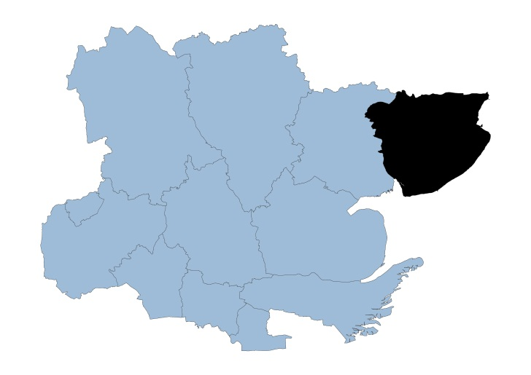

Tendring Locality

Tendring is located in the Northeastern peninsula of Essex and covers an area of approximately 336 square kilometers. The main populous areas are those on the coastline such as Frinton, Walton, Brightlingsea, Clacton and Harwich.

Tendring is the fifth most populous district in Essex with a population of 147,353, with 438 people per square km. 95.4% of the population are of White British ethnicity.

In the Indices of Multiple Deprivation 2019 the Tendring Local Authority area was ranked 32 out of 317 lower tier authorities in England. This places Tendring in the bottom 10% of most deprived Lower Tier Local Authorities (LTLAs) nationally. Tendring is ranked as the most deprived area out of 12 districts in the county for overall deprivation. Tendring is the only area in Essex which falls into the 10% of most deprived areas nationally and is 68 places below the next lowest area in the county.

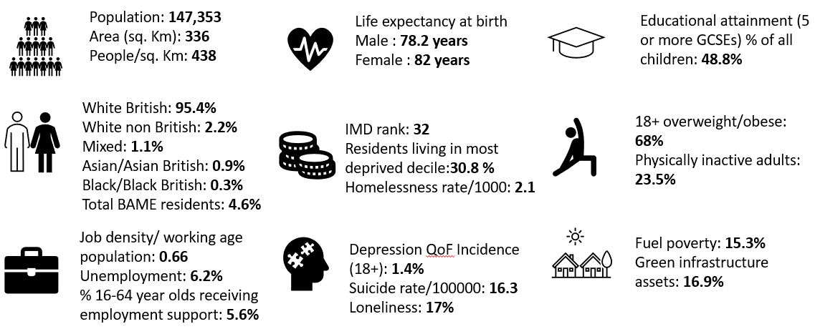

Further details can be accessed in the Essex Joint Strategic Needs Assessment https://data.essex.gov.uk/

Map of Tendring Pharmacies

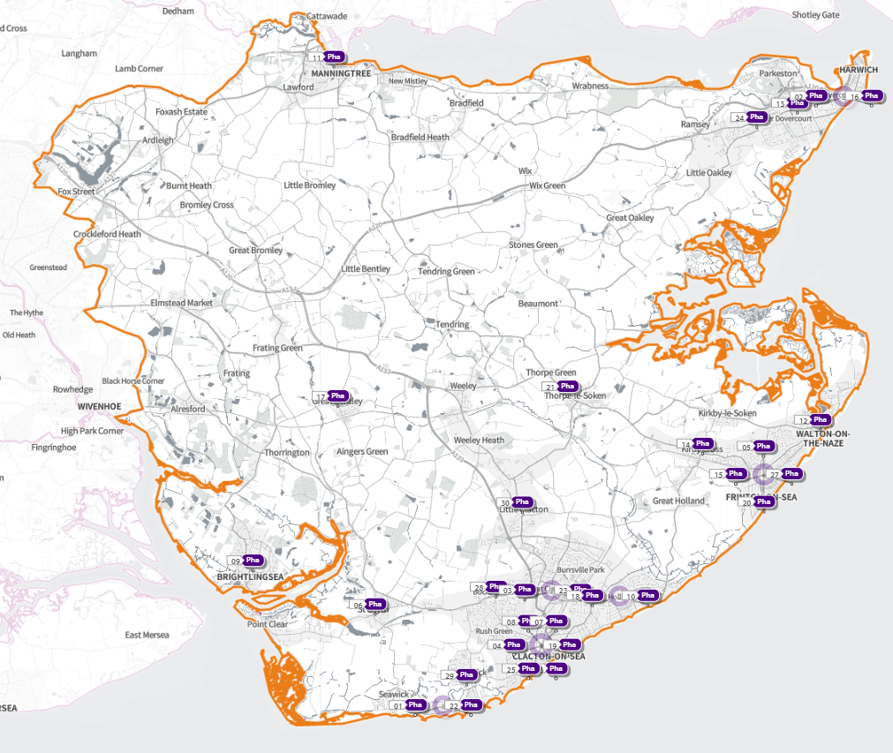 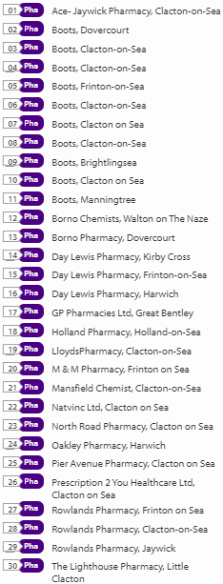
Source: Shape Place Atlas (as at 22/03/22)

Provision

The information contained in this report was obtained from NHSE, local commissioners and a contractor survey.

Opening hours were obtained via the NHSE pharmacy contracts team.

Service provision for advanced services was obtained via NHSE, NHSBSA and with the support of the local LPC.

Access

Appendix F shows that using the base population data on the SHAPE Place Atlas platform, it is possible to calculate the Essex population (and by district) that are estimated to have a journey time either within 20 minutes, 20 - 30 minutes or over 30 minutes to a pharmacy across Essex and within a 1.6km buffer zone around Essex by each journey method.

Overall, across Essex, generally residents are within a relatively short travel time whichever method is chosen:
- 99.9% of the Essex population could get to a pharmacy in a 20-minute drive.
- 95% a 20-minute public transport journey.
- 83% within a 20-minute walk. Residents have to travel for longer if they walk.
- 11% over 30-minute walk away.
- Tendring residents can drive to a pharmacy within 20 minutes.
- Most residents can get to a pharmacy within a 20-minute journey on public transport in most districts. However, some districts see a relatively high % of their population having to travel for longer (Braintree, Maldon, Uttlesford 20-30 minutes; Braintree, Epping Forest, Uttlesford over 30 minutes).
- Most residents can get to a pharmacy within 20-minute walk in most districts. Some districts however see a relatively higher % of their population that’d have to walk further (Braintree, Brentwood, Uttlesford 20-30 minutes; Braintree, Maldon, Uttlesford over 30 minutes).

Travel time to access pharmaceutical services are no longer than journey times to access key services as shown in section 6 of this report.

From the results of the public survey (Appendix E) 83% of residents stated that they had a reasonable distance to travel to the pharmacy equating to less than 20 minutes, 14% had travelled between 20 and 30 minutes, and 3% had travelled between 30-45 minutes. 61% made the trip by car, and 34% had travelled on foot—only 3% used public transport and 2% a bicycle.

Tendring residents also have access to dispensing doctors, pharmacies in other HWB areas and distance selling pharmacies in England. Analysis of dispensing flows in the North East Essex CCG area shows that 89% of prescriptions generated in the CCG are dispensed within the area and 11% out of area including 5% by distance selling pharmacies.

Pharmaceutical services in the locality
Table Number and type of providers of pharmaceutical services in the area
Type Of Contract | Tendring
Total Number of Community Pharmacies | 29
Dispensing Doctors | 8
Dispensing Appliance Contractors | 0
Distance Selling Pharmacies | 0

Table x Pharmacy contractors in the locality and provision of commissioned services
* Friday hours are taken as standard for Mon- Fri
Services key:
Services 1 & 2 are NHSE commissioned Advanced necessary services
Services 3-6 are NHSE commissioned Advanced services
Service 7 is an NHSE commissioned Enhanced service
Service 8 is a CCG locally commissioned services
Services 9-13 are local authority locally commissioned services

Service Code |  |  |  |  |  |  |  |  |  |  | 1 | 2 |  | 3 | 4 |  | 5 | 6 | 7 | 8 |  |  | 9 | 10 |  | 11 | 12 |  | 13
Organisation code | Trading Name |  | Address line |  | Town | Postcode | Hours: M - F* OPENING HOURS SUPPLEMENTARY | Hours: Sat OPENING HOURS SUPPLEMENTARY |  | Hours: Sun OPENING HOURS SUPPLEMENTARY | NMS | CPCS |  | SAC | SCS |  | HYPERTENSION | FLU Vaccination | COVID Vaccination | PALLAITIVE CARE |  |  | SEXUAL HEALTH | SMOKING CESSATION |  | NHS Health Checks | NEEDLE EXCHANGE |  | SUPERVISED CONSUMPTION
FAN43 |  | Boots UK Ltd |  | 224-226 High Street | Dovercourt | CO12 3AJ | 8.30 - 17.30 | 8.30-17.30 | Closed |  |  |  |  |  |  |  |  | ✓ |  |  |  |  |  |  |  |  |  | ✓ |  | ✓
 |  |  |  |  |  |  | 8.30-9.30 | 8.30 - 9.30, 13.30-14.30 & 17.00-17.30 |  |  | ✓
 |  |  |  |  |  |  | 13.30-14.30 & 17.15-17.30
FAN97 |  | Prescription 2 You Healthcare |  | 89/91 Pier Avenue | Clacton-On-Sea | CO15 1QE | 8.00 -18.30 | 9.00 -17.00 | 10.00- 13.00 |  |  |  |  |  |  |  |  | ✓ |  |  |  | ✓ |  |  | ✓ |  |  | ✓ |  | ✓
 |  |  |  |  |  |  | 8.00 - 9.00, 12.00 - 14.00 & 18.00 - 18.30 | 9.00- 13.00 & 16.00- 17.00 |  |  | ✓
FAP95 |  | GM Graham Pharmacies Ltd (100 Hour Pharmacy) |  | 77-79 Frinton Road | Holland-On-Sea | CO15 5UH | 8.00- 23.00 | 8.00- 22.00 | 8.00- 22.00 |  | ✓ |  | ✓ |  |  |  | ✓ | ✓ |  |  | ✓ | ✓
FCX40 |  | Boots UK Ltd |  | 15 North Road | Clacton-On-Sea | CO15 4DB | 8.45 - 20.00 |  |  |  | ✓ |  | ✓ |  |  |  |  | ✓ |  |  |  | ✓ |  |  | ✓ |  |  |  |  | ✓
 |  |  |  |  |  |  | 8.45-9.00 & 17.00- 20.00 | 9am - 17pm | Closed
FD548 |  | Natvinc Ltd |  | 18 Broome Way | Clacton-On-Sea | CO15 2HN | 9.00 - 18.00 |  |  |  |  |  |  |  |  |  |  | ✓ |  |  |  |  |  |  |  |  |  |  |  | ✓
 |  |  |  |  |  |  | 13.00 - 14.00 | 9.00 - 16.00 | Closed
FE590 |  | Boots UK Ltd |  | 54-62 Pier Avenue | Clacton-On-Sea | CO15 1QN | 8.00 - 17.30 | 8.30 - 17.30 |  |  | ✓ |  | ✓ |  |  |  | ✓ | ✓ |  |  |  | ✓ |  |  | ✓
 |  |  |  |  |  |  | 8.00 - 9.30, 13.00 -14.00 & 17.15 - 17.30 | 8.30 - 9.30, 13.00 -14.00 & 17.00 - 17.30 | 10.00 - 16.00
FEV34 |  | L Rowland & Co (Retail) Ltd |  | 98 Connaught Avenue | Frinton-On-Sea | CO13 9PT | 9.00 - 17.30 | 9.00 - 13.00 11.30 - 13.00 |  |  | ✓ |  |  |  |  |  |  | ✓
 |  |  |  |  |  |  | 13.20 - 14.00 |  | Closed
FGR39 |  | Lloyds Pharmacy Ltd |  | 2 Jackson Road | Clacton-On-Sea | CO15 1JA | 9.00 - 18.00 | 9.00 - 12.30 |  |  | ✓ |  |  |  |  |  | ✓ | ✓ |  |  |  |  |  |  | ✓ |  |  |  |  | ✓
 |  |  |  |  |  |  | 11.00 - 14.30 |  | Closed
FGR78 |  | L Rowland & Co (Retail) Ltd |  | 354 St Johns Road | Bockings Elm  Clacton-On-Sea | CO16 8DS | 9.00 - 18.00 |  |  |  | ✓ |  |  |  |  |  |  | ✓ |  |  |  | ✓ |  |  |  |  |  | ✓
 |  |  |  |  |  |  | 13.20 - 14.00 | Closed | Closed
FJF03 |  | GP Pharmacies Ltd |  | The Green Pharmacy | The Green  Colchester | CO7 8PJ | 9.00 - 18.30 |  | Closed |  | ✓ |  | ✓ |  |  |  |  | ✓ |  |  |  | ✓
 |  |  |  |  |  |  | 17.00 - 18.30 | 9.00 - 13.00
FK003 |  | Fourth Dimensions Ltd |  | Maidshead Parade, High St | Clacton-On-Sea | CO16 0DY | 9.00 - 18.00 |  |  |  | ✓ |  |  |  |  |  |  | ✓
 |  |  |  |  |  |  | 13.00 - 14.00 | 9.00 - 13.00 | Closed
FWR90 |  | GM Graham Pharmacies Ltd |  | 78-80 Pier Avenue | Clacton-On-Sea | CO15 1NH | 9.00 - 17.30 |  |  |  |  |  |  |  |  |  | ✓ | ✓ |  |  |  |  |  |  |  |  |  | ✓
 |  |  |  |  |  |  | 13.20 - 13.30 | Closed | Closed
FKJ91 |  | Prescriptions2You Limited (100 Hour Pharmacy) |  | 25 North Road | Clacton-On-Sea | CO15 4DD | 7.00 - 22.00 | 7.00 - 22.00 | 10.00 - 20.00 |  | ✓ |  | ✓ |  |  |  |  | ✓
FLG31 |  | Boots UK Ltd |  | 10 Connaught Avenue | Frinton-On-Sea | CO13 9PW | 9.00 - 17.30 | 9.00 - 17.30 |  |  | ✓ |  |  |  |  |  | ✓ | ✓
 |  |  |  |  |  |  | 9.00 - 9.30 & 13.00 - 14.15 | 9.00 - 9.30, 13.00 - 14.15 & 17.00 - 17.30 | 10.00 - 16.00
FLQ39 |  | Day Lewis Plc |  | 1-5 The Parade | Halstead Road  Kirby Cross | CO13 0LN | 8.30 - 17.30 | Closed |  |  | ✓ |  | ✓ |  |  | ✓ | ✓ | ✓
 |  |  |  |  |  |  | 13.00 - 14.00 |  | Closed
FLY44 |  | Day Lewis Plc |  | 8 The Triangle Shop Ctr | Rochford Way  Frinton-On-Sea | CO13 0AU | 9.00 - 17.30 |  |  |  | ✓ |  | ✓ |  |  |  | ✓ | ✓
 |  |  |  |  |  |  | 17.00 - 17.30 | 9.00 - 13.00 | Closed
FNY90 |  | Borno Chemists Ltd |  | Fryatt Hospital | 419 Main Road  Dovercourt | CO12 4EX | 8.30 - 18.30 |  |  |  | ✓ |  |  |  |  |  |  | ✓ |  |  |  | ✓ |  |  | ✓ | ✓ |  |  |  | ✓
 |  |  |  |  |  |  | 8.30 - 9.00 & 17.00 - 18.30 | Closed | Closed
FPT34 |  | Borno Chemists Ltd |  | 3 Portobello Buildings | High Street  Walton On The Naze | CO14 8BB | 9.00 - 18.30 |  | Closed |  | ✓ |  | ✓ |  |  |  |  | ✓ |  |  |  |  |  |  | ✓ |  |  |  |  | ✓
 |  |  |  |  |  |  | 17.00 - 18.30 | 9.00 - 13.00
FPV12 |  | Boots UK Ltd |  | 19 Clacton Road | Clacton-On-Sea | CO16 8PA | 9.00 - 17.30 | 9.00 - 17.00 |  |  | ✓ |  | ✓ |  |  |  |  | ✓ |  |  |  |  |  |  | ✓ |  |  |  |  | ✓
 |  |  |  |  |  |  | 13.00 - 14.00 & 17.00 - 17.30 | 14.00 - 17.00 | Closed
FQW40 |  | M & M Farmacia Ltd (100 Hour Pharmacy) |  | 152 Connaught Avenue | Frinton-On-Sea | CO13 9NE | 8.00 - 22.00 | 7.00 - 22.00 | 7.00 - 22.00 |  | ✓ |  | ✓ |  |  |  | ✓ | ✓
FRL06 |  | Boots UK Ltd |  | 158 Old Road | Clacton-On-Sea | CO15 3AY | 9.00 - 18.30 | 9.00 - 17.00 |  |  | ✓ |  |  |  |  |  |  | ✓ |  |  |  |  |  |  | ✓
 |  |  |  |  |  |  | 13.00 - 14.00 & 18.00 - 18.30 |  | Closed
FT720 |  | The Lighthouse Pharmacy Ltd |  | 19-21 The Street | Little Clacton | CO16 9LQ | 9.00 - 17.00 |  |  |  | ✓ |  |  |  |  | ✓ |  | ✓ |  |  |  | ✓
 |  |  |  |  |  |  |  | 9.00 - 14.00 | Closed
FTA65 |  | Day Lewis PLC |  | 151 High Street | Harwich | CO12 3AX | 9.00 - 18.00 | Closed |  |  | ✓ |  |  |  |  |  | ✓ | ✓ |  |  |  | ✓ |  |  | ✓
 |  |  |  |  |  |  |  |  | Closed
FVL26 |  | L Rowland & Co (Retail) Ltd |  | Jaywick Community Centre | 32 Crossways  Jaywick | CO15 2NB | 8.30 - 18.00 |  |  |  | ✓ |  |  | ✓ |  |  |  | ✓ |  |  |  | ✓ |  |  |  |  |  | ✓
 |  |  |  |  |  |  | 8.30 - 9.30 & 13.20 - 14.00 | Closed | Closed
FVP82 |  | Boots UK Ltd |  | 86 Pier Avenue | Clacton-On-Sea | CO15 1NJ | 9.00- 18.30 |  |  |  | ✓ |  |  |  |  |  |  | ✓ |  |  |  | ✓ |  |  | ✓ |  |  |  |  | ✓
 |  |  |  |  |  |  | 17.00 - 18.30 | Closed | Closed
FWE04 |  | Boots UK Ltd |  | 52 Victoria Place | Brightlingsea | CO7 0AB | 8.30 - 18.30 | 9.00 - 17.00 |  |  |  |  | ✓ |  |  |  | ✓ | ✓ |  |  |  |  |  |  | ✓
 |  |  |  |  |  |  | 8.30 - 9.00, 13.00 - 14.00 & 18.00 - 18.30 | 13.00 - 17.00 | Closed
FWL47 |  | Boots UK Ltd |  | 75 Frinton Road | Clacton-On-Sea | CO15 5UH | 9.00 - 18.30 |  |  |  | ✓ |  | ✓ |  |  |  |  | ✓
 |  |  |  |  |  |  | 13.00 - 14.00 & 18.00 - 18.30 | 9.00 - 17.00 | Closed
FWW87 |  | Boots UK Ltd |  | Century House | Station Road  Manningtree | CO11 1AA | 8.30 - 19.00 | 8.30 - 17.30 |  |  | ✓ |  |  |  |  |  |  | ✓ |  |  |  |  |  |  | ✓
 |  |  |  |  |  |  | 8.30 - 9.00, 13.00 - 14.00 & 18.00 - 19.00 | 8.30 - 9.00 & 13.00 - 17.30 | Closed
FXX36 |  | Oakley Prescriptions Ltd |  | 10 Oakley Road | Dovercourt | CO12 4QZ | 9.00 - 18.00 |  |  |  | ✓ |  | ✓ |  |  |  |  | ✓ |  |  | ✓ | ✓ |  |  |  | ✓
 |  |  |  |  |  |  | 13.00 - 14.00 | 9.00 - 13.00 | Closed

Tendring opening hours
- Weekday opening hours were taken from Friday as a standard.

Monday to Friday, all 29 community pharmacies are open between the hours of 9:00 to 17:00

Earliest opening time is 7.00 and latest closing time is 23.00
- On Saturdays 22 pharmacies are open in the morning and 13 of the pharmacies remain open in the afternoon. The earliest opening time is 7.00 and the latest closing time is 22.00
- On Sundays six pharmacies open, longest opening times are 8.00 to 22.00

Services (data January 2022)
There is good access to commissioned services within the locality.
The necessary services of NMS and CPCS are provided by many of the pharmacies.
The NHSE commissioned services that are not provided by pharmacies are delivered by other organisations in the locality.

Housing (Appendix G)

The impact of local housing development plans on provision of pharmaceutical services has been considered but has not identified any gaps in pharmaceutical services provision in the area during the lifetime of this PNA.

No gaps in the provision of necessary pharmaceutical services have been identified in the
Tendring locality

No gaps in pharmaceutical services have been identified that if provided either now or in the future would secure improvements or better access to relevant services across the Tendring locality

7.12

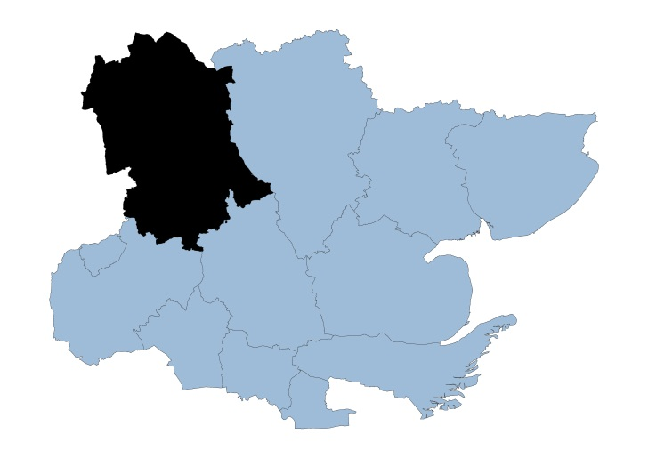

Uttlesford Locality

Uttlesford is located in the North West corner of Essex. It is the largest district in Essex covering approximately 641 square kilometers and is mainly rural in character with four market towns: Saffron Walden, Great Dunmow, Stansted Mountfitchet and Thaxted.

Uttlesford has a population of 92,759 and is the least densely populated district with 145 people living per square km. 92.3% of the population are of White British ethnicity.

In the Indices of Multiple Deprivation 2019 the Uttlesford Local Authority area was ranked 295 out of 317 lower tier authorities in England. This places Uttlesford in the upper 10% of least deprived Lower Tier Local Authorities (LTLAs) nationally.

As of 2019 the Uttlesford area contains 46 LSOAs of which none are ranked in the bottom two most deprived deciles nationally. Uttlesford is one of three LTLAs across the ECC area which do not have any LSOAs in the bottom 10% nationally.

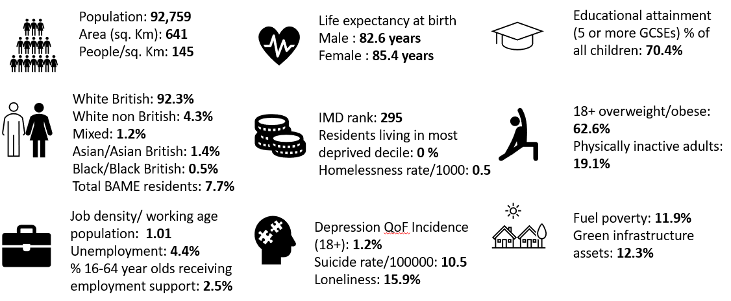

Further details can be accessed in the Essex Joint Strategic Needs Assessment https://data.essex.gov.uk/

Map of Uttlesford Pharmacies
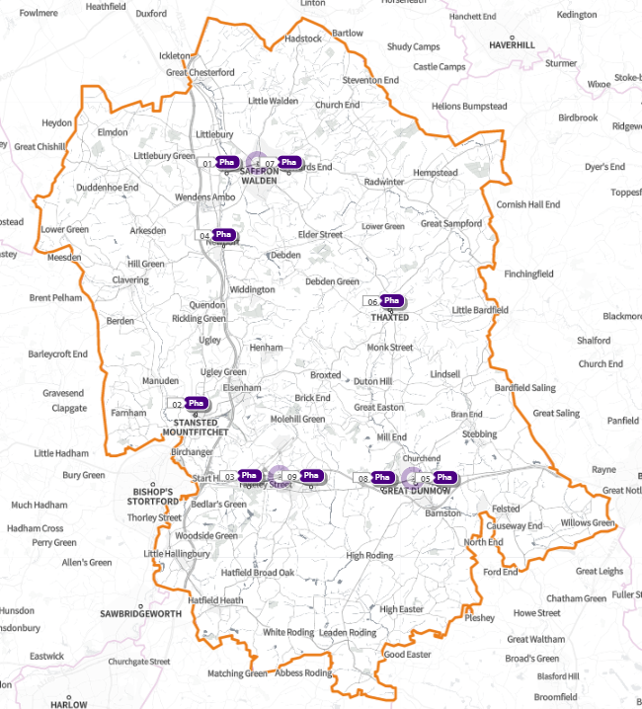

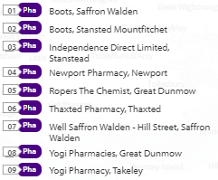

Source: Shape Place Atlas (as at 22/03/22)

Provision

The information contained in this report was obtained from NHSE, local commissioners and a contractor survey.

Opening hours were obtained via the NHSE pharmacy contracts team.

Service provision for advanced services was obtained via NHSE, NHSBSA and with the support of the local LPC.

Access

Appendix F shows that using the base population data on the SHAPE Place Atlas platform, it is possible to calculate the Essex population (and by district) that are estimated to have a journey time either within 20 minutes, 20 - 30 minutes or over 30 minutes to a pharmacy across Essex and within a 1.6KM buffer zone around Essex by each journey method.
- 99.9% of the Essex population could get to a pharmacy in a 20-minute drive.
- 95% a 20-minute public transport journey.
- 83% within a 20-minute walk. Residents have to travel for longer if they walk.
- 11% over 30-minute walk away.
- Uttlesford residents across can drive to a pharmacy within 20 minutes
- Most residents can get to a pharmacy within a 20-minute journey on public transport in most districts. However, some districts see a relatively high % of their population having to travel for longer (Braintree, Maldon, Uttlesford 20-30 minutes; Braintree, Epping Forest, Uttlesford over 30 minutes)
- Most residents can get to a pharmacy within 20-minute walk in most districts. Some districts however see a relatively higher % of their population that’d have to walk further (Braintree, Brentwood, Uttlesford 20-30 minutes; Braintree, Maldon, Uttlesford over 30 minutes).

Travel time to access pharmaceutical services are no longer than journey times to access key services as shown in section 6 of this report.

From the results of the public survey (Appendix E) 83% of residents stated that they had a reasonable distance to travel to the pharmacy equating to less than 20 minutes, 14% had travelled between 20 and 30 minutes, and 3% had travelled between 30-45 minutes. 61% made the trip by car, and 34% had travelled on foot—only 3% used public transport and 2% a bicycle.

Uttlesford residents also have access to dispensing doctors, pharmacies in neighbouring HWB areas and distance selling pharmacies in England. Analysis of dispensing flows in the West Essex CCG area shows that 86% of prescriptions in the CCG are dispensed within the area and 14% out of area including 5% by distance selling pharmacies.

Pharmaceutical services in the locality
Table Number and type of providers of pharmaceutical services in the area
Type Of Contract | Uttlesford
Total Number of Community Pharmacies | 8
Dispensing Doctors | 8
Dispensing Appliance Contractors | 1
Distance Selling Pharmacies | 0

Table Pharmacy contractors in the locality and provision of commissioned services
* Friday hours are taken as standard for Mon- Fri
Services code key:
Services 1 & 2 are NHSE commissioned Advanced necessary services
Services 3-6 are NHSE commissioned Advanced services
Service 7 is an NHSE commissioned Enhanced service
Service 8 is a CCG locally commissioned service
Services 9-13 are local authority locally commissioned services
Service code |  |  |  |  |  |  |  | 1 | 2 | 3 | 4 | 5 | 6 | 7 | 8 | 9 | 10 | 11 | 12 | 13
Organisation code | Trading Name | Address | Town | Postcode | Hours: M - F* CORE SUPPLEMENTARY | Hours: Sat CORE SUPPLEMENTARY | Hours: Sun CORE SUPPLEMENTARY | NMS | CPCS | SAC | SCS | HYPERTENSION | FLU Vaccination | COVID Vaccination | PALLAITIVE CARE | SEXUAL HEALTH | SMOKING CESSATION | NHS Health Checks | NEEDLE EXCHANGE | SUPERVISED CONSUMPTION
FTG55 | Boots | Market Place, Saffron Walden |  | CB10 1HR | 9.00 - 17.30 | 9.00 - 11.30 | Closed | ✓ | ✓ |  |  |  |  |  | ✓ | ✓ |  |  |  | ✓
 |  |  |  |  | 13.00 - 14.00 | 11.30 - 17.30
FW844 | Boots | Unit 2,The Greens Building, 4/8 Cambridge Road, Stansted Mountfitchet | Stansted Mountfitchet | CM24 8BZ | 9.00 - 18.00 | 9.00 - 13.00 | Closed | ✓ | ✓ |  |  |  |  |  | ✓
 |  |  |  |  | 7.00 - 9.00, 13.00 - 14.00 & 18.00 - 19.00 | 13.00 - 17.00
FAG85 | Newport Pharmacy | The Brown House, High Street, Newport | Saffron Walden | CB11 3QY | 9.00 - 17.00 |  |  | ✓ | ✓ |  |  | ✓
 |  |  |  |  | 17.00 - 18.00 | 9.00 - 13.00 | Closed
FTE06 | Ropers The Chemist | 3-5 High Street | Great Dunmow | CM6 1AB | 9.00 - 18.00 |  |  | ✓ |  |  |  | ✓
 |  |  |  |  |  | 9.00 - 17.00 | Closed
FN549 | Thaxted Pharmacy | 3 Town Street | Thaxted | CM6 2LD | 9.00 - 18.00 |  |  | ✓ | ✓ |  |  | ✓ |  | ✓ |  | ✓
 |  |  |  |  | 13.00 - 14.00 | 9.00 - 13.00 | Closed
FXV63 | Well Saffron Walden - Hill Street | 3 The Arches, Hill Street | Saffron Walden | CB10 1ED | 9.00 - 17.30 | 9.00 - 11.30 |  | ✓ | ✓ |  |  | ✓ |  |  |  |  |  | ✓
 |  |  |  |  | 13.30 - 14.30 & 17.30 - 18.30 | 11.30 - 13.00 | Closed
FK965 | Yogi Pharmacies | 7 Market Place | Great Dunmow | CM6 1AX | 9.00 - 18.00 | 9.00 - 13.00 |  | ✓ |  |  |  | ✓ |  |  |  |  |  |  | ✓
 |  |  |  |  | 13.00 - 14.00 |  | Closed
FAE08 | Yogi Pharmacy | Ellesborough House, Dunmow Road | Takeley | CM22 6SH | 9.00 - 18.00 |  |  | ✓ |  |  |  | ✓
 |  |  |  |  | 13.00 - 14.00 | 9.00 - 13.00 | Closed
FJN80 | Independence Direct Ltd (DAC) | Suite 16, 3rd Floor, Endeavour House, Coopers End Road | Stansted | CM24 1SJ | 9.00 - 17.00 |  |  | N/A | N/A | N/A | N/A | N/A | N/A | N/A | N/A | N/A | N/A | N/A | N/A | N/A
 |  |  |  |  |  | Closed | Closed

Uttlesford opening hours
- Weekday opening hours were taken from Friday as a standard.

Monday to Friday, all 8 community pharmacies are open between the hours of 9:00am to 17:30

Earliest opening time is 7.00 and latest closing time is 19.00
- On Saturdays all the pharmacies are open in the morning and 3 of the pharmacies remain open in the afternoon. The latest closing time is 17.30
- On Sundays one pharmacy is open between 10:00 until 16:00

Services (data January 2022)

There is good access to commissioned services within the locality.
The necessary services of NMS and CPCS are provided by almost all the pharmacies.
The NHSE commissioned services that are not provided by pharmacies are delivered by other organisations in the locality.

Housing (Appendix G)

The impact of local housing development plans on provision of pharmaceutical services has been considered but has not identified any gaps in pharmaceutical services provision in the area during the lifetime of this PNA.

No gaps in the provision of necessary pharmaceutical services have been identified in the Uttlesford locality

No gaps in pharmaceutical services have been identified that if provided either now or in the future would secure improvements or better access to relevant services across the Uttlesford locality

8 Likely future needs to consider

Sustainability

The Royal Pharmaceutical Society has identified priorities for pharmacies in partnership with other partners to support sustainability and reduce the environmental impact of medicines use. Medicines account for about 25% of carbon emissions within the NHS. Community pharmacists can play a role in supporting sustainability by:

- Using digital tools to reduce the environmental impact of travel, such as virtual consultations where they are clinically appropriate and appropriate for the patient
- Improving organisational, departmental, and personal transport and travel plans, including maximising working from home to reduce travel
- Streamlining ordering and delivery of medicines to reduce carbon emissions
- Encouraging the public to use active transport
- Educating the public about not stockpiling medicines, only ordering the repeat medicines they need, and appropriate disposal of medicines
- Undertaking education on the impact of climate change, how to implement sustainable practices and carbon literacy.
- Sourcing environmentally friendly reusable alternatives to single use plastics in the pharmacy, such as medicine spoons, medicine cups, oral syringes and plastic compliance aids.
- Providing medication reviews to identify potential medicines waste, improve compliance, deprescribe medicines not required, and change from high-carbon products to low-carbon alternatives and low environmental impact alternatives where appropriate
- Collaborating with other health professionals to reduce use of medicines with the biggest environmental impact, for example inhalers and medical gases
- Lead audit work on environmental sustainability.

Inequalities

The NHS Long -Term Plan, NICE guidelines, the new community pharmacy contractual framework, and learning from the impact of COVID-19 come together to signal the potential for enhancing the role of community pharmacy teams in addressing health inequalities.

Public Health England (PHE) produced a briefing highlighting the unique role that pharmacy teams can play in helping to address health inequalities. The briefing, set out suggestions on how to make the most of pharmacy teams’ potential to work with local community and faith leaders, reach out to under-served communities and those with the poorest health outcomes, and to take on a health inequalities leadership role. It also sets out recommendations for system leaders, commissioners and community pharmacy teams themselves.

The almost 11,200 community pharmacies in England are rooted in the heart of local communities. 80% of people can get to a pharmacy within a 20-minute walk (DHSC internal data – March 2019), with access highest in the most deprived areas, bucking the inverse care law.

Community pharmacy staff are drawn from local communities and reflect their make-up. Community pharmacy teams have a long history of delivering community health promoting interventions – engaging in an annual series of public health campaigns and rolling out initiatives such as stop smoking services, reducing alcohol consumption, sexual health services and dementia friends.

The Community Pharmacy Contractual Framework (CPCF) identifies the critical role of community pharmacy as an agent of improved public health and prevention, embedded in the local community.

The CPCF has also identified community pharmacy as a setting for clinical service delivery, with the potential to support important primary care services to reach further into the heart of communities with the greatest need. New services already introduced include - referrals from NHS111 and GPs to community pharmacists for minor illnesses, the urgent supply of a prescribed medicine, and the Discharge Medicines Service with referrals from hospitals to community pharmacists for patients discharged from hospital who need support with their medicines. From August 2021, blood pressure case finding and stop smoking services for patients discharged from hospital have been embedded within the community pharmacy contractual framework

From 1 January 2021, being a Healthy Living Pharmacy (HLP) was an essential requirement for all community pharmacy contractors in England. The HLP framework is aimed at achieving consistent provision of a broad range of health promotion interventions through community pharmacies to meet local need, improving the health and wellbeing of the local population and helping to reduce health inequalities.

Integrated Care System (ICS) pharmacists will have a critical leadership role in further enhancing the role of community pharmacy teams in addressing health inequalities.

In England there are an estimated 1.2 million health related issue visits to a pharmacy every day and these provide a valuable opportunity to support behaviour change through making every one of these contacts count.

Making healthy choices such as stopping smoking, improving diet and nutrition, increasing physical activity, losing weight and reducing alcohol consumption could make a significant contribution to reducing the risk of disease, improving health outcomes for those with long-term conditions, reducing premature death and improving mental wellbeing.

Pharmacies are ideally placed to encourage and support people to make these healthy choices as part of the provision of pharmaceutical services and services commissioned by the Council and the CCGs.

COVID-19 has clearly demonstrated the value of virtual consultations and enabling people to engage with health professionals is critical to the sustainability of the NHS. Patients have benefited from the multi-disciplinary virtual ward rounds and meetings facilitated through digital technology across primary and secondary care. It is imperative that people can benefit from these digital options when consulting with a pharmacist where appropriate. Access to digital consultation tools and equipment in all pharmacy settings can help to deliver:
- Improved convenience
- Reduced carbon footprint
- Improved safety for patients
It is recognised that these platforms are not always suitable for all patients and should enhance, rather than replace access to face-to-face care. There needs to be flexibility in the delivery of service to balance access and not further the health inequalities gap.

Conclusion

Conclusions for the purpose of schedule 1 to The Regulations

When assessing the provision of pharmaceutical services in the Essex HWB area the steering group considered the following:
- The number and distribution of all contractors in each PNA locality and opening hours
- The location of and choice of pharmaceutical services
- Access to community pharmacies during weekdays, evenings and the weekend
- Access to community pharmacies via various types of transport
- Provision of Essential, Advanced and Enhanced services in each locality
- Provision of necessary and relevant services
- Results of the public questionnaire
- Results of the contractor questionnaires
- The health needs of the population from the JSNA
- Projected population growth
- Specific populations
- The Index of Multiple Deprivation and deprivation ranges as well as the other wider determinants of health
- The general lifestyle including smoking and drug and alcohol misuse
- The disease burden

The PNA is required to clearly state what is considered to constitute Necessary Services as required by paragraphs 1 and 3 of Schedule 1 to the Pharmaceutical Regulations 2013.

For the purposes of this PNA, Necessary Services for the HWB are defined as Essential Services plus NMS and CPCS.
Other Advanced Services are considered relevant as they contribute toward improvement in provision and access to pharmaceutical services.

For the purpose of this PNA, Enhanced Services are defined as pharmaceutical services that secure improvements or better access to, or that have contributed towards meeting the need for pharmaceutical services in the HWB area.

Locally commissioned services are those that secure improvements or better access to, or that have contributed towards meeting the need for pharmaceutical services in Essex and are commissioned by the CCG or local authority, rather than NHSE&I.

Access to pharmaceutical services for the residents of Essex is good and the main conclusion of this PNA is that there are currently no gaps in the provision of necessary or relevant pharmaceutical services.

The PNA also looked at changes which are anticipated within the lifetime of the document, for example the predicted population growth. Given the current population demographics, housing projections and the distribution of service providers across the HWB area, this document concludes that the current provision will be sufficient to meet the likely future needs of the residents during the three-year lifetime of this pharmaceutical needs assessment.

The HWB has not identified any services that would secure improvements, or better access, to the provision of pharmaceutical services either now or within the lifetime of this pharmaceutical needs assessment.

Based on the information available at the time of developing this PNA no current gaps in the provision of essential services during normal working hours have been identified in any of the localities

Based on the information available at the time of developing this PNA no current gaps in the provision of essential services outside normal working hours have been identified in any of the localities

Based on the information available at the time of developing this PNA no current gaps in the provision of the New Medicine Service and Community Pharmacist Consultation Service advanced services have been identified in any of the localities

Based on the information available at the time of developing this PNA no gaps in the need for the necessary services in specified future circumstances have been identified in any of the localities

Based on the information available at the time of developing this PNA no gaps in the current provision of other relevant services or in specified future circumstances have been identified in any of the localities

Based on the information available at the time of developing this PNA no gaps have been identified in essential services that if provided either now or in the future would secure improvements or better access to essential services in any of the localities

Based on the information available at the time of developing this PNA no gaps have been identified in the provision of advanced services that if provided either now or in the future would secure improvements or better access to advanced services in any of the localities

Based on the information available at the time of developing this PNA no gaps in respect of securing improvements or better access to the enhanced services in specified future circumstances have been identified in any of the localities

Appendices

Appendix A Development of PNA and Steering Group
Appendix B Full consultation report
Appendix C List of Pharmacies in the HWB area
Appendix D List of Dispensing Doctors in the HWB area
Appendix E Public survey report
Appendix F Travel times and maps
Appendix G Housing Report
Appendix H Contractor Survey

https://www.legislation.gov.uk/uksi/2013/349/contents
Pharmaceutical Services (Advanced and Enhanced Services) (England) Directions 2013 - GOV.UK (www.gov.uk)
Pharmacy Access Scheme: guidance - GOV.UK (www.gov.uk)
https://www.longtermplan.nhs.uk/
The Future for Community Pharmacy in Integrated Care Systems Breaking Barriers Report https://bbi.uk.com/pharmacy-in-place/
https://psnc.org.uk/contract-it/the-pharmacy-contract/cpcf-settlement-2019-20-to-2023-24/
https://www.rpharms.com/recognition/all-our-campaigns/policy-a-z/future-of-pharmacy
Pharmacy Integration Fund (PhIF) https://www.england.nhs.uk/primary-care/pharmacy/pharmacy-integration-fund/
Essex JSNA https://data.essex.gov.uk/
Mid and South Essex ICS https://www.msehealthandcarepartnership.co.uk/ Hertfordshire and West Essex ICS https://www.healthierfuture.org.uk/ Suffolk and North East Essex ICS https://www.sneeics.org.uk/
www.gov.uk/discrimination-your-rights/types-of-discrimination
Journey Time Statistics (https://www.gov.uk/government/collections/journey-time-statistics)
https://www.dispensingdoctor.org/news/rural-travel-times-to-gp-practice-is-more-than-double-than-in-urban-areas/
https://www.rpharms.com/recognition/all-our-campaigns/policy-a-z/future-of-pharmacy
Pharmacy-teams-seizing-opportunities-for-addresssing-health-inequalities.pdf (psnc.org.uk)
Healthy Living Pharmacies : PSNC Main site
Public Health England, Royal Society of Public Health (2016) Building Capacity: Realising the potential of community pharmacy assets for improving the public’s health rsph.org.uk

