

Thistley Green Transforming Care Supported Living Service

Overview of the service and plan for the 2025 contract

October 2024

# Summary of the service

The below table is a summary of this service as of October 2024.

|  |  |
| --- | --- |
| Address of the scheme | Main Site  3 Thistley Green, Thistley Green Road, Braintree, CM7 9SE  Satellite Site  19 Lyons Hall Road, CM7 9SG |
| Description of scheme | Main Site  A collection of self-contained single occupancy flats, spread across 3 buildings on the same site for adults with complex support needs many of whom previously resided in secure long-term hospitals and were part of the transforming care cohort. The scheme consists of the Stables with two ground floor flats, and Evesgate and Thistley House consisting of two ground floor and two first floor flats in each building. The current care provider also acts as landlord for the service through their property arm.  Satellite site  Lyons Hall Road satellite service consists of a two bedroom single occupancy bungalow purchased through NHS Captial funding to support the discharge for an adult who had been in hospital for several years and whose discharge had been prolonged by a protracted Court of Protection case. Golden Lane Housing Association are landlords, and the adult receives a standalone support service with management oversight from Thistley Green |
| Number of tenancies | Main Site: 10 Tenancies, across 3 buildings  Evegate: 4 tenancies  Thistley House: 4 Tenancies  Stables: 2 Tenancies  Satellite site:  1 tenancy |
| Number of vacant tenancies | 0 |
| Support provider contract start and end date | Start date: 28th November 2017  End date: 31st of October 2025 |
| 2024/5 Total annual support package cost | £2.9M |

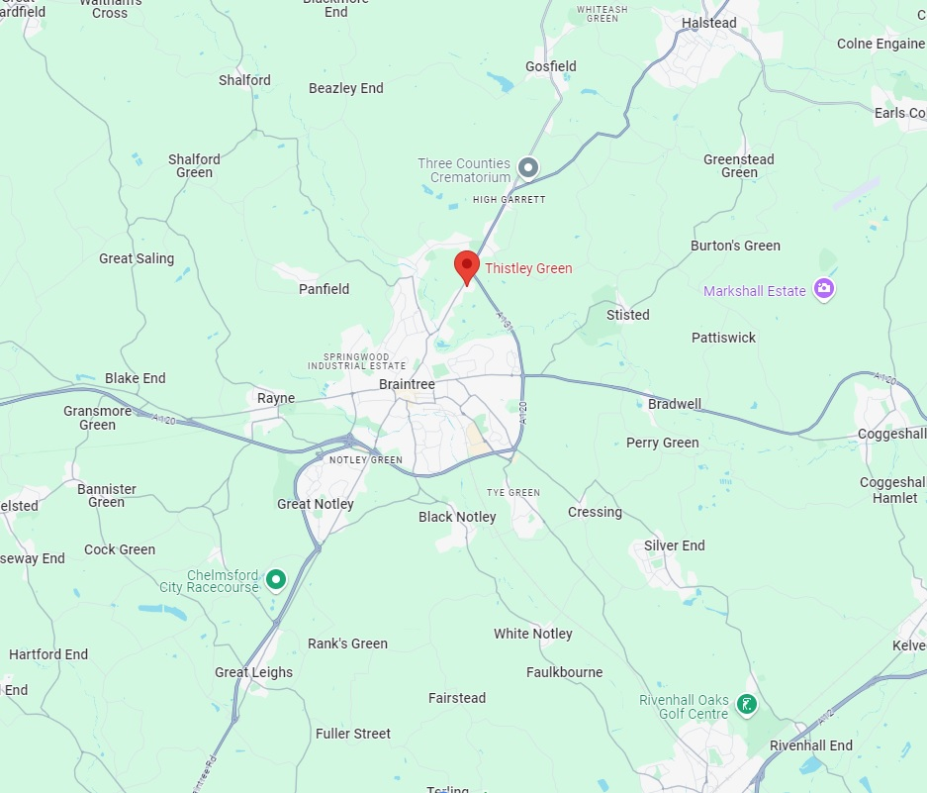

Aerial photograph and site layout of the Thistley Green site outlined in red:

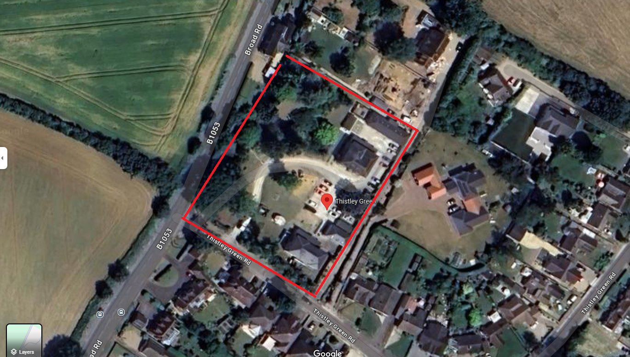

## 

## Background of the service and the adults that are supported

Thistley Green main site

The Thistley Green scheme originated from some creative thinking by the LD Associate Director for Specialist Health in Essex County Council. He, alongside ECC Housing, Commissioning and Procurement colleagues, the Operational team and health partners developed the site specifically around the gap in service for adults with a significant complexity of needs.

A robust and careful approach was taken to the individual assessment, care and support planning and transition of each person into their self-contained flat, with the addition of assistive technology to support the staff and person to build a level of independence, taking a positive approach to risk. This included consideration of the person’s mental capacity and their ability to co-produce their care plans. People were supported to personalise their flats and have some choice and control over their environment. This included families as part of the whole conversation and continues to do so.

The contract for care provision was awarded early in the process to allow time for relationships to be built with the MDT and the adults we anticipated they would be supporting.

The outcomes for the people at the Thistley Green scheme have been very different according to their lived experience. One person at Thistley needed a considerable amount of time to develop his belief that he would not return to a secure hospital setting. Other people at the site have been supported to take a staged approach to their independence in line with the legislative framework around them (Ministry of Justice or Deprivation of Liberty Safeguards). All have had continuous and consistent access to the MDT, that has allowed for a responsive and flexibility in the partnership resulting in only 1 brief detention under the Mental Health Act since Thistley Green opened in 2019.

Lyons Hall Road Satellite site

Lyons Hall Road satellite service consists of a two-bedroom single occupancy bungalow purchased through NHS Capital funding to support the discharge for an adult who had been in hospital for several years. The bungalow was adapted to meet the specific environmental needs of the adult in situ and subsequently further adaptions have been made all funded via NHS England. Golden Lane Housing Association are landlords, and the adult receives a standalone support service with management oversight from Thistley Green.

### Detail on the property lease and rent

* Essex County owns the Thistley Green site and properties and public sector funding was used to develop the site.
* The properties are leased to the care provider, it was a requirement of the tender that the successful support provider also take on the landlord function of the scheme.
* The provider is required to pay the rent to Essex County Council less the budgeted maintenance and deduction for sinking funds.
* Type of tenancies: Assured Shorthold

## Commissioning the 2025 Thistley Green contract

* It is proposed that the new contract will be commissioned separately from the Supported Living framework, the reasons for this are:
  + The unique nature of this service requires a bespoke service specification
  + A bespoke contract enables a longer contract period of 6 years + 2, this is necessary due to the nature of the service and to enable providers recoup any initial upfront investment required.
  + There will be a different approach taken to the evaluation of the tender, as having the right provider in place is critically important to prevent service failure and secure hospital re-admissions. A multi-stage process is envisaged which will set a high bar through use of the Conditions of Participation and will include an in person presentation from bidders for the second stage of the tender.
  + The hourly rates are proposed to track the complex supported living framework hourly rate which currently sits at £23.08 per hour with review to follow in April 2025.
* A key focus of the new contract will be both supporting the existing adults who live at Thistley Green, where appropriate to work with ECC to move adults on to more independent settings and facilitate discharge from hospital to Thistley green for new adults.
* The tender will include a requirement for the support provider to partner with or to provide themselves the landlord function, which will be required to take on the lease and landlord function for Thistley Green