|  |
| --- |
|  |

|  |
| --- |
| **Bus Service Consultation**  Consultation on ECC supported Service 9, Monday – Fridays Walton on the Naze – Great Holland, operated by Stephenson’s of Essex  23 September - 20 October 2019 |
|  |
|  |

**Introduction:** Service 9 operates Mondays – Fridays with financial support from Essex County Council (ECC).

**Background:**  Due to proposed changes to the network following a revision of college time, it is proposed that the timing of one afternoon journey, on service 9 is amended. The proposed change to the timetable is shown below.

**Proposal:**  In order to coincide with changes to the network, it is proposed to amend one afternoon journey as highlighted below.

**Impact:** The highlighted afternoon journey to run later.

**Details of 9 Service journey affected (highlighted):**

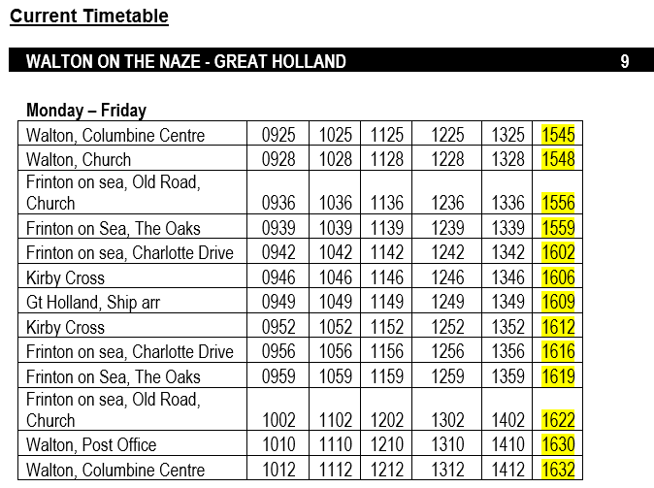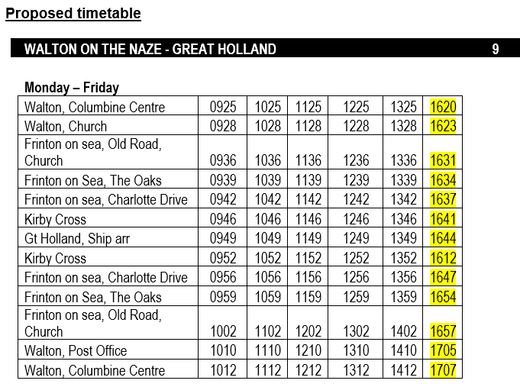

**The consultation:**

The consultation put forward the following question:

* Do you agree with the proposed changes?

This was composed of a consultation letter available on bus and an online survey.

**Key Conclusions**

2 responses

Both respondents advised that they did not use the service.

Both respondents neither agreed or disagreed with the proposal

**Who gave views?**

* 2 male respondents
* 1 respondent under age 25 - 34, 1 65 - 74
* 1 respondent advised he had a long-term health condition which affected transport needs
* 1 respondent is working, 1 is retired

**Summary**

The consultation did not raise objections to this change.

**Final Decision**

Decision made to implement the proposal from 25 November 2019.