|  |
| --- |
|  |

|  |
| --- |
| **Bus Service Consultation**  Consultation on ECC supported Service 115, Schooldays only, Weeley – Tendring Technology College, operated by Stephenson’s of Essex  23 September - 20 October 2019 |
|  |
|  |

**Introduction:** Service 115 operates Schooldays only with financial support from Essex County Council (ECC).

**Background:** From September 2019, Tendring Technology College changed the college finishing time and this consultation proposed amending the timing of the afternoon service 115 journey to reflect this change.

**Proposal:**  In order to coincide with the school’s new finishing time, it is proposed that the afternoon timetable runs later.

**Impact:** Afternoon journey to run later, however as this is a school day service, the impact on the wider public is negligible.

**115 Service timetables:**

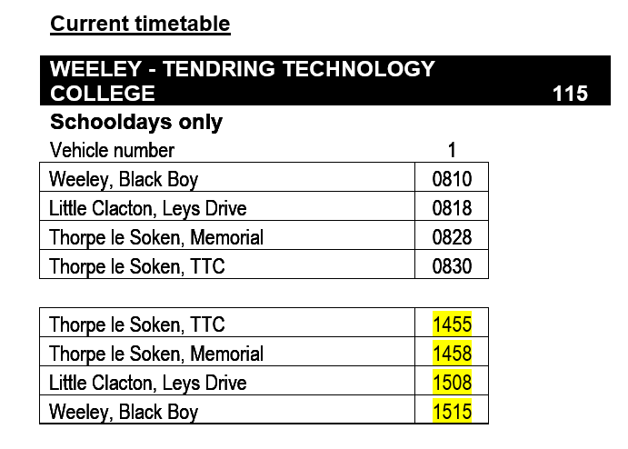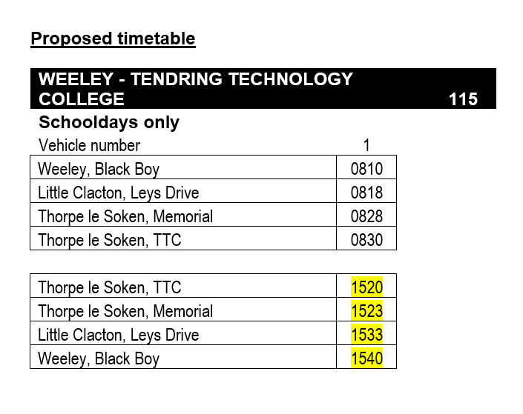

**The consultation:**

The consultation put forward the following question:

* Do you agree with the proposed changes?

This was composed of a consultation letter available on bus and an online survey.

**Key Conclusions**

20 responses

18 responses used the service daily, 2 did not use it at all

19 respondents agreed with the proposal

**Who gave views?**

* 17 female and 3 male respondents
* 3 respondents under 18, 11 age 35 – 44, 6 45-54
* No disability recorded by respondents
* 12 respondents working, 6 studying

**Summary**

Responses indicated that as the service is mainly used by students from Tendring Technical College, the timings should be amended in accordance with the new school finish time. Although one respondent “disagreed”, the comments made suggested that they agreed with the proposal.

**Final Decision**

Decision made to implement the proposal from 25 November 2019.