|  |
| --- |
|  |

|  |
| --- |
| **Bus Service Consultation**  Consultation on ECC supported Service 105, Monday – Saturdays Colchester – Tendring-Walton on the Naze, operated by Stephenson’s of Essex  23 September - 20 October 2019 |
|  |
|  |

**Introduction:** Service 105 operates Mondays to Saturdays with financial support from Essex County Council (ECC).

**Background:**  Due to proposed changes to the network following a revision of college time, it is proposed that the timing of one afternoon journey Monday to Friday only, on service 105 is amended. The proposed change to the timetable is shown below.

**Proposal:**  In order to coincide with changes to the network, it is proposed that the afternoon timetable below runs later.

**Impact:** This afternoon journey to run later.

**Details of 105 Service timetable affected:**

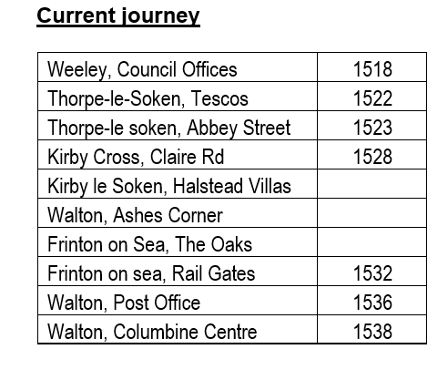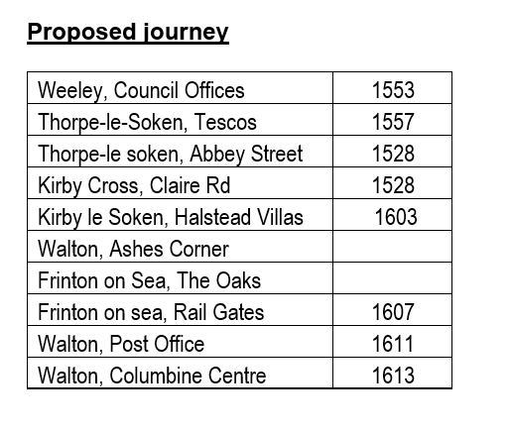

**The consultation:**

The consultation put forward the following question:

* Do you agree with the proposed changes?

This was composed of a consultation letter available on bus and an online survey.

**Key Conclusions**

2 responses

Both respondents advised that they did not use the service.

Both respondents neither agreed or disagreed with the proposal

**Who gave views?**

* 2 male respondents
* 1 respondent under age 25 - 34, 1 65 - 74
* 1 respondent advised they head a long-term health condition which affected transport needs
* 1 respondent is working, 1 is retired

**Summary**

The consultation did not raise objections to this change.

**Final Decision**

Decision made to implement the proposal from 25 November 2019.