Essex County Council

**Infrastructure Delivery**

County Hall, Market Road

Chelmsford, Essex CM1 1QH

8th June 2019

Dear Resident,

**Invitation to review an Online Public Exhibition relating to the proposed new build accommodation at Beauchamps High School, Wickford.**

Essex County Council, as the Education Authority, proposes to provide new build accommodation to provide a new dedicated 6th form block. Two new classrooms will be provided along with a small group room, associated storage, cloak-area and WC facilities. The project design team has been working with Beauchamps High School to develop a proposal that would meet the school’s educational need and fits well on the school site.

We would like to invite you to an online exhibition to review the current proposals and to have your say before the proposals are completed for submission to the County Planning Authority as a detailed planning application. Comment forms are available online and we would be grateful if you could take your time to complete this so that we can capture and consider the views prior to the submission of the planning application.

The online exhibition will be available from **Thursday 22nd August until Thursday 5th September 2019**. And can be viewed at <https://consultations.essex.gov.uk/infrastructure-delivery/beauchamps-high-school>

Please note that the consultation documents will be unavailable until the 22nd August.

We will consider all comments received prior to submitting a detailed planning application to the County Planning Authority. A summary of the pre-application consultation responses will also accompany the submitted planning application.

We hope that you will be able to view the plans and to have your say online. If you have questions in the meantime, or are unable to visit the website and would like more information, please do not hesitate to contact the ECC Project Sponsor at the email address below.

Yours faithfully,

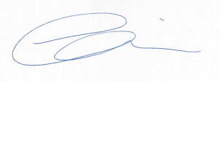

Emma Oni, Project Sponsor

🖂 [Emma.Oni@essex.gov.uk](mailto:Emma.Oni@essex.gov.uk)

Note: Essex County Council is committed to protecting your privacy when you use council services. The Privacy Notice link below explains how the Council uses information about you and the ways in which we protect your privacy. <http://www.essex.gov.uk/privacy-notices/Pages/Default>