Overview

The consultation concerns proposed changes to the Essex Formula for Funding Schools for 2020/21.

Essex County Council has a duty to consult with all schools over proposed changes to the Essex Formula for Funding Schools.

This consultation document has been approved by the Essex Schools Forum at the meeting held on the 11th November 2019.

The consultation will open at 1pm on the 11th November 2019 and close at 11.59pm on the 19th November 2019.

Introduction

The Prime Minister announced on 30th August a £7.1 billion increase in funding by 2022/23 which is:

- £2.6 billion in 2020/21
- £2.2 billion in 2021/22
- £2.3 billion in 2022/23
This will take the Schools Budget from £45.8 billion to £52 billion in 2022/23. The Schools Budget covers the Schools Block, High Needs Block, Early Years Block and Central School Services Block.

The Government has stated that the minimum per pupil level will increase to £3,750 for primary schools, £5,000 for secondary schools, £4,800 for KS3 only schools and £5,300 for KS4 only schools. Subject to consultation with the DfE, the minimum per pupil level is compulsory in 2020/21. This is not to be confused with the Age Weighted Pupil Unit (AWPU). The minimum per pupil level is calculated on all pupil-led and school-led funding and AWPU is one element of pupil-led funding. Pupil-led funding factors are AWPU, deprivation, prior attainment and English as an additional language. School-led funding is the lump sum.

The Government has determined that the minimum funding guarantee must be set between 0.5% and 1.84%.

The Government expects all Local Authorities to move towards the National Funding Formula.

The indicative Schools Block allocation is £896.1m, an increase of £40.3m. The indicative delegation to schools is £889m an increase of £44.6m. The indicative delegation to schools is £4.3m higher than the increase in the indicative allocation as the 0.5% transfer from the Schools Block to the High Needs Block in 2019/20 was a one-off and therefore remains within the Schools Block in 2020/21.

The Authority is not requesting to transfer any funding from the Schools Block in 2020/21.

Why We Are Consulting

Essex County Council is consulting on the changes it is proposing to make to the Essex Formula for Funding Schools in 2020/21.

We are seeking views on the proposed changes to school funding for 2020/21 covering:

- Reducing the lump sum allocation by £10,000 to decrease the gap between the Essex lump sum of £150,000 per school and the proposed National Funding Formula lump sum of £114,400 per school
- Allocating the funding generated by reducing the lump sum through the Age Weighted Pupil Unit (AWPU) for each key stage of education. This means that the funding generated through the proposed £10,000 reduction to the lump sum will be distributed to all schools at the same AWPU uplift for each key stage.
- Moving the primary / secondary funding differential from 1:1.31 to 1:1.30 to decrease the gap between the Essex funding differential currently set at 1.1.31 and the proposed National Funding Formula differential of 1.1.27.
- Setting the minimum funding guarantee (MFG) at 1%. This will guarantee every school will receive as a minimum a 1% increase on each school’s guaranteed per pupil amount.

About the Proposed Changes

The Department for Education has confirmed that it plans to implement a ‘hard’ National Funding Formula as soon as possible, whereby schools will receive what they attract through the National Funding Formula, rather than through the Essex Schools Formula for Funding Schools.

As part of this confirmation a move towards hardening the National Funding Formula has been announced which, subject to consultation, will make the minimum per pupil levels compulsory in 2020/21.

The Authority is therefore proposing to make a move towards the National Funding Formula to help prepare schools for where they should be on that formula. All proposed changes are protected by the minimum funding guarantee.

Who is this consultation for?

This consultation invites views from all schools including academies. The consultation is relevant to headteachers, finance staff and governors. Please note that only one consultation response is allowed from each school.

Responding to this consultation

The consultation is online at https://consultations.essex.gov.uk/ef/school-funding-2020-21

Enquiries

For all enquiries please contact yannick.stupples-whyley@essex.gov.uk or by telephone 033 3013 8464.

Deadline

The consultation closes at 11.59pm on Tuesday 19th November 2019.

The Response

We will publish the response to Schools Forum on 27th November 2019.

Consultation Questions

Section 1 - Lump Sum

The Lump Sum is currently funded at £150,000 for both primary and secondary schools in Essex, but in the National Funding Formula it is £114,400 for 2020/21 (having been increased by 4%).

Chart 1 below shows, within bandings of £10,000, the value that local authorities have funded the lump sum for primary schools between 2017/18 and 2019/20. It can be seen that since the introduction of the National Funding Formula in 2018/19 that most local authorities have moved the value of the lump sum either to or closer to the National Funding Formula. Where in 2017/18 £150,000 was the most common used value for the lump sum, in 2019/20 Essex is an outlier in maintaining the lump sum at £150,000.

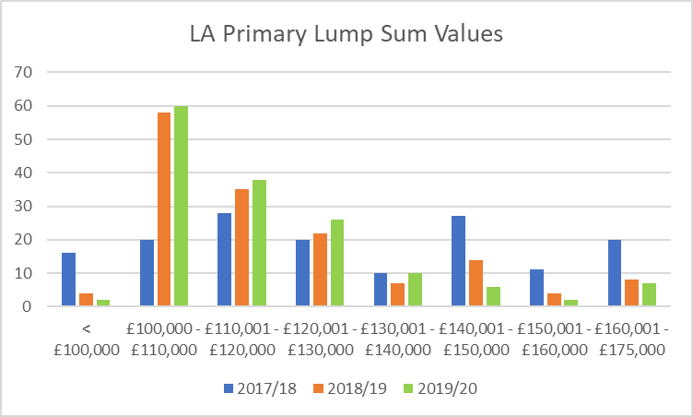

Chart 2 below shows, within bandings of £10,000, the value that local authorities have funded the lump sum for secondary schools between 2017/18 and 2019/20. It can be seen that since the introduction of the National Funding Formula in 2018/19 that most local authorities have moved the value of the lump sum either to or closer to the National Funding Formula. Where in 2017/18 £150,000 was the most common used average value for the lump sum, in 2019/20 Essex is an outlier in maintaining the lump sum at £150,000.

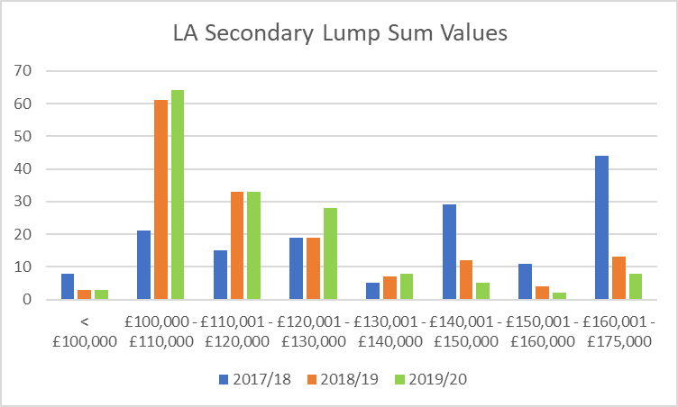

The Authority believes that it should start to prepare schools for the implementation of a ‘hard’ National Funding Formula by gradually reducing the value of the lump sum. Any reduction to the lump sum is protected by the minimum funding guarantee.

Question 1 – Do you agree that the lump sum should be reduced from £150,000 to £140,000 in 2020/21? If not, please explain your reasons.
Section 2 - Allocating the Reduction in the Lump Sum

A reduction in the lump sum of £10,000 reduces the total funding for the lump sum factor by £4.49 million for primary schools and £795,000 for secondary schools.

The proposal is to allow the funding from reducing the lump sum to be allocated through the Age Weighted Pupil Unit (AWPU) also known as the Basic Entitlement within the National Funding Formula. This will increase the AWPU value and schools will receive an increase for all pupils.

If the reduction in funding for the lump sum was allocated through another formula factor schools will only receive funding for pupils that are eligible for the funding factor chosen.

Question 2 – Do you agree that the funding generated by reducing the lump sum is allocated through AWPU? If not, please explain your reasons

Section 3 - Primary / Secondary Funding Differential

The primary / secondary funding differential shows the relative difference in per-pupil funding allocated to secondary pupils compared to primary pupils. Essex currently has a ratio of 1:1.31 which shows on average secondary pupils in Essex receive 31% more funding per head than primary pupils.

The primary / secondary funding differential is 1:1.27 in the National Funding Formula.

Chart 3 below shows, within bandings of 0.05, the value of the primary / secondary funding differential set by local authorities between 2017/18 and 2019/20. In comparison to the lump sum there has been less movement in the funding differential towards the national funding formula. However there has been a slight drift towards the National Funding Formula as the banding including 1:1.27 has increased year-on-year.

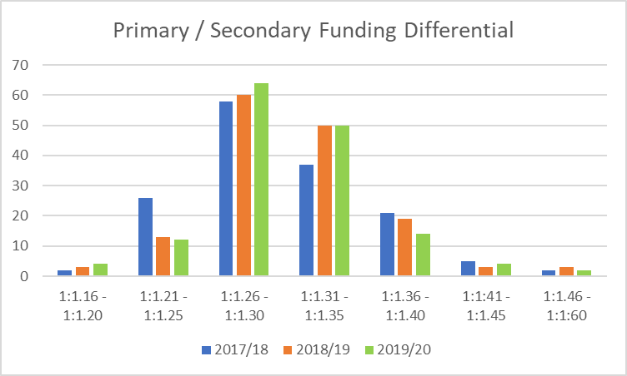

Any movement in the funding differential moves funding from secondary to primary as it reduces the percentage in funding per secondary pupils compared to primary pupils. In financial terms the movement is dependent on the total level of funding but on the indicative funding announced by the DfE on 11th October moving the differential from 1:1.31 to 1:1.30 moves £1.7m from secondary to primary.

Whilst at local authority level there has been a slight drift towards the National Funding Formula, the Authority is proposing to move the funding differential by 0.01 to 1:1.30, to bring it closer to the National Funding Formula. This will aid schools in transitioning to the National Funding Formula.

Q3 – Do you agree that the primary / secondary funding differential is reduced by 0.01 to 1:1.30? If not, please explain your reasons

Section 4 - Minimum Funding Guarantee

The minimum funding guarantee (MFG) either prevents schools from seeing significant year-on-year fluctuations if a negative value is set or it guarantees schools a minimum increase if a positive value is set.

Prior to the National Funding Formula, the MFG was set by the DfE at -1.5%. In 2018/19 the MFG could be set at a local level between -1.5% and 0.5% and in 2019/20 between -1.5% and 1%. For both 2018/19 and 2019/20 the Authority set the MFG at 0%.

For 2020/21 the MFG must be set at a local level between 0.5% and 1.84%. The upper limit matches the funding floor within the National Funding Formula.

The Authority is proposing to set MFG at 1% which will guarantee all schools a minimum increase per pupil (excluding rates and PFI) of 1%. This rate helps to cushion small schools which will feel that impact of a reduced lump sum the most, if implemented.

If the MFG is set higher than 1%, more schools would require protection which reduces the AWPU value allocated to schools. The Authority, if allowable, will seek to increase MFG in future years as funding continues to increase.

Q4 – Do you agree that the minimum funding guarantee is set at 1% for 2020/21? If not, please explain your reasons

Financial Model

The financial model shows the indicative financial impact of the proposed changes upon schools, if implemented, compared to the current level of funding schools receive in 2019/20.

The financial model attached shows for each school their indicative allocations for 2020/21 based on the proposed changes:
- A lump sum of £140,000,
- The reduction in lump sum allocated through AWPU
- The primary / secondary funding differential of 1:1.30, and
- The MFG at 1%.

The final allocations will be dependent on pupil numbers and pupil characteristics from the October 2019 Census and the final DSG settlement which will be announced before Christmas.

There is one AWPU rate for KS1 and KS2 and separate rates for KS3 and KS4.

