Schools Forum | Agenda Item 4
Date 30 September 2026

REPORT TITLE: SCHOOL and HIGH NEEDS FUNDING 2027/28

Report by Yannick Stupples-Whyley and Gareth Rott
Contact details: Telephone (03330 138464); e-mail: yannick.stupples-whyley@essex.gov.uk, gareth.rott@essex.gov.uk

1. Purpose of report

  - To update Schools Forum of the delay in the announcement of the provisional settlement for 2027/28.
  - To update Schools Forum of the pressures within the High Needs Block for 2027/28 to 2030/31.
  - To present the proposal to Schools Forum to transfer 1% (c.£13.3m) from the Schools Block to the High Needs Block.
  - To present to Schools Forum the proposed consultation paper.

2. Recommendations

2.1 To note the pressures in the High Needs Block for 2027/28 to 2030/31.

2.2 To agree the recommendation of the Finance Review Group (FRG) to continue the May 2018 Tendring PPP buyout agreement to support the disapplication request to continue to use an exceptional premises factor at 5.7

2.3 To agree the recommendation of the High Needs Review Group (HNRG) / FRG to support the proposal to transfer 1% from the Schools Block to the High Needs Block at 7.4
2.4 To approve the consultation paper at Annex A

2.5 To agree the recommendation of FRG / HNRG for FRG to undertake a further review of School Balances at 8.4.

3. Relevant Schools Forum Power and Responsibility

3.1 Table 1 is an extract from the Schools Forum Operational and Good Practice Guide (September 2018), which sets out the role of the Authority, Schools Forum and the Secretary of State in setting the Schools Budget.

Function | Local authority | Schools forum | DfE role
Formula change (including redistributions) | Proposes and decides | Must be consulted | Checks for compliance with regulations
Movement of up to 0.5% from the schools block to other blocks | Proposes | Decides | Adjudicates where schools forum does not agree local authority proposal
Movement of above 0.5% from the schools block to other blocks. | Proposes | Must be consulted | Secretary of State will decide.

4. Background

4.1 The DfE has again decided to move away from announcing the provisional DSG settlement in July along with the School Operational Guide which sets out the timetable in setting the DSG budget.

4.2 The 2025 Spending Review announced the funding for the core schools budget from 2025/26 to 2029/30. Table 2 shows the Schools Core Budget announced at the spending review.

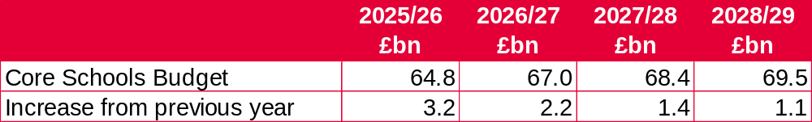

4.3 Nationally funding will increase by £1.4bn in 2027/28, which is an increase of 2.09%. Any changes for 2027/28 will be announced in the budget on 28 October 2026.

4.4 Whilst the year-on-year increase is smaller than the previous year, pupil numbers are declining due to the lower birth rate. The DfE have updated their previous forecast that now shows that nationally pupil numbers will continue to decline to 2031, with primary schools seeing the largest decrease of 473,000 pupils over the next 5 years.

4.5 The 2027/28 DSG allocation updated for the October 2026 schools census will be published in December.

5. Schools Block

5.1 Local authorities have less information available to them, as last year the Schools National Funding Formula (NFF) Summary Policy Document was published in June but so far, no information has been published to date for 2027/28.

5.2 The Authority assumes that the previous pattern of rolling grants into the Schools Block will continue for 2027/28 and therefore assumes the 2026/27 Schools Budget Support Grant, which funded £18.3m to Essex schools, will be rolled into the 2026/27 baseline. Table 3 shows the expected funding that has been modelled.

2027/28
£m
Baseline Funding | 1,294.2
Add back 2026/27 SB transfer | 13.1
Revised Baseline 2026/27 | 1,307.3
School Budget Support Grant 2026/27 | 18.3
Estimated Funding 2027/28 | 1,325.6

5.3 The usual methodology for rolling grants into the schools block is to increase the basic entitlement, the free school meals ever 6 factor and the lump sum. There is also an uplift to the minimum per pupil level.

5.4 It is expected that local authorities will be required to continue to move their local formulae 10% closer to the NFF corresponding values, except where local formulae are already ‘mirroring’ the NFF. These criteria do not apply to rates, PFI or exceptional circumstances.

5.5 If local factors are within +/- 2.5% of the respective NFF values they ‘mirror’ NFF. In 2026/27 Essex fully ‘mirrored’ NFF. Whilst the London Weighting multiplier will need to move at least 10% closer to NFF, it is excluded from the ‘mirroring’ classification.

5.6 Disapplications, such as exceptional premises factors and school block movements, must be submitted by 16 November.

5.7 In May 2018 Schools Forum agreed that the cost of the Tendring PPP buyout will be repaid through an exceptional premises factor within the primary schools funding formula. The DfE now require all exceptional premises factors to be agreed on an annual basis and therefore a disapplication request needs to be submitted. Forum are asked to confirm the May 2018 agreement. The total amount to be funded in 2027/28 is £2.9m which is the same as 2026/27.

5.8 Without any information for 2027/28, the Authority must start planning on estimated funding levels.

5.9 The Authority will need to comply with the following rules to determine budget allocations for schools:

- setting the value for each funding formula factor within the allowed minimum / maximum values;
- implementing the set minimum per pupil level: and
- setting the minimum funding guarantee within the allowed limit.

5.10 Depending upon the allocation within the Schools Block it may be necessary to take action should it not be possible to afford the Essex Formula for Funding Schools. This could be achieved through the following actions:
- Adjusting the value of local factors within the allowable minimum / maximum funding levels.
- Adjusting the minimum funding guarantee within the allowable range.
- Adjust allocations to schools above an agreed level through capping and scaling.
5.11 Under exceptional circumstances where the local formula is still not affordable after using the above actions, local authorities may seek a disapplication from the Secretary of State to set a lower value for MPPL or MFG.

Minimum / Maximum Allowable Local Factor Values

5.12 With the exception of 2025/26 the Authority has funded each factor, excluding the basic entitlement, at the midpoint between the minimum and maximum allowed. In 2025/26 due to the affordability of the formula each factor, excluding the basic entitlement, was funded at the minimum value allowed.

5.13 Depending on the final DSG settlement, the Authority may need to move away from the midpoint value. This could be either a decrease or an increase, as sometimes increasing factor values, especially the lump sum, may increase funding for schools above the minimum per pupil level or minimum funding guarantee, which allows more funding to flow through the basic entitlement.

5.14 Essex will be required to move the London Fringe multiplier at least 10% closer to the NFF value of 1.0347. The London Fringe multiplier was 1.0206 in 2026/27, so it will need to move to a minimum of 1.0220 in 2027/28.

Minimum Funding Guarantee

5.15 The minimum funding guarantee (MFG) protects schools from excessive year-on-year changes. In 2026/27 local authorities could set the MFG between -0.5% and 0.0% per pupil.

5.16 Essex set the MFG at -0.3% for 2026/27 to ensure the Essex formula for funding schools remained affordable. Depending on the funding allocated for 2027/28 the Authority aims to set MFG within the range allowed.

5.17 In extreme circumstances where a local formula remains unaffordable, local authorities can apply to set a lower MFG on the grounds of affordability if all other flexibilities have been exhausted.
Capping and Scaling
5.18 To ensure the local formula is affordable local authorities can choose to cap any gains schools receive. Capping must be applied on the same basis to all schools but cannot be applied to new schools that have opened in the last 7 years and have not reached their full number of year groups.

5.19 Local authorities in consultation with their Schools Forum must determine whether and how to limit gains. Capping cannot take a school below the minimum per pupil level and must be set at least as high as the MFG threshold to ensure schools retain any gains due through MFG.

5.20 An example of where capping could be needed is where there in insufficient funding in the schools block to set the basic entitlement at or above the minimum value allowed. This can occur where the cost of protecting schools through the minimum funding guarantee and the minimum per pupil level is high. The use of capping will allow sufficient funding to set an allowable basic entitlement value.

5.21 Table 4 shows an example of how capping works, for example, if the Authority sets the maximum amount a school can gain is 3%.

School | 2025/26  £ | 2026/27  £ | % Change | 3% Threshold  £ | Reduction  £
School A | 1,000,000 | 1,090,000 | 9% | 1,030,000 | 60,000
School B | 750,000 | 771,000 | 2.8% | 772,500 | 0
School C | 500,000 | 522,500 | 4.5% | 515,000 | 7,500
School D | 1,200,000 | 1,236,000 | 3% | 1,236,000 | 0

5.22 Essex set a cap of 0.5% in 2025/26 which deducted £489,000 from 51 schools. The Authority may need to use capping and scaling in 2027/28 to ensure the local formula remains affordable.

6. The proposal to transfer 1.0% (c.£13.3m) from the Schools Block to the High Needs Block.

6.1 As per previous years including both 2025/26 and 2026/27 and following consultations with schools funding has been transferred from the Schools Block and the Central Support Services Block to help mitigate financial pressures within the High Needs Block (HNB).

6.2 Essex working in partnership with schools has a vital role in supporting children with SEND to achieve the best possible educational and wider outcomes. However, continued increase in the volumes of EHCP’s alongside increasing complexity of need and funding constraints, the Authority is facing significant and increasing financial pressure on the High Needs Block.

6.3 The 2026/27 deficit alone is forecast to be £62.6m. Without the Schools Block transfer agreed for the current year the deficit would be £75.7m. The HNB will continue to face significant financial pressures in 2027/28.

6.4 The Authority does not believe the composition of the High Needs National Funding Formula funds the increased demand appropriately. It is to be noted that the High Needs Funding formula was paused for 2026/27 and a consequence the High Needs Block allocation for Essex did not increase for the current year despite continued growth in EHCP’s. Furthermore, the National Funding Formula also fails to recognise the interaction between the SB and the HNB. There needs to be sufficient funding for all funding blocks which would prevent the need to move funding between blocks.

6.5 As is current practice, the Authority will continue to work with local MPs, the Local Government Association, the Chartered Institute of Public Finance and Accountancy, the Department of Housing and Local Government and the Department of Education to lobby the Treasury for additional funding for the HNB.

6.6 The Authority is part of f40, a local authority campaign group set up by the lowest funded councils which was established to campaign on fairer funding for the lowest funding authorities. The group also campaigns for additional school and high needs funding and is lobbying for major reform and investment in SEND. There are 44 local authorities within the group.

6.7 Benchmarking information available through the f40 group confirms that Essex is ranked 122 out 151 local authorities in terms of its high needs funding per pupil. Without fundamental change to the funding formula this statistic is unlikely to change.

6.8 In 2026/27 £236.6m of DSG High Needs Funding post-recoupment and a further £13.1m transfer from the Schools Block is available to fund High Needs. Chart 1 shows how this funded is to be allocated in 2026/27.
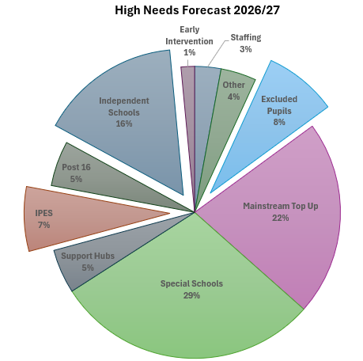

6.9 There are cost increases across the HNB however, significant increases continue in providing independent school provision and Individual Packages of Educational Support (IPES) that supports pupils with SEND and pupils excluded from school. These costs now account for 30% of the total cost of the HNB (£92.5m).

6.10 This upward trend is forecast to continue into 2027/28. Key pressures and high growth budgets are shown in Table 5

Pressures | 2025/26 Outturn £m | 2026-27 Outturn £m | 2027/28 Provisional Forecast £m | Increase from 2025/26 £m
Independent Schools | 40.9 | 46.7 | 54.3 | 13.4
Top-up Funding Mainstream Schools | 59.3 | 64.9 | 66.9 | 7.6
Individual Packages of Education Support | 14.0 | 21.5 | 27.3 | 13.3
Excluded Pupils | 20.9 | 24.3 | 25.2 | 4.3

Education, Health and Care Plans

6.11 The trend in the volume of EHCP’s is forecast to rise significantly. By the end of 2029 there will be 5,239 additional plans when compared to 2025, an increase of 25%. As the volume EHCP’s is the main driver of cost to the HNB, it is inevitable that costs will increase significantly and without continued increases in funding commensurate with the increase in need then an annual funding deficit will continue to arise. Chart 2 shows the increase from 2018/19 to 2025/26 and the forecast through to 2029/30.

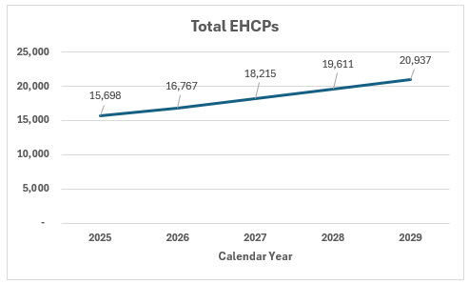

Independent Schools

6.12 To emphasise the cost pressures caused by the need for independent school placements the chart below shows a continuous upward trend in placement volume and overall cost.

6.13 Chart 3, Placements volumes are forecast to increase by 69% from 2021/22 levels which has led to an overall increase in the cost of provision of 82% over the same period.

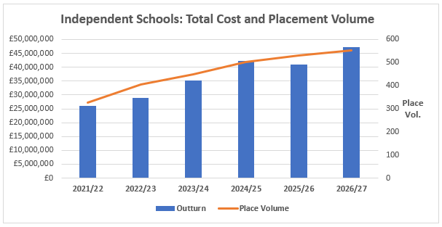

Individual Package of Education Support (IPES)

6.14 Since 2024/25 the need for this provision has increased significantly. To support children with SEN the increase from 2024/25 alone is 106% leading to an increase in cost of £7.2m (92%) p.a over the same period. A similar increase is expected in 2027/28.

6.15 Chart 4 shows the forecast growth in cost for pupils with EHCPs accessing IPES provision.

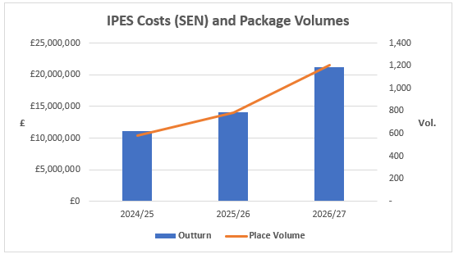

Previous Movements between Blocks

6.16 Table 6 shows previous movements between blocks.

Financial Year | Schools Block £m | High Needs Block  £m | Central School Services Block  £m | Early Years Block  £m
2015/16 | (1.6) | 1.6 | 0 | 0
2016/17 | (4.6) | 1.6 | 0 | 3.0
2017/18 | (1.6) | 1.6 | 0 | 0
2018/19 | 0 | 0 | 0 | 0
2019/20 | (4.3) | 4.3 | 0 | 0
2025/26 | (12.5) | 13.5 | (1.0) | 0
2026/27 | (13.1) | 13.1 | 0 | 0
Total | (37.7) | 35.7 | (1.0) | 3.0

6.17 There were no movements between blocks between 2020/21 and 2024/25.

6.18 The 2026/27 block transfer was to support inclusion and outreach initiatives as well as to provide financial support to help mitigate the deficit. Without the Schools Block transfer agreed for the current year, inclusion and outreach initiatives would be unfunded, and the deficit would be £75.7m rather than the £62.6m currently forecast.

7 Financial Implications

7.1 Table 7 shows the forecast funding that has been allocated through the Essex Formula for Funding Schools to produce indicative allocations for 2027/28.

 | 2026/27  £m | 2027/28  £m | Difference  £m
Schools Block Allocation | 1,307.3 | 1,325.6 | 18.3
Falling Rolls Fund | (0.1) | (0.1) | 0
Growth Fund | (3.6) | (3.6) | 0
Forum approved -Premature Retirement Costs | (1.2) | (1.2) | 0
Transfer to High Needs Block | (13.1) | (13.3) | (0.2)
Allocation to Schools | 1,289.3 | 1,307.4 | 18.1

7.2 The comparison with 2026/27, shows that the impact for schools resulting from the proposal to transfer 1% to the Schools Block is c.£200,000. This is due to the previous year’s transfer being added back as transfers are for one year only.

7.3 Schools will receive in full any increase in funding for 2027/28 except for £200,000 which is the increase in the transfer to the high needs block compared to the transfer in 2026/27.

7.4 The Authority proposes to transfer 1% (c.£13.3m) to reduce the deficit in 2027/28, which the joint meeting of FRG / HNRG recommends that Schools Forum supports the proposal.
7.5 It is to be noted that £13.3m is an estimate and the final financial value may change depending on the funding settlement.

7.6 The impact of the proposed 1% transfer compared to the 1% transfer in 2026/27 increases the primary basic entitlement by £89.43, the key stage 3 basic entitlement by £96.20 and the key stage 4 basic entitlement by £110.74 based on the funding shown in Table 7.

7.7 Annex A shows a breakdown by school of the 2026/27 allocation and forecast 2027/28 allocation assuming a 1% schools block transfer. It can be seen in Annex A, that Montgomery Primary has a decrease of £55,601 due to the removal of the additional lump sum (£107,284), which is not protected by the minimum funding guarantee.

7.8 Table 8 shows the forecast High Needs Block position based on the forecast increase in demand, price and the increasing complexity of pupils excluding any block transfers and other government support in the form of the High Needs Stability Grant.

 | 2026/27 Budget £000 | 2026/27 Outturn £000 | 2027/28 £000 | 2028/29 £000
Total Cost | 349,274 | 352,490 | 370,425 | 396,707
Funding | (277,200) | (276,816) | (276,816) | (276,816)
(Surplus) / Deficit | 72,074 | 75,674 | 93,609 | 119,891
HNB O/balance | 33,586 | 33,586 | 109,260 | 202,860
C/balance | 105,660 | 109,260 | 202,869 | 322,751

7.9 This clearly demonstrates the necessity for the block transfer in limiting financial pressures and contributing to the overall sustainability of the High Needs Block.

7.10 Table 9 shows the impact of the proposal of a 1.0% block transfer to the HNB.
 | 2026/27 Budget £000 | 2026/27 Outturn £000 | 2027/28 £000 | 2028/29 £000
Total Cost | 349,274 | 352,490 | 370,425 | 396,707
Funding | (277,200) | (276,816) | (276,816) | (276,816)
(Surplus) / Deficit | 72,074 | 75,674 | 93,609 | 119,891
Schools Block Transfer to HNB (1%) | (13,073) | (13,073) | (13,256) | (13,256)
(Surplus) / Deficit: post Block Transfer | 59,001 | 62,601 | 80,353 | 106,635
HNB O/balance | 33,586 | 33,586 | 96,187 | 176,540
C/balance | 92,587 | 96,187 | 176,540 | 283,175

High Needs Stability Grant (HNSG)

7.11 The government has confirmed additional support for local authority’s with DSG deficits through the HNSG. The approach taken will be to provide funding equivalent to 90% of the overall DSG deficit (includes all 4 DSG blocks) accumulated up the end of 2025/26. Further support will be provided for deficits accrued in 2026/27 and 2027/28 however, the extent of that support has yet to be confirmed. Eligibility for the HNSG is dependent on the Local Authority’s SEND Reform Plan being approved by the DfE, with the outcome of this decision expected during the Autumn. The forecast value of the HNSG for financial years 2025/26 to 2027/28 is set out in Table 10.

 | 2025/26 | 2026/27 | 2027/28
HNSG (£000): 1.0% | (22.1) | (43.8) | (56.2)
HNSG (£000): 1.2% | (22.1) | (43.8) | (53.9)
% of DSG Deficit | 90% | 70% | 70%

7.12 The impact of the HNSG on the HNB forecast is set out in Table 11

 | 2026/27 Outturn £m | 2027/28 £m | 2028/29 £m
(Surplus) / Deficit | 75.7 | 93.6 | 119.9
Schools Block Transfer to HNB (1%) | (13.1) | (13.3) | (13.3)
(Surplus) / Deficit: post Block Transfer | 62.6 | 80.3 | 106.6
Forecast HNSG | (43.8) | (56.2) | 0
DSG O/balance* | 2.5 | 21.3 | 45.4
DSG Deficit funded by Government | n/a | n/a | (106.6)
C/balance | 21.3 | 45.4 | 45.4
*the DSG opening balance for 2026/27 includes the receipt of the 2025/26 HNSG

7.13 It is evident from the table that even with government support the Local Authority will be faced with a significant DSG deficit by the end of 2027/28.

7.14 The Statutory Override; the treatment of DSG deficits that allows local authorities to hold deficits off the balance sheet is to permanently end on the 31st March 2028. It is at this point Local Authorities will need to fund any residual DSG deficit. Current forecasts suggest this will be £45.4m if a 1.0% transfer was approved for 2027/28 and 2028/29 or £44.4m if a 1.2% transfer was approved. However, these are provisional figures and are subject to change.

7.15 It is to be noted that although the Statutory Override means the Authority does not have to report the DSG deficit within statutory accounts, the cost of the provision is still incurred and has to be funded at a financial cost to the Authority.
School Balances

8.1 Whilst funding in unknown for 2027/28 the last review of school balances is shown in Table 12

Phase | No. of Schools | Maintained School Balances at 31/03/26  £000 | Academy Balances at 31/08/25  £000 | Total Balances  £000
Nursery | 2 | 554 | 0 | 554
Primary | 446 | 38,483 | 56,723 | 95,206
Secondary | 79 | 3,455 | 68,255 | 71,710
All-Through | 2 | 0 | 3,095 | 3,095
Special | 23 | 1,205 | 12,404 | 13,608
PRU | 6 | 2,227 | 2,213 | 4,440
Total | 556 | 45,923 | 142,690 | 188,613

8.2 Table 13 shows the number of maintained schools in surplus or deficit, and for the schools in surplus, how many are above the DfE recommended level of balances.

Phase | Surplus | Deficit | Surplus above DfE Threshold
Nursery | 2 | 0 | 2
Primary | 180 | 5 | 125
Secondary | 4 | 0 | 3
Special | 4 | 1 | 2
PRU | 3 | 0 | 3
Total | 193 | 6 | 135

8.3 Table 14 shows for academies the number of schools in surplus and deficit. For the schools in surplus, it is also shown the number of schools above the DfE thresholds.
Phase | Surplus | New Academies / Pooled | Deficit | Surplus above DfE Threshold
Primary | 128 | 111 | 20 | 92
Secondary | 43 | 30 | 2 | 38
All-Through | 0 | 2 | 0 | 0
Special | 11 | 5 | 2 | 8
PRU | 1 | 0 | 2 | 1
Total | 183 | 148 | 26 | 139

8.4 It is recommended by FRG and HNRG that a further review of balances is undertaken.

9 How will the Transfer be Utilised

9.1 Any funding transferred from the Schools Block will be funded back to mainstream schools

- The Authority will continue to invest in early intervention strategies such as the Inclusion Framework and Outreach.

- The Authority will continue to invest in enhanced provision to provide specialist units for pupils in mainstream schools.

10 Actions taken to Address the Overspend

10.1 Schools Forum approved funding for the Inclusion Framework which enables schools to access pre-statutory funding to develop inclusive practice.

10.2 Schools Forum also agreed funding for Outreach for financial years 2024/25, 2025/26 and 2025/27. To recap, outreach is focussed on meeting needs in mainstream both at SEN Support and at EHCP to prevent escalation to special school; the outreach from PRUs is focussed on reducing permanent exclusions.

10.3 Furthermore, the Authority has invested significant funding in the system as shown in Table 15.

Investment | £000
SEND Assistance Plan | 4,422 | Funding to accelerate the pace of improvement in SEND statutory responsibilities.
Inclusion Strategy | 2,029
Assistant Education Psychologists | 4,061 | Included funding to fund award a contract for the processing of 2,820 EHCP applications.
SEND Business Case | 1,307 | A mix of intervention approaches from Early Years through to the Independent sector to limit d16,426emands on the HNB
Accelerating Improvements to EHC Needs Assessments | 2,614 | EP assessments and additional capacity across SEND Operations and Social Care
Operation Backlog | 1,993 | Included funding to fund award a contract for the processing of 515 EHCP applications plus additional capacity to clear the backlog of EHC needs assessments
Total | 16,426

11 SEND Reform and Experts at Hand

11.1 Following the issue of the SEND white paper Essex has been allocated £11 million of revenue funding in 2026/27 through the Experts at Hand and Transformation Grant from the Department for Education, alongside £21 million of capital funding to increase local SEND provision and strengthen inclusion within mainstream settings.

11.2 The Experts at Hand grant will support the delivery of a countywide model designed to strengthen inclusion in mainstream schools through earlier intervention, specialist outreach and advice, enhanced workforce capacity, and improved access to targeted support. This investment will enable Essex to reduce reliance on specialist provision where appropriate, improve outcomes for children and young people with SEND, and deliver the priorities set out in the Essex SEND Reform Plan.

11.3 The 2026/27 programme focuses on establishing the core components of reform, including:
- Strengthening Mainstream Inclusion
- Access to Specialist Support and Local Placements
- System leadership, collaboration and coproduction
- Culture and workforce

11.4 It is to be noted that a key condition of the Experts at Hand grant is that it cannot be used to fund existing service but to build on and develop the local SEND system.

12 Timeline to Setting School Budgets

12.1 Schools Forum are recommended to support the request to transfer 1.0% from the schools block to the high needs block.

12.2 Consultation will be held with schools between Thursday 1st October and Tuesday 3rd November.

12.3 Results of the consultation will be presented to a joint FRG and HNRG on 10th November where the outcome of the consultation will be discussed along with the recommendations to take to Schools Forum.

12.4 Schools Forum will be presented with the results of the consultation and the outcome of the discussion on 10th November along with the recommendations of the FRG and HNRG. Schools Forum will then decide whether to support the transfer.

12.5 Any disapplication request will be submitted to the Secretary of State by the deadline of 16th November. The disapplication will be updated after Schools Forum to update the outcome of Schools Forum’s decision.

12.6 DSG final settlement expected week commencing 14 December.

12.7 The DSG budget for 2027/28 will be presented to Schools Forum at the January meeting.

13. Further Information

13.1 Annex A – Proposed consultation document

13.2 Annex B – Finance Model

Estimated allocation – actual allocation based on October 2026 Schools Census

