Consultation on the Schools Block Funding Arrangements 2027/28

Launch Date: 1st October 2026
Respond by: 3rd November 2026

Contents

 |  | Page
1. | Overview | 3
2. | Why Are We Consulting | 3
3 | Introduction | 3
4 | Part 1 – Transfer from the Schools Block to the High Needs Block | 4
5 | Part 2 – Adhering with the Schools National Funding Formula | 8

Overview

This consultation has been considered by Schools Forum and covers the following:

- A transfer from the Schools Block to the High Needs Block
- Options to adhere to the Schools National Funding Formula (NFF)

This consultation is for all primary and secondary schools, both maintained and academies.

Why We Are Consulting

The Authority is required to consult annually with all maintained schools and academies on any changes to the Essex Formula for Funding Schools. The consultation responses will inform schools forum and local authority decision making.

We are also seeking the views of mainstream primary and secondary schools on the proposal to transfer 1% from the Schools Block to the High Needs Block in 2027/28.

Introduction

The Government has not published any details of the NFF for schools, central school services or high needs for 2027/28. Following recent years, it is expected the provisional funding settlement will be announced in autumn 2026.

The Authority is unable to wait for this information to become available if we are to meet our consultation obligations.

The Authority has only been able to undertake limited modelling, which assumes the Schools Budget Support Grant allocations in 2026/27 will roll into the Schools Block in 2027/28. The Authority also assumes that the London weighting multiplier will need to move 10% closer to NFF.

The Authority is part of f40, a local authority campaign group set up by the lowest funded councils which was established to campaign on fairer funding for the lowest funding authorities. The group also campaigns for additional school and high needs funding and is lobbying for major reform and investment in SEND. There are currently 44 councils that are members of f40.

Benchmarking information available through the f40 group confirms that Essex is ranked 122 out 151 local authorities in terms of its high needs funding per pupil. Without fundamental change to the funding formula this statistic is unlikely to change.

To lessen the burden on schools the Authority proposes to conduct one consultation for 2027/28, unless there are any significant changes within the provisional settlement that require a further consultation.

Part 1 – Transfer from the Schools Block to the High Needs Block

The Authority may transfer up to 0.5% from the Schools Block to the High Needs Block (HNB) with the agreement of Schools Forum. Any proposal to transfer more than 0.5% is the decision of the Secretary of State for Education.

The Authority proposes to transfer 1% (c.£13.2m) from the Schools Block to the High Needs Block to reduce the deficit in 2027/28.

It is to be noted that the £13.2m noted above is an estimate of the financial value of 1.0% and the final financial value will change depending on the funding settlement.

Essex working in partnership with schools has a vital role in supporting children with SEND to achieve the best possible educational and wider outcomes. However, continued increase in the volumes of EHCP’s alongside increasing complexity of need and funding constraints, the Authority is facing significant and increasing financial pressure on the High Needs Block.

Chart 1 shows the allocation of the High Needs Block in 2026/27.

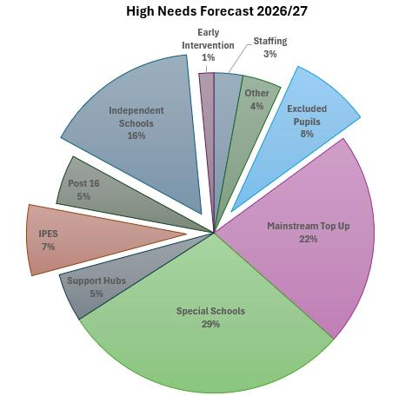

There are cost increases across the HNB however, significant increases continue in
providing independent school provision and Individual Packages of Educational
Support (IPES) that supports pupils with SEND and pupils excluded from school.
These costs now account for 30% of the total cost of the HNB (£92.5m).

This upward trend is forecast to continue into 2027/28. Key pressures and high growth budgets are shown in Table 1 and Chart 2.

Pressures | 2025/26 Outturn £m | 2026-27 Outturn £m | 2027/28 Provisional Forecast £m | Increase from 2025/26 £m
Independent Schools | 40.9 | 46.7 | 54.3 | 13.4
Top-up Funding Mainstream Schools | 59.3 | 64.9 | 66.9 | 7.6
Individual Packages of Education Support | 14.0 | 21.5 | 27.3 | 13.3
Excluded Pupils | 20.9 | 24.3 | 25.2 | 4.3
Total | 135.1 | 157.4 | 173.7 | 38.6

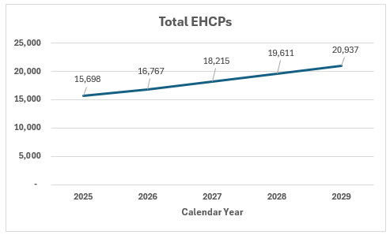

The government has confirmed additional support for local authority’s with DSG deficits through the High Needs Stability Grant (HNSG). The approach taken will be to provide funding equivalent to 90% of the overall DSG deficit (includes all 4 DSG blocks) accumulated up the end of 2025/26. Further support will be provided for deficits accrued in 2026/27 and 2027/28 however, the extent of that support has yet to be confirmed. Eligibility for the HNSG is dependent on the Local Authority’s SEND Reform Plan being approved by the DfE, with the outcome of this decision expected during the Autumn. The forecast value of the HNSG for financial years 2025/26 to 2027/28 is set out in Table 2.

 | 2025/26 | 2026/27 | 2027/28
HNSG (£000): 1.0% | (22.1) | (43.8) | (56.2)
% of DSG Deficit | 90% | 70% | 70%

The impact of a 1% transfer and the HNSG is set out in Table 3.

 | 2026/27 Outturn £m | 2027/28 £m | 2028/29 £m
(Surplus) / Deficit | 75.7 | 93.6 | 119.9
Schools Block Transfer to HNB (1%) | (13.1) | (13.3) | (13.3)
(Surplus) / Deficit: post Block Transfer | 62.6 | 80.3 | 106.6
Forecast HNSG | (43.8) | (56.2) | 0
DSG O/balance* | 2.5 | 21.3 | 45.4
DSG Deficit funded by Government ** | n/a | n/a | (106.6)
C/balance | 21.3 | 45.4 | 45.4
*the DSG opening balance for 2026/27 includes the receipt of the 2025/26 HNSG
** from 2028/29 any DSG deficit will be funded by Government. It is unknown whether the Government will expect future School Block transfers to mitigate the deficit.

It is evident from the table that even with government support the Local Authority will
be faced with a significant DSG deficit by the end of 2027/28.

The Statutory Override; the treatment of DSG deficits that allows local authorities to hold deficits off the balance sheet is to permanently end on the 31st March 2028. It is at this point Local Authorities will need to fund any residual DSG deficit.

It is to be noted that although the Statutory Override means the Authority does not have to report the DSG deficit within statutory accounts, the cost of the provision is still incurred and has to be funded at a financial cost to the Authority.

Actions taken to Address the Overspend

Schools Forum approved funding for the Inclusion Framework which enables schools to access pre-statutory funding to develop inclusive practice.

Schools Forum also agreed funding for Outreach for financial years 2024/25, 2025/26 and 2026/27. To recap, outreach is focussed on meeting needs in mainstream both at SEN Support and at EHCP to prevent escalation to special school; the outreach from PRUs is focussed on reducing permanent exclusions.

Furthermore, the Authority has invested £16.4m in the system.

How will the Transfer be Utilised

Any funding transferred from the Schools Block will be funded back to mainstream schools

- The Authority will continue to invest in early intervention strategies such as the Inclusion Framework and Outreach.

- The Authority will continue to invest in enhanced provision to provide specialist units for pupils in mainstream schools.
Financial Implications

Table 4 shows the forecast funding that has been allocated through the Essex Formula for Funding Schools.

 | 2026/27  £m | 2027/28  £m | Difference  £m
Schools Block Allocation | 1,307.3 | 1,325.6 | 18.3
Falling Rolls Fund | (0.1) | (0.1) | 0
Growth Fund | (3.6) | (3.6) | 0
Forum approved -Premature Retirement Costs | (1.2) | (1.2) | 0
Transfer to High Needs Block | (13.1) | (13.3) | (0.2)
Allocation to Schools | 1,289.3 | 1,307.4 | 18.1

The impact on schools, resulting from the proposal to transfer 1% to the Schools Block is c.£200,000. Therefore, any increase in funding for 2027/28 will be fully funded to schools, except for £200,000 which is the increase in the transfer to the high needs block.

Question 1

Do you agree with the proposal of a 1% transfer from the Schools Block to the High Needs Block to assist with pressures facing the high needs block?

Part 2 – Adhering to the Schools NFF

The Authority will need to comply with the following rules to determine budget allocations for schools for 2027/28:

- setting the value for each funding formula factor within the allowed minimum / maximum values;
- implementing the set minimum per pupil level: and
- setting the minimum funding guarantee within the allowed limit.

The Essex Formula for Funding Schools must be affordable within the resources available, and the Authority has three mechanisms that can be used to achieve this:

- Minimum funding guarantee
- Minimum / Maximum Allowable Local Factor Values
- Capping and Scaling

The following options are available to ensure the affordability of the Formula.

Minimum Funding Guarantee

The minimum funding guarantee (MFG) protects schools from excessive year-on-year changes. In 2026/27 local authorities could set the MFG between -0.5% and 0% per pupil. Essex set the MFG at -0.3% for 2026/27.

Should funding allow, the Authority will seek to move the value of MFG towards a more favourable position (0% or higher if the Government increases the limit).

Adjusting the MFG is an option for managing affordability of the Essex Formula for Funding Schools.

Minimum / Maximum Allowable Local Factor Values

Since 2023/24 in preparation for the introduction of the Direct NFF, where the DfE will calculate school budget allocations, local authorities have been required to move their local formula factor values at least 10% closer to the NFF factor value.
Essex mirrors the NFF for all factors.

The minimum / maximum values are one method the Authority has available to ensure the requirements of the Schools NFF are met and for ensuring the Essex Formula for Funding Schools remains affordable through adjusting values within the allowed range.

Capping and Scaling

To ensure the local formula is affordable local authorities can choose to cap any gains schools receive. Capping and scaling must be applied on the same basis to all schools but cannot be applied to new schools that have opened in the last 7 years and have not reached their full number of year groups.

Capping and scaling cannot take a school below the minimum per pupil level and must be set at least as high as the MFG threshold to ensure schools retain any gains due through MFG.

An example of where capping could be needed is where there in insufficient funding in the schools block to set the basic entitlement at or above the minimum value allowed. This can occur where the cost of protecting schools through the minimum funding guarantee and the minimum per pupil level is high. The use of capping will allow sufficient funding to set an allowable basic entitlement value.

Question 2 – Do you agree the Local Authority can use any of the mechanisms outlined?

Question 3 – Please rank in order of preference the mechanism the Authority should prioritise to ensure the affordability of the Formula..

Appendices

Appendix 1 – Schools Forum Report 30 September 2026

Appendix 2 – Finance Model

Estimated allocation – actual allocation based on October 2026 Schools Census

