Relationships & Sex Education Survey 2022 – responses for Maldon

1085 responses were received for Maldon.
Gender:
- 49% female
- 48% male
- Remainder did not disclose
Age:
- 62% Year 7-9
- 34% Year 10-11
- 4% age 17-25 [this equates to 42 responses and therefore have not been included in this report as sample is too small to be meaningful with many questions – raw data is available]
[Please note some questions were ‘select all that apply’ so percentages do not always add up to 100%. This may also be the case where percentages have been rounded.]
Year 7-9 [675 responses]
Where do you currently look for information on the following topics?
Topics | Top 3 places they’re most likely to look for information
Healthy and respectful relationships | - Friends/family (54%)  - School (38%)  - Online/social media (9%)  - 30% haven’t looked
Consent and the law | - School (38%)  - Friends/family (32%)  - Online/social media (14%)  - 39% haven’t looked
Staying safe online | - School (69%)  - Friends/family (49%)  - Online/social media (16%)  - 9% haven’t looked
Puberty | - Friends / family (55%)  - School (47%)  - Online/social media (6%)  - 18% haven’t looked
Periods | - Friends/family (45%)  - School (31%)  - Online/social media (6%)  - 36% haven’t looked
LGBTQ+ | - School (37%)  - Friends/family (26%)  - Online/social media (14%)  - 45% haven’t looked
In addition to RSE taught at school, which topics would you like to know more about?
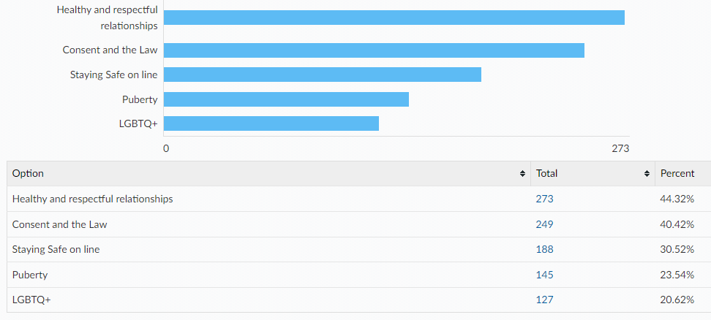
Other topics (not all relevant to SRE):
- LGBTQ+ because I think we need to know more about what people go through trying to figure out what they are and might need more time, help and more.
- Periods
- Hidden disabilities
- All the different genders
- Mental health
- Buying house (learning bills) money handling
- More history and not just always world war and not about how the ink for a bible is made and mode about Henry the VIII or titanic or more! Or more about how we can save money later in life with higher living prices and how to cope or with how to properly do taxes correctly
- Careers and jobs
- Computing, art and woodwork
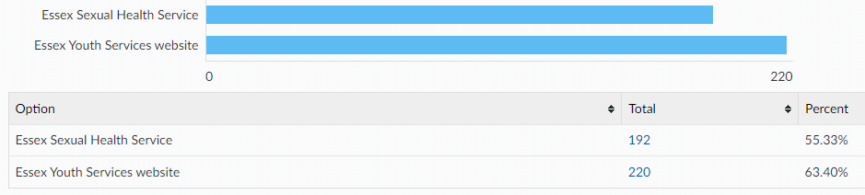
Links to the following sexual health information and services can all be found on the Essex Youth Service website. Which of the following are you already aware of?

When being on the internet or social media have you ever felt...
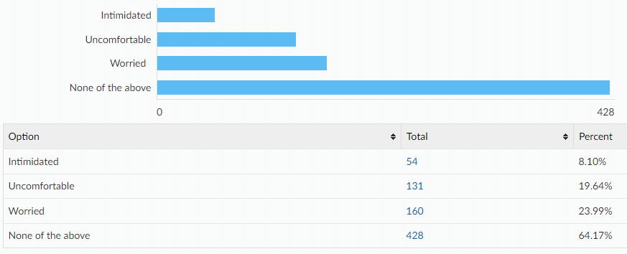
If you were to ever feel intimidated, uncomfortable or worried would you go to any of the following?
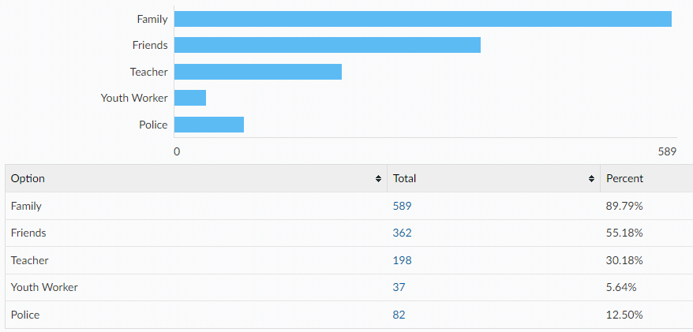
Would you tell an adult if you were asked to do something online that you were uncomfortable with? e.g. sending private pictures or joining an online private chat
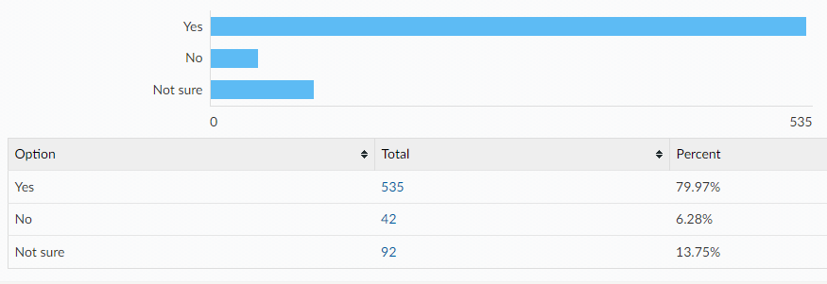
If no, what would be the reasons for not telling an adult?
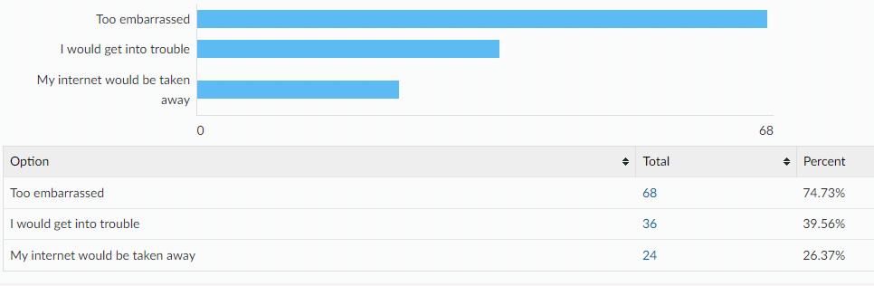
Something else:
- Go to my room
- Too scared
- I would not tell them because i do not want to
- no i just would not want to
- because I don't want to so I don't care
- I would be scared
- i would just block that person and move on
- prefer not to
- They’d make a massive fuss
- Wouldn’t happen
- I aint doing nothing so it dont matter
- no need for them to get involved when me and my mates are capable
- Uncomfortable to talk about and my mates are enough anyway
- I just wouldn't do what they want me to do cuz that dumb
- Because I'm just a child and that's a fully grown adult, it would be wrong and weird
- Uncomfortable
- They won't understand what I'm saying lol
- i wouldnt tell an adult because its not that serious. unless i get a death threat or someone with my location
- I'd just report the message, block and live happily knowing I probably got some sicko banned from that website.
- Uncomfortable with it
- I would be able to sort it out by myself so there wouldn’t be a point
- Not comfortable
- also because not to get them worried
- i just wouldn’t

Year 10-11 [368 responses]
Where do you currently look for information on the following topics?
Topics | Top 3 places they’re most likely to look for information
Healthy and respectful relationships | - Friends/family (50%)  - School (9%)  - Online/social media (6%)  - 33% haven’t looked
Consent and the law | - School (25%)  - Friends/family (25%)  - Online/social media (16%)  - 32% haven’t looked
Staying safe online | - School (39%)  - Friends/family (24%)  - Online/social media (9%)  - 26% haven’t looked
Pornography | - Online/social media (13%)  - Friends/family (7%)  - School (7%)  - 71% haven’t looked
Puberty | - Friends/family (36%)  - School (30%)  - Online/social media (4%)  - 25% haven’t looked
Masturbation | - Online/social media (10%)  - Friends/family (10%)  - Other (4%)  - 71% haven’t looked
Menstruation | - Friends/family (30%)  - School (15%)  - Other (3%)  - 47% haven’t looked
LGBTQ+ | - School (31%)  - Online/social media (14%)  - Friends/family (13%)  - 39% haven’t looked
STIs | - School (38%)  - Friends/family (10%)  - Online/social media (6%)  - 41% haven’t looked
HIV | - School (31%)  - Friends/family (9%)  - Online/social media (7%)  - 47% haven’t looked
Methods of contraception | - School (37%)  - Friends/family (14%)  - Online/social media (5%)  - 39% haven’t looked
How to access contraception | - Friends/family (14%)  - School (13%)  - GP, online/social media (5%)  - 57% haven’t looked
Steps to take after unprotected sex | - Friends/family (16%)  - School (13%)  - Online/social media (9%)  - 55% haven’t looked
Choices around pregnancy | - Friends/family (20%)  - School (11%)  - Online/social media (7%)  - 56% haven’t looked

In addition to RSE taught at school, which topics would you like to know more about?
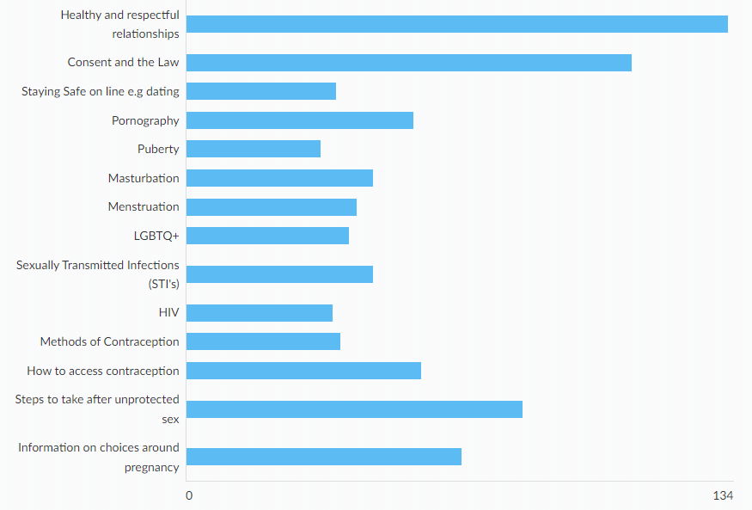
Other:
- How rape and sexual harassment or abuse is not okay and how to respect when someone says no and what people wear shouldn't matter rape is rape it's never on what they wear
- First aid
- None of them
Links to the following sexual health information and services can all be found on the Essex Youth Service website. Which of the following are you already aware of?
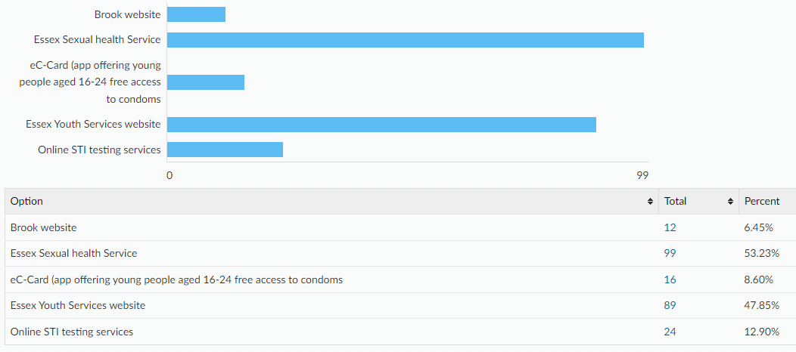

Condoms are the best way to prevent against sexually transmitted infections. There are a wide variety of other contraceptive methods designed to prevent pregnancy, some of which are listed below. All Young People have the right to information and support to allow informed choices on these methods. Please tick if you know how to access the following:

Comments:
- I don't know any of those last ones
- these questions make me uncomfortable
- I don’t know this stuff
- don’t know half of them
- How do u get condoms for free
- I have no idea what most of these mean
- Not sure what some of them are

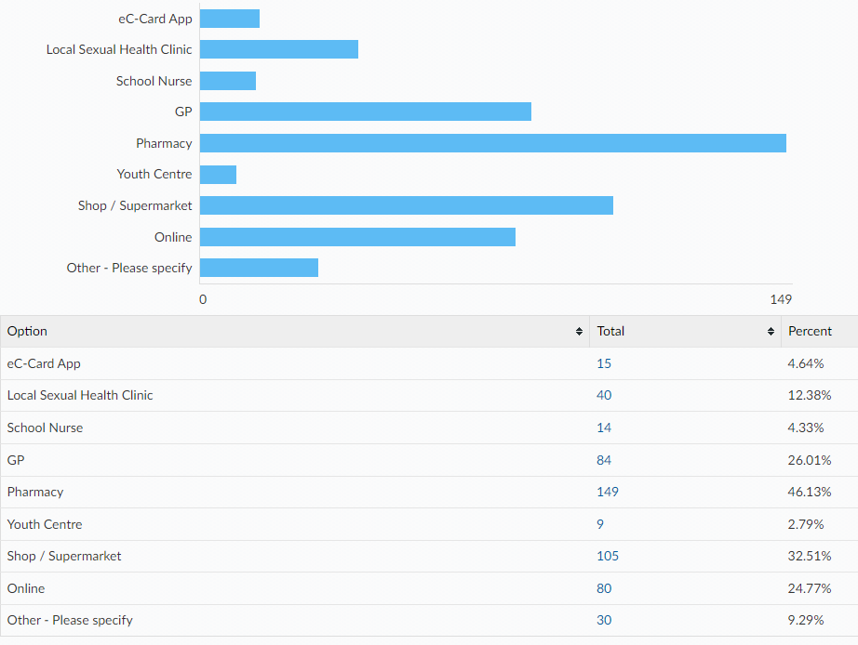
Please tell us where would you feel most comfortable going to access your chosen method of contraception?

How confident do you feel that you would know how to access emergency contraception after unprotected sex (e.g. the 'morning after pill') for yourself or a partner?
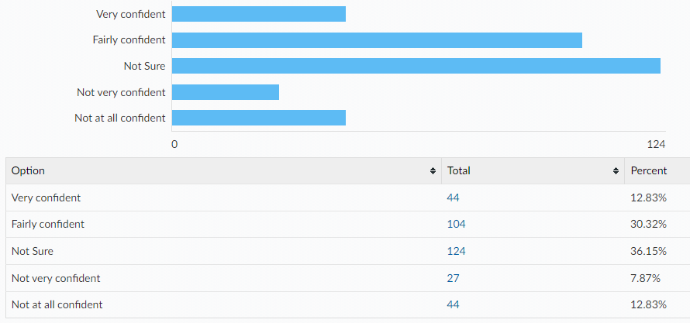

When being on the internet or social media have you ever felt...
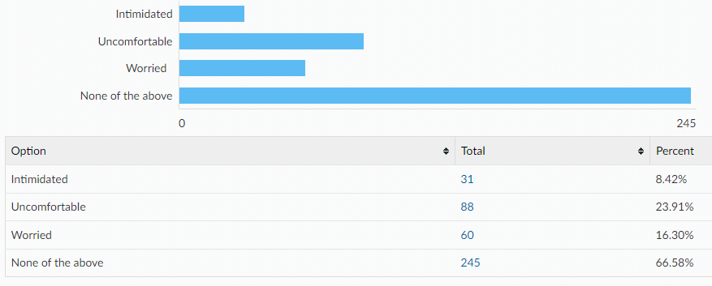
If you have felt intimidated, uncomfortable, worried…
Did you tell anyone?
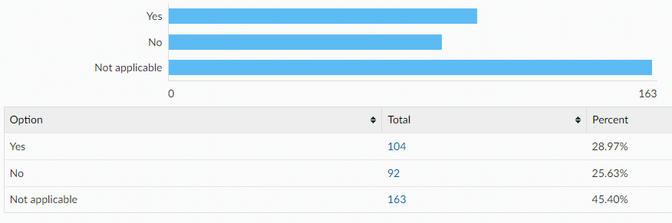
Did you know where to go for help?
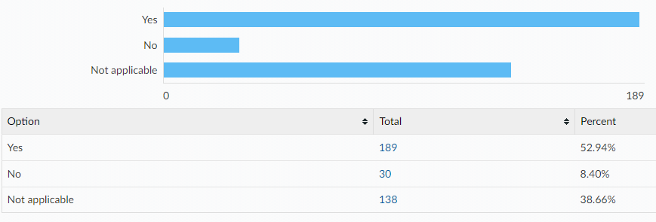

If you were to ever feel intimidated, uncomfortable or worried would you go to any of the following?
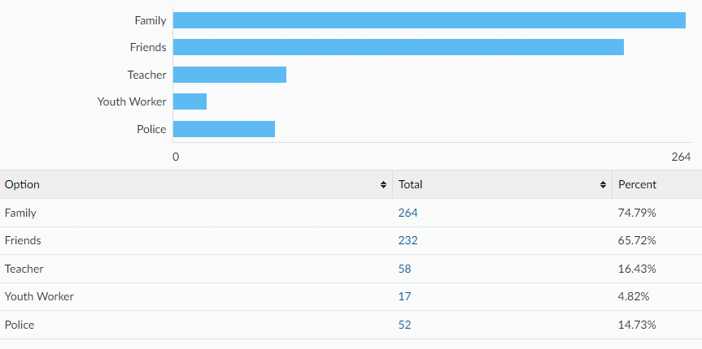
Would you tell an adult if you were asked to do something online that you were uncomfortable with? e.g. sending private pictures or joining an online private chat
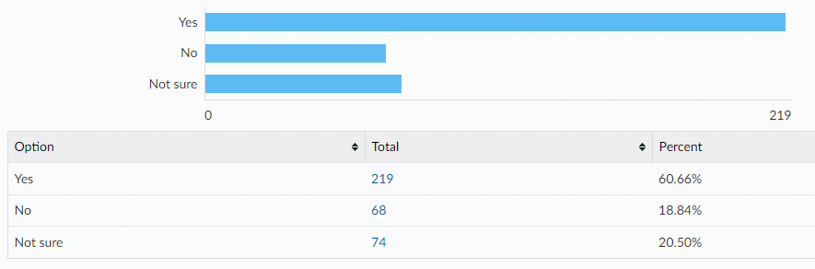
If no, what would be the reasons for not telling an adult? (please tick all that apply)
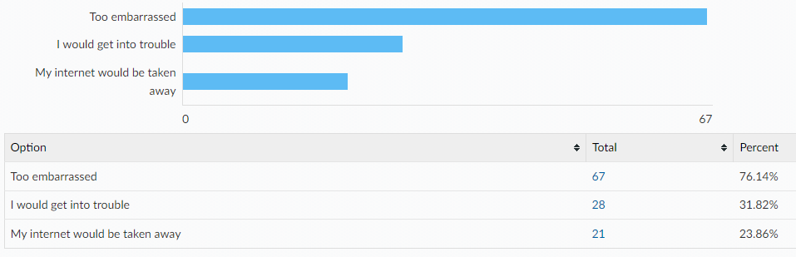

Other reasons:
- I just wouldn’t want to
- wouldn't want to don't feel like i can talk to them sometimes
- Don't want to
- Not sure
- My parents let me choose what to do myself
- None of above
- I would rather keep it to myself
- because im not a idiot i wouldnt do that
- can deal with my own problems
- i can deal with it myself
- Blocking them is just more convenient.
- I wouldn’t
- I'm not an idiot
- No point, i’ll just block them
- Privacy
- if someone asks just block them and it’s not a big deal unless you’re being blackmailed or something.
- Fear of being looked down on, shouted at, treated like a child or told that it’s my fault
- because I'm stupid
- i would not do it
- cant be bothered (im a bit lazy)
- I just block them
- Do not think it is necessary, I would just ignore them, block them and move on.
- I’m aware how to handle it myself
- Because I know I wouldn’t and I would just not speak to them
- keep it to myself
- I can handle it myself, unless serious
All ages:
[A note to help interpret this data: The total column shows percentages for ALL respondents, with age breakdowns shown along each row. E.g. 98.24% of all respondents have a mobile phone, of which 61.17% are in year 7-9, 33.27% are year 10-11 and 3.80% are aged 17-25.]
Do you have any of the following?
A mobile phone with access to the internet
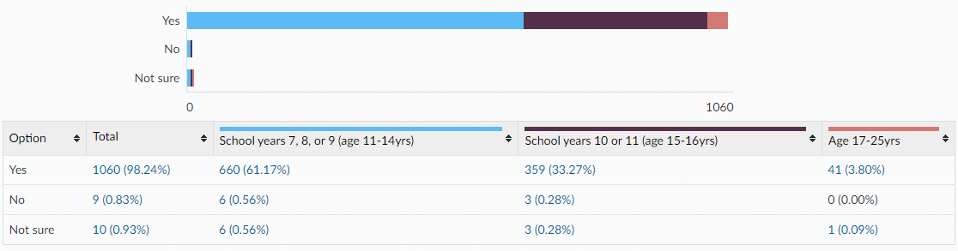

A Snapchat account
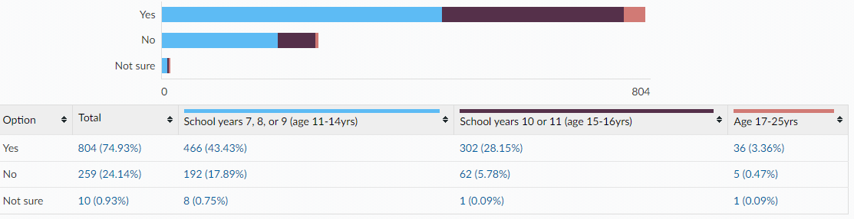
An Instagram account
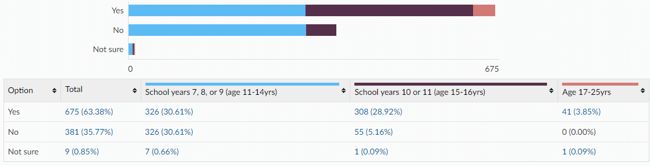
Tik Tok account
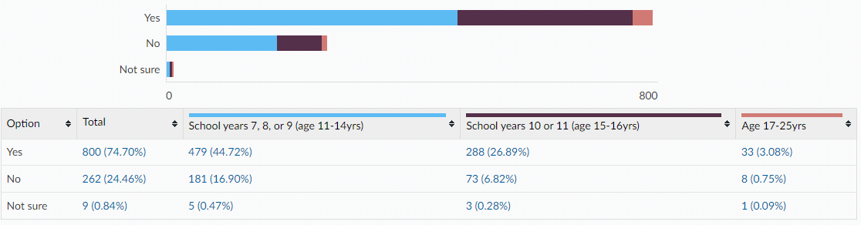
Twitch account
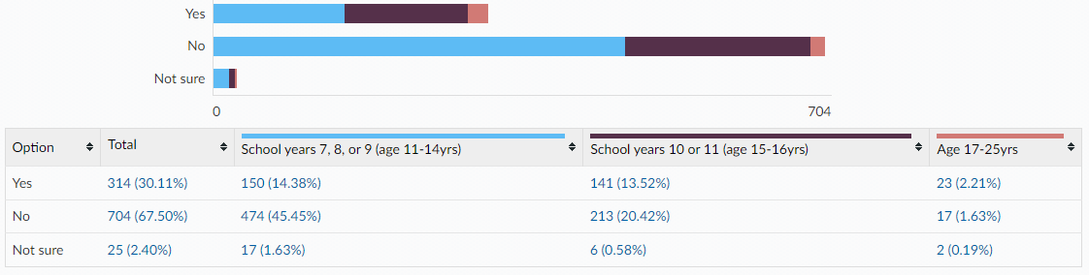

Engage in online gaming
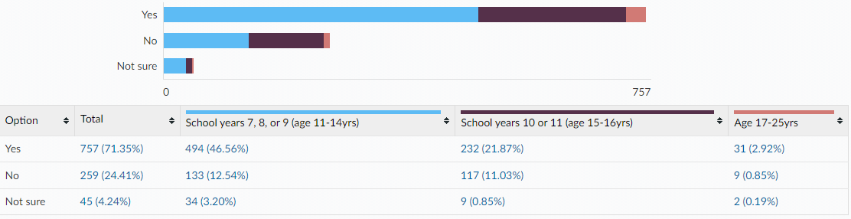
Is there anything else you would like to learn about or get support with around sex and relationships? (All ages)
- Toxic relationships
- I would not like to answer this question
- Nope I'll will just ask my Mum.
- no because i dont like that kind of stuff or relationships to me are a big no no.
- Why do you need to have sex to make the sperm cells and the egg cells mix together
- the dangers of it
- yes,i would like to learn more about puberty
- what a healthy relationship is
- nope I don't want to learn about sex
- how to manage periods in public and not just the how it works part.
- i dont want to do it
- no not really i think school has covered most of it
- The things women have to go through when pregnant
- Everything to which I responded with "I do not know" that applies to a male.
- How to be safe during sex, how to feel comfortable and look after a partner, etc.
- That rape is not okay and no is the best way to go when ur uncomfortable and take no for an answer
- what is sex?
- Same-sex education
- I want to learn about pregnancy and giving birth, like how you push it out, how to tell you’re in labour, etc
- Does daily masturbation limit the amount of times you can ejaculate during sex?
- i would like to learn what happens before, during, and after abortion. does it hurt? i know there is pills to take for abortion and they apparently really hurt but i would like to know all the information, and how to support someone before, during, and after it.
- how to get one
- how an abortion works ins relationship
- abortion
- i would like to learn about friends online and who to trust
- Does it hurt for the women during sex?
- To be able to know where to go or get support about sex and relationships and how a relationship can build up to sex.
- No, i think everything i need to know has been taught in school.
- We don’t do sex Ed at school
- I think boys should be involved in discussions about menstruation since it’s very relevant, and many are very undereducated
- How to not get pregnant
- Learn more about LGBT+ relationships
- nope just the ones i said in the same previous question
- whatever I need to know

This information is issued by:

Essex County Council
Research & Citizen Insight

Contact us:
research@essex.gov.uk
County Hall
Market Road
Chelmsford
CM1 1QH

Sign up to Keep Me Posted email updates:
Essex.gov.uk/keepmeposted
Twitter: Essex_CC
Facebook: Facebook.com/essexcountycouncil

Produced October 2022.

