Relationships & Sex Education Survey 2022 – responses for Epping Forest

625 responses were received for Epping Forest.
Gender:
- 53% female
- 43% male
- 1% non-binary
- Remainder did not disclose
Age:
- 61% Year 7-9
- 33% Year 10-11
- 6% age 17-25 [this equates to 40 responses and therefore have not been included in this report as sample is too small to be meaningful with many questions – raw data is available]
[Please note some questions were ‘select all that apply’ so percentages do not always add up to 100%. This may also be the case where percentages have been rounded.]
Year 7-9 [380 responses]
Where do you currently look for information on the following topics?
Topics | Top 3 places they’re most likely to look for information
Healthy and respectful relationships | - Friends/family (47%)  - School (30%)  - Online/social media (13%)  - 34% haven’t looked
Consent and the law | - School (40%)  - Friends/family (29%)  - Online/social media (13%)  - 38% haven’t looked
Staying safe online | - School (69%)  - Friends/family (49%)  - Online/social media (14%)  - 9% haven’t looked
Puberty | - School (54%)  - Friends/family (51%)  - Online/social media (10%)  - 19% haven’t looked
Periods | - Friends/family (46%)  - School (38%)  - Online/social media (8%)  - 30% haven’t looked
LGBTQ+ | - School (40%)  - Friends/family (22%)  - Online/social media (19%)  - 42% haven’t looked
In addition to RSE taught at school, which topics would you like to know more about?
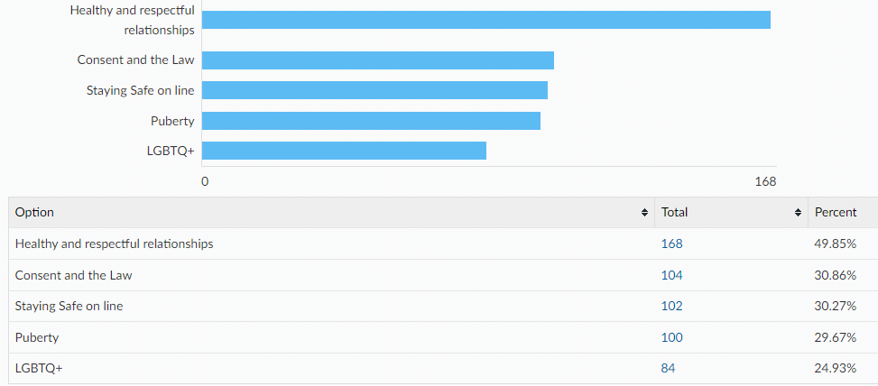
Other topics:
- The emotional side of sex, rather than just the science of it
- Mental health
- Sex

Links to the following sexual health information and services can all be found on the Essex Youth Service website. Which of the following are you already aware of?
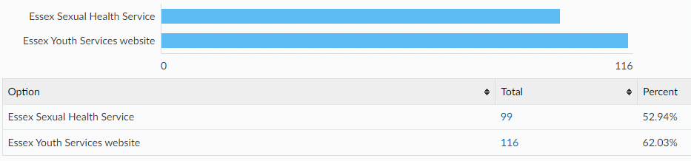

When being on the internet or social media have you ever felt...
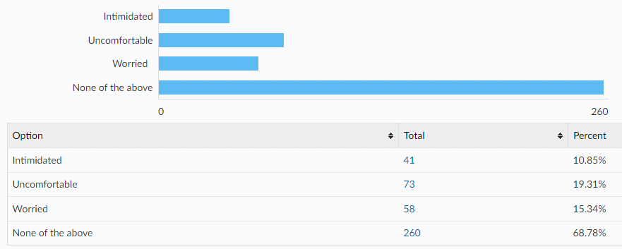
If you have felt intimidated, uncomfortable, worried…
Did you tell anyone?

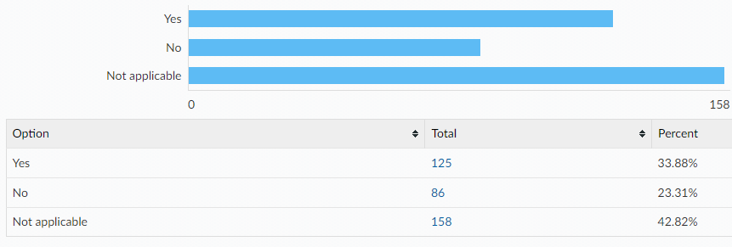
Did you know where to go for help?

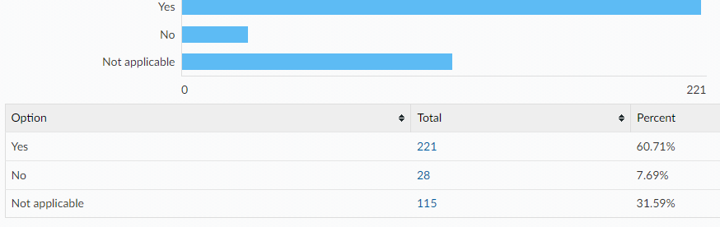

If you were to ever feel intimidated, uncomfortable or worried would you go to any of the following?
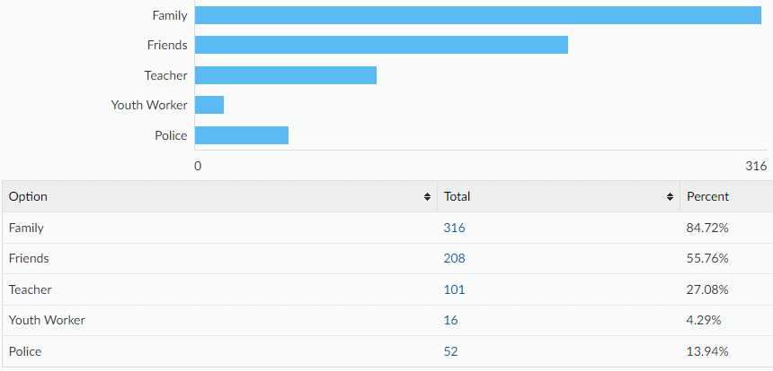
Would you tell an adult if you were asked to do something online that you were uncomfortable with? e.g. sending private pictures or joining an online private chat
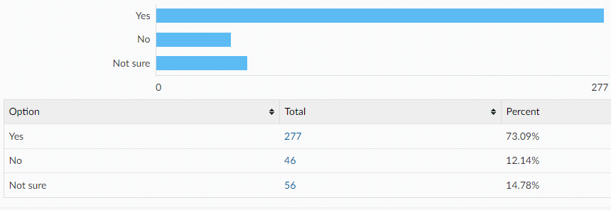
If no, what would be the reasons for not telling an adult?
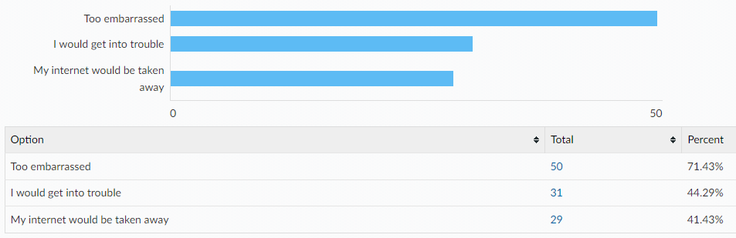

Something else:
- I know how to deal with these things so I’d say no, block and report them, then leave the game
- They don't need to know about my problems when they have their own
- cant be asked, plus half of them dont understand the internet
- Can’t be asked
- I don’t worry
- I don’t feel comfortable
- none of their business
- Never experienced it
- My mum would say I had to do it
- none of their business
- It’s not a big deal
- Because I wouldn’t do it in the first place
- Coz I don’t want to
- I can deal with them myself
- I’d feel wrong and weird
- Too much effort
- wouldn’t feel like it
- Get smacked
Year 10-11 [205 responses]
Where do you currently look for information on the following topics?
Topics | Top 3 places they’re most likely to look for information
Healthy and respectful relationships | - Friends/family (34%)  - School (14%)  - Online/social media (14%)  - 35% haven’t looked
Consent and the law | - School (33%)  - Friends/family (18%)  - Online/social media (18%)  - 27% haven’t looked
Staying safe online | - School (39%)  - Friends/family (19%)  - Online/social media (13%)  - 26% haven’t looked
Pornography | - Online/social media (17%)  - School (12%)  - Other (3%)  - 65% haven’t looked
Puberty | - Friends/family (31%)  - School (26%)  - Online/social media (8%)  - 32% haven’t looked
Masturbation | - Online/social media (13%)  - Other (6%)  - School (5%)  - 70% haven’t looked
Menstruation | - Friends/family (28%)  - School (19%)  - Online (9%)  - 39% haven’t looked
LGBTQ+ | - School (24%)  - Online/social media (17%)  - Friends/family (14%)  - 40% haven’t looked
STIs | - School (36%)  - Online/social media (10%)  - Friends/family (7%)  - 40% haven’t looked
HIV | - School (33%)  - Online/social media (9%)  - Friends/family (5%)  - 44% haven’t looked
Methods of contraception | - School (33%)  - Friends/family (12%)  - Online/social media (10%)  - 38% haven’t looked
How to access contraception | - Friends/family (17%)  - School (13%)  - Online/social media (10%)  - 47% haven’t looked
Steps to take after unprotected sex | - Online/social media (16%)  - Friends/family (14%)  - School (13%)  - 52% haven’t looked
Choices around pregnancy | - Friends/family (22%)  - Online/social media (12%)  - School (12%)  - 47% haven’t looked

In addition to RSE taught at school, which topics would you like to know more about?
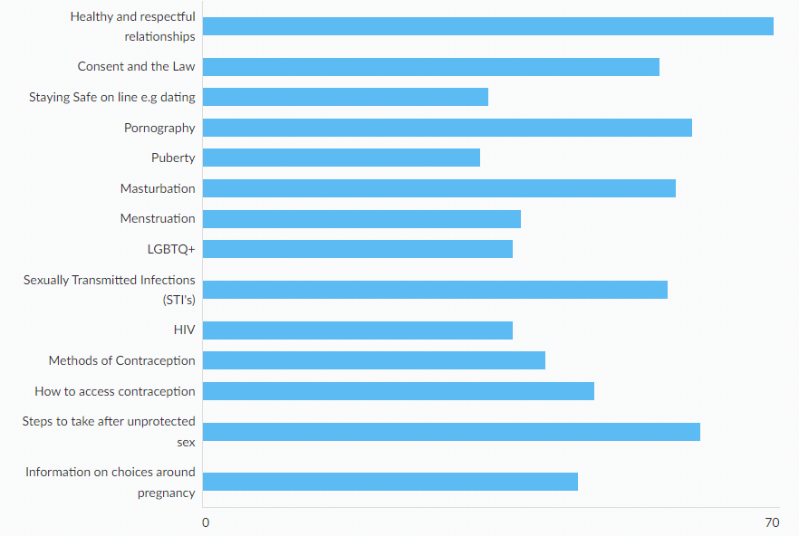
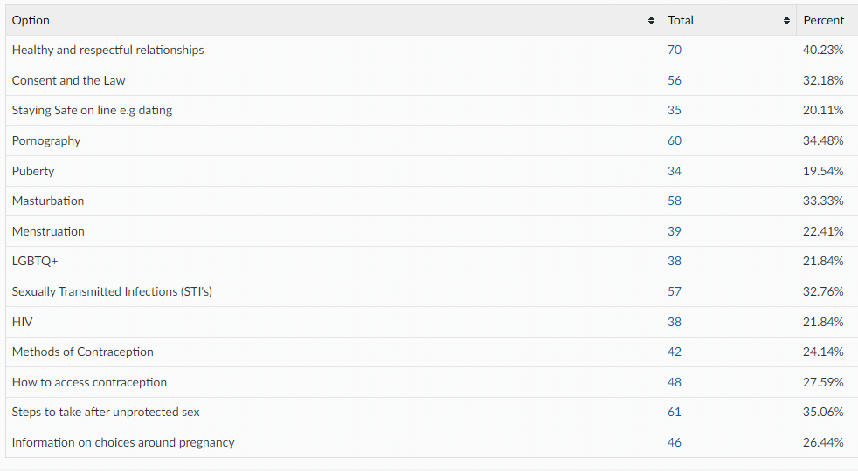
Other:
- Abortion awareness
- Mental health
- Taxes and life after school
Links to the following sexual health information and services can all be found on the Essex Youth Service website. Which of the following are you already aware of?
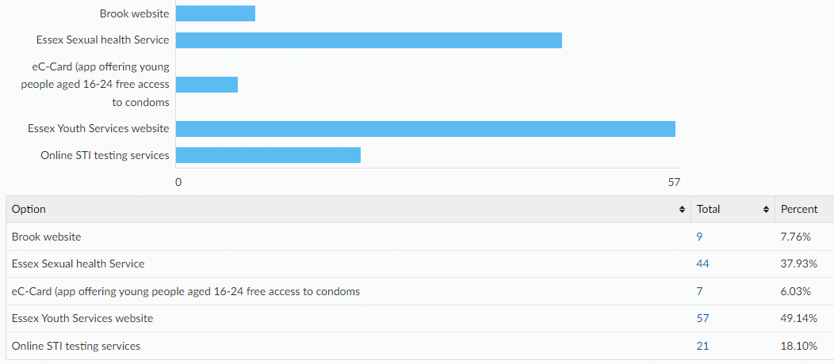
Condoms are the best way to prevent against sexually transmitted infections. There are a wide variety of other contraceptive methods designed to prevent pregnancy, some of which are listed below. All Young People have the right to information and support to allow informed choices on these methods. Please tick if you know how to access the following:

Comments:
- I don’t know what half this stuff is
- Don't know what they are, sorry

Please tell us where would you feel most comfortable going to access your chosen method of contraception?
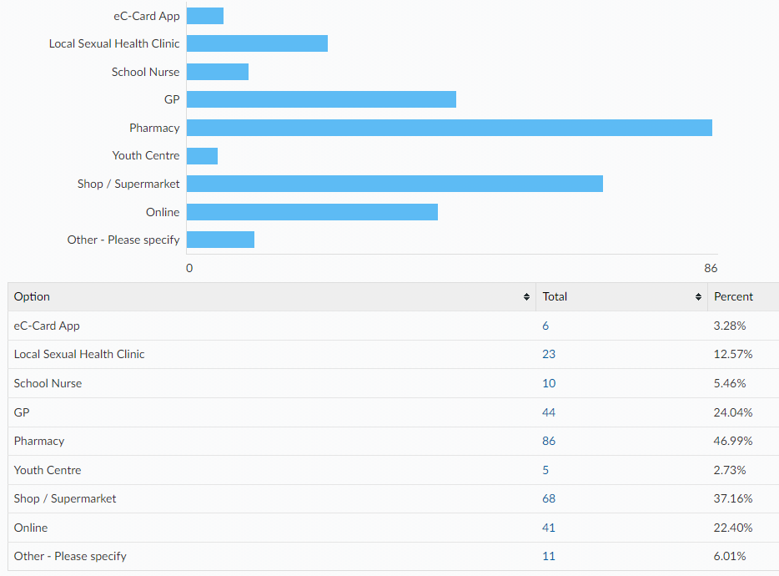
How confident do you feel that you would know how to access emergency contraception after unprotected sex (e.g. the 'morning after pill') for yourself or a partner?
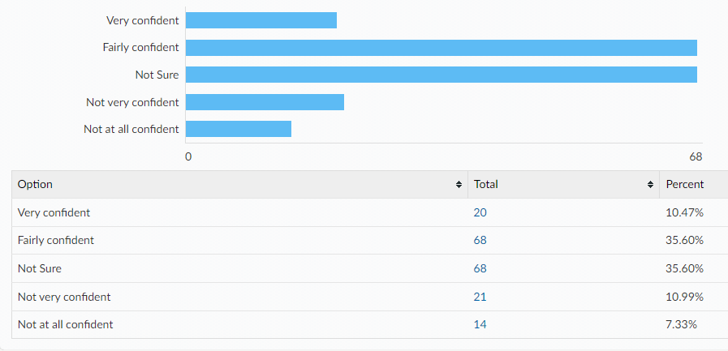

When being on the internet or social media have you ever felt...
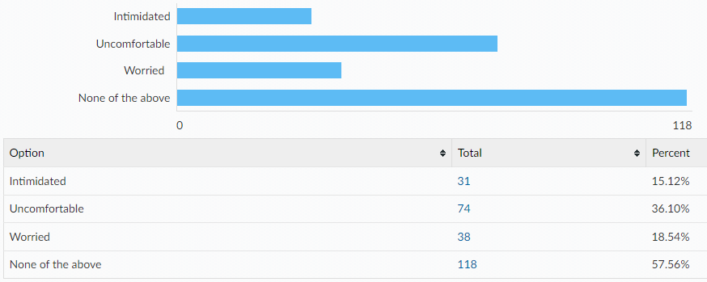
If you have felt intimidated, uncomfortable, worried…
Did you tell anyone?
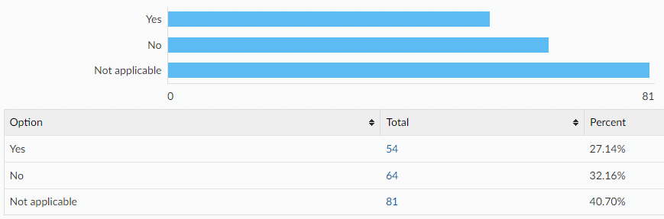
Did you know where to go for help?
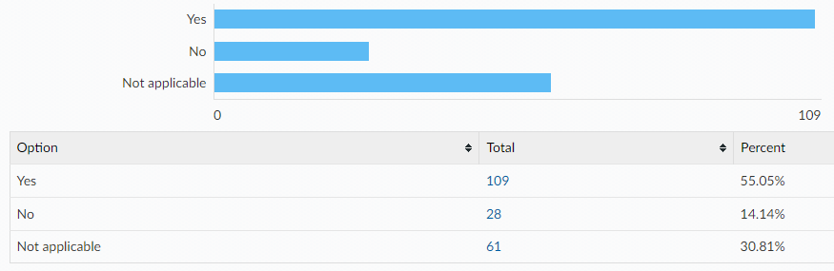

If you were to ever feel intimidated, uncomfortable or worried would you go to any of the following?
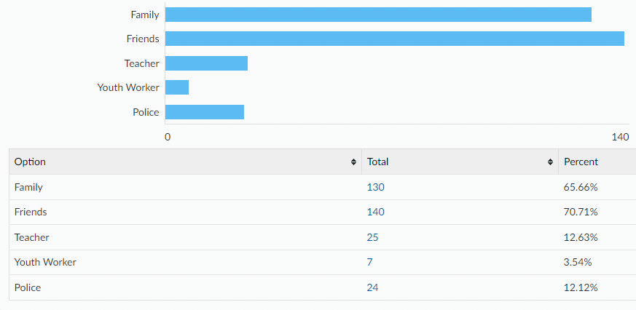
Would you tell an adult if you were asked to do something online that you were uncomfortable with? e.g. sending private pictures or joining an online private chat
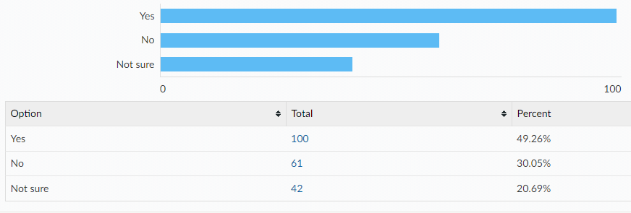
If no, what would be the reasons for not telling an adult? (please tick all that apply)
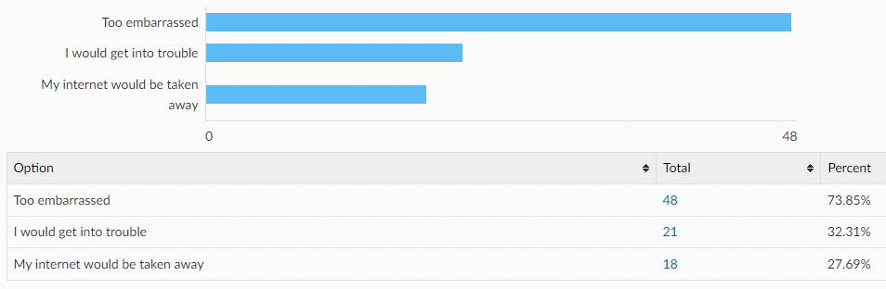

Other reasons:
- I can deal with it myself
- Wouldn’t need to, can confidently handle the situation myself
- old enough to handle it on my own
- I don’t care at this point, it’s better than real life.
- Just wouldn’t
- Not that deep lol would just say no
- I don’t feel comfortable
- i might get beaten
- i would be called a snake
- It’s weird
- Don’t wanna
- Just woudlnt need help
- I don’t know sorry
- effort
- Just don’t feel the need to if I said no myself
- dont feel the need to if i said no myself
- I'm not that bothered
- Independent
- i fight my own battles
- Unless I was really worried I don’t think there’s any need to tell an adult unless I want them to do Something about it as I already know to block them etc if I don’t wanna see or hear anything
- ✨Indian Mother✨
- depending on the situation i would decide if it was crucial for them to know and if it the situation was too inappropriate to the level where an adult should be told.
- i dont get in those situations

All ages:
[A note to help interpret this data: The total column shows percentages for ALL respondents, with age breakdowns shown along each row. E.g. 97.59% of all respondents have a mobile phone, of which 59.07% are in year 7-9, 32.26% are year 10-11 and 6.26% are aged 17-25.]
Do you have any of the following?
A mobile phone with access to the internet
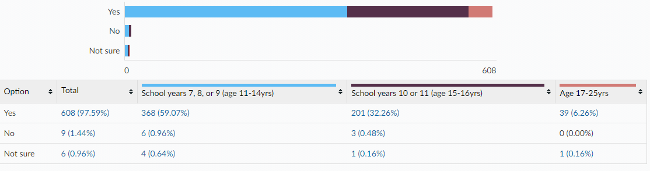

A Snapchat account
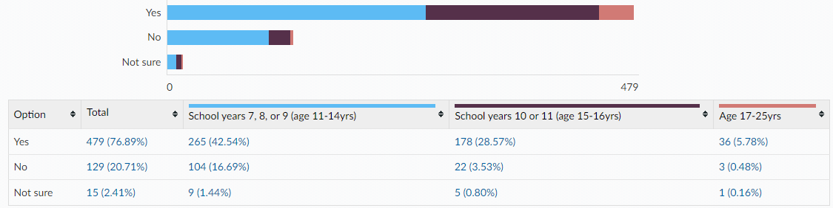
An Instagram account
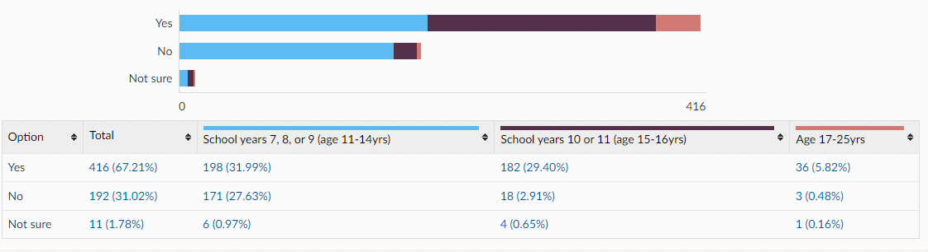
Tik Tok account
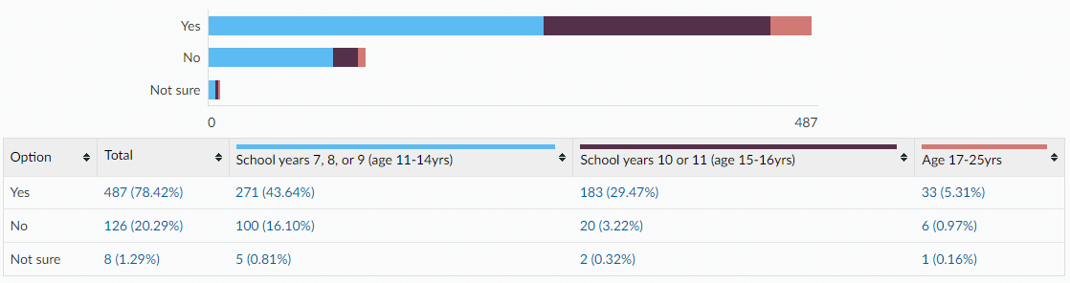
Twitch account
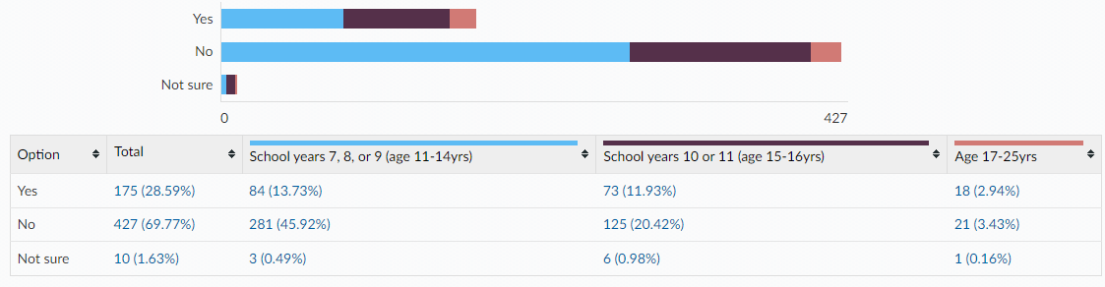

Engage in online gaming
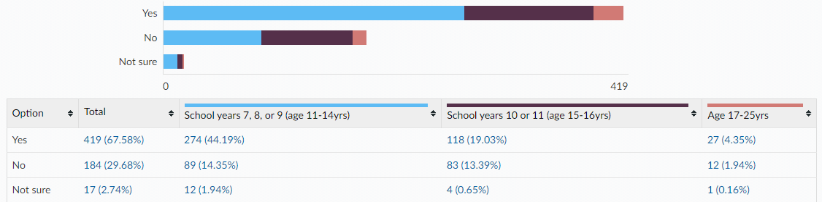
Is there anything else you would like to learn about or get support with around sex and relationships? (All ages)
- not really except about gay relationships like we learn about how to safely practice straight sex but some people will never use that information and need info on how to safely practice gay sex in both men and women
- Much more about LGBTQ relationships as we have learnt nothing about these
- The best type of contraception to use if you are LGBTQ+, even though you may not be able to get pregnant. Not just about different types of sexually transmitted diseases but also what to do if you get one.
- I think different sexualities should be taught at schools and there should be education around treating people with different sexualities. I am asexual (I don’t enjoy sex or dating) and have debilitating period pain, but when I go to the GP they insist to give me contraception as they imply I’m lying and just too embarrassed to admit I’m sexually active. I just want an end to my period pain, why does sex come into it?
- I am in year 11 and no one in my year group has been sexually educated by the school.
- LGBTQ relationships
- The birds and the bees
- the consent age
- Safety
- Sex education
- is the age of consent 13
- what to do if my friends had sex already
- Method
- How to go on the contraceptive pill if you feel too uncomfortable speaking to parents about it.
- demonstrations
- How condoms are used
- Pleasure
- Support for online international relationships and support for safe and healthy queer sex / relationships. The SRE curriculum primarily covers straight relationships and only mentions queer ones when warning about STIs. It’s destructive to impressionable queer people and whilst it’s useful that people know, it scares young queer people.
- I don’t think so but if I did I would go to family,friends and school.
- Teach proper consent and teach men not to rape, I’m fed up of women being blamed for something that’s the fault of men.
- No, but I would like to learn more about British Imperialism and our history.
- where to go for contraception
- What is healthy and what is an bad relationship
- Anything that could potentially cause unwanted pregnancy, like something that could damage or restrict protection
- I want to be able to have sexual education in forms to teach young people safety and how to access contraception, as well as destigmatizing harmful social norms surrounding sex, puberty, menstration, contraception, masturbation and pornography
- To normalise all natural looks of genetalia instead of a scientific diagram that does seem aplicable or relatable.
- What a healthy relationship looks like.
- gay sex transgender people
- Lgbtqia+ sex ed, something that’s needed both for queer kids and those who aren’t. There’s an exorbitant amount of people who don’t know enough, which leads to misinformation and bullying, and schools are not doing enough, and they don’t even provide the right information. Teachers are clearly biased in sex ed lessons, with some stating things such as abstinence is should be used, and abortion is morally wrong, they refuse to provide information on occasion and hurt kids by doing this.
- How to control not watching porn every night

This information is issued by:

Essex County Council
Research & Citizen Insight

Contact us:
research@essex.gov.uk
County Hall
Market Road
Chelmsford
CM1 1QH

Sign up to Keep Me Posted email updates:
Essex.gov.uk/keepmeposted
Twitter: Essex_CC
Facebook: Facebook.com/essexcountycouncil

Produced October 2022.

